




IMPLEMENTATION OF THE STRATEGIC ACTION PROGRAMME (SAP) OF THE DINARIC KARST AQUIFER SYSTEM: IMPROVING GROUNDWATER GOVERNANCE AND SUSTAINABILITY OF RELATED ECOSYSTEMS

OUTPUT 5.1.

JOINT ACTION PROGRAMME
UNA TBA

MARCH 2026



Contents
1. Introduction 1
1.1 Purpose and scope of the Joint Action Programme for Una TBA 1
1.2 Geographic, geological and hydrogeological overview of Una TBA 1
1.3 Legal framework – multilateral and bilateral agreements 5
1.4 Institutional and transboundary cooperation 7
1.5 Alignment of JAP with national RBMPs and the EU WFD 8
1.6 Methodology 9
2. Identified problems and challenges 11
2.1 Microbiological contamination of springs in Bihać region 12
2.2 PCB pollution from military installations (Željava, Udbina) 13
2.3 Insufficient data on groundwater abstraction in rural areas 14
2.4 Anthropogenic pressures on groundwater and groundwater-dependent ecosystems 14
3. Socio-economic setting and challenges of Una TBA 17
3.1 Overall socio-economic characteristics and demographic indicators 17
3.1.1 The Croatian side of Una TBA 17
3.1.2. Overall socio-economic characteristics and demographic indicators - The Bosnia and Herzegovina side of Una TBA 21
3.1.3. Transboundary synthesis 23
3.2. Institutional and financial capacities and challenges 25
3.2.1. Stakeholder analysis 26
3.3. Gender analysis 26
3.3.1 Women in households 27
3.3.2. Women in economic activities 27
3.3.3. Women, use of water and water management 27
3.3.4. Risk exposure and vulnerabilities 28
3.3.5. Adaptive capacities and decision making 30
3.4. Role, services and significance of groundwater and groundwater-dependent ecosystems (GWDEs) 30
3.4.1. Water supply and sanitation infrastructure and challenges 31
3.4.2. Water Supply Infrastructure 31
3.6.2 Sanitation and wastewater treatment 32
3.4.3. Key infrastructure challenges (transboundary perspective) 32
3.4.4. Current water use by sectors 33
3.4.5. Future water demand projections 33
3.5. Implications for DIKTAS and recommendations 33
3.5.1. Key findings and transboundary implications 33
3.5.2. Priority recommendations 34
3.5.3. Water balance and sustainability indicators 35
4. Hydrogeological and environmental characterization 36
4.1 Karst aquifer dynamics and vulnerability 36
4.2 Recharge/discharge zones and flow patterns 39
4.3 Groundwater-dependent ecosystems 43
4.4. Quality indicators of groundwater and groundwater-dependent ecosystems 46
GW chemical status 46
5. Current monitoring for groundwater 52
5.1 Monitoring types and design of monitoring networks 53
5.2 Parameters and frequencies of monitoring 56
5.3 Quality Assurance (QA) / Quality Control (QC) of data 59
6. Current approach for groundwater status and risk assessment 61
6.1 Groundwater standards, criteria and threshold values 61
6.2 Assessment of chemical and quantitative status of groundwater 64
6.3 Trend analysis 65
6.4 Risk assessment 67
7. Institutional and transboundary cooperation measures 68
7.1 Jurisdiction and operations of the Joint Water Management Commission of the Republic of Croatia and Bosnia and Herzegovina 68
7.2 Joint data sharing mechanism 70
7.3 Options for funding through EU and international programmes 72
7.4. Strengthening institutional role and capacities 76
7.5. Strengthening stakeholder engagement and public awareness 77
7.6 Engagement of local and regional authorities 78
8. Measures for sustainable groundwater management 80
8.1 Strategic approach to sustainable groundwater management 80
8.2 Promotion of water-efficient technologies 82
8.3. Control and licencing of groundwater exploitation and wastewater discharge 83
8.4 Community participation in groundwater governance 86
8.5 The role of stakeholders in implementation and monitoring of transboundary cooperation and governance 87
8.6 Communication strategy 88
8.7 Conflict resolution 90
9. Preventive protection measures 91
9.1 Groundwater vulnerability, hazard and risk map 91
9.2 Guidelines for harmonization of criteria for: delineation and types of measures in sanitary protection zones 95
9.3 Regulation, guidelines and risk-based criteria for subsurface wastewater discharge 97
9.4 Prevention and control of point and non-point pollution affecting groundwater quality 102
9.5 Prevention and control of groundwater abstraction affecting groundwater quantity 104
9.6 Guidelines for risk assessment and risk management of catchment areas for abstraction points used for human consumption 106
9.7 Early warning and emergency response 107
9.8 Land use planning instruments for groundwater vulnerability mitigation 109
10. Development of multi-purpose monitoring networks of surface water, groundwater and groundwater-dependent ecosystems 111
10.1 Context and objectives of multi-purpose monitoring networks 111
10.2 Legal and policy background 112
10.3 Joint management targets and priorities 113
10.4 Selection of monitoring sites and parameters and monitoring frequency 114
10.5 Sampling protocols 119
10.6 Integration of existing national monitoring networks 119
10.7 Data collection, validation and storage 119
10.8 Quality assurance and standardisation 120
10.9 Harmonised data exchange and reporting protocols 120
10.10 GIS integration and visualization 120
10.11 Implementation roadmap and action plan 120
11. Guidelines for establishing remediation measures for contaminated aquifer zones (including possible PCB pollution from military installations) 121
11.1 Remediation purpose and objectives 121
11.2 Regulatory and policy context 121
11.3 Contaminated site characterization and risk assessment 122
11.4 Design of contaminated site monitoring network and sampling strategy 123
11.5 Defining remediation goals (restoration vs. risk reduction) 125
11.6 Site-specific cleanup levels and endpoints 126
11.7 In-situ and ex-situ remediation technologies for contaminated karst groundwater 127
11.8 Emergency response planning 129
11.9 Stepwise and risk-based remediation planning 130
11.10 Pilot testing and phased implementation 130
11.11 Effectiveness monitoring of remediation 131
11.12 Adaptive management and optimization strategies 132
11.13 Transboundary and interagency coordination 132
12. Monitoring and evaluation of progress of the JAP Una 133
12.1 Performance indicators 133
12.1.1. Institutional indicators 133
12.1.2. Legal and fiscal indicators 134
12.1.3. Technical indicators 135
12.1.4. Policy planning indicators 135
12.1.5. Recommended approach to monitoring and reporting 135
12.2 Periodic reporting 136
12.3 Review plan 137
12.4 Stakeholders role in monitoring and evaluation 138
13. Annexes 141
13.1 Topographic and hydrogeological maps of Una TBA 141
13.2 Monitoring of groundwater, surface water and hydrometeorology in Una TBA 143
13.3 Stakeholder list 146
13.4 References 149
13.4.1 Legal framework references 149
13.4.2 Reports, studies, papers, regional plans and strategies 152
13.5 Monitoring and remediation practices examples 157
13.5.1 Monitoring 157
13.5.2 Remediation 159
13.6 Qualitative indicators for groundwater governance (example) 163
13.6.1 Indicator category: Institutional 163
13.6.2 Indicator category: Legal & Fiscal 164
13.6.3 Indicator category: Technical 165
13.6.4 Indicator category: Policy & Planning 166
13.7 Methodological tools and templates for indicator tracking 167

List of Figures

Figure 1 Topographic map with Una TBA boundary 2
Figure 2 Hydrogeological map with general groundwater flow directions 5
Figure 3 Conceptual hydrogeological model of Una TBA 38
Figure 4 Spatial distribution of sinkholes, springs and rivers 41
Figure 5 Groundwater-dependent ecosystems for Una TBA (including four (4) terrestrial and two (2) aquatic) 46
Figure 6 Groundwater monitoring in Una TBA 54
Figure 7 Surface water monitoring in Una TBA 55
Figure 8 Meteorological and hydrological stations in Una TBA 56
Figure 9 Vulnerability map of grouped groundwater bodies Una (Biondić et al., 2016) 92
Figure 10 Hazard map of grouped groundwater bodies Una (Biondić, 2016) 93
Figure 11 Risk map of grouped groundwater bodies Una (Biondić, 2016): for point and line sources of pollution 94
Figure 12 Risk map of grouped groundwater bodies Una (Biondić, 2016): for diffuse sources of pollution (agriculture) 94
Figure 13 Sanitary protection zones for Klokot-Privilica springs: Left: from 2004 Study (University of Sarajevo Civil Engineering Faculty); Right: from 2020 Study (Hollinger, 2020) 97
Figure 14 Risk based approach for planning, design, and operation of MAR systems with treated wastewater in Una TBA (modified according to Yuan et al., 2016) 101

List of Tables
Table 1 Estimation of the pollution loads generated in the catchment area of the spring Klokot (2020) 15
Table 2 Population changes in Croatian municipalities within Una TBA (2011–2021) 17
Table 3 Aggregate demographic indicators for the analysed area within Una TBA (Croatia) 20
Table 4 Demographic and socio-economic indicators within Una TBA - Bosnia and Herzegovina 22
Table 5 Institutional and financial capacities in Una TBA (Croatia-Bosnia and Herzegovina comparison) 26
Table 6 Stakeholder analysis for Una TBA 26
Table 7 Key infrastructure challenges in Una TBA (transboundary perspective) 33
Table 8 Priority recommendations and alignment with DIKTAS 2 components 34
Table 9 Priority recommendations for Una TBA: DIKTAS 2 alignment and implementation framework 35
Table 10 Sustainability indicators framework, key vulnerabilities and management 35
Table 11 Sinkhole-spring hydraulic connections identified by tracer tests 39
Table 12 Parameters used for groundwater chemical status assessment and required annual testing frequency - GWS and specific pollutants 47
Table 13 Additional parameters used for groundwater chemical status assessment and required annual testing frequency 48
Table 14 Lists of bioindicator organisms (many taxa not listed to species level here) of groundwater ecosystems with their corresponding habitats according to NKS included in the analysis and assessment of groundwater karst ecosystems 50
Table 15 List of basic physico-chemical parameters and biological elements for quality of ground water 52
Table 16 Groundwater monitoring stations in Una TBA 54
Table 17 Parameters used for groundwater chemical status assessment and required annual testing frequency- GQS and specific pollutants (modified from Water Institute JJS, 2025) 57
Table 18 Additional parameters used for groundwater chemical status assessment and required annual testing frequency (Water Institute JJS) 57
Table 19 Critical and threshold values for karst areas in Croatia 63
Table 20 Spatial, monitoring and pressure-related datasets used for the conceptual model of Una TBA 72
Table 21 Indicative overview of relevant funding instruments 74
Table 22 Indicative priority areas and strategic focus for Una TBA 75
Table 23 Target groups, awareness focus and communication channels for groundwater protection 78
Table 24 Engagement tools for local and regional authorities 80
Table 25 Governance role and communication focus in Una TBA 89
Table 26 List of basic measures for point sources of pollution 103
Table 27 List of basic measures for non-point sources of pollution 104
Table 28 List of basic measures for control of groundwater abstraction 105
Table 29 Operational components of an EWER system in transboundary aquifer management 108
Table 30 Surface water monitoring stations in Una TBA 115
Table 31 Hydrological stations in Una TBA 115
Table 32 Proposed parameters for groundwater quality monitoring and required annual testing frequency 116
Table 33 Additional proposed parameters for groundwater quality monitoring and required annual testing frequency 116
Table 34 Proposed ecological indicators in biological monitoring and sampling frequency 118
Table 35 Proposed physico-chemical parameters in biological monitoring and sampling frequency 119
Table 36 Stakeholders’ roles in monitoring and evaluation 139

PREPARED BY DIKTAS II PROJECT TEAM
Zoran Nakić
Uroš Jurošević
Maja Oštrić
Anita Bušljeta Tonković
Romario Zoga
Želimir Pekaš
Selma Čengić
Marinko Vranić
Ivan Vučković
Anita Dedić
Marina Funduk
Nino Serdarević
Vedran Furtula

Supported By:
Boban Jolović, Project Manager

1. Introduction

1.1 Purpose and scope of the Joint Action Programme for Una TBA
The Joint Action Programme (JAP) for Una transboundary aquifer (TBA) establishes a focused and cooperative framework through which Croatia and Bosnia and Herzegovina can jointly advance the objectives of the DIKTAS Strategic Action Programme at the TBA level. Its purpose is to guide the development and implementation of coordinated actions that enhance the protection, sustainable use, and long‑term resilience of the karst groundwater system shared by the two countries. In doing so, the JAP translates regional agreements and DIKTAS II commitments into a clear, practical instrument tailored to the specific conditions and needs of Una TBA. In developing its framework, the JAP also acknowledges the principles outlined in the UN General Assembly Resolution A/RES/63/124 on the Law of Transboundary Aquifers, which encourages countries sharing groundwater systems to establish appropriate bilateral or regional arrangements for their cooperative governance. This ensures that the joint actions defined for Una TBA are consistent with globally recognized norms for the sustainable and equitable management of transboundary aquifers.
The JAP consolidates the planning functions originally associated with the “Water Master Plan” concept, following the project team’s decision to apply a single, coherent terminology across all transboundary aquifers. This adjustment ensures conceptual clarity and prevents overlap with River Basin Management Plans, which remain the core planning documents required under the EU Water Framework Directive. At the same time, the JAP retains the full scope of activities envisaged for Una TBA, while the specialized “Methodology for groundwater resources assessment at Una TBA level” will be delivered as a separate technical document and referenced as appropriate.
In defining its scope, the JAP focuses on the priority issues identified for Una TBA during the DIKTAS II project implementation and provides a structured basis for selecting and coordinating measures that address pressures on groundwater quantity, quality, and groundwater‑dependent ecosystems. It further outlines how the two countries will work together to strengthen monitoring practices, improve information exchange, and harmonize management approaches, ensuring that jointly agreed actions are feasible, transparent, and aligned with international standards. The JAP also establishes the framework for implementation, follow‑up and periodic review, ensuring that progress can be measured and that cooperative management can evolve in step with new knowledge and changing environmental or socio‑economic conditions.
Overall, the JAP serves as a concise and action‑oriented roadmap for the joint management of Una TBA. It expresses the shared commitment of both countries to protecting a highly valuable and vulnerable karst system, supports their obligations under DIKTAS II, and provides the basis for coordinated activities that complement national policies while reinforcing long‑term transboundary cooperation.

1.2 Geographic, geological and hydrogeological overview of Una TBA
The transboundary aquifer (TBA) Una is situated in the border zone between Croatia and Bosnia and Herzegovina (BiH). It extends across the western part of Bosnia and Herzegovina, including the Bihać region and part of the Una-Sana Canton, and into the eastern part of Croatia, within the Lika region. The aquifer is developed in a predominantly karstified carbonate environment and represents an important shared groundwater resource for both countries.
The estimated total area of Una TBA is 1,692 km², of which around 78 % is karst terrain. The Croatian portion of the TBA covers 1,526 km² while the BiH portion covers 166 km².

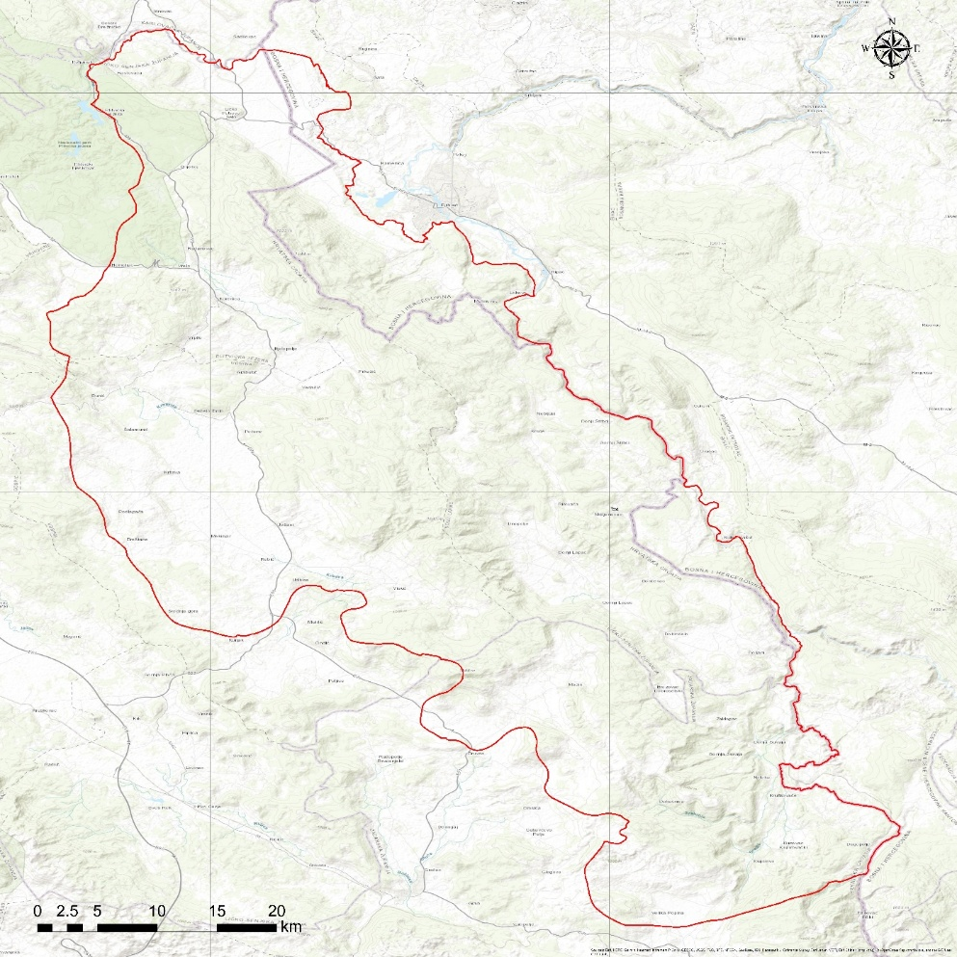
Figure 1 Topographic map with Una TBA boundary
Una TBA belongs mostly to the Una river basin, and a smaller part to the Korana river basin (tributary of the River Kupa). The average flow of the River Una near Bihać is 90 m³/s. The largest portion of Una TBA, or 654 km², belongs to the catchment area of Klokot 1 and 2 springs. The Ostrovica spring drains approximately 200 km², whereas the rest is drained by smaller springs including Dobrenica, Privilica, Ilijića Springs, Žegar, Toplica.
The area is characterized by geomorphological contrasts, from the Una–Korana plateau in the northeastern part, through the central mountainous zone dominated by the Plješevica massif, to extensive karst poljes in the western and southwestern parts. The most prominent morphological feature is the Plješevica mountain range, occupying the central part of the area and reaching elevations exceeding 1,600 m above sea. To the northeast and west, Una TBA area is bordered by the mountain systems of Mala Kapela and Krbava. These mountain ranges enclose typical karst poljes, including Bihaćko, Koreničko, Krbavsko, Lapačko and Bijelo polje, situated at elevations ranging from 537 m above sea level (the lowest point of Lapačko polje) to 740 m above sea level (the highest point of Koreničko polje). In addition to these major karst poljes, numerous smaller uvalas and other characteristic karst landforms (uvalas, sinkholes, dolines, and the absence of permanent surface watercourses) are present, giving the northeastern and particularly the western and southwestern parts of the area a distinctly karstic landscape character.
In the northwestern part of Bosnia and Herzegovina, the transboundary Una aquifer covers the areas of the Bihać and Kulen Vakuf municipalities. The Una River meanders between these regions along the border of Croatia and Bosnia and Herzegovina.
Geological characteristics
The geological structure of Una TBA reflects the structural and stratigraphic complexity of the Dinarides. The aquifer is predominantly developed within Mesozoic carbonate formations that have been strongly affected by tectonic deformation. These geological conditions exert a major control on groundwater flow and discharge.
The oldest rocks exposed within the TBA are Permo–Triassic evaporitic sediments, which form an important subsurface barrier controlling the emergence of the Una River. These units are overlain by Lower Triassic clastic deposits, developed in the areas of Korenica, Bijelo Polje, Udbina, and the Kremen and Čemernica mountains. Middle Triassic formations are dominated by limestones, while Upper Triassic sequences consist mainly of dolomites.
Jurassic rocks form the largest and most continuous part of the aquifer system, particularly in the Donji Lapac area, along the margins of the Bruvno structural unit, and at the southwestern edge of the Krbava polje. Jurassic lithologies are dominated by limestones, with subordinate dolomites, providing high permeability and intensive karstification. Cretaceous carbonate rocks build most of the Plješevica massif, with limestones prevailing in the Lower Cretaceous and alternating limestones and dolomites in the Upper Cretaceous.
Paleogene deposits include Eocene carbonate rocks and coarse clastic breccias, while Neogene sediments are represented by Middle Miocene limestones, marls, and clastics in the Bihać Basin. Neogene clastic deposits play an important hydrogeological role, directing groundwater toward major karst springs such as Klokot and Privilica.
Quaternary deposits are widespread but generally thin and comprise Pleistocene sands and Holocene tufa, alluvial, deluvial, and marsh deposits distributed along river valleys and near major springs.
Red soils with limestone debris form a thin cover over carbonate bedrock, while sediments within karst poljes represent former paleolake environments and important zones of groundwater recharge and discharge. The Krbava polje is especially notable due to its large spatial extent and sediment thickness exceeding 80 m.
Tectonic characteristics
The terrain within the delineated Una TBA is characterized by a highly complex tectonic structure dominated by brittle deformation. Structural development is primarily controlled by normal and reverse faulting, while upright and overturned folds occur less frequently. Major faults define the boundaries between tectonic units and predominantly follow the Dinaric (NW–SE) strike, while a secondary fault system is oriented approximately perpendicular to this trend. Numerous minor faults and crushed zones further increase structural heterogeneity and strongly influence groundwater circulation.
From north to south, several major tectonic units are distinguished within the TBA: the Lika Highlands, Mala Kapela–Lička Plješivica, Kulen Vakuf–Čemernica, and Bihaćko Polje–Bosanski Petrovac units. The Mala Kapela–Lička Plješivica unit represents the central tectonic element of the northern part of the TBA and is composed predominantly of carbonate rocks.
Fault systems play a key hydrogeological role, as intensive karstification developed along fault zones, creating preferential groundwater flow paths. Faults oriented southwest–northeast, consistent with the Dinaric structural trend, are particularly important, as they intersect older structures and enable groundwater flow perpendicular to the main strike of the mountain chains. Along these fault zones, dominant regional groundwater flow occurs from the Krbavsko and Koreničko Polje toward the Klokot and Privilica springs.
Hydrogeological characteristics
Una TBA represents a hydraulically integrated karst groundwater system that extends across the territories of Croatia and Bosnia and Herzegovina. Groundwater recharge areas are predominantly located in Croatia, while major discharge zones, including large karst springs in the Una River valley, occur mainly in Bosnia and Herzegovina. This spatial separation of recharge and discharge areas defines the aquifer as a typical transboundary karst system.
The most significant hydrogeological collectors within the system are carbonate rocks - limestones, dolomitic limestones, and dolomites of Triassic, Jurassic, and Cretaceous age - characterized by well-developed karst-fracture porosity. In the Una River valley, springs commonly occur at the contact between permeable carbonate formations and underlying Triassic (T₁) and Paleozoic (P) clastic deposits, which act as basal hydraulic barriers and control the position of groundwater discharge.
Lithological and structural conditions strongly control subsurface flow directions. The aquifer occupies an extensive karst area extending from the Korana River basin in the northwest to the Velika Popina area in the southeast. It includes the mountainous massifs of Lička Plješevica, Čemernica, Mala Kapela, and parts of the Lika Sredogorie, as well as major karst poljes such as Koreničko Polje, Bijelo Polje, Krbavsko Polje and Lapačko Polje. Numerous tracer tests have confirmed that all these karst poljes are hydraulically connected to springs along the Una River.
The Lička Plješevica massif consists of interbedded Jurassic and Cretaceous carbonate rocks forming a synclinal structure which, despite its pronounced morphology, does not act as a barrier to groundwater flow.
Groundwater from karst poljes located on the southwestern side of the massif flows through the masiff toward major springs in the wider Bihać area, including the Klokot and Ostrovica springs. Tracer tests confirm groundwater connections from the Korana River zone as well as from the Koreničko and Krbavsko poljes. Koreničko Polje functions as a groundwater “stepping zone,” hosting permanent springs fed from the Mala Kapela massif. In contrast, Krbavsko Polje is characterized by less productive karst springs due to its relatively small recharge area within the Lika Sredogorje. During periods of intense precipitation, however, groundwater inflow exceeds the capacity of ponor zones, resulting in temporary flooding of the lowest parts of the polje.
Lapačko Polje represents a continuation of the Lička Plješevica massif toward the Čemernica area. Although it differs significantly in geological composition, it exhibits a similar hydrogeological function. During dry summer periods, this karst polje is practically devoid of active springs, explaining why water supply for the town of Lapac relies on the Ostrovica spring near Vakuf, located in the neighboring country. During wet periods, significant groundwater inflow enters the polje and subsequently infiltrate back into the karst subsurface along the margins of the polje. Tracer tests conducted in the ponor zones have confirmed hydraulic connections with the Ostrovica spring in the Una River valley.

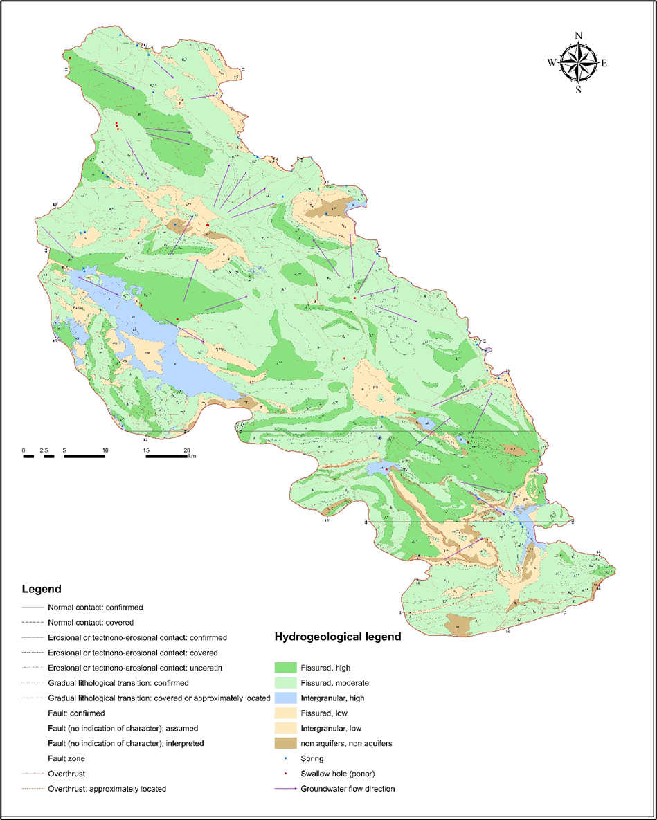
Figure 2 Hydrogeological map with general groundwater flow directions
The spring zone of the Una River in the Srb area is of hydrogeological interest. Springs emerge at the base of the Čemernica massif, whose upper parts are composed of impermeable Triassic clastic rocks. Under typical anticlinal conditions, such springs would be expected to have limited discharge; however, in this case, impermeable clastic formations overlie permeable carbonate rocks, enabling groundwater inflow from more distant recharge areas within the Lika karst. Tracer tests have confirmed connections between minor ponor zones on the western side of the massif near Mazin and the Ostrovica spring near Vakuf. Groundwater inflows toward the Una River source zone are also linked to recharge areas in Lika, although these connections have not yet been directly confirmed by tracer tests.
Local groundwater accumulations of low productivity have developed within Upper Cretaceous flysch formations. Neogene sediments act as confining cover units above the karst aquifers, while Permian–Werfenian formations represent basal impermeable barriers to the movement of groundwater.

1.3 Legal framework – multilateral and bilateral agreements
The legal setting for groundwater management in Una TBA relies on a combination of multilateral conventions, bilateral cooperation instruments, EU legislation, and national laws in both countries. These frameworks provide the basis for the measures and joint actions that the Joint Action Programme (JAP) defines.
At the multilateral level, Croatia and Bosnia and Herzegovina apply the principles of the Convention on the Protection and Use of Transboundary Watercourses and International Lakes. These principles - cooperation, prevention of significant transboundary impacts, reasonable and equitable use of shared waters, information exchange, and environmental impact assessment - will guide the development of coordinated groundwater‑related measures in Una TBA. Regional agreements within the Danube and Sava basins further support the alignment of planned activities across interconnected water systems.
Bilateral cooperation is framed by the 1996 Contract on Water Management Relations between Croatia and Bosnia and Herzegovina. Although the agreement does not explicitly regulate groundwater or karst aquifers, it serves as a legal platform that can be further strengthened. Future cooperation under the JAP will build on this agreement and will likely include more explicit provisions concerning shared monitoring, incident notification, and coordinated criteria for sanitary protection zones in Una TBA.
The Multilateral Agreement developed under DIKTAS II introduces an additional cooperation mechanism relevant for future groundwater governance. Under this agreement, the Consultation and Information Exchange Body (CIE) will be established as a permanent platform through which Parties will exchange data, coordinate monitoring, define common parameters, and develop joint guidance. The CIE will, in the coming period, support the preparation and supervision of joint activities to be applied in Una TBA. National committees will contribute by ensuring that domestic considerations are systematically integrated.
Within the EU legal order, Croatia applies the Water Framework Directive and the Groundwater Directive through the Water Act (Official Gazette 66/2019, 84/2021, 47/2023), the Regulation on Water Quality Standards (Official Gazette 96/2019, 20/2023, 50/2023), and the Rulebook on Sanitary Protection Zones (Official Gazette 66/2011, 47/2013). These acts constitute the legal foundation for groundwater management measures defined under the JAP, especially regarding monitoring obligations, groundwater‑status assessment, discharge control, and the protection of karst sources.
In Bosnia and Herzegovina, groundwater governance in the part relevant to te Una TBA is based on the entity‑level legislation of the Federation of BiH. The key legal acts include the Water Law (Official Gazette 70/06, 01/12, 70/20) and accompanying regulations governing groundwater monitoring, the characterization of water bodies, and the establishment of sanitary protection zones (Official Gazette 71/09; 1/14; 88/12). While many principles of the Water Framework Directive have already been incorporated into this framework, several requirements of the Groundwater Directive are still under development. Further alignment will be needed to ensure that groundwater‑related measures defined in the JAP can be applied consistently and effectively across the transboundary area.
Institutional responsibilities in each country form the operational basis for the measures proposed by the JAP. In Croatia, the Ministry of Environmental Protection and Green Transition and Croatian Waters will continue to lead implementation under Croatian law. In Bosnia and Herzegovina, the Ministry of Foreign Trade and Economic Relations, together with entity ministries and water agencies, will coordinate activities relevant for groundwater protection. Strengthened cooperation between these institutions will be essential for applying JAP measures consistently, especially in areas related to monitoring, enforcement, and the management of sanitary protection zones in the karst environment.
Taken together, multilateral conventions, bilateral agreements, the DIKTAS II multilateral cooperation framework, EU legislation, and the national laws of both countries provide the legal and institutional structure within which the Joint Action Programme defines future joint measures and coordinated approaches for groundwater management in Una TBA.

1.4 Institutional and transboundary cooperation
Institutional and transboundary cooperation in Una TBA area exists in basic form but remains limited in scope and consistency. Under the 1996 bilateral agreement, a Joint Water Management Commission of Croatia and Bosnia and Herzegovina was established with a mandate to coordinate water‑management issues of mutual interest, including water use, pollution control, protection against harmful effects of water, and prompt information exchange on extraordinary pollution events; its membership, rulebook and administrative support are defined by the HR and BiH. In practice, the Commission’s work on aquifer‑specific tasks has been intermittent, with limited operationalization for groundwater monitoring, mutual recognition of sanitary zones and day‑to‑day incident coordination in the Una area.
Croatia manages groundwater through a centralized and EU‑aligned system with clear institutional responsibilities, while Bosnia and Herzegovina applies a decentralized framework divided between entities and cantons, where monitoring, enforcement and planning practices vary significantly. These structural differences affect how each country manages sanitation, land use, and protection of sensitive recharge areas. At the same time, both sides depend on shared karst water systems that respond quickly to pressures and transfer impacts across the border. This creates a situation in which diffuse activities in the Croatian recharge area can affect spring quality and public water supply on the BiH side, particularly at the Klokot and Kostela springs that serve the wider Bihać region, while seasonal tourism pressures influence both countries at the same time.
Existing cooperation is mainly based on general bilateral arrangements that address water management in broad terms but do not provide detailed mechanisms for groundwater protection, monitoring coordination or mutual recognition of sanitary protection zones. There is no established cross‑border platform for regular data exchange, harmonized monitoring or coordinated response to pollution or sudden changes in spring conditions. Local institutions on both sides operate with different capacities, and communication between sectors - such as spatial planning, utilities, tourism and protected‑area administrations - is not yet aligned with the specific vulnerabilities of the karst aquifer. Public awareness of groundwater risks remains limited, especially in rural areas with decentralized sanitation systems, and tourism operators are not uniformly guided by environmental standards relevant for groundwater protection.
Within this context, it is important to recall that the 1996 Agreement between the Government of the Republic of Croatia and the Government of Bosnia and Herzegovina on the Regulation of Water Management Relations already creates several binding obligations that are directly relevant for Una TBA. In particular, the countries committed to take all necessary steps to create conditions for water‑management cooperation, to jointly resolve issues related to water use, pollution control and protection against harmful effects of water, to establish and operate a joint water management commission, and to promptly inform each other about extraordinary or sudden pollution events. These obligations provide a legal basis for systematic cooperation, technical coordination and incident notification in the Una area and should be explicitly implemented for groundwater‑related tasks under the JAP.
Looking ahead, additional cooperation duties are expected to arise under the forthcoming multilateral agreement establishing a Consultation and Information Exchange (CIE) body for the Dinaric Karst aquifer system. The agreement foresees regular exchange of groundwater data, joint monitoring with harmonized parameters, preparation and updating of a shared conceptual model, agreement on sanitary‑zone guidelines, consultation on planned activities with potential transboundary impact, and structured stakeholder participation. These provisions create a clear institutional framework for continuous information sharing, coordinated risk management and alignment of technical practices that the JAP operationalize in Una TBA.
To improve institutional cooperation within the JAP framework, several issues need to be addressed. First, both countries require clearer and more compatible approaches to sanitary protection zones, based on common hydrogeological principles and mutual recognition when zones extend across the border. Second, groundwater monitoring should be strengthened through harmonized parameters, methodologies and shared interpretation of results, including continuous monitoring at major springs and systematic sampling in recharge zones. Third, regular cross‑border exchange of information, early‑warning communication and coordinated responses to incidents should be established in a simple and practical format. Fourth, institutional dialogue must be organized on a stable basis, involving national and local authorities, water utilities, park administrations and relevant stakeholders, so that land‑use decisions, tourism management and sanitation improvements reflect shared risks. Finally, cooperation needs to support better management of decentralized sanitation, illegal dumping and seasonal tourism pressures, since these represent the main drivers of groundwater vulnerability throughout the TBA.

1.5 Alignment of JAP with national RBMPs and the EU WFD
The Joint Action Programme (JAP) for Una TBA is conceived as an implementation‑oriented instrument that operates within the legal and planning framework set by national River Basin Management Plans (RBMPs) and the EU Water Framework Directive (WFD). Its role is to translate basin‑wide objectives to the aquifer scale and to organise cooperative measures so that both countries can reach, and demonstrate progress toward, good groundwater status without duplicating national planning. The JAP therefore adopts RBMP objectives and timeframes as its reference, aligns its monitoring and reporting logic with WFD requirements, and concentrates on gaps that are best closed through joint, aquifer‑specific action.
Methodologically, the JAP follows the RBMP sequence of problem definition, status and risk assessment, measure design, and review, but applies it to the shared karst system. Pressures and risks are described using the same categories and criteria that national authorities apply to groundwater bodies, so that evidence gathered in Una TBA can be used directly in classification and trend evaluation. Where methods on one side of the border are more developed, for example, connectivity tests between groundwater and dependent surface waters, the JAP adopts those approaches as common practice for the shared springs and recharge zones. Where methods are still being refined, for example, elements of chemical‑status assessment or trend reversal, the JAP introduces compatible templates and data protocols that can be incorporated by both sides at the next RBMP update.
The monitoring concept is fully consistent with WFD monitoring types and with national practice. Continuous instruments at priority springs, risk‑based surveillance in recharge corridors, and agreed microbiological and chemical parameter sets ensure that measurements are comparable and usable in national reporting. Quality assurance, metadata, and data validation follow national rules so that results flow into the respective information systems without conversion. Early‑warning procedures for exceedances are defined in the same operational terms used by water utilities and inspectorates, enabling rapid action while preserving the integrity of time‑series data for status and trend analysis.
The JAP positions protection measures so that they reinforce RBMP programmes of measures. Sanitary protection zones are to be delineated using harmonised karst‑appropriate criteria and are to be integrated into local spatial plans on both sides of the border, giving clear guidance for land‑use, permitting, and compliance checks in sensitive areas. Measures targeting decentralized sanitation in rural and peri‑urban settlements, seasonal tourism loads at vulnerable sites, and control of illegal dumping are prioritised according to their relevance for RBMP objectives and scheduled to match the six‑year planning cycle. Where necessary, the JAP specifies common minimum performance standards for on‑site systems and small clusters in recharge areas, so that protection levels are functionally equivalent even where administrative arrangements differ.
Measures are carried out by the institutions that already have responsibilities under the national RBMPs, and the monitoring results are prepared in a way that allows them to be directly added to national reports. The JAP is to be reviewed in the same six‑year cycle as the RBMPs, with short updates prepared as needed to adjust ongoing activities. In this way, joint actions taken in Una TBA count for both countries, support WFD requirements, improve the information used in future RBMPs, and help ensure a coordinated approach to protecting karst aquifer system within Una TBA.

1.6 Methodology
The methodological approach for developing the Joint Action Programme (JAP) for Una TBA aims to create a clear, practical and coordinated plan adapted to the specific characteristics of the shared karst aquifer and to the institutional arrangements in both countries (HR and BiH). The process is designed as one integrated sequence that links the identification of problems, the setting of priorities and the definition of measures with their implementation, monitoring and regular review.
JAP for Una TBA begins by defining the scope of the analysis, including the spatial units to be assessed and the level of detail required. This includes confirming the relevant groundwater bodies, important spring catchments and the time periods needed to understand seasonal and long‑term variations in recharge. In parallel, available data from both countries are collected and reviewed, covering hydrogeological information, climate and hydrology, groundwater use, sanitation, land use and groundwater‑dependent ecosystems. This step ensures that a reliable evidence base is established and that data gaps are clearly identified for future improvement.
Based on the collected information, a shared conceptual model of Una TBA karst aquifer system is developed. This model describes the geological structure, recharge and discharge characteristics, main flow paths and typical water‑quality patterns. It provides a common technical foundation for joint decision‑making, especially where national approaches differ. The model will be refined as new measurements and interpretations become available, and it supports both the assessment of current conditions and the development of measures.
The analytical phase follows three main directions. The first describes the natural characteristics of the aquifer system and its vulnerability. The second reviews current monitoring practices, data quality procedures and methods used for assessing groundwater status and risks in both countries. The third identifies the most relevant pressures, including contamination from inadequate sanitation, seasonal tourism impacts and localised pollution sources. Together, these analyses provide the necessary basis for selecting measures that directly address the most important challenges in the aquifer.
Measures are then developed using a stepwise and risk‑based approach. Preventive measures focus on protecting sensitive recharge areas, harmonising approaches to sanitary protection zones and improving land‑use management. Management measures address sustainable groundwater abstraction, regulation of discharges, and targeted actions for pollution control and remediation where needed. Every measure is linked to a responsible institution, expected performance and a method for tracking progress.
Monitoring and data management support the JAP. A joint monitoring concept is defined to complement existing national networks, especially at key springs and in vulnerable recharge zones. Sampling parameters and procedures are aligned to ensure comparability, while quality control follows national standards. Early‑warning procedures are included to support timely response to changes in groundwater conditions. The monitoring system also provides the information needed for evaluating the effectiveness of measures and for adjusting the JAP over time.
Stakeholder participation is an important aspect of future work within Una TBA and will support the practical implementation of the JAP. Local authorities, water utilities, protected‑area managers and user groups are expected to play a key role in applying recommended measures, strengthening communication efforts and contributing to long‑term acceptance and compliance. Their involvement will help ensure that actions are adapted to local conditions and that cooperation among relevant actors is enhanced during implementation.
Implementation is based on cooperation between national and local institutions, supported by joint coordination mechanisms that are outlined in the section on institutional and transboundary cooperation (subchapter 1.4) and further developed throughout the JAP to ensure consistent application of agreed actions at Una TBA level.
The methodology of the JAP for Una TBA provides common templates, clear guidance and consistent decision criteria that enable both countries to apply measures in a coordinated manner while keeping procedures practical and easy to implement. The JAP also includes a regular review cycle, comparable in timing and structure to the review cycles used for national River Basin Management Plans, ensuring alignment with broader water‑management planning processes and allowing the JAP to evolve in step with new knowledge and changing conditions. Progress is assessed through a defined set of performance indicators and regular updates. If new risks appear or if measures do not achieve the expected results, corrective actions are to be introduced based on the same structured, risk‑based approach. This ensures that the JAP remains adaptive and responsive to new knowledge and changing conditions.

2. Identified problems and challenges
Generally, the chemical quality of karst groundwater in the TBA is good and does not require treatment according to current drinking water standards and regulations. In the Transboundary Diagnostic Analysis (TDA) prepared within the DIKTAS I project (2013), it is reported that the main tapped springs in the Bihać area of Bosnia and Herzegovina (Klokot, Privilica, Ostrovica and Toplica) had, in earlier periods, occasionally exceeded drinking water standards with respect to ammonia (NH₄⁺), nitrite (NO₂⁻), and orthophosphate (HPO₄²⁻) concentrations. Referring to Džankić (2006), the document further notes that the presence of microorganisms in springs, as indicators of fecal contamination, does not necessarily imply anthropogenic sources. However, it should be emphasized that the large number of inadequately constructed septic systems within the catchment areas of the tapped karst springs, both in Croatia and in Bosnia and Herzegovina, represents a potential risk of microbiological contamination from diffuse sources (Miošić, 2008).
The recent results of physico-chemical monitoring indicate a stabilization of water quality. According to data from the competent authorities, in recent years all tapped springs in the Bihać region have complied with applicable drinking water standards. Monitoring activities are conducted by the Public Health Institute of Bihać.
Furthermore, according to the Study for the Establishment of Transboundary Sanitary Protection Zones for the Klokot Spring (2020), during the ten-year period preceding the preparation of the study - except in extreme hydrological situations - no exceedances of ammonia concentrations were recorded, nor was there an increased potassium permanganate consumption (KMnO₄), confirming stable conditions with respect to organic and chemical loading at the spring source.
At the beginning of 2020, upon request of Croatian Waters, two boreholes (piezometers) were drilled at the Željava airport site, directly adjacent to the state border between Croatia and Bosnia and Herzegovina, for the purpose of exploratory investigations and the establishment of national monitoring. Both boreholes were constructed in the immediate hinterland of the Klokot spring, at elevations of 345 m a.s.l. (PCB-1) and 346 m a.s.l. (PCB-2), each to a depth of 250 m. Upon completion of drilling, groundwater samples were collected from both boreholes and submitted to the Central Water Management Laboratory of Croatian Waters in Zagreb for detailed analysis. A wide range of physico-chemical parameters was examined; however, none of the analyzed parameters exceeded the maximum allowable concentrations (MAC). It can therefore be concluded that groundwater quality in this part of the Klokot spring catchment complies with the applicable Rulebook on the Health Safety of Drinking Water in the Federation of Bosnia and Herzegovina. Moreover, groundwater sampled from these boreholes exhibited very similar characteristics to water sampled at the Klokot spring during the same month.
Extended analyses were also performed on water samples collected at three locations in Croatia - Rastovača, the Korenički ponor, and the sinking stream in Prijeboj - for which tracer tests confirmed hydraulic connectivity with the Klokot spring. The results indicated that water infiltrating in Croatia did not exceed maximum allowable concentrations for aromatic hydrocarbons, pesticides, phenols, PCBs, metals and metalloids, or other analyzed parameters. Although concentrations of certain substances were higher at the sinking locations than at the Klokot spring, they remained below regulatory limits.
The most significant operational challenges at the Klokot spring and within the Bihać water supply system are primarily related to turbidity episodes and microbiological contamination.

2.1 Microbiological contamination of springs in Bihać region
Microbiological contamination represents one of the most significant and recurrent problems affecting karst springs in the Bihać region. Major water supply sources, including Klokot, Privilica, Žegar, and Toplica, are hydraulically connected to recharge areas characterized by diffuse and concentrated infiltration through swallow holes and losing streams.
Due to the conduit-dominated flow regime, groundwater residence times are short, and natural filtration processes are limited. Recharge through ponors bypasses soil and unsaturated zone attenuation, allowing rapid transmission of microbiological contaminants from surface sources to spring discharge points.
Una TBA is characterized by strong hydraulic connectivity, conduit-controlled groundwater circulation, and limited natural attenuation capacity. While these features enable high groundwater productivity, they simultaneously increase system vulnerability. Several key problems and challenges have been identified that directly affect groundwater quality, resource sustainability, and dependent ecosystems.
Results presented in the Study for the Establishment of Transboundary Sanitary Protection Zones for the Klokot Spring (2020) indicate persistent microbiological vulnerability of the Klokot spring system. Out of 474 analyzed samples (399 basic and 75 extended analyses), non-compliance with drinking water standards was recorded in 93% of extended analyses and 11% of basic analyses. Total coliforms were detected in 93% of extended samples, Escherichia coli in 73%, and intestinal enterococci in 53%, confirming dominant faecal contamination signals.
These findings demonstrate that raw water at Klokot is bacteriologically unsafe without treatment. Importantly, microbiological non-compliance was also detected in approximately 11% of chlorinated water samples, indicating that disinfection alone does not fully mitigate contamination during certain hydrological conditions, particularly high-flow events.
The contamination pattern reflects the intrinsic vulnerability of the karst system. Rapid conduit flow, limited residence time, and negligible natural attenuation enable efficient transport of pathogens from surface recharge zones to the spring. Tracer-confirmed hydraulic connections between Klokot and sinking streams in Croatia (Rastovača, Korenički ponor, and Prijeboj) further confirm the transboundary character of contamination pathways.
Anthropogenic pressures within the recharge area, particularly intensified tourism and associated wastewater generation in the Plitvice Lakes area, have likely increased microbiological loading. The expansion of accommodation infrastructure has not been proportionally accompanied by adequate wastewater collection and treatment systems, reinforcing diffuse faecal contamination risks in this highly permeable karst environment.
The study (2020) further concludes that the marked increase in tourist activity within the Klokot spring recharge area over the past 5-7 years has contributed to a measurable deterioration of microbiological water quality. The installation of a temporary modular wastewater treatment plant in Rastovača in late 2018 resulted in a partial reduction of bacteriological contamination, with the most visible improvements recorded during the summer of 2019.
Microbiological contamination exhibits a strong hydrological control. High-intensity rainfall events trigger rapid groundwater discharge responses at Klokot, resulting in elevated turbidity and increased concentrations of bacteriological indicators exceeding drinking water standards. Enhanced bacterial presence is particularly evident following prolonged precipitation, when flushing of karst conduits occurs. However, elevated contamination has also been observed during dry summer periods, when relatively high wastewater loads are diluted within reduced spring discharge, leading to increased concentration effects.
The dominant contamination sources are associated with untreated municipal wastewater, improperly constructed permeable septic systems, direct discharge of effluents into sinking streams and karst depressions on both sides of the border, livestock activities in karst poljes, and uncontrolled surface runoff during intense rainfall events. Short-duration, high-intensity precipitation events additionally amplify turbidity peaks, which are consistently accompanied by increased bacteriological contamination, confirming the rapid transport dynamics typical of conduit-dominated karst systems.
Based on these findings, the Study (2020) emphasizes the urgent need for coordinated transboundary measures, including expansion of wastewater collection and treatment infrastructure, proper construction of watertight septic systems, remediation of illegal and former municipal landfills, and reduction of erosion processes linked to intensified deforestation and forest road construction within the recharge area. Furthermore, the construction of a dedicated drinking water treatment facility near the Klokot spring is recommended to ensure effective turbidity removal and to mitigate episodic microbiological contamination.
It is important to note that the monitoring period partially coincided with reduced tourist activity during the COVID-19 pandemic and with pronounced drought conditions, suggesting that contamination pressures under normal or peak tourism scenarios may be even higher.
Seasonal increases in turbidity and microbiological indicators such as Escherichia coli, total coliform bacteria, and intestinal enterococci are consistently associated with high-precipitation events. During flood conditions, activation of secondary conduit pathways enhances hydraulic connectivity within the karst system, significantly increasing the likelihood of contamination reaching major springs used for public water supply.
The transboundary character of the aquifer further complicates effective contamination control, as recharge zones located in Croatia directly influence discharge areas in Bosnia and Herzegovina. Given that groundwater flow paths do not coincide with surface watershed boundaries, contamination sources may be spatially distant from impacted springs, making management and source tracing particularly challenging.

2.2 PCB pollution from military installations (Željava, Udbina)
Potential historic contamination originating from former military installations represents a long-term environmental risk within Una TBA recharge area. The Željava airbase, located directly at the Croatia - Bosnia and Herzegovina border, and the Udbina military complex are situated in highly karstified carbonate terrains characterized by rapid infiltration, thin soil cover, and structurally controlled groundwater flow. Polychlorinated biphenyls (PCBs), historically used in electrical equipment and military infrastructure, are persistent organic pollutants (POPs) with high environmental stability, bioaccumulation potential, and toxicity. Although PCBs are hydrophobic, they may adsorb to fine particles and organic matter and be transported through karst systems during high-flow and turbidity events.
While current monitoring data do not indicate active PCB contamination in groundwater, systematic investigations specifically targeting PCB source characterization, sediment-associated transport mechanisms, and long-term migration pathways within the heterogeneous karst conduit network remain limited. Given the structural complexity of the aquifer, predicting contaminant transport dynamics under variable hydrological conditions is inherently uncertain.
The potential presence of historic contamination therefore highlights the need for continued monitoring, targeted hydrogeological investigations, and coordinated cross-border risk assessment and remediation strategies.

2.3 Insufficient data on groundwater abstraction in rural areas
Groundwater abstraction in rural areas of Una TBA region is predominantly conducted through private wells, local boreholes, and small-scale capture systems that are not systematically monitored or officially reported.
In contrast to regulated public water supply systems, rural groundwater use typically lacks reliable abstraction records, standardized water quality monitoring, hydrogeological impact assessments, and evaluation of cumulative withdrawal effects. This data gap introduces uncertainty in understanding the overall pressure exerted on the aquifer.
Given the high hydraulic connectivity characteristic of karst aquifers, even localized abstractions may influence spring discharge and shallow groundwater levels, particularly under low-flow conditions. While individual rural withdrawals are generally small, their aggregated impact at the sub-catchment scale may be hydrologically relevant.
The absence of comprehensive abstraction data complicates quantitative groundwater balance calculations, seasonal water stress assessment, and long-term sustainability evaluations. Furthermore, undocumented wells may intersect preferential flow conduits, potentially increasing vulnerability to contamination and facilitating hydraulic short-circuiting between aquifer compartments.

2.4 Anthropogenic pressures on groundwater and groundwater-dependent ecosystems
Urbanisation worldwide represents an increasingly important pressure on groundwater systems and associated groundwater-dependent ecosystems. However, within the catchment areas of the Klokot and Ostrovica springs in Bosnia and Herzegovina, urban pressure remains relatively limited. Large parts of these catchments are characterised by rural land use, extensive forest cover, and sparsely populated or uninhabited areas. Consequently, no significant point pollution sources typical of urban environments, such as shopping centres, fuel stations, or industrial plants, have been identified within the Bosnian and Herzegovinian part of the catchment (WBG, 2020).
In contrast, a significantly higher number of potential pollution sources has been registered within the catchment area of the Klokot spring on the territory of Croatia. These sources generate a substantially higher estimated pollution load compared to those identified in Bosnia and Herzegovina, as reflected in the assessment presented in Table 2.4.1. The distribution of pollution loads highlights the transboundary character of the catchment and the uneven spatial distribution of anthropogenic pressures.
Table 1 Estimation of the pollution loads generated in the catchment area of the spring Klokot (2020)
Polluters |  |  | Unit | Quantity | Unit load (PE) | Total load (ES)
Bosnia and Herzegovina |  |  |  |  |  | 12.885,00
Quarry Željava/Baljevac 1 |  |  | ha | 0,4 | 500 | 250
Quarry Baljevac 2 |  |  | ha | 0,1 | 500 | 50
Quarry Baljevac 3 |  |  | ha | 0,6 | 500 | 300
Quarry /material lenders Zavalje |  |  | ha | 1,6 | 500 | 800
Quarry Međudražje |  |  | ha | 4,6 | 500 | 2.300
Landfill Vučjak |  |  | ha | 8,0 | 870 | 6.960
Landfill Mali Baljevac |  |  | t | 17,5 | 2,5 | 44
Landfill ''Bezdan'' Međudražje |  |  | t | 10,5 | 2,5 | 26
Border crossing Izačić |  |  | PE | 283 | 1 | 283
Permanently inhabited population |  |  | person | 510 | 1 | 510
Forest exploitation |  |  | km² | 40,4 | 30 | 1212
Roads (No. of vehicles / day) |  |  | vehicles | do 500 | 0,8 | 400
Croatia |  |  |  |  |  | (28.187,00)
Quarry Prijeboj |  |  | ha | 2,2 | 500 | 1.100
Gravel Frkašić |  |  | ha | 10,3 | 500 | 5.150
Landfill Vrpile / Kalebovac |  |  | ha | 3,34 | 870 | 2.906
Wild landfills (karstic pits) |  |  | t | 54 | 2,5 | 135
Livestock farms |  | Cattle | livestock | 1.050 | 0,83 | 871
 |  | Small cattle | livestock | 7.400 | 0,08 | 592
Permanently inhabited population |  |  | person | 6.247 | 1 | 6.247
Agriculture (tillage) |  |  | ha | 100 | 4,5 | 450
Tourist capacities of NP "Plitvice Lakes" and private offer |  |  | tourists  employees | 1.220  90 | 0,08  0,42 | 98  38
Forest exploitation |  |  | km² | 220 | 30 | 6600
Roads (state road D1) |  |  |  | do 5.000 | 0,8 | 4.000
 |  |  |  | Total (BiH and HR): |  | 41.072,00

The assessment of pollution loads within the Klokot spring catchment area was carried out based on available data on identified polluters and standardised unit pollution loads expressed in population equivalents (PE). The results indicate a total estimated pollution load of approximately 41,000 PE for the entire catchment area. In Bosnia and Herzegovina, the dominant contributions originate from landfills (particularly the Vučjak landfill), quarrying activities, forest exploitation, road traffic, and permanently inhabited population. In Croatia, the most significant contributions are associated with permanent settlements, quarrying and gravel extraction, forest exploitation, major transport corridors, agricultural activities, and tourism-related pressures.
In peri-urban and partially sewered areas, limitations in wastewater collection and treatment infrastructure increase the risk of nutrient and microbiological contamination of groundwater. Septic systems installed in highly permeable karst terrain allow rapid vertical percolation of effluents, effectively bypassing natural attenuation processes. Given the conduit-dominated groundwater circulation and limited filtration capacity of the aquifer, even moderate pollutant inputs may be rapidly transported toward major springs. The lack of protective low-permeability layers further increases the system’s vulnerability.
A particularly most important pressure within the Croatian part of the catchment area is associated with tourism development in Plitvice Lakes National Park (NP), which represents the most significant tourist area within the Klokot spring catchment. The NP covers approximately 29.7 km² and includes several hotel facilities with a total capacity exceeding 400 rooms. Wastewater from the core tourist area is collected through a sewerage network serving the settlements of Jezerce, Mukinje, Plitvice, and Rastovača, and is treated at a wastewater treatment plant in Rastovača with a design capacity of 2,000 PE. During peak summer tourist seasons, inflow to the plant may reach approximately 2,500 PE, temporarily exceeding its nominal capacity.
Additional tourist-related pressures originate from accommodation facilities such as the Borje motel and campsite, the Korana campsite (Čatrnja), and hotels in Ličko Petrovo Selo and Korenica. Wastewater from these facilities is managed through a combination of local treatment plants, collection pits, and regular removal by utility services. In recent years, the most dynamic growth has occurred in private accommodation, including apartments and rooms, which has expanded significantly. In 2019, a total of 445,247 overnight stays were recorded in the Plitvice Lakes municipality, representing an increase of nearly 50% over the previous five years. (WBG, 2020).
According to the Plitvice Lakes National Park’s 2024 tourism analysis, 1,492,994 visitors from about 163 countries visited the park in 2024 (Plitvice Lakes National Park, 2025).
Despite these developments, groundwater abstraction for public water supply has not increased proportionally. This is partly due to demographic trends characterised by population stagnation or decline and migration from rural areas, which offset increased seasonal demand associated with tourism. As a result, overall water demand has remained relatively stable and does not currently pose a critical quantitative pressure on the aquifer.
Nevertheless, urban and tourist expansion into recharge areas modifies natural infiltration patterns. Impervious surfaces reduce diffuse recharge while enhancing concentrated runoff toward swallow holes and losing streams, thereby increasing contaminant loading intensity at discrete infiltration points. Construction activities and land grading may further disturb shallow karst features and alter local drainage pathways, influencing small-scale recharge dynamics.
Groundwater-dependent ecosystems along the Una River valley and within spring discharge zones are directly regulated by groundwater quantity and quality. Changes in groundwater discharge regimes may affect baseflow stability, nutrient transport, thermal conditions, and riparian soil moisture. As these ecosystems respond to both hydrological variability and water chemistry, cumulative anthropogenic pressures may gradually influence their ecological integrity.

3. Socio-economic setting and challenges of Una TBA

3.1 Overall socio-economic characteristics and demographic indicators

3.1.1 The Croatian side of Una TBA
The Transboundary Aquifer Una (Una TBA) encompasses predominantly rural and sparsely urbanized areas on the Croatian side, while the Bosnian and Herzegovinian part also includes larger urban and peri-urban centres. The spatial structure of settlement directly influences patterns of water use, pressures on infrastructure, and risks to groundwater within the sensitive karst system.
The Croatian part of Una TBA encompasses predominantly karst areas with an extremely low permanent population density and a dispersed settlement pattern. There is no larger urban center within the analysed area, although municipal centers exist; most settlements consist of small villages and hamlets. Demographic trends are characterized by a long-term population decline, a negative migration balance, and pronounced population ageing. The average population density of the analysed area is approximately 3.9 inhabitants per km², confirming its extremely sparse settlement pattern and pronounced demographic peripherality. This is further compounded by a highly unfavourable age structure, with an aggregated ageing index of 233. These processes are the result of long-term peripheralization, limited economic opportunities, and weak transport connectivity.
Socio-economically, the analysed area records an average monthly net income of approximately €1,223 (Q2 2024), a registered unemployment rate of around 21%, and an employment structure dominated by services and tourism, followed by manufacturing and construction, indicating a structurally fragile and seasonally dependent local economy.
Depopulation reduces continuous pressure on groundwater in terms of wastewater volumes, but at the same time increases structural risks:
• reliance on individual septic systems,
• poor maintenance of water supply networks,
• limited local capacities for monitoring and enforcement.

Table 2 Population changes in Croatian municipalities within Una TBA (2011–2021)
Municipality | Population 2021 | Change 2011–2021 (%)
Plitvička Jezera | 3,649 | −16.3
Udbina | 1,334 | −30.1
Donji Lapac | 1,366 | −37.9
Gračac | 3,136 | −33.1
TOTAL (combined) | 9,485 | −27.9

Settlements of the Municipality of Plitvička Jezera – demographic and socio-economic characteristics
In the period 2011–2021, the population of settlements in the Municipality of Plitvička Jezera included in Una TBA analysis decreased from 4,358 to 3,649, representing a decline of 16.3% and confirming long-term and intensive depopulation processes in the area.
At the same time, the area of Plitvice Lakes National Park has experienced strong and continuous growth in tourist activity. In 2024, the Park was visited by nearly 1.5 million visitors, with pronounced seasonality between May and September. This imbalance between a declining demographic base and increasing tourism intensity generates significant pressures on natural resources, infrastructure, and the karst aquifer system.
Depopulation reduces local human and institutional capacities for infrastructure maintenance and monitoring, while mass tourism creates seasonal and cumulative pressures that are not aligned with the existing management capacities of local communities. In this context, the growth of tourism does not represent a compensatory development trend in terms of long-term demographic sustainability, but rather coexists with depopulation, often accompanied by increased environmental and governance risks.
These findings point to the need for integrated approaches to groundwater and environmental management in Una TBA that simultaneously account for demographic structure, the seasonality of tourism pressures, and limited local capacities, in line with the EU water and environmental governance framework.
Settlements of the Municipality of Udbina – demographic and socio-economic characteristics
In the period 2011–2021, the Municipality of Udbina recorded a pronounced demographic decline, with the total population decreasing from 1,909 to 1,334 (−30.1%). Despite this trend, the local socio-economic structure remains partially active due to a combination of primary activities and public transfers. Agriculture represents one of the key pillars of the local economy, with a strong emphasis on livestock farming alongside crop production.
According to data from the Agency for Payments in Agriculture, Fisheries and Rural Development (APPRRR), beneficiaries in the Municipality of Udbina received a total of EUR 5,841,333.14 in agricultural subsidies in the 2024 financial year. Relative to the population recorded in the 2021 Census, this amounts to approximately EUR 4,400 per capita, indicating the significant relative importance of agricultural support within the local socio-economic context. By comparison, beneficiaries in the Municipality of Plitvička Jezera received a total of EUR 2,833,534.37 in agricultural subsidies in 2024, corresponding to approximately EUR 780 per capita.
In addition to agriculture, Udbina hosts limited industrial activities, including wood processing and a registered tobacco facility, although their effects on demographic revitalization remain modest. The spatial and development framework is further shaped by the military use of part of the area, which constrains land use and development options but does not generate lasting demographic effects. In recent years, selective forms of tourism have also expanded; however, these activities remain seasonal and supplementary and do not function as a corrective to long-term depopulation processes. The presence of a Serbian national minority across the municipality is relevant for understanding local social dynamics, but it does not alter the underlying pattern of demographic decline presented in the table.

Settlements of the Municipality of Donji Lapac – demographic and socio-economic characteristics
In the period 2011–2021, the Municipality of Donji Lapac recorded a very strong demographic decline, with the total population decreasing from 2,200 to 1,366 (−37.9%), representing the most intensive depopulation trend among the analysed municipalities within Una TBA.
The social structure of the municipality is characterized by a significant presence of the Serbian national minority, while post-war in-migration of Bosnian Croats has also been recorded, like the Municipality of Gračac. The spatial impacts of the Homeland War remain pronounced: all analysed settlements, as in other municipalities within Una TBA, were affected by war-related events, including occupation, destruction of infrastructure, and long-term displacement. As a result, these municipalities entered the post-socialist transformation period with a highly unfavourable starting position for modernization processes.
The contemporary socio-economic structure of Donji Lapac relies largely on primary activities, primarily agriculture and forestry, while secondary and tertiary activities are weakly developed and spatially limited. According to APPRRR data, beneficiaries in the Municipality of Donji Lapac received a total of EUR 1,654,372.39 in agricultural subsidies in the 2024 financial year, corresponding to approximately EUR 1,210 per capita. This indicates an important, though comparatively modest, role of agricultural support in the local socio-economic context.
At the same time, low levels of urbanization, limited industrial capacities, and well-preserved natural resources across all analysed municipalities and their settlements create favourable conditions for selective and long-term sustainable development, in line with the United Nations Sustainable Development Goals.
Settlements of the Municipality of Gračac – demographic and socio-economic characteristics
According to the 2021 Population Census, the Municipality of Gračac has a total of 3,136 inhabitants, representing a decrease of 1,554 residents (33.1%) compared to 2011. The social structure of the municipality is characterized by a significant presence of the Serbian national minority, as well as the in-migration of Bosnian Croats after the Homeland War, which has shaped current demographic and social patterns. War-related destruction, occupation, population displacement, and long-term infrastructural degradation resulted in a below-average development starting position after the 1990s. Consequently, based on national development indicators, Gračac is classified among the least developed municipalities in the Republic of Croatia, despite being administratively part of the more developed Zadar County.
Nevertheless, research points to the important role of local civil society organizations which, under conditions of depopulation and institutional weakness, act as key carriers of social cohesion and initiatives oriented toward sustainable rural development. Agriculture plays a significant role in the local socio-economic structure. In 2024, a total of EUR 5,303,084.21 in agricultural subsidies was disbursed in the Municipality of Gračac, amounting to approximately EUR 1,690 per capita. The Municipality of Donji Lapac has spatial and ecological importance due to the presence of the sources of the Una River within its territory, which further underscores the sensitivity of the area and the strategic importance of integrated water and natural resource management within the Una TBA.
The table 3.1.2 presents official settlement-level population data according to the 2011 and 2021 censuses. Due to very small population bases in certain settlements, full settlement data are shown for settlements partially covered by Una TBA polygon, as well as for settlements outside Una TBA. Note: Of the total population, 2,750 residents live in areas fully or partially covered by Una TBA, accounting for 87.7% of the population.
Tourism and seasonality
Despite a very low permanent population, the Croatian part of Una TBA is exposed to strong seasonal tourism pressures, primarily due to its proximity to Plitvice Lakes National Park. Available data indicate that the area records approximately 1.4 million tourist arrivals annually, with peak intensity concentrated in the period from May to September. During this time, the number of people present in the area exceeds the permanent population by several times, resulting in short-term but highly intensive peak loads on water supply, wastewater management, solid waste management, and transport infrastructure. These pressures are further exacerbated by insufficient and fragmented infrastructure in rural settlements, as well as by long-term depopulation processes that constrain local governance and operational capacities. At the same time, tourism demand drives changes in land use patterns, including the sale of traditional agricultural holdings and the expansion of holiday home construction, altering settlement structures and increasing diffuse pressures on the karst groundwater system. In the context of Una TBA, tourism seasonality thus represents a key socio-economic factor generating disproportionate environmental pressures relative to the local demographic base and existing infrastructure capacity.
Table 3 Aggregate demographic indicators for the analysed area within Una TBA (Croatia)
Indicator | Value / Range | Source / Notes
DEMOGRAPHICS
Total population within the TBA (2021) | 9,485 | CBS, Population Census 2021
Population density (inhabitants/km²) | 3.9 | Extremely sparse settlement pattern
Municipalities within TBA | Plitvička Jezera, Udbina, Donji Lapac, Gračac | Based on hydrogeological delineation
Population change (2011–2021) | −27.9% | Strong depopulation trend
Ageing index | 233.4 | Highly unfavourable age structure
Settlement pattern | Dispersed rural; no major urban centre | Small villages and hamlets dominate
SOCIO-ECONOMIC
Agricultural support (2024, total selected municipalities) | ~€15.6 million | APPRRR 2024 (Udbina, Plitvička Jezera, Donji Lapac, Gračac combined)
Agricultural subsidies per capita (range) | €780 – €4,400 | Highest in Udbina; reflects structural dependence on agriculture
Main economic activities | Agriculture (livestock dominant), forestry, limited industry, seasonal tourism | Peripheral development context
Development status | Structurally peripheral; some municipalities among least developed nationally | National development index classification
WATER-RELATED INDICATORS
Groundwater dependence for public supply | Low–moderate (within TBA) | No major abstraction centres serving large urban populations
Sanitation coverage | Predominantly decentralised (<30% centralised) | Septic systems dominant in rural settlements
Wastewater treatment plants | Limited | Small-scale or absent in most settlements
Infrastructure condition | Fragmented; ageing networks | Limited maintenance capacity
TOURISM & SEASONALITY
Plitvice Lakes National Park visitors (annual) | ~1.4–1.5 million | Strong peak May-September
Seasonal water demand increase | Significant seasonal peaks | Tourism-driven pressure
Tourism pressure zones | NP Plitvička jezera; accommodation clusters | Diffuse seasonal impact
PRESSURES & VULNERABILITY
Groundwater pressure type | Diffuse | Tourism, septic systems, small-scale agriculture
Sanitation risk | Medium | Karst vulnerability + decentralised systems
Infrastructure resilience | Low | Depopulation limits financial sustainability
Institutional capacity | Moderate (EU-aligned framework) but weak local implementation | Croatian Waters central oversight; local capacity limited

3.1.2. Overall socio-economic characteristics and demographic indicators - The Bosnia and Herzegovina side of Una TBA
The BiH part of Una TBA encompasses suburban zones and rural settlements associated with the city of Bihać. Unlike the Croatian side, the BiH portion includes areas with higher settlement density and more diverse demographic structures, including functionally urbanised zones where groundwater abstraction and sanitation pressures are more continuous.
Population and settlement structure
The permanent population within the BiH part of Una TBA is estimated at approximately 10,000 inhabitants (BGGDA Una, 2025). This estimate is based on Census 2013 data for municipalities partially overlapping the TBA boundaries, spatially disaggregated according to the hydrogeological delineation of the karst recharge zone. Population density within the TBA ranges from 5 to 15 inhabitants per km², with higher concentrations in suburban areas near Bihać and lower densities in dispersed rural settlements.
The City of Bihać, while not fully within the TBA boundaries, exerts significant functional influence on the aquifer through suburban expansion and groundwater-dependent infrastructure. The presence of urban centres near the aquifer recharge and discharge zones introduces a larger number of stakeholders, including public water utilities, municipal authorities, tourism operators, and protected area management bodies.
Demographic trends
Demographic trends in the BiH part of Una TBA reflect broader patterns observed across the Una-Sana Canton: long-term population decline, negative migration balance, and population ageing. Census 2013 data indicate a population decrease of approximately 7-8% compared to Census 1991, with this trend continuing through to 2024. The estimated annual depopulation rate is -0.6% to -0.8%, driven primarily by emigration of working-age population and declining birth rates.
The ageing index is increasing, reflecting a growing proportion of elderly residents and a shrinking working-age population. While depopulation reduces continuous pressure on groundwater in terms of wastewater generation, it simultaneously increases structural vulnerability due to:
- Heavy reliance on decentralised septic systems in rural areas,
- Limited capacity for infrastructure maintenance and monitoring,
- Reduced local financial and human resources for environmental management.
Socio-economic characteristics
The economy of the BiH part of Una TBA is characterised by a mix of small-scale agriculture, public sector employment, services, and tourism. Key socio-economic indicators (Una-Sana Canton, 2020-2023):
- Average monthly net income: €650-750,
- Unemployment rate: 18-25%,
- Employment structure: public administration and education (30-35%), services (25-30%), industry (15-20%), agriculture (10-15%).
Agriculture is predominantly small-scale and extensive, with limited use of irrigation and agrochemicals compared to intensively cultivated plains. Livestock farming is present but generally low intensity. Economic activity is concentrated in municipal centres, while rural settlements within the TBA rely on subsistence farming, remittances, and seasonal employment.
Tourism and seasonality
Una National Park represents a key spatial and socio-economic feature. Tourism activities associated with the park generate strong seasonal population fluctuations, with several hundred thousand visitors annually during peak years, particularly in summer months (July-August). This results in:
- Seasonal water demand peaks of +30-50% above baseline,
- Increased wastewater generation in groundwater-vulnerable karst terrain,
- Concentrated pressure on springs and surface-groundwater interaction zones.
While rural settlements rely largely on decentralised sanitation systems, suburban areas are more closely linked to centralised water supply and wastewater infrastructure.
Overall assessment
Demographic pressures on the BiH side are more continuous and institutionally complex than in Croatia, reflecting higher population density, stronger dependence on groundwater for public supply, more intensive tourism development, and greater proximity to urban centres. The combination of centralised abstraction serving a large urban population and decentralised sanitation in the recharge zone creates a spatial mismatch between water use and pollution sources, requiring coordinated cross-sectoral management approaches.
Table 4 Demographic and socio-economic indicators within Una TBA - Bosnia and Herzegovina
Indicator | Value/Range | Source/Notes
DEMOGRAPHICS
Total population in TBA (2024 estimate) | ~10,000 | BGGDA Una, 2025
Population density | 5-15 inhabitants/km² | Variable: higher near Bihać, lower in rural areas
Municipalities (partial overlap) | Bihać, Cazin, Bosanska Krupa | Hydrogeological boundaries
Urban-suburban population share | ~40-50% | Suburban Bihać zones
Rural population share | ~50-60% | Dispersed settlements
Annual population change (2013-2024) | -0.6% to -0.8% | Una-Sana Canton trend
Ageing index | Increasing | Growing elderly share, declining working-age population
SOCIO-ECONOMIC
Average monthly net income | €650-750 | Una-Sana Canton (2020-2023)
Unemployment rate | 18-25% | Una-Sana Canton official data
Main employment sectors | Public admin (30-35%), Services (25-30%), Industry (15-20%), Agriculture (10-15%) | Canton level
Agricultural intensity | Low-moderate | Small-scale, extensive farming
WATER-RELATED
Public water supply source | Klokot, Kostela springs | Supplies ~56,000 (Bihać municipality)
Population served by springs | ~56,000 | Beyond TBA boundaries
Sanitation coverage (urban/suburban) | 60-70% | Bihać suburban areas
Sanitation coverage (rural TBA) | <30% | Predominantly septic tanks
Planned WWTP | Bihać WWTP | Under development
TOURISM & SEASONALITY
Una National Park visitors (annual) | Several hundred thousand | Peak: July-August
Seasonal water demand increase | +30-50% | Summer months
Tourism pressure zones | Park area, river corridors | Concentrated seasonal impact
PRESSURES & VULNERABILITY
Groundwater dependence | Very high | Strategic supply for Bihać
Sanitation risk | Medium-high | Diffuse pollution from septic systems
Infrastructure resilience | Low-medium | Limited maintenance capacity
Institutional complexity | High | Multiple authorities, utilities, protected area
Notes: Population estimates are based on BGGDA Una (2025), using Census 2013 data spatially disaggregated according to the hydrogeological boundaries of Una TBA. Socio-economic indicators reflect Una-Sana Canton averages and may therefore mask local-level variation. Tourism figures are subject to annual fluctuations, with peak years significantly exceeding baseline values. Furthermore, the water supply system serves a population extending well beyond the TBA boundaries, which increases the strategic importance of groundwater protection and coordinated management.

3.1.3. Transboundary synthesis
Una TBA exhibits a clear demographic and spatial asymmetry between its Croatian and BiH sides, with significant implications for transboundary groundwater management.
Population distribution and density
The Croatian part of the TBA is characterised by very low permanent population (~9,500 inhabitants) and dispersed rural settlement patterns, with population densities typically below 10 inhabitants per km². In contrast, the BiH side hosts a comparable permanent population within the TBA boundaries (~10,000 inhabitants) but is functionally linked to the wider Bihać urban area (~56,000 inhabitants), creating substantially higher institutional and infrastructural complexity. Settlement density in the BiH portion ranges from 5 to 15 inhabitants per km², with suburban zones near Bihać exhibiting characteristics of peri-urban development.
Demographic trends and vulnerability
Both sides experience long-term depopulation and population ageing, though driven by different dynamics. The Croatian side has undergone a pronounced decline of more than 20% between 2011 and 2021, with depopulation concentrated in remote rural areas. The BiH side shows a more moderate but consistent decline of approximately 7-8% since 1991, with emigration primarily affecting working-age population. In both cases, depopulation reduces quantitative water demand but increases structural vulnerability due to:
- Reduced capacity for infrastructure maintenance and monitoring,
- Ageing sanitation systems with limited oversight,
- Declining local financial and human resources for environmental management.

Functional urban-rural linkages
A key transboundary characteristic is the spatial mismatch between groundwater abstraction points and population centres. On the Croatian side, groundwater pressures are diffuse and primarily associated with tourism (Plitvice Lakes National Park), with limited permanent settlements directly within the TBA. On the BiH side, major karst springs (Klokot, Kostela) located within or immediately adjacent to the TBA serve the much larger urban population of Bihać, creating concentrated abstraction points and strategic dependence on TBA groundwater quality.
This asymmetry has direct implications for transboundary risk distribution: land-use changes or pollution incidents in upstream Croatian zones can disproportionately affect downstream BiH water supply, despite the Croatian side having minimal local dependence on TBA groundwater for public supply.
Tourism and seasonal dynamics
Tourism represents a shared pressure but with different spatial patterns. On the Croatian side, Plitvice Lakes National Park (over 1.4 million visitors annually) generates significant seasonal demand, though its hydrogeological connection to Una TBA is indirect and complex. On the BiH side, Una National Park (several hundred thousand visitors annually) creates direct and concentrated seasonal pressures within the TBA, particularly along river corridors and in proximity to key springs.
Both sides experience summer peak demand (+30-50% above baseline), but the BiH side faces additional institutional challenges in managing visitor infrastructure, wastewater treatment, and solid waste disposal in karst-vulnerable zones.
Sanitation and pollution risk
Sanitation infrastructure differs markedly between the two sides. The Croatian side relies almost entirely on decentralised systems (septic tanks, small communal systems), with limited municipal wastewater collection. The BiH side exhibits a dual pattern: suburban areas near Bihać have partial connection to centralised sewerage systems (60-70% coverage), while rural TBA settlements rely on septic tanks and pit latrines (<30% coverage). The planned Bihać wastewater treatment plant will address urban loads but will not mitigate diffuse pollution from decentralised systems in the upstream recharge zone.
From a transboundary perspective, pollution sources are spatially distributed across both sides, but the consequences are asymmetric: the BiH side bears the primary water supply risk, while both sides contribute to pollution loads through decentralised sanitation, agricultural activities, and tourism infrastructure.
Institutional and governance complexity
The Croatian side benefits from alignment with EU water management frameworks and relatively streamlined institutional structures but suffers from limited local capacity in remote rural municipalities. The BiH side operates within a more fragmented governance context (entity, cantonal, and municipal levels) but has stronger institutional presence due to proximity to the City of Bihać and the operational responsibilities of public water utilities.
Transboundary cooperation is essential to address the spatial disconnect between pollution sources, recharge zones, and abstraction points, requiring coordinated monitoring, data sharing, and joint planning across two distinct regulatory and institutional environments.
Implications for joint action
The demographic and socio-economic asymmetry between the Croatian and BiH sides of the Una TBA necessitates a differentiated yet coordinated approach to groundwater management:
- Croatian side: Focus on diffuse pollution prevention, tourism infrastructure standards, and strengthening local monitoring capacity.
- BiH side: Prioritise protection of strategic springs, expansion of wastewater treatment coverage, and management of seasonal tourism pressures.
- Joint priorities: Establish transboundary monitoring networks, harmonise land-use planning in sensitive recharge zones, and develop shared protocols for incident response and drought management.
The relatively balanced population distribution (~9,500 vs ~10,000) masks a functional imbalance in groundwater dependence, stakeholder complexity, and institutional capacity, requiring tailored interventions that recognise both shared vulnerabilities and distinct national contexts.
The asymmetry between the sparsely populated Croatian side and the more demographically concentrated Bosnian and Herzegovinian side represents a key socio-economic challenge for cross-border governance of Una TBA. Pressures on groundwater are generated unevenly; however, their hydrogeological impacts transcend national borders.

3.2. Institutional and financial capacities and challenges
The institutional framework for water management on the Croatian side of Una TBA is fully aligned with European Union legislation, particularly the Water Framework Directive. The system is clearly structured in hierarchical terms, with national institutions responsible for strategic planning, regulation, and supervision, while operational implementation is delegated to regional and local levels. The main challenges do not stem from the legal framework itself, but from limited implementation capacities at the local level. Low population density, a small number of users, and high costs of construction and maintenance of water infrastructure constrain the financial sustainability of systems, particularly in rural and depopulated areas.
In Bosnia and Herzegovina, the institutional framework for water management is characterized by a complex and fragmented distribution of competences across state, entity, cantonal, and local levels. This fragmentation hampers coordination, data exchange, and consistent implementation of measures, while at the same time increasing the need for formalized transboundary cooperation mechanisms within Una TBA. Financing of water management in Bosnia and Herzegovina relies primarily on national budgets and international donor programmes, while access to EU funds remains more limited compared to Croatia.
At the transboundary level, basic institutional preconditions for cooperation exist, including bilateral agreements and joint bodies, but their operational role remains limited. Key challenges include uneven technical capacities, differences in institutional stability, and the absence of permanent financial mechanisms for joint activities. In this context, the Joint Action Programme for Una TBA has the potential to serve as an instrument for strengthening coordination, harmonising measures, and improving the effective use of available financial resources.
Table 5 Institutional and financial capacities in Una TBA (Croatia-Bosnia and Herzegovina comparison)
Element | Croatia | Bosnia and Herzegovina
Alignment with the EU Water Framework Directive | High | Partial
Local implementation capacity | Limited | Limited
Main sources of financing | EU funds, national budget | National budgets, international donors
Transboundary mechanisms | Existing, with limited operational capacity | Partial

3.2.1. Stakeholder analysis
The stakeholder analysis for Una TBA identifies a wide range of actors involved in groundwater management and use, including public institutions, utility companies, protected area authorities, local communities, economic actors, and civil society organisations. Their roles, levels of influence, and interests differ, but they are closely interconnected within the context of a highly vulnerable karst aquifer system.
At the national and regional levels, public water authorities play a key role in planning, regulation, and supervision of water management. These actors have high institutional influence and a strong interest in maintaining both the quantitative and qualitative status of groundwater. Local water utilities play an important operational role in water supply and wastewater management but face limited financial and technical capacities.
Authorities managing protected areas, including national parks, have a high level of interest and influence due to the strong link between groundwater, ecosystem conservation, and tourism. Local populations represent a key group of end users, with a high interest in secure and reliable water services but limited formal influence on decision-making processes. Civil society organisations and local initiatives in some areas play an important role in raising awareness, strengthening social cohesion, and promoting sustainable practices.
In the context of the JAP, effective stakeholder engagement is essential for the implementation of measures, particularly those related to decentralized sanitation, source protection, and the management of seasonal pressures. Special emphasis should be placed on strengthening participatory mechanisms and transboundary information exchange.
Table 6 Stakeholder analysis for Una TBA
Stakeholder group | Role | Level of influence | Level of interest
Croatian Waters and relevant institutions in BiH | Management and regulation | High | High
Local water utilities and communal companies | Operational implementation | Medium | High
Protected area authorities | Nature protection and tourism | High | High
Local population | End users | Low | High

3.3. Gender analysis
The gender analysis establishes baseline of women and men in selected rural settlements with a specific focus on household dynamics, economic participation, access to and management of water resources, and gender-differentiated risks. The targeted settlements are characterized by long-term depopulation, population ageing, male out-migration, limited economic diversification, and uneven water infrastructure. These structural conditions are well documented for rural Croatia and Bosnia and Herzegovina and strongly influence gender relations and inequalities (CBS, 2021; BHAS, 2022; UNDP, 2020). Regional and rural proxy indicators are applied, following accepted practice in rural gender analysis (FAO, 2018; UN Women, 2022). The methodological limitation posed by data aggregation is acknowledged, but the convergence of evidence across sources provides a reliable baseline picture.

3.3.1 Women in households
At baseline, women in the target settlements carry a disproportionate share of unpaid household and care work. Regional rural data indicate that women perform between 65 and 75 per cent of unpaid domestic and care labour in both Croatia and Bosnia and Herzegovina, including food preparation, cleaning, childcare, elder care, subsistence production, and household water management (UN Women, 2022; FAO, 2023). Demographic trends intensify these burdens. Census data show that Lika-Senj County and Una-Sana Canton have some of the oldest rural populations in their respective countries, with female populations over-represented in older age cohorts due to male labour migration (CBS, 2021; BHAS, 2022). As a result, many households are female-headed or effectively managed by women, who assume responsibility for agricultural labour, household finances, and care provision. Despite this central role, women’s decision-making power remains largely limited to day-to-day household management. Strategic decisions related to land ownership, asset disposal, and engagement with community institutions are predominantly male-dominated, reflecting persistent patriarchal norms in rural areas (World Bank, 2020).

3.3.2. Women in economic activities
Women’s economic participation in the target settlements is substantial but largely informal and under-recognised. Rural female labour force participation is estimated at approximately 45–48 per cent in Croatia and 35-38 per cent in Bosnia and Herzegovina, with most women engaged in agriculture, livestock keeping, and unpaid family labour (CBS, 2021; BHAS, 2022). Land ownership is a critical structural constraint. FAO and national statistics indicate that approximately 70-80 per cent of agricultural land in rural Croatia and Bosnia and Herzegovina is registered to men, limiting women’s access to credit, agricultural subsidies, and formal producer status (FAO, 2018; World Bank, 2020). Even where women contribute significantly to production, control over income frequently rests with male household members or migrant relatives.
Time poverty further constrains women’s economic engagement. Extensive unpaid care work and water-related labour reduce opportunities for paid employment, skills training, and entrepreneurship, a pattern widely documented in rural gender studies across Europe and the Western Balkans (UN Women, 2022; FAO, 2023).

3.3.3. Women, use of water and water management
Women are the primary users and managers of domestic water in most households in the target settlements. Responsibilities include securing water for drinking, cooking, hygiene, childcare, and small-scale agricultural activities. Although piped water infrastructure exists in many areas, coverage and reliability vary, particularly in remote and sparsely populated settlements (WHO/UNICEF, 2023). Where water supply is intermittent or dependent on wells and springs, women spend significant time managing scarcity. WHO/UNICEF Joint Monitoring Programme data indicate that rural women may spend between 45 and 90 minutes per day on water collection or water-related tasks when on-premises supply is unreliable (WHO/UNICEF, 2023). This time burden directly exacerbates gender inequality by increasing unpaid labour and reducing time available for economic and civic participation.
Water quality issues further affect women disproportionately, as they bear primary responsibility for household health and caregiving. Studies consistently show that inadequate water quality increases women’s care workload during illness episodes, reinforcing gendered vulnerability (UNICEF, 2021).
Despite their central role in household water use, women’s participation in formal water governance structures is very limited at baseline. Available municipal and utility data suggest that women constitute less than 20 per cent of members in local water committees or user associations, and fewer than 10 per cent occupy leadership or technical decision-making roles (UNDP, 2020; UN Women, 2021). This exclusion persists despite women’s extensive practical knowledge of water availability, seasonality, and household consumption patterns. Barriers to participation include restrictive social norms, lack of targeted capacity-building, limited confidence, and time constraints linked to unpaid labour. The absence of gender-responsive planning tools at municipal level further perpetuates these inequalities (UNDP, 2016).

3.3.4. Risk exposure and vulnerabilities
Women in the target settlements face intersecting environmental, economic, and social risks.
Economic vulnerability
Economic vulnerability is intensified by reliance on informal livelihoods and remittances, both of which are highly sensitive to external shocks. Social risks include isolation, limited access to health and social services, and increased workloads among elderly women living alone, patterns documented across rural Western Balkan contexts (UNDP, 2020).
On the Croatian side, the economic activity across settlements around Plitvice Lakes function as the service and accommodation belt with small hotels/guesthouses, private rentals, restaurants, guided excursions, transport, and basic retail/services. The rural hinterland forces livelihoods dependence on extensive livestock grazing, hay/forage production, small family farming, forestry work, and local public services (municipality, education, utilities) with the private-sector activity mostly micro-scale (construction trades, transport, small shops), with seasonal work and out-migration influencing labour availability and demand. The highland is also agro-pastoral and forestry-based, with a smaller but visible layer of rural tourism (heritage/nature, transit stays) and public/security-related employment linked to strategic infrastructure in the wider area.
Women in these predominantly rural, low-density settlements face higher economic vulnerability because paid jobs are limited and seasonal tourism work is often short-term, lower paid, and insecure. In more remote villages, women frequently rely on unpaid family labour (small farming, caregiving, household production), which reduces independent income and weakens access to pensions and social protection. Depopulation and weak services also increase time poverty—women absorb more care and “coping” work when transport, childcare, healthcare, or water/utility services are constrained. As a result, women are more exposed to income shocks, higher dependence on partners or remittances, and lower capacity to invest in skills, entrepreneurship, or asset ownership.
The economic activity on the BiH side is primarily driven by nature-based tourism along the Una River, small-scale agriculture/forestry, and border/transit-related services in the Bihać–Croatia interface zone. Along the Una National Park cluster the economy is dominated by tourism and hospitality: guesthouses, family-run rentals, restaurants, guiding, and outdoor activities (rafting/kayaking, hiking, sightseeing). In rural settlements livelihoods tend to be mixed and household-based, combining extensive livestock grazing, small plots/orchards, forestry-related work, construction trades, and remittances, with some spill over income from park visitation (selling local products, informal services) with the area (Štrebački Buk) benefiting from cross-border proximity and visitor flows (day trips, transit) and corridor (Izačić) that supports border and logistics-oriented activity (transit traffic, local trade, services for travellers) given its role as a key connection point for Bihać and the wider canton.
Seasonable employment, especially in tourism areas (guesthouses, catering, cleaning and service roles) generates unstable and informal earnings, while women’s work in villages is frequently unpaid or low-paid within family farming and household production. These limit independent income and reduce long-term social security and pension coverage. Limited transport and childcare options increase time poverty, making it harder for women to take jobs, attend training, or start micro-businesses. As a result, women are more exposed to income shocks (bad tourist season, price rises, health costs) and may rely more on partners, remittances, or intermittent casual work.
Climate and climate change
Climate variability directly affects agricultural yields, pasture availability, and livestock health. As women are heavily involved in food production and processing at household level, climate-induced crop failures or livestock losses increase women’s workload while reducing household food availability. Women often compensate by increasing unpaid labour, adjusting food consumption patterns, and prioritising children’s and men’s nutritional needs over their own, a pattern documented across rural Europe and the Western Balkans (FAO, 2018; World Bank, 2020).
Women and men in the target rural settlements experience climate change impacts differently due to gendered roles, responsibilities, access to resources, and decision-making power. At baseline, women’s exposure to climate-related risks is significantly higher, particularly in relation to water security, food production, health, and care responsibilities. These differentiated impacts are not primarily the result of biological differences, but of socially constructed gender roles that shape vulnerability and adaptive capacity (IPCC, 2022; UN Women, 2023).
Increasing frequency and intensity of droughts in Lika–Senj County and Una-Sana Canton directly affect household water availability and agricultural productivity. Women, as primary managers of household water, are disproportionately exposed to the impacts of reduced water supply. During drought periods, women spend more time securing water, rationing household use, and maintaining hygiene under constrained conditions, significantly increasing their unpaid labour burden (WHO/UNICEF, 2023).
Water scarcity also affects women’s livelihoods, particularly subsistence agriculture, home gardens, and small livestock activities, which are critical for household food security. As these activities are often informal and unprotected, climate-induced losses translate directly into reduced household nutrition and increased care responsibilities, which fall primarily on women (FAO, 2023).
Settlements located near river systems and flood-prone areas, particularly in Bosnia and Herzegovina (e.g. Una River basin), face increasing risks from extreme rainfall and flooding. During flood events, women are more likely to assume responsibility for evacuating children, elderly family members, and persons with disabilities, while also safeguarding household assets and food supplies. This exposes women to heightened physical risk and psychological stress (World Bank, 2021). Post-flood recovery further exacerbates gender inequalities. Women are typically responsible for cleaning homes, restoring water safety, managing hygiene in disrupted conditions, and providing care to family members affected by illness or injury. These recovery tasks are largely unpaid and unrecognised, yet essential to household and community resilience (UNDP, 2020).
Limited access to land ownership, credit, and climate-resilient technologies further constrains women’s adaptive capacity. As a result, women are less able than men to invest in irrigation, water storage, or climate-resilient inputs, reinforcing structural vulnerability (IPCC, 2022).

3.3.5. Adaptive capacities and decision making
Women’s adaptive capacity to climate change is constrained by their limited participation in local governance and planning processes, including water management, disaster risk reduction, and climate adaptation initiatives. Although women possess extensive local knowledge of environmental change, water seasonality, and household coping strategies, this knowledge is rarely integrated into formal planning or early warning systems (UN Women, 2021). The exclusion of women from climate-related decision-making reduces the effectiveness of adaptation measures and increases the likelihood that interventions will fail to address household-level vulnerabilities. Strengthening women’s participation and leadership is therefore not only a gender equality objective but also a prerequisite for effective climate resilience (UNDP, 2016; IPCC, 2022).
Without gender-responsive adaptation and water governance measures, climate change is likely to deepen structural disadvantages faced by women in the target settlements. Integrating women’s leadership, reducing time burdens through climate-resilient water infrastructure, and strengthening women’s access to resources and decision-making are therefore essential to achieving a transition toward explicit, measurable, and transformative gender equality outcomes.
The baseline reveals significant gaps between current conditions and gender equality standards. Women’s participation in decision-making remains low, control over productive assets is limited, unpaid labour burdens are excessive, and access to economic opportunities is constrained. These gaps are mutually reinforcing and, without targeted intervention, are likely to persist or deepen under ongoing demographic decline and climate stress (UN Women, 2022).
In conclusion, women in the target rural settlements are central to household survival, water security, and local economies, yet remain structurally disadvantaged in terms of recognition, decision-making power, and access to resources.

3.4. Role, services and significance of groundwater and groundwater-dependent ecosystems (GWDEs)
Groundwater in Una TBA plays a key role in ensuring water supply, maintaining ecological stability, and supporting local economic activities, particularly tourism and agriculture. It represents the core natural infrastructure in a predominantly karst area characterized by low population density and limited alternative water sources.
Groundwater-dependent ecosystems, including karst springs, surface water bodies, wetlands, and associated protected ecosystems, are particularly sensitive to changes in both the quantity and quality of groundwater. Even relatively small alterations in recharge regimes or contamination levels can result in disproportionate impacts on biodiversity and ecosystem functioning.
In the context of Una TBA, the importance of GWDEs extends beyond the local scale, as these ecosystems are directly linked to transboundary hydrological processes. Their protection therefore has strategic relevance for transboundary water management, in line with the objectives of the Water Framework Directive and relevant international obligations.

3.4.1. Water supply and sanitation infrastructure and challenges
Water supply within Una TBA relies predominantly on groundwater, while the coverage and quality of infrastructure are highly uneven. In rural and depopulated areas, a low level of connection to public wastewater systems is observed, combined with widespread use of individual septic tanks, often lacking adequate maintenance and control.
High water losses in distribution networks represent an additional challenge, resulting from ageing infrastructure, limited investment, and constrained technical capacities of local water service providers. In a karst environment, such deficiencies significantly increase the risk of groundwater contamination, particularly in abstraction zones and environmentally sensitive areas.
Sanitation infrastructure constitutes one of the key structural weaknesses in Una TBA. While wastewater treatment plants (WWTPs) exist on the Bosnia and Herzegovina side, further efforts are needed to increase sewerage network coverage and ensure broader connectivity. In parallel, dispersed settlement patterns and limited centralized systems, particularly in rural areas, underscore the need for tailored, decentralized and environmentally sound solutions aligned with the spatial and demographic characteristics of the area.

3.4.2. Water Supply Infrastructure
Croatia
Croatian part of Una TBA is characterized by low population density and dispersed settlements. Public water supply systems are predominantly spring-based, supplemented by local wells. Connection rates are generally moderate to high in municipal centers but significantly lower in scattered rural settlements.
Seasonal pressure is strongly tourism-driven, particularly due to Plitvice Lakes National Park (1.4 million visitors in 2024). During peak months (June–September), water demand may increase by 400–500% relative to winter baseline. However, annual abstraction volumes remain relatively low due to limited resident population.
Infrastructure challenges on the Croatian side include:
- Dispersed distribution networks with high per-capita infrastructure cost,
- Ageing pipelines in small municipalities,
- Limited storage buffering capacity in rural supply systems,
- High seasonal variability in demand.
Croatian abstraction remains well below estimated renewable recharge volumes, indicating no structural annual overexploitation. However, temporal concentration of abstraction in summer coincides with low recharge periods, increasing seasonal stress.
Bosnia and Herzegovina
The BiH part of Una TBA presents a fundamentally different infrastructure profile due to population concentration in the City of Bihać.
Public Water Supply – Bihać
- Primary sources: Klokot and Kostela karst springs,
- Population served within TBA: approx. 10.000,
- Urban connection rate: 85–90%,
- Peri-urban connection rate: 60–70%,
- Network losses: estimated 35–45%.
Abstraction from Klokot and Kostela does not exceed renewable recharge on an annual basis. However, summer low-flow periods combined with peak demand create localized vulnerability.

3.6.2 Sanitation and wastewater treatment
Croatia
The Croatian TBA side is characterized by very low sewerage coverage outside municipal centers. Many households rely on individual septic systems. In karst terrain, inadequate or poorly maintained septic systems pose a significant groundwater contamination risk.
Wastewater treatment capacity is limited in small municipalities. Seasonal tourism intensifies loads during summer, increasing contamination risk in recharge zones.
Bosnia and Herzegovina
Sewerage and WWTP – Bihać Agglomeration
According to the EUUWWTD Master Plan for BiH:
- Bihać agglomeration is designated under the Urban Waste Water Treatment Directive framework,
- Estimated agglomeration size: >20,000 PE,
- Sewerage coverage: approx. 60–70% of urban population,
- Existing WWTP: primary and secondary treatment,
- Design capacity: approx. 12,000–15,000 PE.
Rural Sanitation
In peri-urban and rural TBA areas:
- The most of population relies on septic tanks or cesspits.
- Maintenance is inconsistent.
- No systematic monitoring of septic system performance.
- In karst zones, rapid infiltration pathways increase groundwater contamination vulnerability.
Master Plan of agglomerations alignment requires progressive extension of sewerage and upgrading of treatment levels to meet EU standards, particularly if BiH moves toward full UWWTD compliance.

3.4.3. Key infrastructure challenges (transboundary perspective)
The transboundary infrastructure profile of Una TBA demonstrates marked asymmetries in demographic concentration, service coverage and source dependency, with direct implications for groundwater pressure distribution and coordinated management.

Table 7 Key infrastructure challenges in Una TBA (transboundary perspective)
Aspect | Croatia | Bosnia and Herzegovina
Population density | Very low | Moderate to high (Bihać)
Water demand pattern | Highly seasonal | Concentrated + seasonal
Sewerage coverage | Low | Moderate (urban), low (rural)
WWTP compliance | Limited capacity | In compliance in urban area
Source dependency | Diffuse | Highly concentrated (Klokot + Kostela)

3.4.4. Current water use by sectors
Current water use in Una TBA is distributed across several key sectors, with pronounced spatial and seasonal differences. Households represent the primary water users, particularly in permanently inhabited areas, with consumption closely linked to demographic trends and infrastructure availability.
Tourism plays an increasingly important role in overall water demand, generating significant seasonal peaks, especially in areas associated with protected natural sites. This seasonality places additional pressure on local water supply systems and increases the vulnerability of groundwater resources during low-flow periods.
Agriculture, primarily livestock production and limited irrigation, represents an important but spatially uneven source of water demand. Industrial water use within Una TBA remains limited and localized, with no major impact on the overall water balance, although localized risks to water quality cannot be excluded.

3.4.5. Future water demand projections
Future water demand projections for Una TBA are based on a scenario-based approach that considers demographic trends, economic developments, and climate-related factors. The baseline scenario assumes a continuation of current demographic and economic trends, resulting in stable or slightly declining overall water demand.
The tourism growth scenario anticipates an increase in seasonal water consumption, particularly during summer months, leading to potential peak pressures on water supply systems and increased risks for sensitive karst aquifers. This scenario requires careful capacity planning and demand management measures.
The climate stress scenario considers the impacts of climate change, including prolonged dry periods, altered precipitation regimes, and reduced groundwater availability. Under this scenario, projections highlight the need for preventive measures, increased system resilience, and integrated water resources management at the scale of the entire Una TBA.

3.5. Implications for DIKTAS and recommendations

3.5.1. Key findings and transboundary implications
Critical asymmetries that shape groundwater management in Una TBA:
Demographic and spatial patterns: The Croatian side exhibits severe depopulation (-20% between 2011-2021) with dispersed rural settlements, while the BiH side shows moderate decline but higher functional dependence on TBA, with Klokot and Kostela springs serving ~56,000 inhabitants in Bihać. Tourism generates seasonal peaks (+30-50%) on both sides, coinciding with low-flow periods.
Infrastructure and pollution risks: Sanitation coverage remains critically low (<30% rural areas, both sides), with widespread reliance on septic tanks in vulnerable karst terrain. WWTP Bihać (Velhovo, operational since 2017) addresses urban loads but does not mitigate diffuse pollution from decentralised systems in recharge zones. This creates asymmetric transboundary risk: pollution sources are distributed across both sides, but BiH bears primary water supply consequences.
Institutional fragmentation: Croatian EU-aligned frameworks contrast with BiH multi-level governance (state-entity-canton-municipal), limiting effective coordination. Transboundary cooperation exists formally but lacks operational mechanisms for systematic data exchange and joint planning.
Climate vulnerability: Projected recharge reductions of 10-20% by 2050 will narrow the current margin (abstraction ~10-15% of recharge) to potentially unsustainable levels, particularly under tourism growth scenarios.

3.5.2. Priority recommendations
The priority recommendations for Una TBA combine structural investments, governance reforms and knowledge development measures to address identified hydrogeological vulnerabilities, sanitation gaps and institutional fragmentation. The proposed actions operationalise the DIKTAS 2 framework by linking infrastructure improvements, transboundary coordination mechanisms, monitoring indicators and gender-responsive governance into a coherent implementation matrix aligned with the specific characteristics of the karst aquifer system.
Table 8 Priority recommendations and alignment with DIKTAS 2 components
Category | Priority measures (key targets) | DIKTAS 2 component(s) addressed
Structural measures | • Expand sewerage coverage in Bihać suburban and tourist zones (80% by 2030)  • Upgrade rural sanitation (enhanced septic systems, constructed wetlands)  • Rehabilitate water supply networks (losses <25%) | Component 2 (Governance) Component 4 (Transboundary Influence Areas)
Non-structural measures | • Establish transboundary monitoring network (15 observation wells; 5 spring gauges; quarterly data exchange)  • Harmonise land-use regulations and sanitation standards in recharge zones  • Develop joint drought management protocol (seasonal allocation rules)  • Strengthen gender mainstreaming (40% women in decision-making bodies) | Component 1 (Multi-Country Cooperation) Component 2 (Governance) Component 3 (Monitoring) Component 5 (Gender Mainstreaming)
Knowledge development | • Refine hydrogeological model and recharge estimates  • Establish GWDE baseline (biodiversity, ecological flows, tufa formation)  • Implement emerging contaminants monitoring programme | Component 3 (Monitoring) Component 4 (Transboundary Influence Areas)
The priority recommendations for Una TBA integrate structural investments, governance reforms and targeted knowledge development to address sanitation deficits, hydrogeological vulnerabilities and institutional fragmentation in a transboundary karst context. The measures operationalise the DIKTAS2 framework by linking infrastructure upgrading, coordinated monitoring, regulatory harmonisation and gender-responsive governance into a phased implementation pathway (2026–2036 for high-priority structural investments; continuous for monitoring and governance). Implementation should be overseen by a Joint Technical Committee ensuring systematic cooperation between Croatian and Bosnia and Herzegovina authorities, with active participation of local communities, water utilities, protected area administrations and civil society organisations.
Table 9 Priority recommendations for Una TBA: DIKTAS 2 alignment and implementation framework
Measure category | Key actions (with targets) | Supported DIKTAS2 component(s) | Implementation horizon & governance
Structural measures | • Expand sewerage coverage in Bihać suburban and tourist zones (80% by 2030)  • Upgrade rural sanitation (enhanced septic systems; constructed wetlands)  • Rehabilitate water supply networks (losses <25%) | C2 – Groundwater Governance C4 – Transboundary Influence Areas | 2026–2036 (priority investments); financed through national budgets, EU funds and international donors; overseen by Joint Technical Committee
Non-structural measures | • Establish transboundary monitoring network (15 observation wells; 5 spring gauges; quarterly data exchange)  • Harmonise land-use and sanitation standards in recharge zones  • Develop joint drought management protocol (seasonal allocation rules) • Strengthen gender mainstreaming (40% women in decision-making bodies) | C1 – Multi-Country Cooperation C2 – Governance C3 – Monitoring C5 – Gender Mainstreaming | Continuous implementation; coordinated by Joint Technical Committee with participation of utilities, protected areas and civil society
Knowledge development | • Refine hydrogeological model and recharge estimates  • Establish GWDE baseline (biodiversity; ecological flows; tufa formation)  • Implement emerging contaminants monitoring programme | C3 – Monitoring C4 – Transboundary Influence Areas | Continuous; integrated into monitoring framework and adaptive management cycle

3.5.3. Water balance and sustainability indicators
Under average hydrological conditions, Una TBA operates within a sustainable water balance. However, several factors introduce vulnerability: seasonal peaks in tourism-driven demand (+30-50% in July-August) coincide with natural low-flow periods; diffuse pollution from decentralised sanitation systems affects water quality despite modest abstraction rates; and climate projections suggest potential recharge reductions of 10-20% by mid-century, which could narrow the current margin of sustainability.
Table 10 Sustainability indicators framework, key vulnerabilities and management
Indicator domain | Core indicators | Key vulnerabilities identified | Management implications / priorities
Quantitative sustainability | • Abstraction-to-recharge ratio (annual & seasonal) • Spring discharge variability  • Groundwater level trends in observation wells | Low–moderate stress under average conditions; vulnerability to seasonal demand peaks; climate-driven recharge reduction; limited karst storage capacity | Demand management during tourism peaks; drought preparedness protocols; continuous recharge–abstraction monitoring; exploration of managed aquifer recharge
Qualitative sustainability | • Nutrient concentrations (nitrate, phosphorus)  • Microbiological indicators (faecal contamination)  • Emerging contaminants (pharmaceuticals, microplastics) | High vulnerability due to septic tanks in permeable karst; short groundwater transit times; diffuse pollution from decentralised sanitation; rapid contamination risk during rainfall and tourism peaks | Prioritise sanitation infrastructure expansion; harmonise sanitation standards; strengthen microbiological and emerging contaminants monitoring capacity
Ecosystem integrity (GWDEs) | • Ecological status of springs, wetlands and tufa formations  • Baseflow contribution to Una River during low-flow periods  • Tufa formation rates | Sensitivity of GWDEs to water quality decline and reduced baseflow; risk to biodiversity and ecological flows during drought | Integrate ecological flow requirements into allocation rules; establish GWDE baseline; protect recharge zones through land-use controls
Institutional & management performance | • Frequency/consistency of transboundary data exchange  • Coverage and representativeness of monitoring network  • Sanitation infrastructure coverage | Asymmetric risk (pollution sources dispersed; abstraction concentrated in BiH); fragmented governance; uneven monitoring coverage | Strengthen transboundary data exchange; harmonise land-use and sanitation standards; expand monitoring network; establish adaptive governance mechanisms

4. Hydrogeological and environmental characterization
The Transboundary Aquifer Una (Una TBA) is predominantly developed within thick Mesozoic carbonate formations, mainly limestones and subordinately dolomitic limestones and dolomites of Triassic, Jurassic, and Cretaceous age. From a hydrogeological perspective, the system represents a structurally controlled karst aquifer characterized by pronounced heterogeneity, anisotropy, and multi-scale groundwater circulation.
Based on lithological composition and type of porosity, rocks and deposits within the investigated area can be classified into units with primary intergranular porosity and rocks dominated by secondary fissured–cavernous porosity. The interaction between fracture networks and dissolution conduits creates a dual-porosity system in which groundwater is stored within smaller fissures and matrix blocks but transmitted rapidly through enlarged conduits.
According to permeability criteria and in accordance with the International Legend for Hydrogeological Maps (UNESCO, 1983), hydrogeological environments in the study area include intergranular aquifers, fissured aquifers (including karst aquifers), and strata with limited or negligible groundwater resources (Figure 1.2.2).

4.1 Karst aquifer dynamics and vulnerability
The carbonate formations of Una TBA are intensely fractured and faulted along the dominant NW–SE Dinaric structural trend. These tectonic structures significantly enhance permeability by increasing fracture density and promoting dissolution along preferential pathways. Consequently, groundwater flow is strongly controlled by regional structural orientation.
Secondary porosity developed along fault zones and fracture systems enables rapid vertical infiltration and lateral groundwater circulation. The upper parts of the carbonate sequence are typically more intensely karstified, forming highly conductive zones with well-developed conduits and enlarged fractures. In contrast, deeper zones may exhibit reduced karstification and slower siphonal circulation. This vertical differentiation results in significant variations in hydraulic conductivity with depth and creates complex storage–transmission relationships within the aquifer.
At the base of the carbonate succession, Lower Triassic clastic formations composed of sandstones, schists, and marly sediments act as regional aquicludes, limiting vertical groundwater flow and forming the basal boundary of the karst system. Locally, Neogene deposits function as aquitards, creating semi-confined or confined conditions in certain parts of the aquifer.
Recharge represents the fundamental driving mechanism of the karst aquifer system. In Una TBA, recharge is primarily controlled by climatic conditions, lithology, degree of karstification, and surface morphology
Recharging of the karst aquifer depends more on precipitation regime than on precipitation quantity during a year of very intensive precipitation and affects most favourably the recharge of an aquifer whereas a low precipitation does not produce a significant replenishment. According to A. Stepinac (1969), if the precipitation in the Dinaric region were distributed at an average of approximately 1.5 mm per day in cold months of the year and about 4.0 mm per day during the seven warm months, water outflow for this aquifer would practically not exist. It would mean no recharge of the aquifer would occur even though the total precipitation for the described, idealized case would exceed 1050 mm per year (Milanović, 2018).
Two principal recharge mechanisms are recognized: diffuse infiltration of precipitation and concentrated recharge through losing streams, sinking streams, and swallow holes. Diffuse recharge occurs across extensive carbonate outcrops where thin soil cover and highly permeable fractured limestone facilitate rapid infiltration with minimal surface runoff. Due to the absence of significant matrix storage, infiltration rapidly enters fracture systems and conduits, resulting in a quick hydraulic response of springs following precipitation events.
Concentrated recharge through swallow holes and sinking streams represents the most efficient and hydrologically significant mechanism. Surface water is directly transferred into the subsurface without substantial attenuation or filtration, creating a direct hydraulic link between surface and groundwater systems. These concentrated recharge features are spatially associated with structural discontinuities and karst poljes and represent critical points of aquifer vulnerability.
The principal recharge area of Una TBA is in the territory of Croatia, confirming the transboundary nature of the aquifer. Recharge waters originating in Croatian karst terrains flow predominantly toward discharge zones in Bosnia and Herzegovina. Groundwater flow within Una TBA is structurally controlled and predominantly conduit dominated. Miošić et al. (2008) describe tracer test results and subsurface hydraulic connections within the investigated area. Numerous dye tracing tests demonstrate this general groundwater flow direction. Measured groundwater flow velocities range from 0.11–0.22 cm/s (from the Prijeboj swallow hole toward the Privilica and Žegar springs) up to 14.64 cm/s (from the Donji Lapac swallow hole to the Ostrovica spring). The most common velocities are between 1 and 4 cm/s, which are typical for well-developed conduit systems. These values indicate short travel times and high hydraulic connectivity between recharge and discharge zones.
In the 3D block diagram of Una TBA conceptual model (Figure 4.1.1), the defined boundaries are explicitly represented to illustrate their spatial relationships within the groundwater flow system. No-flow boundaries are depicted as the basal and lateral limits of the model domain, corresponding to low-permeability lithological units that constrain vertical and lateral groundwater movement. The basal boundary represents the lower limit of active karst circulation, while selected structural elements are shown to indicate their potential role as either hydraulic barriers or preferential flow zones. The Una River is represented as the principal constant-head boundary, forming the regional discharge zone and controlling hydraulic gradients within the karst aquifer system. Springs located along the river valley are illustrated as fixed-head outlets, linking subsurface flow paths to the surface drainage network. Recharge boundaries are shown along watershed divides that delimit the spatial extent of the modelled system and define the areas contributing groundwater through diffuse infiltration, ponors, and losing streams.

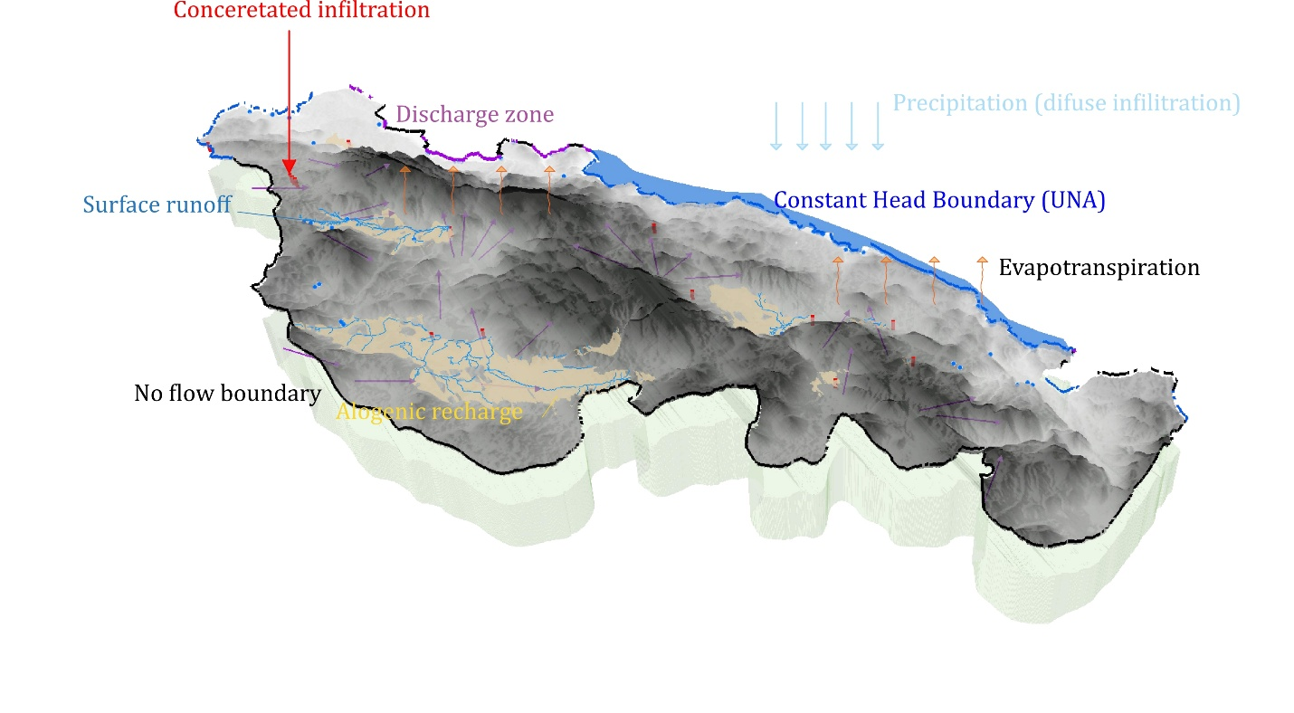
Figure 3 Conceptual hydrogeological model of Una TBA
Such a recharge regime, characterized by rapid and poorly attenuated transfer of water into the subsurface, governs both the highly dynamic behaviour and the pronounced intrinsic vulnerability of the karst aquifer.
Groundwater circulation occurs at multiple scales. Local flow systems connect nearby swallow holes and springs; intermediate systems extend across karst poljes; and regional flow systems drain extensive recharge areas of the Lika karst toward major discharge zones along the Una River valley.
Groundwater discharge predominantly occurs through large karst springs located along the Una River valley, which represents the regional erosion base of the system. Jurassic and Cretaceous limestones form the principal aquifers feeding the Klokot and Privilica springs.
Spring discharge variability is high, with a discharge variability coefficient (Qmax/Qmin) typically exceeding 10. This pronounced variability reflects the rapid hydraulic response of the karst aquifer to recharge events, limited storage capacity in conduit systems, and the dominance of quick-flow components.
The strong hydraulic connection between groundwater and surface water results in gaining stream conditions along certain reaches of the Una River, particularly downstream of major spring outlets.
Stable isotope analyses provide additional evidence of hydraulic interconnections within the system. Springs such as Klokot and Privilica exhibit isotopic signatures comparable to those of the Plitvice Lakes catchment, indicating shared recharge areas in Croatia. More positive deuterium values within the Una River catchment suggest additional recharge zones located further south and closer to the Adriatic moisture source, corresponding to lower mean recharge altitudes compared to the Plitvice Lakes catchment (Babinka, 2007).
Combined dye tracing and isotopic evidence indicates not only groundwater flow from the southern karst fields of the Plitvice area toward the Una River, but also possible subsurface flow contributions from the northern side of the Plitvice Lakes toward the Una basin. These findings confirm the complexity and regional extent of the transboundary karst groundwater system.

4.2 Recharge/discharge zones and flow patterns
In the investigated karst area of Una TBA, recharge is primarily controlled by climatic conditions, lithology, surface morphology, and the degree of karstification. Losing streams, sinking streams, and ponors represent closely related manifestations of the same recharge mechanism, whereby surface water is directly transferred into the groundwater system through hydraulically connected karst features.
In the karst system, water losses are particularly pronounced within karst poljes, where surface streams commonly disappear into the subsurface through ponors and fractured carbonate beds. River and stream sections flowing over karstified limestones and dolomites allow rapid infiltration through open fractures, enlarged fissures, and sinkhole zones, resulting in concentrated recharge directly into the karst aquifer.
Recharge through losing streams is strongly seasonal. During periods of high-water levels, large volumes of surface water are rapidly transferred into the subsurface, activating deep conduit systems and contributing to regional groundwater flow toward major discharge springs. During low-flow periods, surface-water losses are reduced or intermittent, and recharge is limited to permanent ponors and active fracture zones.
Sinkholes (ponors) represent direct and highly efficient entry points into the karst aquifer system. Recharge through ponors is typically rapid and concentrated, bypassing the soil zone and entering the subsurface through open conduits, fractures, and karst channels. As a result, this type of recharge is characterized by minimal natural filtration, making ponors particularly sensitive points with respect to groundwater quantity and quality.
Due to their hydraulic efficiency, ponors exert a strong control on groundwater flow patterns, influencing both the direction and velocity of subsurface circulation within the karst system.
Tracer tests and hydrogeological investigations have demonstrated that sinkhole-spring relationships in the investigated area are complex and highly dispersed. A single ponor may be hydraulically connected to several springs, while individual springs may receive recharge from multiple ponors. These relationships reflect the presence of a branched and heterogeneous conduit network, operating at local, intermediate, and regional scales.
Table 11 Sinkhole-spring hydraulic connections identified by tracer tests
SINKHOLE | CONNECTION SPRING
Ponor u Dnopolju | Ostrovica,
Ponor u Dnopolju | Toplica
Ponor u Dobroselu | Ostrovica
Ponor na Lapčkom polju (Bare) | Ostrovica
Ponor na Lapčkom polju (Bare) | Dobrenica
Ponor Jaruga - Vidrovac | Klokot I
Ponor kod Korenice | Klokot I
Ponor kod Korenice | Klokot II
Ponor kod Korenice | Ilića Vrelo
Ponor kod Korenice | Vedro polje - Panjak
Ponor u Mazinu | Ostrovica
Jama kod Vijenca | Toplica
Jama kod Vijenca | Crno vrelo
Jama kod Vijenca | Loskun-Pećina
Jama kod Vijenca | Loskun-Džakula
Jama kod Vijenca | Dobrenice – Lijepa voda
Jama kod Vijenca | Dobrenica
Jama kod Vijenca | Piskovac
Rastovača | Klokot
Prijeboj 1 | No confirmed connections; several connections are assumed.
Željava | Klokot I
Željava | Klokot II
Željava | Privilica
Željava | Žegar
Željava | Arkovac
Željava | Briševac
Brezovac Dobroselski | Joševica
Brezovac Dobroselski | Samac
Brezovac Dobroselski | Kamčarovac
Brezovac Dobroselski | Vrelo Une
Brezovac Dobroselski | Mala Neteka
Brezovac Dobroselski | Velika Neteka
Koreničko polje | Klokot I
Koreničko polje | Klokot II
Koreničko polje | Privilica
Koreničko polje | Dobrenica
Koreničko polje | Ilica Vrelo
Prijeboj 2 | Klokot I
Prijeboj 2 | Klokot II
Prijeboj 2 | Žegar
Prijeboj 3 | Klokot I
Prijeboj 3 | Klokot II
Pejićev ponor | Klokot I

Several ponors, including those in Donje Polje, Dobroselo, Mazin, and Koreničko Polje, predominantly drain toward the Ostrovica spring, indicating a major regional flow pathway toward the Una River valley. Other ponors, such as Jaruga–Vidrovac, Rastovača, Pejićev ponor, and ponors near Korenica, show strong connections to Klokot I and Klokot II, confirming the role of the Klokot spring system as the principal regional discharge zone.
Highly dispersed hydraulic connections are observed at Željava and Prijeboj, where tracer tests indicate links to multiple springs, including Klokot I, Klokot II, Privilica, Žegar, Arkovac, and Briševac. These ponors function as major distributive nodes, capable of recharging several flow systems depending on hydraulic conditions. Figure 4.2.1 illustrates the spatial distribution of sinkholes, springs, and rivers.
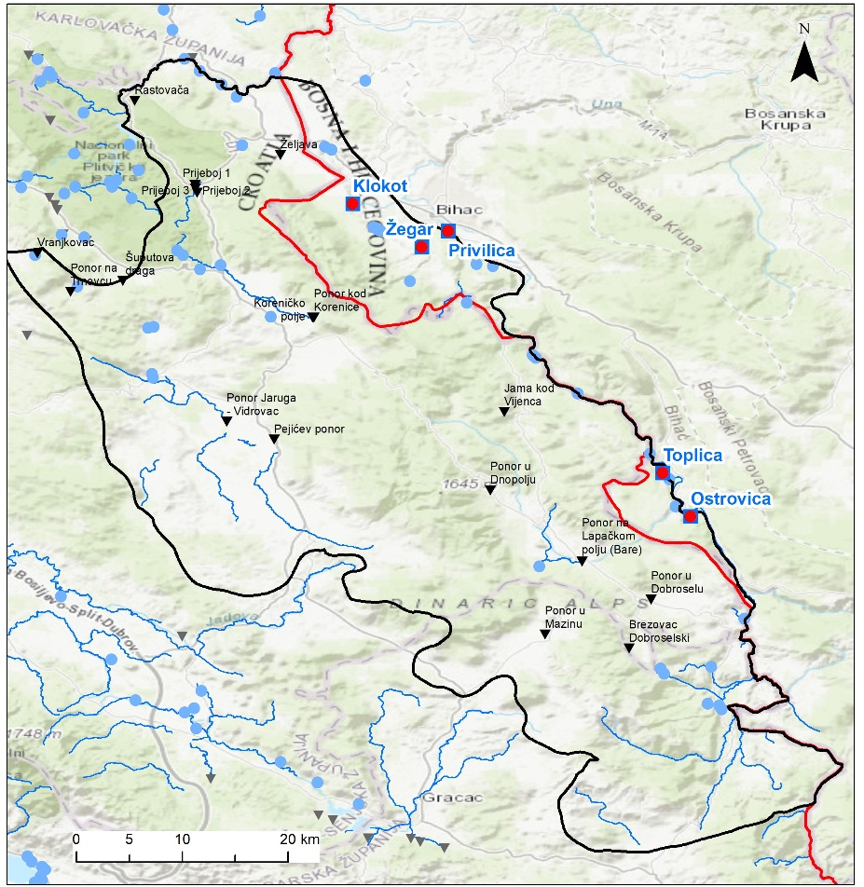
Figure 4 Spatial distribution of sinkholes, springs and rivers
The identified recharge mechanisms demonstrate that losing streams and ponors represent key control points within the karst groundwater system, governing the initiation, direction, and distribution of subsurface flow. The direct hydraulic linkage between recharge areas, conduit-controlled flow paths, and discharge springs results in rapid groundwater circulation and strong hydraulic connectivity across the system.
Because recharge through losing streams and ponors bypasses natural filtration, the karst aquifer exhibits high vulnerability to contamination. Consequently, these features represent priority locations for groundwater monitoring, both in terms of water quantity and water quality. Once groundwater enters the karst aquifer through these natural recharge mechanisms, its circulation occurs through a complex network of fissures and conduits, as described in the following section on the groundwater flow system.
Artificial groundwater recharge and irrigation return flow are not present in the investigated area. Groundwater recharge is therefore entirely controlled by natural processes, including precipitation infiltration, losing streams, and concentrated recharge through ponors and sinking streams.
Recharge from extensive karst terrains surrounding the Krbavsko, Prijeboj, and Koreničko Polje karst fields, as well as from the Plješivica Mountain massif, drains toward major springs in the Bihać valley, ranging from Klokot to Dobrenica. Additional karst poljes east of the Una River (Gornje and Donje Lapačko, Mazin, and Bijelo Polje) discharge groundwater to springs along the Una River valley between Dobrenica and Ostrovica.
In the Lika karst poljes on the left bank of the Una River, groundwater circulation occurs through both diffuse and concentrated sinking flow paths, draining toward one or more springs located at significantly lower elevations (<380 m a.s.l.) in the Una canyon and valley. Some ponors, particularly Donji Lapac and Prijeboj, also show local and intermittent hydraulic connections toward higher karst levels (>570 m a.s.l.) within the Lika massif (Gornji Lapac, Krbava, Koreničko Polje). These upward connections are characterized by lower hydraulic gradients and limited hydraulic significance. Overall, the dominant regional groundwater flow direction is toward the Una River valley, with the notable exception of the Prijeboj-Mirić Štropina connection draining toward the Korana River basin.
Tracer tests indicate that the main groundwater flow directions from high-elevation and high-infiltration ponors are oriented toward the north and northeast, while ponors at lower elevations exhibit greater dispersion toward multiple springs. Prijeboj is unique in showing hydraulic connections in all directions. Flow paths are strongly controlled by lithology and tectonic structure. Groundwater flow directions from recharge areas toward discharge zones are indicated by arrows in the conceptual sketch, highlighting dominant northward and north-eastward regional flow toward the Una River valley.
Measured apparent groundwater velocities range from 1.4 to 14.6 cm/s, confirming highly developed conduit flow. Koreničko Polje shows dispersed discharge toward several springs (Klokot, Vedro Polje, Privilica, Dobrenica), although the largest proportion of flow is directed toward the Klokot spring. Krbavsko Polje is hydraulically connected exclusively to Klokot, whereas ponors in Donji and Gornji Lapac and Brezovac drain predominantly toward Ostrovica. Mazin shows a single connection to Ostrovica.
Most ponors (Željava, Vučjak, Prijeboj, Korenica, Krbava) belong to the Klokot spring catchment. Separate deep conduit pathways from Krbava and Korenica toward Klokot are inferred, supported by tracer studies indicating a vertical supply conduit exceeding 110 m in depth. During high-water conditions, Prijeboj acts as a major distributive node, connecting simultaneously to the Una valley, Krbavsko and Koreničko Polje, and the Plitvice area.
A distinct and anomalous northwest-directed groundwater flow from the Vučjak ponor toward Klokot was identified, representing an inverse flow direction relative to other documented connections.
No systematic relationship between hydraulic gradient and groundwater velocity was observed, indicating that structural and conduit-controlled flow dominates over gradient-controlled flow in the karst aquifer system.
The results of tracer tests conducted in the Una River catchment indicate a highly complex and ramified karst drainage system, characterized by rapid, concentrated, and frequently multidirectional groundwater flow. Subsurface connections between swallow holes in the karst poljes of the Lika region and springs in the Bihać area are controlled by privileged karst conduits, whereby a single ponor may be hydraulically connected to one or several springs, while multiple ponors may contribute to the discharge of a single spring.
Hydraulic head distribution is controlled by elevation differences between recharge areas located at higher karst plateaus and discharge areas at significantly lower elevations within the Una River valley.
Most swallow holes exhibit dispersed recharge patterns with pronounced branching of underground flow paths, particularly those located at higher elevations (Prijeboj, Koreničko Polje, Krbavsko Polje). In contrast, ponors situated at lower elevations (Vučjak, Željava) display lower dispersion and higher groundwater velocities, indicating a more mature and hydraulically efficient karstification in zones closer to the main discharge areas.
During high-water conditions, a larger number of underground connections become active, including secondary flow paths, whereas under low-flow conditions groundwater drainage is largely restricted to deep, well-developed karst conduits. More distant karst poljes (Krbavsko and Koreničko Polje) predominantly drain toward the lowest and most productive springs (Klokot and Ostrovica), while connections to smaller springs are limited or intermittent.
Tracer test results demonstrate that groundwater velocities are not correlated with hydraulic gradient, confirming the dominance of conduit-controlled flow and strong structural control over groundwater circulation. The highest tracer recoveries were recorded at the most productive springs, emphasizing their role as principal drainage outlets of the karst aquifer system.
The Dinaric structural trend (NW–SE) provides more favourable hydrogeological conditions and higher groundwater velocities compared to the transverse NE–SW direction, highlighting the fundamental role of tectonic structures in the development and functioning of the karst aquifers.
The groundwater flow system can be subdivided into local, intermediate, and regional components. Local flow systems are represented by short and shallow connections between nearby ponors and springs, particularly within individual karst poljes. Intermediate flow systems connect karst poljes to springs at moderate distances and elevations. Regional flow systems dominate overall circulation, draining large recharge areas of the Lika karst toward major springs in the Una River valley.

4.3 Groundwater-dependent ecosystems
Both aquatic and terrestrial GDEs were identified for Croatia’s 2nd and 3rd RBMPs. In addition, ecosystems directly linked to groundwater, such as surface water bodies relying on groundwater for their ecological functions, were considered. For all these groundwater-dependent ecosystems - terrestrial, aquatic, and surface waters - quality standards were established.
Groundwater quality standards (GQS) for ecosystems linked to groundwater (surface water) in Croatia are based on surface water Environmental Quality Standards (EQS) for priority substances.
Similarly, because the impacts of groundwater chemistry on terrestrial groundwater-dependent ecosystems (GDE) are not well understood, Croatia also adopts EQS values for priority substances as the reference standards for terrestrial GDE, in line with CIS Guidance No. 18. This approach is also applied to aquatic groundwater-dependent ecosystems (GDTE), including those in karst and cave environments (Croatian Geological Survey, 2016). In identifying groundwater-dependent ecosystems in Croatia, special attention is given to the role of groundwater in the environment and how it can transmit the effects of anthropogenic pressures (pollution of groundwater or reduction in groundwater flow or level) within groundwater bodies (GWBs). To assessing the condition of groundwater within which ecosystems connected or dependent on groundwater exist, it is necessary to consider saturated zone of the aquifer.
In Bosnia and Herzegovina, the Water Framework Directive (WFD) recognizes two types of ecosystems associated with groundwater. The first type refers to groundwater-associated aquatic ecosystems (where groundwater interacts with surface water). The second type includes terrestrial ecosystems that depend on groundwater for their survival and functioning.
Bosnia and Herzegovina has a rich subterranean biodiversity, reflecting the ecological uniqueness of the Dinaric karstic region, especially in karstic cave systems and underground rivers. These habitats are home of a wide variety of specialized and very often, endemic species. Bosnia and Herzegovina´s underground ecosystems are considered among the most biologically diverse in Europe, with species such as cave-dwelling amphipods, isopods, and the olm highlighting the ecological significance of these hidden environments (Delić et al., 2023; Falniowski et al., 2021).
The WFD recognizes two types of ecosystems that may be associated with groundwater. One is groundwater-associated aquatic ecosystem, which refers exclusively to the connection of groundwater with surface waters and the ecosystems within them. The other type includes terrestrial ecosystems dependent on groundwater.
Karst terrains are characterized by high permeability of fractured carbonate rocks, allowing infiltration of significantly larger amounts of precipitation than other less permeable terrains. Therefore, surface watercourses are very rare in karst areas, and most of the discharge occurs underground. One karst-specific feature is the presence of extensive closed depressions, or karst fields, often with sinking rivers, which are also a peculiarity of such areas.
Considering that groundwater plays a key role in the sustainability of many terrestrial ecosystems, it is critically important not only for human life and socioeconomic development but also for numerous flora and fauna species (Gibert et al., 2008). As a refuge for many diverse organisms, complex relationships between groundwater and subterranean biota generate dynamics in many ecological systems (Danielopol et al., 2003).
In the Dinaric region of Croatia, about twenty large karst fields are located at average altitudes between 250 and 700 m. Morphologically, they are usually elongated parallel to the Dinaric geological structures (NW-SE) and situated between mountain or highland massifs also elongated in the same direction. In the Dinaric region of Bosnia and Herzegovina, numerous large karst fields (polja) are found at altitudes typically ranging from 300 to 800 meters above sea level. These fields are morphologically elongated along the northwest-southeast axis, following the dominant orientation of the Dinaric geological structures. They are situated between mountain ranges or highland massifs that also extend in the same structural direction. Notable karst poljes in Bosnia and Herzegovina include Livanjsko, Duvanjsko, Glamočko, Nevesinjsko, Gatačko, and Popovo polje, many of which are seasonally or permanently flooded and serve as important hydrological and ecological systems within the Dinaric karst region.
A common phenomenon in Dinaric karst is stepped drainage, where sinking waters from one field feed springs located in a lower-neighbouring karst field. In this way, waters infiltrated in the upper parts of the catchment change their character several times on their path to the final recipient, switching from groundwater to surface water and vice versa. Flow conditions in karst are very complex, and part of the groundwater may not emerge at a lower water step but drain directly through deeper aquifer zones to the main regional erosion base.
In Croatian karst areas, groundwater and surface waters are multiply connected. The focus is primarily on karst aquifers and on ecosystems connected to groundwater in karst, such as karst springs, rivers, and lakes. The dominant groundwater-dependent ecosystem in this part of Croatia consists of freshwater karst cave habitats (according to the national habitat classification, NKS), i.e., caves and pits closed to the public (according to NATURA 2000), many of which are connected to natural groundwater discharge locations (springs). As mentioned above, only speleological objects that reach the groundwater level in the saturated part of the karst aquifer are considered. All sites listed in the Natura 2000 habitat list of Croatia were selected, as well as a small number not listed but containing findings of targeted bioindicator species, covering various types of subterranean aquatic habitats in the karst areas of the Pannonian and Dinaric parts of Croatia within the aquifer zone or anhydrophyaline caves with groundwater inflow.
In Bosnia and Herzegovina focus is primarily on karst aquifers, i.e., caves and subterranean habitats fully dependent on groundwater, as well as on other ecosystems linked to groundwater in karst, such as karst springs, sinking rivers, and polje systems. The dominant groundwater-dependent ecosystems in Bosnia and Herzegovina include freshwater karst cave habitats, according to the national habitat classification, i.e., caves, pits, and siphons often closed to the public. Many of these are directly connected to natural groundwater discharge points, particularly karst springs such as Buna, Bunica, and Trebižat, which act as hotspots of subterranean biodiversity. The dominant groundwater-dependent ecosystems in Bosnia and Herzegovina consist of freshwater karst cave habitats, according to the national habitat classification, i.e., caves, pits, and siphons often closed to the public. Only speleological objects that reach the groundwater level in the saturated zone of the karst aquifer are considered. Sites included cover locations listed in Natura 2000 as well as additional caves, springs, and sinking streams not officially listed but containing findings of targeted bioindicator species. This selection represents a variety of subterranean aquatic habitats in the Dinaric karst regions of Herzegovina, western Bosnia, and parts of central and southern Bosnia, encompassing cave systems, siphons, ponors, and groundwater-fed aquatic habitats.
Speleological objects such as caves, pits, and karst springs are protected under national legislation, including entity-level environmental and nature protection laws, which recognize these sites as natural and cultural goods of general interest and regulate their management and conservation. Ongoing projects at the national and regional levels focus on mapping karst springs, caves, sinking rivers, and groundwater-dependent habitats, particularly within areas identified for potential inclusion in the Natura 2000 network. Protection and management measures are implemented in accordance with the Water Framework Directive (2000/60/EC), the Habitats Directive (92/43/EEC), and relevant national and entity-level environmental regulations. Efforts include monitoring hydrological regimes, controlling land use in karst catchments, and conserving biodiversity hotspots linked to subterranean waters.
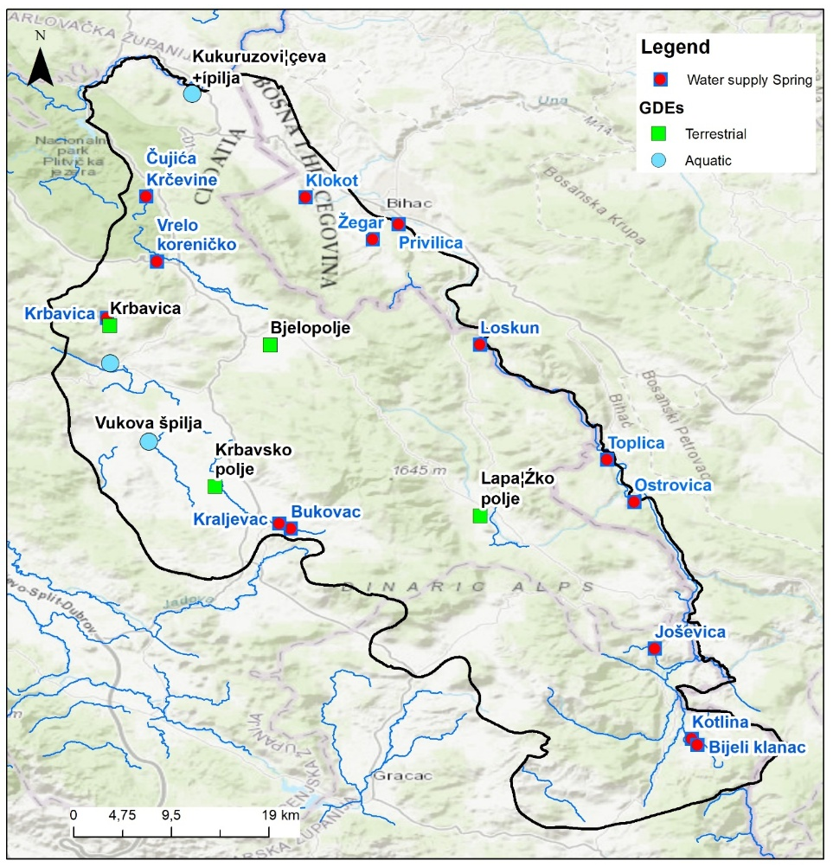
Figure 5 Groundwater-dependent ecosystems for Una TBA (including four (4) terrestrial and two (2) aquatic)

4.4. Quality indicators of groundwater and groundwater-dependent ecosystems
For water status monitoring in support of river basin management planning, the responsible authorities are the Agency for the Sava River Basin (FBiH) and Croatian Waters and Josip Juraj Strossmayer Water Institute (HR). In Croatia and BiH, the Hydrometeorological Institutes handle hydrological and meteorological monitoring and data processing, while the Institutes of Public Health are responsible for drinking water quality monitoring.
In Una TBA monitoring of groundwater quality is performed on all springs used for water supply and according to DWD (and national Drinking Water Act), while the groundwater monitoring for assessment of GW chemical status for the karst aquifers is not yet established in BiH. Monitoring of groundwater quality on all GW monitoring stations in Croatia is in accordance with WFD, GWD and DWD.

GW chemical status
The assessment of chemical status is conducted according to groundwater quality standards (GQS) for nitrates and pesticides and the threshold values for specific pollutants. In Croatia, these standards are established under the Regulation on Water Quality Standards (Official Gazette No. 96/2019, 20/2023, and 50/2023, Annex 6), while in the Federation of Bosnia and Herzegovina, they are defined by the Decision on the Characterization of Surface and Groundwater, Reference Conditions, and Parameters (Official Gazette FBiH, No. 1/14, Annex 8).
Tables 4.4.1 and 4.4.2 present the parameters and sampling frequency for assessing the chemical status of groundwater for both surveillance and operational monitoring. Table 4.4.1 was adopted from the Croatian national monitoring plan for 2025, with an additional final column included for Federation of Bosnia and Herzegovina (FB&H).
Within the framework of surveillance and operational monitoring, basic and additional indicators are monitored in accordance with Annex 6 of the Regulation on Water Quality Standards. The chemical status assessment is carried out according to groundwater quality standards and the threshold values for specific pollutants (Tables 3 and 4 of Annex 6 of the Regulation), which are monitored as part of surveillance and operational monitoring. Other indicators not included in the Regulation but monitored within the surveillance and operational monitoring framework are selected according to Directive (EU) 2020/2184 on the quality of water intended for human consumption – DWD (European Commission, 2020a) (Table 37).
Table 12 Parameters used for groundwater chemical status assessment and required annual testing frequency - GWS and specific pollutants
INDICATOR | FREQUENCY |  | FBiH
INDICATOR | SURVEILLANCE | OPERATIONAL | FBiH
CHEMICAL STATUS
Nitrates | 4/yr-6/yr | 4/yr-12/yr | +
Pesticide active substances (plant protection products and biocides, in accordance with regulations on permitted active substances) |  |  | +
Organochlorine Pesticides (4,4 DDT; 2,4 DDT; 4,4 DDE; 4,4 DDD; HCB; DDT Total; Heptachlor; Heptachlorepoxide; Metoksiklor; HCH, α- and β-Endosulfan; Endosulfan Total; α-HCH, β-HCH, γ-HCH, δ-HCH) (µg/l) | 4/yr | 4/yr-6/yr | -
Cyclodiene Pesticides (Aldrin, Dieldrin, Endrin, Isodrin) (µg/l) | 4/yr | 4/yr-6/yr | -
Organophosphorus Pesticides (Dimethoate, Pirimiphos-methyl, Chlorvenphos, Chlorpyrifos (Chlorpyrifos-ethyl), Chlorpyrifos-methyl, Omethoate, Pirimiphos-methyl, Glyphosate, total organophosphorus pesticides) (µg/l) | 4/yr-6/yr | 4/yr-6/yr | -
Triazine Pesticides (Atrazine, Simazine, Terbuthylazine) | 4/yr-6/yr | 4/yr-12/yr | -
Bromazil | 6/yr | 6/yr | -
Chloroacetamides (Acetochlor, s- Metolachlor µg/l) | 4/yr | 4/yr | -
SPECIFIC POLLUTANTS
Arsenic (µg/l As) | 4/yr-12/yr | 4/yr-12/yr | +
Cadmium (µg/l Cd) | 4/yr-12/yr | 4/yr-12/yr | +
Lead (µg/l Pb) | 4/yr-12/yr | 4/yr-12/yr | +
Mercury (µg/l Hg) | 4/yr-12/yr | 4/yr-12/yr | +
Ammonium (mg/l NH₄⁺) | 4/yr-6/yr | 4/yr-12/yr | Ammonia (NH₃)
Chloride (mg/l Cl⁻) | 4/yr-6/yr | 4/yr-6/yr | +
Sulphate (mg/l SO₄²⁻) | 4/yr-6/yr | 4/yr-6/yr | +
Orthophosphate (mg/l P) | 4/yr-6/yr | 4/yr-12/yr | -
Nitrites (mg/l NO₂⁻) | 4/yr-6/yr | 4/yr-12/yr | -
Total phosphorus (mg/l P) | 4/yr-6/yr | 4/yr-12/yr | -
Trichloroethylene (µg/l TCE) | 4/yr-6/yr | 4/yr-12/yr | +
Tetrachloroethylene (µg/l PCE) | 4/yr-6/yr | 4/yr-12/yr | +
Electrical conductivity (µS/cm) | 4/yr-6/yr | 6/yr-12/yr
Cyanides (CN⁻) | - | - | +

Table 13 Additional parameters used for groundwater chemical status assessment and required annual testing frequency
INDICATOR | DWD  Indicator | FREQUENCY
INDICATOR | DWD  Indicator | SURVEILLANCE | OPERATIONAL
BASIC PHYSICO-CHEMICAL INDICATORS
Temperature °C |  | 4/yr-6/yr | 6/yr-12/yr
pH | + | 4/yr-6/yr | 6/yr-12/yr
Redox potential (Mv) |  | 4/yr-6/yr | 6/yr-12/yr
Total suspended solids (TSS) |  | 4/yr
Alkalinity (mg/l CaCO₃) |  | 4/yr-6/yr | 6/yr-12/yr
Total hardness (mg/l CaCO₃) |  | 4/yr-6/yr | 6/yr-12/yr
Turbidity (NTU) | + | 4/yr-6/yr | 6/yr-12/yr
Dissolved oxygen (DO) (mg/l O₂) | + | 4/yr-6/yr | 6/yr-12/yr
COD Mn (mg O₂/l) |  | 4/yr-6/yr | 6/yr-12/yr
Total Organic Carbon (TOC) (mg/l C) | + | 4/yr-6/yr | 6/yr-12/yr
Total Nitrogen (mg/l N) |  | 4/yr-6/yr | 6/yr-12/yr
Colour |  | 4/yr-12/yr | 4/yr-12/yr
Odor / Smell |  | 4/yr-12/yr | 4/yr-12/yr
IONS
Calcium (mg/l) | + | 4/yr-6/yr | 4/yr-6/yr
Magnesium (mg/l) | + | 4/yr-6/yr | 4/yr-6/yr
Sodium (mg/l) | + | 4/yr-6/yr | 4/yr-6/yr
Potassium (mg/l) | + | 4/yr-6/yr | 4/yr-6/yr
Cyanides (mg/l) | + | 4/yr-6/yr | 4/yr-6/yr
Fluorides (mg/l) | + | 4/yr-6/yr | 4/yr-6/yr
Bromates (mg/l) | + | 4/yr-6/yr | 4/yr-6/yr
Hydrogen carbonates (mg/l) | + | 4/yr-6/yr | 4/yr-6/yr
Hydrogen sulphide (mg/l) | + | 4/yr | 4/yr-6/yr
Silicates (mg/l) |  | 4/yr | 4/yr-6/yr
MICROBIOLOGICAL INDICATORS
Total coliform bacteria (count/100 ml) | + | 4/yr-6/yr | 6/yr-12/yr
Faecal coliform bacteria (count/100 ml) |  | 4/yr-6/yr | 6/yr-12/yr
Faecal streptococci – intestinal enterococci (count/100 ml) | + | 4/yr-6/yr | 6/yr-12/yr
Aerobic bacteria (22°C) (count/1 ml) | + | 4/yr-6/yr | 6/yr-12/yr
Aerobic bacteria (36°C) (count/1 ml) |  | 4/yr-6/yr | 6/yr-12/yr
Clostridium perfringens, including spores (count/100 ml) | + | 4/yr | 4/yr-6/yr
Escherichia coli (count/100 ml) | + | 4/yr-6/yr | 6/yr-12/yr
Pseudomonas aeruginosa (count/100 ml) |  | 4/yr-6/yr | 6/yr-12/yr
METALS
Iron (μg/l) | + | 4/yr-12/yr | 4/yr-12/yr
Manganese (μg/l) | + | 4/yr-12/yr | 4/yr-12/yr
Copper (μg/l) | + | 4/yr-12/yr | 4/yr-12/yr
Zinc (μg/l) |  | 4/yr-6/yr | 4/yr-6/yr
Chromium (μg/l) | + | 4/yr-12/yr | 4/yr-12/yr
Nickel (μg/l) |  | 4/yr-12/yr | 4/yr-12/yr
Aluminium (μg/l) | + | 4/yr-12/yr | 4/yr-12/yr
Barium (μg/l) |  | 4/yr-6/yr | 4/yr
Beryllium (μg/l) |  | 4/yr | 4/yr
Vanadium (μg/l) |  | 4/yr | 4/yr
Antimony (μg/l) | + | 4/yr-6/yr | 4/yr-12/yr
Boron (μg/l) | + | 4/yr-6/yr | 4/yr-12/yr
Selenium (μg/l) | + | 4/yr-6/yr | 4/yr-12/yr
Cobalt (μg/l) | + | 4/yr | 4/yr-6/yr
Silver (μg/l) | + | 4/yr | 4/yr-6/yr
Uranium (μg/l) | + | 4/yr-6/yr | 4/yr-12/yr
PHARMACEUTICAL COMPOUNDS
Erythromycin (μg/l) |  | 4/yr | 4/yr
Azithromycin (μg/l) |  | 4/yr | 4/yr-6/yr
Sulfamethoxazole (μg/l) |  | 4/yr | 4/yr
Torasemide (μg/l) |  | 4/yr | 4/yr
Azithromycin N-desmethylazithromycin (μg/l) |  | 4/yr | 4/yr
Memantine (μg/l) |  | 4/yr | 4/yr
Warfarin (μg/l) |  | 4/yr | 4/yr
Carbamazepine (μg/l) |  | 4/yr | 4/yr
HYDROCARBONS
Halogenated hydrocarbons (1,1,1-Tetrachloroethane, Trichloroethylene, 1,1,2-Trichloroethane, 1,2-Dichloroethane, Hexachlorobutadiene, Tetrachloromethane (Carbon tetrachloride), Trichloromethane (Chloroform), Dichloromethane) (μg/l) |  | 4/yr-6/yr | 4/yr-6/yr
Aromatic hydrocarbons (benzene, total xylenes, toluene) (μg/l) | + | 4/yr-6/yr | 4/yr-6/yr
Polycyclic aromatic hydrocarbons (PAHs: benzo(a)pyrene, benzo(b)fluoranthene, benzo(k)fluoranthene, benzo(ghi)perylene, indeno(1,2,3-cd)pyrene) (μg/l) | + | 4/yr-6/yr | 4/yr-6/yr
ORGANIC COMPOUNDS – DETERGENTS
Anionic detergents (μg/l) | + | 4/yr-6/yr | 4/yr-6/yr
Non-ionic detergents (μg/l) | + | 4/yr-6/yr | 4/yr-6/yr
Total phenols (μg/l) | + | 4/yr-6/yr | 4/yr-6/yr
OTHER ORGANIC COMPOUNDS
Bisphenol A (BPA) (μg/l) |  | 4/yr-6/yr
Chloroacetamides μg/l) |  | 4/yr
Acetochlor (μg/l) |  | 4/yr | 4/yr
S-metolachlor (μg/l) |  | 4/yr | 4/yr

Groundwater-dependent ecosystems
River streams with intergranular aquifers, hyporheic zones, and riparian vegetation host a very large diversity of fauna and flora dependent on good qualitative and quantitative groundwater status. Due to the lack of recent faunistic research on aquifers in Croatia, available results from benthic macroinvertebrate studies in river ecosystems and targeted research of the hyporheic zone are included. Key indicators of good river system status are numerous aquatic macroinvertebrates, particularly stoneflies (Plecoptera) and decapod crustaceans of Austropotamobius genus (A. pallipes and A. torrentium). Perlodidae family (Plecoptera) is especially indicative of good hyporheic zone status.
Karst and intergranular aquifers in Croatia support diverse obligate groundwater fauna, most dominantly crustaceans from Amphipoda, Copepoda, Decapoda, Isopoda, Ostracoda, Syncarida, and Thermosbaenacea groups. Other important and highly adapted groundwater invertebrates valuable for ecosystem monitoring include protozoa, micrometazoa (Gastrotricha, Nematoda, Nemertina, Rotifera, Tardigrada), sponges (Porifera), flatworms (Turbellaria), snails (Gastropoda), oligochaetes, polychaetes, leeches (Hirudinea), aquatic insects (Insecta), water mites (Hydrachnellae), and vertebrates such as amphibians and fish (Gottstein, 2010; Gottstein et al., 2001).
Many are narrowly distributed endemic species with limited ranges, complicating the choice of universal indicator species for monitoring multiple groundwater-dependent ecosystems. However, findings of many subterranean fauna species in adjacent groundwater-dependent ecosystems are excellent indicators of these systems’ reliance on groundwater and their ecological stability and conservation status, supporting their use in monitoring.
Groundwater crustaceans, as a dominant group, are relatively under-researched in Croatia. New species and subspecies are expected to be discovered, especially in subterranean habitats. The genus Niphargus is very species-rich, including surface-dwelling representatives dependent on high-quality groundwater (included here). One endemic genus of isopods included in the analysis is the troglobiont Monolistra, which inhabits karst springs and caves with flowing groundwater. It reaches about 10 mm length with distinct habitus and is suitable for biomonitoring. It coexists with the largest subterranean isopod in Croatia, Sphaeromides, another suitable species for ecological monitoring of groundwater and groundwater-dependent ecosystems. The genus Troglocaris is also widespread across the Dinarides of Croatia.
The genus Congeria is another subterranean bioindicator organism for groundwater-dependent systems. Croatia has 16 known cave mussel sites, but living populations are confirmed at only six. Congeria kusceri inhabits the Neretva River basin in southern Dalmatia and Herzegovina (three known sites), while Congeria jalzici inhabits the Lika River basin (Markov ponor, Dankov ponor, Lukina jama–Trojama system).
The olm (Proteus anguinus) is especially noteworthy, inhabiting caves and sinkholes of karst fields from Istria to Dubrovnik. It is considered endangered and listed in Croatia’s Red Book of cave fauna as a vulnerable species (VU B1+2bc; C2a).
Proteus anguinus is strictly protected by nature protection laws, included in the EU Natura 2000 Annex II and IV. Main threats include uncontrolled urbanization, changes in groundwater regimes due to hydrotechnical interventions (dam construction, water abstraction), and groundwater pollution. It is highly suitable as a bioindicator species for groundwater-dependent ecosystems.

Table 14 Lists of bioindicator organisms (many taxa not listed to species level here) of groundwater ecosystems with their corresponding habitats according to NKS included in the analysis and assessment of groundwater karst ecosystems
Natura 2000 code | 8310 |  |  | 8330
NKS code | H. 1.3. | H 1.3.1. | H. 1.3.2.1. | H 1.4.
Habitat type (NKS) | Freshwater karst cave habitats | Underground streams | Underground lakes | Anchialine karst caves
Congeria | x |  | x
Enapus | x | x | x
Lanzaia | x
Marifuga | x | x | x
Monolista | x | x | x
Niphargus | x | x | x | x
Proteus | x | x | x | x
Saxurinator | x
Stigodiaptomus | x |  | x
Spheromides | x |  | x | x
Troglocaris | x |  | x | x

Karst aquifers in Bosnia and Herzegovina support a highly diverse obligate groundwater fauna, with dominant groups including crustaceans such as Amphipoda, Copepoda, Decapoda, Isopoda, Ostracoda, and Syncarida. Other important and highly adapted groundwater invertebrates, valuable for ecosystem monitoring, include protozoa, micrometazoa (Gastrotricha, Nematoda, Nemertina, Rotifera, Tardigrada), sponges (Porifera), flatworms (Turbellaria), snails (Gastropoda), oligochaetes, polychaetes, leeches (Hirudinea), aquatic insects (Insecta), and water mites (Hydrachnellae).
Some vertebrate species, particularly endemic and relict amphibians (e.g., Proteus anguinus in certain Dinaric caves) and freshwater fish, are also closely linked to karst aquifers and associated springs. These groundwater-dependent organisms serve as bioindicators of ecological integrity and hydrological connectivity, reflecting both the quality and quantity of subterranean water resources across the Dinaric karst region of Bosnia and Herzegovina (Džajić & Milanović, 2012; Gottstein et al., 2001, Delić et al., 2023).The occurrence of stygobiont fauna, such as endemic amphipods (Niphargus spp.), crayfish (Austropotamobius pallipes and A. torrentium), and other cave-adapted invertebrates across adjacent karst springs, caves, and hyporheic zones, provides excellent indicators of groundwater dependence. These species reflect the ecological integrity, hydrological connectivity, and conservation status of these subterranean ecosystems, supporting their use in monitoring and management programs throughout the Dinaric karst of Bosnia and Herzegovina.
Groundwater crustaceans, as a dominant group in subterranean aquatic ecosystems of Bosnia and Herzegovina, remain relatively under-researched, and new species and subspecies are expected to be discovered, particularly in karst caves, springs, and intergranular aquifers. The genus Niphargus is highly species-rich and includes both surface-dwelling and strictly groundwater-dependent representatives, serving as excellent bioindicators of aquifer quality.
Among endemic isopods, the troglobiont Monolistra inhabits karst springs and caves with flowing groundwater (Delić et al., 2023). Monolistra often coexists with Sphaeromides, one of the largest subterranean isopods in the region, also used as an indicator species for ecological monitoring of groundwater and groundwater-dependent ecosystems. The genus Troglocaris is widespread across the Dinaric karst of Bosnia and Herzegovina, occupying numerous caves and spring systems. Another important groundwater bioindicator is the genus Congeria, a subterranean bivalve. In Bosnia and Herzegovina, Congeria kusceri has been reported from the Neretva River basin and associated karst poljes and caves, forming small but ecologically significant populations (Bilandžija et al., 2013). These species are sensitive to hydrological and water quality changes, making them valuable indicators for the status and conservation of groundwater-dependent ecosystems in the country.
The olm (Proteus anguinus) is a flagship species of subterranean aquatic ecosystems in Bosnia and Herzegovina, inhabiting caves, sinkholes, and subterranean rivers within the Dinaric karst, particularly in Herzegovina and parts of western and central Bosnia. It is considered endangered and is strictly protected under national nature protection laws. Proteus anguinus is also listed in the EU Natura 2000 Annex II and IV, highlighting its conservation importance at the European level.
Table 15 List of basic physico-chemical parameters and biological elements for quality of ground water
BASIC PHYSICO-CHEMICAL PARAMETERS | PARAMETER | FREQUENCY
BASIC PHYSICO-CHEMICAL PARAMETERS | Water temperature | 2/yr
BASIC PHYSICO-CHEMICAL PARAMETERS | pH value | 2/yr
BASIC PHYSICO-CHEMICAL PARAMETERS | Dissolved oxygen | 2/yr
BASIC PHYSICO-CHEMICAL PARAMETERS | Electrical conductivity | 2/yr
BASIC PHYSICO-CHEMICAL PARAMETERS | Total dissolved solids (TDS) | 2/yr
BASIC PHYSICO-CHEMICAL PARAMETERS | Basic cations (e.g. Ca2+, Mg2+, Na+, K+) and  Anions (e.g. HCO3-, SO42-, Cl-). | 2/yr
BASIC PHYSICO-CHEMICAL PARAMETERS | Turbidity | 2/yr
BASIC PHYSICO-CHEMICAL PARAMETERS | Organic and Inorganic carbon (TOC, DOC) | 2/yr
BIOLOGICAL QUALITY ELEMENTS | Benthic macroinvertebrates | 1/yr
BIOLOGICAL QUALITY ELEMENTS | Vertebrates | 1/yr

5. Current monitoring for groundwater
Although Croatia is EU member and B&H is a candidate country for EU membership, they both have River Basin Management Plans (RBMP) in force. Two RBMP are relevant for Una TBA: the third RBMP until 2027 is currently valid in Croatia and second RBMP for Sava River in the Federation of BiH (2022-2027). All the data in this document regarding the monitoring are provided from this official documentation and relevant institutions.
For water status monitoring, in support of river basin management planning, the responsible authorities are the Agency for the Sava River Basin (FBiH) and Croatian Waters and Josip Juraj Strossmayer Water Institute. In Croatia and BiH hydrometeorological institutes handle hydrological and meteorological monitoring and data processing, while the Institutes of Public Health are responsible for drinking water quality monitoring.
Croatia has fully implemented chemical groundwater monitoring, while in Federation of Bosnia and Herzegovina (FBiH) comprehensive groundwater monitoring network has not yet been fully established, especially in karst part of Sava catchment. In both countries, quantitative groundwater monitoring is generally limited to springs used for public water supply. Systematic monitoring of spring capacity is lacking, leaving the actual availability and long-term sustainability of groundwater resources largely unassessed. Only the extracted groundwater volumes are measured, while overflow or natural discharge from springs is rarely monitored.
Regarding groundwater-dependent ecosystems (GDEs), both aquatic and terrestrial GDEs were identified in Croatia’s 3rd River Basin Management Plan (RBMP). In the FBiH, GDEs are not explicitly defined in water legislation, but their protection is indirectly addressed through broader environmental protection laws. However, both Croatia and Bosnia and Herzegovina currently lack a national, systematic monitoring program for GDEs, leaving a significant knowledge gap in assessing and managing the ecological status of these critical ecosystems.
Regarding cross-border aquifer monitoring, in this case Una TBA, Croatia has initiated research monitoring on two boreholes in the immediate catchment of the Klokot spring. However, most of the hydrometeorological stations in the Lika region, particularly Krbavsko and Koreničko polje, which are the main recharge areas of the Klokot spring, were discontinued in the 1990s, significantly limiting data availability. Therefore, further harmonization of monitoring approaches across transboundary aquifers and groundwater bodies is essential. Such harmonization could be developed and facilitated through the DIKTAS II project, specifically by establishing an integrated multi-purpose monitoring network within Una TBA pilot area.

5.1 Monitoring types and design of monitoring networks
In both countries and the relevant RBMP, there are three types of monitoring for surface waters (SW) as well as groundwater (GW) that are conducted in accordance with the objectives of the Water Framework Directive (WFD): surveillance monitoring, operational monitoring, and investigative (research) monitoring. There is also quality monitoring according to the Drinking Water Directive (DWD) on all springs used for public water supply, both in Croatia and BiH as well as their quantitative monitoring.
In both countries, hydrometeorological monitoring is organized at the level of national institutes and is primarily focused on flood protection and flood risk management, while its application for water resources balance assessment, including groundwater for drinking water supply and groundwater balance analysis, is considerably more limited.
Groundwater monitoring
In Una TBA monitoring of groundwater quality is performed on all springs used for water supply and according to DWD (and national Drinking Water Act), while the groundwater monitoring for assessment of GW chemical status for the karst aquifers is not yet established in BiH. Monitoring of groundwater quality on all GW monitoring stations in Croatia is in accordance with the WFD, Groundwater Directive (GWD) and DWD.
Regarding the quantitative monitoring in Una TBA, almost all springs used for water supply have measurements of abstracted quantities, but only for Klokot spring there is a gauging station for measurement of overflow volumes.
Out of nine groundwater (GW) monitoring stations in Croatian part of Una TBA, seven are under surveillance monitoring (S). Operational monitoring is carried out at two stations: Una, Donja Suvaja (14004G) and Joševica Spring (30223G). Investigative monitoring is conducted at Una, Donja Suvaja (14004G) and, more recently, at the Klokot-1 (30327) and Klokot-2 (30327) boreholes. On two surveillance monitoring stations: Una, Donja Suvaja (14004G) and Loskun spring (30222G) additional parameters are measured for drinking water, as defined in the DWD, but in accordance with the surveillance monitoring regime (more frequent than DWD).
Table 5.1 provides data on groundwater monitoring stations in Una TBA, including both chemical (quality) and quantitative status. The locations of the stations are shown in the figure 5.1.
Surface water monitoring
Unlike groundwater monitoring, surface water monitoring in both countries is mainly aligned with the WFD and EU standards. The ecological status of surface waters is assessed based on biological, basic physico-chemical, and chemical elements that complement the biological and hydromorphological components. The chemical status is assessed with respect to the relevant chemical status indicators.
Based on the definitions outlined in the WFD, 4 biological elements can be distinguished in rivers and lakes: phytoplankton and macrophytes/phytobenthos, and macrozoobenthos (Benthic Invertebrates) and fish. The basic physico-chemical and chemical quality elements in surface freshwater bodies are temperature, salinity, pH, oxygen regime, nutrient concentrations, and specific pollutants (arsenic, copper, zinc, chromium and their compounds, fluorides, and organically bound halogens).
The hydromorphological quality elements for rivers include elements of the hydrological regime, river continuity, and morphological conditions.
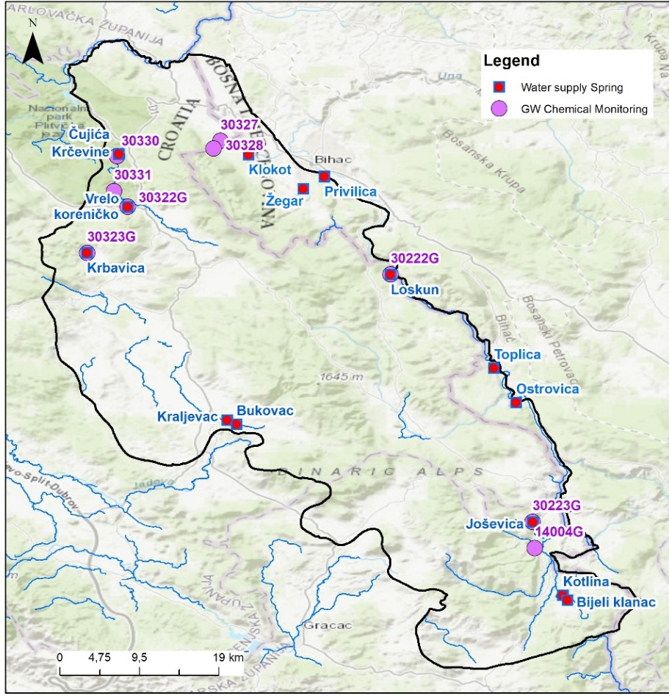
Figure 6 Groundwater monitoring in Una TBA
Table 16 Groundwater monitoring stations in Una TBA
NAME | CODE | TYPE QUALITY | QUANTITY | COUNTRY
Una, izvorište Donja Suvaja | 14004G | S, O, I; DWD |  | Croatia
Loskun izvorište, Donji Lapac | 30222G | S; DWD | QA | Croatia
Joševica izvorište | 30223G | S, O; DWD | QA | Croatia
Vrelo Koreničko - izvorište | 30322G | S; DWD | QA | Croatia
Krbavica izvorište | 30323G | S; DWD | QA | Croatia
Klokot 1, Vojni aerodrom Željava | 30327 | I | - | Croatia
Klokot 2, Vojni aerodrom Željava | 30328 | I | - | Croatia
Čujića Krčevina | 30330 | S; DWD | QA | Croatia
Izvor Korenica (Korenička rijeka) | 30331 | S; DWD | QA | Croatia
Klokot* | - | DWD | QA; QH | B&H
Privilica* | - | DWD | QA | B&H
Ostrovica* | - | DWD | QA | B&H
Toplica* | - | DWD | QA | B&H
Żegar** (Trbljenik- Žegar) | - | DWD |  | B&H
Gata*
Kamp Lipa**
S- surveillance monitoring, O- operational, I- investigative monitoring
*Vodovod Bihać daily measurement of parameters
** QA- abstracted quantities; QH- overflow on hydrological station
The elements of chemical status include priority and hazardous substances, which are assessed based on environmental quality standards (EQS) defined for each category of substances. A good chemical status is achieved when the observed indicators do not exceed the threshold values, expressed as: annual average concentration, maximum annual concentration and quality standards for biota for specific categories of substances.
In Croatian part of Una TBA, there are 6 surface water monitoring stations: 4 surveillance monitoring stations (Code 14006, 16338, 30224 and 14004) and 3 operational monitoring stations (code 16338, 30324, 30325) with additional water quality measurement on springs used for water supply (30322S, 30323S, 30222S, 30223S). In the part of TBA on Bosnian territory, there are, according to RBMP Sava, 7 monitoring stations.
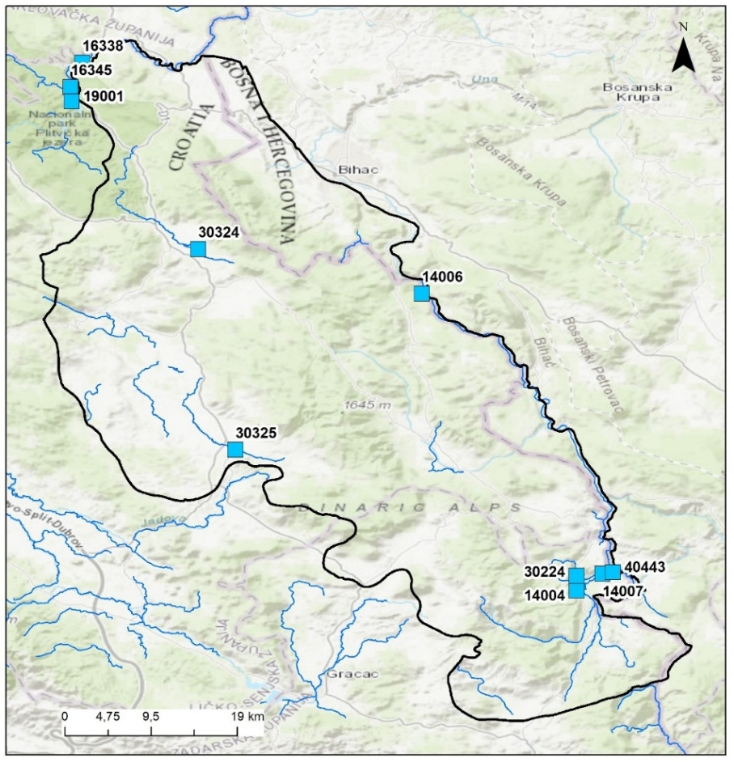
Figure 7 Surface water monitoring in Una TBA
Hydrometeorological monitoring
Official data from the National Hydrometeorological Service were used, Croatian National Hydrometeorological Service (DHMZ) and Federal Hydrometeorological Institute (FHMI). Both institutions are responsible for meteorological and hydrologic data. Unfortunately, many hydrological and meteorological stations of this region of Lika in Croatia and Bihać in BIH experienced interruptions in monitoring during the military conflicts in 1990s.
In Una TBA, there are currently nine active meteorological stations (mainly climatological), of which six are in the territory of Croatia and two in Federation of Bosnia and Herzegovina (FBiH). Regarding the hydrological stations, major number of stations, especially those at Krbavsko and Koreničko polje are inactive and only few in Una TBA are active (the ones on river Una).
The locations of the meteorological and hydrological stations in Una TBA are shown in the figure 5.1.3.
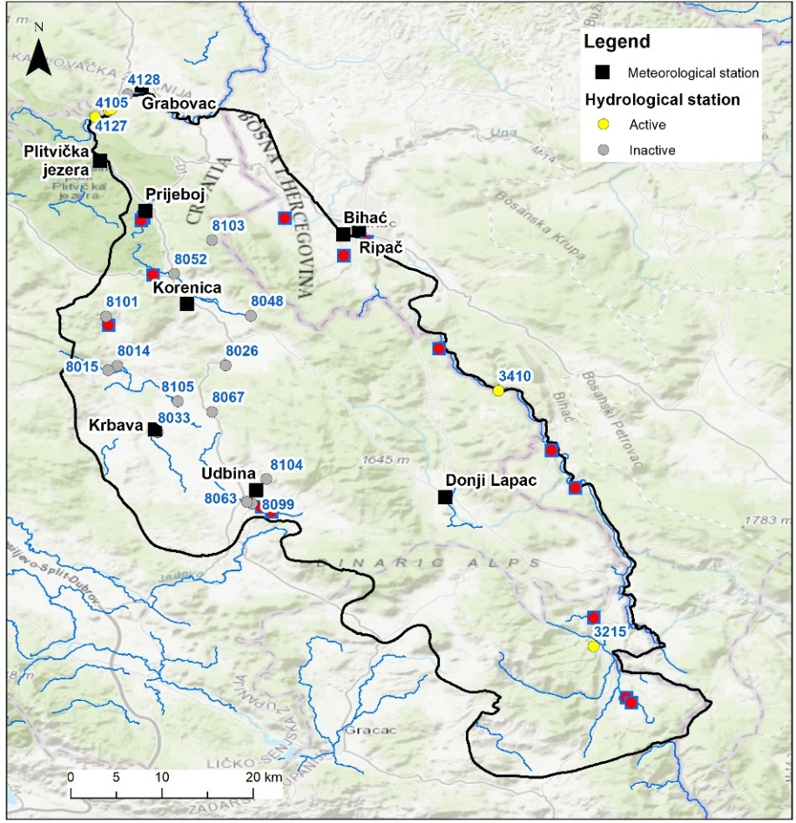
Figure 8 Meteorological and hydrological stations in Una TBA

5.2 Parameters and frequencies of monitoring
A detailed list of all parameters measured at groundwater (GW) and surface water (SW) monitoring stations in Una TBA, including the sampling frequency, is provided and explained in a separate DIKTAS II project document (Output 3.1 – Design of DIKTAS-wide groundwater multi-purpose monitoring network; SITE 1: Una TBA shared between Bosnia and Herzegovina and Croatia).
In this chapter, only a list of parameters for the chemical status assessment of groundwater bodies (GWB), along with their sampling frequency, is presented in Table 5.2 and 5.3, while a summarized version is provided for surface water monitoring (ecological and chemical status).
Groundwater monitoring
The assessment of chemical status is conducted according to groundwater quality standards (GQS: nitrates and pesticides) and the threshold values for specific pollutants. In Croatia, these standards are established under the Regulation on Water Quality Standards (Official Gazette RC, No. 96/2019, 20/2023, and 50/2023, Annex 6), while in the Federation of Bosnia and Herzegovina, they are defined by the Decision on the Characterization of Surface and Groundwater, Reference Conditions, and Parameters (Official Gazette FBiH, No. 1/14, Annex 8). Frequency in both countries are similar: mainly 4-6 times a year for surveillance monitoring and 4-12 times a year for operational monitoring.
Table 5.2.1 lists the parameters according to Croatian legislation, with the last column indicating the parameters that differ in BiH compared to Croatia.
Additional parameters provided in Table 5.2.2 are also considered for the chemical status assessment in Croatia.
Table 17 Parameters used for groundwater chemical status assessment and required annual testing frequency- GQS and specific pollutants (modified from Water Institute JJS, 2025)
INDICATOR | FREQUENCY |  | FB&H
INDICATOR | SURVEILLANCE | OPERATIONAL | FB&H
CHEMICAL STATUS
Nitrates | 4/yr-6/yr | 4/yr-12/yr | +
Pesticide active substances (plant protection products and biocides, in accordance with regulations on permitted active substances) * | 4/yr | 4/yr-6/yr | +
SPECIFIC POLLUTANTS
Arsenic (µg/l As) | 4/yr-12/yr | 4/yr-12/yr | +
Cadmium (µg/l Cd) | 4/yr-12/yr | 4/yr-12/yr | +
Lead (µg/l Pb) | 4/yr-12/yr | 4/yr-12/yr | +
Mercury (µg/l Hg) | 4/yr-12/yr | 4/yr-12/yr | +
Ammonium (mg/l NH₄⁺) | 4/yr-6/yr | 4/yr-12/yr | Ammonia (NH₃)
Chloride (mg/l Cl⁻) | 4/yr-6/yr | 4/yr-6/yr | +
Sulphate (mg/l SO₄²⁻) | 4/yr-6/yr | 4/yr-6/yr | +
Orthophosphate (mg/l P) | 4/yr-6/yr | 4/yr-12/yr | -
Nitrites (mg/l NO₂⁻) | 4/yr-6/yr | 4/yr-12/yr | -
Total phosphorus (mg/l P) | 4/yr-6/yr | 4/yr-12/yr | -
Trichloroethylene (µg/l TCE) | 4/yr-6/yr | 4/yr-12/yr | +
Tetrachloroethylene (µg/l PCE) | 4/yr-6/yr | 4/yr-12/yr | +
Electrical conductivity (µS/cm) | 4/yr-6/yr | 6/yr-12/yr
Cyanides (CN⁻) | - | - | +
*In Croatia 4 groups of pesticides are listed

Table 18 Additional parameters used for groundwater chemical status assessment and required annual testing frequency (Water Institute JJS)
INDICATOR | DWD  Indicator | FREQUENCY
INDICATOR | DWD  Indicator | SURVEILLANCE | OPERATIONAL
BASIC PHYSICO-CHEMICAL INDICATORS
Temperature °C |  | 4/yr-6/yr | 6/yr-12/yr
pH | + | 4/yr-6/yr | 6/yr-12/yr
Redox potential (Mv) |  | 4/yr-6/yr | 6/yr-12/yr
Total suspended solids (TSS) |  | 4/yr
Alkalinity (mg/l CaCO₃) |  | 4/yr-6/yr | 6/yr-12/yr
Total hardness (mg/l CaCO₃) |  | 4/yr-6/yr | 6/yr-12/yr
Turbidity (NTU) | + | 4/yr-6/yr | 6/yr-12/yr
Dissolved oxygen (DO) (mg/l O₂) | + | 4/yr-6/yr | 6/yr-12/yr
COD Mn (mg O₂/l) |  | 4/yr-6/yr | 6/yr-12/yr
Total Organic Carbon (TOC) (mg/l C) | + | 4/yr-6/yr | 6/yr-12/yr
Total Nitrogen (mg/l N) |  | 4/yr-6/yr | 6/yr-12/yr
Color |  | 4/yr-12/yr | 4/yr-12/yr
Odor / Smell |  | 4/yr-12/yr | 4/yr-12/yr
IONS
Calcium (mg/l) | + | 4/yr-6/yr | 4/yr-6/yr
Magnesium (mg/l) | + | 4/yr-6/yr | 4/yr-6/yr
Sodium (mg/l) | + | 4/yr-6/yr | 4/yr-6/yr
Potassium (mg/l) | + | 4/yr-6/yr | 4/yr-6/yr
Cyanides (mg/l) | + | 4/yr-6/yr | 4/yr-6/yr
Fluorides (mg/l) | + | 4/yr-6/yr | 4/yr-6/yr
Bromates (mg/l) | + | 4/yr-6/yr | 4/yr-6/yr
Hydrogen carbonates (mg/l) | + | 4/yr-6/yr | 4/yr-6/yr
Hydrogen sulphide (mg/l) | + | 4/yr | 4/yr-6/yr
Silicates (mg/l) |  | 4/yr | 4/yr-6/yr
MICROBIOLOGICAL INDICATORS
Total coliform bacteria (count/100 ml) | + | 4/yr-6/yr | 6/yr-12/yr
Faecal coliform bacteria (count/100 ml) |  | 4/yr-6/yr | 6/yr-12/yr
Faecal streptococci – intestinal enterococci (count/100 ml) | + | 4/yr-6/yr | 6/yr-12/yr
Aerobic bacteria (22°C) (count/1 ml) | + | 4/yr-6/yr | 6/yr-12/yr
Aerobic bacteria (36°C) (count/1 ml) |  | 4/yr-6/yr | 6/yr-12/yr
Clostridium perfringens, including spores (count/100 ml) | + | 4/yr | 4/yr-6/yr
Escherichia coli (count/100 ml) | + | 4/yr-6/yr | 6/yr-12/yr
Pseudomonas aeruginosa (count/100 ml) |  | 4/yr-6/yr | 6/yr-12/yr
METALS
Iron (μg/l) | + | 4/yr-12/yr | 4/yr-12/yr
Manganese (μg/l) | + | 4/yr-12/yr | 4/yr-12/yr
Copper (μg/l) | + | 4/yr-12/yr | 4/yr-12/yr
Zinc (μg/l) |  | 4/yr-6/yr | 4/yr-6/yr
Chromium (μg/l) | + | 4/yr-12/yr | 4/yr-12/yr
Nickel (μg/l) |  | 4/yr-12/yr | 4/yr-12/yr
Aluminium (μg/l) | + | 4/yr-12/yr | 4/yr-12/yr
Barium (μg/l) |  | 4/yr-6/yr | 4/yr
Beryllium (μg/l) |  | 4/yr | 4/yr
Vanadium (μg/l) |  | 4/yr | 4/yr
Antimony (μg/l) | + | 4/yr-6/yr | 4/yr-12/yr
Boron (μg/l) | + | 4/yr-6/yr | 4/yr-12/yr
Selenium (μg/l) | + | 4/yr-6/yr | 4/yr-12/yr
Cobalt (μg/l) | + | 4/yr | 4/yr-6/yr
Silver (μg/l) | + | 4/yr | 4/yr-6/yr
Uranium (μg/l) | + | 4/yr-6/yr | 4/yr-12/yr
PHARMACEUTICAL COMPOUNDS
Erythromycin (μg/l) |  | 4/yr | 4/yr
Azithromycin (μg/l) |  | 4/yr | 4/yr-6/yr
Sulfamethoxazole (μg/l) |  | 4/yr | 4/yr
Torasemide (μg/l) |  | 4/yr | 4/yr
Azithromycin N-desmethylazithromycin (μg/l) |  | 4/yr | 4/yr
Memantine (μg/l) |  | 4/yr | 4/yr
Warfarin (μg/l) |  | 4/yr | 4/yr
Carbamazepine (μg/l) |  | 4/yr | 4/yr
HYDROCARBONS
Halogenated hydrocarbons (1,1,1-Tetrachloroethane, Trichloroethylene, 1,1,2-Trichloroethane, 1,2-Dichloroethane, Hexachlorobutadiene, Tetrachloromethane (Carbon tetrachloride), Trichloromethane (Chloroform), Dichloromethane) (μg/l) |  | 4/yr-6/yr | 4/yr-6/yr
Aromatic hydrocarbons (benzene, total xylenes, toluene) (μg/l) | + | 4/yr-6/yr | 4/yr-6/yr
Polycyclic aromatic hydrocarbons (PAHs: benzo(a)pyrene, benzo(b)fluoranthene, benzo(k)fluoranthene, benzo(ghi)perylene, indeno(1,2,3-cd)pyrene) (μg/l) | + | 4/yr-6/yr | 4/yr-6/yr
ORGANIC COMPOUNDS – DETERGENTS
Anionic detergents (μg/l) | + | 4/yr-6/yr | 4/yr-6/yr
Non-ionic detergents (μg/l) | + | 4/yr-6/yr | 4/yr-6/yr
Total phenols (μg/l) | + | 4/yr-6/yr | 4/yr-6/yr
OTHER ORGANIC COMPOUNDS
Bisphenol A (BPA) (μg/l) |  | 4/yr-6/yr
Chloroacetamides μg/l) |  | 4/yr
Acetochlor (μg/l) |  | 4/yr | 4/yr
S-metolachlor (μg/l) |  | 4/yr | 4/yr

Surface water monitoring
According to the 2025 Monitoring Plan for Croatia, surveillance monitoring of the elements of ecological and chemical status of SW shall be carried out annually for the duration of the River Basin Management Plan cycle until 2027, with the exception of the biological quality elements of macrophytes and fish, which are monitored every third year, and hydromorphological elements, which are monitored once per planning cycle. Operational monitoring is conducted every third year for biological elements, and annually for physico-chemical elements, specific pollutants, and priority or priority hazardous substances.
Similar monitoring scheme is applied in the Federation of Bosnia and Herzegovina (FBiH), based on the Decision on Characterization of Surface and Groundwaters (Official Gazette FBiH, No. 1/14, Annex 11). Surveillance monitoring in FBiH follows the same principles, with biological elements assessed up to every three years, physico-chemical parameters monitored throughout the year, and hydromorphological elements assessed once per planning cycle. Operational monitoring is focused on water bodies at-risk, with biological elements monitored every three years and physico-chemical and chemical pollutants monitored periodically throughout the year, depending on pressure and risk.

5.3 Quality Assurance (QA) / Quality Control (QC) of data
Quality assurance and quality control (QA/QC) in water monitoring are ensured by conducting sampling and parameter analyses in accordance with relevant standards and accredited methods, covering both groundwater chemical status monitoring and surface water chemical and ecological monitoring.
Federation of Bosnia and Herzegovina (FBiH)
In FBiH, QA/QC of water monitoring is defined in Annex 12 of the Decision on Characterization of Surface and Groundwaters (Official Gazette FBiH, No. 1/14, Annex 11). All analytical methods -including laboratory, on-site, and online techniques - must be validated, documented, and compliant with BAS ISO 17025 or other internationally recognized equivalent standards. This framework ensures reliable monitoring results and provides a solid foundation for chemical status assessment and trend analysis.
Croatia
In Croatia, QA/QC is addressed separately for chemical and biological elements of groundwater and surface water in the National Monitoring Plan (Water Institute JJS, 2025).
Groundwater monitoring
Sampling and storage of samples for chemical analyses are carried out in accordance with Croatian standards: Guidelines for Groundwater Sampling (HRN ISO 5667-11:2001) and Guidelines for Sample Preservation and Handling (HRN EN ISO 5667-3:2018). Sampling and testing are performed using methods accredited by the Croatian Accreditation Agency in accordance with the standard General Requirements for the Competence of Testing and Calibration Laboratories (HRN EN ISO/IEC 17025:2017). If non-accredited methods are applied, they must be fully documented and validated in accordance with HRN EN ISO/IEC 17025:2017 or other equivalent internationally recognized standards.
Surface water monitoring
Sampling and storage of samples for chemical analyses are carried out in accordance with Croatian standards: Guidelines for Sampling River and Stream Water (HRN EN ISO 5667-6:2016), Guidelines for Sampling Natural and Artificial Lakes (HRN ISO 5667-4:2016), and Guidelines for Sample Preservation and Handling (HRN EN ISO 5667-3:2018). Sampling and testing are performed using methods accredited by the Croatian Accreditation Agency in accordance with the standard General Requirements for the Competence of Testing and Calibration Laboratories (HRN EN ISO/IEC 17025:2017). If non-accredited methods are applied, they must be fully documented and validated in accordance with HRN EN ISO/IEC 17025:2017 or other equivalent internationally recognized standards.
Sampling, storage, and quantitative and qualitative analysis of samples for biological quality elements are conducted in accordance with the standards prescribed in the Methodology for Sampling, Laboratory Analyses, and Determination of Ecological Quality Ratios from Article 19 of the Water Quality Standard Regulation (Official Gazette No. 96/19, 20/23, and 50/23 – correction).
Calculation of indices/indicators and ecological quality ratios is performed according to classification methods defined in the reports of completed intercalibration exercises, in accordance with Article 50, paragraph 5 of the Water Act (Official Gazette No. 66/19, 84/21, 47/23) and the procedure described in CIS Guidance No. 30 – Procedure to Fit New or Updated Classification Methods to the Results of a Completed Intercalibration (European Commission, 2015).
For common intercalibration types for which no intercalibration exercise has been carried out at the level of Geographic Intercalibration Groups (GIG), methods have been developed that comply with the normative definitions of the WFD and address the relevant pressures. For national types that do not correspond to any inter-calibration type for ecological status assessment, the existing classification system has been retained with minor adjustments.
This structured QA/QC approach ensures that monitoring data are accurate, comparable, and suitable for chemical status assessments, trend analyses, and ecological quality evaluations across both FBiH and Croatia.

6. Current approach for groundwater status and risk assessment
There is no officially prescribed approach for groundwater status and risk assessment in the Federation of Bosnia and Herzegovina. Nevertheless, the legal framework aligned with EU standards is implemented through the RBMP Sava, which provides methodologies for groundwater assessment. The plan outlines procedures for establishing background concentrations and pollutant threshold values, based on available monitoring data and expert judgment.
In the 2nd Sava RBMP, a risk assessment was conducted to evaluate the likelihood of failing to meet environmental objectives due to both quantitative and qualitative pressures on grouped groundwater bodies (GGWB). However, groundwater status and trend assessments for karst aquifers were not performed, mainly because no established monitoring program was in place.
For this reason, in the following text, as well as in Sections 6.2 to 6.3, the procedures for assessing the status of groundwater bodies and trend analysis are described only for Croatia.
The methodology for groundwater status and risk assessment was developed in two studies prepared for the 2nd RBMP in Croatia: “Definition of Trends and Assessment of Groundwater Status in the Karst Area of Croatia” (Faculty of Geotechnical Engineering, 2016) and “Assessment of Groundwater Status in Areas Directly Connected to Surface Waters and Terrestrial Groundwater-Dependent Ecosystems” (Croatian Geological Survey, CGS, 2016).
In Croatia’s 2nd River Basin Management Plan (RBMP), both aquatic and terrestrial groundwater-dependent ecosystems (GDEs) were identified (CGS, 2016), largely corresponding to Natura 2000 sites. In addition, ecosystems directly linked to groundwater - such as surface water bodies that rely on groundwater inputs to sustain their ecological functions - were also considered.
For these groundwater-dependent ecosystems, including terrestrial, aquatic, and connected surface waters, quality standards were defined and a methodology for status and risk assessment was proposed. However, the main purpose of this approach was not to assess the ecosystems individually, but rather to support assessment at the groundwater body (GWB, or group of GWBs) scale, particularly regarding their hydraulic and ecological connections to surface waters and dependent terrestrial or aquatic ecosystems.

6.1 Groundwater standards, criteria and threshold values
The assessment of GW chemical status is conducted according to groundwater quality standards (GQS: nitrates and pesticides) and the threshold values for specific pollutants. In Croatia, these standards are established under the Regulation on Water Quality Standards (Official Gazette, No. 96/2019, 20/2023, and 50/2023, Annex 6).
All parameters used for chemical status assessment: GQD and specific pollutants, are given in the Tables 5.2 and 5.3 in the previous chapter 5.
Within the proposed methodology for groundwater status and risk assessment in Croatia’s 2nd RBMP, the determination of Background Levels (BL) and Threshold Values (TV) was crucial for evaluating chemical status and identifying groundwater bodies at risk of failing to meet good status due to pollution pressures.
Determination of Background Levels (BL) and Threshold Values (TV)
The first step in assessing groundwater chemical status under the Water Framework Directive (WFD) involves establishing background levels (BL) and threshold values (TV):
- Background Levels (BL) represent the concentration of a groundwater quality parameter under natural conditions, i.e., not influenced or only minimally affected by human activity.
- Threshold Values (TV) correspond to national groundwater quality standards defined in accordance with the Groundwater Directive (GWD).
In the Croatian karst region, due to broadly similar aquifer characteristics and the limited number of available observation points, BL and TV were determined on a regional basis, rather than individually for each grouped groundwater body (GGWB).
Determination of Background Levels (BL)
Background levels were calculated using chemical analyses from all monitoring stations fulfilling the defined selection criteria. Data sources included:
- national surveillance monitoring networks, and
- raw water monitoring from springs and wells used for public water supply.
BLs were derived only for those parameters that met the required standards for data quality, representativeness, and spatial coverage.
Determination of Reference Criteria (CV) and Threshold Values (TV)
The next step consisted of defining reference criteria (CV) based on national legislation, considering both environmental protection and groundwater use requirements. Where multiple criteria applied, the stricter value was selected as the reference.
Environmental criteria included:
- seawater or other saline intrusions,
- interactions with surface waters, and
- protection of terrestrial and aquatic groundwater-dependent ecosystems (GDEs).
Use criteria included:
- drinking water abstraction in protected areas (sanitary protection zones), and
- other groundwater uses (e.g., irrigation, industrial supply).
For the Croatian karst region, the focus was placed on criteria related to seawater intrusion and groundwater use, with drinking water standards generally representing the strictest use criterion.
Establishing Threshold Values (TV)
Threshold values were determined through comparison of BL and CV, following two possible cases:
- If BL < CV, then TV may be set equal to CV, or alternatively TV = 0.75 × CV, to trigger earlier preventive measures.
- If BL > CV, then TV = BL, although no such cases were identified in the Croatian karst region.
In practice, TV = CV was generally applied in Croatian karst aquifers, except for nitrates, for which TV = 0.75 × CV was adopted to anticipate potential future increases and support early preventive action.
The calculated threshold values are presented in the Table 6.1.1.
Table 19 Critical and threshold values for karst areas in Croatia
CRITERIA |  | PARAMETER | CV | TV
Environmental | Use | Electrical conductivity (µS/cm) | 1250 | 1250
Seawater or other saline intrusions | Drinking water | Dissolved OXYGEN | No significant change | No significant change
Seawater or other saline intrusions | Drinking water | pH | 6,5-9,5 | 6,5-9,5
Seawater or other saline intrusions | Drinking water | Electrical conductivity | 2500 (µS/cm) | 2500 (µS/cm)
Seawater or other saline intrusions | Drinking water | Nitrates | 50 (mg/l) | 37,5 (mg/l)
Seawater or other saline intrusions | Drinking water | Ammonium (mg/l NH₄⁺) | 0,5 (mg/l) | 0,5 (mg/l)
Seawater or other saline intrusions | Drinking water | Pesticides | 0,5 (µg/l) (total)  0,1 (µg/l) (individual) | 0,5 (µg/l) (total)  0,1 (µg/l) (individual)
Seawater or other saline intrusions | Drinking water | Arsenic (µg/l As) | 10 (µg/l) | 10 (µg/l)
Seawater or other saline intrusions | Drinking water | Lead (µg/l Pb) | 10 (µg/l) | 10 (µg/l)
Seawater or other saline intrusions | Drinking water | Mercury (µg/l Hg) | 1 (µg/l) | 1 (µg/l)
Seawater or other saline intrusions | Drinking water | Cadmium (µg/l Cd | 5 (µg/l) | 5 (µg/l)
Seawater or other saline intrusions | Drinking water | Chloride (mg/l Cl⁻) | 250 (mg/l) | 250 (mg/l)
Seawater or other saline intrusions | Drinking water | Sulfate (mg/l SO₄²⁻) | 250 (mg/l) | 250 (mg/l)
Seawater or other saline intrusions | Drinking water | Orthophosphate (mg/l P) | 0,2 (mg/l) | 0,2 (mg/l)
Seawater or other saline intrusions | Drinking water | Trichloroethylene + Tetrachloroethylene (µg/l TCE) | 10 (µg/l) | 10 (µg/l)

Groundwater dependent ecosystems
Regarding groundwater-dependent ecosystems (GDEs), both aquatic and terrestrial GDEs were identified for Croatia’s 2nd RBMP. In addition, ecosystems directly linked to groundwater, such as surface water bodies relying on groundwater for their ecological functions, were considered. For all these groundwater-dependent ecosystems - terrestrial, aquatic, and surface waters - quality standards were established.
Groundwater quality standards (GQS) for ecosystems linked to groundwater (surface water) in Croatia are based on surface water Environmental Quality Standards (EQS) for priority substances.
Similarly, because the impacts of groundwater chemistry on terrestrial groundwater-dependent ecosystems (GDE) are not well understood, Croatia also adopts EQS values for priority substances as the reference standard, in line with CIS Guidance No. 18. This approach is also applied to aquatic groundwater-dependent ecosystems (GDTE), including those in karst and cave environments (Croatian Geological Survey, 2016).

6.2 Assessment of chemical and quantitative status of groundwater
As previously mentioned, the methodology for groundwater status assessment (covering both chemical and quantitative aspects) was developed in the study: “Definition of Trends and Assessment of Groundwater Status in the Karst Area of Croatia” (Faculty of Geotechnical Engineering, 2016). This study also proposed a methodology for assessing the chemical status of groundwater bodies, including procedures for determining background and threshold values, performing chemical status evaluations, and identifying statistically significant trends as well as trend reversal points. Within this study 4 out of 6 tests were proposed and performed for GWB status assessment, namely: Water balance test, General Quality Assessment test, Salinization and Other Intrusions test and Sanitary Protection Zone test. The other two tests: Surface Water test and Groundwater-Dependent Ecosystem test were proposed and performed within the Assessment of Groundwater Status in Areas Directly Connected to Surface Waters and Terrestrial Groundwater-Dependent Ecosystems (Croatian Geological Survey, 2016).
Quantitative GW status assessment
The quantitative status of groundwater bodies (GWBs) in Croatia’s karst regions was assessed using monitoring data, selected hydrological stations, water use records (abstractions), water balance calculations and trend analyses. A major challenge is the lack of reliable data on water use per GWB, particularly for irrigation, which is mostly small-scale and unmonitored. Due to data limitations, irrigation and other water uses could not be fully integrated into water balance assessments, highlighting the need for more comprehensive monitoring and accurate evaluation of water abstraction in future planning periods.
The chemical status of groundwater in Croatia’s karst areas was assessed through a stepwise procedure, by using 4 tests: Water balance test, Salinization and Other Intrusions test, Surface Water test and Groundwater-Dependent Ecosystem test. In all River Basin Management Plans in Croatia, the Una GGWB was assessed as being in good quantitative status, mainly due to favourable water balance indicators (average annual flow and average annual runoff coefficient) and the very low level of water use (abstraction) in this groundwater body.
Chemical GW status assessment
In Croatia, the chemical status of grouped groundwater bodies (GGWB) in karst areas is assessed using existing monitoring networks and their representativeness relative to conceptual models of each groundwater body. Key parameters include naturally occurring or anthropogenic ions (As, Cd, Pb, Hg, NH₄⁺, Cl⁻, SO₄²⁻), synthetic pollutants (trichloroethene, tetrachloroethene), indicators of seawater intrusion (electrical conductivity), nitrates, dissolved oxygen, pH, pesticides, and orthophosphates.
Monitoring points in the Dinaric karst are primarily natural springs, supplemented by captured wells in flatter areas supplying public water. For adequate assessment, at least three spatially distributed points per GGWB are required, with five or more recommended for optimal evaluation.
The chemical status of groundwater in Croatia’s karst areas was assessed through a stepwise procedure. First, a preliminary test checks whether average values of any quality parameters at monitoring points exceed threshold values (TV). If no exceedances occur, the GW body is classified as good status, with reliability rated as high (≥5 points) or low (<5 points or any exceedance in maxima). If at least one exceedance is observed, individual classification tests are performed at the GW body level to determine whether good status is compromised.
The main tests include:
- General Quality Assessment test,
- Salinization and Other Intrusions test,
- Sanitary Protection Zone test,
- Surface Water test and
- Groundwater-Dependent Ecosystem test.
All tests are applied to all GW bodies regardless of preliminary assessment. The final status is based on the worst result of all individual tests, with reliability reported in the same manner.
In all River Basin Management Plans in Croatia, the Una GGWB was assessed as being in good chemical status., mainly because there are very fey point and diffuse sources of pollution.
At all monitoring points within the Una GGWB (Joševica, Krbavica, Loskun, Koreničko Vrelo, Bukovac, Čujića Krčevina), the annual average values of quality parameters were below 75% of the specified threshold value (TV). Based on the results of the Sanitary Protection Zone Test for drinking water sources, the Una groundwater body is assessed as being in GOOD STATUS. Since the analysis was conducted at six monitoring points, the reliability of this assessment is considered HIGH according to this test (Faculty of Geotechnical Engineering, 2016).

6.3 Trend analysis
In the Federation of Bosnia and Herzegovina, trend analysis is regulated under Annex 11 of the Decision on the Characterization of Surface and Groundwaters (Official Gazette FBiH, No. 1/14). According to this annex, data derived from surveillance and operational monitoring should be used to detect long-term anthropogenic upward trends in pollutant concentrations, as well as any significant changes in these trends over time. The regulation further requires the definition of a baseline year or reference period as the starting point for trend assessment. Trend calculations are performed for each groundwater body individually or, where appropriate, for groups of groundwater bodies, and the results must be presented using statistical methods with an indication of the associated confidence level. Nevertheless, due to the absence of an established groundwater monitoring programme for karst aquifers within the Sava River Basin Management Plan (RBMP), no trend analysis has been conducted.
In Croatia, methodology for trend analysis was proposed in the Study: “Definition of Trends and Assessment of Groundwater Status in the Karst Area of Croatia” (Faculty of Geotechnical Engineering, 2016).
The purpose of trend identification in groundwater is to detect significant increases in pollutant concentrations or changes in groundwater levels and discharges that could indicate a risk of failing to prevent deterioration or achieve good status. A significant trend is defined as any statistically and environmentally relevant rise in pollutant concentrations or other indicators, for which a reversal is required under the GWD.
Trend analysis of groundwater quality was performed at the groundwater body level using both surveillance and operational monitoring to identify long-term anthropogenic trends and any reversals. It involved graphical inspection of time series, statistical determination of trends, and comparison with threshold and reference values. In Croatia’s karst areas, representative monitoring points were selected, and semi-annual averages were calculated for aggregation at both point and groundwater body levels. Linear regression and the non-parametric Mann–Kendall test were used to identify statistically significant trends, with a minimum of 10 data points over at least 5 years. For time series showing sudden changes due to pollution reduction measures, a two-section model was applied, with trend turning points determined through analysis of subsequent differences (Faculty of Geotechnical Engineering, 2016).
Trend analysis by water quality parameters in the GGWB Una
After aggregating monitoring data from individual stations to the groundwater body level, trend analyses were conducted for parameters meeting the criteria for trend assessment. Parameters for which more than 80% of measurements were below detection limits (< LOQ) were excluded from trend analysis. The Mann–Kendall test was applied to time series with a minimum of 10 values, achieved using semi-annual averages over at least 5 years (2009–2013). Some analyses were performed even if the minimum number of values was not fully met (Faculty of Geotechnical Engineering, 2016).
Results of trend analysis for Una in 2nd RBMP for Croatia showed no statistically significant trend in any of analysed parameters:
- Dissolved oxygen: Average 11.54 mg/L; stable throughout the observation period; no statistically significant trend,
- pH: Average 7.70; very stable; no significant trend,
- Electrical conductivity: Average 471 μS/cm; stable; no significant trend,
- Nitrates: Average 1.68 mg/L NO₃⁻; stable; no significant trend,
- Ammonium: Average 0.0514 mg/L; very low and stable; no significant trend,
- Chlorides: Average 13.11 mg/L; very low and stable; no significant trend,
- Sulphates: Average 7.53 mg/L; very low and stable; no significant trend,
- Orthophosphates: Average 0.0160 mg/L; very low and stable with a slight upward trend; a statistically significant increasing trend was detected, but the latest-year concentration is less than 10% of the threshold value (TV),
- For pesticides, arsenic, lead, cadmium, mercury, and the sum of trichloroethene and tetrachloroethene, trend analysis could not be conducted because more than 80% of measurements were below the detection limit (< LOQ).
Trend analysis shows that all major water quality parameters in the GGWB Una are stable, with no statistically significant trends, except for orthophosphates, which exhibit a slight upward trend but remain well below 10% of the threshold value. Parameters with very low detection frequencies (e.g., pesticides and heavy metals) could not be analysed. Overall, the chemical quality of the GGWB Una is stable over the observed period (Faculty of Geotechnical Engineering, 2016).
Trend analysis of water abstraction within the GGWB Una
Within the Una grouped groundwater body (GGWB), water abstraction by the Korenica water supply utility company showed an increasing trend during the six-year period 2008–2013, whereas abstractions by other water utilities exhibited a decreasing trend. In addition, long-term groundwater resource flows used for public water supply have demonstrated an overall increasing trend over the period 1961–2014, which has also continued in recent years (Faculty of Geotechnical Engineering, 2016).

6.4 Risk assessment
As already mentioned, in the 2nd RBMP Sava, risk assessment was carried out regarding the failure to achieve environmental objectives due to quantitative pressures on grouped groundwater bodies (GGWB), as well as due to the failure to achieve environmental objectives resulting from qualitative pressures.
Risk assessment of quantitative pressures on grouped groundwater bodies (GGWB)
The 2nd Sava RBMP analysed major pollution sources affecting GGWB s, including agriculture, livestock, forests and pastures, settlements without sewage systems, and waste disposal sites. Only GGWB s within the Federation of BiH were considered due to unavailable boundaries outside the entity, so total pollution load relative to volume could not be assessed. Nitrogen compounds were used as indicators, with pressures classified as “likely significant” or “likely not significant” and associated risks as “potentially at risk” or “likely not at risk”, depending on whether calculated nitrogen concentrations exceeded the threshold.
Risk assessment of quantitative pressure on GGWBs
Groundwater abstraction volumes were compared with the balance reserves of the GGWBs. Pressure is considered significant if it exceeds 10% of the reserves, otherwise it is not significant. Accordingly, the risk of failing to achieve environmental objectives is classified as either “at risk” (significant pressure) or “not at risk” (not significant pressure). The GGWB Upper Una was assessed as not being at risk.
The GGWB Upper Una was assessed as not being at risk for both risk assessments in the 2nd RBMP Sava.
Risk assessment approach in Croatia to evaluate the likelihood of failing to achieve good water status
The groundwater risk assessment methodology combines indirect and direct approaches to evaluate the likelihood of failing to achieve good water status under the WFD. The indirect method maps natural vulnerability of aquifers and overlays it with classified pollutant sources to identify areas where human activities may cause significant degradation over the planning period. The direct method projects trends of water quality parameters from monitoring data to detect potential exceedances of threshold values. The assessment is performed at the level of groundwater bodies (GGWBs), and reliability is classified as high or low based on the number of monitoring points and the influence of transboundary pressures. This methodology ensures a comprehensive evaluation of both spatial risk factors and temporal trends to support management decisions.
Risk Assessment of the GGWB Una (for the 2nd RBMP)
Indirect Method
The risk from agricultural activities (mainly arable farming) is concentrated in flat areas of the groundwater body (Krbavsko Polje, Bjelopolje, Lapačko Polje, and the area from Ličko Petrovo Selo to the BiH border). Most of these areas are classified as moderate to high risk, with no areas of very high risk identified. No significant groundwater degradation is expected over the next 6-year period.
For other economic activities assessed with a multiparameter approach, no areas of very high risk were identified. Areas of high risk were limited to the Čojluk landfill. Again, no significant degradation of groundwater quality is expected over the next 6 years.
Using the indirect method, the GGWB Una is classified as NOT AT RISK with high reliability.
Direct Method
Predicted trends for key water quality parameters over the next 6 years:
- Dissolved oxygen: Slight decreasing trend; expected ~9.5 mg/L,
- pH: Slight increasing trend; expected ~8.0,
- Electrical conductivity: Stable around 500 μS/cm,
- Nitrates: Stable; expected ~2.5 mg/L,
- Ammonium: Very low; mostly below or near detection limits,
- Total pesticides: Only measured once at Loskun and Joševica; below detection limits,
- Arsenic: Very low; one slightly higher measurement in 2013 still well below TV; expected to remain very low,
- Cadmium, Lead, Mercury: Very low; below detection limits; expected to remain very low.
- Chlorides and Sulfates: Very low, except slightly higher at Loskun due to evaporite deposits; expected to remain below TV,
- Orthophosphates: Very low with a slight increasing trend; expected to remain stable,
- Trichloroethene + Tetrachloroethene: Below detection limits at all points; no increase expected.
The final risk assessment combines the indirect and direct methods. Both approaches classify the GGWB Una as NOT AT RISK with HIGH reliability. The worst-case result from the two methods is taken for the final assessment, confirming the GGWB Una is NOT AT RISK with HIGH reliability.

7. Institutional and transboundary cooperation measures

7.1 Jurisdiction and operations of the Joint Water Management Commission of the Republic of Croatia and Bosnia and Herzegovina
The Agreement between the Government of the Republic of Croatia and the Government of Bosnia and Herzegovina on the Regulation of Water Management Relations, signed in Dubrovnik in 1996, provides the formal legal structure for cooperation between the two countries in all matters concerning shared water resources. Reflecting the principles of the Helsinki Convention, the Agreement emphasises mutual interest in coordinated water management and establishes a basis for joint action in areas such as water use, pollution control, protection from harmful effects of water and the maintenance and development of water‑management infrastructure.
At the core of this cooperative framework lies the Joint Water Management Commission. The Commission consists of six members, three appointed by each State, supported by a Chairperson, a Deputy and a Technical Secretary. Its jurisdiction derives directly from the Agreement, permitting it to address a broad range of water‑management issues on shared or intersected watercourses and on other areas where both States identify common interest. Through its mandate, the Commission facilitates the preparation of technical documentation, oversight of water‑management activities, mutual notification of extraordinary pollution events and the coordination of measures with an impact on shared waters. Its work is further organised through a Rulebook, and administrative support is provided by the relevant authorities in each country.
The Agreement does not specifically differentiate between surface water and groundwater, and therefore the Commission’s authority over groundwater matters arises indirectly through the general obligations of cooperation, environmental protection and rational water use. While this structure has enabled coordination over the years, evolving understanding of the hydrogeological characteristics of the region has brought to light areas where further specification or refinement could enhance bilateral cooperation.
One such area relates to groundwater monitoring frameworks. Croatia applies a nationally standardised and centralised approach to groundwater monitoring, aligned with EU requirements and covering both chemical and quantitative status of aquifers. In Bosnia and Herzegovina, monitoring responsibilities are distributed across different administrative levels and may vary depending on local and entity‑level arrangements. These differences do not prevent cooperation but may make it more challenging for the Commission to base joint assessments on fully harmonised datasets or methodologies, especially in zones of rapid groundwater flow where data comparability is important for timely evaluation.
Another consideration concerns sanitary protection zones for drinking‑water sources. Both countries legally require protection zones, but the underlying methodologies used for delineation and enforcement are not identical. Croatia mandates detailed hydrogeological investigations, while approaches within Bosnia and Herzegovina differ depending on the entity. Although this does not hinder the Commission from exchanging information or supporting protection efforts, a more clearly harmonised or mutually recognised framework could provide additional clarity for managing shared recharge areas or springs located near the border.
Differences are also observable in the regulation of discharges that may affect groundwater. Both countries prohibit direct discharge, and both regulate indirect discharges under specified conditions. However, technical guidance and risk‑assessment procedures may reflect different national standards. While the Agreement supports cooperation in preventing pollution and keeping each other informed of extraordinary events, the Commission’s role could potentially be strengthened if more detailed bilateral procedures were to be adopted, enabling more consistent handling of activities that carry groundwater‑related risks.
Institutional organisation likewise varies between the two countries. Croatia maintains a centralised water‑management authority with unified technical and administrative capacity. In Bosnia and Herzegovina, responsibilities are distributed across entities, cantons and municipal institutions, each with defined competencies. These structural differences do not preclude effective cooperation, but they may require additional coordination efforts within Bosnia and Herzegovina before matters can be addressed at the bilateral level. The Agreement does not specifically address such internal coordination, and the Commission must operate based on the institutional arrangements presented by each country.
In recent years, socio‑economic developments in the shared region have introduced additional considerations for water management, particularly in relation to sanitation, land use and tourism. Rural settlements often rely on decentralised sanitation systems, and wastewater infrastructure can vary significantly between and within the two countries. Seasonal increases in tourism‑related activity further intensify the need for careful oversight in sensitive karst environments, where changes in water quality can occur rapidly. While the Commission’s general mandate to promote water protection and exchange relevant information remains applicable, the Agreement does not contain detailed mechanisms specifically tailored to these contemporary pressures. As a result, some challenges may require supplementary bilateral arrangements or enhanced technical coordination beyond what the original text envisaged.
Data exchange represents another area where practices could potentially be further formalised. The Agreement provides for mutual information, but it does not prescribe specific formats, frequencies or technical platforms for routine data sharing. In practice, this leaves the modalities of data exchange largely to the discretion of national authorities. A more structured system could support the Commission’s work by ensuring consistent access to comparable data, particularly for groundwater‑related assessments.
The 1996 Agreement provides a solid foundation for future bilateral cooperation, and the Joint Water Management Commission continues to serve as the central mechanism through which the two countries coordinate on shared water issues. Nevertheless, the developments in water‑management practices, environmental standards and scientific understanding of karst systems suggest that the Commission’s operational effectiveness could be further strengthened through additional clarity in specific technical fields. Enhancing joint monitoring practices, refining approaches to protection zones, and establishing more structured data‑exchange mechanisms could, if mutually agreed, complement the existing bilateral framework and support sustainable management of shared groundwater resources. By gradually adapting cooperative practices to contemporary needs, the Commission can continue to fulfil its original purpose and ensure coherent water management of Una TBA.

7.2 Joint data sharing mechanism
Establishing a joint data-sharing mechanism is a necessary first step toward coordinated RBMP development and implementation, sustainable groundwater governance, and effective transboundary aquifer management. A joint data-sharing mechanism for Una TBA should encompass both an institutional framework and the technical data infrastructure.
The institutional framework defines the roles, responsibilities, and procedures for data collection, exchange, and access among the competent authorities in Croatia and Bosnia and Herzegovina. It is proposed that data-sharing activities for Una TBA be integrated into the work of the International Sava River Basin Commission (ISRBC) or, for bilateral matters, the Joint Water Management Commission between Croatia and Bosnia and Herzegovina. This approach ensures that the institutional framework for data sharing is aligned with existing coordination mechanisms, while the technical systems for collecting and exchanging data are integrated into a GIS platform. In this way, coordinated monitoring, information exchange, and sustainable management of transboundary water resources can be achieved.
The technical component includes exchange of data preferably integrated into a GIS platform. The technical data should include all information relevant to the aquifer, encompassing data necessary for the development of a conceptual model, information on pressures and stresses within the catchment, as well as monitoring data from both existing stations and comprehensive monitoring planned under the DIKTAS II project. This comprehensive dataset ensures that all aspects of groundwater dynamics, anthropogenic impacts, and hydrological conditions are captured to support effective modeling, assessment, and sustainable management of the aquifer.
The technical dataset for development of the conceptual model of Una TBA should include:
- Hydrogeological maps – showing lithology, aquifer boundaries, and geological structures; (based on Basic Geologc map of Croatia and B&H, M 1:100.000),
- Tracing tests data – for understanding groundwater flow and connectivity,
- Springs and recharge/discharge points – location, flow rates, and characteristics,
- Sinkholes, ponors, and other karst features – important for groundwater dynamics,
- Hydrological network data – rivers, streams, and lakes, ponds and surface water interactions (from topographic map M 1:25.000),
- Monitoring data – existing and planned groundwater and surface water monitoring stations; hydrometeorological data,
- Pressures and stresses within the catchment – abstraction points, land use impacts, pollution sources.
This dataset provides the foundation for a robust conceptual model, enabling accurate assessment of aquifer behavior, flow patterns, interactions with surface water, and sustainable management of Una TBA.
Most of the data described above are being applied in the preparation of the third Croatian RBMP and the second Sava RBMP in FBiH, while further monitoring activities and are going to be developed through the DIKTAS II project to strengthen the assessment and management of Una TBA. Most of the data will be officially requested from Croatian Waters and the Sava River Basin Water Agency for project needs.
In addition to institutional and technical arrangements for inter-authority data exchange, the joint data-sharing mechanism should include provisions for public access to basic, general and non-sensitive information. Public access should cover aggregated monitoring results, general groundwater status assessments, maps of protection zones, and non-confidential spatial datasets relevant for spatial planning and environmental awareness.
Such access may be provided through an online portal or publicly accessible GIS viewer, ensuring transparency while respecting data protection, security considerations and legal restrictions related to sensitive infrastructure or abstraction points.
Enabling access to non-sensitive data supports informed stakeholder participation, strengthens public trust in transboundary groundwater governance, and contributes to accountability in the implementation of RBMP and Joint Action Programme measures. Clear categorisation of data into publicly accessible and restricted datasets should therefore form an integral part of the institutional framework for data management within Una TBA.
All the technical data necessary for conceptual model as well as the existing and planned monitoring data are provided in table 7.2.1.

Table 20 Spatial, monitoring and pressure-related datasets used for the conceptual model of Una TBA
Data | Type
Hydrologic network (25:000) | Line data
Catchment boundaries-topographic | Polygon data
Groundwater bodies | Polygon data
Surface bodies typology | Line data
Protected areas (national park, Natura 2000) | Polygon data
Sanitary protection zones | Polygon data
Water supply springs | Point data
Springs | Point data
Ponors | Point data
Tracing tests (connections) | Line data
Meteorological stations | Point data
Hydrologic stations | Point data
RBMP MONITORING
Surface water (chemical and ecological monitoring) | Point data
Groundwater (chemical and quantitative monitoring) | Point data
PRESSURES
Administrative boundaries | Polygon data
CORINE 2018 | Polygon/Raster
WWTP | Point data
Agglomerations | Polygon data
Industry | Point data
Waste disposal | Point data

7.3 Options for funding through EU and international programmes
The Joint Action Programme for Una TBA is being developed in a context of different access to European Union funding instruments between Croatia, as an EU Member State, and Bosnia and Herzegovina, which currently holds the status of a candidate country for EU membership. These differences have direct implications for the selection, design and feasibility of funding pathways supporting groundwater protection, institutional strengthening and implementation of measures proposed under the JAP.
Funding instruments available to Croatia
As a Member State of the European Union, Croatia has access to a broad range of EU funding instruments relevant to groundwater governance, environmental protection, agriculture, tourism development and waste and wastewater management. These include in particular:
- EU Cohesion Policy Funds, notably:
  - European Regional Development Fund (ERDF),
  - Cohesion Fund - which support investments in wastewater collection and treatment, drinking-water protection, environmental monitoring infrastructure, data systems, risk prevention and institutional capacity building,
- Common Agricultural Policy instruments, including:
  - European Agricultural Fund for Rural Development (EAFRD), supporting measures related to sustainable land management, nutrient control, rural sanitation solutions and protection of water resources in agricultural areas,
- Recovery and Resilience Facility under NextGenerationEU, accessed through Croatia’s National Recovery and Resilience Plan, which may support time-limited investments in water infrastructure, digitalisation of monitoring systems and institutional reforms relevant to groundwater management,
- EU sectoral programmes supporting tourism sustainability, nature protection and waste management, where groundwater protection objectives can be integrated.
Access to these funds is mediated through national and regional operational programmes, ensuring alignment with EU regulatory frameworks and national strategic priorities.
Funding instruments available to Bosnia and Herzegovina
Bosnia and Herzegovina does not have access to EU Cohesion Policy funds or NextGenerationEU instruments. Support for water management, environmental protection and institutional development is primarily provided through:
- Instrument for Pre-Accession Assistance (IPA III), supporting reforms, capacity building, infrastructure investments and alignment with the EU acquis in the water and environment sectors,
- Interreg cross-border and transnational cooperation programmes, in which Bosnia and Herzegovina participates alongside EU Member States under specific eligibility rules,
- Western Balkans Investment Framework (WBIF), blending EU grants with loans from international financial institutions for large-scale infrastructure and environmental projects,
- Financing provided by international financial institutions such as the European Investment Bank, European Bank for Reconstruction and Development and the World Bank.
Joint and internationally accessible funding opportunities
Despite differences in EU funding access, both countries can jointly participate in several international and EU-level programmes relevant to Una TBA, particularly where transboundary cooperation is central. These include:
- Interreg programmes supporting joint monitoring, data exchange, institutional coordination and stakeholder engagement,
- Horizon Europe, in which Bosnia and Herzegovina participates as an associated country, enabling joint research and innovation projects related to groundwater, climate impacts, monitoring technologies and governance frameworks,
- International donor programmes and foundations supporting transboundary water governance, feasibility studies, pilot actions and institutional strengthening.
In this differentiated funding context, a coherent reference framework is required to align project proposals with shared groundwater management priorities, identify instruments appropriate to different eligibility statuses, and ensure coordinated and non-fragmented implementation of measures within Una TBA.
Table 21 Indicative overview of relevant funding instruments
Funding instrument | Territorial eligibility | Eligible actors | Relevant focus areas for Una TBA
EU Cohesion Policy Funds (ERDF, Cohesion Fund) | Croatia only | National, regional and local authorities; public utilities | Wastewater management, drinking-water protection, monitoring infrastructure, data systems, institutional capacity
Common Agricultural Policy (EAFRD) | Croatia only | Public authorities; rural stakeholders | Sustainable agriculture, nutrient management, rural sanitation, groundwater protection
NextGenerationEU (RRF) | Croatia only | National authorities; public utilities | Water infrastructure, digitalisation, monitoring systems, institutional reforms
IPA III | Bosnia and Herzegovina | National and sub-national authorities; utilities | Water management, institutional strengthening, EU acquis alignment
Interreg Cross-Border and Transnational Programmes | Croatia & Bosnia and Herzegovina | Public authorities; utilities; protected areas; NGOs | Joint monitoring, data exchange, institutional coordination, stakeholder engagement
Horizon Europe | Croatia & Bosnia and Herzegovina | Research institutions; public authorities as partners | Research, innovation, modelling, monitoring tools, groundwater governance
WBIF; EIB; EBRD; World Bank | Croatia & Bosnia and Herzegovina | National and sub-national authorities; utilities | Technical assistance, feasibility studies, infrastructure, transboundary coordination
International donors and foundations | Croatia & Bosnia and Herzegovina | Public authorities; NGOs; research institutions | Pilot actions, capacity building, transboundary cooperation
Indicative Funding Needs for Una TBA Joint Action Program
The funding priorities presented below reflect the main action areas identified through the DIKTAS diagnostic analysis and stakeholder consultations. The listed projects serve as illustrative examples aligned with the defined priority areas and potentially available financing instruments. They do not constitute a final or exhaustive list of projects.
Priority 1: Infrastructure – Critical
This priority focuses on infrastructure measures aimed at reducing pressures on groundwater in sensitive recharge areas. Indicative actions include septic system improvements in critical recharge zones such as the Klokot and Kostela areas, sewerage extension in peri-urban and rural settlements within the TBA, and network loss reduction programmes.
Priority 2: Monitoring and Data – High
Priority Area 2 operationalises the joint data-sharing mechanism described in Chapter 7.2 and provides the technical and financial basis for harmonised monitoring, shared GIS infrastructure and joint groundwater assessment within Una TBA.
Indicative joint measures include monitoring network expansion and standardisation, GIS platform development and integration, and joint water balance modelling.
Priority 3: Institutional Strengthening – High
This priority supports reinforcement of institutional capacities necessary for effective groundwater governance. Joint measures include capacity-building programmes for utilities and local authorities, as well as stakeholder engagement and awareness actions.
Priority 4: Governance and Coordination – Medium-High
This priority addresses operational coordination and long-term governance stability. Indicative measures include operational support for Joint Water Management Commission activities related to Una TBA and strengthening of emergency response capacity for pollution incidents and related risks.
Joint Definition of Priority Projects
Final selection, sequencing and packaging of priority projects under Priority Areas 1 to 4 should be jointly defined by the competent authorities of both countries, considering environmental urgency, technical feasibility, financial readiness and transboundary relevance.
A jointly agreed multi-annual list of priority projects will provide the operational basis for coordinated funding applications and ensure that implementation of the Joint Action Programme remains coherent, balanced and aligned with shared groundwater management objectives within Una TBA.
Table 22 Indicative priority areas and strategic focus for Una TBA
Priority Area | Strategic Focus | Key Indicative Actions | Implementation Scope
Priority 1 – Infrastructure (Critical) | Reduction of groundwater pressures in recharge zones | Septic upgrades; sewerage extension; network loss reduction | Croatia and Bosnia and Herzegovina
Priority 2 – Monitoring and Data (High) | Implementation of joint data-sharing mechanism | Monitoring expansion; GIS integration; joint modelling | Joint
Priority 3 – Institutional Strengthening (High) | Capacity reinforcement for groundwater governance | Capacity building; stakeholder engagement | Joint
Priority 4 – Governance and Coordination (Medium–High) | Operational coordination and response readiness | Commission support; emergency response strengthening | Joint

Final selection, sequencing and packaging of priority projects under Priority Areas 1 to 4 should be jointly defined by the competent authorities of both countries, based on environmental urgency, technical feasibility, financial readiness and transboundary relevance.
A jointly agreed multi-annual list of priority projects will provide the operational basis for coordinated funding applications and ensure coherent and balanced implementation of the Joint Action Program within Una TBA.

7.4. Strengthening institutional role and capacities
Groundwater governance in the project area is characterized by strong hydrogeological connectivity combined with uneven institutional capacity and fragmented responsibilities across borders. The protection and management of the shared aquifer involve multiple institutions operating at national, cantonal and municipal levels, with mandates covering water management, environment, spatial planning, sanitation, tourism and emergency response. While national water authorities generally possess strong technical expertise and monitoring capacity, implementation at local level remains constrained, particularly in rural karst areas and locations exposed to seasonal tourism pressure.
Institutional cooperation across borders currently relies largely on project-based arrangements and informal exchanges between competent authorities. Although these arrangements enable ad hoc coordination, they do not provide a stable framework for systematic alignment of monitoring practices, protection measures and response procedures. As a result, groundwater risks are often addressed in a fragmented manner, and opportunities for joint prevention and early intervention are missed. Strengthening institutional capacity therefore requires improving coordination between existing institutions, clarifying roles at key interfaces, and reinforcing practical implementation capacity where pressures on the aquifer are highest.
Under the Joint Action Programme, a dedicated coordination function will be operationalized using existing national platforms and focal points as defined in the Stakeholder Involvement Plan. This function will serve as a practical coordination mechanism rather than a new legal entity, enabling regular technical exchange between institutions responsible for water management, environment, spatial planning, sanitation, tourism and protected areas. Coordination will focus on operational issues directly affecting groundwater protection, including monitoring results, emerging risks, planned developments in recharge areas and seasonal pressure management.
Institutional roles and responsibilities related to groundwater monitoring, land-use planning, sanitation oversight and emergency response will be clarified through joint working sessions and written coordination notes. Attention will be given to interfaces between national water authorities, municipalities, protected area administrations and water utilities operating in recharge and protection zones. Clarifying these interfaces will help reduce overlaps, address gaps in responsibility and improve consistency in the application of protection measures across borders.
Capacity strengthening efforts will focus on municipalities, cantonal authorities and local water utilities, which play a central role in translating national policies into on-the-ground action. Activities will address practical implementation challenges, including inspection and management of on-site sanitation systems, enforcement of groundwater protection zones in karst terrain, integration of groundwater considerations into spatial and development planning, and coordination with tourism permitting and infrastructure development. Emphasis will be placed on hands-on learning and peer exchange, building confidence and competence among local practitioners.
Groundwater monitoring practices across the border will be aligned for the shared aquifer, including key parameters, sampling frequency and data formats. Joint interpretation of monitoring results and structured data exchange will be facilitated through mechanisms established in the Stakeholder Involvement Plan. This will support transparency, shared risk awareness and evidence-based decision-making, while also strengthening trust between institutions.
To improve preparedness and resilience, cross-border procedures will be agreed for notification, communication and response in the event of groundwater contamination incidents or abnormal spring behavior. These procedures will define clear roles for water utilities, environmental authorities, municipalities and communication focal points, enabling faster, more coordinated and more transparent action when risks arise.

7.5. Strengthening stakeholder engagement and public awareness
Effective groundwater protection depends not only on institutional coordination but also on the behavior, awareness and participation of key stakeholder groups. At present, stakeholder engagement related to groundwater protection in the project area is uneven and largely administrative. While outreach activities exist, they are fragmented and not systematically focused on groundwater vulnerability, upstream-downstream linkages or shared responsibility for protecting the aquifer.
Stakeholders with the greatest influence on groundwater conditions include municipalities, water utilities, tourism operators, rural households relying on on-site sanitation systems, protected area administrations and civil society organizations. Awareness of karst groundwater vulnerability and the rapid transmission of pollution through the aquifer remains limited among several of these groups, particularly small tourism operators and rural communities. Differences in pressure and impact across borders further contribute to perception gaps and weaken collective ownership of groundwater protection.
Under the Joint Action Programme, stakeholder engagement and public awareness activities will be implemented as a targeted application of the Stakeholder Involvement Plan. Engagement tools, frequency and formats will be scaled to the capacity of small municipalities and seasonal stakeholder groups, focusing on actors whose decisions and practices have the greatest impact on groundwater quality and quantity. The emphasis will be on meaningful participation and practical relevance rather than broad but superficial outreach.
Engagement will prioritize municipalities in karst areas, water utilities dependent on the aquifer, tourism operators in sensitive zones and rural households using on-site sanitation systems. Practical formats such as municipal and basin-level clinics, sector-specific consultations and focused dialogues will be used in preference to large public events. These formats will allow for two-way exchange, problem-solving and clarification of responsibilities, and will be timed to align with planning, permitting and seasonal tourism cycles.
Public awareness actions will focus on improving understanding of karst groundwater vulnerability, groundwater flow pathways and upstream-downstream interdependence within the shared aquifer. Messaging will be coordinated across borders to ensure consistency and credibility, and disseminated through municipal channels, protected area visitor centers, tourism platforms and local civil society networks. Communication will prioritize clear, concrete messages linked to everyday decisions on sanitation, land use, construction and tourism operations.
Civil society organizations and community groups will be engaged as partners in awareness-raising, feedback collection and early identification of local risks. The limited development and uneven capacity of civil society actors in the project area represents an additional challenge for sustained stakeholder engagement and local ownership of groundwater protection measures. Their role as trusted intermediaries will help reach stakeholder groups that are otherwise difficult to engage, support inclusion of underrepresented voices and strengthen local ownership of groundwater protection measures.
Transparency and feedback will be ensured through disclosure and grievance mechanisms defined in the Stakeholder Involvement Plan. Stakeholders will have access to information on groundwater status, planned actions and consultation outcomes, and will be able to raise concerns and receive timely responses. Engagement activities will be monitored using agreed indicators, and feedback will be used to adjust formats, priorities and messages over time, ensuring that stakeholder engagement remains adaptive and effective.
Table 23 Target groups, awareness focus and communication channels for groundwater protection
Target group | Awareness Focus | Key Message | Main Channels | Responsible actors
Municipal authorities | Local responsibilities in karst | Planning and sanitation decisions directly affect groundwater | Municipal clinics; guidance notes | Water authorities; municipalities
Water utilities | Risk awareness and coordination | Upstream pressures affect drinking-water security | Technical meetings; data exchange | Utilities; water authorities
Tourism operators | Seasonal pressure reduction | Clean groundwater underpins tourism viability | Sector workshops; visitor centres | Municipalities; protected areas
Rural households (septic systems) | Sanitation behavior | Poorly maintained septic systems contaminate groundwater | Local outreach; NGOs | Municipalities; NGOs
Protected area visitors | Stewardship | Karst groundwater is fragile and shared | Signage; visitor centres | Protected area administrations
Schools and youth | Long-term awareness | Local water depends on shared aquifers | Education activities | NGOs; schools
General public | Baseline understanding | Shared aquifer, shared responsibility | Public portal; local media | SIP coordination
These public awareness actions are implemented through the Stakeholder Involvement Plan and adapted to the scale, capacity and seasonal dynamics of communities in the project area.

7.6 Engagement of local and regional authorities
Local and regional authorities play a decisive role in the protection and sustainable management of groundwater within Una TBA, as many pressures affecting groundwater originate at local level. Responsibilities related to spatial planning, land use regulation, sanitation services, waste management, tourism development, local inspections and emergency response are largely exercised by municipal, cantonal and county-level administrations. Effective engagement of these authorities is therefore essential for translating national policies, transboundary commitments and Joint Action Programme objectives into practical and enforceable action on the ground.
In Una TBA, local and regional authorities operate within different administrative systems and levels of decentralisation in Croatia and Bosnia and Herzegovina. While institutional mandates and governance structures differ, authorities on both sides of the border face similar challenges, including limited financial and human resources, fragmented responsibilities and technical constraints related to groundwater vulnerability in karst environments. These constraints are particularly pronounced in rural areas and in locations exposed to seasonal tourism pressure, where local authorities are required to manage fluctuating demands on sanitation, water services and waste management with limited operational capacity.
Engagement of local and regional authorities under the Joint Action Programme is designed to be practical, proportionate and closely linked to their statutory responsibilities. The Programme does not introduce new institutional layers but builds on existing mandates and coordination mechanisms. Engagement focuses on strengthening the role of local and regional authorities as key implementation actors, improving coordination with national institutions and enhancing their capacity to integrate groundwater protection considerations into everyday governance practices.
Local and regional authorities will be engaged through structured and recurring formats, including targeted municipal and cantonal clinics, technical briefings and facilitated coordination meetings. These formats are intended to support two-way exchange rather than one-directional information delivery. Engagement activities will focus on concrete implementation challenges such as the application of groundwater protection zones, management and inspection of on-site sanitation systems, integration of groundwater considerations into spatial and development planning, and coordination of tourism-related infrastructure and services in sensitive recharge areas.
Vertical coordination between national water authorities and local and regional administrations will be strengthened through regular exchange and clarification of roles. Engagement activities will support better understanding of national groundwater protection requirements, monitoring results and transboundary obligations, while also providing channels for local authorities to communicate implementation constraints, data gaps and local knowledge. This two-way coordination is essential to ensure that measures proposed under the Joint Action Programme remain realistic, enforceable and adapted to local conditions.
Cross-border engagement of local and regional authorities will be promoted where relevant, particularly in areas sharing similar pressures or hydrological connectivity within the aquifer system. Joint exchanges and thematic meetings will be used selectively to align approaches to land use planning, sanitation management and tourism-related pressures, and to promote mutual understanding of groundwater risks across administrative boundaries. Such engagement supports consistency in implementation and reduces the risk of asymmetric measures undermining groundwater protection objectives.
Special attention will be given to engagement of authorities operating in areas exposed to seasonal tourism pressure. Engagement will focus on managing peak demand, coordinating temporary infrastructure solutions, aligning permitting practices and strengthening cooperation with protected area administrations and tourism authorities. This includes improving coordination between spatial planning, sanitation services and tourism management to reduce cumulative pressures on groundwater during high-use periods.
Engagement of local and regional authorities will be closely linked with institutional capacity strengthening measures and stakeholder engagement activities defined elsewhere in the Joint Action Programme. Authorities will not only be recipients of guidance but active contributors to the design, refinement and evaluation of measures. Their feedback will inform adaptive implementation and support continuous improvement of groundwater governance practices within Una TBA.
By strengthening engagement of local and regional authorities, the Joint Action Programme aims to ensure that groundwater protection measures are embedded in routine governance processes, supported by informed decision-making and reinforced through effective coordination across administrative levels and borders. This engagement is essential for achieving durable improvements in groundwater protection and for sustaining transboundary cooperation beyond the duration of the Programme.
Table 24 Engagement tools for local and regional authorities
Target group | Awareness Focus | Key Message | Main Channels | Responsible actors
Municipal and cantonal clinics / services | Operational responsibilities in groundwater protection | Groundwater protection requires consistent local implementation of agreed measures | On-site meetings; operational briefings; written guidance | Municipal and cantonal authorities; local utilities; health and environmental services
Municipal, cantonal and county authorities | Legal and institutional responsibilities | Clear understanding of roles is essential for effective groundwater protection | Technical briefings; targeted presentations; policy notes | Regional and cantonal administrations; sectoral authorities
Municipal and regional administrations | Groundwater vulnerability and risk dynamics | Karst aquifers are highly vulnerable and require preventive, risk-aware planning | Technical briefings; monitoring reports; expert presentations | Water authorities; research institutions; environmental agencies
Local, regional and national authorities | Institutional coordination and governance | Effective groundwater protection depends on vertical and horizontal coordination | Facilitated coordination meetings; inter-sectoral workshops | Lead water authorities; coordination bodies; ministries
Municipal and regional authorities (HR & BiH) | Transboundary interdependence | Hydrologically connected areas require aligned measures across borders | Cross-border thematic exchanges; joint workshops | Transboundary coordination bodies; competent national authorities
Municipal and cantonal authorities | Practical implementation guidance | Clear, accessible guidance supports consistent local decision-making | Targeted guidance notes; checklists; advisory sessions | Water authorities; planning authorities; technical experts
Authorities in pressure hotspots | Location-specific risks | Localised pressures require tailored mitigation measures | Joint problem-solving sessions; field-based discussions | Local authorities; sectoral services; technical experts
Local and regional authorities | Bottom-up communication and learning | Local feedback is essential for adaptive management | Feedback and reporting channels; periodic reporting | Municipal and regional authorities; coordination units
Municipal and regional authorities | Monitoring and evaluation awareness | Regular review improves effectiveness and feasibility of measures | Participation in joint reviews; evaluation workshops | Lead coordinating institutions; national authorities

8. Measures for sustainable groundwater management

8.1 Strategic approach to sustainable groundwater management
Sustainable groundwater management requires a long-term strategic approach that balances human water needs with the natural limits of aquifer. The first essential step is understanding the groundwater resource through scientific assessment. This includes mapping aquifer boundaries, identifying recharge zones, monitoring groundwater quantity and quality, and analysing water quality trends. Reliable data and groundwater modelling are crucial for predicting future conditions and guiding effective decision-making.
A key part of the strategy is establishing clear sustainability goals. These goals often include preventing continuous groundwater level decline, protecting water quality, and maintaining groundwater-dependent ecosystems such as rivers, wetlands, and springs. Defining these objectives helps ensure that groundwater use remains within environmentally and socially acceptable limits.
However, these goals should be defined separately for each area according to its specific hydrogeological and socio-economic characteristics. In particular, Una TBA represents a relatively water-rich karst groundwater body. Based on its mean annual discharge and average annual runoff coefficient, it ranks among the most productive karst systems in Croatia. Therefore, sustainability objectives for Una TBA should reflect its high recharge potential, strong groundwater-surface water interactions, and the ecological importance of connected river and spring systems.
Based on the considerations discussed above, sustainability goals for Una TBA should focus on protecting the karst aquifer that sustains the Una River and its main springs. These goals should include:
- preventing pollution and maintaining good water quality, and
- ensuring efficient and sustainable groundwater use,
- strengthening community involvement and policy frameworks to support long-term management.

Regarding the first goal, Una TBA is sparsely populated and generally experiences low pressures from water pollution. The main area of concern is the Plitvice Lakes National Park, which lies outside the TBA, but the Korenica area and Koreničko polje are part of the recharge zone for the Klokot spring and therefor are impacted by the park’s high tourist activity. Tourism growth and the construction of new facilities, often without adequate wastewater treatment, have led to increased microbiological contamination of water at the Klokot spring. Pollution peaks after heavy rainfall, which flushes contaminants through karst fissures, but high bacterial levels also occur during dry summer periods due to concentrated wastewater inputs. Overall, improper wastewater disposal from tourist facilities has been identified as the primary cause of bacterial contamination at the Klokot spring. This goal is expected to be further achieved through control measures and the issuance of wastewater discharge permits applied throughout the TBA, as well as stricter measures implemented in sanitary protection zones, which are addressed in more detail in Chapter 9.
Regarding the second goal, ensuring efficient and sustainable groundwater use, Una TBA benefits from relatively low water demand due to its sparse population. However, water supply systems in the Lika region experience exceptionally high losses, often exceeding 70-90% in several municipalities, significantly above the Croatian national average of approximately 50%. These losses are largely caused by outdated infrastructure, leaking pipes, inefficient distribution, and, in part, the legacy of war-related damage, which has left some systems in poor condition. This issue has been recognized in the national water management plan (2nd and 3rd RBMPs), and one of the key measures to address it is the reduction of water supply losses, particularly through projects financed by Croatian Waters programs. The plan includes technical interventions such as pipeline rehabilitation, pressure management, active leakage control, and the installation of flow meters at abstraction points to improve monitoring and management of water use. Addressing these inefficiencies is crucial to maintaining sustainable groundwater abstraction while minimizing environmental impacts and ensuring that local communities have reliable access to water.
The third goal emphasizes the importance of community engagement and policy support to ensure long-term sustainability. Active participation of residents, municipalities, and tourism operators, combined with regulatory frameworks and cross-border coordination with Bosnia and Herzegovina, ensures that human activities align with aquifer protection. Ongoing implementation of national water management measures, including flow monitoring and infrastructure investments, further strengthens governance and resilience, addressing both water quality and efficiency challenges while supporting long-term sustainable management of Una TBA.
Sustainable groundwater management must account for climate change and future uncertainty. Increasing drought frequency, as well as flood events and shifting rainfall patterns make adaptive management essential. Continuous monitoring, regular assessment, transparent data sharing, and flexible policies allow groundwater systems to be managed dynamically, ensuring long-term water security and environmental protection.

8.2 Promotion of water-efficient technologies
Efficient water use is a key aspect of sustainable groundwater management. The Lika region, characterized by sparsely populated areas and exceptionally high-water supply losses, highlights the need for practical measures to reduce demand and minimize losses.
Water-efficient technologies can be applied at multiple levels. In public water supply systems, this includes the installation of flow meters and pressure regulation systems, which allow precise monitoring of consumption and help prevent leaks and overflows. Leak detection systems and targeted pipeline rehabilitation further reduce physical losses, while automated pressure and flow management improves network efficiency. These measures have already been recognized at the national level, and their implementation is currently underway in Croatia.
At the end-user level, water-efficient technologies and responsible water practices play a crucial role in reducing both water consumption and wastewater generation. In households and commercial settings, this includes the adoption of low-consumption sanitary devices such as water-saving faucets, toilets, and showerheads, as well as efficient appliances and behavioural measures like turning off taps when not in use and limiting shower duration. Additionally, greywater reuse and rainwater harvesting can supplement freshwater supplies, reducing pressure on the aquifer and minimizing discharge into the environment.
In agriculture and recreational areas, technologies such as drip irrigation, automated irrigation systems with soil moisture sensors, and rainwater collection help optimize water application, prevent overuse, and limit nutrient leaching into karst systems. In Una TBA, agricultural water use is currently limited, with only four irrigation permits issued in Udbina and Krbava - two for surface water and two for wells - indicating minimal pressure on the aquifer. Linking irrigation permits to the adoption of efficient practices ensures that even this limited agricultural use remains sustainable and aligned with aquifer protection.
The promotion of these technologies must be complemented by education and community engagement, targeting households, farmers, tourism operators, and recreational users. Informing end users about the relationship between their water consumption, wastewater generation, and groundwater quality encourages responsible practices, reinforcing the broader sustainability goals of Una TBA. By integrating technological solutions with behavioural change and regulatory measures, it is possible to maintain efficient and sustainable groundwater use, reduce environmental impacts, and safeguard the ecological and hydrological functions of key springs such as Klokot.
Although not the most critical measure in this catchment, water-efficient technologies help increase resilience under climate change and seasonal variability.

8.3. Control and licencing of groundwater exploitation and wastewater discharge
Controlling and licensing groundwater exploitation and wastewater discharge is essential for protecting water resources and ensuring sustainable use. A proper regulatory framework helps prevent over-extraction of aquifers, reduces pollution risks, and ensures that both groundwater and surface water remain safe for human consumption, agriculture, and ecosystems.
In both Croatia and Bosnia and Herzegovina, water use and discharge are regulated through the relevant water acts and supporting regulations, which establish a clear permitting system for groundwater abstraction and wastewater discharge, supplemented by concession rules for large-scale uses. Water acts prohibit direct discharges into groundwater and allow indirect discharges only under strict conditions, requiring risk assessments and compliance with emission limit values.
Water use
In Croatia, the Water Act (Official Gazette No. 66/2019, 84/2021 and 47/2023) and the Rulebook on the Issuance of Water Acts (Official Gazette No. 9/2020 and 39/2022) regulate the use of surface and groundwater, ensuring that waters are treated as a public good and protected from private ownership. Water use permits, issued by Croatian Waters for up to 12 years, cover public water supply, technological or industrial water, and small-scale irrigation of less than 10,000 m³ per year. Water use concessions, issued by the Ministry of Environmental Protection and Green Transition for waters used for economic purposes, cover large-scale irrigation, water for electricity production, and the abstraction of mineral, geothermal, or marketable drinking water, and are typically valid for 30-40 years. Croatian Waters must provide their opinion when concessions are considered, ensuring coordination between permit management and large-scale economic water use. All permit and concession holders are required to record the quantities of water they abstract and report them to Croatian Waters. However, the legal requirements regarding reporting periods are not clearly defined, particularly for irrigation and industrial or technological water use, which are generally reported annually for smaller volumes. For public water supply, the reporting system is now integrated with the Croatian Waters database, enabling continuous monitoring of all abstraction quantities from public water supply springs/wells.
For exploratory or investigative drilling of wells, it is necessary to obtain preliminary water conditions and a water consent from Croatian Waters before a full water permit can be issued. Although these permits require that such water works (drilling and test pumping) do not affect neighbouring wells/springs/ surface water, the cumulative impact is difficult to determine and is therefore assessed only within the analysis for evaluating the quantitative status of groundwater bodies.
In general, the extracted quantities used for public water supply were primarily considered for status assessment, while other forms of use (irrigation, technological/industrial water) were also included, but the data were incomplete and difficult to quantify (the third river basin management plan did not specify separate categories of water use).
One of the measures in the River Basin Management Plan (RBMP) is the restriction on issuing new water use permits, which applies only to groundwater bodies assessed as having poor quantitative status or those at risk of failing to achieve good quantitative status.
In the Federation of Bosnia and Herzegovina, the Water Law (Official Gazette FBiH, No. 70/06) regulates the use and protection of surface and groundwater, ensuring that water is treated as a public good and managed in a sustainable and equitable manner. Water use is subject to a clear permitting system, and water acts (permits) are required for activities that may affect the water regime or involve abstraction beyond general household needs. The allocation of groundwater is regulated through water use permits, and for economically significant or long-term uses also through concessions, governed by the Law on Concessions (Official Gazette FBiH, No. 2/02). Concessions are required for activities such as irrigation, hydropower, tourism, and industrial water use, and applicants must obtain a valid water use permit prior to the granting of a concession. Priority uses, such as public water supply, are legally defined within the framework of the Water Law. In FBiH, the issuance of water permits is the responsibility of the Water Agencies and cantonal authorities. For abstraction facilities with a water capacity greater than 10 l/s, permits are issued by the Agency for the Water Basin of the Sava River, while for capacities below 10 l/s, permits are issued by the competent cantonal ministries. Permit holders in the FBiH are legally required to measure, record, and report abstracted water quantities to the competent authorities.
For exploratory or investigative drilling of wells in the Federation of Bosnia and Herzegovina, it is necessary to obtain preliminary water conditions and the relevant water consent from the competent water authority (the Agency for the Water Basin of the Sava River or the cantonal ministry, depending on the abstraction capacity) before a full Water Use Permit can be issued. Additionally, any investigations on groundwater (geophysical investigations, drilling, mining works, etc.) cannot be carried out without Approval for geological investigation issued by the Federal Ministry of Energy, Mining and Industry (FMERI).
Wastewater discharge
In both, the Croatian Water Act and the Federation of Bosnia and Herzegovina Water Law, direct discharge of wastewater and pollutants into groundwater is prohibited.
In Croatia, the discharge of wastewater, including impacts on groundwater, is regulated through the Water Act and a set of implementing regulations, which establish a combined system of water permits and environmental permits (IPPC/IED permit). Direct discharges of pollutants into groundwater are not permitted, except in exceptional cases involving the discharge of treated wastewater, when surface waters are distant from the discharge location and the drainage of treated wastewater would cause significant material costs, and provided that it is demonstrated that the discharge of treated wastewater into groundwater has no negative impact on the environment and groundwater. This is determined through:
- Environmental impact assessment (EIA) in accordance with environmental regulations (where prescribed),
- Impact analysis on groundwater and the aquatic environment (when EIA is not required),
- Establishment of appropriate, usually detailed, monitoring (monitoring of pollutant loads).
The Regulation on Emission Limit Values for Wastewater (Official Gazette No. 26/20) sets out pollutant-specific limits and monitoring obligations, applying to both industrial and municipal wastewater, including facilities that do not require a full environmental permit. Larger projects, such as municipal agglomerations with more than 2,000 population equivalents or significant industrial discharges, are subject to environmental permitting, which incorporates the best available techniques (BAT) to minimize impacts on groundwater.
In the Federation of Bosnia and Herzegovina (FBiH), the Water Law prohibits the direct discharge of wastewater into groundwater. Indirect discharge is allowed only under conditions and procedures defined by law and by-laws. These requirements are detailed in the Rulebook on the Conditions for Discharging Wastewater into the Environment and Public Sewage Systems (Official Gazette of FBiH, Nos. 26/20 and 96/20), which specify technical and sanitary standards, maximum allowable pollutant concentrations, and monitoring and reporting obligations. These regulations ensure that wastewater management protects groundwater quality and supports sustainable water resource management throughout the Federation. It sets out the conditions for collection, treatment, and discharge of municipal and industrial wastewater, including limit values, monitoring obligations, and reporting requirements, on the basis that direct discharge into groundwater is prohibited and indirect discharge must meet legal standards. For karst and other sensitive groundwater bodies, the regulatory framework is often complemented by sanitary protection zone requirements and monitoring obligations specified in other by‑laws (e.g., sanitary zone determination rules), rather than by unique discharge limits in the wastewater Rulebook itself. In summary, the Rulebook applies uniformly to all water resources, including groundwater, but does not separately prescribe technical discharge conditions specific to karst environments. Protection of karst groundwater is achieved through the combination of the general prohibition of direct discharge into groundwater, technical and emission limits on indirect discharges, and additional protective measures that can be enacted at federal or cantonal level for sensitive areas.
The basic instruments of water management are water permits/concessions (environmental permits) issued for the purpose of achieving established objectives: ensuring the required quantities of water of appropriate quality for various economic and personal needs and fulfilling water protection objectives.
In Croatia, water permits must be revised based on the status of groundwater, ensuring sustainable abstraction, water quality, and protection goals. In Federation of Bosnia and Herzegovina, water management follows similar principles: permits and authorizations align with the RBMP and are updated periodically based on monitoring data. The key difference is that in FBiH, revisions focus on updating the plan itself, whereas in Croatia, permit revisions are explicitly tied to groundwater status.
In Croatia and Bosnia and Herzegovina, water permits related to water use (abstraction) and wastewater discharge are subject to inspection by the competent water authorities. In Croatia, supervision is carried out by the State Inspectorate (water management inspectors) and Croatian Waters. In the Federation of Bosnia and Herzegovina, inspections are performed by water inspectorates at the federal and cantonal levels, as well as by the competent ministry and the Sava River Basin Agency. Water inspectorates oversee compliance with the conditions defined in the permits, including authorized quantities, discharge limits, monitoring requirements, and environmental protection measures.

8.4 Community participation in groundwater governance
Community participation is a critical component of effective groundwater governance in Croatia and Bosnia and Herzegovina, particularly in transboundary contexts where groundwater vulnerability is closely linked to everyday practices related to sanitation, waste disposal, land use and small-scale economic activities. Local communities are not only beneficiaries of groundwater protection but also key actors whose behaviour and decisions directly influence groundwater quality and long-term sustainability.
In both countries, communities within the project area, especially rural households and small settlements, rely directly on groundwater for drinking water and local livelihoods. At the same time, awareness of groundwater vulnerability, particularly in karst environments, is uneven. Many pressures on groundwater originate from diffuse and cumulative community-level practices, such as the use and maintenance of on-site sanitation systems, informal waste disposal and unregulated land use. Strengthening community participation is therefore essential for reducing risks that cannot be effectively addressed through institutional measures alone.
Under the Joint Action Program for Una TBA, community participation in groundwater governance in Croatia and Bosnia and Herzegovina should be practical, inclusive and proportionate. Participation mechanisms should be designed to enable communities to understand groundwater risks, contribute local knowledge, provide feedback on proposed measures, and adopt practices that support groundwater protection. Community participation should be understood as a complement to institutional and regulatory actions, strengthening social ownership of groundwater governance across the border.
Communities in both countries will be engaged primarily through locally adapted formats that encourage dialogue and trust rather than formal consultation procedures. These include community meetings, local clinics, thematic discussions linked to sanitation or land use, and participatory awareness activities supported by municipalities and civil society organisations. Engagement formats will be simple and accessible, avoiding technical language and focusing on concrete links between everyday practices and groundwater impacts.
Civil society organisations and community-based groups in Croatia and Bosnia and Herzegovina will play an important role in facilitating community participation. As trusted intermediaries, they can help reach vulnerable or hard-to-engage groups, support awareness-raising activities and channel community feedback to institutions. Their involvement also supports inclusion of women, youth and other under-represented groups, in line with gender-sensitive and socially inclusive governance principles.
Community participation will be further supported through transparent access to information. Communities will be informed about groundwater conditions, risks and planned measures through locally appropriate channels, including municipal communication, community notice boards, local media and digital platforms where feasible. Transparency strengthens trust and enables informed participation rather than passive reception of decisions.
Legal and policy frameworks in Croatia and Bosnia and Herzegovina provide for public participation in environmental decision-making. The Joint Action Program builds on these frameworks by promoting early and meaningful involvement of communities in issues that affect groundwater, particularly where local practices or development decisions may create risks. Community inputs will be considered in the refinement of measures and in the evaluation of their effectiveness.
By strengthening community participation in both countries, the Joint Action Program aims to reduce diffuse pressures on groundwater, improve compliance with protection measures and build long-term stewardship of the shared aquifer. Community participation enhances the legitimacy, effectiveness and sustainability of groundwater governance and supports durable transboundary cooperation.

8.5 The role of stakeholders in implementation and monitoring of transboundary cooperation and governance
Effective transboundary groundwater governance between Croatia and Bosnia and Herzegovina depends on clearly defined and complementary roles of stakeholders throughout the implementation and monitoring of agreed actions. The Joint Action Program relies on coordinated contributions from institutions, utilities, local authorities, economic actors, civil society organisations and communities in both countries, each acting within their mandate and capacity while supporting cross-border cooperation.
National water and environmental institutions in Croatia and Bosnia and Herzegovina play a central role in overseeing implementation of transboundary commitments. Their responsibilities include coordinating groundwater monitoring, aligning methodologies, consolidating data and facilitating cross-border exchange of information. These institutions provide the technical and regulatory backbone for cooperation and ensure that implementation remains consistent with national policies and bilateral and international obligations.
Sub-national and local authorities in both countries are key implementation actors, responsible for translating transboundary commitments into local action. Their role includes integrating groundwater protection into spatial and development planning, overseeing sanitation and waste management services, supporting inspections and reporting on local pressures. Through their proximity to local conditions, these authorities provide essential feedback on feasibility and effectiveness of measures.
Water utilities in Croatia and Bosnia and Herzegovina play a dual role in implementation and monitoring. As operational actors, they implement risk-management measures related to abstraction, supply and water quality protection. As monitoring partners, they provide critical operational data, support early warning systems and participate in joint interpretation of groundwater trends. Given their direct dependency on groundwater, utilities also serve as important communicators of groundwater risks to authorities and the public.
Protected area administrations and tourism authorities in both countries support implementation by managing activities in environmentally sensitive zones and areas subject to seasonal pressure. Their role includes applying environmental guidelines, monitoring tourism-related impacts and supporting awareness measures targeting visitors and operators. Their involvement is essential for aligning conservation objectives, tourism development and groundwater protection across borders.
Economic stakeholders, including tourism operators, small businesses and agricultural users in Croatia and Bosnia and Herzegovina, contribute to implementation primarily through compliance with agreed measures and adoption of good practices. While their individual influence may be limited, collective compliance is critical for reducing diffuse pressures on groundwater. Engagement and monitoring mechanisms therefore emphasise gradual improvement, guidance and cooperation alongside enforcement.
Civil society organisations and community groups in both countries support transboundary cooperation by enhancing transparency, facilitating participation and providing bottom-up feedback. Their role in monitoring includes participatory observation, reporting of local issues and contribution to qualitative assessments of governance effectiveness. Civil society involvement strengthens trust, accountability and social legitimacy of transboundary governance arrangements.
Monitoring of transboundary cooperation and governance is carried out through structured coordination mechanisms and joint stakeholder review processes involving Croatian and Bosnian institutions. Stakeholders contribute data, feedback and evaluations according to their roles, while joint reviews assess progress, identify challenges and agree on corrective actions. Monitoring results support adaptive management, enabling continuous improvement of cooperation arrangements over time.
By clearly defining stakeholder roles in implementation and monitoring in both Croatia and Bosnia and Herzegovina, the Joint Action Program ensures that transboundary cooperation is operational, inclusive and resilient. Stakeholder contributions reinforce institutional coordination, support evidence-based decision-making and help sustain cooperation beyond the duration of the Program.

8.6 Communication strategy
Communication under the Joint Action Program for Una TBA serves as a structured instrument to support transparency, cooperation and shared understanding between Croatia and Bosnia and Herzegovina in the governance of the transboundary aquifer. In the context where groundwater systems are hydrogeologically interconnected while institutional frameworks differ, coordinated communication is essential to foster mutual confidence, ensure clarity of information and reinforce the credibility of joint action.
The communication strategy is designed to complement institutional coordination and stakeholder engagement processes established under the Joint Action Program and the Stakeholder Involvement Plan. It does not establish parallel communication mechanisms but strengthens coherence and alignment of existing institutional communication practices in both countries.
Strategic objectives
Communication under the Joint Action Program is structured around three interrelated pillars:
These pillars will be carried out in accordance with the principles of transboundary cooperation and institutional respect.
Target audiences
The table below summarizes the principal audience groups, their governance role and the corresponding communication focus under the Joint Action Program for Una TBA.
Audience group | Governance role | Communication focus | Main channels
National water and environmental authorities (HR & BiH) | Policy coordination and monitoring oversight | Alignment of technical information and cross-border decisions | Coordination meetings; formal reports; official platforms
Regional and local authorities | Planning, sanitation and local implementation | Integration of groundwater protection into local governance | Municipal briefings; guidance notes
Water utilities | Abstraction and operational monitoring | Risk management and early warning coordination | Technical exchanges; operational meetings
Protected area and tourism authorities | Management of sensitive and high-pressure areas | Prevention of tourism-related groundwater impacts | Sectoral workshops; coordination sessions
Economic actors | Resource use and compliance | Practical obligations and good practices | Targeted workshops; municipal channels
Civil society organisations | Participatory input and transparency | Structured engagement and feedback | Consultations; public briefings
Local communities and general public | Groundwater dependency | Accessible information on risks and shared responsibility | Municipal notices; local media
Table 25 Governance role and communication focus in Una TBA

Guiding principles
Communication under the Joint Action Program for Una TBA is guided by the following principles:
- Accuracy and reliability: Information is verified and technically sound prior to dissemination.
- Consistency across borders: Key messages related to groundwater status, risks and response measures are aligned between Croatian and Bosnian authorities.
- Proportionality: Communication efforts correspond to the significance and potential impact of the issue addressed.
- Clarity and accessibility: Information intended for non-specialist audiences is presented in clear and understandable language without compromising technical integrity.
- Institutional legitimacy: Communication is undertaken through competent authorities in accordance with their respective mandates.
Communication arrangements and coordination framework
Communication under the Joint Action Program is organized within the existing institutional structures of Croatia and Bosnia and Herzegovina and coordinated to ensure consistency across governance levels and across the border.
The framework operates through:
- Institutional reporting and information exchange: monitoring results, implementation progress and technical updates are communicated through formal reporting channels, coordination meetings and official institutional platforms;
- Cross border alignment: matters with transboundary relevance are coordinated between designated focal points to ensure coherent, accurate and timely messaging in both countries;
- Transparency and stakeholder access: information on Program implementation and groundwater status is made accessible through appropriate institutional channels, supported by established feedback mechanisms.

8.7 Conflict resolution
Groundwater in Una TBA is a vital resource, but it is also vulnerable to disputes over abstraction rights, pollution risks, or land use restrictions. To manage these challenges, the countries require a framework for cooperation, prevention, and dispute resolution.
Bosnia and Herzegovina and Croatia already have a bilateral water agreement that provides a legal foundation for collaboration. This bilateral framework should be strengthened through a Multilateral agreement among DIKTAS countries, under which a Consultation and Information Exchange (CIE) body is planned to be established.
This integrated framework ensures that conflicts are prevented or minimized wherever possible, addressed step by step when they arise, and resolved through recognized international mechanisms if bilateral and multilateral efforts prove insufficient. By combining preventive measures, multilateral institutional support and bilateral cooperation, Croatia and Bosnia and Herzegovina can safeguard the Una aquifer, build trust, and secure its sustainable use and avoid Arbitration/Legal Procedures to resolve disputes.
Preventive measures
Prevention is the most effective way to avoid disputes. These measures are designed to reduce the likelihood of disputes and create a cooperative environment in Una TBA.
Key preventive tools include:
- Joint Monitoring and Data Exchange: harmonized monitoring stations, identical parameters, and shared methodologies ensure reliable and comparable results;
- Real Time Data Sharing: automatic transmission of groundwater levels, quality, and abstraction volumes keeps both sides informed at the same time;
- Common Indicators: agreed chemical, biological, and land use indicators track risks and compliance;
- Harmonized Protection Zones: aligned delineation and restrictions across the border make rules consistent and enforceable
- Joint Inspections: teams from both countries verify compliance on site, ensuring transparency;
- Community Participation; involving municipalities, farmers, and local stakeholders reduces mistrust;
- Early Warning Systems; rapid notification protocols for accidental pollution events minimize damage.
Conflict resolution mechanisms
Disputes should be resolved through a staged process that begins at the technical level and proceeds step by step if not solved:
  - Consultation and Information Exchange (CIE) will be established under the multilateral DIKTAS agreement; the CIE is the first forum for dispute resolution. It brings together experts from Bosnia and Herzegovina, Croatia, Albania, and Montenegro to review evidence, propose solutions, and mediate disagreements. Because it is technical and neutral, the CIE can often resolve issues before they become political, even when the dispute concerns only two countries.
  - Negotiation at ministerial level If the CIE cannot resolve the dispute within its mandate, the matter is referred to ministries and water agencies. For Bosnia and Herzegovina and Croatia, this process is additionally supported by their existing bilateral water agreement, which provides a legal foundation for cooperation between the two countries. At this level, governments negotiate wider regulatory, financial, or policy measures - such as adjusting national regulations, agreeing on compensation arrangements, or coordinating major infrastructure projects that may affect the aquifer. This step ensures that political authority supports technical recommendations and provides binding decisions where needed.
  - Third Party Facilitation via international conventions if bilateral and multilateral mechanisms fail. International conventions provide recognized pathways for resolution.
  - Arbitration/Legal Procedures: as a last step, disputes may be referred to international arbitration or courts, in line with international law.

9. Preventive protection measures

9.1 Groundwater vulnerability, hazard and risk map
Natural vulnerability, hazard, and risk maps have been developed in the Republic of Croatia for the purposes of the 2nd RBMP for the period 2016-2021, including the Croatian part of the Una River Basin District, while no such analyses have been carried out in the Federation of Bosnia and Herzegovina (FBiH).
In the following section, the methodology used to develop vulnerability, hazard, and risk maps in the Republic of Croatia is presented, together with an overview of the main advantages and limitations of this approach, as well as a proposal for a methodology that could be applied to Una TBA. The vulnerability, hazard, and risk maps were produced for the purpose of analysing the pressure and impact of human activities on groundwater.
Vulnerability
Natural vulnerability map was created, and the GIS-based spatial assessment was conducted to determine the proportion of each vulnerability level within groundwater units. The raster analysis was carried out using datasets with a resolution of 75 × 75 m. Various base maps of different scales were used. Some required data were digitized from topographic maps, while others were applied at the best available scale. For example, contour lines, precipitation data, and information on swallow holes and caves were available at 1:25,000, sinkholes were digitized from 1:100,000 maps, and the hydrogeological base map was used at 1:300,000.
This natural vulnerability analysis represented the first phase of the spatial assessment and provided the basis for developing a general vulnerability map and protecting drinking water springs.
Vulnerability was assessed using three groups of spatial layers:
1. Lithology,
2. Degree of karstification (sinkhole density, caves, swallow holes),
3. Slope and precipitation (derived from DEM and rainfall data).
The final vulnerability score was obtained by overlaying these layers and summing the assigned values for each category. Vulnerability was classified into five main categories: very low, low, moderate, high, and very high vulnerability.
Hazard
Hazard analysis assessed the potential impact of identified actual and potential pollutants on groundwater using a multi-parameter GIS methodology. The process was carried out in two phases:
- Unclassified hazard map - all potential pollutants were spatially allocated in a GIS database and
- Classified hazard map - pollutants were classified, and weighting factors were assigned to indicate their potential impact on groundwater. The classified map was created by adding influence zones (buffers) around point and linear sources and converting the data into raster format. All layers were overlaid to emphasize the maximum hazard at each location.

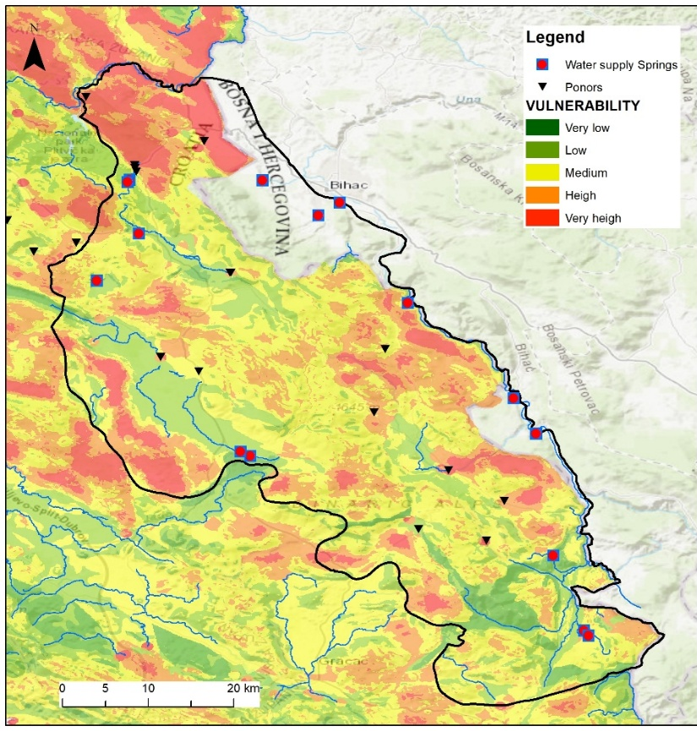
Figure 9 Vulnerability map of grouped groundwater bodies Una (Biondić et al., 2016)
Diffuse agricultural activities were analysed separately using CORINE Land Cover 2006 (CLC, 2006). Polygons representing different types of agricultural land were assigned weights according to their estimated impact, then converted to raster, and used to produce a classified hazard map.
Collected data for pollutants included: airports, highways, state roads, railways, oil pipelines, gas stations, farms, facilities with hazardous substances, industrial and SJO discharges, diffuse urban drainage, recycling yards, asbestos cassettes, landfills, fishponds, major accidents, and quarries and mines.

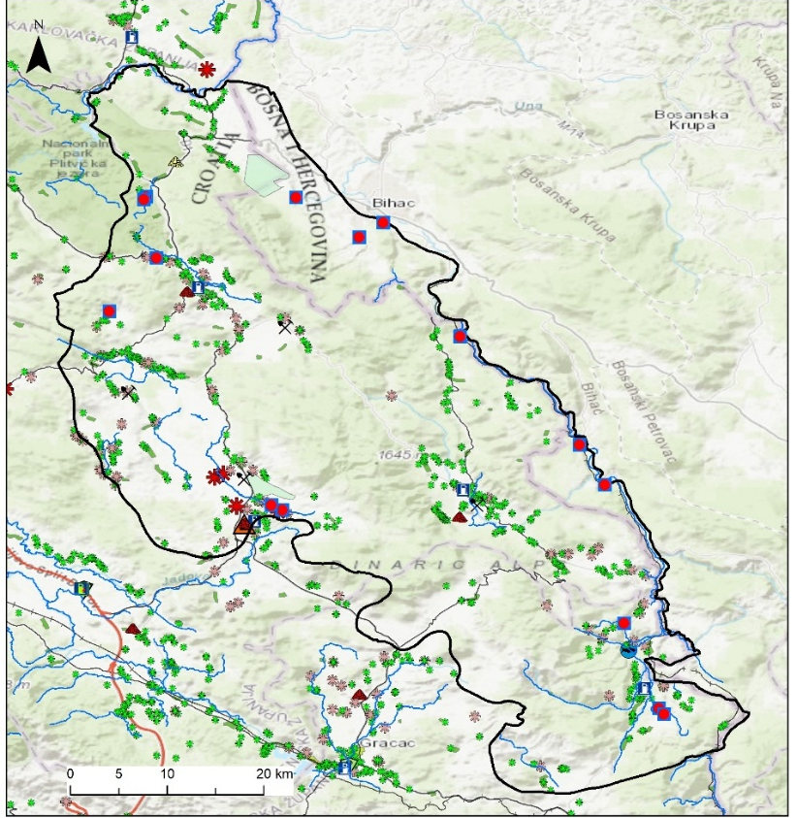
Figure 10 Hazard map of grouped groundwater bodies Una (Biondić, 2016)
Risk
Using a multi-parameter GIS approach, raster layers from natural vulnerability and hazard analyses were combined to produce a groundwater contamination risk map. Risk was assessed only at locations of existing or potential pollutants relative to the natural vulnerability of the terrain. In this context, “risk” represented the potential threat of contamination based on both natural conditions and the type and distribution of pollutants, with probability and impact derived from the hazard analysis.
Risk was quantified as the product of hazard and vulnerability, reflecting both the likelihood of a potentially harmful event (hazard) and the susceptibility of the groundwater system (vulnerability): risk = hazard × vulnerability. Six risk categories were defined: no risk, very low, low, moderate, high, and very high (blue to red in Figure 9.1.3 and 9.1.4).
Most pollutants were classified as low or moderate risk, with only a few locations showing high risk. Many high-risk areas corresponded to wastewater treatment plant (WWTP) discharge points, where weighting values depended on treatment level. Both connected and unconnected discharges were considered, with unconnected ones assigned maximum points, increasing the number of high-risk locations.

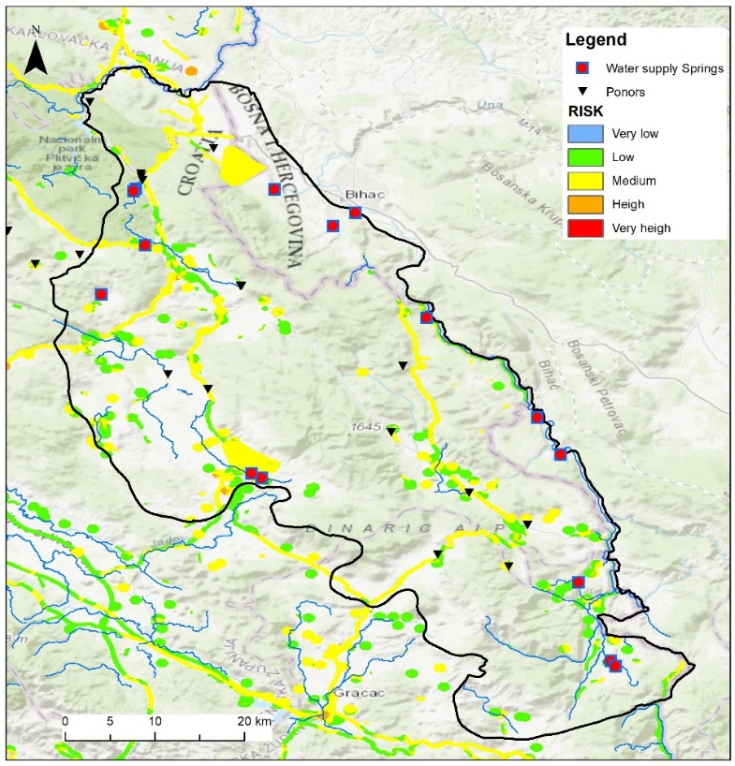
Figure 11 Risk map of grouped groundwater bodies Una (Biondić, 2016): for point and line sources of pollution

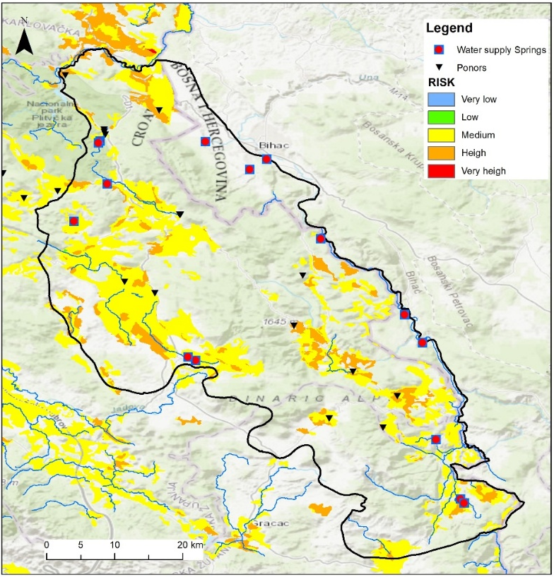
Figure 12 Risk map of grouped groundwater bodies Una (Biondić, 2016): for diffuse sources of pollution (agriculture)
In the referenced analyses and study, some of the most significant pollutants in the Una grouped groundwater bodies were identified. However, the database used for these analyses was compiled for the purposes of the 2nd RBMP and therefore requires updating to reflect current field conditions. This should include potential pollutant sources from the territory of Bosnia and Herzegovina, as well as from the areas of Plitvice Lakes National Park and the Korana groundwater body.
Furthermore, the methodology applied in the development of the 2016 natural vulnerability map relied on available datasets and base maps covering the entire territory of Croatia, rather than on one of the standard karst-specific vulnerability assessment methods (e.g., SINTACS, EPIK, COST 620 or similar). Hence, it is necessary to assess which of these standardized methods could be applied to Una TBA and to produce a new vulnerability map. Following the development of the updated vulnerability map, it will be possible to produce hazard and risk maps based on the updated pollutant database and the more recent CORINE Land Cover data set.

9.2 Guidelines for harmonization of criteria for: delineation and types of measures in sanitary protection zones
In the border area between Bosnia and Herzegovina and Croatia, there are many karst springs that are used in public water supply and have a cross-border character. Therefore, in accordance with national legislation, their protection is necessary through the adoption of a decision on the protection of water sources.
To make this possible, it is necessary to:
- amend the existing laws and by laws regulating this field,
- establish common criteria based on recharge areas of the springs, their protection zones, and the corresponding protection measures and
- define the method for preparing the sanitary protection zone study, as well as the procedure for adopting the decision on the protection of water sources.
The need for establishing groundwater protection of transboundary areas has been recognized for a long time. In 2010, a document entitled: “Proposal of a protection system and research methods for the protection of karst aquifers in the border areas of Bosnia and Herzegovina and Croatia” was prepared by a working group within the framework of the Subcommission for the Adriatic Sea Basin and the Black Sea Basin. Since then, legislative changes have occurred in both the Republic of Croatia and Bosnia and Herzegovina. Joint working group of Bosnia and Herzegovina and the Republic of Croatia was established to update this document, with the task of updating (revising) this document.
The resulting proposal of the joint working group was shown below.
It defines the conditions and methodology for determining sanitary protection zones for karst springs and protection measures, the method for preparing the study of sanitary protection zone, and the procedure for adopting the decision on the protection of water sources. Furthermore, it establishes a framework for protecting karst water sources through the definition of four sanitary protection zones, ranging from the least restrictive (Zone IV) to the most strictly protected (Zone I):
- Limited protection zone – zone IV,
- Restriction and control zone – zone III,
- Strict restriction zone – zone II, and
- Zone of the strictest prohibitions and restrictions – zone I.
Protection zones are determined based on key hydrogeological criteria, including:
- groundwater travel time to the abstraction point,
- apparent groundwater flow velocity, and
- the catchment/recharge area of the spring.
Each zone includes specific restrictions and prohibitions:
- Zone IV (Limited Protection) covers wider catchment areas where water reaches the source in 10–50 days; it prohibits untreated wastewater discharge, hazardous industries, unsafe waste storage, and unprotected infrastructure,
- Zone III (Restriction and Control) applies stricter controls, banning waste disposal sites, recycling facilities without safeguards, mineral exploitation, military zones, and uncontrolled deforestation,
- Zone II (Strict Restriction) protects areas where groundwater reaches the source within 24 hours; it prohibits agriculture (except organic), livestock production beyond household use, urban expansion, roads, petrol stations, industrial development, and any wastewater discharge,
- Zone I (the Strictest Protection) includes the immediate abstraction area and allows only activities directly related to water supply operations; access is restricted to authorized personnel only.
This proposal also introduces micro-zoning, allowing limited exceptions to certain prohibitions only if detailed hydrogeological studies prove no risk to groundwater. Finally, it outlines requirements for preparing a study of sanitary protection zones and the procedure for adopting official cross-border decisions on spring protection, including monitoring, enforcement, and institutional responsibilities.
Regarding Una TBA, all water-supply springs located on the Croatian side (Krbavica, Loškun, Joševica, Kraljevac & Bukovac, Kotilina & Bijeli Klanac) have catchment areas entirely within the territory of the Republic of Croatia. In contrast, the Klokot-Privilica and Ostrovica-Toplica springs are situated in Bosnia and Herzegovina, but most of their recharge areas (approximately 80–90%) extend into Croatian territory.
There are numerous detailed hydrogeological investigations that have been carried out specifically for the purpose of protecting these springs and defining their protection zones. The research began as early as the 1980s, during the former Yugoslavia, focusing on two separate catchment areas. The northern catchment area relates to the protection of the Klokot and Privilica springs, which are used for the water supply of the city of Bihać. The southern catchment area covers the springs Ostrovica and Toplica, which are used for the water supply of Donji Vakuf and were previously also used for supplying Donji Lapac. However, the protection zones were never established.
As part of the Una River Basin development program (Bosnian Swiss Cooperation Program), funding was provided for the hydrogeological studies of the Una River catchment, separately for Klokot- Privilica catchment area and Ostrovica-Toplica (University of Sarajevo Civil Engineering Faculty, 2004). Pursuant to these studies, official decisions were adopted for the protection of both spring catchment areas in 2009.
Technical study on the protection of the Klokot and Privilica springs (IBIS, 2019), was financed by UNDP in 2019 to support the adoption of the: “Decision on the protection of drinking water sources Klokot and Privilica” (Official Gazette of the City of Bihać, 12/2019). At the same time, the World Bank financed the preparation of the study on the establishment of cross-border sanitary protection zones of the Klokot spring (Hollinger, 2020). The objective of this study was to assist the Federation of Bosnia and Herzegovina and the Republic of Croatia in developing a Study on the spring sanitary protection zones, to provide a baseline for: establishing the boundaries of the catchment area, and making recommendations for the protection of the Klokot and Privilica springs.
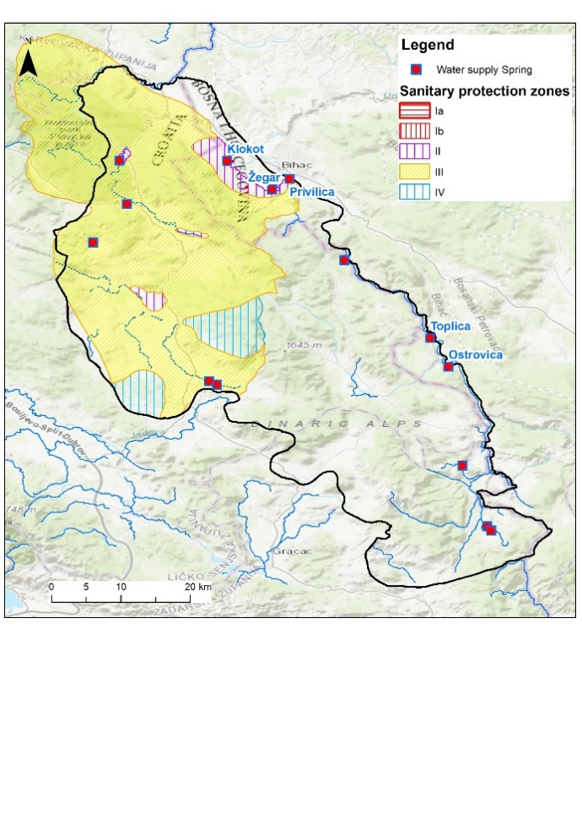
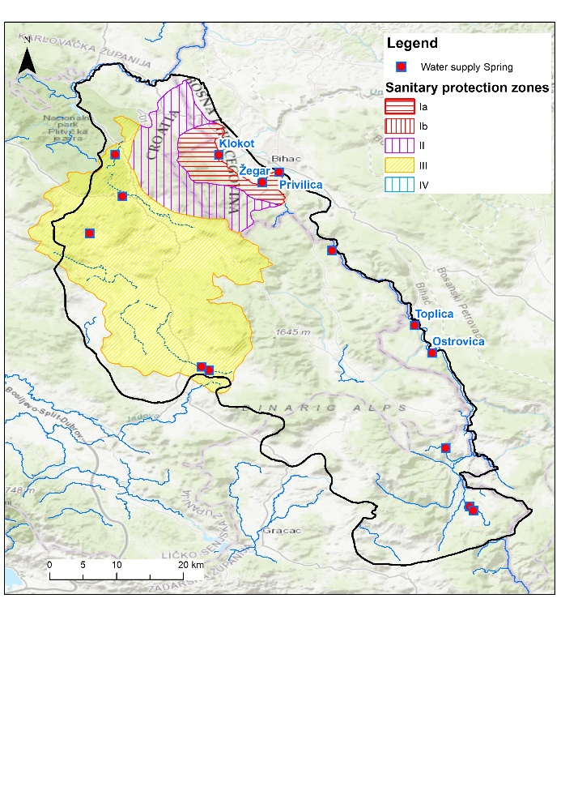
The Decision from 2019 states that the influence area of the Klokot and Privilica springs is a hydrogeological catchment of 686 km², which includes the Koreničko and Krbavsko fields in the Republic of Croatia and the slopes of Plješivica Mountain near the City of Bihać in Bosnia and Herzegovina. In the study financed by the World Bank, the catchment for these springs was defined as approximately 952 km², with 90% in Croatia and 10% in Bosnia and Herzegovina.
Figure 13 Sanitary protection zones for Klokot-Privilica springs: Left: from 2004 Study (University of Sarajevo Civil Engineering Faculty); Right: from 2020 Study (Hollinger, 2020)
Although many studies have defined catchment areas and sanitary protection zones, the legislative framework for cross-border protection is still lacking and should be strengthened. Guidelines need to be developed to support legislative amendments and proposal for a joint Rulebook and accompanying implementation guidance should be conducted. The Rulebook can establish common criteria and methodologies for the delineation of cross-border sanitary protection zones, as well as cost-effective groundwater protection measures.

9.3 Regulation, guidelines and risk-based criteria for subsurface wastewater discharge
Subsurface wastewater discharge requires a carefully structured regulatory approach, particularly in karst environments such as Una TBA, where groundwater moves rapidly and natural filtration is limited. In Croatia, the legal basis for managing this type of discharge is established through the Water Act (Official Gazette No. 66/2019, 84/2021, 47/2023), which fully incorporates the principles of the EU Water Framework Directive and Groundwater Directive. The Act prohibits direct discharge of pollutants into groundwater, while allowing indirect infiltration of treated wastewater only under specific and controlled conditions. These conditions are further elaborated in the Regulation on Emission Limit Values for Wastewater (Official Gazette No. 26/2020), which defines indirect discharge as the infiltration of treated wastewater through natural or engineered subsurface layers. Such discharge is permitted only when alternative solutions would impose disproportionate costs and when a scientifically supported assessment demonstrates that groundwater status will not deteriorate. Although the regulation identifies substances that may not be discharged and requires an impact analysis, further development of technical guidance would support more consistent application, particularly in defining methodological steps for evaluating the suitability of infiltration sites and the protective capacity of the unsaturated zone.
In the Federation of Bosnia and Herzegovina, groundwater protection is regulated primarily through the Water Law of the Federation of BiH (Official Gazette FBiH No. 70/2006, 01/2012, 70/2020), which prohibits activities that may endanger groundwater quality and requires permits for wastewater discharge. However, the legislation does not explicitly define indirect subsurface discharge, nor does it outline conditions under which treated wastewater may be infiltrated into the subsurface. Wastewater management is oriented mainly toward surface‑water receivers, and procedures for assessing the acceptability of subsurface discharge are not specifically developed. Environmental permitting, regulated through the Law on Environmental Protection (Official Gazette FBiH No. 33/2003, 38/2009, 66/2011), requires an evaluation of potential impacts on groundwater, yet the absence of detailed criteria, definitions, and technical guidelines makes it difficult to apply these requirements consistently. Strengthening the regulatory framework by introducing clear definitions, hydrogeological criteria, and technical procedures would significantly improve the ability to assess whether subsurface discharge can be safely implemented.
Monitoring obligations related to groundwater protection in Croatia are defined through the national monitoring system implemented under the River Basin Management Plan, adopted pursuant to the Water Act (Official Gazette No. 66/2019, 84/2021, 47/2023). This system includes the monitoring of chemical and quantitative status of groundwater, but it does not contain specific procedures or methodologies designed to assess the impacts of potential subsurface discharge of treated wastewater. The monitoring framework is not structured around the concept of compliance points in the unsaturated or saturated zone (pursuant to the Guidance on preventing or limiting direct and indirect inputs in the context of the Groundwater directive 2006/118/EC, CIS Guidance document No 17), nor does it include requirements for tracking the behaviour of infiltrated water. In the Federation of Bosnia and Herzegovina, groundwater monitoring is regulated through the Water Law of the Federation of BiH (Official Gazette FBiH No. 70/2006, 01/2012, 70/2020), but the monitoring system remains general in scope and is not specifically oriented toward assessing the impacts of subsurface discharge of treated wastewater. Monitoring is fragmented, with limited coverage in karst areas and without methodological components that would allow for tracking the behaviour of infiltrated water, including contaminant transport. The system does not include defined compliance locations or requirements for modelling the movement of potential pollutants. In this regard, upgrading the existing regulatory framework, relevant for Una TBA, by developing monitoring framework pursuant to the CIS Guidance document No 17, such as targeted observation (compliance) points near potential infiltration areas and parameters relevant for risk assessment, would strengthen the capacity to evaluate the feasibility and safety of subsurface discharge in the whole area of Una TBA.
Permitting and enforcement procedures also play a central role in ensuring that subsurface wastewater discharge does not compromise groundwater resources. In Croatia, permits for indirect discharge are issued under the Water Act (Official Gazette No. 66/2019, 84/2021, 47/2023) and require a detailed assessment demonstrating that groundwater status will not deteriorate. Enforcement mechanisms, carried out by water inspectors, allow authorities to intervene if monitoring results indicate risks. Further refinement of technical criteria would support more uniform decision‑making. In the Federation of Bosnia and Herzegovina, permitting procedures under the Water Law (Official Gazette FBiH No. 70/2006, 01/2012, 70/2020) and the Law on Environmental Protection (Official Gazette FBiH No. 33/2003, 38/2009, 66/2011) do not explicitly address subsurface discharge, and enforcement relies on general provisions for groundwater protection. Developing dedicated procedures relevant for Una TBA, supported by clear technical requirements and hydrogeological assessments, would strengthen the ability to evaluate applications and ensure that protective measures are implemented effectively.
Given the hydrogeological sensitivity of Una TBA, there is clear need in further strengthening the regulatory instruments that govern subsurface wastewater discharge. Enhancing the existing framework by developing procedures that explicitly account for the characteristics of karst systems, such as rapid groundwater flow, limited natural attenuation, and high vulnerability, would create a more robust foundation for determining when and under what conditions subsurface discharge may be safely considered within Una TBA. Building on these needs, the text that follows provides a structured approach for evaluating whether subsurface discharge of treated wastewater may be safely considered within Una TBA.
In karst environments, such as those that dominate the Una basin, the feasibility of subsurface discharge depends strongly on the hydrogeological setting. Shallow infiltration systems, such as infiltration basins, trenches, or galleries, represent the only technically realistic option for introducing treated wastewater into the subsurface, as they rely on percolation through the soil and the unsaturated zone rather than direct injection into highly permeable karst. Where sufficiently thick and heterogeneous vadose zones exist, these systems can support additional natural attenuation processes, including filtration, sorption, biodegradation, and pathogen reduction. However, in many parts of Una TBA, the unsaturated zone is thin, discontinuous, or bypassed by rapid preferential flow, which significantly limits the protective capacity of the subsurface. For this reason, any consideration of subsurface discharge must begin with a detailed understanding of local karst features, the depth and structure of the unsaturated zone, and the likelihood of rapid transport pathways.
A robust conceptual hydrogeological model is therefore essential for assessing the suitability of any potential infiltration site. Conceptual models provide the framework for understanding groundwater flow, recharge mechanisms, and the interaction between the unsaturated and saturated zones. In the context of Una TBA, such models must explicitly account for the characteristics of karst aquifers, including the presence of conduits, epikarst, concentrated recharge zones, and highly variable hydraulic conductivities. Key elements of a conceptual model that support decision-making on subsurface discharge include:
- characterisation of the unsaturated zone, including its thickness, lithology, permeability, and capacity for natural attenuation,
- identification of preferential flow paths, such as sinkholes, swallow holes, and fracture networks that may rapidly transmit infiltrated water,
- delineation of groundwater flow directions and velocities, with particular attention to springs, drinking-water sources, and environmentally sensitive areas,
- assessment of existing pressures and background groundwater quality, ensuring that any additional load does not compromise good status,
- evaluation of potential interactions with surface water, given the strong hydraulic connectivity typical of karst systems.
Such conceptual models should be developed using all available data from both countries, harmonised through the institutional cooperation mechanisms defined for Una TBA. Joint interpretation of geological, hydrological, and monitoring information is essential to ensure that both sides of the border share a consistent understanding of risks and system behaviour.
Monitoring of potential impacts on human health and the environment must be designed to reflect the specific vulnerabilities of the Una karst system. Natural attenuation processes in karst are often limited, and travel times from infiltration points to springs or wells may be extremely short. Monitoring must therefore be capable of detecting changes in groundwater quality early enough to allow corrective action. A monitoring framework adapted to Una TBA should include targeted compliance points located downgradient of potential infiltration areas, ideally in zones where flow converges toward major springs or abstraction wells. Parameters should include microbiological indicators, nutrients, organic matter, persistent organic pollutants, and emerging contaminants relevant to treated wastewater. Given the rapid flow dynamics in karst, high-frequency monitoring or event-based sampling may be required during periods of high recharge.
Institutionally, monitoring should be embedded within a joint groundwater monitoring system, coordinated by the relevant water agencies of Croatia and the Federation of Bosnia and Herzegovina. Responsibilities should include:
- joint planning of monitoring locations to ensure coverage of transboundary flow paths;
- harmonised sampling and analytical protocols to ensure comparability of results;
- shared data management and reporting through a common information platform;
- mechanisms for early warning and coordinated response if monitoring indicates deterioration of groundwater quality.
Such an institutional framework would significantly strengthen the capacity of both countries to evaluate and manage risks associated with subsurface discharge.
A risk-based approach to subsurface discharge, aligned with the planning and operational principles of managed aquifer recharge (MAR) systems, provides a structured pathway for decision-making. The approach illustrated in Figure 9.3.1 can be adapted for Una TBA and organised into several key phases:
Phase I. (Planning)
1. Preliminary assessment and site screening. This phase involves identifying potential infiltration locations and evaluating their basic suitability based on geological, hydrogeological, and environmental criteria. Areas with thin or absent unsaturated zones, direct karst features, or proximity to drinking-water sources should be excluded at this stage.
2. Development of a conceptual model and risk identification. A detailed conceptual model is prepared to identify potential hazards, exposure pathways, and receptors. Risks to human health, groundwater status, and dependent ecosystems are characterised, considering the specific behaviour of karst aquifers.
Phase II. (Design)
3. Detailed investigation and design. Hydrogeological testing, infiltration trials, and modelling are conducted to quantify infiltration capacity, travel times, and natural attenuation (SAT) processes. Engineering design of infiltration structures is developed to minimise clogging, ensure operational reliability, and maintain adequate residence time in the subsurface.
4. Risk evaluation and decision-making. Risks are evaluated against regulatory requirements and acceptable reference values/thresholds. If risks cannot be mitigated to an acceptable level, the project should not proceed. If risks are manageable, conditions for permitting are defined, including operational limits and monitoring obligations.
Phase III. (Operation)
5. Implementation, monitoring, and adaptive management. During operation, continuous monitoring is carried out at compliance points. Results are regularly reviewed, and operational adjustments are made as needed. If monitoring indicates unacceptable impacts, infiltration must be reduced or suspended.
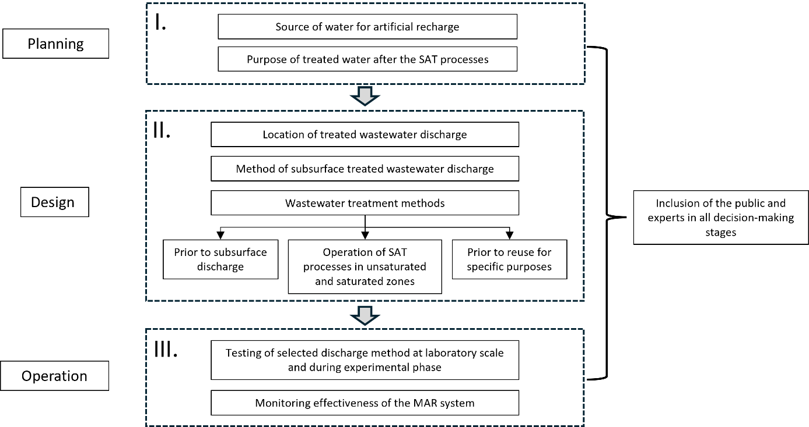
Figure 14 Risk based approach for planning, design, and operation of MAR systems with treated wastewater in Una TBA (modified according to Yuan et al., 2016)
There is the need for a cautious, evidence-based approach to subsurface discharge of treated wastewater in Una TBA. The key elements include a thorough understanding of karst hydrogeology through conceptual modelling, a monitoring framework tailored to rapid groundwater flow and high vulnerability, and a structured risk-based process that guides decisions from initial screening to long-term operation. Together, these components provide a practical and scientifically grounded basis for determining whether subsurface discharge can be safely considered in this sensitive transboundary aquifer.
It is worth mentioning that Croatia has recently initiated drafting of technical document elaborating criteria for indirect discharges into groundwater. This draft document stipulates that individual wastewater systems with a load of up to 50 PE are to be applied where connection to the public sewerage system or the use of a septic tank does not represent a feasible and optimal solution aligned with the user’s capabilities, or as a temporary solution until a public wastewater collection and disposal system is established. In areas where a centralized sewerage system is not applied, it is anticipated that individual wastewater solutions be defined considering the treatment capacity of relevant agglomerations. Furthermore, potential natural receiving bodies is to be assessed and specific water bodies under pressure identified, while treatment requirements for small-scale systems is dependent on location, agglomeration size, and environmental conditions and based on a comprehensive cost analysis to ensure long-term sustainability. It is planned that individual systems up to 50 PE do not require separate impact assessments for indirect groundwater discharges, and wastewater management is to be defined through an adequate feasibility study.

9.4 Prevention and control of point and non-point pollution affecting groundwater quality
Both management plans (the 3rd RBMP of Croatia and the 2nd Sava RBMP in the FBiH) contain lists of measures in accordance with the WFD: basic, additional, and supplementary measures. However, the Croatian RBMP elaborates these measures in much greater details, so the measures for controlling point and non-point (linear and diffuse) pollution were adopted from it and modified accordingly. In this subchapter, only measures related to pollution sources affecting groundwater quality are presented, while measures addressing pressures from groundwater abstraction that affect groundwater quantity are discussed in the following subchapter.
Control measures for point sources of pollution
Point-source pollution control measures aim to prevent or reduce the direct discharge of contaminants from identifiable sources such as industrial facilities, wastewater treatment plants, and others into groundwater systems.
Basic measures for controlling and reducing water pollution from point sources are prescribed in the water act, based on the principles of: pollution prevention at the source; combined approach, and polluter pays principle. Discharge of pollutants from point sources is controlled through the issuance of water permits or within environmental permits, which set conditions for wastewater discharge (permitted quantities, emission limit values, monitoring and reporting obligations, and other requirements and potential exemptions). These obligations apply to all municipal, industrial, and other wastewater discharges for which emission limit values are prescribed. Limit values are set for individual pollutants or groups of pollutants.
The basic instruments of water management are water permits/concessions (environmental permits) issued for the purpose of achieving established objectives: ensuring the required quantities of water of appropriate quality for various economic and personal needs and fulfilling water protection objectives. Accordingly, one of the primary measures is the revision and alignment of water permits for wastewater discharge with the requirements of the RBMP. This measure is further supported and complemented by the completion of the regulatory framework, including the establishment and control of individual wastewater systems, as well as continuous education and capacity building at all levels of the management and control system. Capacity building should also include institutions responsible for issuing water permits to ensure more effective preparation, implementation, and enforcement of projects and regulatory requirements.
Other measures include improving the monitoring of pressures on water bodies and intensifying activities to ensure compliance with discharge standards, particularly for municipal wastewater treatment projects in agglomerations larger than 2,000 population equivalent (PE) and for industrial wastewater discharges. The programme for controlling point sources of municipal wastewater comprises the construction and expansion of municipal wastewater collection systems, as well as the construction and upgrading of treatment facilities for all agglomerations exceeding 2,000 PE. Priority is given to agglomerations larger than 15,000 PE.

Table 26 List of basic measures for point sources of pollution
Measure | Responsible institution
Revision and alignment of water permit with the RBMP | Croatian Waters / Ministry
Improving monitoring of pressures | Croatian Waters / Ministry
Development of the Water Information System - Water Protection Register (load from municipal wastewater, industrial wastewater, etc.) | Croatian Waters / Ministry
Investments in public wastewater collection and treatment systems | Relevant Water Utilities / Competent Authorities
Completion of the Guidelines for discharge into groundwater | Croatian Waters / Ministry

Control measures for non-point sources of pollution
Non-point source of pollution refers to mainly diffuse contamination that does not originate from a single identifiable discharge point but results from land-based activities such as agricultural practices, waste disposal, and inadequately managed wastewater discharges. It is primarily generated through surface runoff, infiltration, and leaching processes that transport pollutants into soil and groundwater bodies. Common contaminants include nutrients from fertilizers, pesticides, untreated or inadequately treated wastewater, hydrocarbons, heavy metals, and other hazardous substances.
The basic measures for the control and reduction of non-point source pollution originating from agricultural production are focused on nutrient pollution, particularly nitrates. Croatian Ministry of Agriculture adopted the 3rd Action Programme for the protection of waters against pollution caused by nitrates from agricultural sources, which prescribes the measures to be implemented in designated nitrate vulnerable areas, in accordance with the requirements of the Nitrates Directive and in support of the objectives of the WFD. In the FBiH, similar measures are still being aligned with EU requirements, and a fully operational system of nitrate vulnerable zones and action programmes has not yet been fully implemented.
The control and reduction of non-point source pollution from waste disposal sites in the Republic of Croatia are governed by waste management legislation, in particular the Waste Management Act and the Waste Management Strategy of the Republic of Croatia (Official Gazette No. 130/05), which prescribe the remediation and closure of existing landfills. Within the framework of the 2nd RBMP and hazard analysis for Una TBA, three active waste disposal sites were identified in Croatia: Bare, Čojluk and Kalebovac, while the landfill Prijeboj has been closed and remediated. At the time of preparation of the plan, all three active sites were in the process of remediation. Regarding the situation in the FBiH, the waste management system is still in the process of alignment with EU standards. There is no comprehensive and publicly accessible registry of waste disposal sites, and a significant number of illegal dumpsites still exist, while remediation and systematic monitoring remain limited compared to EU requirements.
Control and reduction of non-point source pollution from individual wastewater disposal systems have been strengthened through amendments to the Water Act (Official Gazette No. 46/18). The Amendments established the foundations for a comprehensive regulatory framework for individual wastewater systems:
- The term “individual wastewater system” has been defined;
- Through the decision on wastewater disposal regulating wastewater management within a specific agglomeration, their application is defined in more detail;
- It is stipulated that the public water service provider shall supervise the installation of individual systems for which, under special regulations, a building permit is not required;
- Supervision over the maintenance of individual wastewater systems is prescribed;
- It is determined that the contents of septic tanks and sludge from individual systems up to 50 population equivalents (PE) may be emptied by the public water service provider or a concessionaire.
The lack of a detailed legal framework for individual wastewater systems made it difficult to assess compliance with the Urban Wastewater Treatment Directive, as the adequacy of treatment provided by these systems could not be properly evaluated. Clear criteria and guidelines are needed to define acceptable technological solutions, financing mechanisms, and operational requirements. Establishing a system for registration and monitoring by water service providers would improve data availability and enable better assessment of system performance and compliance.
Table 27 List of basic measures for non-point sources of pollution
Measure | Responsible institution
Implementation of measures prescribed by the Waste Management Plan | Ministry
Development and continuation of the registry system for issued water permits for placing mineral fertilizers and plant protection products on the market | Ministry
Implementation of measures from the Action Plan in vulnerable areas | Ministry/Croatian Waters
Revision of vulnerable areas | Ministry
Proposal of mechanisms to incentivize implementation of Action Programme measures outside designated vulnerable areas | Ministry
Proposal of mechanisms to incentivize implementation of Action Programme measures outside designated vulnerable areas | Ministry
Establishment of a register of septic tanks and cesspools and their users; development of an effective supervision model to detect leakage and ensure proper emptying and wastewater disposal | Public Water Service Providers
Intensified supervision of good agricultural practice, especially regarding reduction of mineral and organic fertilizer use | Ministry
Promotion of rational fertilizer use in agriculture based on mandatory soil analysis | Ministry
Regulation of monitoring measures for pesticide consumption in forestry | Ministry
Development of a methodology for estimating water emissions from non-remediated landfills | Croatian Waters
Promotion of green infrastructure to address surface runoff from urban areas | Croatian Waters

In the Federation of Bosnia and Herzegovina, individual wastewater systems are recognized and partially regulated under general water and communal legislation, but they lack a comprehensive and fully operational regulatory framework with clearly defined technical standards, monitoring, and control mechanisms comparable to EU requirements.
In view of the above, measures to reduce water pollution from non-point sources will be established, primarily in the sectors of agriculture and waste management, including measures to control pollution from individual wastewater disposal systems, which have been identified as one of the main contributors to non-point source water pollution.

9.5 Prevention and control of groundwater abstraction affecting groundwater quantity
Prevention and control of groundwater abstraction aim to ensure the sustainable use of groundwater resources and to maintain a balanced water regime. Effective management focuses on regulating abstraction within sustainable limits and monitoring its impacts on groundwater systems.
In Croatia, the legal framework clearly defines the system for issuing water permits and concessions for water use, including obligations for their revision and alignment with RBMPs, as described in the previous chapter. Although legislation requires all water users to report abstracted and used water quantities, implementation is not uniform across all categories of use. A similar situation exists in the Federation of Bosnia and Herzegovina regarding water use permitting and quantity reporting obligations. In Croatia, automated monitoring of abstraction volumes for abstractions used for public water supply has recently been established as one of the nationally implemented measures. Accordingly, a database on abstracted quantities for public water supply exists.
However, monitoring of abstracted quantities for other users (technological water use and irrigation) is not well established. These users are legally required to report abstracted quantities on a monthly, quarterly, or annual basis. Although RBMPs envisaged the implementation of metering for all water uses, this requirement has not been fully implemented in practice. This significantly complicates the quantification of pressures in the assessment of the quantitative status of groundwater bodies.
Below, the water abstraction control measures established in the 3rd RBMP of Croatia are briefly outlined, since comparable measures are not addressed in the 2nd Sava RBMP of FBiH.
Croatian water abstraction control measures include:
- Strengthening control and monitoring of water abstraction and its impact on water bodies,
- Introducing mandatory cumulative impact assessments at early planning and project stages,
- Developing methodologies and criteria to assess abstraction impacts on hydrological parameters and ecological status,
- Promoting incentives to reduce water losses and improve efficient water use,
- Investing in water supply infrastructure to ensure compliance with drinking water standards and increase public connectivity,
- Promoting public irrigation systems as an alternative to inefficient individual abstractions.
Table 28 List of basic measures for control of groundwater abstraction
Measure | Responsible institution
Improvement of the Water Information System regarding abstraction monitoring | Croatian Waters / Ministry
Implementation of mandatory water metering for all types of water abstraction and use (by revising Water Permits for all users)
Monitoring and analysis of abstracted quantities and assessment of impacts on the quantitative status of groundwater bodies | Croatian Waters / Ministry
Application of temporary criteria (groundwater levels and renewable reserves) for reviewing and restricting abstraction rights | Croatian Waters / Ministry
Temporary reduction or suspension of abstraction rights in groundwater bodies failing or at risk of failing quantitative environmental objectives | Croatian Waters / Ministry
Implementation of a water use rationalization programme, including reduction of losses in supply networks and promotion of water-efficient technologies (irrigation, industry, energy production) | Water Service Providers / Croatian Waters / Ministry
Preparation of expert assessments of cumulative impacts of planned abstractions, particularly in areas with poor quantitative status or significant environmental pressures | Croatian Waters / Ministry
Requirement for new projects to incorporate water-efficient technologies and ensure environmentally acceptable flow at the design stage | Competent Authorities / Croatian Waters / Ministry

It is necessary to establish systematic measurement of the discharge of all major karst springs (including both overflow and abstraction volumes) and to ensure continuous monitoring of groundwater levels in representative piezometers, where feasible.

9.6 Guidelines for risk assessment and risk management of catchment areas for abstraction points used for human consumption
The methodology for conducting risk assessment and risk management of catchment areas for abstraction points used for human consumption in Una TBA, jointly shared by Croatia and the Federation of Bosnia and Herzegovina, must ensure a comprehensive, coordinated, systematic and documented approach. This approach is to be fully aligned with Directive (EU) 2020/2184, particularly Articles 7-9 and Annex II, while also reflecting the specific requirements, institutional arrangements and data‑sharing needs inherent to transboundary catchments. The methodology must therefore integrate delineation and characterisation of the transboundary catchment area, identification of hazards across both jurisdictions, harmonised monitoring requirements, joint risk evaluation, transparent reporting and bilateral data management, and the definition and implementation of coordinated risk management measures.
Risk assessment begins with the spatial delineation and detailed characterisation of the catchment area of each abstraction point, considering the hydrological and hydrogeological realities of a shared water body. In line with Annex II, point 1 of Directive (EU) 2020/2184, georeferenced cartographic representations must be prepared at an appropriate scale to capture the full transboundary extent of the surface and groundwater systems that contribute to the abstraction source. This process must incorporate all sanitary protection zones designated under national provisions in both countries and must integrate georeferenced abstraction data managed under restricted‐access regimes in accordance with national legal requirements. The characterisation of Una TBA area must further include land‑use patterns, surface runoff and flooding dynamics, groundwater recharge conditions, and transboundary hydrogeological connections between the water bodies supplying the abstraction points in Croatia and FBiH. An integrated and jointly coordinated risk assessment must be undertaken to ensure consistency, efficiency and the coherent interpretation of hydrological and regulatory information across the two jurisdictions.
Hazard identification must be based on a systematic, shared and mutually recognised analysis of all potential hazards and hazardous events that could adversely affect raw water quality to a degree that poses a risk to human health, as required by Article 8 and Annex II, point 1(c) of Directive (EU) 2020/2184. This analysis must consider pressures originating from both territories, including agricultural practices, industrial installations, wastewater discharges, landfills, contaminated sites, transport corridors, accidental pollution events, and natural hazards such as floods, droughts or landslides. Data on human activities and pressures collected under national water legislation must be exchanged and used bilaterally to provide a harmonised basis for hazard identification. Attention should be given to upstream-downstream relationships, and to pressures located in one country that may affect abstraction points located in the other.
Monitoring obligations within Una TBA shall be established in accordance with Article 9 of Directive (EU) 2020/2184, with a focus on microbiological and chemical parameters required under drinking water legislation, priority and specific pollutants, river basin-specific pollutants, naturally occurring substances that may pose risks, and substances included in the watch‑list framework. Parameter selection must be informed by the jointly identified hazards and by monitoring data available from water suppliers and public health institutions in both countries. Monitoring activities not covered by existing programmes may be incorporated into the monitoring plan pursuant to Article 50. Institutions responsible for monitoring in HR and FBiH must establish operational coordination mechanisms to ensure comparability of methods, consistency of sampling strategies and mutual exchange of results.
Risk evaluation for Una TBA shall be conducted jointly or in a mutually coordinated manner, based on the spatial analysis, identified hazards and monitoring results, in accordance with Annex II, point 3 of Directive (EU) 2020/2184. The evaluation must assess the likelihood of hazardous events, potential impacts on drinking water quality in both countries, the vulnerability of abstraction sources, and the adequacy of existing control measures. Comprehensive “Report on the results of the Risk Assessment” must be prepared based on relevant inputs from authorities and institutions in HR and FBiH, where transboundary interactions are identified. The Report must be submitted to the competent ministry, public health authorities, the national public health institute, the inspectorate and the relevant water supplier. Monitoring results must be accessible to water suppliers in both countries where transboundary influences exist, ensuring transparency and operational applicability.
To support traceability, long‑term planning and compliance with Article 18 of Directive (EU) 2020/2184, an electronic dataset must be maintained containing all relevant information on catchment delineation, monitoring results, implemented risk management measures and data related to access to drinking water. This dataset must be updated every six years. For Una TBA, mechanisms must be established to ensure bilateral exchange of relevant data, harmonisation of datasets where needed and consistent interpretation of transboundary pressures and measures.
Where the risk assessment identifies risks to water intended for human consumption, appropriate preventive and mitigation measures must be defined and implemented in accordance with Article 8 of Directive (EU) 2020/2184 and Article 100.c of national legislation. In the transboundary context of Una TBA, such measures may include preventive actions incorporated into national River Basin Management Plans, joint or coordinated interventions to reduce pressures originating on either side of the border, and the reassessment or adjustment of sanitary protection zones where scientific evidence indicates transboundary impacts. Responsibilities for implementation may be assigned to polluters, water suppliers or other relevant stakeholders through water law instruments and permitting procedures, and implementation arrangements should include provisions for cross‑border notification and communication.
Risk management measures must be reviewed at least every six years and updated where necessary, ensuring alignment with the revised risk assessment and the planning cycles in both countries. Continuous improvement of source protection, proactive prevention of new risks, and the systematic incorporation of updated scientific, hydrological and monitoring knowledge must steer the periodic review and adjustment of all measures. Given the shared nature of Una TBA, the review process must also include mechanisms for bilateral consultation, coordination and information exchange to ensure that measures taken in one country remain consistent with and supportive of objectives in the other.

9.7 Early warning and emergency response
Early warning and emergency response (EWER) represents an integrated preventive management mechanism designed to detect risks to groundwater resources at an early stage and to enable timely intervention before significant environmental or public health impacts occur. In transboundary aquifer (TBA) systems, where groundwater resources are shared between two or more countries, EWER plays a critical role in strengthening cooperation, transparency, and coordinated risk management. Its implementation is consistent with risk-based water management principles promoted under the framework of the WFD and supported through transboundary cooperation mechanisms under the United Nations Economic Commission for Europe.
An effective EWER system is built upon continuous monitoring, predefined thresholds, clear communication channels, and established emergency response procedures. In practice, it integrates both water quality and water quantity monitoring to detect deviations from normal hydrogeological conditions. The system relies on observation networks that include monitoring wells, automatic sensors, and strategically selected control points near abstraction zones and potential pollution sources. Key monitored parameters typically include nitrates, pesticides, heavy metals, electrical conductivity, temperature, and groundwater levels. Continuous data collection enables the identification of trends, anomalies, and sudden changes that may indicate contamination events, overexploitation, or hydro-climatic stress.
Trigger Mechanism and Response Protocol
A central component of EWER is the establishment of scientifically defined threshold values that determine when an alert is activated. Thresholds generally include:
- Normal variability range,
- Alert level (increased risk),
- Emergency level (immediate intervention required).
When monitoring data exceed predefined thresholds, automatic notification mechanisms should be activated, followed by field verification and risk assessment. Emergency response measures may include temporary shutdown of abstraction wells, containment or remediation of contamination sources, activation of alternative water supply systems, and targeted hydrogeological investigations. In transboundary settings, rapid information exchange between competent authorities is essential to ensure coordinated action and to prevent cross-border impacts.
Application Beyond Pollution Control
Although EWER systems are commonly associated with early detection of groundwater contamination, their scope should extend beyond pollution events. Modern groundwater management requires the inclusion of hydro-climatic extremes within the early warning framework.
Drought monitoring is an essential component, particularly in regions where groundwater constitutes the primary drinking water source. Early warning indicators for drought may include long-term declines in groundwater levels, reduced recharge rates, and decreasing spring discharge. When critical thresholds are reached, response actions can involve water use restrictions, prioritization of drinking water supply, and demand management measures.
Flood-related risks also need to be considered, as extreme precipitation and flooding may lead to rapid rises in groundwater levels, increased hydraulic pressure, and enhanced vulnerability to contamination through surface infiltration. In such cases, preventive actions may include temporary closure of vulnerable wells and intensified monitoring of water quality.
Table 29 Operational components of an EWER system in transboundary aquifer management
Component | Purpose | Key parameters / Actions | Responsible institution
Monitoring Network | Continuous data collection | Groundwater level, nitrates, pesticides, conductivity, temperature | National monitoring agencies
Threshold System | Risk detection | Alert & emergency levels based on hydrogeological baseline | Joint technical working group
Data Exchange | Cross-border transparency | Real-time / periodic data sharing | Designated national contact points
Early Warning | Detection of anomalies | Automatic alerts when thresholds exceeded | Monitoring authority + joint coordination
Emergency Response | Impact mitigation | Well closure, source control, alternative supply activation | Competent authorities of affected states
Drought Monitoring | Quantity risk management | Level decline trends, recharge deficit | Hydro-meteorological + water agencies
Flood Risk Monitoring | Contamination prevention | Rapid level rise, infiltration risk | National + transboundary coordination

9.8 Land use planning instruments for groundwater vulnerability mitigation
Land-use planning is preventive tool for mitigating groundwater vulnerability. By integrating protection zones and restrictions directly into spatial planning frameworks, FBiH and HR can prevent high-risk activities in Una TBA and ensure long-term sustainability of drinking water sources. European practice shows that zoning, agricultural regulation, and environmental impact assessments are powerful tools that can be adapted to transboundary context.
In both, Croatia and FBIH, sanitary protection zones are legally required to be integrated into spatial plans. However, delays in updating spatial plans, inconsistent enforcement of zoning restrictions and gaps in vulnerability mapping persist.
Key spatial planning instruments
- Zoning and regulatory measures
The essential preventive mechanism for protecting aquifer contamination lies in zoning and regulation. Zoning provides the spatial framework, while regulatory measures give it operational and legal force. Together, they form a layered system of groundwater protection. Land use planning encompasses both: it is the overall process of integrating spatial zoning and regulatory frameworks into a coherent plan for how land should be used, developed, or restricted.
Areas identified as highly vulnerable, such as recharge zones or aquifers supplying drinking water (karst sinkholes and springs), should be designated as protection zones. Within these zones, industrial development, intensive agriculture, and urban expansion should be strictly limited or prohibited. In karst aquifers, sinkholes are recognized as critical recharge points, therefore, strict protection zones around sinkholes and springs should be designated. Building on these measures, it is essential to establish multi-tiered protection zones around drinking water sources. This layered approach ensures that restrictions are applied with varying intensity depending on proximity to the source.
- Integration into spatial plans as a key measure for aquifer protection
Integrating aquifer protection zones into relevant spatial plans is powerful instrument available for safeguarding groundwater resources. When such measure is legally binding and consistently applied, it ensures that land use decisions are directly aligned with the long-term protection of aquifers. This approach demonstrates how spatial planning can serve as a robust legal and operational framework for water security. Embedding aquifer protection zones into spatial plans transforms groundwater protection from a technical recommendation into a binding legal requirement, ensuring that aquifers are shielded from harmful land use practices and that water security is integrated into broader territorial development strategies.
To strengthen this instrument, the following practical measures can be applied:
- Mandatory harmonization: administrative units (also in neighbouring countries) sharing an aquifer should adopt identical maps and restrictions, ensuring that protective measures are consistent across administrative boundaries and preventing regulatory gaps.
- Regular updates: protection zones must be revised periodically to incorporate new hydrogeological data and reflect changes in aquifer vulnerability. Any revision of groundwater protection zones must be accompanied by a corresponding amendment of spatial plans, ensuring that updated delineations and restrictions are legally binding and fully integrated into land‑use regulation.
- Cross sector coordination: protection zones should be aligned with other spatial planning instruments, such as flood risk maps, biodiversity corridors, or agricultural zoning. This avoids overlaps and contradictions while creating synergies between different sustainability goals.

- Environmental impact assessment
All infrastructure projects located within groundwater protection zones within transboundary aquifers, must undergo a detailed hydrogeological assessment, as part of the Environmental Impact Assessment (EIA). Construction permits shall only be issued if the assessment confirms that aquifer vulnerability will not be compromised. The importance of this measure lies in its ability to make aquifer protection scientifically grounded and legally enforceable. By embedding hydrogeological assessments into the EIA process, groundwater vulnerability is systematically considered alongside other environmental factors. For shared aquifers, neighbouring administrative units should ensure that projects carried out in one country do not undermine protection efforts in the other.
- Regulation of agriculture
In Una TBA, agriculture is potential source of contamination. Therefore, regulatory measures should be introduced to ensure sustainable practices. It should be mandatory to promote low‑input farming systems that minimize the use of fertilizers and pesticides, thereby reducing the risk of leaching into aquifers. Furthermore, agroforestry and vegetative cover should be encouraged as binding measures within agricultural zones, since they stabilize soils and act as natural filters, slowing infiltration and trapping pollutants before they reach groundwater. These regulatory instruments align agricultural productivity with environmental protection and provide a clear framework for safeguarding groundwater resources.
- Combining engineered and nature-based solutions
Nature-based solutions, including wetlands and forest belts, could serve as biological filters that improve water quality and reduce vulnerability. Monitoring systems should be mandatory, and regulatory oversight must ensure sustainability and protect water quality. At the same time, upgrading sewage and drainage systems is essential to prevent leakage and infiltration of contaminated water. By combining engineered and natural approaches, land use planning can strengthen aquifer resilience.

10. Development of multi-purpose monitoring networks of surface water, groundwater and groundwater-dependent ecosystems

10.1 Context and objectives of multi-purpose monitoring networks
In the context of management of river basins, all countries involved in the DIKTAS II project have obligation to align their methodological approach with the requirements of the EU Water Framework Directive (WFD) its daughter directives and CIS guidance. This primarily pertains to establishing all types of monitoring necessary for the development of River Basin Management Plans (RBMP).
The EU WFD and its daughter directives inadequately define the criteria for establishing monitoring in karst regions. Karst terrains are characterized by the high permeability of fractured and karstified carbonate rocks, allowing for fast infiltration of precipitation, which results in a strong dominance of underground flow in karst areas. Consequently, there is a lack of a developed surface water network and, unlike other aquifers, developed ecosystems in groundwater. Furthermore, due to the relief of the terrain, often the same water appears multiple times during its flow towards the erosion base, first as groundwater and then as surface water.
The greatest water quality issues in karst areas are turbidity and microbiological contamination. According to the requirements of the WFD, biological monitoring of groundwater is not foreseen and is generally not carried out in the catchment areas of major springs. Water from karst aquifers is globally utilized as a quality and reliable source of drinking water. The discharge of larger springs is mostly monitored, but variations in groundwater levels during different hydrological periods are very rarely measured, which is a problem in groundwater balancing under varying hydrological conditions and optimal utilization of groundwater for various purposes.
Considering the afore mentioned and the fact that each country has its own approach to establishing monitoring, it is essential to define a common approach to the fundamental principles before establishing joint monitoring in the UNA TBA:
- define the criteria that a representative monitoring station must meet to be included in the quantitative and qualitative monitoring of groundwater and surface water,
- define the method and frequency of sampling,
- define the sampling procedure from wells and springs for biological monitoring needs,
- jointly determine the locations of monitoring stations,
- jointly establish monitoring stations for stable isotopes,
- harmonize analytical methods for determining individual parameters,
- harmonize databases and the method of data exchange.
The primary goals of multi-purpose monitoring are:
- to create a basis for the optimal utilization and protection of groundwater and surface waters in Una TBA.
- to enable monitoring of the quantitative and qualitative status of groundwater at the borders of the countries sharing Una TBA.

10.2 Legal and policy background
The legal and policy basis for establishing a multi‑purpose monitoring network in Una TBA derives from a combination of international conventions, EU directives and national legislation that govern how Croatia and Bosnia and Herzegovina (BiH) monitor surface water, groundwater and groundwater‑dependent ecosystems (GDEs). Both countries are Parties to the UNECE Water Convention (1992) and the Danube Convention (1994), which mandate cooperation, information exchange and compatible monitoring approaches for shared waters. The UN Draft Articles on the Law of Transboundary Aquifers further emphasise the need for joint monitoring and coordinated data sharing among states sharing aquifers, a principle consistent with DIKTAS II objectives.
Within the European framework, EU directives define the most detailed technical requirements for monitoring. Croatia has fully transposed the Water Framework Directive (Directive 2000/60/EC) through its Water Act (Official Gazette No. 66/2019, 84/2021, 47/2023), establishing clear rules for delineating groundwater and surface‑water bodies, for surveillance and operational monitoring and for integrating monitoring of protected areas, including drinking‑water abstraction zones and GDEs. Croatia has also fully transposed the Groundwater Directive (Directive 2006/118/EC and Directive 2014/80/EU) via the Regulation on Water Quality Standards (Official Gazette No. 96/2019, 20/2023, 50/2023), which defines threshold values, trend‑assessment obligations and monitoring parameters for karst aquifers. Monitoring in drinking‑water catchments is regulated by the Rulebook on Sanitary Protection Zones (Official Gazette No. 66/2011, 47/2013), while the River Basin Management Plan of the Republic of Croatia until 2027 (Official Gazette No. 84/2023) integrates karst‑specific methodologies and monitoring obligations.
Other Croatian instruments affecting monitoring include:
- Environmental Protection Act (Official Gazette No. 80/2013, 153/2013, 78/2015, 12/2018, 118/2018)
- Nature Protection Act (Official Gazette No. 80/2013, 15/2018, 14/2019, 127/2019, 155/2023)
- Rulebook on Conformity Parameters, Analytical Methods, and Monitoring of Water Intended for Human Consumption (Official Gazette No. 64/2023, 88/2023)
These acts reinforce Croatia’s fully WFD/GWD‑aligned monitoring structure and ensure comprehensive monitoring of surface waters, groundwater and GDEs.
In contrast, BiH has only partially aligned its monitoring‑related legislation with EU requirements. In FBiH, the main legal basis is the Water Law of FBiH (Official Gazette No. 70/06, 01/12, 70/20), supported by the Rulebook on Monitoring of Surface and Groundwater (Official Gazette No. FBiH 71/09) and the Rulebook on the Method for Determining Sanitary Protection Zones (Official Gazette No. FBiH 88/12). The Decision on Characterisation of Surface and Groundwater (Official Gazette No. FBiH 1/14) and the Regulation on Conditions for Discharging Wastewater (Official Gazette No. FBiH 26/20, 96/20) regulate operational aspects of monitoring related to anthropogenic pressures. Although FBiH’s instruments formally prescribe surveillance and operational monitoring, systematic groundwater‑body monitoring began only recently, remains incomplete and is especially limited in karst areas where monitoring focuses on spring discharge rather than aquifer‑scale parameters.
Strategic documents reinforce these differences. Croatia’s Water Management Strategy (Official Gazette No. 91/2008) and RBMP emphasise harmonised networks, automated and continuous monitoring, karst‑specific criteria and integration of groundwater and surface‑water monitoring. In BiH, the Water Management Strategy of FBiH 2022–2032 (Official Gazette No. FBiH 9/23) acknowledges significant monitoring gaps and the need for improved alignment with EU directives, while RBMPs in both entities delineate groundwater bodies but do not establish monitoring fully compliant with WFD/GWD requirements, particularly regarding trend assessment, threshold values and ecological indicators.
The existing legal and policy framework relevant to monitoring reveals clear differences: Croatia operates a complete, EU‑aligned system with defined obligations for groundwater, surface water and GDE monitoring, while BiH’s frameworks remain fragmented, only partially implemented and insufficiently adapted to the characteristics of karst aquifers.
For these reasons, the subsequent sections of Chapter 10 propose a series of practical, harmonised and technically grounded measures aimed at directly improving the shortcomings identified in this legal and policy background. The chapter introduces a joint framework for defining management targets, selecting monitoring sites and parameters, and establishing consistent sampling frequencies and protocols adapted to Una TBA. It further expands on integrating existing national networks, applying stepwise and risk‑based optimisation of monitoring coverage, and strengthening procedures for data collection, validation and storage. In addition, it provides guidance for quality assurance and standardisation, harmonised data‑exchange formats, GIS‑based visualisation tools, and a structured implementation roadmap. Together, these elements respond to the legal and policy gaps identified above and establish the basis for a unified, scientifically robust and operationally effective multi‑purpose monitoring network for Una TBA.

10.3 Joint management targets and priorities
The joint management targets of Una TBA are to establish a joint multi-level monitoring system, which includes unifying qualitative, quantitative, and biological monitoring of groundwater and surface waters, as well as the monitoring of stable isotopes in Una TBA. This includes the formation of identical databases in each country and the definition of protocols for data exchange. This entails the joint selection of monitoring stations, jointly defining parameters and analytical methods, establishing mutual sampling methods and dynamics, and harmonizing the assessment of quantitative and qualitative status of groundwater and surface waters, as well as risk assessment.
Priority activities include:
- harmonizing the sampling method and chemical and biological parameters for interlinking biological and quality monitoring of underground waters,
- defining parameters and dynamics of sampling
- selecting monitoring stations for quantitative groundwater monitoring in the vicinity of major water supply sources,
- initiating stable isotope monitoring,
- creating identical databases in each country and
- defining a protocol for data exchange.

10.4 Selection of monitoring sites and parameters and monitoring frequency
Selection of groundwater monitoring sites is based on the conceptual model of Una TBA with subcatchments: one corresponding to the Klokot-Privilica springs and the other to the Ostrovica-Toplica springs.
Regarding the existing monitoring, improvements are needed for both the qualitative and quantitative assessment of groundwater status within the Una TBA and the Klokot-Privilica subcatchment.
It is proposed to establish monitoring at significant ponors in the Koreničko and Krbavsko poljes, which represent the recharge areas of the Klokot and Privilica springs and from which underground connections to these springs have been confirmed through tracer tests. This monitoring would include continuous measurement of water quantities (at both the ponors and the springs) as well as the measurement of chemical and biological parameters.
To delineate the catchment area more accurately, it is recommended, in addition to further groundwater investigations using tracer tests, to carry out isotopic studies with stable isotopes within the recharge area. Furthermore, hydrological catchment delineation methods should be applied, particularly water balance analysis, which compares precipitation input with spring discharge to estimate the catchment size. For this purpose, it is necessary to expand the existing hydrometeorological monitoring network.
Proposed groundwater monitoring sites are:
- quality and biological monitoring of the main springs of the TBA Una: Klokot, Privilica, Žegar and Ostrovica on the BiH site and Čuića krčevine, Koreničko vrelo, Loskun and Joševica on the Croatian site,
- quality and biological monitoring on three exploratory wells (Klokot -1 and Klokot- 2 in Croatia) and the planned one the BiH site,
- Quality and biological monitoring at ponors: Rastovača, Prijeboj, ponor Koreničke rijeke, ponor Jaruga (Krbavsko polje), Bare (Lapačko polje), Mazin.
Proposed quantitative monitoring sites are:
- Klokot, Privilica, Žegar and Ostrovica (BiH) and Čuića krčevine, Koreničko vrelo, Loskun and Joševica (Croatia) - continuous measurement of overflow and abstracted water on daily basis,
- Exploratory wells: Klokot-1, Klokot-2 in Croatia and new borehole in BiH: measurement of groundwater levels,
- Ponors: Rastovača, Prijeboj, ponor Koreničke rijeke, ponor Jaruga (Krbavsko polje), Bare (Lapačko polje), Mazin: continuous measurement of water level and seasonal measurement of discharge.
According to the EU standards, ecological status of surface waters is assessed in relation to biological, basic physico-chemical and chemical elements that accompany biological elements and hydromorphological elements. Chemical status is assessed in relation to indicators of chemical status.
The existing monitoring stations for surface waters are sufficient for assessing the quantitative, qualitative, and ecological status of surface waters, and they are also adequate for evaluating the qualitative status of groundwater. It is only necessary to harmonize the names of the monitoring stations, as in the current monitoring of surface waters, springs are classified as surface water.

Table 30 Surface water monitoring stations in Una TBA
No. | CODE | NAME | TYPE | COUNTRY
1 | 14006 | Una, kod izvorišta Loskun | S | Croatia
2 | 16338 | Korana, selo Korana, Plitvička jezera | S; O | Croatia
3 | 30322S | Vrelo Koreničko-izvorište
4 | 30324 | Matica, selo Šuputi | O | Croatia
5 | 30323S | Krbavica izvorište | -
6 | 30222S | Loskun izvorište, Donji Lapac | -
7 | 30325 | Krbava, Udbina | O | Croatia
8 | 40443 | Izvor Krke, (pritok Une), granični prijelaz |  | Croatia
9 | 30224 | Joševica, most na cesti D. Suvaja-Brotnja | S
10 | 14004S | Una, izvorišite Donja Suvaja | S | Croatia
11 | BA_UNA_3 | Una | O | BIH
12 | BA_UNA_DOBRENICA_1 | Dobrenica | N | BIH
13 | BA_UNA_DROB_1 | Drobnica | N | BIH
14 | BA_UNA_KLO_1 | Klokot-ušće | O | BIH
15 | BA_UNA_KLO_1 | Klokot-izvor | O | BIH

Table 31 Hydrological stations in Una TBA
CODE | Name | Country | CODE | Name | Country
3215 | DONJA SUVAJA | HR | − | KRALJE | BiH
8099 | UDBINA UZV | HR | − | KLOKOT | BiH
8063 | UDBINA | HR | − | BIHAĆ | BiH
3410 | ŠTRBAČKI BU | HR | − | RIPAČ | BiH
4028 | KORANA | HR | − | ŠTRBAČKI BUK | BiH
4127 | KORANA MOST | HR | − | KULEN VAKUF | BiH
4128 | ČATRNJA | HR | − | MARTIN BROD-NIZVODNO | BiH
4605 | KOZJAK | HR | − | MARTIN BROD-NIZVODNO | BiH
8033 | KRBAVA | HR | − | MANASTIR | BiH
8048 | PONORI | HR
8052 | RUDANOVAČKI MOST | HR
8101 | KRBAVICA | HR
8014 | BUNIĆ | HR
8103 | JOŠANI | HR
8067 | PEĆANI | HR
8104 | MEKINJAR | HR
8105 | ŠIJANI | HR
8015 | BUNIĆ | HR
8026 | GRABUŠIĆ | HR

Table 32 Proposed parameters for groundwater quality monitoring and required annual testing frequency
INDICATOR | FREQUENCY |  | FBiH
INDICATOR | SURVEILLANCE | OPERATIONAL | FBiH
CHEMICAL STATUS
Nitrates | 4/yr-6/yr | 4/yr-12/yr | +
Pesticide active substances (plant protection products and biocides, in accordance with regulations on permitted active substances) |  |  | +
Organochlorine Pesticides (4,4 DDT; 2,4 DDT; 4,4 DDE; 4,4 DDD; HCB; DDT Total; Heptachlor; Heptachlorepoxide; Metoksiklor; HCH, α- and β-Endosulfan; Endosulfan Total; α-HCH, β-HCH, γ-HCH, δ-HCH) (µg/l) | 4/yr | 4/yr-6/yr | -
Cyclodiene Pesticides (Aldrin, Dieldrin, Endrin, Isodrin) (µg/l) | 4/yr | 4/yr-6/yr | -
Organophosphorus Pesticides (Dimethoate, Pirimiphos-methyl, Chlorvenphos, Chlorpyrifos (Chlorpyrifos-ethyl), Chlorpyrifos-methyl, Omethoate, Pirimiphos-methyl, Glyphosate, total organophosphorus pesticides) (µg/l) | 4/yr-6/yr | 4/yr-6/yr | -
Triazine Pesticides (Atrazine, Simazine, Terbuthylazine) | 4/yr-6/yr | 4/yr-12/yr | -
Bromazil | 6/yr | 6/yr | -
Chloroacetamides (Acetochlor, s-Metolachlor µg/l) | 4/yr | 4/yr | -
SPECIFIC POLLUTANTS
Arsenic (µg/l As) | 4/yr-12/yr | 4/yr-12/yr | +
Cadmium (µg/l Cd) | 4/yr-12/yr | 4/yr-12/yr | +
Lead (µg/l Pb) | 4/yr-12/yr | 4/yr-12/yr | +
Mercury (µg/l Hg) | 4/yr-12/yr | 4/yr-12/yr | +
Ammonium (mg/l NH₄⁺) | 4/yr-6/yr | 4/yr-12/yr | Ammonia (NH₃)
Chloride (mg/l Cl⁻) | 4/yr-6/yr | 4/yr-6/yr | +
Sulfate (mg/l SO₄²⁻) | 4/yr-6/yr | 4/yr-6/yr | +
Orthophosphate (mg/l P) | 4/yr-6/yr | 4/yr-12/yr | -
Nitrites (mg/l NO₂⁻) | 4/yr-6/yr | 4/yr-12/yr | -
Total phosphorus (mg/l P) | 4/yr-6/yr | 4/yr-12/yr | -
Trichloroethylene (µg/l TCE) | 4/yr-6/yr | 4/yr-12/yr | +
Tetrachloroethylene (µg/l PCE) | 4/yr-6/yr | 4/yr-12/yr | +
Electrical conductivity (µS/cm) | 4/yr-6/yr | 6/yr-12/yr
Cyanides (CN⁻) | - | - | +

Table 33 Additional proposed parameters for groundwater quality monitoring and required annual testing frequency
INDICATOR | DWD  INDICATOR | FREQUENCY
INDICATOR | DWD  INDICATOR | SURVEILLANCE | OPERATIONAL
BASIC PHYSICO-CHEMICAL INDICATORS
Temperature °C |  | 4/yr-6/yr | 6/yr-12/yr
pH | + | 4/yr-6/yr | 6/yr-12/yr
Redox potential (Mv) |  | 4/yr-6/yr | 6/yr-12/yr
Total suspended solids (TSS) |  | 4/yr
Alkalinity (mg/l CaCO₃) |  | 4/yr-6/yr | 6/yr-12/yr
Total hardness (mg/l CaCO₃) |  | 4/yr-6/yr | 6/yr-12/yr
Turbidity (NTU) | + | 4/yr-6/yr | 6/yr-12/yr
Dissolved oxygen (DO) (mg/l O₂) | + | 4/yr-6/yr | 6/yr-12/yr
COD Mn (mg O₂/l) |  | 4/yr-6/yr | 6/yr-12/yr
Total Organic Carbon (TOC) (mg/l C) | + | 4/yr-6/yr | 6/yr-12/yr
Total Nitrogen (mg/l N) |  | 4/yr-6/yr | 6/yr-12/yr
Colour |  | 4/yr-12/yr | 4/yr-12/yr
Odor / Smell |  | 4/yr-12/yr | 4/yr-12/yr
IONS
Calcium (mg/l) | + | 4/yr-6/yr | 4/yr-6/yr
Magnesium (mg/l) | + | 4/yr-6/yr | 4/yr-6/yr
Sodium (mg/l) | + | 4/yr-6/yr | 4/yr-6/yr
Potassium (mg/l) | + | 4/yr-6/yr | 4/yr-6/yr
Cyanides (mg/l) | + | 4/yr-6/yr | 4/yr-6/yr
Fluorides (mg/l) | + | 4/yr-6/yr | 4/yr-6/yr
Bromates (mg/l) | + | 4/yr-6/yr | 4/yr-6/yr
Hydrogen carbonates (mg/l) | + | 4/yr-6/yr | 4/yr-6/yr
Hydrogen sulphide (mg/l) | + | 4/yr | 4/yr-6/yr
Silicates (mg/l) |  | 4/yr | 4/yr-6/yr
MICROBIOLOGICAL INDICATORS
Total coliform bacteria (count/100 ml) | + | 4/yr-6/yr | 6/yr-12/yr
Faecal coliform bacteria (count/100 ml) |  | 4/yr-6/yr | 6/yr-12/yr
Faecal streptococci – intestinal enterococci (count/100 ml) | + | 4/yr-6/yr | 6/yr-12/yr
Aerobic bacteria (22°C) (count/1 ml) | + | 4/yr-6/yr | 6/yr-12/yr
Aerobic bacteria (36°C) (count/1 ml) |  | 4/yr-6/yr | 6/yr-12/yr
Clostridium perfringens, including spores (count/100 ml) | + | 4/yr | 4/yr-6/yr
Escherichia coli (count/100 ml) | + | 4/yr-6/yr | 6/yr-12/yr
Pseudomonas aeruginosa (count/100 ml) |  | 4/yr-6/yr | 6/yr-12/yr
METALS
Iron (μg/l) | + | 4/yr-12/yr | 4/yr-12/yr
Manganese (μg/l) | + | 4/yr-12/yr | 4/yr-12/yr
Copper (μg/l) | + | 4/yr-12/yr | 4/yr-12/yr
Zinc (μg/l) |  | 4/yr-6/yr | 4/yr-6/yr
Chromium (μg/l) | + | 4/yr-12/yr | 4/yr-12/yr
Nickel (μg/l) |  | 4/yr-12/yr | 4/yr-12/yr
Aluminium (μg/l) | + | 4/yr-12/yr | 4/yr-12/yr
Barium (μg/l) |  | 4/yr-6/yr | 4/yr
Beryllium (μg/l) |  | 4/yr | 4/yr
Vanadium (μg/l) |  | 4/yr | 4/yr
Antimony (μg/l) | + | 4/yr-6/yr | 4/yr-12/yr
Boron (μg/l) | + | 4/yr-6/yr | 4/yr-12/yr
Selenium (μg/l) | + | 4/yr-6/yr | 4/yr-12/yr
Cobalt (μg/l) | + | 4/yr | 4/yr-6/yr
Silver (μg/l) | + | 4/yr | 4/yr-6/yr
Uranium (μg/l) | + | 4/yr-6/yr | 4/yr-12/yr
PHARMACEUTICAL COMPOUNDS
Erythromycin (μg/l) |  | 4/yr | 4/yr
Azithromycin (μg/l) |  | 4/yr | 4/yr-6/yr
Sulfamethoxazole (μg/l) |  | 4/yr | 4/yr
Torasemide (μg/l) |  | 4/yr | 4/yr
Azithromycin N-desmethylazithromycin (μg/l) |  | 4/yr | 4/yr
Memantine (μg/l) |  | 4/yr | 4/yr
Warfarin (μg/l) |  | 4/yr | 4/yr
Carbamazepine (μg/l) |  | 4/yr | 4/yr
HYDROCARBONS
Halogenated hydrocarbons (1,1,1-Tetrachloroethane, Trichloroethylene, 1,1,2-Trichloroethane, 1,2-Dichloroethane, Hexachlorobutadiene, Tetrachloromethane (Carbon tetrachloride), Trichloromethane (Chloroform), Dichloromethane) (μg/l) |  | 4/yr-6/yr | 4/yr-6/yr
Aromatic hydrocarbons (benzene, total xylenes, toluene) (μg/l) | + | 4/yr-6/yr | 4/yr-6/yr
Polycyclic aromatic hydrocarbons (PAHs: benzo(a)pyrene, benzo(b)fluoranthene, benzo(k)fluoranthene, benzo(ghi)perylene, indeno(1,2,3-cd)pyrene) (μg/l) | + | 4/yr-6/yr | 4/yr-6/yr
ORGANIC COMPOUNDS – DETERGENTS
Anionic detergents (μg/l) | + | 4/yr-6/yr | 4/yr-6/yr
Non-ionic detergents (μg/l) | + | 4/yr-6/yr | 4/yr-6/yr
Total phenols (μg/l) | + | 4/yr-6/yr | 4/yr-6/yr
OTHER ORGANIC COMPOUNDS
Bisphenol A (BPA) (μg/l) |  | 4/yr-6/yr
Chloroacetamides μg/l) |  | 4/yr
Acetochlor (μg/l) |  | 4/yr | 4/yr
S-metolachlor (μg/l) |  | 4/yr | 4/yr

Table 34 Proposed ecological indicators in biological monitoring and sampling frequency
ELEMENT | INDICATOR/INDEX OF STATUS | ABBREVIATED NAME | FREQUENCY SM | FREQUENCY OM
Phytoplankton | River Potamoplankton Index | HRPI | 1/ yr | 6/yr in 3 yrs (from April to September)
Phytobenthos | Diatom Trophic Index | TID _{HR} | 1/ yr | 1x in 3 yrs
Macrophytes | Reference Index | RI-MHR | 1x in 3 yrs | 1x in 3 yrs
Macrozoobenthos/ Benthic Invertebrates | Croatian Saprobic Index for Macrozoobenthos | SI _{HR} | 1/ yr | 1x in 3 yrs
Macrozoobenthos/ Benthic Invertebrates | Multimetric Index of Overall Degradation of River Macrozoobenthos | MMIR | 1/ yr | 1x in 3 yrs
Fish | Croatian River Fish Multimetric Index | CFIR | 1x in 3 yrs | 1x in 3 yrs

Table 35 Proposed physico-chemical parameters in biological monitoring and sampling frequency
ELEMENT OF QUALITY | STATUS INDICATOR | FREQUENCY SM | FREQUENCY OM | FBiH
BASIC PHYSICO-CHEMICAL INDICATORS
Thermal Conditions | Temperature (water) | 12/yr | 12/yr | +
Thermal Conditions | Temperature (air)
Salinity | Salinity | 12/yr | 12/yr | Electrical Conductivity (EC)
Acidity | pH | 12/yr | 12/yr | +
Oxygen regime | Biochemical Oxygen Demand over 5 days (BOD₅) | 12/yr | 12/yr | +
Oxygen regime | Chemical Oxygen Demand (COD-Mn) | 12/yr | 12/yr | -
Nutrients | Ammonium | 12/yr | 12/yr | + 13*
Nutrients | Nitrates | 12/yr | 12/yr | +12*
Nutrients | Total nitrogen | 12/yr | 12/yr | + 14
Nutrients | Orthophosphates | 12/yr | 12/yr | + 16
Nutrients | Total phosphorus | 12/yr | 12/yr | + 15
SPECIFIC POLLUTANTS
Specific Pollutants | Arsenic and its compounds | 12/yr | 12/yr
Specific Pollutants | Copper and its compounds | 12/yr | 12/yr
Specific Pollutants | Zinc and its compounds | 12/yr | 12/yr
Specific Pollutants | Chromium and its compounds | 12/yr | 12/yr
Specific Pollutants | Fluorides | 12/yr | 12/yr
Specific Pollutants | Adsorbable organically bound halogens (AOX) | 12/yr | 12/yr
Specific Pollutants | Polychlorinated biphenyls (PCBs) | 12/yr | 12/yr

10.5 Sampling protocols
Water sampling should be conducted simultaneously, or within as short timeframe as possible, at all monitoring stations. The sampling should be carried out by an authorized person from the accredited laboratory that performs physical-chemical analyses of water, according to the standards for sampling groundwater and surface water.
Water sampling for biological monitoring should be conducted at the same time with the sampling for physical-chemical analyses of water from springs and surface waters.

10.6 Integration of existing national monitoring networks
The establishment of a multi-purpose monitoring network is primarily aimed at improving the existing monitoring networks in each country for the optimal management of Una TBA.
The final proposal for the establishment of the multi-purpose monitoring system will be made based on assessment of groundwater balance, evaluation of the quantitative status of groundwater, preparation of vulnerability maps, creation of a registry of potential polluters, risk assessment of pollution of groundwater and surface waters and multi-criteria analysis of the existing monitoring network.

10.7 Data collection, validation and storage
Data collection will begin once the final list of parameters for each monitoring programme has been established and field sampling and laboratory analyses are initiated. Evaluation of the collected data will be carried out both in accredited laboratories performing the analyses and within the competent national agencies responsible for groundwater and surface‑water monitoring in each country. Ultimately, all validated data will be stored within a harmonised national database managed by the respective monitoring authority in each country, ensuring consistency, long‑term accessibility, and compatibility for transboundary data exchange.

10.8 Quality assurance and standardisation
Quality assurance and standardisation will be ensured once the parameters for each monitoring programme have been formally defined, together with the prescribed sampling methods and monitoring frequency. Accredited laboratories will be engaged for all sampling and analytical activities, guaranteeing that data collection and analysis are carried out in accordance with recognised technical standards and quality‑control procedures.

10.9 Harmonised data exchange and reporting protocols
Harmonised protocols for data exchange will be developed once the coordinated national databases are established and the competent agencies responsible for groundwater and surface‑water monitoring in each country are formally designated. Each agency will then prepare and submit annual data‑exchange reports to its respective ministry as well as to the Joint Water Management Commission, ensuring transparency, consistency and cross‑border comparability of monitoring results.

10.10 GIS integration and visualization
GIS integration and visualisation will be implemented once all monitoring stations have been finalised. The spatial representation of monitoring locations will form one of the dedicated layers within the DIKTAS II GIS platform, which will be made publicly accessible online. As soon as enough data points has been collected, validated and processed, the status of water at each monitoring station will be visualised within the GIS environment, enabling clear interpretation of spatial patterns and trends.

10.11 Implementation roadmap and action plan
Once all prerequisite steps for establishing a multi‑purpose monitoring network for groundwater and surface waters have been completed, a comprehensive implementation plan will be prepared, followed by the development of an action plan in which priority measures will be clearly defined.

11. Guidelines for establishing remediation measures for contaminated aquifer zones (including possible PCB pollution from military installations)

11.1 Remediation purpose and objectives
The term groundwater remediation refers to the deliberate process of treating contaminated subsurface water to remove pollutants and restore water quality to regulatory standards or beneficial use levels. The core objective is safeguarding human health by preventing exposure to toxins in drinking water sources. Successful remediation also prevents the spread of contaminant plumes to adjacent, uncontaminated areas.
Various methodologies are employed, depending on the contaminant type and hydrogeological setting, including pump-and-treat systems that extract and process polluted water above ground. In-situ methods, such as chemical oxidation or bioremediation, introduce agents directly into the subsurface to neutralize or degrade contaminants. Selection of the correct method relies heavily on site-specific geological and chemical analysis.
This intervention is critically applied at former industrial sites, hazardous waste landfills, and locations affected by chemical spills or leaking underground storage tanks. Groundwater cleanup forms a vital part of site closure and redevelopment, enabling safe land use. Remediation efforts are often mandated by environmental protection agencies to address historical pollution legacies.
Efficacy is determined by achieving measurable reductions in contaminant concentrations and attaining closure status from regulatory authorities. Effective remediation significantly reduces a corporation’s environmental liability and improves its environmental performance rating under ESG frameworks. Long-term success provides restored water resources for community and ecological use, supporting social welfare.

11.2 Regulatory and policy context
The regulatory and policy frameworks governing remediation of contaminated groundwater in Una TBA are primarily built upon legislative instruments that define obligations for identifying contamination, assessing risks to drinking‑water sources, determining exceedances of groundwater quality standards, and initiating corrective or remedial actions.
In Croatia, the central legal basis for remediation derives from the Water Act (Official Gazette 66/2019, 84/2021, 47/2023) and Regulation on Water Quality Standards (Official Gazette No. 96/2019, 20/2023, 50/2023), which incorporate the requirements of the Water Framework Directive and the Groundwater Directive into national law. These instruments establish binding quality standards, threshold values for pollutants, and mandatory procedures for trend assessment and reversal when contamination is detected. When monitoring results indicate deterioration of groundwater chemical status, especially within aquifers used for public water supply, the Act requires competent authorities to identify the source of contamination, impose restrictions on activities contributing to pollution, and initiate appropriate remediation measures. Corrective actions are carried out in coordination with Croatian Waters, which is mandated to implement operational programmes of measures and ensure that groundwater status is restored to legally prescribed conditions. Funding mechanisms for such interventions are provided under the Water Management Financing Act (Official Gazette 153/2009, 36/2024), which enables financing of remedial investigations, pollution‑source removal, and post‑remediation verification.
In the Federation of Bosnia and Herzegovina, the Water Law (Official Gazette FBiH 70/06, 01/12, 70/20) similarly defines contamination prevention and sets obligations for remediation when groundwater quality is impaired. The law prohibits direct discharges into groundwater and regulates indirect discharges in a manner that activates remedial responses whenever contamination migrates into aquifers. Several accompanying rulebooks, including the Regulation on the Characterization of Surface and Groundwater, Reference Conditions and Parameters for Assessing the Status of Water, and Water Monitoring (Official Gazette of the Federation of BiH No. 1/14), the Rulebook on Monitoring of Surface and Groundwater (Official Gazette of the Federation of BiH No. 71/09), and the Rulebook on the Classification of Waters and Categorization of Watercourses (Official Gazette of the Federation of BiH No. 18/99), define chemical parameters, threshold values, and monitoring obligations whose exceedance constitutes a legal basis for initiating remediation procedures. Although implementation differs among cantons, the Federation’s legal framework establishes a clear obligation for competent authorities to identify the source of contamination, issue binding orders requiring pollution removal, containment or cleanup, and ensure that groundwater quality is restored where remediation is technically feasible. In addition, the Rulebook on the Method of Determining Conditions for Establishing Sanitary Protection Zones and Protective Measures for Water Sources for Public Water Supply (Official Gazette of the Federation of BiH No. 88/12) serves as a direct remediation trigger whenever contamination threatens drinking‑water sources within designated sanitary zones, obliging authorities to undertake immediate corrective actions and to intensify monitoring until risks are eliminated.
Across both jurisdictions, the operative regulatory driver for remediation is the exceedance of legally established groundwater‑quality standards or evidence of pollution posing a risk to human health or drinking‑water supply. When such exceedances occur, authorities are legally obliged to determine the scope of contamination, restrict the activities causing pollution, and undertake or mandate remediation. The policy alignment with EU directives further reinforces these obligations through requirements for chemical‑status assessment, the trend‑reversal test, and restoration of “good groundwater chemical status.”
For Una TBA, where groundwater supplies key springs used for public water supply, the legal frameworks in both countries therefore create a clear obligation to remediate contamination in cases where monitoring identifies deterioration attributable to anthropogenic sources. Remediation actions may include pollution‑source removal, containment measures, hydraulic or natural attenuation strategies, and verification monitoring to confirm recovery. Though institutional capacities differ, the underlying regulatory mandate, to restore groundwater contamination, is firmly established in HR and FBiH.

11.3 Contaminated site characterization and risk assessment
Among the challenges that the future poses to water management experts, particularly hydrogeologists, the safeguard and the preservation of the groundwater are surely included. In this perspective, groundwater behavior is one of the main topics for hydrogeologists. Polluted sites represent a substantial problem all over the world and risk assessment (RA) for contaminated sites is the tool that allows for verifying that risks associated with contaminated soil or groundwater at a particular site are tolerable or not.
Risk assessment is the estimate of the effect on human health of a potentially harmful event, in terms of probability that the effects themselves occur. RA calculations with reference to polluted sites start from the definition of the Contaminated Site Characterization or Conceptual Site Model (CSM) and the description of the three components: source of contamination, migration paths and targets of contamination. Based on the CSM and through the migration models, it is possible to calculate the exposure of the targets to contamination. In addition to the direct exposure of targets (i.e. ingestion of contaminated soil and dermal contact), chemicals could reach the different targets via volatilization (from soil or from groundwater), leaching from soil with lateral transport or directly in groundwater (e.g. in karst aquifers).
The definition of “risk” related to contaminated sites is derived from the general formulation of risk as the product of the damage connected with the occurrence of an event, D, and the probability of the event to happen, P, that is equal to 1 (contamination has already happened = certain event). The damage, D, is in turn defined as the product of a factor of danger, FD, represented by the toxicity of the contaminant, T, and a contact factor, FC, represented by the exposure, E, calculated with the CSM, as previously mentioned. The specific expression of risk for contaminated sites is then: R = P · (FD·FC) =T · E (1).
Within Una TBA, shared by Bosnia and Herzegovina and Croatia, the above-mentioned could be considers e.g. in case of historical contamination, associated with former military installations and damaged infrastructure in the wider Željava-Plješivica area. It has been considered a potential source of persistent organic pollutants, including PCBs, within the recharge zone of Una TBA. Historical data indicate that elevated PCB concentrations were primarily detected in sediments, fish, and suspended material at specific locations. The observed variability in PCB concentrations between upstream and downstream locations reflects the influence of karst groundwater circulation, sediment transport processes, and localized accumulation zones rather than continuous or uniform contamination of the aquifer. Thus, the CSM represent key starting point in any consideration of possible RA.
Available hydrogeological and tracer studies confirm strong hydraulic connectivity between sinking streams and ponors in Croatia and major springs in the Bihać area, including Klokot, Privilica, and Ostrovica. However, despite these proven connections, extended physicochemical analyses of water samples collected from key sinkholes and karstic infiltration points in Croatia (Rastovača, Prijeboj, and Korenica) did not reveal exceedances of maximum allowable concentrations for PCBs, pesticides, aromatic hydrocarbons, metals, or other priority substances (Geoservis AS, 2020).
This fact entails further improvement of the CSM for comprehensive understanding of the potential effects and risks of contaminated site and once time again demonstrate inseparability of CSM-RS process.

11.4 Design of contaminated site monitoring network and sampling strategy
Identification and delineation of contamination sources represent a critical component of site characterization in karst aquifer systems and provide a fundamental basis for the design of an effective monitoring network. In complex karst environments, contamination sources are often multiple, spatially dispersed, and temporally long-lasting, making it difficult to clearly distinguish between primary release points and secondary source zones (below the surface). Evidence from the historical studies of Una TBA area indicates that elevated concentrations of a pollutant may occur in soils, sediments, groundwater, surface waters, and biota, reflecting both historical activities and ongoing redistribution processes within the karst system. These characteristics require a monitoring strategy capable of capturing contamination across multiple environmental compartments and at different spatial scales.
Primary sources of a contamination in karst terrains are commonly associated with former industrial, military, or infrastructure-related facilities where potential hazardous substances are stored or disposed of. In this context, e.g. large underground military installations such as the Željava airbase complex represent potentially significant source zones that warrant specific consideration in monitoring network design, particularly where electrical equipment, hydraulic systems, or construction materials were damaged, abandoned, or destroyed during periods of operation or subsequent decommissioning.
Such facilities are typically located within karstified carbonate formations and constructed within fractured bedrock. Under normal operating conditions, underground structures may be hydraulically isolated from the surrounding karst aquifer. However, structural damage, degradation of sealing elements, cracking of concrete linings, or failure of technical barriers may locally modify hydraulic conditions and lead to increased hydraulic connectivity with adjacent fracture and conduit systems. Under such circumstances, potential contaminant releases occurring within the facility or in its immediate vicinity could, under certain hydraulic conditions, be transferred into the subsurface groundwater system. For this reason, the monitoring approach should include both targeted monitoring in the vicinity of such installations and downstream monitoring at receptors integrating groundwater discharge from the wider karst system.
Secondary source zones emerge because of long-term accumulation and retention of a pollutant following their initial release and represent important targets for environmental monitoring. In karst systems, these zones commonly include contaminated soils in recharge areas, infill materials within underground structures, and sediments in both surface and subsurface watercourses. River and spring sediments are of particular importance for monitoring purposes, as they can act as long-term contaminant reservoirs and contribute to intermittent secondary contamination during high-flow events, sediment remobilisation, or changes in hydraulic conditions.
Source delineation in karst aquifers cannot rely solely on surface mapping or conventional subsurface investigation techniques. Due to strong hydraulic connectivity and rapid groundwater flow, contaminants may be transported far from their original release points, resulting in contamination patterns that do not correspond to surface topography, surface drainage boundaries, or administrative borders. The occurrence of contaminants at springs, river reaches, and downstream ecosystems therefore provides critical monitoring points that integrate contamination signals from potentially distant or indirect source areas, including underground facilities and karst recharge zones.
Effective source identification and delineation, as well as the design of an appropriate monitoring network, require an integrated approach combining historical land-use analysis, targeted field investigations, and hydrogeological interpretation. This includes systematic sampling of soils, sediments, groundwater, and surface waters, with particular emphasis on recharge features such as swallow holes, losing streams, fractured zones, and artificial underground structures that may serve as direct entry points into the karst aquifer.
Hydrogeological methods play a central role in both source delineation and monitoring network optimisation. Tracer tests, analysis of groundwater flow directions and velocities, and hydrochemical or isotopic fingerprinting provide critical evidence for establishing hydraulic connections between suspected source zones and impacted receptors, thereby supporting the selection of representative monitoring locations. In highly karstified terrains, contributing areas must be defined based on hydrogeological catchments rather than surface watersheds to accurately reflect subsurface flow conditions.
Given the transboundary nature of many karst aquifers in the region, source identification, delineation, and monitoring design should be conducted at the scale of the entire groundwater flow system. Contamination originating in one jurisdiction may rapidly affect receptors located downstream or across international borders, underscoring the need for coordinated investigations, harmonised monitoring strategies, data sharing, and joint interpretation. The outcome of this integrated process should be a clearly defined set of priority primary and secondary source zones and a corresponding monitoring framework, providing the basis for subsequent risk assessment, monitoring implementation, and targeted remediation planning.

11.5 Defining remediation goals (restoration vs. risk reduction)
The definition of clear and realistic remediation goals represents a key step in the management of potentially contaminated sites and groundwater systems. Remediation goals should be aligned with the nature and extent of contamination, the hydrogeological characteristics of the system, the technical feasibility of available measures, as well as regulatory requirements and the need to protect human health and the environment. In complex karst aquifer systems, the definition of remediation goals requires caution due to pronounced heterogeneity, rapid groundwater flow, and limited natural attenuation capacity.
In karst environments potentially affected by e.g. persistent organic pollutants, remediation goals typically range between full system restoration and risk-based management approaches. Full restoration aims to remove contaminants to levels that allow groundwater and associated ecosystems to return to conditions close to their natural state. However, in conduit-dominated karst systems, complete restoration is often technically challenging or impractical due to rapid contaminant transport, limited access to subsurface pathways, and the presence of secondary source zones in sediments and the rock matrix.
For these reasons, remediation planning is commonly based on risk reduction objectives, particularly when contamination is confirmed through monitoring and site investigations. This approach focuses on the protection of key receptors, such as drinking water sources, surface water bodies, and groundwater-dependent ecosystems, through a combination of source control, containment, and exposure reduction measures. Risk-based remediation strategies can achieve substantial environmental and health benefits even in cases where residual contamination remains within the system.
It is important to emphasise that the implementation of remediation measures is conditional upon the confirmation of contamination. Monitoring and site characterisation activities are therefore essential prerequisites for defining appropriate remediation actions. If monitoring results indicate that contaminant concentrations exceed relevant environmental or health-based thresholds, remediation goals and corresponding measures must be defined in accordance with the identified risks and system behaviour. Conversely, where contamination is not confirmed or remains below levels of concern, management efforts may focus on continued monitoring and preventive measures rather than active remediation.
Remediation goals should be defined based on a site-specific risk assessment that considers multiple exposure scenarios and hydrological conditions, including high-flow events during which contaminant mobilisation and transport may be enhanced. Both short-term objectives aimed at immediate risk mitigation and longer-term objectives focused on system stabilisation and prevention of further contamination should be considered. As additional data become available through monitoring and further investigations, remediation objectives and measures may be refined to reflect improved understanding of contamination patterns, system dynamics, and technical feasibility.
In transboundary karst aquifer systems, the definition of remediation goals should address the entire groundwater flow system and consider potential cross-border impacts. Where contamination is confirmed, remediation objectives and measures should be coordinated between the responsible authorities and expert teams of the involved jurisdictions to ensure a consistent level of protection and to avoid the transfer of risk downstream or across national borders.

11.6 Site-specific cleanup levels and endpoints
The definition of site-specific cleanup levels and remediation endpoints represents a key step in the management of potentially contaminated sites and karst aquifer systems. Cleanup levels define target contaminant concentrations considered acceptable for the protection of human health and the environment, while remediation endpoints describe the conditions under which remediation objectives are considered achieved. In complex karst environments, as well as in areas with historical military and infrastructure-related activities, the establishment of such criteria requires caution due to pronounced hydraulic connectivity, rapid contaminant transport, and the presence of secondary source zones.
Cleanup levels and remediation endpoints should be defined only if contamination is confirmed based on monitoring results and detailed site characterisation. In the context of areas that include large underground military facilities, such as the Željava complex, monitoring plays a particularly important role in determining whether residual of contamination associated with historical use of electrical and technical equipment is present, and whether such contamination affects the surrounding karst aquifer, surface waters, or sediments. If contaminant concentrations remain below relevant regulatory or risk-based thresholds, active remediation measures may not be required, and continued preventive monitoring may be considered sufficient.
Where monitoring and risk assessment indicate the need for remediation, cleanup levels should be defined using a site-specific and risk-based approach. This includes consideration of applicable national and international standards for groundwater and surface water quality, drinking water criteria, and ecological protection thresholds. Specific attention should be given to downstream receptors, including karst springs, river sediments, and ecosystems that integrate impacts from wider contributing areas, which is especially relevant considering potential PCB burdens in sediments and biota.
When defining cleanup levels and remediation endpoints, the temporal dimension and dynamic behaviour of the karst system must be considered. Short-term endpoints may focus on risk mitigation during unfavourable hydrological conditions, such as high-flow events and intense recharge periods, when contaminant mobilisation is most pronounced. Long-term endpoints should ensure sustained protection of receptors and prevent reactivation of secondary sources, including contaminated sediments and low-permeability zones.
In transboundary karst aquifer systems, such as Una TBA, site-specific cleanup levels and remediation endpoints should be defined in a coordinated manner between the responsible authorities of the involved jurisdictions. Where national standards differ, the application of the most protective or mutually agreed thresholds at shared receptors may be appropriate. Cleanup levels and remediation endpoints should be considered adaptive and subject to periodic review. As new monitoring data become available and understanding of the relationships between potential source zones (including underground military facilities), transport pathways, and receptors improves, target values and endpoints may be refined accordingly.

11.7 In-situ and ex-situ remediation technologies for contaminated karst groundwater
The selection of appropriate remediation technologies for contaminated karst groundwater requires careful consideration of the hydrogeological characteristics of karst systems, the physicochemical properties of pollutant, and the technical feasibility of intervention. Pronounced heterogeneity, conduit-dominated flow, high groundwater velocities, and limited accessibility of subsurface flow pathways in karst impose significant constraints on the applicability and effectiveness of conventional groundwater remediation technologies and necessitate a cautious, site-specific approach.
Remediation technologies should be considered only when contamination is confirmed through monitoring and site characterisation activities, and after remediation goals and cleanup levels have been clearly defined. In many karst settings, remediation strategies focus primarily on risk reduction and source control rather than on complete contaminant removal, recognising the inherent limitations associated with intervention in conduit-dominated systems.
In-situ remediation approaches
In-situ remediation technologies aim to treat contamination directly within the subsurface without excavation or removal of contaminated materials. In karst groundwater systems, the applicability of in-situ methods is generally limited by the difficulty of achieving controlled and uniform delivery of treatment agents within highly variable fracture-conduit networks.
In-situ options for contamination may include monitored natural attenuation, hydraulic control measures, and targeted treatment of accessible secondary source zones. Monitored natural attenuation may be considered where pollutant concentrations are low, stable, or decreasing, and where exposure pathways are adequately controlled. This approach relies on natural processes such as dilution, sorption to sediments and biodegradation, supported by long-term monitoring to demonstrate system stability.
Hydraulic control measures, such as interception of contaminated groundwater at strategic discharge points or modification of flow paths, may be applied to limit contaminant migration toward sensitive receptors. In karst systems, such measures are typically implemented at springs, galleries, or other accessible discharge features rather than within the diffuse subsurface network.
Active in-situ treatment technologies, including chemical oxidation, bioremediation, or amendment-based approaches, are generally difficult to apply effectively in karst aquifers due to the inability to control reagent distribution and contact time. Their use is therefore typically restricted to well-defined and accessible zones, such as tunnel systems, exposed fractured rock surfaces, or localised source areas where hydraulic conditions can be reasonably characterised and managed.
Ex-situ remediation approaches
Ex-situ remediation technologies involve the removal of contaminated media from the subsurface for treatment or disposal. In the context of contaminated karst systems, ex-situ approaches are often more feasible and controllable than in-situ methods, particularly for addressing discrete source zones and secondary source zones.
Ex-situ options may include excavation and removal of contaminated soils, sediments, infill materials, or construction materials from identified source areas, followed by off-site treatment or disposal in accordance with hazardous waste regulations. This approach is particularly relevant for surface soils, river and spring sediments, and materials within accessible underground structures where source of pollution may accumulate and act as long-term secondary sources.
Pump-and-treat systems may be applied in limited circumstances, primarily as containment or interception measures for contamination plume (dissolved phase) rather than as comprehensive remediation solutions. In karst aquifers, pump-and-treat is generally ineffective for restoring groundwater quality at the system scale due to rapid flow through conduits and continuous recharge. However, it may be used to protect specific receptors, such as drinking water abstraction points or sensitive discharge zones, by capturing contaminated water for above-ground treatment.
The emphasis should be placed on remediation measures implemented directly at identified contamination (secondary) sources, where monitoring and further investigations confirm the presence of spatially limited and accessible source zones. In areas associated with complex underground facilities, such as the Željava military complex, source-focused remediation may represent the most effective and sustainable risk management strategy. Addressing contamination at the source aims to remove, isolate, or stabilise contaminants before they enter the active karst aquifer and are transported in separate (liquid) phase or dissolved phase toward downstream receptors.
If contaminated materials are identified within or in the immediate vicinity of underground structures, remediation measures may include the removal and safe management of contaminated infill materials, soils, sediments, or construction materials, as well as localised remediation of damaged structural elements that may act as potential entry points for contaminants into the subsurface system. In such cases, ex-situ approaches are often technically more reliable than in-situ methods, as they allow greater control over remediation processes and reduce uncertainty.
Implementing remediation measures at the source can significantly reduce the need for extensive downstream interventions within the karst aquifer, where remediation effectiveness is inherently limited. This approach is consistent with the principles of preventive management and intervention at the earliest feasible point, which is particularly important in karst systems. Decisions regarding source remediation must, however, be based on detailed risk assessment, technical feasibility, and safety considerations, especially in the context of abandoned or structurally compromised underground facilities.
The selection of remediation technologies should be guided by site-specific conditions, including the location and nature of contamination sources, accessibility of contaminated media, hydrogeological setting, and defined remediation objectives. In karst aquifers, effective remediation often requires a combination of measures that integrate source removal, containment, and long-term monitoring rather than reliance on a single technology.
In transboundary karst aquifer systems, the selection and implementation of remediation technologies should be coordinated between the relevant jurisdictions. Where contamination affects or may affect downstream areas across national borders, remediation measures should be designed to provide system-wide benefits and avoid unintended transboundary impacts.

11.8 Emergency response planning
Emergency response planning represents an essential element of groundwater protection and risk management in karst aquifer systems potentially affected by a contamination. Due to the rapid groundwater flow, strong hydraulic connectivity, and limited natural attenuation characteristic of karst environments, accidental releases or sudden mobilisation of contaminants can lead to fast and far-reaching impacts. For this reason, preparedness for emergency situations is a critical complement to routine monitoring and long-term remediation planning.
Emergency response planning should be based on the recognition that contamination events in karst systems may develop quickly and may not follow predictable pathways. High-intensity precipitation, flooding, structural failure of underground facilities, accidental disturbance of contaminated materials, or unexpected changes in hydraulic conditions can result in rapid transport of contaminants toward springs, surface waters, or water supply abstraction points. The emergency response framework must therefore be proactive and focused on early detection, rapid communication, and timely intervention.
A key component of emergency response planning is the definition of clear procedures for identifying and reporting potential emergency situations. These may include sudden exceedances of threshold concentrations detected through monitoring, visible contamination of surface waters or sediments, structural damage to facilities that could act as contamination sources, or unusual changes in spring discharge or water quality. Clear responsibilities should be assigned for initiating emergency actions, including notification of relevant authorities, water supply operators, and environmental protection agencies.
Emergency response measures should prioritise the protection of human health and critical receptors. In the event of confirmed or suspected contamination affecting drinking water sources, immediate actions may include temporary suspension of abstraction, implementation of alternative water supply arrangements, or installation of temporary treatment measures. For surface waters and sensitive ecosystems, short-term containment or mitigation measures may be considered where feasible, recognising the limitations of intervention in karst systems.
Coordination and communication are particularly important in transboundary karst aquifer systems. Emergency response planning should therefore include mechanisms for timely information exchange and coordination between responsible institutions in neighbouring countries. Joint notification procedures, shared data platforms, and predefined contact points can significantly improve the effectiveness of response actions and reduce the risk of delayed or uncoordinated measures.
Emergency response plans should also consider practical constraints related to site access, safety, and technical feasibility, especially in areas with abandoned or structurally compromised underground facilities. Any emergency intervention must be carried out in a manner that does not increase risk to personnel or exacerbate contamination. As a result, emergency measures are typically focused on control, isolation, and protection rather than on full remediation. Plans should be periodically reviewed and updated based on monitoring results, new information on system behaviour, changes in land use, or experience gained from response exercises or real events. Training activities and scenario-based exercises can help ensure that responsible institutions are familiar with procedures and able to act effectively under time pressure.

11.9 Stepwise and risk-based remediation planning
Stepwise and risk-based remediation planning provides a practical and flexible framework for managing contamination in karst aquifer systems. Given the inherent uncertainties associated with karst hydrogeology, remediation planning should avoid rigid, one-size-fits-all solutions and instead be based on progressive decision-making informed by monitoring data and risk evaluation.
A stepwise approach recognises that remediation is a process rather than a single intervention. Initial steps focus on data collection, confirmation of contamination, and identification of priority areas based on potential risks to human health and the environment. Where monitoring indicates that contaminant concentrations remain below relevant thresholds, continued observation and preventive measures may be sufficient. If exceedances are detected, subsequent steps involve more detailed investigations, refinement of remediation objectives, and evaluation of feasible response options.
Risk-based prioritisation is central to this approach. Remediation efforts should be directed first toward situations where the potential for exposure is greatest, such as drinking water sources, major karst springs, surface waters with ecological significance, and areas where rapid contaminant transport could lead to downstream impacts. In karst systems, where contamination can propagate quickly over large distances, early attention to high-risk receptors is particularly important for effective risk management.
The stepwise framework also allows for the gradual implementation of remediation measures, starting with actions that provide immediate risk reduction, such as source control, access restrictions, or hydraulic containment. More intensive or intrusive measures may be considered only if initial actions prove insufficient or if monitoring data indicate increasing risk. This phased implementation reduces the likelihood of unnecessary or ineffective interventions and supports efficient use of resources.
In transboundary karst aquifer systems, stepwise and risk-based remediation planning provides a transparent basis for coordination between neighbouring jurisdictions. By linking remediation actions to clearly defined risk levels and agreed decision thresholds, authorities can align priorities, share responsibilities, and avoid inconsistent or conflicting measures across borders.

11.10 Pilot testing and phased implementation
Pilot testing and phased implementation represent key steps in the development and application of remediation measures in karst aquifer systems. Due to heterogeneity and limited predictability of system behaviour, direct implementation of full-scale remediation without prior testing may result in ineffective outcomes or unintended impacts. A pilot-based approach allows the technical feasibility, effectiveness, and potential limitations of proposed measures to be evaluated under controlled conditions before broader application.
Pilot testing should be considered only when contamination is confirmed, and after remediation objectives and risk-based priorities have been clearly defined. The purpose of the pilot phase is not to achieve full remediation, but to generate reliable site-specific information on system response to selected measures. In karst environments, pilot testing is particularly important because unexpected hydraulic connections and rapid propagation of impacts beyond the immediate intervention area may occur.
Pilot activities may include testing remediation technologies in spatially limited and well-characterised zones, such as accessible source areas, underground facilities, galleries, or selected discharge points. The emphasis should be placed on source control measures, where pilot testing can provide clear evidence of the effectiveness of removing, isolating, or stabilising contaminated materials before they enter the active karst aquifer.
Results of pilot testing are used to assess technical performance, operational requirements, safety aspects, and potential secondary effects of the applied measures. The pilot phase also supports evaluation of costs, logistical constraints, and implementation feasibility, which are essential inputs for decision-making on subsequent steps. Based on these findings, remediation strategies may be refined, optimised, or, if necessary, reconsidered.
Phased implementation represents the continuation of the pilot approach and involves the gradual expansion of remediation activities in line with demonstrated effectiveness and updated risk assessments. Rather than applying measures simultaneously across large areas, phased implementation allows controlled scaling of interventions, combined with continuous evaluation of system response. This approach is particularly appropriate for karst aquifers, where spatial and temporal variability can strongly influence remediation outcomes.

11.11 Effectiveness monitoring of remediation
Effectiveness monitoring is a critical component of remediation management in karst aquifer systems and provides the basis for evaluating whether implemented measures are achieving their intended objectives. Continuous and well-designed effectiveness monitoring is essential to ensure that remediation actions remain protective of human health and the environment.
The primary purpose of effectiveness monitoring is to assess whether remediation goals and site-specific cleanup levels, where defined, are being met. This includes verifying reductions in contaminant concentrations, stabilisation of contaminant trends, or successful containment of contamination at identified source zones. In karst systems, effectiveness monitoring must account for both long-term trends and short-term variability associated with hydrological events such as intense precipitation, snowmelt, or rapid recharge.
Effectiveness monitoring should be implemented only after remediation measures have been initiated, and it should be closely integrated with the existing monitoring network. Key monitoring locations typically include source areas where remediation actions are applied, downstream receptors such as karst springs and surface waters, and sensitive points related to drinking water supply or ecological protection. Monitoring at these locations provides both local and system-level information on remediation performance.
Effectiveness monitoring parameters should be selected to directly reflect remediation objectives. These typically include selected contaminants, supported by physico-chemical parameters such as flow conditions, turbidity, and suspended solids, which aid interpretation of transport processes. Where appropriate, sediment monitoring may be included to evaluate changes in secondary contamination reservoirs over time.
Monitoring results should be regularly evaluated and compared against defined remediation endpoints and decision thresholds. Where monitoring indicates that remediation objectives are being achieved, monitoring frequency may be adjusted accordingly. Conversely, if monitoring results show limited effectiveness, unexpected contaminant behaviour, or emerging risks, remediation measures may need to be modified, intensified, or supplemented with additional actions.
In line with adaptive management principles, effectiveness monitoring supports informed decision-making throughout the remediation lifecycle. It provides early warning of potential issues, reduces uncertainty, and helps optimise remediation strategies over time. Documentation and transparent reporting of monitoring results are essential to support regulatory oversight, stakeholder communication, and transboundary coordination where applicable. In transboundary karst aquifer systems, effectiveness monitoring should be harmonised across border to ensure consistent interpretation of results and coordinated responses.

11.12 Adaptive management and optimization strategies
Adaptive management and optimisation strategies provide a practical framework for managing uncertainty and improving the effectiveness of remediation measures. It is based on an iterative approach in which remediation actions are implemented using the best available knowledge, while monitoring results are continuously used to evaluate system response. This feedback enables timely adjustments to remediation measures, ensuring that actions remain proportionate to actual risks and aligned with defined objectives.
Optimisation focuses on improving the efficiency and sustainability of remediation efforts. In karst systems, this often involves prioritising source control and protection of sensitive receptors rather than attempting large-scale aquifer restoration, which is typically not feasible in conduit-dominated systems. Adjustments may include refining the location or intensity of interventions, modifying operational practices, or optimising the combination of applied measures.
Monitoring data are central to both adaptive management and optimisation. Observed trends in contaminant concentrations, flow conditions, and responses to hydrological events support informed decision-making and help identify when remediation measures are effective or when additional action is required. Clearly defined performance indicators and decision thresholds enhance transparency and consistency in this process.

11.13 Transboundary and interagency coordination
Effective transboundary and interagency coordination is essential for the protection and management of Una TBA. Activities and decisions taken in one country may directly affect groundwater quality and related receptors in neighbouring country. Coordinated action is therefore necessary to ensure consistent protection of shared water resources.
Relevant institutions responsible for groundwater protection, contaminated site management, water supply, environmental monitoring, and emergency response should operate within a clearly defined coordination framework. This framework should support information exchange, alignment of technical approaches, and timely communication between agencies involved at national, regional, and local levels. Coordination mechanisms should include agreed procedures for data sharing, harmonised monitoring practices, and regular technical consultations.
Where regulatory standards or assessment criteria differ, coordination should aim to achieve mutually acceptable protection levels for shared groundwater and surface water receptors. Effective coordination is particularly important in emergency situations, where rapid notification and joint response can prevent or limit adverse impacts. Predefined communication channels and response protocols should be established to support timely action.

12. Monitoring and evaluation of progress of the JAP Una

12.1 Performance indicators
A recommended framework is provided for monitoring the implementation of the Joint Action Programme (JAP) for Una TBA, offering a coherent structure for evaluating progress, supporting adaptive decision‑making, and reinforcing long‑term cooperation between Croatia and Bosnia and Herzegovina in managing this shared karst system. The performance indicators within the framework are organized into four domains: institutional, legal and fiscal, technical, and policy planning, each representing a distinct yet interconnected dimension of effective transboundary groundwater governance.
This framework explicitly follows the approach set out in the “Global Framework for Action on Groundwater Governance”, the final output of the FAO/UNESCO/IAH/World Bank/GEF “Groundwater Governance Project”, which emphasizes that sound governance requires strong institutions, clear legal and financial instruments, technically robust measures, and planning grounded in reliable evidence. By reflecting these principles, the JAP adopts a structure that supports practical implementation while remaining consistent with internationally recognized groundwater‑governance standards.
The indicators should be practical, measurable, and compatible with the administrative capacities of both countries. They should emphasize cooperation, transparency, compliance, and the systematic application of technically sound measures, all of which contribute to the long‑term protection of groundwater resources and groundwater‑dependent ecosystems. The recommended structure is also intended to align with national monitoring practices, environmental planning processes, and existing international cooperation arrangements, allowing results generated under the JAP to be efficiently incorporated into broader reporting requirements.
Together, these indicators should form an integral part of the overall monitoring for the JAP for Una TBA. While this subsection explains their purpose, characteristics, and the rationale for organizing them into coherent domains, the examples of indicators, presented in structured tables, are provided in Annex 13.6.

12.1.1. Institutional indicators
Institutional indicators are intended to measure how effectively the organizational arrangements for cooperation, coordination, and participation function in practice. Given the highly interconnected nature of Una TBA, it is recommended that special attention be devoted to indicators that reflect cross‑border collaboration and mutual trust.
A core component of institutional performance is regular bilateral data sharing. It is therefore advisable to monitor the proportion of groundwater and groundwater‑dependent ecosystem monitoring sites for which data are exchanged according to jointly agreed formats and schedules. Complementarily, the preparation of joint status reports on groundwater conditions offers a clear indicator of the countries’ ability to interpret data collaboratively and produce harmonized assessments.
Another recommended set of institutional indicators relates to stakeholder participation. These include the frequency of multi‑stakeholder meetings, the diversity of representation, and the extent to which stakeholder perspectives influence JAP‑related decisions. Such indicators serve as proxies for the inclusiveness and transparency of governance processes, which are especially important in areas where groundwater use intersects with tourism, agriculture, and public water supply.
Performance of the joint water‑management bodies can also be tracked by monitoring the number of groundwater‑related agenda items discussed annually, the number of jointly adopted resolutions, and the implementation of joint field activities. These indicators provide concrete evidence of how well the bilateral governance architecture is functioning and whether it is evolving toward more practical and solution‑oriented cooperation.
Institutional capacity development may be evaluated by tracking the number of trained staff in hydrogeology, monitoring, data quality assurance, law, and enforcement, as well as the gradual establishment and strengthening of dedicated groundwater units or teams in relevant institutions. Such indicators help ensure that the JAP is supported by adequate human resources over time.

12.1.2. Legal and fiscal indicators
Legal and fiscal indicators are recommended to assess the degree to which regulatory frameworks and financial mechanisms are operationalized to support groundwater protection and sustainable use. They provide important information about the level of compliance with established rules and the effectiveness of enforcement.
Among the key legal indicators could be the percentage of licensed groundwater abstractions, the comprehensiveness of the registry of wells and springs, and the frequency and outcomes of inspections, including compliance rates and the number of violations corrected. It is also advisable to track the number of illegal abstractions closed or regularized and the extent to which discharge permitting procedures are consistently applied. These indicators offer insight into whether groundwater resources are effectively safeguarded under the existing legal framework.
In addition to monitoring legal instruments, it is recommended to track fiscal mechanisms that underpin sustainable resource management. These include the scope and uptake of financial incentives for water‑efficient technologies, the degree to which such incentives lead to measurable reductions in groundwater abstraction or pollution pressure, and the annual volume of water saved per unit of incentive granted. Furthermore, tracking the implementation of cost‑recovery measures, especially for large commercial groundwater users, helps assess whether financial contributions appropriately support the costs associated with monitoring, data management, and enforcement under the JAP.
These legal and fiscal indicators contribute to understanding whether the enabling environment is sufficiently robust to ensure compliance, promote responsible use, and provide sustainable funding for the long‑term management of the aquifer.

12.1.3. Technical indicators
Technical indicators measure the direct effects of management measures implemented under the JAP. They are focused on quantifying improvements in groundwater status, reductions in pressures, and the performance of interventions aimed at strengthening aquifer resilience.
One recommended group of technical indicators should be related to the adoption of water‑saving technologies in both agriculture and domestic use. Suggested measures may include the adoption rate among target user groups, the annual volume of groundwater saved, and trends in nitrates or other key quality parameters at priority abstraction points. Such indicators could provide evidence of reduced stress on groundwater bodies and improved water‑quality outcomes in vulnerable areas. Where pilot activities such as managed aquifer recharge (MAR) are implemented, additional indicators may include the annual infiltration volume achieved, corresponding changes in groundwater levels at observation wells, and observable changes in water quality, such as turbidity or bacteriological content.
Technical indicators also serve an important role in validating the effectiveness of monitoring systems. The reliability of monitoring networks can be assessed through metrics such as the number of operational monitoring stations, continuity of time‑series measurements, and the share of stations meeting agreed quality‑control standards.

12.1.4. Policy planning indicators
Policy planning indicators assess how effectively the JAP’s strategic intentions are translated into operational practice and whether implementation remains aligned with agreed policy directions. These indicators help determine if planned activities are carried out as scheduled, if institutional responsibilities are met, and if the programme is progressing toward its long‑term objectives.
A central element in this group is the adoption and financing of operational plans that convert JAP measures into concrete, time‑bound actions. Clearly defined quantitative and qualitative targets, such as groundwater‑level objectives, quality thresholds, or specific risk‑mitigation outcomes, enhance the precision and transparency of expected results.
Progress under the JAP can also be assessed through the preparation of regular implementation reports. These reports document achievements, highlight constraints, and propose adjustments needed for the next planning cycle. Indicators may additionally track the effectiveness of communication and awareness‑raising activities, including the reach of public‑information efforts, results of stakeholder‑awareness surveys, and the availability of targeted informational materials.
Where competing interests or user demands arise, policy planning indicators can also be used to monitor the functioning of conflict‑resolution procedures. Relevant measures include the number of disputes addressed, the average time required to reach a resolution, and the level of satisfaction expressed by the parties involved. Taken together, these indicators would show whether planning processes and policy instruments are successfully guiding coordinated and cooperative management under the JAP.

12.1.5. Recommended approach to monitoring and reporting
For each indicator, it is recommended to establish a clear baseline, define realistic targets, and specify an appropriate monitoring frequency. Institutional, legal, and fiscal indicators can generally be evaluated annually, while many technical indicators should follow the measurement intervals defined by the monitoring network. Planning‑related indicators should be reviewed annually, with more extensive evaluations aligned with longer water‑management planning cycles.
Both countries are encouraged to prepare joint annual progress summaries, consolidating indicator results and highlighting priority measures for the subsequent cycle. A more comprehensive review of indicators and measures is recommended every six years, ensuring alignment with broader water‑management planning processes (RBMPs) and allowing for the structured refinement of JAP measures.

12.2 Periodic reporting
Periodic reporting is an essential component of the performance‑indicator monitoring established for the Joint Action Programme (JAP) for Una TBA. It ensures that the indicators described in the preceding section are translated into actionable information and that implementation progress can be measured in a transparent and comparable manner by both countries. Reporting serves several functions simultaneously: it documents the extent to which planned measures are carried out, evaluates whether governance arrangements are functioning as intended, identifies challenges that may require corrective action, and provides a basis for updating and refining the JAP over time. The overall purpose of this reporting system is therefore not only to measure performance, but also to reinforce cooperation, strengthen accountability, and support adaptive management.
To fulfil these functions, periodic reporting should follow a structured approach that links performance indicators, institutional responsibilities, and harmonized reporting tools. This approach is built on a set of methodological elements designed to support consistent and comparable reporting, with detailed descriptions provided in subchapter 13.7 “Methodological tools and templates for indicator tracking” within the Annexes. These elements are organized into four mutually supportive categories: methodological guidance, standardized reporting templates, monitoring protocols, and capacity‑building components. Each category has a specific role, and together they contribute to a coherent reporting cycle that aligns institutional obligations, technical procedures, and data requirements across the Croatian and Bosnian and Herzegovinian parts of the TBA.
The reporting process should begin with methodological guidance that defines how performance indicators are to be measured, validated, and interpreted. In the context of the JAP, this methodological foundation is operationalized through Template 1 (Annual Indicator Reporting Table) and Template 2 (Dashboard for Governance Indicator Tracking), which translate the guidance into practical reporting formats. Template 1 establishes common definitions for baseline values, target values, trends, and review frequency, while Template 2 supports clear interpretation by summarizing indicator status and trends in a structured visual overview. Together, these tools help ensure that indicator values carry a consistent meaning on both sides of the border and that definitions and methods remain harmonized throughout the reporting cycle.
The second element consists of standardized templates that maintain uniformity in reporting indicator status and ensure that information submitted by both countries is directly comparable. This function is served by Template 3 (Data Quality Assurance & Harmonization Checklist), which provides a step‑by‑step process for validating the consistency, accuracy, and cross‑border comparability of indicator data, and by Template 4 (Indicator Selection & Prioritization Flowchart), which defines a transparent and harmonized approach for selecting and prioritizing indicators before they are included in reporting. These templates support periodic updates, enable indicator values to be aggregated into joint summaries, and facilitate structured interpretation across the institutional, legal and fiscal, technical, and policy‑planning domains.
Monitoring protocols constitute the third component of the framework and establish the procedures by which data are collected, validated, and documented in practice. The JAP adopts Template 5 (Monitoring Protocol Table), which specifies agreed monitoring procedures, responsible institutions in each country, measurement frequency, and required tools; and Template 6 (Stakeholder Involvement Log), which documents participation and engagement activities relevant for certain governance‑related indicators. These templates ensure that monitoring steps are implemented consistently for groundwater‑level measurements, water‑quality sampling, sanitation inspections, tourism‑pressure observations, stakeholder attendance records, and documentation of cross‑border cooperation activities.
The fourth element comprises the capacity‑building components that accompany and reinforce the reporting cycle. Template 7 (Qualitative Capacity‑Building Assessment Form) provides a structured way to assess cooperation, transparency, responsiveness, and engagement quality across the institutions involved in indicator tracking. The template enables both countries to identify capacity needs, evaluate institutional strengths and weaknesses, and define steps for improving coordination and performance in future reporting cycles. Over time, systematic use of this assessment contributes to more accurate reporting and supports more robust and informed decision‑making at the transboundary level.
Together, these four elements form a coherent system for structuring periodic reporting. Each reporting cycle involves data collection by responsible institutions, national‑level validation, cross‑border harmonization, preparation of indicator summaries using standardized templates, and joint interpretation of results during bilateral coordination meetings. This process produces annual progress summaries that consolidate indicator values, assess the realism of targets, and identify priority actions for the following year. More comprehensive evaluations should be prepared every six years, aligned with national water‑management planning cycles (RBMPs).

12.3 Review plan
It is recommended that the review of progress under the Joint Action Programme (JAP) for Una TBA be organised as a structured and cyclic process aligned with the six‑year River Basin Management Plan (RBMP) cycles in Croatia and Bosnia and Herzegovina. Such an approach would help ensure that the Programme remains responsive to hydrogeological conditions, institutional priorities, and regulatory developments. To maintain flexibility and adaptive capacity, it is further advisable to complement the six‑year strategic cycle with intermediate review points that allow for timely operational adjustments.
Regarding performance indicators (defined in Chapters 12.1 and 13.6), it is recommended to conduct regular assessments to verify whether the indicator set remains relevant, measurable, and feasible for both countries. Annual reviews could be used to examine the validity of indicator definitions, the suitability of baseline and target values, and the reliability and comparability of monitoring data. These annual reviews would also help identify methodological inconsistencies or implementation challenges that may require corrective action. Additionally, a comprehensive reassessment every six years is advisable to determine whether indicators should be modified, expanded, or streamlined in response to new information, monitoring results, or evolving management needs.
Furthermore, beyond the illustrative examples listed in the Annexes of the JAP document, it is essential to develop a complete, formally adopted list of indicators. This comprehensive set should systematically cover all relevant aspects of joint management, provide clear definitions and measurement methodologies, and ensure consistency and traceability of monitoring over time. Establishing such a full indicator framework will strengthen the robustness, transparency, and long‑term comparability of performance assessment between the two countries.
The procedures and templates used for indicator tracking (defined in Chapters 12.2 and 13.7) should likewise undergo periodic review. Annual evaluations may focus on the usability, clarity, and practicality of the templates, considering feedback from national institutions and cross‑border coordination structures (e.g. CIE). Such assessments could help maintain the functionality of reporting tools and ensure that they support the efficient preparation of national and joint summaries. A more detailed methodological review every six years is recommended to align templates and procedures with possible updates in legislation, monitoring technologies, or governance arrangements. This would also provide an opportunity to consider whether guidance documents, harmonisation checklists, or elements of monitoring protocols require revision.
It is further recommended that the JAP itself be reviewed in accordance with the six‑year RBMP cycle. Such a review could evaluate the coherence of the Programme’s objectives, the realism of its measures, and the adequacy of institutional, technical, and financial arrangements supporting implementation. Incorporating findings from indicator assessments, stakeholder‑engagement records, and monitoring results would provide a comprehensive basis for considering adjustments to the Programme. To ensure continuity between full review cycles, a mid‑term assessment, approximately every three years, may also be beneficial. This would serve as an operational checkpoint for evaluating progress, identifying obstacles, and determining whether interim modifications may be warranted.
Conducting the review through coordinated national preparations followed by bilateral evaluation is recommended to support balanced participation of both countries. National summaries could consolidate indicator findings and methodological observations, while joint sessions would allow for harmonised interpretation and the formulation of shared recommendations. Outputs of each review cycle should ideally include a joint summary report documenting key findings and priority follow‑up actions. Annual outputs may focus on operational improvements, while six‑year reviews would guide more strategic updates for the next planning cycle.

12.4 Stakeholders role in monitoring and evaluation
Monitoring and evaluation of the Joint Action Programme require coordinated involvement of stakeholders in Croatia and Bosnia and Herzegovina whose mandates, activities and practices influence groundwater governance outcomes. Stakeholder participation in monitoring and evaluation is essential to ensure transparency, data reliability, accountability and adaptive management of actions implemented under the Programme.
Stakeholders contribute to monitoring and evaluation through provision of data, technical input, operational reporting, participatory feedback and joint review processes. Roles are defined according to institutional mandates, operational capacity and proximity to groundwater pressures and impacts. The monitoring and evaluation framework builds on existing national systems and institutional responsibilities and does not introduce parallel monitoring structures.
National water and environmental authorities in Croatia and Bosnia and Herzegovina play a central coordinating role in monitoring and evaluation. They are responsible for organising groundwater quantity and quality monitoring, validating and consolidating data, ensuring methodological consistency and supporting cross-border exchange of information. These institutions lead the assessment of progress against agreed indicators and provide the technical basis for evaluation of governance and management measures.
Environmental authorities and inspectorates in both countries contribute through compliance monitoring and enforcement activities. Their role includes inspections related to groundwater protection zones, pollution sources, sanitation systems and environmentally sensitive activities. Inspection findings support evaluation of the effectiveness of regulatory and preventive measures and help identify implementation gaps.
Sub-national and local authorities, including cantonal, county and municipal administrations, support monitoring and evaluation at local level. Their responsibilities include reporting on implementation of sanitation, land-use and tourism-related measures, identifying local pressures on groundwater and providing feedback on feasibility and effectiveness of actions. Local authorities also facilitate stakeholder participation in review meetings and consultations and act as an interface between communities and national institutions.
Water utilities in Croatia and Bosnia and Herzegovina play a dual role as operational actors and monitoring partners. They provide data related to groundwater abstraction, spring discharge, water quality parameters and incident reporting. Given their direct dependency on groundwater resources, utilities contribute to early warning, support evaluation of risk-management measures and participate in joint interpretation of monitoring results.
Protected area administrations and tourism authorities contribute to monitoring and evaluation by tracking tourism-related pressures, visitor numbers, seasonal dynamics and compliance with environmental guidelines. Their inputs support evaluation of measures addressing tourism impacts on groundwater and sensitive recharge areas.
Civil society organisations and community groups support participatory monitoring and qualitative evaluation of governance effectiveness. Their role includes reporting local issues, providing feedback on stakeholder engagement and awareness measures, and contributing to assessments of transparency, trust and inclusiveness. Civil society participation strengthens social accountability and complements formal monitoring systems.
Monitoring and evaluation results are reviewed periodically through joint technical and stakeholder review processes involving Croatian and Bosnian institutions. These reviews assess progress, identify challenges and agree on corrective actions where needed. Stakeholder feedback is used to adjust implementation approaches and improve the effectiveness of the Joint Action Programme over time.
Table 36 Stakeholders’ roles in monitoring and evaluation
Stakeholder group | Role in monitoring | Role in evaluation | Key outputs
National water authorities (HR & BiH) | Coordinate groundwater monitoring; validate and consolidate data; support data exchange | Assess progress against indicators; lead joint reviews | Monitoring reports; indicator assessments
Environmental authorities / inspectorates | Compliance monitoring; inspections of pollution sources and protection zones | Evaluate effectiveness of enforcement measures | Inspection reports; compliance findings
Cantonal / municipal authorities | Report on local implementation; identify pressures | Provide feedback on feasibility and effectiveness | Local monitoring inputs
Water utilities | Provide abstraction, discharge and water-quality data; incident reporting | Evaluate effectiveness of risk-management measures | Utility datasets; incident logs
Protected area administrations | Monitor tourism pressure and sensitive zones | Assess tourism-related impacts | Seasonal pressure reports
Tourism authorities | Track visitor dynamics and practices | Review awareness and mitigation measures | Tourism monitoring data
NGOs and community groups | Participatory monitoring; reporting of local issues | Qualitative feedback on governance and engagement | Community inputs
Coordination mechanisms | Consolidate monitoring inputs; organise joint reviews | Support adaptive management | Joint evaluation summaries

13. Annexes

13.1 Topographic and hydrogeological maps of Una TBA
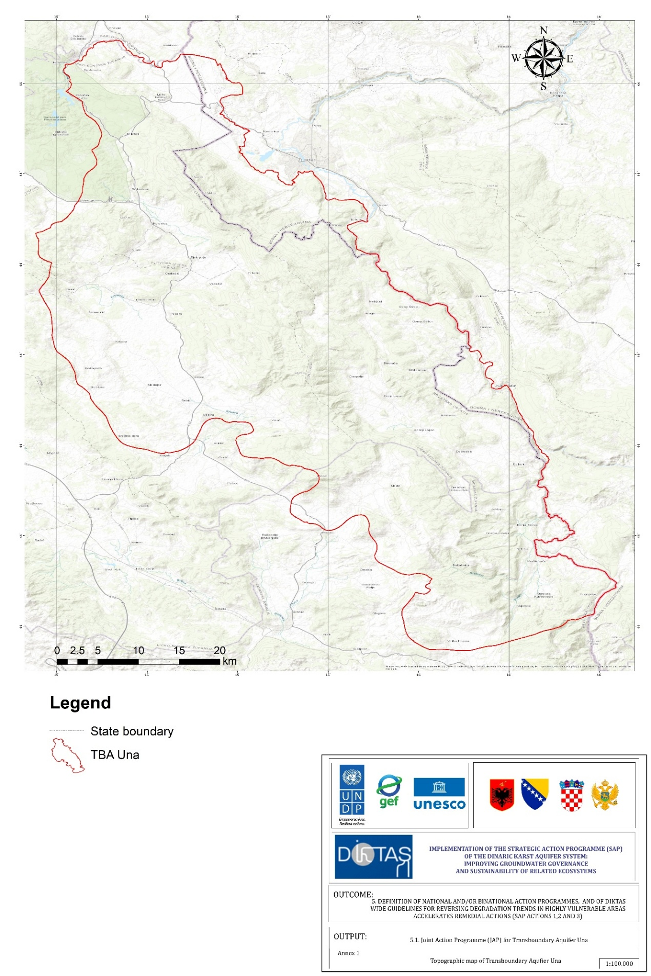
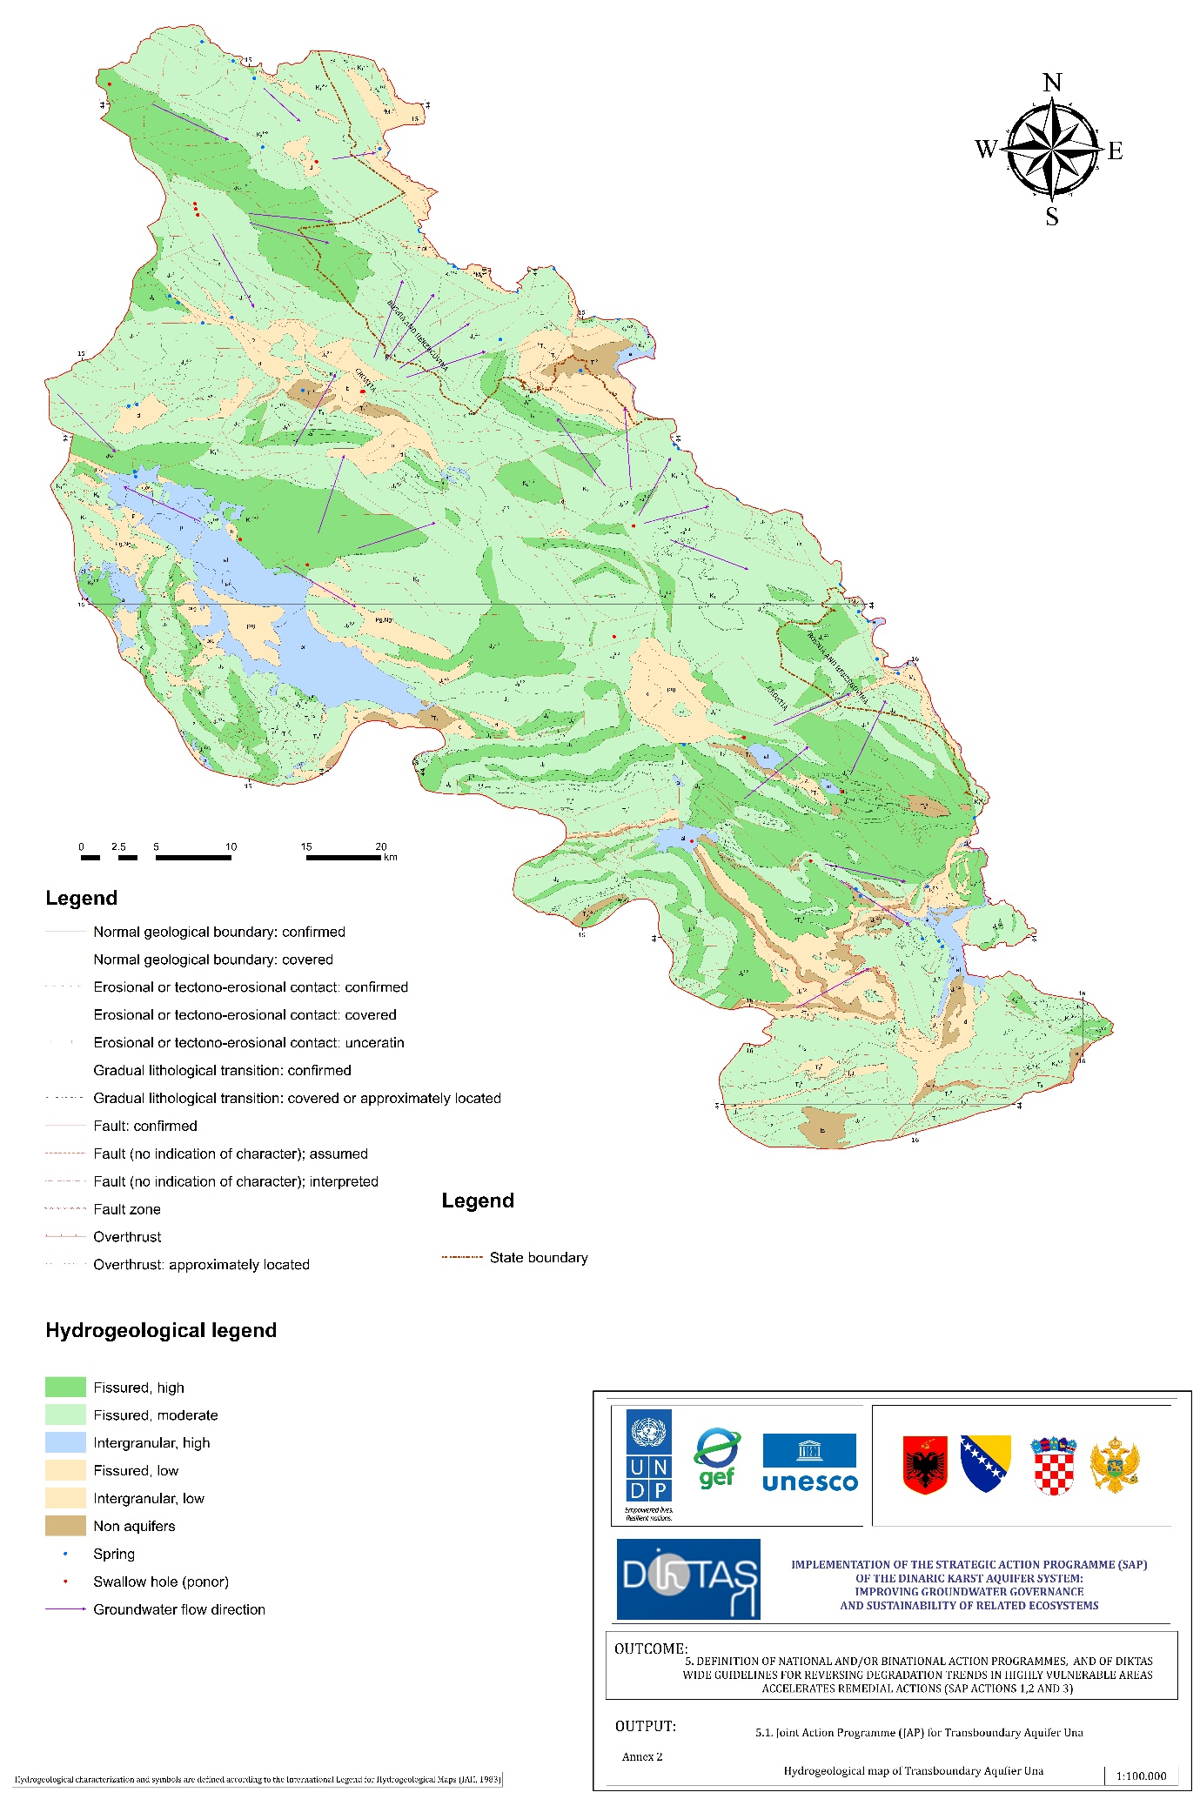

13.2 Monitoring of groundwater, surface water and hydrometeorology in Una TBA
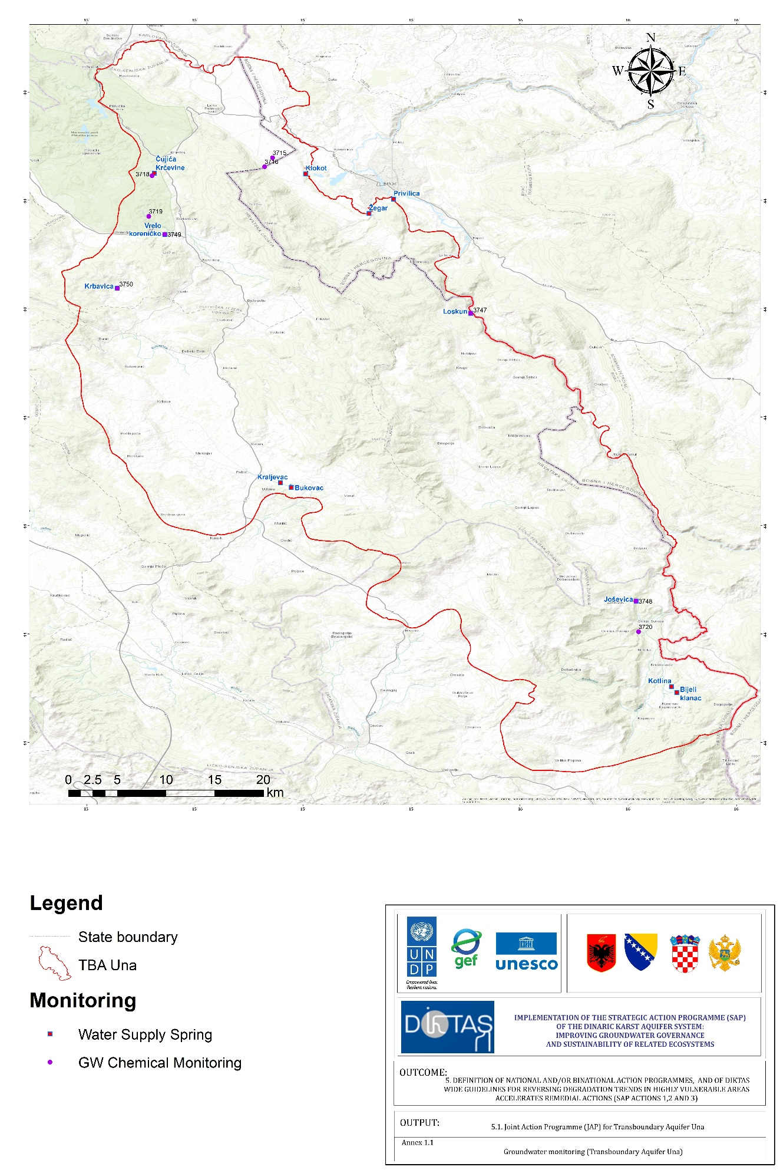
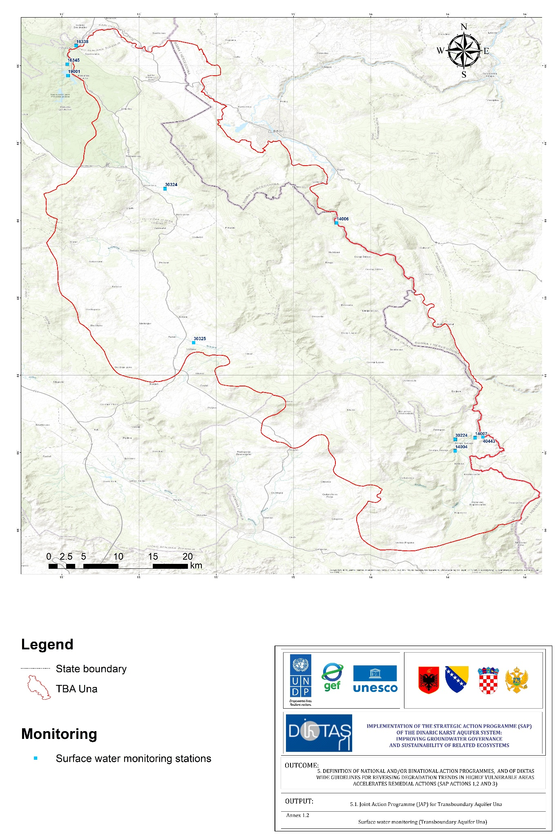
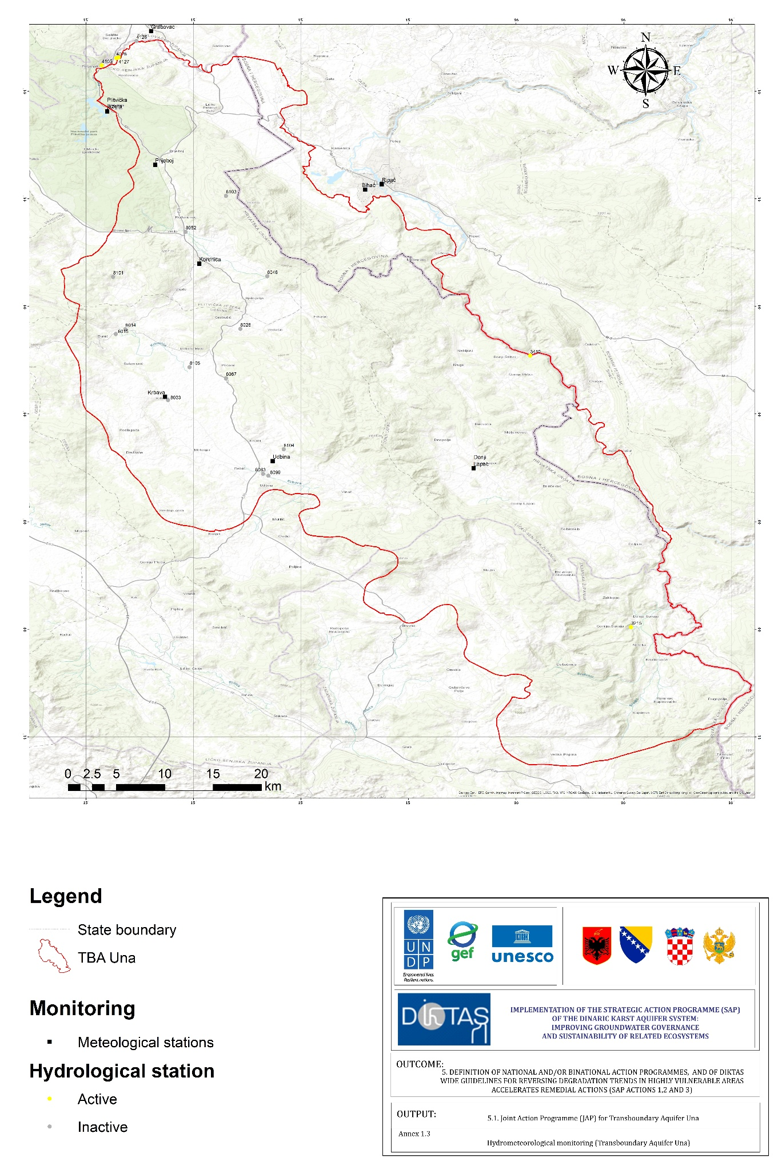

13.3 Stakeholder list
CROATIA
Stakeholder Group | Key Actors | Mandates / Roles | Relevance to Groundwater
National Authorities | Ministry of Economy and Sustainable Development (MESD); Ministry of Agriculture | Water policy, groundwater protection, sanitation standards | High – sets regulatory framework
Water Management Institutions | Hrvatske Vode | Monitoring, abstraction permits, enforcement, protection zones | Very High – core technical authority
County Governments | Lika-Senj County, Karlovac County | Environmental management, spatial planning | Medium – decisions affect recharge zones
Municipalities | Plitvička Jezera, Rakovica, Korenica, Slunj | Local planning, sanitation, waste management, inspections | High (local) – septic & land-use control
Public Utilities | Local water-supply utilities | Operate small systems dependent on springs and wells | Medium – ensure safe supply
Waste Management Operators | Municipal service providers | Waste collection & disposal | Medium – prevent illegal dumping
Tourism & Protected Areas | Plitvice Lakes NP (influence), tourism boards | Manage tourism flows, environmental messaging | Medium–High – seasonal pressure
Tourism Private Sector | Guesthouses, campsites, restaurants | Water use, wastewater handling | Medium – seasonal demand & pollution
Agriculture Stakeholders | Small farmers, livestock owners | Local food production, manure storage | Medium – diffuse pollution
Civil Society | Environmental NGOs, community groups | Awareness, reporting, advocacy | Medium – support monitoring
Local Communities | Rural settlements within TBA | Daily sanitation practices, land use | High – household-level impacts

BOSNIA AND HERZEGOVINA
Stakeholder Group | Key Actors | Mandates / Roles | Relevance to Groundwater
Entity Authorities | FBiH Ministry of Agriculture, Water Management and Forestry | Water governance, regulation, permitting | High – defines policy & oversight
Cantonal Authorities | Una-Sana Canton | Environment, forestry, communal services | High – strong operational influence
Municipal Authorities | City of Bihać | Spatial planning, sanitation, inspections | High – manages urban/peri-urban pressure
Water Utilities | Vodovod Bihać | Abstraction from Klokot/Kostela, supply operations | Very High – critical dependency on springs
Waste & Sanitation Services | JKP utilities | Waste collection, wastewater operations | High – influence water quality
Protected Area Authorities | Una National Park | Tourism management, conservation, infrastructure | High – concentrated seasonal use
Tourism Private Sector | Rafting operators, lodges, guesthouses | Seasonal water use, wastewater loads | Medium–High – pressure in summer
Agriculture Stakeholders | Small farmers, livestock households | Livestock watering, manure management | Medium – diffuse pollution risk
Civil Society & NGOs | Environmental NGOs, youth groups | Monitoring, awareness, advocacy | Medium – strong in Bihać region
Local Communities | NP Una villages, peri-urban Bihać | Everyday sanitation & land-use behaviour | High – directly affect recharge zones
Research & Academia | Universities, hydrologists | Data, studies, vulnerability assessments | Medium – evidence base
International Actors | UNESCO, GEF, EU | Funding, technical support, governance frameworks | High – strategic cooperation role

CROSS-BORDER COORDINATION ROLES – UNA TBA
Actor / Institution | Country | Mandate in National System | Role in Cross-Border Cooperation | Priority Coordination Functions
Hrvatske Vode (Croatian Waters) | Croatia | Groundwater monitoring, abstraction control, protection zones, WFD/GWD compliance | Core technical counterpart to BiH institutions | Joint monitoring design  Data harmonization  Early warning & incident communication
Bihać Water Utility (Vodovod Bihać) | BiH | Abstraction from Klokot/Kostela, water-supply operations | Key downstream actor; highly dependent on aquifer status | Sharing operational data  Participating in joint risk assessments  Coordinating emergency response
Ministry of Economy and Sustainable Development (MESD) | Croatia | National water/waste/environment policy | Strategic-level coordination, legislative alignment | Legal harmonisation  Transboundary agreements  Strategic guidance
FBiH Ministry of Agriculture, Water Management and Forestry | BiH | Entity-level water governance & permitting | Strategic-level coordination and regulatory alignment | Joint policy discussions  Harmonising standards  Coordinating permits affecting transboundary zones
Una-Sana Canton Government | BiH | Environment, forestry, communal services | Operational coordination with Croatian counties | Coordinated land-use planning  Tourism pressure management  Joint hotspot mapping
County Authorities (Lika-Senj, Karlovac) | Croatia | Spatial planning, environmental oversight | Operational partner to Una-Sana Canton | Land-use coordination  Sanitation priorities  Joint awareness initiatives
Municipalities (Bihać, Plitvička Jezera, Rakovica, Korenica, Slunj) | HR & BiH | Local planning, wastewater, inspections | Local-level actors directly implementing measures | Coordinated sanitation improvements  Rural engagement  Reporting local incidents
Una National Park Administration | BiH | Protected area management, tourism control | Key actor for tourism-related coordination with Croatia | Harmonised visitor messaging  Joint environmental guidelines  Seasonal monitoring
Plitvice Lakes NP (influence zone) | Croatia | Tourism management, biodiversity protection | Influences visitor flows into Una TBA | Joint communication campaigns  Shared sustainability standards
NGOs and Civil Society Networks | HR & BiH | Advocacy, community mobilisation, monitoring | Neutral facilitators supporting trust-building | Reporting hotspots  Participatory monitoring  Public awareness
Tourism Operators (rafting, lodges, campsites) | HR & BiH | Service provision, seasonal water use | Require harmonised environmental practices | Adoption of cross-border guidelines  Data on seasonal loads
Research & Academic Institutions | HR & BiH | Hydrology, karst research, data analysis | Provide evidence base for bilateral decisions | Joint studies  Methodology alignment  Technical training
UNESCO / DIKTAS II Partners | International | Coordination of project activities, facilitation | Catalytic role in formalising cooperation frameworks | Supporting creation of permanent coordination group  Providing tools, guidance, and reporting mechanisms

13.4 References

13.4.1 Legal framework references
I. Policy, legal and regulatory framework in Croatia
- Agriculture Strategy of the Republic of Croatia until 2030, Official Gazette No. 26/2022.
- Environmental Protection Act, Official Gazette No. 80/2013, 153/2013, 78/2015, 12/2018, 118/2018.
- Forest Act, Official Gazette No. 68/2018, 115/2018, 98/2019, 32/2020, 145/2020, 101/2023, 36/2024.
- Nature Protection Act, Official Gazette No. 80/2013, 15/2018, 14/2019, 127/2019, 155/2023.
- Regulation on the Ecological Network (Natura 2000), Official Gazette No. 124/2013.
- Regulation on Emission Limit Values for Wastewater, Official Gazette No. 26/2020.
- Regulation on Water Quality Standards, Official Gazette No. 96/2019, 20/2023, 50/2023.
- Regulation on Water Service Pricing Methodology, Official Gazette No. 70/2023.
- River Basin Management Plan of the Republic of Croatia until 2027, Official Gazette No. 84/2023.
- Rulebook on Conditions for Establishing Sanitary Protection Zones of Water Sources, Official Gazette No. 66/2011, 47/2013.
- Rulebook on Conformity Parameters, Analytical Methods, and Monitoring of Water Intended for Human Consumption, Official Gazette No. 64/2023, 88/2023.
- Rulebook on Technical Requirements for Drainage Structures, Official Gazette No. 3/2011.
- Rulebook on the Issuance of Water Acts, Official Gazette No. 9/2020, 39/2022.
- Rulebook on Water Sampling and Testing, Official Gazette No. 125/2017.
- Spatial Development Strategy of the Republic of Croatia, Official Gazette No. 106/2017.
- Sustainable Tourism Development Strategy of the Republic of Croatia until 2030, Official Gazette No. 2/2023.
- Transport Development Strategy of the Republic of Croatia 2017–2030, Official Gazette No. 84/2017.
- Waste Management Act, Official Gazette No. 84/2021.
- Waste Management Plan of the Republic of Croatia for the Period 2023–2028, Official Gazette No. 84/2023.
- Water Act, Official Gazette No. 66/2019, 84/2021, 47/2023.
- Water for Human Consumption Act, Official Gazette No. 30/2023.
- Water Management Financing Act, Official Gazette No. 153/2009, 90/2011, 56/2013, 154/2014, 119/2015, 120/2016, 127/2017, 66/2019, 36/2024.
- Water Management Strategy of the Republic of Croatia, Official Gazette No. 91/2008.
- Water Services Act, Official Gazette No. 66/2019, 84/2021, 47/2023, 110/2024.
II. Policy, legal and regulatory framework in Bosnia and Herzegovina
- Agriculture and Rural Development Strategy of the Federation of Bosnia and Herzegovina 2021–2027, Official Gazette of the Federation of BiH No. 52/24.
- Agriculture and Rural Development Strategy of the Republic of Srpska 2021–2027, Official Gazette of the Republic of Srpska No. 123/21.
- Decision on the Characterization of Surface and Groundwater, Reference Conditions and Parameters for Assessing the Status of Water, and Water Monitoring, Official Gazette of the Federation of BiH No. 1/14.
- Decision on the Adoption of the Strategy of Integral Water Management of the Republic of Srpska 2015–2024. Official Gazette of the Republic of Srpska 17/16 (18 February 2016).
- Energy Development Strategy of the Federation of Bosnia and Herzegovina until 2035, Official Gazette of the Federation of BiH No. 28/20 (2020).
- Energy Development Strategy of the Republic of Srpska until 2035, Official Gazette of RS No. 49/09.
- Environmental Protection Strategy of the Republic of Srpska 2022–2032, Official Gazette of RS No. 96/22.
- Law on Environmental Protection, Official Gazette of the Federation of BiH, No. 33/03 and 38/09.
- Law on Environmental Protection, Official Gazette of the Republic of Srpska, No. 71/12, 79/15, 70/20 – consolidated text.
- Law on Spatial Planning and Construction of the Republic of Srpska, Official Gazette of the Republic of Srpska No. 40/13.
- Law on Spatial Planning and Land Use of the Federation of BiH, Official Gazette of the Federation of BiH No. 2/06, 72/07, 32/08, 4/10, 13/10, 45/10, 85/21, 92/21, 72/24.
- Regulation on Amendments and Supplements to the Regulation on Conditions for Discharge of Wastewater into the Environment and Public Sewerage Systems, Official Gazette of the Federation of BiH No. 01/24.
- Regulation on the Characterization of Surface and Groundwater, Reference Conditions and Parameters for Assessing Water Status and Monitoring, Official Gazette of the Republic of Srpska No. 1/14.
- Regulation on the Classification of Waters and Categorization of Watercourses, Official Gazette of Federation of BiH No. 18/99.
- Regulation on the Classification of Waters and Categorization of Watercourses, Official Gazette of the Republic of Srpska No. 42/01.
- Regulation on the Conditions for Discharging Wastewater into the Environment and Public Sewerage Systems, Official Gazette of the Federation of BiH No. 101/2015.
- River Basin Management Plan for the Adriatic Sea Basin in the Federation of BiH (2022–2027).
- River Basin Management Plan for the Sava River Basin in the Republic of Srpska 2016–2021.
- River Basin Management Plan for the Sava River Basin in the Federation of BiH (2022–2027).
- River Basin Management Plan for the Trebišnjica/Adriatic Basin in the Republic of Srpska 2016–2021.
- Rulebook on the Classification of Waters and Categorization of Watercourses, Official Gazette of the Federation of BiH No. 18/99.
- Rulebook on Conditions for Discharge of Wastewater into Surface Waters, Official Gazette of the Republic of Srpska No. 44/01.
- Rulebook on the Conditions for Discharging Wastewater into the Environment and Public Sewage Systems, Official Gazette of Federation of BiH, No. 26/20 and 96/20.
- Rulebook on Determining Areas Prone to Eutrophication and Sensitive to Nitrates, Official Gazette of the Federation of BiH No. 71/09.
- Rulebook on Measures of Protection, Method of Determining and Maintaining Sanitary Protection Zones of Water Sources and Facilities, Official Gazette of the Republic of Srpska No. 7/03.
- Rulebook on Monitoring in Areas Prone to Eutrophication and Sensitive to Nitrates, Official Gazette of the Federation of BiH No. 71/09.
- Rulebook on Monitoring of Surface and Groundwater (FBiH), Official Gazette of the Federation of BiH No. 71/09.
- Rulebook on the Method of Determining Conditions for Establishing Sanitary Protection Zones and Protective Measures for Water Sources for Public Water Supply of the Population, Official Gazette of the Federation of BiH No. 88/12.
- Rulebook on the Treatment and Drainage of Wastewater for Urban Areas and Settlements without Public Sewerage Systems, Official Gazette of the Republic of Srpska No. 68/01.
- Tourism Development Strategy of the Federation of BiH 2022–2027, Official Gazette of the Federation of BiH No. 88/23.
- Tourism Development Strategy of the Republic of Srpska 2021–2027, Official Gazette of RS No. 119/21.
- Water Management Strategy of the Federation of BiH 2022–2032, Official Gazette of the Federation of BiH No. 9/23.
- Water Strategy of the Federation of BiH, Government of FBiH, 2012.
- Water Law of the Federation of BiH, Official Gazette No. 70/06, 01/12, 70/20.
- Water Law of the Republic of Srpska (Official Gazette No. 50/06, 92/09, 121/12, 39/13, 44/15, 19/16, 1/20.

III. International laws, contracts and agreements, EU directives
- Barcelona Convention – Convention for the Protection of the Marine Environment and the Coastal Region of the Mediterranean (1976, revised 1995), International Contracts, Official Gazette No. 17/1998.
- Contract between the Government of the Republic of Croatia and the Government of Bosnia and Herzegovina on Water Management Relations (Dubrovnik, 1996), International Contracts, Official Gazette No. 12/1996.
- Convention on Cooperation for the Protection and Sustainable Use of the Danube River, Sofia, 1994. International Contracts, Official Gazette No. 2/1996.
- Convention on the Protection and Use of Transboundary Watercourses and International Lakes, Helsinki, 1992. International Contracts, Official Gazette No. 4/1996.
- Convention on the Transboundary Effects of Industrial Accidents, Helsinki, 1992., International Contracts, Official Gazette No. 7/1999.
- Environmental Liability Directive (2004/35/EC).
- Framework Agreement on the Sava River Basin, Kranjska Gora, 2002. International Contracts, Official Gazette No. 14/2003.
- Groundwater Directive (GWD), Directive 2006/118/EC and 2014/80/EU.
- Habitats Directive (92/43/EEC)
- INSPIRE Directive, Directive 2007/2/EC.
- Nitrates Directive (91/676/EEC).
- UN General Assembly, The Law of Transboundary Aquifers, GA Res 63/124, UN Doc A/RES/63/124 (2008).
- Urban Wastewater Directive (91/271/EEC).
- Water Framework Directive (WFD), Directive 2000/60/EC.

13.4.2 Reports, studies, papers, regional plans and strategies
- Agency for Payments in Agriculture, Fisheries and Rural Development: Database of subsidy beneficiaries. https://www.apprrr.hr/baza-korisnika-potpora/
- Agency for Payments in Agriculture, Fisheries and Rural Development: Direct payments. https://www.apprrr.hr/izravne-potpore/
- Agency for Payments in Agriculture, Fisheries and Rural Development (2024): Agricultural subsidy payments by local government units – Financial year 2024 [Power BI dashboard]. Microsoft Power BI. Retrieved January 11, 2026, from https://app.powerbi.com/
- Agency for Statistics of Bosnia and Herzegovina (BHAS) (2022): Labour force survey and demographic statistics. BHAS.
- Babinka, S. (2007): Multi-Tracer Study of Karst Waters and Lake Sediments in Croatia and Bosnia and Herzegovina: Plitvice Lakes National Park and Bihać Area (Doctoral dissertation), University of Bonn, Bonn, Germany.
- BGGDA for Una TBA (2025): Baseline groundwater and groundwater-dependent assessment for Una transboundary aquifer. DIKTAS2 Project Deliverable.
- Bilandžija, H., Morton, B., Podnar, M. et al. (2013): Evolutionary history of relict Congeria (Bivalvia: Dreissenidae): unearthing the subterranean biodiversity of the Dinaric Karst. Front Zool 10, 5. https://doi.org/10.1186/1742-9994-10-5.
- Biondić, R., Rubinić, J., Biondić B., Meaški H., Radišić M. (2016): Defining trends and assessing the status of groundwater in karst areas of Croatia (in Croatian: “Definiranje trendova i ocjena stanja podzemnih voda na području krša u Hrvatskoj”), University of Zagreb, Faculty of Geotechnical Engineering, & University of Rijeka, Faculty of Civil Engineering, Zagreb.
- Bonacci, O. (2015): Karst hydrogeology/hydrology of Dinaric chain and isles. Environmental Earth Sciences, 74(1), 37–47.
- Bušljeta Tonković, A. (2019): Social entrepreneurship as a supporting model for sustainable rural development: Review of the Lika region (Croatia) case study [Paper prepared for UNTFSSE]. Institute of Social Sciences Ivo Pilar.
- Bušljeta Tonković, A., Puđak, J., & Šimleša, D. (2018): Social entrepreneurship as a supporting model for sustainable rural development: A case study of central Lika (Croatia). Socijalna ekologija, 27(1), 3–26. https://doi.org/10.17234/SocEkol.27.1.1
- Commission of the European Communities (2007): Guidance on preventing or limiting direct and indirect inputs in the context of the Groundwater directive 2006/118/EC Guidance document No 17. Technical Report – 2007 – 012. ISBN 978-92-79-06277-3, European Communities, Luxembourg.
- Commission of the European Communities (2015): Procedure to fit new or updated classification methods to the results of a completed intercalibration exercise. CIS Guidance Document No. 30, Brussels: Publications Office of the European Union.
- Croatian Bureau of Statistics (2011): Population by ethnicity by towns/municipalities, Census 2011. https://web.dzs.hr/
- Croatian Bureau of Statistics (2012a): 2011 census of population, households and dwellings: Population by settlements [Dataset]. https://www.dzs.hr/
- Croatian Bureau of Statistics (2012b): 2011 census of population, households and dwellings: Population by settlements and ethnicity [Dataset]. https://www.dzs.hr/
- Croatian Bureau of Statistics (2021): 2020 census of agriculture: Structure of agricultural holdings [Dataset]. https://www.dzs.hr/
- Croatian Bureau of Statistics (2022): 2021 population census: Population by settlements [Dataset]. https://podaci.dzs.hr/
- Croatian Bureau of Statistics (2025): Population by towns and municipalities – GeoSTAT (2021 population census) [Dataset]. https://podaci.dzs.hr/
- Croatian Geological Survey (2016): Assessment of Groundwater Status in Areas Directly Connected to Surface Waters and Terrestrial Ecosystems Dependent on Groundwater. Study, Zagreb.
- Danielopol, D.L., Griebler, C., Gunatilaka, A., Notenboom, J. (2003): Present state and future prospects for groundwater ecosystems. Environmental Conservation, 30(2), 104–130. https://doi.org/10.1017/S0376892903000109.
- Delić, T., Pipan, T., Ozimec, R., Culver, D. C., & Zagmajster, M. (2023): The Subterranean Species of the Vjetrenica Cave System in Bosnia and Herzegovina. Diversity, 15(8), 912. https://doi.org/10.3390/d15080912.
- Dmitrović, D.; Savić, A.; Šukalo, G.; Pešić, V. (2023): An Updated Checklist of Freshwater Gastropods (Mollusca: Gastropoda) of Bosnia and Herzegovina, with Emphasis on Crenobiotic Species. Diversity, 15, 357. https://doi.org/10.3390/d15030357.
- European Commission (2013): Croatia’s accession to the European Union – Q&A (MEMO-13-629). https://europa.eu/rapid/press-release_MEMO-13-629_en.htm
- European Environment Agency (2018): Tourism and the environment in Europe: Challenges and opportunities. Publications Office of the European Union. https://www.eea.europa.eu/publications/tourism-and-the-environment
- European Environment Agency (2019): Climate change adaptation in the water sector (EEA Report No 04/2019).
- European Parliament & Council of the European Union (2000): Directive 2000/60/EC establishing a framework for Community action in the field of water policy (Water Framework Directive). https://eur-lex.europa.eu/eli/dir/2000/60/oj.
- Faculty of Geotechnical Engineering, University of Zagreb (2016): Definition of Trends and Assessment of Groundwater Status in Karst Areas of Croatia, Study, Zagreb.
- Falniowski A, Lewarne B, Rysiewska A, Osikowski A, Hofman S. (2021): Crenobiont, stygophile and stygobiont molluscs in the hydrographic area of the Trebišnjica River Basin. Zookeys. Jun 28; 1047:61-89. https://doi: 10.3897/zookeys.1047.64034.
- FAO (2016): Global framework for action to achieve the vision on groundwater governance. FAO.
- FAO (2018): Gender and land rights database: Country profiles for Croatia and Bosnia and Herzegovina. Food and Agriculture Organization of the United Nations.
- FAO (2023): The status of women in agrifood systems. FAO.
- FINA – Financial Agency. (n.d.). Tobacco Factory Udbina Ltd. (in bankruptcy) – Info.BIZ (company profile). https://infobiz.fina.hr/
- FININFO (n.d.). Pilana Udbina Ltd. – Detailed company information. https://www.fininfo.hr/
- Ford, D., & Williams, P. (2007): Karst hydrogeology and geomorphology. John Wiley & Sons.
- Geoservis A.S. d.o.o., Zagreb (2020): Report: Drilling investigate boreholes in Klokot spring catchment area (In Croatian: Izvještaj: Izrada istražnih bušotina u slivu izvora Klokot).
- Gibert, J., Culver, D., Danielopol, D.L., Griebler, C., Gunatilaka, A., Notenboom, J., Sket, B. (2008): Groundwater ecosystems: human impacts and future management. In: Polunin N.V.C. (ed.) Aquatic Ecosystems. Trends and Global Prospects. Cambridge University Press, Cambridge, pp. 30–44.
- Global Environment Facility, United Nations Development Programme, & Food and Agriculture Organization of the United Nations (2016): Groundwater governance: A global framework for action. GEF/UNDP/FAO Groundwater Governance Project.
- Goldscheider, N., & Drew, D. (Eds.) (2007): Methods in karst hydrogeology: IAH international contributions to hydrogeology 26. Taylor & Francis.
- Gottstein, S. (2010): Manual for the Identification of Subterranean Habitats in Croatia in Accordance with the EU Habitats Directive. State Institute for Nature Protection, Zagreb.
- Gottstein, S., Matočec, S. (eds.), Bakran-Petricioli, T., Bedek, J., Bukovec, D., Buzjak, S., Franičević, M., Jalžić, B., Kerovec, M., Kletečki, E., Kralj, J., Kružić, P., Kučinić, M., Kuhta, M., Matočec, N., Ozimec, R., Rađa, T., Štamol, V., Ternjej, I., Tvrtković, N. (2001): Croatia. In: Juberthie, C., Decu, V. (eds.) Encyclopaedia Biospeologica, III. Société de Biospéologie, Moulis, pp. 2237–2287.
- IBIS d.o.o. (2019): Protection of the Klokot and Privilica Springs – City of Bihać, Study, Zavidovići.
- IGRAC (2021): Transboundary aquifers of the world map 2021. International Groundwater Resources Assessment Centre.
- Institute of Hydraulic Engineering, Faculty of Civil Engineering, University of Sarajevo (2004): Project for the Protection of the Ostrovica and Toplica Springs, City of Bihać.
- Institute of Hydraulic Engineering, Faculty of Civil Engineering, University of Sarajevo (2004): Project for the Protection of the Klokot and Privilica Springs, City of Bihać.
- Intergovernmental Panel on Climate Change (IPCC) (2022): Sixth assessment report: Impacts, adaptation and vulnerability. IPCC.
- Jolović B., (2009): National hydrogeological report for Bosnia and Herzegovina, Preparatory stage of DIKTAS Project, Zvornik.
- Kreiling, A.-K., Govoni, D.P., Pálsson, S., Jónsson, J. (2022): Indicator species of rheocrene and limnocrene springs at the surface. PLOS ONE, 17(5), e0264501. https://doi.org/10.1371/journal.pone.0264501.
- Kuhta M., Brkić Ž. (2020): Analysis of tracer tests conducted in karst areas of the Republic of Croatia (In Croatian: Analiza trasiranja provedenih na području krša u Republici Hrvatskoj), Croatian Geological Survey, Zagreb
- Kupusović T., (2004): Project for the protection of the Klokot and Privilica springs (in BiH: Projekat zaštite Klokot i Privilica), Institute of Hydrotechnics, Faculty of Civil Engineering, University of Sarajevo, Sarajevo.
- Kupusović T., (2004): Project for the protection of the Ostrovica and Toplica and Privilica springs (in BiH: Projekat zaštite Ostrovica i Toplica), Institute of Hydrotechnics, Faculty of Civil Engineering, University of Sarajevo, Sarajevo.
- Martin, P., Brunke, M. (2012): Faunal typology of lowland springs in northern Germany. Freshwater Science, 31(2), 542–562.
- Milanović, P. (2018): Karst hydrogeology. Water Resources Publications, reprint Centre for Karst Hydrogeology, Belgrade.
- Ministry of Defence of the Republic of Croatia (2025): Battle of the Croats – Archaeological research project of the Battle of Krbava. https://hrvatski-vojnik.hr/
- Ministry of Economy and Sustainable Development of the Republic of Croatia (2023): River basin management plan of the Republic of Croatia 2022–2027. Official Gazette, No. 84/2023. https://narodne-novine.nn.hr/.
- Miošić, N., Samardžić N., Hrvatović H., Brkić E. (2008): Groundwater flow connections and waters supply in holokarstic Lika and Bihać region, Croatia and Bosnia and Herzegovina, Herald Geological, 37, Geological Institute of the FBIH, Sarajevo.
- Miošić, N., Samardžić N. (2008): Anthropogenic pollution before and after war 1991-1995 and measures for protection of parts of Lika and Bihać region at the border area of Croatia and Bosnia and Herzegovina, Herald Geological, 37, Geological Institute of the FBIH, Sarajevo.
- Miošić, N., Samardžić N. (2008): Polychlorinated biphenyls (PCBs) pollution of ecosystems as a consequence of war destruction from 1991-1995 in Bosnia and Herzegovina, 37, Geological Institute of the FBIH, Sarajevo.
- Nakić, Z., Balaž, B.I. (2024): A contribution to understanding the issues of treated wastewater discharges into underground (in Croatian), Hrvatske vode, 32, 130, 303-324.
- National Monitoring Plan for 2025, Water Institute Josip Juraj Strossmayer, 2025.
- Plitvice Lakes National Park (2025): Analysis of year-round tourism in 2024. Retrieved from https://np-plitvicka-jezera.hr/analiza-cjelogodisnjeg-turizma-u-2024-godini/
- Plitvice Lakes National Park Public Institution (2025): Analysis of year-round tourism in 2024. https://np-plitvicka-jezera.hr/
- Sergiacomi, C., D’Alessandro, F., Fratini, R., & Salvati, L. (2022): Exploring tourist preferences on the visitor management system: The case study of Plitvice Lakes National Park. South-east European Forestry, 13(2), 67–77. https://doi.org/10.15177/seefor.22-06.
- Slišković, I. (1973): Regional hydrogeological investigations of the Una River basin (In BiH: Regionalna hidrogeološka istraživanja sliva rijeke Une), Geoinženjering, Sarajevo.
- Stepinac, A., (1969): Runoff in the Dinaric karst (In Croatian; Otjecanje na Dinarskom kršu), Carsus Iugoslaviae,Zagreb, Yugoslavia.
- Stevanović, Z., Pekaš, Ž., Maran Stevanović, A., Eftimi, R. (2021): Springs as essential water sources for dependent ecosystems in karst. ResearchGate. Available at: https://www.researchgate.net/publication/356997571_Springs_as_essential_water_sources_for_dependent_ecosystems_in_karst.
- UNDP (2016): Gender equality strategy 2014–2017: Guidance note on gender mainstreaming. United Nations Development Programme.
- UNDP (2020): Human development report: Western Balkans. UNDP.
- UNESCO-IHP (2022): Transboundary aquifer management: Guidelines and best practices. UNESCO International Hydrological Programme.
- UNICEF (2021): Gender-responsive WASH programming guidance. UNICEF.
- United Nations (2015): Transforming our world: The 2030 agenda for sustainable development. United Nations General Assembly.
- UN Women (2021): Gender and water governance. UN Women.
- UN Women (2022): Turning promises into action: Gender equality in Europe and Central Asia. UN Women.
- UN Women (2023): Gender, climate change and disaster risk reduction. UN Women.
- WHO/UNICEF (2023): Progress on household drinking water, sanitation and hygiene: JMP report. World Health Organization & UNICEF.
- World Bank (2020): Gender dimensions of agriculture and rural employment. World Bank.
- World Bank (2021): Climate change and gender in Europe and Central Asia. World Bank.
- World Bank Group (2020): Development of a Study on the Establishment of the Klokot (Bihac) Spring Cross-Border Sanitary Protection Zones (Vol. 1 of 24) : Final Report (English). Washington, D.C. http://documents.worldbank.org/curated/en/876781602132853101.
- World Health Organization (WHO) (2021): Climate change and health. WHO.
- Yuan, J., Van Dyke, M.I., Huck, P.M. (2016): Water reuse through managed aquifer recharge (MAR): assessment of regulations/guidelines and case studies, Water Quality Research Journal, (2016) 51 (4): 357–376.

13.5 Monitoring and remediation practices examples

13.5.1 Monitoring
In karst areas groundwater bodies are generally connected with surface waters. A typical example of such a connection is the emergence of groundwater at the contact with less permeable clastic layers deposited in karst fields, the formation of surface flows along karst fields, and their infiltration into the subsurface when encountering karstified carbonate rocks. Although ponors are important in karst areas, playing a crucial role in both groundwater quantity and quality, their significance has often been neglected in monitoring programs.
Monitoring in Una TBA of groundwater abstraction quantities was generally the responsibility of water utilities, mainly for the purpose of calculating water-use charges. Consequently, only abstracted (pumped) volumes were routinely measured, whereas total spring capacity was determined only occasionally. Overflow volumes at water-supply springs were not subject to legal monitoring requirements and were therefore typically assessed indirectly via hydrological stations located downstream of the springs.
Such approach does not allow an accurate water balance assessment. A more comprehensive monitoring system, including both abstraction and overflow volumes, is needed to determine the total spring capacity. Quantitative monitoring of groundwater was generally limited to public water supply springs. Determination of spring capacity requires defining the minimum exploitable discharge corresponding to return periods of 2, 5, 10, and 20 years. The most objective evaluation of the minimum spring capacity is achieved through statistical analysis of long-term discharge data collected during continuous exploitation (by measuring both abstraction and overflow volume).
In Una TBA, groundwater quality monitoring is performed on all springs used for water supply and according to Drinking Water Directive (DWD, 98/83/EC) (and national drinking water acts) while the groundwater monitoring for assessment of groundwater chemical status in karst aquifers is not yet established in BiH. In Croatian part of TBA Una there is a significant improvement in groundwater chemical monitoring from the first RBMP when there was only one monitoring stations compared to the 3rd RBMP and seven monitoring stations. Monitoring of groundwater on all GW monitoring stations in Croatia is in accordance with the Water Framework Directive (WFD, 2000/60/EC); Groundwater Directive (GWD, 2006/118/EC) and DWD.
Both countries have harmonized their national water legislation in accordance with the EU Water Directives (WFD, GWD, and DWD). However, for groundwater in karst aquifers, the parameters used for status assessment under the WFD are insufficient and do not fully reflect actual conditions. More relevant are the physicochemical and chemical parameters monitored under the DWD, which better represent water quality in karst systems. Also, the sampling frequency prescribed by EU legislation (DWD especially) is not sufficient to adequately characterize karst aquifers.
The Water Management Plan for the Sava River Basin District in the Federation of Bosnia and Herzegovina (2022–2027) foresees the implementation of a groundwater monitoring network as part of its programme of measures. In this context, a 2019 study conducted by the Sava River Basin Agency selected 20 representative karst springs for monitoring, including the Klokot Spring.
The assessment of chemical status is conducted according to groundwater quality standards (GQS: nitrates and pesticides), and the threshold values for specific pollutants. In Croatia, these standards are established under the Regulation on Water Quality Standards (Official Gazette, No. 96/2019, 20/2023, and 50/2023, Annex 6), while in the Federation of Bosnia and Herzegovina, they are defined by the Decision on the Characterization of Surface and Groundwater, Reference Conditions, and Parameters (Official Gazette FBiH, No. 1/14, Annex 8).
In terms of GW chemical status, grouped groundwater body Una (code CSGI-18) in RBMP of Croatia has been assessed as having good chemical status while Sava RBMP due to the lack of monitoring dana did not make assessment of GWB.
Regarding the existing monitoring, improvements are needed in both the qualitative and quantitative assessment of groundwater status within Una TBA and the Klokot–Privilica subcatchment (Figure 13.5.1).
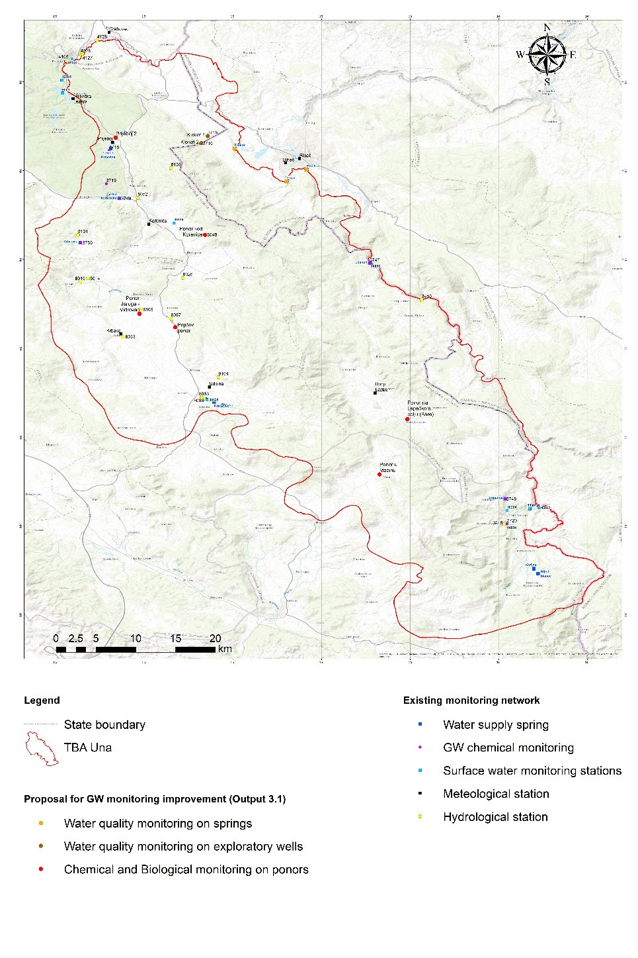
Figure AN-1 Comprehensive monitoring map of Una TBA
In Output 3.1. of the DIKTAS II project: “Design of DIKTAS-wide groundwater multi-purpose monitoring network SITE 1: TBA Una shared between Bosnia and Herzegovina and Croatia”, it is proposed to establish monitoring at significant ponors in the Koreničko and Krbavsko poljes, which represent the recharge areas of the Klokot and Privilica springs and from which underground connections to these springs have been confirmed through tracer tests. This monitoring would include continuous measurement of water quantities (at both the ponors and the springs) as well as the assessment of chemical and biological parameters.
To delineate the catchment area more accurately, it is recommended, in addition to further groundwater investigations using tracer tests, to carry out isotopic studies with stable isotopes within the recharge area. Furthermore, hydrological catchment delineation methods should be applied, particularly water balance analysis, which compares precipitation input with spring discharge to estimate the catchment size. For this purpose, it is necessary to expand the existing hydrometeorological monitoring network.
In terms of existing groundwater chemical monitoring, this means:
- Chemical monitoring on the main springs of the catchment: Klokot and additionally Privilica and Žegar (WFD, GWD and DWD),
- Chemical monitoring on 3 exploratory wells (Klokot-1 and Klokot-2 in Croatia) and the planned one in BiH,
- Chemical and biological monitoring on ponors.
Regarding the existing quantitative monitoring this means:
- Klokot, Privilica and Žegar - continuous measurement of overflow and abstracted quantities on daily basis),
- Exploratory wells: Klokot-1, Klokot-2 and new borehole, measurement of groundwater levels,
- Ponors: continuous measurement of water level and seasonal measurement of discharge.
Regarding the hydrometeorological monitoring this means:
- Instalment of meteorological station and precipitation measurement on additional locations.
Based on conceptual model (Figure 4.1.1) and the existing monitoring network, a new monitoring scheme has been designed to more accurately characterize the features of this karst aquifer. The program would provide detailed data on groundwater quality, quantity, and dynamics, ultimately enabling the assessment of hazards and risks associated with the aquifer and supporting more effective water management.
In addition, an improved understanding of groundwater flow patterns and hydraulic connectivity within the system, obtained through enhanced monitoring, represents a key prerequisite for the identification and tracking of potential contamination sources, the interpretation of contaminant transport mechanisms, and the selection, design, and evaluation of remediation measures. In complex karst environments, remediation strategies must be closely integrated with monitoring programs to ensure that remedial actions are appropriately targeted, their effectiveness can be reliably assessed, and potential unintended impacts are identified at an early stage.

13.5.2 Remediation
Groundwater remediation in fractured rock environments is inherently complex due to the heterogeneous nature of the rock mass, the presence of discrete fracture networks, and the limited ability to directly characterize groundwater flow pathways. Unlike porous media, contaminant transport in fractured rock occurs primarily through interconnected fractures, while the rock matrix often acts as a long-term contaminant reservoir because of diffusion and sorption processes. In karst systems, these challenges are further amplified by the presence of conduits, highly variable hydraulic connectivity, and rapid groundwater flow, which can lead to unpredictable contaminant migration and limited control over remediation zones. Consequently, conventional remediation technologies frequently exhibit limited effectiveness, and the design of remediation strategies requires detailed site characterization, specialized monitoring approaches, and realistic expectations regarding achievable remediation objectives.
Groundwater flow analysis in fractured rock is most addressed using the equivalent porous medium assumption, which is satisfactory for many flow-related problems. However, for the assessment of contaminant transport and fate, approaches based on discrete fracture network concepts are generally required. Based on extensive field research, Parker et al. (2012) developed a comprehensive methodology referred to as the discrete fracture network approach for investigating contaminated sites in sedimentary rocks such as sandstone, siltstone, shale, limestone, and dolostone. This research resulted in the development of a general conceptual model describing the formation and long-term evolution of source zones and contaminant plumes in fractured sedimentary rock.
Most sedimentary rocks exhibit significant effective matrix porosity (typically 2–20%), which allows contaminant mass to readily diffuse from fractures into the rock matrix during the early decades of contamination, and subsequently diffuse back into fractures over longer time scales. Although groundwater flow occurs predominantly within the fracture network, at historical contaminated sites most of the contaminant mass is typically stored within the low-permeability rock matrix blocks between fractures. Consequently, the discrete fracture network approach emphasizes the use of rock core analyses to delineate contaminant distributions within the matrix, combined with detailed investigation of the fracture network.
Although originally developed for sedimentary rock environments, the discrete fracture network approach is applicable to other rock types, if rock core sampling strategies are adapted to account for matrix porosity, sorption characteristics, contaminant type, and diffusion time scales. Conventional investigation approaches are often inadequate for fractured sedimentary rock because they are primarily designed to address groundwater quantity and water-supply issues. As a result, the rock matrix is commonly overlooked and many hydraulically active fractures remain unidentified, making it difficult or impossible to reliably characterize contaminant plumes in fractured porous rock using conventional methods alone (Parker et al., 2012).
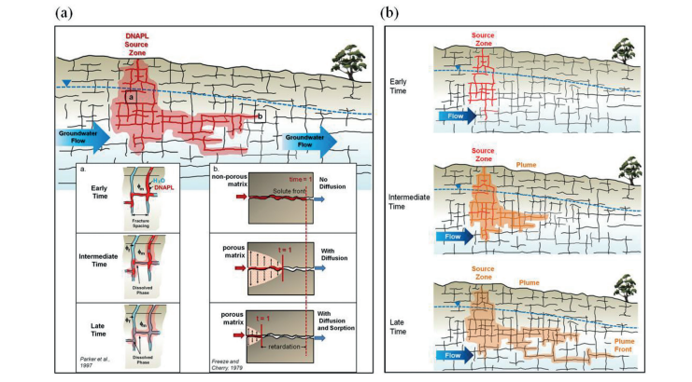
Figure AN-2 Conceptualization of source zone and plume evolution in fractured sedimentary rock:
(a) schematic cross-section showing DNAPL release and formation of a downgradient plume, including source zone evolution and diffusion-driven contaminant migration, and (b) conceptual stages of source zone and plume evolution (after Parker et al., 2012)
At many karst sites, remediation is complicated by the presence of an irregular residual soil cover overlying the karstified bedrock, through which contaminants typically migrate from the surface to the underlying aquifer. Furthermore, the occurrence of highly permeable karst conduits with uncertain extent and connectivity significantly limits control over contaminant transport, making remediation in karst environments more challenging than in most other hydrogeological settings.
Remediation of contaminated sites is typically complex, costly, and rarely results in complete removal of contaminant mass from the subsurface. Reported remediation costs range from several hundred thousand to tens of millions of dollars, while residual contamination often persists even after extensive remedial efforts (Krešić, 2020). Source zone remediation can reduce mass discharge to downgradient plumes. However, the extent to which reduced mass loading allows natural attenuation processes to maintain acceptable concentration levels remains site-specific. Consequently, regulatory guidance commonly emphasizes integrated remediation strategies combining source control, plume management, and containment measures, particularly in complex hydrogeological environments such as karst and fractured rock systems
In general, remediation technologies can be divided (Krešić, 2020):
- Source zone technologies,
- Plume technologies,
- Containment:
  - Hydraulic and Physical Barries,
  - Groundwater Extraction with Treatment (P&T).
Among these, in-situ remediation technologies are often promoted due to their ability to treat contamination without groundwater extraction and ex-situ treatment. Such technologies are frequently cited by regulators as having the potential to achieve site closure at DNAPL-contaminated sites and are increasingly being applied at fractured rock and karst locations. Common in-situ approaches include thermal treatment, chemical oxidation, and bioremediation.
However, preferential flow features characteristic of karst environments presents a significant challenge to in-situ remediation technologies. Just as karst conduits rapidly dissipate heat, they can also rapidly disperse injected amendments used for enhanced treatment, thereby limiting effective contact with contaminants stored in the rock matrix. Identification and consideration of conduit pathways during remedial design are therefore essential to avoid inefficient use of resources. Nevertheless, appropriate selection of remediation technologies remains possible (Figure 13.5.2), and targeted contaminant removal may still be achieved under suitable site-specific conditions (Krešić, 2020).
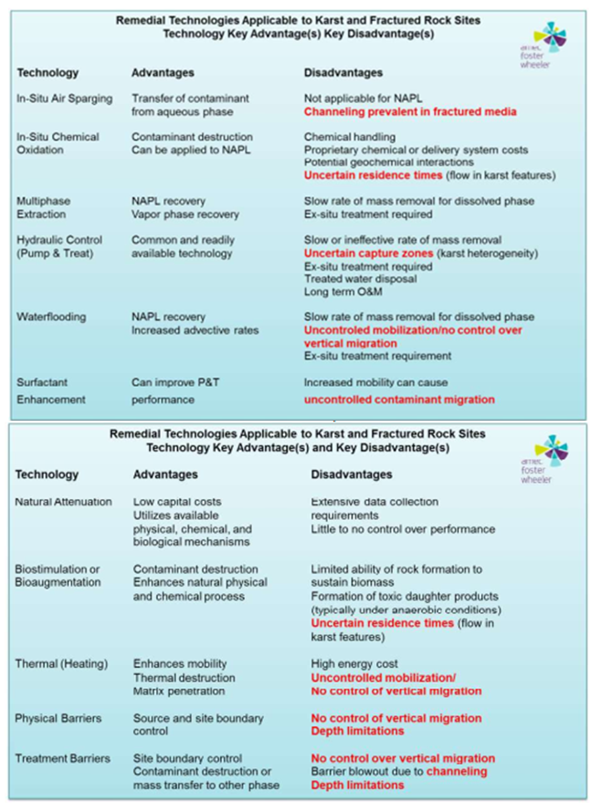
Figure AN-3 Overview of remediation technologies applicable to karst and fractured rock sites (after Krešić, 2020; courtesy of Amec Foster Wheeler)
References:
  - Krešić, N. (2022): Remediation Measures for Karst Sources and Waters. Characterization and Engineering of Karst Aquifers (CEKA), Trebinje, Bosnia and Herzegovina. Tutorial/course material.
  - Parker, B. L., Cherry, J. A., & Chapman, S. W. (2012): Discrete fracture network approach for studying contamination in fractured sedimentary rock. AQUA mundi (2012) - Am06052: 101-116.

13.6 Qualitative indicators for groundwater governance (example)

13.6.1 Indicator category: Institutional
Activity | Indicators | Activity Implementation Time | Context for Application | Competence (if applicable)
Establish a Joint Data Sharing Protocol for TBA Una (under JAP) | • % of groundwater & GWDE monitoring sites with bilateral data sharing  • Number of joint status reports per year | Short-term (one year) | Builds on JAP Ch. 7.2 Joint data sharing mechanism; aligns with need for transparent, widely shared knowledge and open data to enable governance. | CIE
Create a Permanent Stakeholder Platform for groundwater | • Number of multi-stakeholder meetings/year  • Stakeholder diversity index (metric that quantifies the variety and representation of different stakeholder groups)  • % JAP decisions reflecting stakeholder inputs | Short-term (one year) / Medium-term (2-4 years) | Directly tied to JAP Ch. 8.5 Community Participation and JAP Ch. 9.7 Role of stakeholders, and to GGP (UNDP/GEF Groundwater Governance Project) requirement for permanent stakeholder engagement as a governance cornerstone. | CIE; relevant stakeholders
Strengthen the Joint Water Management (JWM) Commission mandate on groundwater | • Number of groundwater agenda items/year  • Number of adopted cross-border resolutions  • Number of joint field inspections/activities | Medium-term (2-4 years) | Leverages JAP Ch. 7.1 Commission operations and GGP guidance on transboundary aquifers: start with professional cooperation → joint programs → agreements. | JVM Commission secretariat
Implement joint data-sharing mechanism for Una TBA | Institutional framework agreed; regular bilateral data exchange in place | Short-term (1 year) | Directly linked to JAP Chapter 7.2 Joint data sharing mechanism | National water management authorities; ISRBC / JWM Commission
Engage local and regional authorities in groundwater governance | Active involvement of authorities; continuity of engagement | Short-term (1 year) / Medium-term (2–4 years) | Linked to JAP Chapter 7.6 and Stakeholder Involvement Plan | Local/regional authorities in each country
Strengthen local implementation capacity | Groundwater consideration reflected in local planning and sanitation decisions | Medium-term (2–4 years) | Addresses implementation gaps in rural karst and tourism-affected areas | Local/regional authorities in each country
Establish cross-border notification and response procedures | Procedures agreed; timely information exchange during incidents | Medium-term (2–4 years) | Supports preparedness and coordinated response under JAP Chapter 7.4 | Water utilities; environmental authorities; municipalities
Apply feedback and learning in institutional cooperation | Feedback reviewed; coordination practices adjusted | Medium-term (2–4 years) | Ensures adaptive governance under JAP Chapter 7 measures | All relevant institutions involved in transboundary cooperation
Ensure the sustainability of cooperation mechanisms beyond the project duration | Responsibilities embedded in existing institutions | Long-term (5–6 years) | Reduces dependences on project-based arrangements and external facilitation | National water management authorities; JVM Commission secretariat
Build local institutional capacity for JAP delivery (training) | • Number of staff trained (hydrogeology, QA/QC, law)  • Dedicated groundwater unit/team established | Medium-term (2-4 years) | GGP recommends national & local groundwater units with specialist staff and secure financing; supports JAP Ch.8 consolidation and JAP Ch.5 financing. | JVM Commission secretariat

13.6.2 Indicator category: Legal & Fiscal
Activity | Indicators | Activity Implementation Time | Context for Application | Competence
Implement licensing & control of groundwater abstraction and wastewater discharge | • % of wells/springs licensed & in registry  • Number of inspections & compliance rate  • Number of illegal water supply objects closed  • Number of discharge permits issued/denied | Short-term (one year) → Medium-term (2-4 years) | Directly based on JAP Ch. 8.3 Control and licensing; mirrors GGP core legal provisions: bring groundwater under public control, license wells (springs)/uses, and control point-source pollution. | Local/regional authorities in each country
Introduce graduated sanctions & permits | • Number of sanctions applied  • % permits with adaptive (reviewable) conditions  • Reduction in over-abstraction hotspots | Medium-term (2-4 years) | GGP recommends adaptive rights, loss if unused, termination if environmental damage occurs | Local/regional authorities in each country
Design fiscal incentives for water-efficient technologies | • Number of beneficiaries of incentives  • Reduction in energy subsidies tied to pumping  • m³ saved per Euro of incentive | Medium-term (2-4 years) | Connects JAP Ch. 8.2 Promotion of water-efficient technologies with GGP redirecting finance & aligning incentives to discourage depletion and reward efficiency. | Local/regional authorities in each country
Establish charging schemes for large commercial groundwater users | • Number of users charged  • Annual revenue for JAP monitoring/QA  • % cost recovery for governance functions | Long-term (5-6 years) | GGP highlights charging for groundwater use (where feasible) and using ICT/pre-paid systems to regulate consumption and recover costs. | Local/regional authorities in each country

13.6.3 Indicator category: Technical
Activity | Indicators | Activity Implementation Time | Context for Application | Competence
Implementation of water-saving technologies (for irrigation and household supply) | • Adoption rate (% of target users)  • m³/year groundwater saved  • Trend in nitrate and key quality indicators at important water supply facilities | Short-term (one year) → Medium-term (2-4 years) | JAP Ch. 8.2 promotes efficient technologies; GGP cautions to balance efficiency & recharge; indicators track real savings and quality benefits amid microbiological & nutrient pressures. | Local/regional authorities in each country
Use shared GIS datasets for joint assessments | Compatible datasets used in joint analyses and reporting | Medium-term (2–4 years) | Supports coordinated RBMP implementation and DIKTAS monitoring objectives | Local/regional authorities in each country; JVM Commission
Align monitoring and assessment approaches | Core parameters agreed; joint or coordinated monitoring activities | Medium-term (2–4 years) | Responds to methodological differences identified in JAP (Chapters 5&6) | National water management authorities; competent monitoring authorities
Pilot Managed Aquifer Recharge (MAR) in suitable recharge zones | • Annual infiltration volume (m³)  • Water level change at observation wells  • Quality change (e.g., turbidity, pathogens) | Long-term (5-6 years) | JAP Ch. 9.3 Guide to MAR strategy; pilots respond to Una karst characteristics and rural supply reliability; pair with QA/QC protocols. | JVM Commission; Local/regional authorities in each country
Implement conjunctive use pilots (surface–groundwater) (if applicable) (explanation: At a selected karst aquifer site excess surface water could be directed into infiltration basins and sinkholes to replenish groundwater reserves) | •Surface / groundwater supply ratio  • Reduction in waterlogging or depletion indicators  • Stability of spring/baseflow | Long-term (5-6 years) | GGP / IWRM principle - balance to avoid both depletion and waterlogging; relevant to river - aquifer interactions. | JVM Commission; Local/regional authorities in each country

13.6.4 Indicator category: Policy & Planning
Activity | Indicators | Activity Implementation Time | Context for Application | Competence
Develop and adopt an operational Plan for Sustainable Groundwater Management | • Plan adopted & budgeted  • Targets (abstraction, quality) defined  • Annual progress report | Short-term (one year) | Directly from JAP Ch. 8.1 Strategic approach; operationalizes GGP planning & management process with evidence-based, contestable plans and clear indicators. | CIE / JVM Commission
JAP Communication Strategy for groundwater governance | • Campaign reach (% population)  • Awareness score (survey)  • Number of media pieces / stakeholder toolkits | Short-term (one year) → Medium-term (2-4 years) | JAP Ch. 8.6 Communication strategy; GGP awareness-raising is vital for sustained compliance and adaptive management across rural/urban audiences. | JVM Commission
Establish Conflict Resolution Mechanism for competing uses | • Number of disputes resolved/year  • Avg. time to resolution  • Satisfaction index of parties (quantitative measure of how satisfied all involved stakeholders are with the conflict resolution process and its outcome) | Short-term (one year) → Medium-term (2-4 years) | JAP Ch. 8.7 Conflict resolution supports cooperative governance; complements GGP guidance on stakeholder engagement & transboundary cooperation. | JVM Commission

13.7 Methodological tools and templates for indicator tracking
Templates for groundwater governance indicator tracking are organized into four mutually supportive categories:
A) METHODOLOGICAL GUIDANCE
B) STANDARDIZED REPORTING TEMPLATES
C) MONITORING PROTOCOLS
D) CAPACITY‑BUILDING COMPONENTS
More detailed information on the purpose and use of each template is provided in Section 12.2 Periodic Reporting of the JAP for TBA Una.

- METHODOLOGICAL GUIDANCE
TEMPLATE 1 – ANNUAL INDICATOR REPORTING TABLE
Indicator | Baseline | Current Value | Trend | Target | Responsible Institutions | Actions Required
Example: Sanitation coverage in high-risk villages | 22% | 27% | ↑ Improving | 50% | Municipalities, Utilities | Funding for upgrades needed
Example: Joint monitoring events | 1 | 2 | ↑ Improving | ≥3 | Croatian Waters, Water Utility Bihać | Schedule additional sampling
Expand rows for each governance indicator.

TEMPLATE 2 – DASHBOARD FOR GOVERNANCE INDICATOR TRACKING (can be updated yearly)
TBA UNA – Governance Indicator Dashboard (Example)
Reporting Year: ______
Indicator | Status | Trend | Alert Level | Comments
Legal harmonization | 65% alignment | ↑ | 🟡 Medium | Draft amendments pending
Data sharing frequency | Quarterly uploads | ↑ | 🟢 Good | Functioning platform
Stakeholder participation | 60% inclusiveness | → | 🟡 Medium | Private sector under-represented
Sanitation upgrades | 14% implemented | ↑ | 🟠 Low | Funding constraints
Tourism environmental compliance | 25% operators | → | 🟡 Medium | Training needed
Joint monitoring events | 2 per year | ↑ | 🟠 Needs improvement | Target ≥3
Legend:
🟢 = Good progress
🟡 = Moderate progress
🟠 = Needs improvement
🔴 = Critical attention required

- STANDARDIZED TEMPLATES FOR REPORTING INDICATOR STATUS
TEMPLATE 3 – DATA QUALITY ASSURANCE & HARMONIZATION CHECKLIST
(Use this checklist every time data is submitted by HR or BiH authorities.)
1. Technical Consistency
□ Units of measurement harmonized (e.g., mg/L, L/s)
□ Same sampling frequency applied
□ Same laboratory methods or mutually recognized methods
□ Metadata complete (location, time, method, weather conditions)
2. Internal Validation (Country Level)
□ Data reviewed by national technical institution
□ Errors, missing values, outliers addressed
□ Clear explanation for any gaps
3. Cross-Border Harmonization
□ Indicators calculated using identical formulas
□ Thresholds and classification levels matched
□ Data comparable across both sides of the TBA
4. Final Quality Verification
□ Approved by responsible institutions in HR and BiH
□ Ready for inclusion in joint reporting
□ Archived in shared digital platform

TEMPLATE 4 – INDICATOR SELECTION & PRIORITIZATION FLOWCHART (TEXT DIAGRAM)
STEP 1: Identify management need
STEP 2: Define governance question
STEP 3: Check indicator relevance (Does it measure pressure, state, response, or cooperation?)
STEP 4: Check feasibility
• Is data available?
• Can both countries measure it?
STEP 5: Cross-border harmonization test
• Same definitions?
STEP 6: Prioritize
• High relevance + High feasibility + High transboundary significance
STEP 7: Approve indicator and assign responsibilities

- MONITORING PROTOCOLS
TEMPLATE 5 – MONITORING PROTOCOL TABLE
Monitoring Component (example) | Procedure | Responsible Actors (HR/BiH) | Frequency | Required Tools
Groundwater quantity | Measure spring discharge at agreed stations | Hrvatske Vode / Water Utility Bihać | Monthly | Flow meters, database
Groundwater quality | Sample microbiological & chemical parameters | Utilities / Accredited labs | Quarterly | Sampling kits, QA forms
Sanitation monitoring | Inspect septic tanks in high-risk settlements | Municipalities | Annual | Inspection checklist
Tourism pressure | Record visitor numbers, wastewater loads | NP Una, Tourism Boards | Seasonal | Visitor count sheets
Stakeholder engagement | Record participation in meetings/forums | Coordination Group | Annual | Attendance logs
Cross-border cooperation | Document bilateral meetings & joint actions | HR–BiH Coordination Group | Annual | Joint report template

TEMPLATE 6 – STAKEHOLDER INVOLVEMENT LOG (FOR MONITORING PARTICIPATION)
ID | Date | Country | Event type (consultation/clinic/forum/briefing) | Title / Topic | Invited Stakeholder groups | Attendance (f / m / youth*) | Key points / issues | Agreed actions (deadline) | Satisfaction (1–5)
Note: Record youth if feasible. Keep personal data minimal; publish aggregates only.

- CAPACITY BUILDING COMPONENTS
TEMPLATE 7 – QUALITATIVE CAPACITY-BUILDING ASSESSMENT FORM (TRUST & COOPERATION)
Governance Dimension | Assessment Question | Rating (1–5) | Evidence / Notes
Trust between institutions | Do HR & BiH authorities view each other as reliable partners? | __ | Examples of cooperation / conflict
Transparency | Are decisions and monitoring results publicly accessible? | __ | Communication status
Participation quality | Are stakeholders meaningfully engaged? | __ | Feedback from forums
Perceived fairness | Do communities feel included and respected? | __ | Observed concerns
Responsiveness | Are issues addressed promptly by responsible institutions? | __ | Response time logs

