
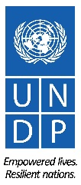



IMPLEMENTATION OF THE STRATEGIC ACTION PROGRAMME (SAP) OF THE DINARIC KARST AQUIFER SYSTEM: IMPROVING GROUNDWATER GOVERNANCE AND SUSTAINABILITY OF RELATED ECOSYSTEMS

OUTPUT 5.1

Joint Action Program of Cemi/Cijevna TBA
(Draft)

May 2026

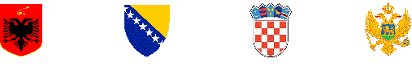
Contents
Joint Action Program of Cemi/Cijevna TBA i
March 2026 i
LIST OF TABLES vi
LIST OF FIGURES ix
ACRONYMS x
PREPARED BY DIKTAS II PROJECT TEAM xi
1. Introduction 1
1.1 Purpose and scope of the Joint Action Program for the Cemi/Cijevn TBA 1
1.2 Geographic, geological and hydrogeological overview of the Cemi/Cjevna TBA 1
1.3 Legal framework – multilateral and bilateral agreements 6
1.4 Institutional and transboundary cooperation 8
1.5 Alignment of JAP with national RBMPs and the EU WFD 9
1.6 Methodology 10
2. Identified problems and challenges. 13
2.1 Microbiological contamination of springs in Region. 13
2.2 PCB Pollution threats from different waste sources. 13
2.3 Insufficient data on groundwater abstraction in rural areas. 15
2.4 Urban pressure on groundwater and dependent ecosystems. 16
3. Socio-economic setting and challenges. 18
3.1 Overall socio-economic characteristics and demographic indicators 18
3.2. Institutional and financial capacities and challenges. 21
3.3. Stakeholder analysis. 24
3.4. Gender analysis 27
3.5 Role, services and significance of groundwater and groundwater dependent ecosystems 28
3.6 Water supply and sanitation infrastructure and challenges 33
3.7 Current water use by sectors (domestic, agriculture, industry) 34
3.8 Future demand projections 37
3.9 Water balance and sustainability indicators 39
4. Hydrogeological and environmental characterization 42
4.1 Karst aquifer dynamics and vulnerability. 42
4.2 Recharge/discharge zones and flow patterns. 44
4.3 Groundwater-dependent ecosystems. 46
4.4. Quality indicators of groundwater and groundwater-dependent ecosystems. 47
4.5 Natural hazards (seismic, flood, climate change) 48
5. Current monitoring and data management practices for groundwater and groundwater-dependent ecosystems in the neighbouring countries 52
5.1 Monitoring types and design of monitoring networks. 52
5.2 Parameters and frequencies of monitoring. 54
5.3 Quality Assurance (QA) / Quality Control (QC) of data. 55
6. Current approach for groundwater and groundwater-dependent ecosystem status and risk assessment in the neighbouring countries. 58
6.1 Groundwater and groundwater-dependent ecosystems standards, criteria and threshold. 58
6.2 Assessment of chemical and quantitative status of groundwater. 61
6.3 Assessment of chemical and ecological status of groundwater-dependent ecosystems. 66
6.4 Trend analysis. 67
6.5 Risk assessment. 67
7. Institutional and transboundary cooperation measures 69
7.1 Jurisdiction and operations of the Joint Water Management Commission of the Republic of Albania and Montenegro. 69
7.2 Joint data sharing mechanism. 70
7.3 Options for funding through EU and International Programs. 72
7.4. Strengthening institutional role and capacities. 75
7.5. Strengthening stakeholder engagement and public awareness 77
7.6 Engagement of local and regional authorities. 80
8. Measures for sustainable groundwater management. 84
8.1 Strategic approach to sustainable groundwater management (in rural areas). 84
8.2 Promotion of water-efficient technologies. 86
8.3 Guide to control and licencing of groundwater exploitation and wastewater discharge. 90
8.4 Guide to Managed Aquifer Recharge (MAR) strategy (optional) 92
8.5 Conjunctive use of surface and groundwater (optional). 94
8.6 Community Participation in groundwater governance. 95
8.7 The role of stakeholders in implementation and monitoring of transboundary cooperation and governance. 96
8.8 Communication strategy. 99
8.9 Conflict resolution. 101
9. Preventive protection measures. 103
9.1 Groundwater vulnerability map, classified hazard map and risk map 103
9.2 Guidelines for harmonization of criteria for: delineation and types of measures in sanitary protection zones. 105
9.3 Regulation, guidelines and risk-based criteria for subsurface wastewater discharge. 109
9.4 Control and mitigation of the impact of point and non-point pollution sources on GW and GWDE status. 112
9.5 Guidelines for risk assessment and risk management of catchment areas for abstraction points used for human consumption. 115
9.6 Land Use Planning Instruments for Groundwater Vulnerability Mitigation 119
10. Development of multi-purpose monitoring network of surface water, groundwater and groundwater dependent ecosystems. 121
10.1 Context and objectives of multi-purpose monitoring networks 121
10.2 Legal and policy background. 122
10.3 Joint management targets and priorities. 122
10.4 Selection of monitoring sites and parameters. 123
10.5 Sampling protocols. 125
10.6. Integration of existing national monitoring networks. 126
10.7 Data collection validation and storage. 126
10.8 Quality assurance and standardisation. 126
10.9 Harmonised data exchange and reporting protocols. 126
10.10 GIS integration and visualization. 126
10.11 Implementation roadmap and action plan. 127
11. Guidelines for establishing remediation measures for contaminated aquifer zones 128
11.1 Remediation purpose and objectives. 128
11.2 Regulatory and policy context. 129
11.3 Contaminated site characterisation and risk assessment. 130
11.4 Design of contaminated site monitoring network and sampling strategy 132
11.5 Defining remediation goals (e.g., restoration vs. risk reduction) 135
11.6 Site-specific cleanup levels and endpoints. 137
11.7 In-situ and ex-situ remediation technologies for PCB-contaminated karst groundwater. 139
11.8 Emergency response planning. 142
11.9 Stepwise and risk-based remediation planning. 143
11.10 Pilot testing and phased implementation. 145
11.11 Effectiveness monitoring of remediation. 147
11.12 Adaptive management and optimization strategies. 149
11.13 Transboundary and interagency coordination. 150
11.14 Funding and liability considerations. 151
12. Monitoring and evaluation of progress of the JAP Cemi/Cjevna. 153
12.1 Performance Indicators. 153
12.2 Periodic reporting. 156
12.3 Plan review (every six years). 157
12.4 Stakeholders role in monitoring and evaluation. 158
13. Annexes. 159
13.1 Hydrogeological Map 159
13.2 Monitoring Station 160
13.3 Stakeholder list 161
13.4 References.. 163
13.5 Qualitative indicators for groundwater governance. 167
13.6 Monitoring and remediation best practice examples. 170
13.7 Methodological tools and templates for indicator tracking 181

LIST OF TABLES
Table 3.1 Socio-Economic Indicators United with JAP Strategic Objectives
Table 3.2 Stakeholders group and their dependency on groundwater
Table 3.3 Implications for JAP and Socio-Economic Relevance of Groundwater.
Table 3.4 Socio-Economic Functions of Groundwater in the Cem Basin
Table 3.5 Socio-Economic Risks from Groundwater Degradation
Table 3.6 Groundwater Pressure Assessment and Configuration of JAP Actions.
Table 3.7 Findings for JAP – Water Supply & Sanitation (Malësi e Madhe / Kelmend
Table 3.8 Overview of Current Water Use by Sector in Malësi e Madhe and Kelmend
Table 3.9 Projected Water Demand by Sector in the Cem Basin (2030)
Table 3.10 Implications for JAP from Future Water Demand Projections (Albanian Context).
Table 4.1 Characteristic flows of major karst spring in the TBA Cemi River
Table 4.2 Summary results – June 2025
Table 4.3 Coordinates of the springs sampled in Cemi/Cijevna river basin (AKKSHI&ASHSH project, 2025-2026)
Table 4.4 Catchment areas (DEM-based delineation, Krstajic et al., 2026).
Table 4.5 Mean annual precipitation (mm):
Table 4.6 Mean annual temperature
Table 5.1 Quality elements
Table 6.1 Key parameter ranges in Albania (June 2025; M-1 to M-8).
Table 6.2 Baseline groundwater quality summaries for Montenegro (Joint Monitoring Project).
Table 7.1 Potential Funding Sources and Implications for JAP (Albanian Part of the Cem Basin).
Table 7.2 Link Between Investment Directions in the Albanian Cem Basin and JAP Chapters.
Table 7.3 Overview of Potential Funding Sources.
Table 7.4 Stockholders role
Table 7.5 Local and Regional Authorities’ Engagement & Relevance for the Transboundary Dimension (Albanian Cem Basin)
Table 7.6 Role of Local and Regional Authorities in the Implementation of JAP Measures (AL-ME)
Table 8.1 Indicators (Socio-Economic Focus).
Table 8.2 Key Socio-Economic Activities, Expected Results, and Indicators for Water-Efficient Technologies
Table 8.3 Stakeholders’ roles in monitoring and evaluation
Table 8.4 Stakeholder list
Table 8.5 Cross Border Institution
Table 9.1 Harmonized matrix of measures (model)
Table 9.2 Criteria and zones
Table 9.3 Matrix for the Report
Table 9.4 Minimum dataset and concrete evidence inputs for risk assessment of abstraction-point catchments (Albanian part, TBA Cemi/Cijevna).
Table 10.1 Ecological indicators in biological monitoring and sampling frequency
Table 10.2 Physico-chemical parameters in biological monitoring and sampling frequency
Table 10.3 Sampling frequency for ecological monitoring of surface waters.
Table 11.1 Main contamination sources and potential pathways
Table 11.2 Water quality monitoring parameters
Table 11.3 Groundwater monitoring parameters
Table 11.4 Sampling frequency
Table 11.5 Conceptual remediation objectives for the Cemi/Cijevna basin
Table 11.6 Example cleanup targets for the Albanian section of the Cem/Cijevna basin
Table 11.7 Environmental endpoints for remediation
Table 11.8 Comparison of remediation technologies for PCB-contaminated groundwater
Table 11.9 Main stages of emergency response planning
Table 11.10 Stepwise remediation framework for the Albanian section of the Cemi/Cijevna basin
Table 11.11 Phased implementation framework for the Cemi/Cijevna basin
Table 11.12 Key parameters monitored during pilot implementation
Table 11.13 Key indicators used for effectiveness monitoring in the basin
Table 11.14 Evaluation framework for remediation effectiveness
Table 11.15. Potential funding sources and responsible institutions for Relevance for groundwater protection and corrective actions in the Cemi/Cijevna TBA
Table 13.1. Stockohders List
Table 13.2. Crosborder Institutional Coordination
Table 13.3. Instututional Indicators
Table 13.4. Legal and Fiscal Indicators
Table 13.5. Technical Indicators
Table 13.6. Policy and Planing Indicators
Table 13.7. Dinamic of Sampling

LIST OF FIGURES
Figure 1.1 Geological map, scale 1:25 000, tablet K-34-51-Db (Grabron)
Figure 1.2 Geological map, scale 1:25 000, tablet K-34-52-Ca (Tamara)
Figure 1.3 Hydrogeological map of Cemi/Cijevna TBA
Figure 3.1 Domestic Water Supply and Sanitation Coverage
Figure 4.1 Boundary of Cemi/Cijevna TBA
Figure 4.2 Hydrogeological map of Cemi/Cijevna TBA
Figure 4.3 Schematic tectonic and geological map of Albania, providing further details on geological, tectonic and neotectonic processes in and around the country's territory (Aliaj et al., 2010). Major active transboundary faults are shown in red.
Figure 5.1 Location of surface and groundwater monitoring sites in Albania and Montenegro
Figure 9.1 Corine land cover in the Drini-Buna River Basin
Figure 13.1 Hydrogeological Map of Cemi/Cijevna TBA
Figure 13.2 Map of Surface, Groundwater and Hydrometeorological Monitoring in Cemi/Cijevna TBA

ACRONYMS
AGS Albania Geologic Service
BGGDA Bilateral Groundwater Governance Diagnostic Analysis
CWRB Council of Water River Basin
EPA Environmental Protection Agency
GGDA Groundwater Governance Diagnostic Analysis
GSM Geological survey of Montenegro
GWD Groundwater Directive
GWDE Groundwater-dependent ecosystems
IHMS Institute of Hydrometeorology and Seismology
MAFWM Ministry of Agriculture, Forestry and Water Management
NAP National Action Programs
NAWSW/AKUK National Agency of Water Supply and Waste
NCTW National Council of Territory and Water
NGO Non-Governmental Organization
NWTC National Water and Territory Council
REGAGEN Energy and Regulated Utilities Agency
RB River Basin
RBMP River Basin Management plan
SAP Strategic Action Programme
SDG Sustainable Development Goal
SPZ Sanitary Protection Zones
TBA Transboundary Area
TDA Transboundary Diagnostic Analysis
WRMA / AMBU Water Resources Management Agency
WD Water Directorate
WFD Water Framework Directive
WAO Water Administration Office

PREPARED BY DIKTAS II PROJECT TEAM
Halit Kamberi, National Expert for Legal policy, Albania
Neda Dević, National Expert for Legal policy, Montenegro
Nevila Koçollari Furxhiu, National Expert for Sociology, Albania
Romario Zoga, International expert for Stakeholder Involvement
Arben Pambuku, National Expert for Hydrogeology, Albania
Dragan.Radojevi, National Expert for Hydrogeology, Montenegro
Erjola Keci Biologist Albania
Snezana Dragicevic Biologist Montenegro
Lidija Brnović, National Expert for Gender, Montenegro
Irena Topalli, National Expert for Gender, Albania
Ermal Gjinaj, National Comunication Expert
Zelimir Pekas, International Hydrological Expert
Vedran Furtula GIS Expert

1. Introduction

1.1 Purpose and scope of the Joint Action Program for the Cemi/Cijevn TBA
The Joint Action Program (JAP) for the Cemi/Cijevna TBA establishes a focused and cooperative framework through which Albania and Montenegro can jointly advance the objectives of the DIKTAS Strategic Action Programme at the TBA level. Its purpose is to guide the development and implementation of coordinated actions that enhance the protection, sustainable use, and long‑term resilience of the karst groundwater system shared by the two countries. In doing so, the JAP translates regional agreements and DIKTAS II commitments into a clear, practical instrument tailored to the specific conditions and needs of the Cemi/Cijevna TBA.
The JAP consolidates the planning functions originally associated with the “Water Master Plan” concept, following the project team’s decision to apply a single, coherent terminology across all transboundary aquifers. This adjustment ensures conceptual clarity and prevents overlap with River Basin Management Plans, which remain the core planning documents required under the EU Water Framework Directive. At the same time, the JAP retains the full scope of activities envisaged for the Cemi/Cijevna TBA, while the specialized “Methodology for groundwater resources assessment at the Cemi/Cijevna TBA level” will be delivered as a separate technical document and referenced as appropriate.
In defining its scope, the JAP focuses on the priority issues identified for the Cemi/Cijevna TBA during the DIKTAS II project implementation and provides a structured basis for selecting and coordinating measures that address pressures on groundwater quantity, quality, and groundwater‑dependent ecosystems. It further outlines how the two countries will work together to strengthen monitoring practices, improve information exchange, and harmonize management approaches, ensuring that jointly agreed actions are feasible, transparent, and aligned with international standards. The JAP also establishes the framework for implementation, follow‑up and periodic review, ensuring that progress can be measured and that cooperative management can evolve in step with new knowledge and changing environmental or socio‑economic conditions.
Overall, the JAP serves as a concise and action‑oriented roadmap for the joint management of the Cemi/Cijevna TBA. It expresses the shared commitment of both countries to protecting a highly valuable and vulnerable karst system, supports their obligations under DIKTAS II, and provides the basis for coordinated activities that complement national policies while reinforcing long‑term transboundary cooperation.

1.2 Geographic, geological and hydrogeological overview of the Cemi/Cjevna TBA

Geography
Kelmendi Commune is rich in water resources. Cemi is the main river that runs through the Commune. It runs along the northwest of the Alps. It has a total length of 62.2 km. Its basin covers an area of 368 km², 238 km² of its basin and 30.8 km of its length are within the territory of the Republic of Albania. The average altitude of the Cemi River is 1237 m above sea level. Cemi is composed of two branches: Cemi of Selca and Cemi of Vukli. Cemi of Selca is 22.5 km long and Cemi of Vukli 17.9 km long. Cemi of Selca is the northern branch. It begins in the springs of Koprishti and goes up to the Holes of Selca. Its valley has the features of a canyon, with very steep crests, significant slope and many small waterfalls. Cemi of Vukli is the southern branch of the Cemi's river. It begins in the spring of Vukli (in Lluga). After it passes Flishi, in the upper part of its stream it enters the ridge of Golishti and Dubina, where it forms narrow valleys with very steep crests and waterfalls.
Both branches of Cemi join each other in Tamara. Then, Cemi runs in the southwest direction going through a typical valley that has a 'V' shape. It goes through limestone blocks of Mizhdrakuli and Kapezdroja and near Grabomi, it leaves the Albanian territory. Cemi brings 25.5 m³/sec water, and it is rich in trout.

Geology and Geomorphology
The area selected for monitoring in the territory of the village of Grabom, at the Albania-Montenegro customs border point consists of only a very limited “fragment” of the Cemi/Cijevna river valley, with two incomplete slopes, the valley which has its development in the “neighboring” Tamara plateau. This valley is built of two slopes extending east-west. They have high, rarely average slopes, from 35 to 55º. The valley elevations range from 140 m to 600 m above sea level. Geologically, it is mainly composed of carbonate rocks, limestone and dolomitized limestone of the Upper Triassic (T3), which build the valley slopes, Lower Jurassic deposits (J1) and less of the Quaternary (Qp-h) friable formations represented by gravel and sand, which mainly build the Cem River bed and the areas near it.
Upper Triassic (T3) - Deposits of this age, Upper Triassic (T3) have the greatest distribution in our area and spread in the southwestern part, in the Cemi Valley from Grabomi to the state border, building the lowest part of the Cemi Valley. These deposits are represented by limestone and dolomite of the Alpine zone, with megalodons as well as stromatolitic limestone. They mainly appear in medium layers and rarely in thin and thick layers. These contact with normal boundaries with the Lower Jurassic deposits. They have a southwest - northeast extension and a northwest dip. The thickness of these deposits is up to 850 m.
Lower Jurassic J1- Lower Jurassic deposits extend on both sides of the Cemi/Cijevna river valley, gradually overlying T.3by stromatolitic limestones. Above, the section continues with biomicritic marly and bituminous limestones, thin-medium layer, dark gray to black, rich in bivalves and gastropods. In special sectors, marly limestones with coal material up to coal seams are found. Above, the section closes with biogenic limestones, mainly with lithiotis. They have a southwest-northeast extension and a northerly dip with an angle of up to 20°. They contact the surrounding rocks with normal boundaries. They have a thickness of up to 260-280 m.
Quaternary (Q4 p.m.) - Quaternary deposits, Pleistocene - Holocene deposits are found in limited areas and extend to the lowest parts of the valley, near the Cemi / Cijevna river bed, building the riverbed itself. They are represented by mixed alluvial-eluvial deposits as well as colluvial-proluvial, sand, gravel and silt. Their thickness reaches up to 5 m. These deposits, as mentioned above, are represented by:
- alluvial-proluvial deposits along the riverbed,
- eluvial and colluvial materials on mountain slopes.
Selected area for monitoring in the territory of Tamare village, topographic map Tamara lies in the Albanian Alps. The geological structure of this plateau includes rock formations of the Upper Triassic, Lower, Middle and Upper Jurassic, Lower and Upper Cretaceous, Paleogene and Pleistocene - Holocene (Quaternary) sediments. The main part of the plateau is dominated by Cretaceous deposits, while deposits of other ages and Quaternary deposits are more limited. Below, according to ages, we are treating them in more detail:
Upper Triassic (T₃) - Deposits of this age in this planchet have a limited distribution. They occur in the two extremes northwest and southeast. They are represented by limestones and dolomites of the Albanian Alps area with megalodons as well as stromatolitic and biomicritic limestones. Their contacts are mainly of an overlying character on the flysch deposits of (Pg1 -2), but in places also normal with Lower Jurassic a.to. These deposits have a southwest-northeast extension and a northwest dip at an angle of 20 - 25°.
Lower Jurassic J1- Lower Jurassic deposits extend on both sides of the Cemi/Cijevna river valley, gradually overlying T.3by stromatolitic limestones. Above, the section continues with biomicritic marly and bituminous limestones, thin-medium layer, dark gray to black, rich in bivalves and gastropods. In special sectors, marly limestones with coal material up to coal seams are found. Above, the section closes with biogenic limestones, mainly with lithiotis. They have a southwest-northeast extension and a northerly dip with an angle of up to 20°. They contact the surrounding rocks with normal boundaries. They have a thickness of up to 260-280 m.
Middle – Upper Jurassic (J₂₋₃) - The Middle and Upper Jurassic deposits in this plateau are found on small areas, but in many isolated sectors in the form of thin belts, curved in different directions near the Triassic deposits. They normally contact the Lower Jurassic and Kimmeridgian formations. Tectonic contacts are also found with the Upper Triassic and Lower Cretaceous deposits. These formations are represented by dolomites with limestone and limestone interlayers. They are placed on the Lower Jurassic siliceous limestone package and are covered by Kimmeridgian limestones. In the lower section, biopelmicritic and biofelsparitic limestones with rare oolites, medium layer, dark gray color, with many crinoid segments are placed.
Above, the cutting continues with the intrusion of biosparitic limestone packages, a middle layer with dolosparitic packages, thick layers, dark gray in color and biofelsparitic and biopelmicritic limestone packages, rich in crinoid remains. These deposits are characterized by dolomitization, which in different sectors affects different parts of the cutting. The total thickness reaches up to 320 m.
Upper Jurassic - Kimmeridgian (J₃)- The Kimmeridgian deposits have a limited distribution. They are found in the form of belts in the west, southwest and southeast of the plateau. They are represented by limestones with Hydrozoa, corals and algae, thin-medium layers as well as limestones with siliceous lenses. They contact normally and tectonically with other formations and in the cross-section, they are placed on the deposits of the Middle and Upper Jurassic (J2 -3) and below those of the Tithonian. They have a southwest-northeast extension and a northwest dip at an angle of 20 - 25°. They are up to 500 m thick.
Tithonian deposits in these plateaus have a limited distribution. They are represented by limestones and dolomites. They have normal and tectonic contacts with the limiting rocks, extend in the southwest-northeast direction and have a northwest dip at an angle of 20 – 25°. They have a small thickness of 50 – 75 m and are placed in a cut above the Kimmeridgian limestones and below those of the Lower Cretaceous (Neocomian).
Quaternary (Q₄ p.m.) - Quaternary deposits, Pleistocene - Holocene deposits are found in limited areas and extend to the lowest parts of the valley, near the Cemi/Cijevna riverbed, building the riverbed itself. They are represented by mixed alluvial-eluvial deposits as well as colluvial – proluvial, sand, gravel and silt. Their thickness reaches up to 5 m. These deposits, as mentioned above, are represented by:
- alluvial-proluvial deposits along the riverbed,
- eluvial and colluvial materials on mountain slopes.
Carbonate formations (limestone and dolomite) of various geological ages are widely developed in the Albanian Alps and southern Montenegro. These formations are characterized by:
- high degree of karstification,
- developed network of karst cracks and channels,
- very high hydraulic permeability.
Quaternary friable formations are not very widespread, however they are present both at the Grabomi customs point and in the village of Tamare, i.e. in the two locations selected for the installation of monitoring equipment and for the process of monitoring surface and groundwater itself.
The combination of these lithological units creates complex conditions for water circulation and the connection between surface and groundwater.

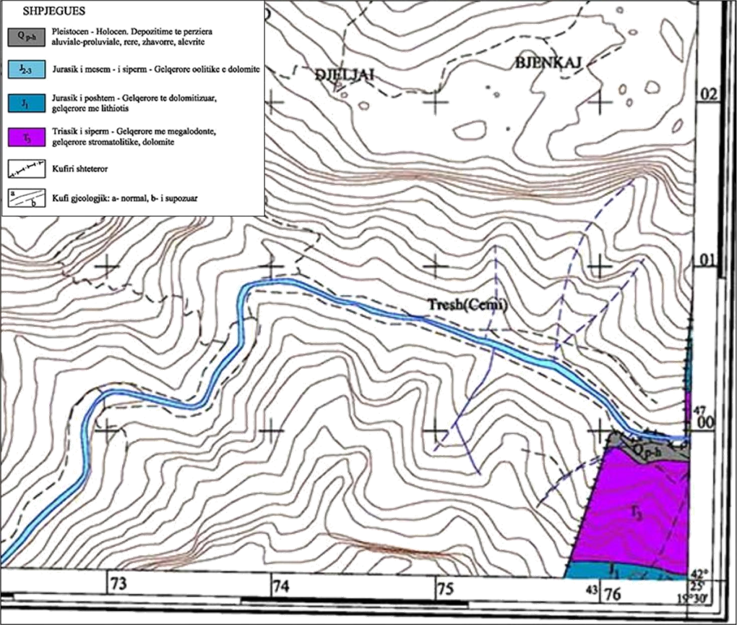
Figure 1.1 Geological map, scale 1:25 000, tablet K-34-51-Db (Grabom)
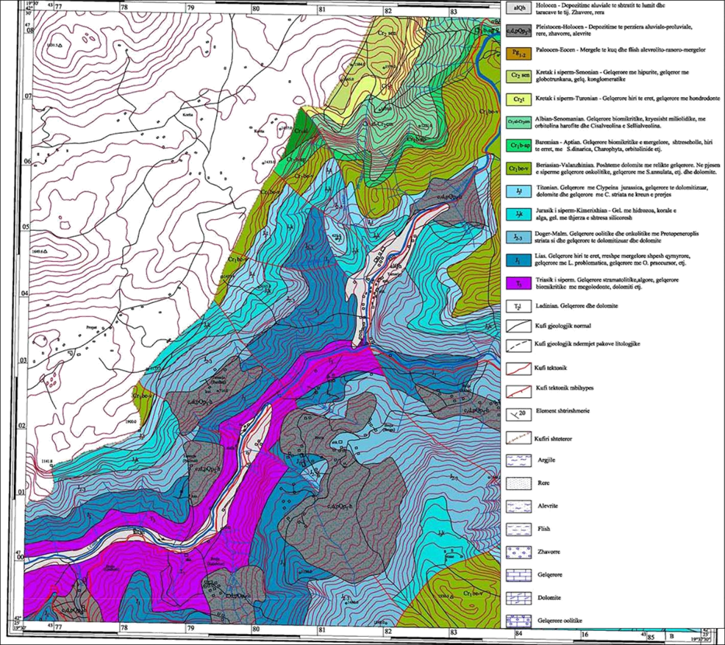
Figure 1.2 Geological map, scale 1:25 000, tablet K-34-52-Ca (Tamara).
Hydrogeology
The area under study presents very good hydrogeological conditions in limestone formations with high water retention. The area has numerous springs that have security in their flows and a highly developed dynamic of groundwater and surface waters. Underground waters emerge in the form of springs, distributed almost throughout the area. Carbonate formations appear with high water retention.
Compact rocks with high water retention - This complex includes carbonate rocks of the Upper Triassic, Lower Jurassic and Upper Cretaceous. These karst aquifers are characterized by:
- rapid response to precipitation,
- large changes in the piezometric level,
- strong connections with surface runoff.
The water retention of these rocks, their high permeability is related to the existence of numerous cracks and karst phenomena. Carbonate rocks have a considerable spread in the region. The Upper Triassic limestones, in the form of caps, overlie the flysch. The above limestones appear cracked and karstified, especially those of the Upper Triassic - Jurassic and Upper Cretaceous. The cracks encountered in these rocks are of different dimensions and often filled with calcite. The compact rocks with cracks are rich in groundwater. This is also evidenced by the springs that emerge from these formations. The flow rates of the springs vary from 0.1-0.2 to 15-20-30 1/sec but the springs with flow rates of 1-5 l/s predominate. The springs are found mainly in the contact of limestone rocks with rocks with low permeability or in tectonic faults. This means that we are dealing with mainly descending springs of the contact - karst - fissure or tectonic - karst - fissure type. These waters have a small circulation area, so they belong to the upper part, where the feeding area coincides with the drainage area.
From a hydrogeological point of view, the area represents a complex karst system, where groundwater circulates mainly in:
- carbonate aquifers with very high permeability,
- karst channels and structural cracks,
- developed infiltration and recharge areas.
These features make continuous monitoring of level and electrical conductivity in monitoring wells a critical component of the project.
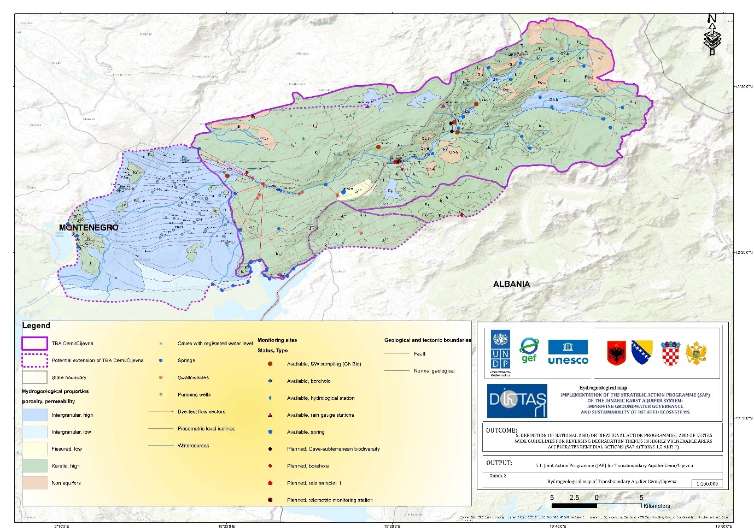
Figure 1.3 Hydrogeological map, Cemi/Cijevna TBA.

River–aquifer interaction
In many segments of the Cemi/Cijevna basin, the river and the surrounding aquifer are in direct hydraulic interaction. This interaction can manifest itself:
- as aquifer recharge from the river during periods of high flow,
- or as river nourishment from the aquifer during dry periods.
Identifying the direction and intensity of this interaction is essential for:
- assessing the sustainability of water resources,
- pollution risk management,
- understanding the functioning of the karst system.

The DIKTAS project, through a combination of hydrometric, hydrogeological and isotopic monitoring, aims to provide a complete picture of this interaction.

1.3 Legal framework – multilateral and bilateral agreements
The legal setting for groundwater management in the Cemi/Cijevna TBA relies on a combination of multilateral conventions, bilateral cooperation instruments, EU legislation, and national laws in both countries. These frameworks provide the basis for the measures and joint actions that the Joint Action Program (JAP) defines.
At the multilateral level, Albania and Montenegro will apply the principles of the Convention on the Protection and Use of Transboundary Watercourses and International Lakes (1992). These principles provide cooperation, prevention of significant transboundary impacts, reasonable and equitable use of shared waters, information exchange, and environmental impact assessment - will guide the development of coordinated groundwater‑related measures in the Cemi/Cijevna TBA.
A Memorandum of Understanding for the Drin Basin – Drin Declaration was signed in November 2011 by the countries of the Drin Basin (Montenegro, Albania, North Macedonia, Greece, and Kosovo). The aim of the Drin Declaration is to strengthen cross-border cooperation in integrated water management and sustainable development of the region, in accordance with the Water Convention and the Water Framework Directive. This project is of particular importance for Montenegro in terms of its impact on the Bojana River and the coastal sea.
The Draft Multilateral Agreement developed under DIKTAS II will introduces an additional cooperation mechanism relevant for future groundwater governance. Under the draft agreement, Consultation and Information Exchange Body (CIE) is proposed as a permanent platform through which Parties will exchange data, coordinate monitoring, define common parameters, and develop joint guidance. The draft agreement proposed also for establishment National committees ensuring that domestic considerations are systematically integrated.
The primary legislative instrument governing water management in Albania is Law No. 29/2024 “On Water Resources.” This comprehensive law establishes the foundation for integrated water resources management, aligning Albania’s framework with the principles of the EU Water Framework Directive (WFD) and Groundwater Directive (GWD).
- Law No. 10431 on Environmental Protection.
- Law No. 9115/2003 on the Environmental Treatment of Polluted Waters
- Law No. 9244 on Agricultural Land Protection.
- Regulation No. 379 (25 May 2016) — Regulation on the Quality of Drinking Water.
- Regulation No. 177 on the Discharge of Liquid Wastes and the Criteria for Zoning Water Environments
These acts constitute the legal foundation for groundwater management measures defined under the JAP, especially regarding monitoring obligations, groundwater‑status assessment, discharge control, and the protection of karst sources.
Groundwater (and surface water) in Montenegro is regulated by the Water Law (“Official Gazette of the Republic of Montenegro”, no. 027/07; “Official Gazette of Montenegro”, nos. 073/10, 032/11, 047/11, 048/15, 052/16, 055/16, 002/17, 080/17, 084/18, 084/24), which governs the status of water, rules for use, protection, and monitoring. In practice, this law provides the basis for issuing permits/concessions for water use and monitoring obligations.
The Law on Geological Research (“Official Gazette of the Republic of Montenegro”, nos. 028/93, 027/94, 042/94, 026/07; “Official Gazette of Montenegro”, nos. 073/10, 028/11) (a new version is under preparation) regulates basic and detailed hydrogeological research to determine the status of groundwater, properties and characteristics of rocks and soils, as well as protection measures.
The Environmental Protection Law (“Official Gazette of Montenegro”, nos. 52/16, 59/18, 10/23) introduces principles of pollution prevention, the “polluter pays” principle, ensures public access to information, and provides mechanisms for environmental impact assessment
The Nature Protection Law (“Official Gazette of Montenegro”, nos. 054/16, 018/19, 084/24) protects biological and geological diversity, ensures the preservation of the quality, quantity, and availability of groundwater and surface water, protects habitats and ecosystems dependent on water, and regulates zoning and protection regimes in protected areas.
Funding for water management in Montenegro is provided under the Law on Financing Water Management (“Official Gazette of Montenegro”, nos. 065/08, 074/10, 040/11, 082/20), through fees for water use and discharge, watercourse regulation, and other sources, and is used for the protection, regulation, and maintenance of water resources.
Institutional responsibilities in each country form the operational basis for the measures proposed by the JAP. In Albania, the Waters Resource Management Agency and the Ministry of Environmental and will continue to lead implementation. In Montenegro, Surface and groundwater monitoring in Montenegro carried out by the Institute of Hydrometeorology and Seismology of Montenegro.
Strengthened cooperation between these institutions will be essential for applying JAP measures consistently, especially in areas related to monitoring, enforcement, and the management of sanitary protection zones in the karst environment.
Taken together, multilateral conventions, bilateral agreements, the DIKTAS II multilateral cooperation framework, EU legislation, and the national laws of both countries provide the legal and institutional structure within which the Joint Action Program defines future joint measures and coordinated approaches for groundwater management in the Cemi/Cijevna TBA.

1.4 Institutional and transboundary cooperation
Institutional and transboundary cooperation in the Cemi/Cijevna TBA area exists in basic form but remains limited in scope and consistency. The ccross-border cooperation on the Cijevna/Cem River – supported also by the Water Convention’s Implementation Committee as part of the advisory procedure on the Cijevna/Cem River (2023). A protocol is in formulation stage for better coordination of parties.
It is clear that the protection and improved management of the Cemi/Cijevna aquifer will largely depend on each country’s ability to recognize that cooperation and alignment on legal acts and management measures are key elements that can serve as improvement factors in the integration of water management policies, particularly regarding groundwater issues.
This should be achieved not only through the bilateral agreement on transboundary water resources management at the central level, involving the main institutions responsible for groundwater, but also through close cooperation at the local level, which should be considered an important factor for effective implementation.
Existing cooperation is mainly based on general bilateral arrangement that address water management in broad terms but do not provide detailed mechanisms for groundwater protection, monitoring coordination or mutual recognition of sanitary protection zones. There is no established cross‑border platform for regular data exchange, harmonized monitoring or coordinated response to pollution or sudden changes in spring conditions. Local institutions on both sides operate with different capacities, and communication between sectors - such as spatial planning, utilities, tourism and protected‑area administrations - is not yet aligned with the specific vulnerabilities of the karst aquifer. Public awareness of groundwater risks remains limited, especially in rural areas with decentralized sanitation systems, and tourism operators are not uniformly guided by environmental standards relevant for groundwater protection.
Looking ahead, additional cooperation duties could arise under draft multilateral agreement which establishing a Consultation and Information Exchange (CIE) body for the Dinaric Karst aquifer system. The agreement foresees regular exchange of groundwater data, joint monitoring with harmonized parameters, preparation and updating of a shared conceptual model, agreement on sanitary‑zone guidelines, consultation on planned activities with potential transboundary impact, and structured stakeholder participation. These provisions create a clear institutional framework for continuous information sharing, coordinated risk management and alignment of technical practices that the JAP operationalize in the Cemi/Cijevna TBA.
To improve institutional cooperation within the JAP framework, several issues need to be addressed. First, both countries require clearer and more compatible approaches to sanitary protection zones, based on common hydrogeological principles and mutual recognition when zones extend across the border. Second, groundwater monitoring should be strengthened through harmonized parameters, methodologies and shared interpretation of results, including continuous monitoring at major springs and systematic sampling in recharge zones. Third, regular cross‑border exchange of information, early‑warning communication and coordinated responses to incidents should be established in a simple and practical format. Fourth, institutional dialogue must be organized on a stable basis, involving national and local authorities, water utilities, park administrations and relevant stakeholders, so that land‑use decisions, tourism management and sanitation improvements reflect shared risks. Finally, cooperation needs to support better management of decentralized sanitation, illegal dumping and seasonal tourism pressures, since these represent the main drivers of groundwater vulnerability throughout the TBA.

1.5 Alignment of JAP with national RBMPs and the EU WFD
The Joint Action Programme (JAP) for the Cemi/Cijevna TBA is conceived as an implementation‑oriented instrument that operates within the legal and planning framework set by national River Basin Management Plans (RBMPs) and the EU Water Framework Directive (WFD). Its role is to translate basin‑wide objectives to the aquifer scale and to organise cooperative measures so that both countries can reach, and demonstrate progress toward, good groundwater status without duplicating national planning. The JAP therefore adopts RBMP objectives and timeframes as its reference, aligns its monitoring and reporting logic with WFD requirements, and concentrates on gaps that are best closed through joint, aquifer‑specific action.
Methodologically, the JAP follows the RBMP sequence of problem definition, status and risk assessment, measure design, and review, but applies it to the shared karst system. Pressures and risks are described using the same categories and criteria that national authorities apply to groundwater bodies, so that evidence gathered in the Cemi/Cijevna TBA can be used directly in classification and trend evaluation. Where methods on one side of the border are more developed, for example, connectivity tests between groundwater and dependent surface waters, the JAP adopts those approaches as common practice for the shared springs and recharge zones. Where methods are still being refined, for example, elements of chemical‑status assessment or trend reversal, the JAP introduces compatible templates and data protocols that can be incorporated by both sides at the next RBMP update.
The monitoring concept is fully consistent with WFD monitoring types and with national practice. Continuous instruments at priority springs, risk‑based surveillance in recharge corridors, and agreed microbiological and chemical parameter sets ensure that measurements are comparable and usable in national reporting. Quality assurance, metadata, and data validation follow national rules so that results flow into the respective information systems without conversion. Early‑warning procedures for exceedances are defined in the same operational terms used by water utilities and inspectorates, enabling rapid action while preserving the integrity of time‑series data for status and trend analysis.
The JAP positions protection measures so that they reinforce RBMP programmes of measures. Sanitary protection zones are to be delineated using harmonised karst‑appropriate criteria and are to be integrated into local spatial plans on both sides of the border, giving clear guidance for land‑use, permitting, and compliance checks in sensitive areas. Measures targeting decentralized sanitation in rural and peri‑urban settlements, seasonal tourism loads at vulnerable sites, and control of illegal dumping are prioritised according to their relevance for RBMP objectives and scheduled to match the six‑year planning cycle. Where necessary, the JAP specifies common minimum performance standards for on‑site systems and small clusters in recharge areas, so that protection levels are functionally equivalent even where administrative arrangements differ.
Measures are carried out by the institutions that already have responsibilities under the national RBMPs, and the monitoring results are prepared in a way that allows them to be directly added to national reports. The JAP is to be reviewed in the same six‑year cycle as the RBMPs, with short updates prepared as needed to adjust ongoing activities. In this way, joint actions taken in the Cemi/Cijevna TBA count for both countries, support WFD requirements, improve the information used in future RBMPs, and help ensure a coordinated approach to protecting karst aquifer system within the Cemi/Cijevna TBA.

1.6 Methodology
The methodological approach for developing the Joint Action Program for the Cemi/Cijevna TBA aims to create a clear, practical and coordinated plan adapted to the specific characteristics of the shared karst aquifer and to the institutional arrangements in both countries Al and MN). The process is designed as one integrated sequence that links the identification of problems, the setting of priorities and the definition of measures with their implementation, monitoring and regular review.
The work begins by defining the scope of the analysis, including the spatial units to be assessed and the level of detail required. This includes confirming the relevant groundwater bodies, important spring catchments and the time periods needed to understand seasonal and long‑term variations in recharge. In parallel, available data from both countries are collected and reviewed, covering hydrogeological information, climate and hydrology, groundwater use, sanitation, land use and groundwater‑dependent ecosystems. This step ensures that a reliable evidence base is established and that data gaps are clearly identified for future improvement.
Based on the collected information, a shared conceptual model of the Cemi/Cijevna TBA karst aquifer system is developed. This model describes the geological structure, recharge and discharge characteristics, main flow paths and typical water‑quality patterns. It provides a common technical foundation for joint decision‑making, especially where national approaches differ. The model will be refined as new measurements and interpretations become available, and it supports both the assessment of current conditions and the development of measures.
The analytical phase follows three main directions. The first describes the natural characteristics of the aquifer system and its vulnerability. The second reviews current monitoring practices, data quality procedures and methods used for assessing groundwater status and risks in both countries. The third identifies the most relevant pressures, including contamination from inadequate sanitation, seasonal tourism impacts and localised pollution sources. Together, these analyses provide the necessary basis for selecting measures that directly address the most important challenges in the aquifer.
Measures are then developed using a stepwise and risk‑based approach. Preventive measures focus on protecting sensitive recharge areas, harmonising approaches to sanitary protection zones and improving land‑use management. Management measures address sustainable groundwater abstraction, regulation of discharges, and targeted actions for pollution control and remediation where needed. Every measure is linked to a responsible institution, expected performance and a method for tracking progress.
Monitoring and data management support the JAP. A joint monitoring concept is defined to complement existing national networks, especially at key springs and in vulnerable recharge zones. Sampling parameters and procedures are aligned to ensure comparability, while quality control follows national standards. Early‑warning procedures are included to support timely response to changes in groundwater conditions. The monitoring system also provides the information needed for evaluating the effectiveness of measures and for adjusting the JAP over time.
Stakeholder participation is an important aspect of future work within the Cemi/Cijevna TBA and will support the practical implementation of the JAP. Local authorities, water utilities, protected‑area managers and user groups are expected to play a key role in applying recommended measures, strengthening communication efforts and contributing to long‑term acceptance and compliance. Their involvement will help ensure that actions are adapted to local conditions and that cooperation among relevant actors is enhanced during implementation.
Implementation is based on cooperation between national and local institutions, supported by joint coordination mechanisms that are outlined in the section on institutional and transboundary cooperation (1.4) and further developed throughout the JAP to ensure consistent application of agreed actions at the Una TBA level.
The methodology of the JAP for the Cemi/Cijevna TBA provides common templates, clear guidance and consistent decision criteria that enable both countries to apply measures in a coordinated manner while keeping procedures practical and easy to implement. The JAP also includes a regular review cycle, comparable in timing and structure to the review cycles used for national River Basin Management Plans, ensuring alignment with broader water‑management planning processes and allowing the JAP to evolve in step with new knowledge and changing conditions. Progress is assessed through a defined set of performance indicators and regular updates. If new risks appear or if measures do not achieve the expected results, corrective actions are to be introduced based on the same structured, risk‑based approach. This ensures that the JAP remains adaptive and responsive to new knowledge and changing conditions.

2. Identified problems and challenges.

2.1 Microbiological contamination of springs in Region.
In early November 2021, for the purposes of the Study on the Status, Protection and Valorization of Groundwater Resources of the Zeta Plain, raw water sampling was carried out at four water abstraction sites in the Zeta Plain (Ržanički most IB-45, Šipčanik, Srpska and Kuće Rakića), within the Cijevna/Cemi catchment area in Montenegro.
The analytical results indicated microbiological non-compliance in all four samples, while three samples also showed physico-chemical non-compliance with the Rulebook on parameters, compliance verification, methods, scope of analysis and monitoring of drinking water quality (Official Gazette of Montenegro No. 64/18).
Elevated turbidity levels were recorded in nearly all samples, as well as increased nitrate concentrations at the Kuće Rakića site. These findings indicate significant anthropogenic pressure on groundwater resources in the downstream section of the Cijevna basin, particularly within the Zeta Plain (Dević, 2025). Given the transboundary character of the Cijevna/Cemi basin and the hydrogeological connectivity of the aquifer system, such findings may also have implications for groundwater quality in the wider transboundary context.
For the upstream section of the Cijevna/Cemi basin, there is currently no systematic analysis of microbiological parameters, particularly with regard to smaller captured springs used for local water supply. Additional targeted investigations are therefore required in order to ensure a comprehensive assessment of groundwater quality across the entire basin.
The Albanian part of the Cem River basin (Kelmend: Vermosh, Selcë, Vukël, and Tamarë) shows high sensitivity to microbiological contamination of springs due to its mountainous/karst hydrogeological conditions, the strong surface water–groundwater connection, and rapid infiltration. Under these conditions, fecal contamination can be transmitted to springs, especially during periods of intense rainfall and snowmelt. This issue is associated with typical rural pressures such as septic tanks, incomplete sewerage systems, livestock activities, and insufficient sanitary protection of spring catchment areas. The assessment of the sanitary safety of these springs should be based on periodic monitoring of E. coli, intestinal enterococci, and total coliforms, with reference to the standard of 0/100 mL for E. coli and intestinal enterococci in water intended for human consumption.

2.2 PCB Pollution threats from different waste sources.
Cemi/Cijevna River basin is exposed to a combination of pollution threats originating from different waste sources, whose effects often overlap and intensify one another. This vulnerability is amplified by the basin’s mountainous and karstic hydrogeological setting, where infiltration is rapid and the hydraulic connection between surface water and groundwater is strong. In such environments, pollutants released on the land surface can be transferred relatively quickly to streams, springs, and shallow groundwater, especially during periods of intense rainfall and snowmelt.
In the Albanian section of the basin, one of the most significant pollution threats is associated with domestic wastewater and the management of household sewage in dispersed rural settlements. In areas where sewerage coverage is limited or absent, wastewater is commonly managed through individual septic systems or other on-site disposal practices. When these systems are poorly constructed, inadequately maintained, or located too close to springs and drainage pathways, they can become a direct source of fecal contamination to both groundwater and surface water. This risk is particularly relevant in the Cem basin because hydrological events such as heavy rainfall or rapid snowmelt can accelerate the transfer of contaminants through runoff and infiltration. As a result, domestic wastewater is not only a sanitation issue, but also a major water-quality threat with direct implications for microbiological contamination of springs and stream reaches.
A second important threat comes from municipal solid waste and improper disposal practices. Even where formal waste collection exists, seasonal pressures, distance from service points, and local management limitations may contribute to informal dumping near stream channels, riverbanks, or slopes draining toward the river. In mountainous terrain, such disposal sites can become active pollution sources during rainfall events, when lightweight waste is transported by wind and runoff, while finer particles and leachate are washed downslope into tributaries and the main channel. Beyond visible aesthetic degradation, these processes can contribute to localized chemical and microbiological contamination and may alter the ecological condition of the river corridor.
Livestock and agro-rural activities represent another major diffuse pollution pressure in the Albanian part of the Cem basin. In Kelmend, where animal husbandry is an integral part of local livelihoods, manure production, barn wastewater, and runoff from grazing areas can all contribute to water quality deterioration if not managed with appropriate protective measures. Where manure is stored without isolation from rainfall, or where animal facilities are located close to watercourses and springs, precipitation events can mobilize organic matter, nutrients, and microbial contaminants and transport them into the drainage network.
Seasonal tourism and service-related activities add a further layer of pressure, especially in areas such as Vermosh and Tamarë that experience periodic increases in visitors. During peak tourist periods, the generation of municipal waste and domestic wastewater rises substantially, while local collection, transport, and treatment capacity may not increase at the same pace. This mismatch can lead to temporary overloading of septic systems, irregular disposal practices, and greater risk of uncontrolled discharges or waste accumulation near watercourses
Construction and demolition waste, including inert materials from road works, repairs, and small-scale building activity, also pose a relevant threat in the basin, even when they are not the dominant source of chemical contamination. Inappropriately placed inert waste can destabilize slopes, obstruct natural drainage paths, increase sediment delivery, and intensify turbidity in receiving waters.
A smaller but potentially serious category of pollution threats comes from hazardous wastes generated in low volumes but with high local impact potential, such as used oils, fuels, detergents, solvents, batteries, and other chemical residues linked to transport, vehicle maintenance, service activities, and tourism facilities.
Overall, domestic wastewater, municipal solid waste, livestock-related waste, tourism-generated waste, inert materials, and small-scale hazardous waste each contribute through different pathways, but all may converge in the same river system through surface runoff, infiltration, and direct or indirect discharge. This makes the Cem basin particularly sensitive to seasonal loading dynamics and to short-term contamination events after rainfall. A realistic pollution assessment for this basin therefore requires an integrated perspective that links waste management practices, settlement patterns, tourism intensity, and karst hydrogeology, rather than treating each pressure in isolation.

2.3 Insufficient data on groundwater abstraction in rural areas.
Groundwater abstraction in the Cijevna/Cemi basin differs significantly between the downstream and upstream parts of the basin within the territory of Montenegro.
In the downstream part of the basin – the Zeta Plain – the public water supply system was upgraded in 2014 through the construction of hydro-technical infrastructure in the municipalities of Zeta and Tuzi. This enabled the establishment of an integrated water supply system with the Capital City of Podgorica, comprising five main wellfields: Tuzi–Dečić, Milješ, Vuksan Lekići, Karabuško Polje, and Dinoša B2.
In the upstream part of the basin, water supply is predominantly based on small springs and individual systems. The Kroni and Traboini springs, located within the cadastral area of the village of Traboini, are used for local water supply.
Although individual spring yields have been documented in previous hydrogeological investigations, there is no consolidated and regularly updated database on the actual volumes of abstracted water, seasonal variations in abstraction, or the cumulative pressure on groundwater resources in the rural parts of the basin. In this regard, it is recommended to establish a systematic register of groundwater abstractions in rural areas, including small captured springs and individual water supply systems, together with the gradual introduction of minimum monitoring of discharge and groundwater levels. Such an approach would enable a more reliable assessment of total abstraction and improve water resources management planning at the basin scale.
The lack of systematic data on groundwater abstraction in rural areas represents a significant challenge for integrated water resources management, particularly in the context of climate variability and potential transboundary implications within the Cijevna/Cemi TBA.
In the Albanian part of the Cemi River basin (Kelmend: Vermosh, Selcë, Vukël, Tamarë), insufficient data on groundwater abstraction is a major management constraint, particularly in rural areas where water use often depends on springs, small local captures, and decentralized systems rather than fully monitored public supply infrastructure. The main difficulty is not only the absence of measurements at basin scale, but also the combination of fragmented reporting, incomplete abstraction registration, weak monitoring coverage, and limited technical capacity for regular water accounting.
For the Albanian part of the Cemi/Cijevna basin, the practical implication is that groundwater abstraction may be systematically underestimated in official records, especially in dispersed settlements and seasonal-use areas. This is particularly problematic in Kelmend, where seasonal variability (tourism peaks, drought-sensitive summer flows, snowmelt pulses) can sharply change water demand and water availability. Without a reliable abstraction inventory, source metering, and periodic verification of actual withdrawals, it becomes difficult to assess cumulative pressure on springs and shallow aquifer systems, or to distinguish between natural low-flow conditions and abstraction-driven stress.
In a scientific or technical report, this theme can therefore be framed as a data-governance and monitoring gap rather than only a hydrological gap: the challenge is not simply that groundwater is abstracted, but that the abstraction is often insufficiently registered, insufficiently measured, and insufficiently integrated into basin-level water accounting. For a basin such as the Cemi/Cijevna, this directly affects risk assessment for drinking water security, spring sustainability, and ecological flow protection.

2.4 Urban pressure on groundwater and dependent ecosystems.
In the Cemi/Cijevna River basin “urban pressure” should be understood less as large-city expansion and more as the cumulative effect of settlement concentration in village centers, service growth, road-access development, and seasonal tourism intensity. This pressure is hydrologically important because the Cem/Cijevna basin is a highly sensitive karst–alluvial system. A key transboundary study reports that the basin has a surface area of 650 km², and emphasizes the high permeability of karst and intergranular aquifers, with river water sinking along the riverbed; it also notes that in summer the river can dry at the confluence section, which is a strong indicator of groundwater–surface water interaction and ecosystem dependence on flow conditions. The same study quantified drought-period river losses between sections at 0.137 to 0.765 m³/s/km, showing how rapidly water can move from the channel into the subsurface system.
From an ecosystem perspective, the significance of urban pressure in the Cemi/Cijevna basin lies in timing and concentration rather than in absolute urban population size. During summer, when natural flows are lower and tourism-related demand may increase, even modest increases in groundwater abstraction can have visible effects on spring discharge and stream dilution capacity. At the same time, wastewater and waste-management shortcomings can elevate pollution risks exactly when ecosystems are most hydrologically stressed. In a karst-sensitive basin, these effects can be transmitted quickly through infiltration pathways and groundwater-fed discharge points, making dependent ecosystems particularly vulnerable to short-term but repeated pressure peaks.
Overall, urban pressure on groundwater and groundwater-dependent ecosystems in the Cemi/Cijevna River basin should be interpreted as a small-settlement / high-sensitivity problem: the resident population is relatively low, but the hydrogeological vulnerability is high, seasonal demand peaks are likely, and abstraction and infrastructure data remain incomplete. Under these conditions, groundwater pressure can be underestimated in official records while ecological impacts on spring-fed and low-flow habitats become visible on the ground.
Modern water resource management and biodiversity conservation, based on the principles of Integrated Water Resources Management (IWRM), involves the systematic collection, processing, and spatial analysis of data on Groundwater-Dependent Ecosystems (GDE), including their structure, function, and condition. This obligation stems from the requirement to achieve and maintain good ecological and chemical status of waters, as well as to ensure the favorable condition of natural habitats and species, in accordance with the Law on Nature Protection (2016), the Water Law (2016), and Montenegro's assumed international obligations. In this context, these requirements also apply to the Cijevna River basin.
In this context, it is necessary to establish an integrated system for the inventory and monitoring of karst springs, spring zones with active gypsum deposition, hyporeic systems, river stretches sustained by groundwater inflow, wetlands fed by groundwater, as well as subterranean aquatic ecosystems. Special attention must be paid to the biological component of these systems, including the fauna of subterranean ecosystems and endemic, sensitive, and threatened taxa, as well as the moss communities in spring complexes, which serve as reliable indicators of the stability of the hydrological regime and the quality of groundwater. The application of the principles of integrated water management implies that the protection of these ecosystems is viewed as an integral part of managing water bodies, taking into account the interdependence between the quantitative and chemical status of groundwater, the ecological status of surface waters, and biodiversity conservation. The collected data will serve as the basis for planning measures for the protection, management, and sustainable use of water resources.

3. Socio-economic setting and challenges.

3.1 Overall socio-economic characteristics and demographic indicators

Albania context
The area around the Cem River is part of the Shkodra Prefecture, which is characterized by a population density of 43,4 Inhabitants / km² according to the Census 2023 (INSTAT, 2024). Demographic data indicate a significant population decline and very low population density in the Kelmend Municipal Unit, reflecting long-term depopulation trends typical of remote mountainous areas in northern Albania. In 2023, Kelmend had a population of 1,464 inhabitants distributed over an area of 377.7 km², resulting in an extremely low population density of 3.88 persons per km². The area experienced a pronounced population decrease of approximately 6.0% over the period 2011–2023, driven primarily by outmigration and population ageing (INSTAT, 2011; INSTAT, 2023). By contrast, Malësi e Madhe Municipality presents a relatively higher population concentration, although demographic decline remains evident. In 2023, the municipality recorded a population of 21,684 inhabitants across an area of 949.6 km², corresponding to a population density of 22.84 persons per km². Despite being higher than that of Kelmend, this density remains below the national average. The annual population change for the period 2011–2023 indicates a population decrease of 2.9%, suggesting slower but persistent depopulation processes linked to migration and socio-economic restructuring (INSTAT, 2011; INSTAT, 2023).The region has experienced a steady decline in population over the past decade, reflecting national trends of low birth rates, aging population, and out-migration.
The age structure highlights a trend of an aging population. In Kelmend, 22.8% are aged 0–14, 62.6% are 15–64, and 14.4% are aged 65 and above years. Malësi e Madhe municipality shows a similar pattern, with 22.8% aged 0–14, 63.6% aged 15–64, and 22.7% aged aged 65 and above (INSTAT, 2023; INSTAT, 2023).
Gender distribution in Kelmend is nearly balanced, with 728 males (49.7%) and 736 females (50.3%), while the Malësi e Madhe municipality also shows a near-equal gender split with 10,879 males (49.8%) and 10,805 females (50.2%) (INSTAT, 2023; INSTAT, 2023).
Household assets and access to Information and Communication Technology (ICT) are important indicators of socio-economic conditions and development potential in Malësi e Madhe, including the Kelmend Administrative Unit (AU). These factors influence access to services, economic opportunities, education, and participation in modern governance initiatives such as the Joint Action Plan (JAP) for the Cemi/Cijevna basin.

Employement and Labour Market
Employment-to-population ratio (age 15+): 56%. Labour force participation rate: 57%. Main important sectors are: Agriculture: 42%, Services: 39%, Industry: 19%. Prefecture-level average monthly wage: ALL 57,043. National average: ALL 70,539. Female average wage in Shkodër: ALL 56,713 (INSTAT, 2023; INSTAT, 2024).
Employment concentrated mainly in: public administration, defence, social security, education, health, and social work (~62,000 people).

Healthcare and Sanitation – Socio-Economic Context
Access to healthcare and sanitation services in Malësi e Madhe Municipality and Kelmend Administrative Unit reflects the broader socio-economic patterns of the region, characterized by mountainous terrain, dispersed settlements, and limited infrastructure. Public health facilities are concentrated primarily in urban centers such as Koplik, leaving many highland villages with restricted access. In 2023, Malësi e Madhe had six public health centers, 18 general practitioners, and 72 nurses, whereas Kelmend AU had an estimated two clinics, 4–5 doctors, and 15–20 nurses (Prefecture of Shkodër, 2024; Ministry of Health, 2023). Hospital bed availability per 1,000 inhabitants was 2.1 in the municipality, and roughly 1.5 in Kelmend (INSTAT, 2023), with residents in remote areas often traveling 35–40 km to reach the nearest hospital (STAR2 UNDP, 2025). Sanitation services show a similar spatial disparity. Around 85% of households in Malësi e Madhe have access to piped water, while only 40–50% of households in Kelmend are connected. Improved sanitation coverage reaches 78% in the municipality but falls to 30–35% in Kelmend. Waste collection covers about 78% of the municipality’s population but only 20–25% in Kelmend, and sewage network coverage is 65% versus less than 15% in the remote administrative unit (INSTAT, 2023; Municipality of Malësi e Madhe, 2025). These gaps in healthcare and sanitation infrastructure have direct socio-economic implications. Limited access increases vulnerability to waterborne and communicable diseases, affects workforce productivity, and constrains human capital development. Seasonal tourism, which peaks during summer months, further stresses these services, increasing temporary demand for healthcare and waste management in both the municipality and highland villages.
For the Joint Action Plan (JAP), these data highlight critical priorities: improving access to health and sanitation in remote areas, strengthening municipal capacity for service delivery, and integrating water and sanitation planning with socio-economic development and transboundary water management. Targeted investments in Kelmend can reduce vulnerability, improve quality of life, and support sustainable rural livelihoods dependent on agriculture, tourism, and water resources.

Table 3.1. Socio-Economic Indicators United with JAP Strategic Objectives

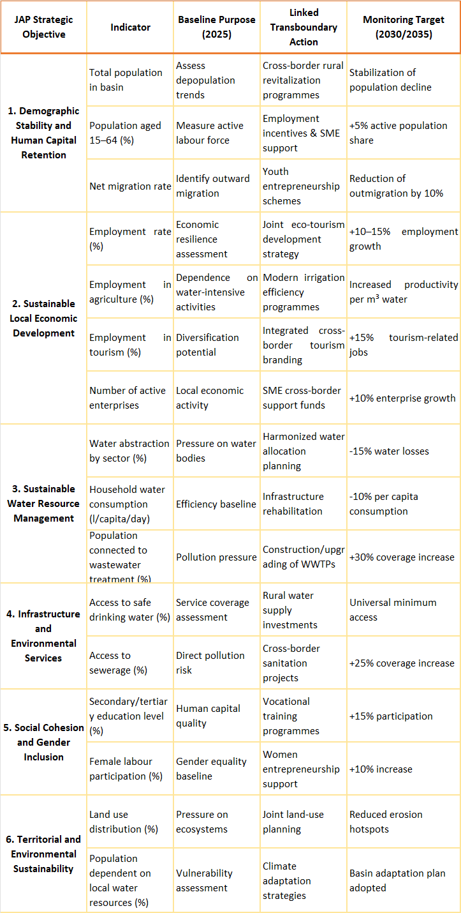

3.2. Institutional and financial capacities and challenges.
The provision of drinking water and the management of water resources in the Cemi River basin, within the Malësi e Madhe Municipality, reflect a mix of ongoing reforms, targeted investments, and persistent institutional and financial challenges. Historically, water supply systems in the municipality were largely outdated, offering intermittent service of only a few hours per day due to decades of underinvestment. This situation highlighted the need for a strong institutional capacity to manage and maintain complex water infrastructure.
To address these gaps, the Albanian government has committed to major rehabilitation projects. For example, new water networks have been designed to provide continuous 24-hour service, replacing systems last upgraded in the 1970s. These investments demonstrate an institutional commitment to improving service reliability through capital-intensive projects (Open Procurement, 2025).
Institutional Capacities in Albania
Groundwater and surface water governance in Albania are regulated under Law No. 111/2024 “On Water Resources”, which strengthens the integration of surface and groundwater management at the river basin level (Republic of Albania, 2024). The National Agency for Water Resources Management (AMBU) oversees water allocation, permitting, and monitoring, while River Basin Councils serve as platforms for stakeholder participation and basin-level planning.
At the local level, municipalities such as Malësi e Madhe are responsible for drinking water supply, sanitation, and local development planning. However, their capacity to effectively manage groundwater remains limited due to fragmented mandates, insufficient technical expertise, and weak integration of water management into socio-economic planning (World Bank, 2022). Coordination between water authorities, municipal structures, and sectoral institutions (agriculture, energy, environment) has improved but remains largely procedural rather than operational. The municipality currently employs 63 staff members, with technical departments responsible for water and environmental services remaining understaffed relative to local needs, particularly in rural and mountainous areas where service provision is logistically challenging (Prefecture of Shkodër, 2024).
Financial Capacities and Constraints
Funding for water management institutions in Albania relies heavily on state budget allocations and donor-supported projects, while cost recovery mechanisms (especially for groundwater abstraction), are inconsistent (European Commission, 2023). Local water utilities often face financial stress due to ageing infrastructure, high non-revenue water, and limited investment capacity, which indirectly increases pressure on groundwater resources.
Budget execution data indicate that realized expenditures for water and drainage infrastructure are often lower than planned, reflecting challenges in project implementation, procurement, or technical preparation (Prefecture of Shkodër, 2024). This is particularly evident in remote villages where maintenance and expansion require significant logistical and financial effort.
Sectoral Water Use and Budget Implications
Water use in the Cemi River basin spans domestic, agricultural, industrial, and tourism sectors, all of which are influenced by municipal and national budget allocations.
Domestic water supply relies mainly on groundwater and springs. The Bajza Water Supply Project provides continuous access to safe drinking water, with 33.2 million ALL allocated in 2025 for pipeline rehabilitation, storage improvement, and metering infrastructure. Supervision contracts, such as the 1.3 million ALL for Tamare village, ensure quality control (Open Procurement, 2025).

Agriculture, the dominant local economic activity, depends heavily on irrigation. National programs have expanded the rehabilitated irrigated area from 135,000 ha in 2015 to about 265,000 ha in 2025, covering approximately 75% of potentially irrigable land. The Ministry of Agriculture allocated 2.9 billion ALL in 2025 for irrigation and drainage infrastructure across 29 municipalities, including Malësi e Madhe, improving water availability for crops and livestock during dry periods (MBZHR, 2024).
Industrial water use is limited but indirectly benefits from improved drinking water infrastructure. Small agro-processing units and local water-dependent businesses rely on a reliable supply for operational continuity, particularly during peak tourism seasons.
Tourism development in the Municipality of Malësia e Madhe (Tamarë, Lepushë, Kelmend) area represents a growing seasonal pressure on local water resources, particularly groundwater and spring-fed systems. Based on registered accommodation capacity (approximately 1,150–1,250 beds) and standard assumptions regarding seasonal occupancy and length of stay, the number of overnight tourists in the area is estimated at approximately 30,000–40,000 visitors per year. This seasonal influx substantially increases water demand during summer months, when natural water availability is typically at its lowest (European Commission, 2021; OECD, 2018). Average water consumption by tourists in rural and mountain destinations ranges between 120 and 200 litres per person per day*, depending on service level and accommodation type. Applying conservative estimates, tourism-related water demand in the study area may reach 140–250 m³/day* during peak season, in addition to local domestic and agricultural water needs. This additional demand places pressure on groundwater abstraction and spring sources, which constitute the primary water supply for both residents and visitors (UNWTO, 2019; WHO & UNICEF, 2021).
The seasonal concentration of tourism intensifies short-term water stress, increases competition between domestic, agricultural, and tourism water uses, and heightens the risk of over-abstraction and reduced environmental flows. In the absence of centralized water supply systems and wastewater treatment infrastructure, increased tourism activity may also contribute to groundwater quality pressures through higher wastewater generation and reliance on septic systems. These dynamics highlight tourism as a significant socio-economic pressure driver, with direct implications for sustainable water management and planning in the Cem/Cjevna River Basin.
The water supply sector in Malësi e Madhe Municipality is served by the Shkodër Regional Water Supply and Sewerage Company, which regulates tariffs under the authority of ERRU (Water Regulatory Authority). For 2025, the household/domestic tariff is set at 55 ALL per cubic metre, effective from January 1, 2025, reflecting a ~37.5 % increase from the previous rate. Small businesses and public institutions are charged the same unit rate, although in many cases, tariffs for these categories have remained unchanged. Additional fixed fees per construction may apply depending on meter size. These regulated tariffs support the sustainability of the water supply system, allowing it to meet the domestic, agricultural, and seasonal tourism demand in the region (ERRU, 2025). Overall, these budgetary measures illustrate a multi-sectorial approach to water management, integrating infrastructure development, project supervision, and financial sustainability to meet the needs of households, farmers, industry, and tourism in the Cemi basin. The alignment of municipal investments with national sectorial funding ensures that the local water system supports both socio-economic development and environmental sustainability.

Despite such investments, institutional weaknesses persist at the utility level across Albania, including in regional water companies such as UK Shkodër, which serves Malësi e Madhe among other municipalities. According to the World Bank’s Albania Water Sector Governance and Financing Diagnostic, most water utilities in Albania continue to perform poorly both technically and financially, which limits their ability to expand services—particularly in rural areas. A significant proportion of the 58 municipal water utilities rely on central government budget transfers due to insufficient cost recovery and low revenue generation, with approximately 37 utilities depending on state subsidies to maintain operations. This reliance on external financing highlights deep institutional and financial constraints that hinder long-term sustainability, service quality, and investment planning (World Bank, 2022).
At the national level, the Water Supply and Sewerage Sector Strategy 2022–2030 emphasizes the need for comprehensive governance reform to strengthen institutional capacity, improve organizational efficiency, and ensure long-term financial sustainability. A central component of this reform is the regionalization process, which merges small municipal water utilities into larger regional companies. In the northern region, this includes the establishment of the Regional Water Utility of Shkodër (UKR Shkodër), which is planned to incorporate Malësi e Madhe.
The regionalization model aims to generate economies of scale, enhance technical and operational performance, and improve access to international financing and technical expertise (AKUM/AKUK, 2025; MIE, 2023) .However, financial challenges remain significant. Water utilities nationwide have faced structural financial deficits, with large accumulations of debt due to inefficiencies and high operating costs, particularly energy costs for pumping in older systems. While national reporting does not yet provide municipality-specific debt data for Malësi e Madhe, the broader trend in Albania, including utility debts reaching hundreds of millions of euros, illustrates the magnitude of the financial challenge for water service providers and underscores the need for stronger financial planning and revenue collection mechanisms.
According to the 2022 Annual Report of the Albanian Water Regulatory Entity (ERRU), the water supply and sewerage sector received 1.68 billion lek (~€14 million) in foreign financing, primarily from KFW (Municipal Infrastructure Programs III, IV, and V), the World Bank, SECO, and SIDA, and 99.4 % of this amount had been disbursed, with funds directed mainly to ongoing projects to fulfill the National Strategy for sector reform (ERRU, 2023).
Complementing these institutional and financial reforms, capacity-building activities, such as technical training for staff of the Shkodër Regional Water Supply and Sewerage Company and support to the Municipality of Malësi e Madhe (ASIG & ASPA), aim to strengthen local administrative and technical skills, particularly in data management and geospatial information systems, which are critical for planning and operational efficiency (ASIG, 2025).
Institutional and Financial Challenges
Despite significant investments, institutional challenges persist:
- Institutional weaknesses at utility and municipal levels limit operational performance. Many small municipal water utilities rely on central government subsidies due to insufficient cost recovery, with approximately 37 out of 58 utilities dependent on state transfers (World Bank, 2022).
- Financial deficits are common, with debt accumulation caused by inefficiencies, high operating costs, and energy-intensive pumping in older systems.
- Capacity-building gaps exist in technical skills, data management, and geospatial planning, despite ongoing support from initiatives such as ASIG & ASPA (ASIG, 2025).
- Regionalization reforms aim to merge small municipal utilities into larger regional companies, such as the UKR Shkodër, to improve economies of scale, operational efficiency, and access to international financing (AKUM/AKUK, 2025; MIE, 2023).
- In this context, the key financial challenges can be summarized as:
- Energy-biased investments: Hydropower development dominates financial priorities, limiting support for multifunctional river ecosystem management.
- Underfunded ecological maintenance: Insufficient resources for monitoring, river flow protection, fish habitat restoration, and community water management.
- Difficult mobilization for sustainable projects: Eco-tourism, biodiversity, and community-focused projects face higher funding barriers compared to energy projects.

At the transboundary level, challenges are amplified due to:
- Absence of a formal bilateral agreement for shared groundwater management, despite hydrological interdependence.
- Cooperation has been project-based and episodic, without institutionalized joint monitoring or coordinated investment planning (UNECE, 2018).
- Limited financial and institutional capacity threatens equitable water allocation, long-term resource sustainability, and resilience to climate pressures.
Strengthening local institutional capacity, financial mechanisms, and structured transboundary cooperation frameworks is essential to ensure sustainable groundwater management in line with DIKTAS II methodology.

3.3. Stakeholder analysis.
From a socio-economic perspective, stakeholders in the Albanian part of the Cemi River basin are diverse and highly interdependent, reflecting the basin’s rural character, reliance on natural resources, and institutional complexity. Local households and rural communities, particularly in Kelmend Administrative Unit, are primary stakeholders, as their livelihoods depend directly on reliable access to groundwater and spring water for domestic use, small-scale agriculture, livestock breeding, and seasonal tourism. These groups are among the most vulnerable to water supply interruptions, quality degradation, and climate-induced variability, given limited infrastructure, lower income levels, and reduced access to alternative services (INSTAT, 2023; Prefecture of Shkodër, 2024).
Small farmers and agri-pastoral producers constitute another key stakeholder group, representing a significant share of local employment and economic activity. Their dependence on irrigation, informal abstractions, and natural springs links agricultural productivity directly to groundwater availability and management decisions. At the same time, tourism operators and rural guesthouses, which have expanded in recent years along the Cemi corridor, are increasingly influential stakeholders, as seasonal tourism significantly increases water demand and sanitation pressures, creating both economic opportunities and resource stress (MTE/INSTAT, 2025).
From an institutional standpoint, local government authorities, particularly the Municipality of Malësi e Madhe and associated public service providers, play a central role in water supply, sanitation, and local development planning. However, their ability to act effectively is constrained by limited financial resources, staffing shortages, and dependence on national programs and donor funding (World Bank, 2022). Regional and national institutions, including the Water Resources Management Agency, sectoral ministries, and the Water Regulatory Authority (ERRU), are influential stakeholders through policy setting, regulation, and financing, but their engagement at the local basin level remains largely top-down and project-driven.
Civil society organizations and NGOs in the region such as environmental and community-based groups active in northern Albania, function as bridging stakeholders by raising awareness, supporting community engagement, and participating in pilot initiatives related to water protection and sustainable development (UNECE, 2015; Riverwatch, 2015).
Within the Joint Action Plan, this stakeholder landscape underscores the need to balance national-level governance with local socio-economic realities, ensuring that water management measures support livelihoods, reduce vulnerability, and deliver tangible benefits to communities most dependent on the Cemi basin’s water resources.
Stakeholder analysis
Effective governance of the transboundary aquifer in the TBA Cemi Cijevna depends on the interaction of stakeholder groups operating at different administrative levels and with uneven influence, dependency and capacity. The stakeholder landscape is shaped by a clear upstream downstream asymmetry. In Albania, pressures are generated through dispersed household level and land use practices under limited local institutional capacity. In Montenegro, exposure and dependency are concentrated through peri urban growth and reliance on public water services, supported by stronger operational institutions but limited leverage over upstream drivers.
This stakeholder analysis identifies key actors relevant to groundwater governance, assesses their roles and interests, and highlights coordination challenges that affect implementation of the Joint Action Program. It builds on the Bilateral Groundwater Governance Diagnostic Analysis for the TBA Cemi Cijevna and focuses on stakeholders whose decisions, practices or mandates influence groundwater quantity, quality and long term sustainability.
Stakeholder categories and roles
Stakeholders relevant to groundwater governance can be grouped into seven broad categories: national institutions, sub national and local authorities, water utilities, protected area and tourism authorities, economic users, civil society organisations, and local communities.
National water and environmental institutions define policy frameworks, protection standards and monitoring systems. They hold high influence through regulatory authority, technical expertise and access to data. Their direct dependency on groundwater may be moderate, but their decisions shape the operating space for all other stakeholders.
Sub national and local authorities are responsible for spatial planning, sanitation, waste management, local inspections and permitting. Their formal influence is moderate, but their practical role is critical because many pressures originate at local level. Capacity constraints and competing priorities often reduce their ability to integrate groundwater protection into routine decisions.
Water utilities are key operational stakeholders with high dependency on groundwater resources, particularly in the downstream Montenegrin context where service continuity and public accountability are directly linked to groundwater status. Utilities provide valuable operational data and have strong incentives to protect groundwater, but their influence over upstream land use and diffuse pollution sources is structurally limited.
Protected area administrations and tourism authorities influence groundwater outcomes in environmentally sensitive zones and recreation corridors where seasonal pressure concentrates water use, wastewater generation and waste accumulation. Their influence is moderate to high in specific locations and periods, with dependency linked to ecosystem quality and sustainable tourism revenue.
Economic users including tourism operators, small businesses and agricultural users influence groundwater through abstraction, wastewater generation and land use practices. Individually their influence is often low, but cumulatively they represent a significant pressure on groundwater quality, especially in karst recharge zones. Dependency varies by sector, with agriculture and tourism sensitive to water availability and environmental quality.
Civil society organisations and community groups support awareness raising, advocacy and participatory monitoring. Their formal influence is low, but they contribute to transparency and trust building, especially where institutional presence is limited. Their effectiveness depends on institutional openness and structured channels for feedback.
Local communities, especially upstream rural households relying on on site sanitation systems, have direct and continuous interaction with groundwater. Individual influence is low, but collective practices related to sanitation, waste disposal and land use are major diffuse pressure drivers. Communities are highly dependent on groundwater but often have limited awareness of vulnerability and upstream downstream linkages.
Stakeholder influence and dependency
Stakeholders differ significantly in influence and dependency. National institutions combine high influence with low to moderate direct dependency. Water utilities combine high dependency with moderate influence. Local authorities and tourism related authorities hold moderate influence but face capacity constraints. Communities and small economic users have high dependency but low individual influence. This imbalance creates a governance challenge because those most dependent on groundwater often have the least authority and capacity to drive protection measures, while those with high influence are institutionally distant from local pressures.
Transboundary asymmetries
Stakeholder roles and capacities differ across Albania and Montenegro due to different administrative systems, levels of decentralisation and enforcement capacity. These asymmetries complicate coordination and contribute to perception gaps, particularly where upstream diffuse pressures affect downstream public water security. Effective implementation of the Joint Action Program therefore requires differentiated engagement and capacity strengthening that recognises upstream downstream dependencies while promoting shared responsibility across the border.

Implications for the Joint Action Program
- The stakeholder analysis highlights the need to:
- Prioritize stakeholders with high dependency and high impact on groundwater outcomes
- Strengthening the capacity of local and sub-national authorities as key implementation actors
- Engage economic users and communities through practical, behaviour-focused mechanisms
- Use civil society as a bridge between institutions and communities
- Clarify and coordinate roles across borders to address asymmetries

These findings directly inform the design of institutional strengthening measures, stakeholder engagement activities, community participation mechanisms and monitoring and evaluation arrangements under the Joint Action Program.

Table 3.2 Stakeholders group and their dependency on groundwater

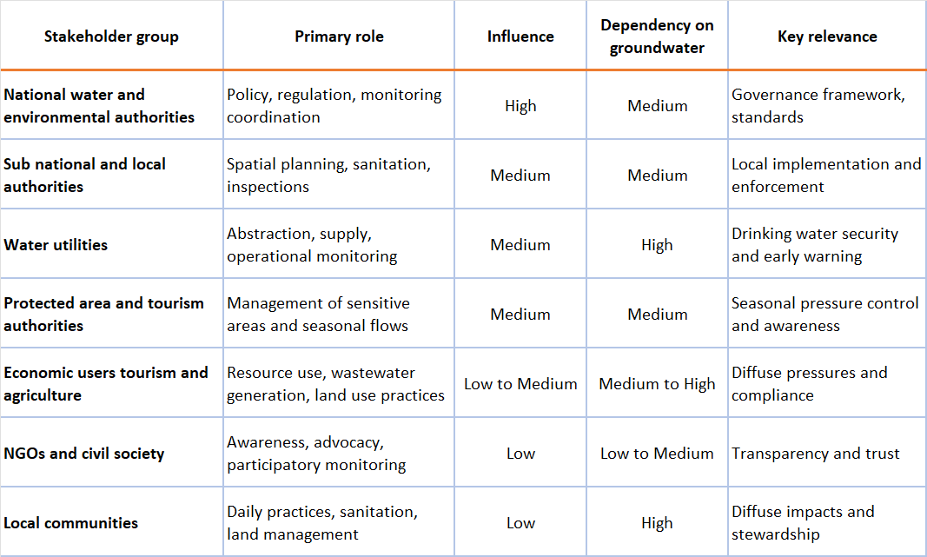

3.4. Gender analysis
From a socio-economic and governance perspective, gender dimensions play a critical role in water use, access to resources, and livelihood resilience in the Albanian part of the Cemi River basin. Women are central actors in household water management, small-scale agriculture, livestock care, and rural tourism activities, particularly in remote areas such as the Kelmend Administrative Unit. Despite this central role, women’s access to productive assets, formal decision-making, and property ownership remains significantly lower than that of men, shaping unequal exposure to water-related risks and limiting their capacity to benefit from development interventions (INSTAT, 2023; World Bank, 2019).
According to INSTAT and World Bank data, women in northern rural Albania are more likely to be engaged in unpaid family work, subsistence agriculture, and informal economic activities, while formal employment and higher-income opportunities remain male-dominated. In Shkodër Prefecture, female employment rates are lower than male rates, and women’s average wages are among the lowest nationally, reinforcing economic dependency and vulnerability (INSTAT, 2023; INSTAT, 2024). These disparities are particularly relevant in the Cemi basin, where livelihoods are highly dependent on water availability and where economic diversification options are limited.
Land and property ownership represent a key structural constraint. Nationally, women own or co-own less than 20% of registered agricultural land and property, despite legal equality in inheritance rights (FAO, 2021; World Bank, 2019). In rural and mountainous areas such as Malësi e Madhe and Kelmend, traditional inheritance practices and informal land tenure systems further reduce women’s effective control over land, water sources, and irrigation infrastructure. This limits women’s eligibility for agricultural subsidies, irrigation schemes, credit, and compensation mechanisms linked to water infrastructure investments, thereby constraining their socio-economic empowerment.
From a water governance perspective, women are underrepresented in formal decision-making structures, including water user associations, basin-level consultations, and municipal planning processes. While women are primary managers of domestic water use and sanitation, their participation in institutional forums related to groundwater protection, infrastructure planning, and tariff setting remains limited (UNECE, 2015; World Bank, 2022). This gap reduces the responsiveness of water management measures to household-level needs and social equity concerns.
Within the Joint Action Plan (JAP) framework, addressing gender inequalities is therefore not only a social objective but also a functional requirement for effective water governance. Integrating gender considerations into JAP actions—such as ensuring women’s access to information, supporting women-led rural enterprises linked to agriculture and tourism, and promoting gender-sensitive criteria in land registration and water infrastructure projects—can enhance the sustainability and socio-economic impact of water management in the Cemi basin. Strengthening women’s rights to property and productive resources, alongside their participation in water-related decision-making, contributes directly to improved household resilience, more equitable resource use, and long-term sustainability of the transboundary aquifer system.

3.5 Role, services and significance of groundwater and groundwater dependent ecosystems
In the Cem/Cijevna River Basin, groundwater is not only a hydrological component but a critical socio-economic asset, underpinning livelihoods, settlement viability, public health, and ecosystem services. This importance is particularly pronounced in the Albanian part of the basin, where demographic decline, ageing population, dispersed rural settlements, and limited infrastructure make groundwater the most reliable and cost-effective water source for both households and economic activities (INSTAT, 2024; STAR2 UNDP, 2025).
The basin’s karstic hydrogeology supports numerous springs and shallow aquifers that are directly linked to rural resilience. In areas such as Kelmend, where population density often falls below 20 inhabitants/km² and centralized water infrastructure is economically unviable, groundwater enables continued habitation, livestock farming, and seasonal tourism (CityPopulation.de, 2025; EcoAlbania, 2023). Thus, groundwater plays a stabilizing role in a region experiencing out-migration and labour force contraction, acting as a foundational resource that sustains remaining populations and prevents further socio-economic marginalization.
Groundwater services for human use
Groundwater constitutes the primary source of drinking water for a large share of rural and mountainous settlements in Malësi e Madhe, especially where centralized surface water supply systems are absent or technically unfeasible. Many villages rely on spring capture systems, small gravity-fed networks, and shallow boreholes, which provide relatively stable water quantities throughout the year compared to surface streams that experience strong seasonal variability (Prefecture of Shkodër, 2024). In addition to domestic supply, groundwater supports: a) livestock watering, particularly in pasturelands and transhumance areas;b) small-scale irrigation during dry summer months; c) seasonal tourism infrastructure, especially in areas such as Vermosh, Boga, and Razma, where summer population peaks increase water demand (EcoAlbania, 2023; STAR2 UNDP, 2025). However, groundwater abstraction remains largely decentralized and weakly monitored, with limited data on abstraction volumes, recharge rates, and long-term sustainability. This poses risks of localized over-abstraction, particularly during drought periods and tourism peaks.
Groundwater as a pillar of rural livelihoods and local economies
Groundwater is the primary drinking water source for most rural settlements in Malësi e Madhe, supplied through spring captures and small gravity-fed systems. These systems are relatively low-cost and community-managed, making them suitable for sparsely populated mountainous areas with limited municipal budgets and technical capacity (Prefecture of Shkodër, 2024).
From a socio-economic perspective, groundwater supports: a) subsistence and semi-subsistence agriculture, particularly livestock watering and small irrigated plots; b) pastoral systems and seasonal grazing, which remain central to household incomes; c) tourism-related services, including guesthouses and mountain lodges, where water availability directly affects business viability during peak summer months (EcoAlbania, 2023).
Seasonal tourism in corridors such as Vermosh–Boga–Razma introduces temporary population surges, increasing groundwater abstraction during periods of low recharge. While tourism contributes positively to local income diversification, it also creates short-term stress on groundwater systems, highlighting the need for adaptive management under JAP for Cemi/Cijevna.
Groundwater-dependent ecosystems (GDEs) are a critical but often under-recognized component of the Cem/Cijevna basin’s ecological system that provide ecosystem services with direct socio-economic value, even if these benefits are not always monetized. In the basin, GDEs include: a) karst springs and spring-fed streams; b) riparian zones sustained by shallow groundwater tables; c) wet meadows and pasturelands in valley bottoms; d) subsurface aquatic ecosystems within karst conduits (European Commission, 2018; UNECE, 2021).
These ecosystems depend on both the quantity and quality of groundwater, and are particularly sensitive to changes in recharge, abstraction, and contamination. Springs along the Cem River corridor contribute to maintaining baseflow during dry periods, ensuring ecological continuity and supporting aquatic habitats of high biodiversity value (UNECE, 2015). Groundwater-dependent riparian vegetation also plays an important role in bank stabilization, nutrient retention, and temperature regulation, which are essential for achieving and maintaining good ecological status under the EU Water Framework Directive (European Commission, 2000).
Socio-economic benefits of GDEs include: a) sustaining baseflows that support fisheries, livestock access, and water abstraction during dry periods; b) maintaining landscape quality, which underpins eco-tourism attractiveness; c) reducing flood and erosion risks through riparian stabilization; d) supporting traditional land uses, such as hay meadows and grazing lands.
In ageing and depopulating communities, these ecosystem services help reduce vulnerability by maintaining natural capital where financial and institutional capital are limited. The degradation of GDEs would therefore have disproportionate socio-economic impacts on rural households with few alternative resources.
Socio-Economic pressures and risks on Groundwater Systems
Groundwater and associated ecosystems in the Cem basin face several pressures linked to socio-economic conditions and land use patterns:
- Diffuse pollution from inadequate sanitation systems and partial waste collection coverage (~78% of population), particularly in remote villages, poses risks to groundwater quality (Municipality of Malësi e Madhe, 2025)
- Agricultural activities, including livestock feeding and manure management, contribute to nutrient loading and localized contamination of shallow aquifers.
- Seasonal water demand peaks associated with tourism increase abstraction pressure during summer low-recharge periods.
- Climate variability and climate change, including reduced snowpack and altered precipitation patterns, may affect groundwater recharge dynamics in mountainous areas (European Environment Agency [EEA], 2019).
Karst aquifers are especially vulnerable because contaminants can travel rapidly through subsurface conduits with limited natural attenuation, increasing the risk of cross-border pollution impacts.

Table 3.3. Implications for JAP and Socio-Economic Relevance of Groundwater
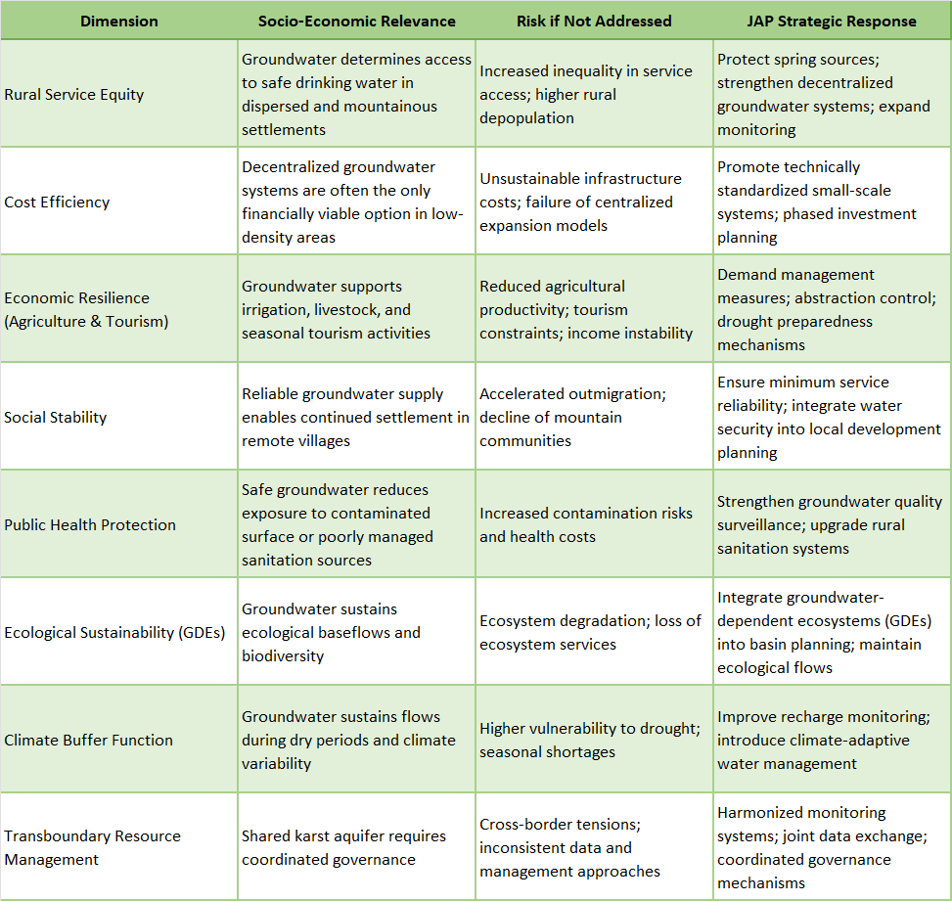

Table 3.4. Socio-Economic Functions of Groundwater in the Cem Basin
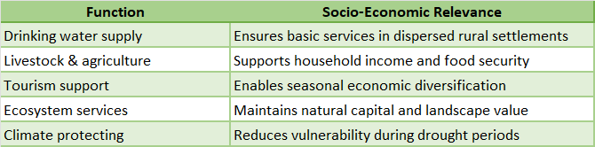
Source: STAR2 UNDP (2025); EcoAlbania (2023); UNECE (2015)

Table 3.5 Socio-Economic Risks from Groundwater Degradation
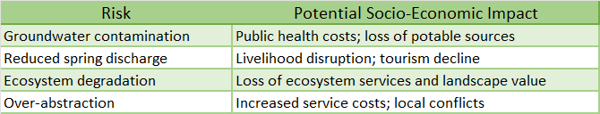
Source: EEA (2019); Municipality of Malësi e Madhe (2025)

Table 3.6 Groundwater Pressure Assessment and Configuration of JAP Actions
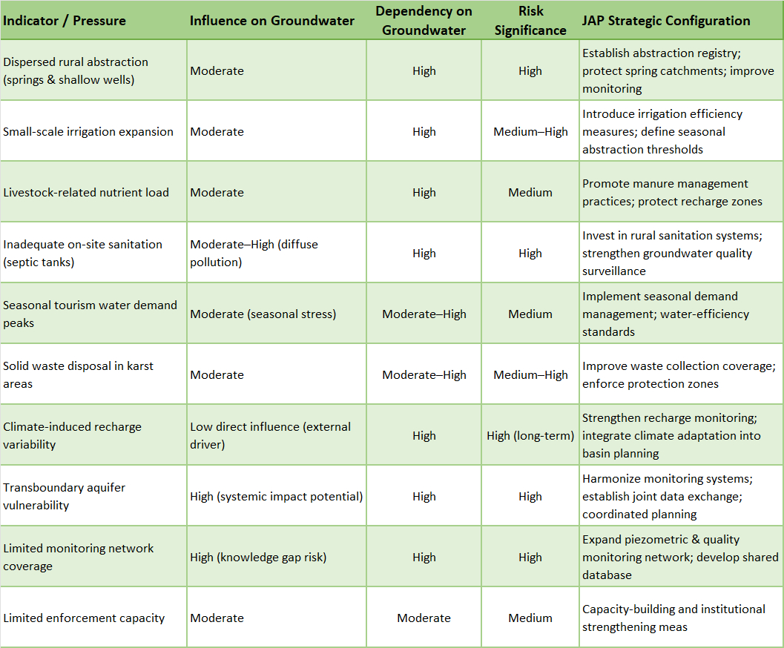

3.6 Water supply and sanitation infrastructure and challenges
Water supply infrastructure in the Municipality of Malësi e Madhe is shaped by the municipality’s dispersed settlement pattern, mountainous terrain, and declining population, particularly in the Administrative Unit of Kelmend. According to municipal and regional profiles, water supply services are more developed in urban and peri-urban centres such as Koplik and Bajzë, while rural and mountainous villages rely primarily on small-scale and decentralized water supply systems (STAR2 UNDP, 2025). In Kelmend, where population density is very low and settlements are scattered, households are commonly supplied through local spring catchments, gravity-fed systems, and small networks, rather than through centralized infrastructure. These systems typically serve limited numbers of households and are vulnerable to seasonal variability, particularly during summer periods when water demand increases and spring discharge may decrease (STAR2 UNDP, 2025). Although specific per-capita water supply indicators are not published in the available municipal datasets, budgetary information confirms that water and drainage infrastructure remains a priority investment area. In 2023, the Municipality of Malësi e Madhe allocated 24.3 million ALL for water and drainage infrastructure, of which 16.6 million ALL were actually realized, indicating implementation constraints (Prefecture of Shkodër, 2024).
Sanitation infrastructure and wastewater management
Sanitation infrastructure across Malësi e Madhe shows a similar spatial imbalance. Organized wastewater collection and drainage systems are concentrated in urban areas, while rural and mountainous settlements largely depend on individual solutions, such as septic tanks or informal disposal systems (STAR2 UNDP, 2025; Prefecture of Shkodër, 2024). The absence of extended sewerage networks in many villages, combined with dispersed housing patterns, increases the risk of environmental contamination, particularly in settlements relying on nearby water sources for domestic use.
Municipal budget data show that waste management services received 5.7 million ALL in both planned nd realized expenditures in 2023, indicating stable but limited financial capacity to expand or upgrade sanitation-related services (Prefecture of Shkodër, 2024).
The Administrative Unit of Kelmend, which experienced a 52.1% population decline between 2011 and 2023, faces the greatest challenges in water supply and sanitation provision. Extremely low population densities and difficult access conditions increase the per-capita cost of infrastructure investments and limit economies of scale (INSTAT, 2024; CityPopulation.de, 2025).These conditions result in: a) limited coverage of centralized water supply systems; b) reliance on decentralized and household-level solutions, and c) uneven access to sanitation services compared to municipal centers.
As highlighted in the STAR2 UNDP (2025) local governance profile, service provision in remote villages is more fragmented and less reliable, reinforcing territorial inequalities within the municipality.
Key challenges and socio-economic implications
Based on available municipal and regional data, the main challenges related to water supply and sanitation infrastructure in Malësi e Madhe and Kelmend include:
- Dispersed settlements and low population density, increasing infrastructure costs per capita;
- Limited centralised infrastructure in mountainous areas;
- Dependence on small-scale and decentralized water systems, with variable reliability;
- Uneven sanitation coverage, particularly outside urban centres;
- Institutional and budgetary constraints limiting service expansion and maintenance.
- These challenges directly affect quality of life, public health conditions, and socio-economic development, particularly for residents of remote mountain villages.
Addressing them requires targeted planning approaches that reflect demographic trends, settlement patterns, and financial realities at the municipal level.

Table 3.7. Findings for JAP – Water Supply & Sanitation (Malësi e Madhe / Kelmend)
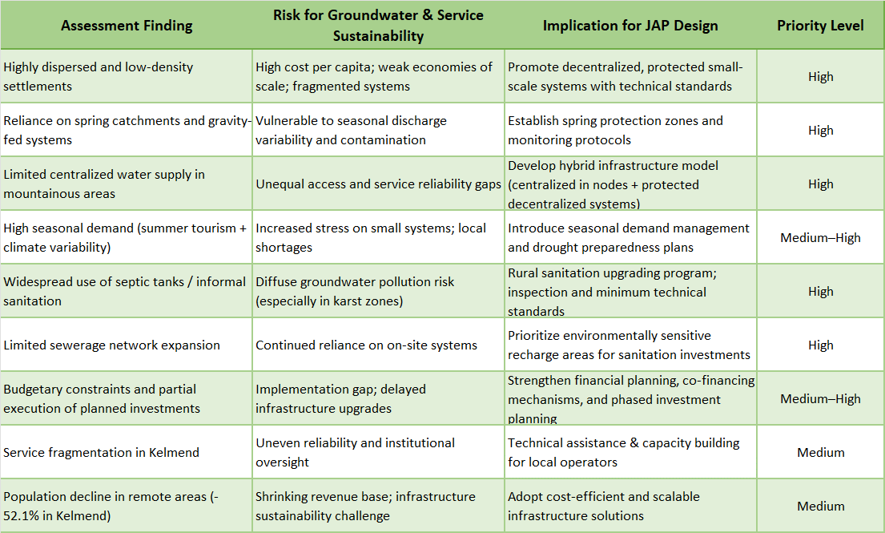

3.7 Current water use by sectors (domestic, agriculture, industry)
If we analyse data from INSTAT, easily can notice that current water use in the Albanian part of the Cem River basin remains relatively low compared to other national sub-basins. This is due to the small population size, limited industrial activities, and the dominance of subsistence-level agriculture in the region. Despite the modest overall abstraction, seasonal variability, outdated infrastructure, and climate pressures make the assessment of sectorial water use essential (INSTAT, 2023).
General context of water use
Current water use in the Albanian part of the Cem/Cijevna River basin reflects the rural and mountainous character of Malësi e Madhe, the dispersed settlement pattern, and the limited presence of industrial activities at AU of Kelmend. Available municipal and regional documentation does not provide sector-specific quantitative water abstraction data; therefore, water use patterns are described based on demographic structure, land use, service provision profiles, and municipal planning documents (STAR2 UNDP, 2025; Prefecture of Shkodër, 2024).
Overall, water use is dominated by domestic consumption and agriculture/livestock, while industrial water use is negligible. Domestic water use in the basin relies mainly on spring-fed systems, small piped networks, and local groundwater sources. Household water consumption in rural and mountainous areas of the Cem/Cijevna basin is generally modest and lower than urban averages, reflecting intermittent supply systems, dispersed settlements, and reliance on local groundwater sources. International rural water supply benchmarks indicate indicative consumption levels typically below standard urban norms, often cited in the range of approximately 70–110 liters per capita per day (WHO & UNICEF, 2023; UNDP, 2022). Access to a piped water supply varies substantially across the basin. Municipal centers such as Bajzë generally have higher coverage and more stable access. In contrast, many rural and mountainous settlements—including those in the Kelmend Administrative Unit—continue to rely on a mix of local springs, wells, and small community-managed systems, reflecting the lower level of centralized water service coverage in rural northern Albania. National assessments note that rural areas often depend on non-centralized schemes or self-provision where full network infrastructure is lacking (UNECE, 2022). The residents of Tamara and the areas where the Cemi River and other natural water sources flow, draw water to their homes, directly from the source through pipes. This is an old traditional method, also known by the residents, who in fact did not report how they paid for water, implying the approximate payments for this public service in the Kelmend municipal unit (PD)*.
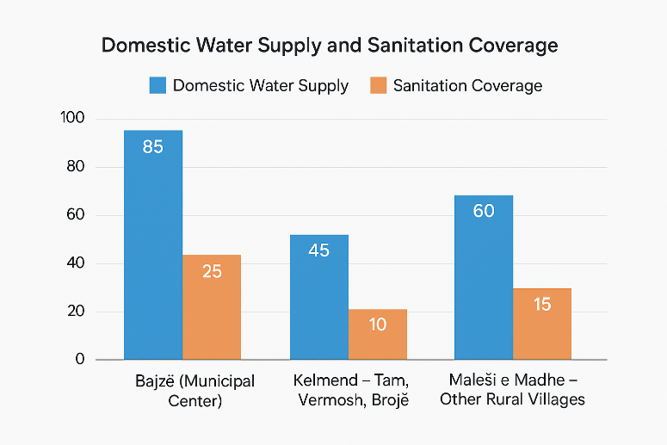
Figure 3.1. Domestic Water Supply and Sanitation Coverage

Domestic water use shows seasonal variation, particularly in mountain areas with tourism activity, where temporary population increases during summer months raise short-term demand for drinking water and sanitation services (STAR2 UNDP, 2025).
Agricultural and livestock water use
Agriculture and livestock are identified as the main economic activities in rural areas of Malësi e Madhe. Water use in this sector is largely non-industrial and small-scale, focused on: livestock watering; irrigation of small agricultural plots, and fodder production. Agriculture is predominantly rain-fed, with limited formal irrigation infrastructure. Where irrigation is practiced, it relies mainly on local water sources, including springs, shallow abstractions, and surface water from small streams (STAR2 UNDP, 2025). The decline in rural population, particularly in Kelmend, has contributed to a reduction in cultivated land and agricultural water demand, but livestock activities continue to require regular access to water throughout the year. Agricultural water use is therefore spatially dispersed and seasonally variable, rather than concentrated or intensive.
However, in the Cem River basin, agricultural water use is significantly lower because the local landscape is dominated by mountainous terrain and small settlements, where most agricultural activity is based on rain-fed crops, livestock grazing, and small household gardens. These production forms require minimal active water abstraction, keeping overall agricultural demand low in the basin (FAO, 2021; UNECE, 2022). Small-scale irrigation is present only in a few lowland areas near the lower part of the basin, but its extent remains limited. As a result, irrigation is either absent or used at minimal capacity in most of the Cem basin. Seasonal pressures on water use do occur during dry summer months, mainly due to increased livestock watering, which reflects the dominant role of pastoral systems in the local economy. Livestock water needs are typically met through natural springs, surface runoff, and shallow groundwater. These conditions make water demand in the agricultural sector highly seasonal but overall low compared to other river basins in the country.
Industrial and Service-Sector Water Use
Industrial water use in the Cem/Cijevna basin is very limited. Available municipal documentation indicates that Malësi e Madhe does not host significant water-intensive industrial facilities, due to the absence of large industrial facilities and the predominantly rural, small-scale economic profile of the area, and agri-based activities, primarily in urban centres (STAR2 UNDP, 2025; Municipality of Malësi e Madhe planning documents).The main water users in this sector include local businesses, small agro-processing units, and tourism-related establishments, which typically rely on municipal water networks, private wells, or local spring-based systems. As a result, industrial water abstractions do not represent a significant pressure on local water resources and are not considered a dominant water use sector in the basin. These patterns are consistent with national data showing that rural areas in northern Albania depend more heavily on decentralized or mixed water sources (INSTAT, 2023; UNECE, 2022).
The Energy Regulatory Authority (ERA / ERE) initiated procedures to modify the license of the hydropower plant “HEC Selca”, located in Selcë village, Tamarë Administrative Unit, Malësia e Madhe, increasing its installed capacity from approximately 1.6 MW to 1.98 MW during the Board meeting on 08 August 2023. This update is confirmed in the official ERE Decision Register for 2023 (ERE, 2023).According to the ERE Decision Register for 2024, the small hydropower plant “Murasi”, with an installed capacity of approximately 2 MW, has been licensed as a facility on the Selca branch of the Cem River in Malësia e Madhe (ERE, 2024).
Business registry sources indicate that Selca Energji sh.p.k., along with other entities such as MATEO & CO and United Energy, are linked to hydropower projects in the region, including areas adjacent to the Cem River (Open Corporates Albania, 2023).
It is evident that several HPPs (Hydropower Plants) in the Malësia e Madhe / Cem area are either licensed or in the process of licensing; however, some projects — such as Ura e Tamarës, Kozhnjë 1/2, and Tamara (according to 2022 documents) — are recorded as suspended or prohibited procedures by ERE, and not always as active facilities (ERE, 2022).
Table 3.8. Overview of Current Water Use by Sector in Malësi e Madhe and Kelmend
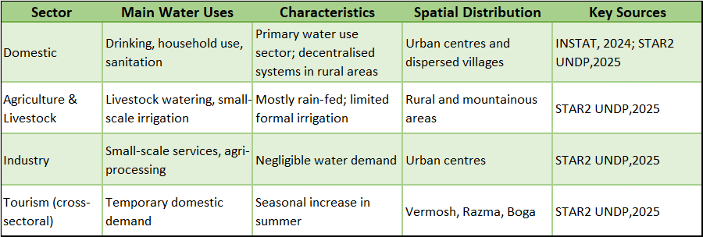

3.8 Future demand projections
Projected future demand for water resources in the Cem River basin and the wider Malësia e Madhe/Kelmend region reflects ongoing socio-economic development, including tourism expansion, agriculture, livestock production, and small hydropower (HPP) development. Seasonal increases in tourism, particularly around Tamara, Selca canyon, and other natural attractions, are expected to put additional pressure on freshwater resources for recreational, domestic, and ecosystem purposes.
Agricultural and livestock water use is projected to remain stable or slightly increase, reflecting rural households’ reliance on stream and groundwater resources for irrigation and livestock, while also seeking income diversification. Concurrently, small hydropower plants, such as HEC Selca (1.98 MW) and HEC Murasi (2 MW), licensed by the Energy Regulatory Authority (ERE), contribute to changing water allocation patterns and necessitate integrated planning to balance energy production, ecological flow requirements, and multi-sectoral water demands (ERE, 2023; ERE, 2024). Climate variability, including potential changes in precipitation and seasonal flows, may further increase stress on water resources, emphasizing the need for adaptive, cross-sectorial water management. Integrated planning that accounts for the demands of tourism, agriculture, energy, and ecosystem services is essential to maintain socio-economic resilience while safeguarding the hydrological integrity of the Cem basin. Considering these drivers, future water demand is expected to increase moderately, especially in the dry season. Seasonal tourism peaks, small-scale irrigation, and climate-induced variability may stress the water system unless investments in efficiency, monitoring, and integrated planning are implemented (World Bank, 2023; Albanian Water Partnership, 2023).
The Cem (Cemi) river basin, located in northern Albania and extending into Montenegro, provides water for domestic supply, small-scale irrigation, livestock, and ecosystem services in both countries. While detailed basin-specific water demand projections are not currently available, national and regional studies guide more credible trends. Establishing basin-specific monitoring and planning tools is recommended to support sustainable water management in the Cem /Cjevna basin.
Transboundary Harmonization under DIKTAS II
The following indicators should be jointly tracked by Albania and Montenegro:
- Water use per capita
- Share of households connected to piped water/wastewater
- Agricultural water demand per hectare
- Tourism intensity index
- Waste collection coverage
- Number of illegal dumping hotspots
- Groundwater quality indicators (nitrates, organic load)
- Ecological flow compliance
- Demographic dependency ratio
- Employment share in agriculture and tourism

Proposed indicators that both Albania and Montenegro can track consistently under DIKTAS II, such as: water use per-capita; share of households connected to piped water/wastewater; agricultural water demand per hectare; tourism intensity index; waste collection coverage; the number of illegal dumping hotspots; demographic dependency ratio; employment share in agriculture and tourism.

Table 3.9 Projected Water Demand by Sector in the Cem Basin (2030)
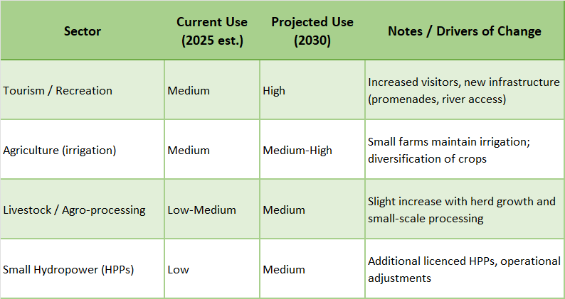

Table 3.10 Implications for JAP from Future Water Demand Projections (Albanian Context)
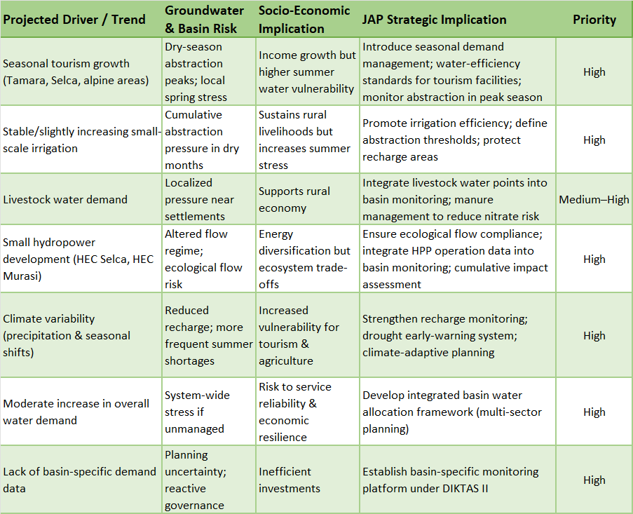

3.9 Water balance and sustainability indicators
The Albanian part of the Cem sub-basin, with a confirmed area of 368 km², represents a mountain–karst hydrological system of high importance for natural water supply. This preliminary water-balance assessment is prepared in a project-report format, using a conservative approach based on: (i) the known hydrogeological behavior of the basin (strong surface water–groundwater interaction in karst terrain), (ii) the current land-cover characteristics, and (iii) the field-based estimate of total discharge from natural springs.
In this sub-basin, water availability should not be interpreted only through river flow. The hydrological regime is controlled by the combined effects of precipitation, infiltration into carstifyed carbonate formations, groundwater storage and release through springs, seasonal snow contribution at higher elevations, and short-term flow variations during wet and dry periods. As a result, the basin behaves as a responsive mountain system, where recharge and discharge can vary significantly across seasons.
Water balance framework
For reporting and planning purposes, the basin water balance may be expressed as:
P+Qin+Gin=ET+Qout+Gout+A+ΔS

Where:
P = precipitation over the Albanian sub-basin
Qin = surface inflow (if considered at the defined assessment boundary)
Gin = groundwater inflow (including karst transfer from adjacent zones, where relevant)
ET = evapotranspiration
Qout = surface outflow
Gout = groundwater outflow
A = abstractions/consumptive use (water supply, irrigation, livestock, etc.)
ΔS = change in storage (groundwater, soil moisture, snow, and minor channel/alluvial storage)

In the case of the Albanian Cem sub-basin, this formulation is particularly important because the system has no natural or artificial reservoirs, meaning that regulation is mainly provided by subsurface karst storage rather than visible surface storage bodies.
Natural spring-water contribution (core input for the preliminary assessment)
Based on field information provided for the Albanian part of the sub-basin, the total discharge of all-natural springs is estimated at:
- Minimum: 975 l/s – (84,240 m³/day ≈ 30.7 million m³/year)
- Maximum: over 1500 l/s – (129,600 m³/day ≈ 47.3 million m³/year)
These values provide a strong basis for a practical and conservative estimate of available water from natural sources.
Using these flow values, the annual volume generated by springs is approximately:
Since the upper value is stated as “over 1500 l/s”, the real seasonal maximum annualized equivalent may exceed 47.3 million m³/year. However, for planning purposes, it is appropriate to treat 1500 l/s as a conservative upper reference and 975 l/s as the operational minimum baseline.
Specific yield of the sub-basin (based on spring discharge only)
When related to the confirmed area of 368 km², the spring discharge corresponds to a specific natural contribution of approximately:

- 2.65 l/s/km² (minimum condition)
- 4.08 l/s/km² (favorable condition, at 1500 l/s)

In equivalent annual depth terms (spring contribution only), this represents roughly:
- 84 mm/year (minimum)
- 129 mm/year (at 1500 L/s)

These values indicate that the Albanian Cemi/Cijevna sub-basin has a meaningful natural water-yield capacity, while also confirming that the springs reflect only part of the total water balance (the remainder being partitioned among evapotranspiration, direct runoff, groundwater transfer, and seasonal storage changes).
Evapotranspiration (preliminary indicative value)
For a forest-covered mountain basin such as this one—where slopes are largely covered by broadleaf forests at lower elevations and coniferous forests at higher elevations, with limited cultivated land—evapotranspiration is expected to be a significant component of the annual water balance. For a preliminary project-level assessment, a reasonable indicative range for actual evapotranspiration (AET) is:
~500 to 700 mm/year (working range)

Over an area of 368 km², this corresponds approximately to:
~184 to 258 million m³/year

A practical mid-value for initial calculations may be taken as:
AET ≈ 600 mm/year, equivalent to about 221 million m³/year

This is an approximate planning value, to be refined later using local meteorological records (temperature, precipitation, humidity, wind), elevation zoning, and preferably a method such as Thornthwaite, Turc, or Penman-Monteith depending on data availability.

Land cover and implications for water balance
The land-cover structure of the basin supports relatively good natural recharge conditions. The mountain areas are largely forested, with altitudinal transition from broadleaf to coniferous forests. This forest cover helps regulate the hydrological response by reducing rapid overland runoff, enhancing infiltration, limiting erosion, and supporting gradual recharge of the karst aquifer system.
At the same time, the basin contains limited cultivated land, which implies relatively low irrigation demand compared to intensively farmed basins. This reduces consumptive pressure on water resources, especially during the dry season, and improves the balance between natural availability and current demand.
The absence of natural or artificial reservoirs means the basin does not have significant surface storage capacity to buffer seasonal fluctuations. Therefore, hydrological regulation depends mainly on karst groundwater storage and delayed spring discharge. In practical terms, this makes the system relatively reactive: flows may increase rapidly after rainfall events, but can also decline substantially during extended dry periods if recharge is limited.
Project-level interpretation for water management
For planning and sustainable management purposes, the minimum spring discharge (975 L/s) should be treated as the conservative operational reference for baseline water availability. Flows above 1500 L/s should be considered a favorable seasonal potential, not a guaranteed year-round supply.
This approach avoids overestimation of available water resources and provides a safer basis for decisions related to water use, source protection, and medium- to long-term resource management.

Conclusion
The Albanian part of the Cem sub-basin (368 km²) has a good natural water-resource potential, supported by substantial spring discharge, forest-covered recharge areas, and karst groundwater storage. Based on currently available field information, the natural springs alone provide an estimated 30.7–47.3+ million m³/year. At the same time, the basin’s mountain–karst nature, absence of reservoirs, and strong seasonal variability require a conservative interpretation of water availability and continued hydrological monitoring to improve the accuracy of the full water-balance assessment.

4. Hydrogeological and environmental characterization

4.1 Karst aquifer dynamics and vulnerability.
The Cemi/Cijevna River watershed represents a typical but highly dynamic Dinaric karst system, where surface water and groundwater are hydraulically interconnected across national boundaries. Originating in the Albanian Alps and flowing downstream into Montenegro before reaching the Zeta Plain, the river traverses massive carbonate formations characterized by intensive karstification, high secondary permeability, and rapid subsurface flow.
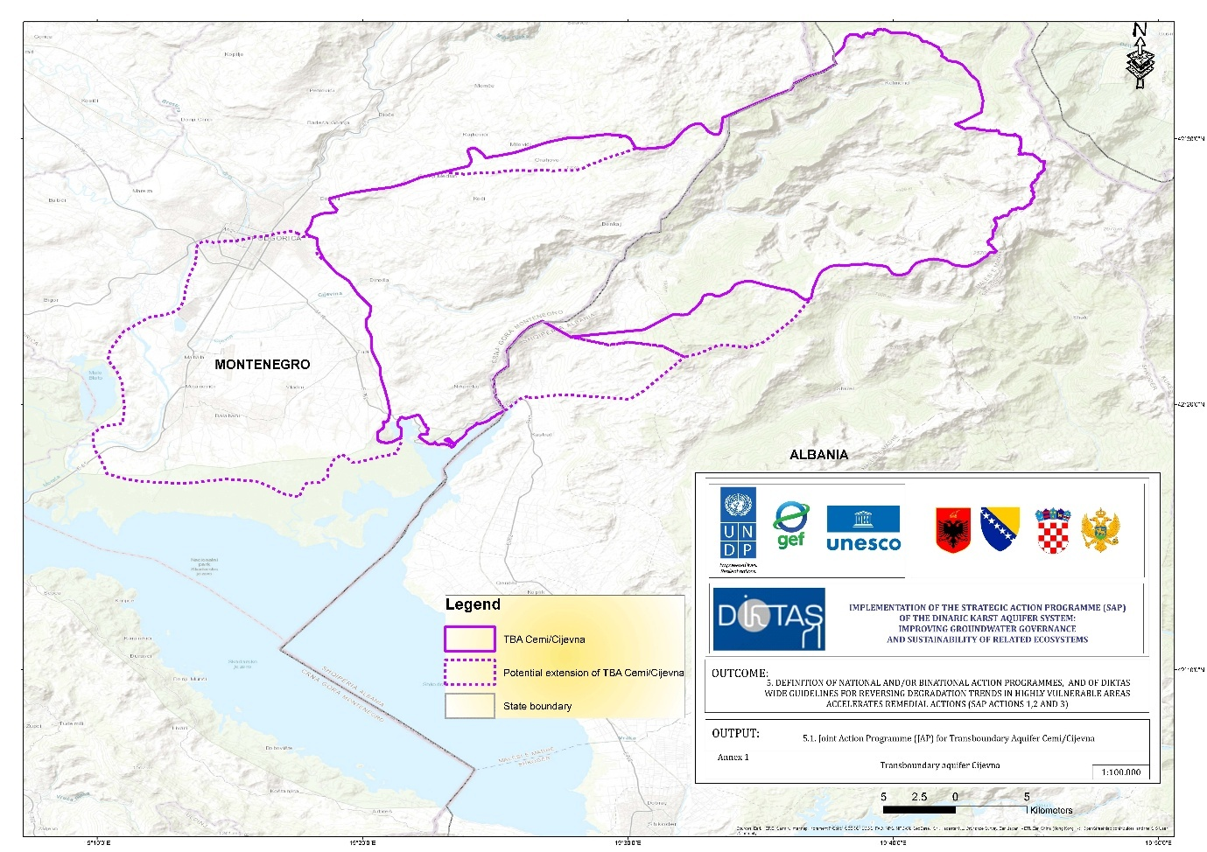
Figure 4.1. Boundary of Cemi/Cijevna TBA

This geological setting governs the hydrological behavior of the basin and determines both its productivity and its vulnerability.
In the upstream and midstream of Albanian sector (Kelmend region, including Grabom and Tamara), the river corridor is incised into thick sequences of limestone and dolomite. These formations host a well-developed karst aquifer, where groundwater flow is controlled by fractures, faults, and solution conduits. Recharge occurs through a combination of diffuse infiltration across exposed carbonate outcrops and concentrated infiltration through losing river reaches, sink points, and epikarst features. The presence of a potential losing segment upstream of Tamara suggests that the river may locally contribute direct recharge to the karst system, particularly during high-flow conditions. Such interactions create rapid hydraulic pathways between the river and groundwater, reducing natural attenuation capacity and increasing system sensitivity to contamination.
The karst aquifer in this sector responds quickly to precipitation events. During intense rainfall or snowmelt, infiltration rates increase sharply, producing rapid rises in spring discharge and marked fluctuations in electrical conductivity and temperature. This “flashy” behavior is typical of conduit-dominated karst systems, where groundwater residence time may vary from hours to weeks depending on flow conditions. Springs such as Grabom and Tamara act as hydrodynamic windows into the aquifer, reflecting its internal storage and flow regime.
As the river crosses into Montenegro, the hydrogeological framework gradually transitions toward a mixed karst–alluvial system. In the upper Montenegrin section (Kuči–Cijevna Canyon), the river still interacts strongly with carbonate bedrock. However, further downstream toward the Zeta Plain, alluvial deposits become increasingly significant. Here, groundwater flow occurs both within karstified bedrock and within intergranular sediments. Seasonal dynamics play a key role: during dry periods, the river may be sustained by groundwater discharge (gaining conditions), whereas during wet periods or high stages, infiltration into the subsurface may occur locally (losing conditions).
This bidirectional exchange mechanism has important transboundary implications. Hydrological processes initiated in Albania-whether related to recharge variability, land use changes, or water abstraction can influence groundwater discharge patterns and water quality conditions downstream in Montenegro. Conversely, groundwater withdrawals or land management practices in the lower basin may alter hydraulic gradients and affect baseflow contributions.
The intrinsic vulnerability of the Cemi/Cijevna karst aquifer is high. Karst systems typically lack the protective filtering capacity found in porous media aquifers. Thin soil cover, open fractures, and direct recharge points facilitate the rapid transfer of surface-derived contaminants into the groundwater system. Potential pressures include untreated wastewater from rural settlements, agricultural runoff containing nutrients or pesticides, solid waste disposal in karst depressions, and morphological alterations of the riverbed. Because of short travel times within conduits, contaminants introduced in recharge zones may reach springs or river sections downstream with limited dilution or degradation.
Climate variability further amplifies vulnerability. Increased frequency of extreme rainfall events can intensify the “first flush” effect, mobilizing accumulated pollutants from the surface into the karst network. Prolonged droughts, on the other hand, reduce dilution capacity and increase pollutant concentrations in both groundwater and surface water. In the context of climate change, the balance between recharge and discharge may become more unstable, potentially affecting water supply reliability for local communities. From a management perspective, understanding the dynamics of losing and gaining river segments is essential. Identifying zones of concentrated recharge allows delineation of priority protection areas.
Springs serving as water supply sources require protective perimeters adapted to karst conditions, acknowledging that groundwater flow paths may not correspond to surface watershed boundaries. Continuous monitoring of discharge, temperature, electrical conductivity, and selected chemical parameters, complemented by environmental tracers such as radon or stable isotopes, can provide critical insight into exchange processes and groundwater residence times.
The Cemi/Cijevna watershed therefore functions as a single hydrogeological unit despite administrative borders. Its karst aquifer exhibits rapid flow dynamics, strong surface–groundwater coupling, and high intrinsic vulnerability. Sustainable management requires coordinated monitoring, data sharing, and harmonized protection measures between Albania and Montenegro. Only through a joint, system-based approach can the ecological integrity of the river and the security of groundwater resources be preserved in the long term.

4.2 Recharge/discharge zones and flow patterns.
The Cem/Cijevna River is a transboundary karst river formed by the confluence of two headwater streams (Cem at Selcë and Cem at Vukël), which merge downstream of Tamara (Albania). The river then crosses the Albania–Montenegro border and joins the Morača River in Montenegro; Morača drains into Lake Shkodra, from which the Buna River flows to the Adriatic Sea.
The river corridor is developed entirely within massive limestone formations, implying a high potential for advanced karstification, conduit-dominated flow and rapid surface water–groundwater exchanges. In the downstream sector in Montenegro, Quaternary deposits occur down to approximately 60 m a.s.l. up to the confluence with Morača, introducing an additional alluvial/intergranular component to the hydrogeological setting.
Several karst springs discharge directly into the river along both valley sides. The springs at Grabom, Grabom 2, Tamara and Tamara 2 (b.5) represent key karst outflow points and provide direct observation windows for aquifer response (discharge, EC, temperature, pH and hydrochemistry). The working hypothesis is the presence of a losing reach approximately 2–3 km upstream of Tamara, where river water may infiltrate through the riverbed and enter the karst network via diffuse leakage and/or focused conduit recharge. The suspected losing reach is defined by UTM Zone 34N coordinates: upstream point E = 382240.17, N = 4702846.51 and downstream point E = 381665.99, N = 4702101.67. If confirmed, this reach would represent a critical river-to-karst recharge window potentially contributing to downstream karst spring discharge and/or to subsurface transfer along the valley.
At present, no direct quantitative evidence is available to confirm the losing-reach hypothesis. Therefore, the conceptual model must be coupled with a dedicated monitoring network designed to test river–karst connectivity using synchronized discharge measurements and high-frequency physico-chemical monitoring in both the river and the candidate springs, complemented where feasible by natural or artificial tracers. This approach provides a defensible basis for confirming or rejecting riverbed drainage into karst and for understanding its role in the transboundary water balance of the Cem/Cijevna–Morača–Lake Shkodra system.

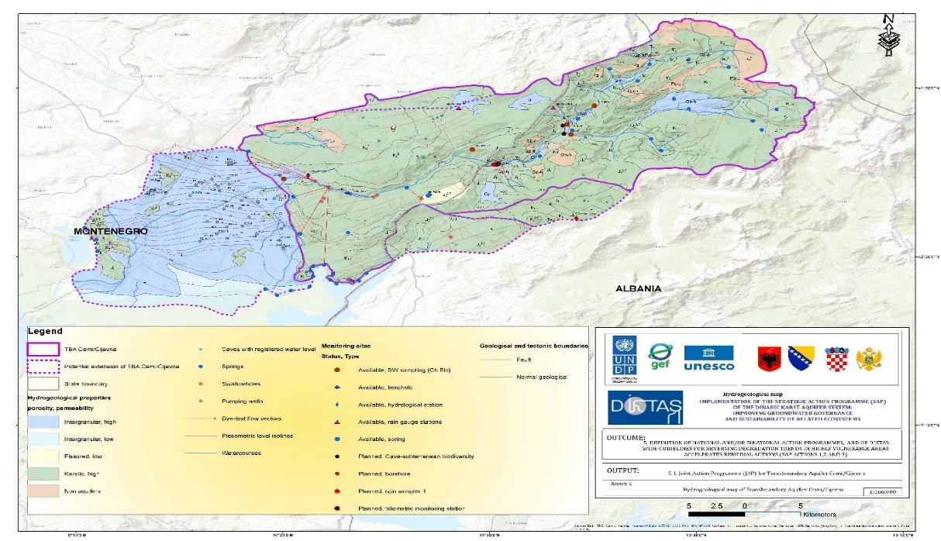

Figure 4.2 Hydrogeological map of Cemi/Cijevna TBA
Table 4.1 Characteristic flows of major karst spring in the TBA Cemi River
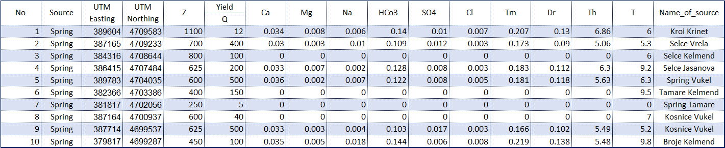
Table 4.2 Summary results – June 2025
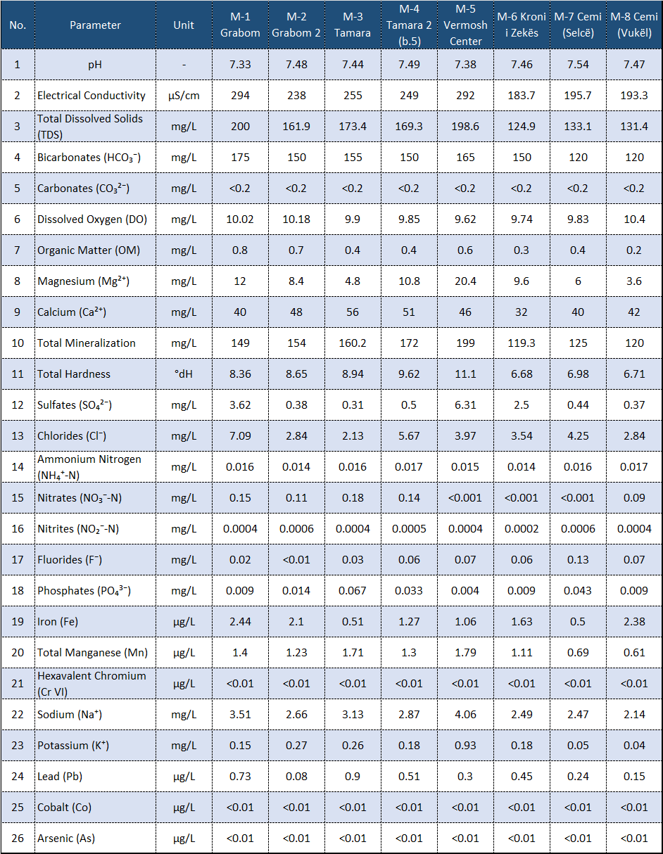
Table 4.3 Coordinates of the springs sampled in Cemi/Cijevna river basin (AKKSHI & ASHSH project, 2025-2026)
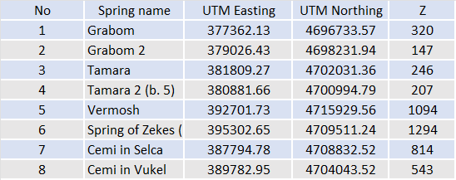

4.3 Groundwater-dependent ecosystems.
In the Albanian karst there are roughly 110 springs with an average discharge exceeding 100 l/s. Of these, 17 have discharges exceeding 1,000 l/s. The majority of them are in the Dinaric part of the country (north from Vjosa). It is estimated that 2/3 of groundwater resources in the entire country are in karstic aquifers which provide more than 60% of the water consumed in Albania (DIKTAS TDA, 2013).
In Albania, out of 60 identified GWBs, 18 are classified as “carbonate”. Iti s estimated that highly karstified rocks and productive karst aquifers crop out over an area of about 6,500 km² or ¼ of Albania’s total surface area. Large karstic areas in the Ionian and Kruja zones and in the Adriatic, basin are covered by flysch and molasses deposits (DIKTAS TDA, 2013).
In Albania Subterranean habitats, within the Dinaric karst area are almost not studied; limited studies have been carried out during 2006-2016 focused only to subterranean gastropods (Grego J. et al, 2017), which represents a very small fraction of the actual species richness. Albanian subterranean environment diversity is still not discovered.
The project karstic watershed in Albania is represented by the transboundary area of Cemi/Cijevna watershed shared between Albania and Montenegro is of special ecological importance due to its high groundwater connectivity.
In Montenegro, the importance of preserving the hydrological, geological, and biodiversity values of the Cijevna River has been formally recognized, and since 2017 the river has been designated as a protected natural asset. This recognition is further supported by hydrological and bioecological studies conducted under the DIKTAS and GEF projects emphasize the need for continued investigation and protection of these shared karst systems (Radulović et al., 2021).
The Water Framework Directive (WFD) recognizes two types of ecosystems that may be associated with groundwater. One is groundwater-associated aquatic ecosystem, which refers exclusively to the connection of groundwater with surface waters and the ecosystems within them. The other type includes terrestrial ecosystems dependent on groundwater.
Karst terrains are characterized by high permeability of fractured carbonate rocks, allowing infiltration of significantly larger amounts of precipitation than other less permeable terrains. As a consequence, surface watercourses are very rare in karst areas, and the majority of discharge occurs underground. One karst-specific feature is the presence of extensive closed depressions, or karst fields, often with sinking rivers, which are also a peculiarity of such areas.
Considering that groundwater plays a key role in the sustainability of many terrestrial ecosystems, it is critically important not only for human life and socioeconomic development but also for numerous flora and fauna species (Gibert et al., 2008).
Although considered a renewable natural resource, groundwater has been depleted in many parts of the world or its ecological status permanently degraded over the last 50 years. As a refuge for a large number of diverse organisms, complex relationships between groundwater and subterranean biota generate dynamics in many ecological systems (Danielopol et al., 2003). Over the past 20 years, analyses related to groundwater ecology have significantly increased, integrating both hydrological and ecological research frameworks. Most surface waters originate from groundwater, and the majority of the Earth's freshwater is stored in aquifers (Gibert et al., 2008).
Many ecosystems are directly or indirectly dependent on groundwater, so it is necessary to first define the main ecological characteristics and interactions of groundwater-dependent ecosystems. Groundwater-dependent ecosystems include:

- Terrestrial ecosystems seasonally or periodically dependent on groundwater;
- Riverine habitats including aquatic, hyporheic, and riparian zones;
- Karst aquifers and cave ecosystems;
- Wetlands constantly dependent on groundwater;
- Springs;
- Estuaries and marine ecosystems dependent on groundwater.

4.4. Quality indicators of groundwater and groundwater-dependent ecosystems.
Quality control in bio - speleological research ensures data reliability for cave ecosystems, species, and habitats, especially in NATURA 2000 areas. Standardized protocols, method repeatability, and result validation are key to avoiding errors in field and lab phases. This aligns with EU biodiversity monitoring guidelines. ​
Standardized Protocols -The use of established protocols for inventory and monitoring, such as those from HBSD (Hrvatsko biospeleološko društvo/Croatian Biospeleological Society) projects for indicator species in caves is recommended for Albania as well. They include site descriptions, indicator species, sampling, and data forms to ensure replicability. In the Cemi River basin, they can integrate with WFD and NATURA 2000 standards for biospeleological species.
Field Methods - Application of visual census, photo-sampling, and repeated sampling in spring/autumn, using GPS and fixed sampling units for repeatability. Measurement of biota coverage, habitat complexity, and stressors (e.g., sedimentation), plus 3D mapping (laser, SfM) for accuracy. Duplication of samples and blind tests reduce bias.
Lab Control - Laboratory control - internal quality control: measurement standards, spiked samples, CRM (certified references), and control charts for result validity. Ensure data traceability and continuous improvement. For biospeleological samples, check of LOQ (Limit of Quantification) and temporal reliability.
Data Validation - Standardized data Exchange per FAIR (Finable, Accessible, Interoperable and Reusable principles), Darwin Core (global standard for describing biodiversity), GBIF platform (Global Biodiversity Information Facility - platforms for transboundary monitoring). Include QA/QC in QAPP (Quality Assurance Project Plan) with coverage assessment and detection probability. Use statistical analysis for trends and errors.
A long-term monitoring system for surface and groundwater cannot be considered functional and reliable without fully addressing three key components:
- physical security of infrastructure and equipment,
- data quality control and assurance (QA/QC),
- structured data management, archiving and access.
In this project, these three components have been integrated since the design phase and are considered as integral parts of the methodology, not as secondary elements.

4.5 Natural hazards (seismic, flood, climate change)
This section provides a data-based assessment of natural hazards in the Cemi/Cijevna transboundary watershed, drawing directly from the Hydrogeological Study of the Transboundary Cem/Cijevna River Basin (Krstajic et al., 2026), as well as supporting regional studies (Blagojevic et al., 2020; DIKTAS, 2013; SAFEGE, 2020; Beqiraj et al., 2024). The analysis integrates seismic, hydrological and climatic evidence and highlights transboundary implications for Albania and Montenegro.
Seismic Hazard
Albania and the surrounding area are located in the Alpine-Mediterranean seismic belt and are part of the deformation associated with the collision of the Adriatic microplate with the Eurasian plate (Mazzoli & Helman, 1994). Geographically, it is bordered by Montenegro and Kosovo to the north, the former Yugoslav Republic of Macedonia (FYROM) to the east, Greece to the south and southeast, and the Adriatic and Ionian seas to the west (Fig. 1).
The main cause of seismicity in Albania is the collision of the Adriatic with the Albanian orogen. This continental collision not only directly affects the activation of longitudinal faults at the edges of the orogen and in the segments of transverse faults that intersect this contact, but also has tectonic implications in the interior of the country, along the longitudinal and transverse faults that cross eastern and southeastern Albania with North Macedonia, the northeastern area with Kosovo, and the northwestern area with Montenegro (Ormeni, 2013). In the cross-border region between Albania and Montenegro, we also have the Lezhe-Ulqin transverse line.
The basin is located within the Dinaric tectonic belt, characterized by folded and faulted Mesozoic carbonate formations. Structural control on groundwater flow is documented in the hydrogeological study (Krstajic et al., 2026), which confirms that groundwater circulation follows fracture systems and tectonic discontinuities. The canyon morphology and the presence of ponors and karst conduits indicate a structurally controlled drainage network. Seismic activity may reactivate faults, modify fracture permeability and alter hydraulic gradients, especially in the karst–intergranular interface zone of the Zeta Plain. Given the recharge function of the Cem/Cijevna River toward the Zeta aquifer, seismic disturbances may:

- temporarily modify spring discharge (Ribnica, Milješ, Krvenica),
- increase turbidity in wells, • destabilize canyon slopes and riverbanks,
- affect hydropower intake structures in Selcë and Dobrinje sectors.

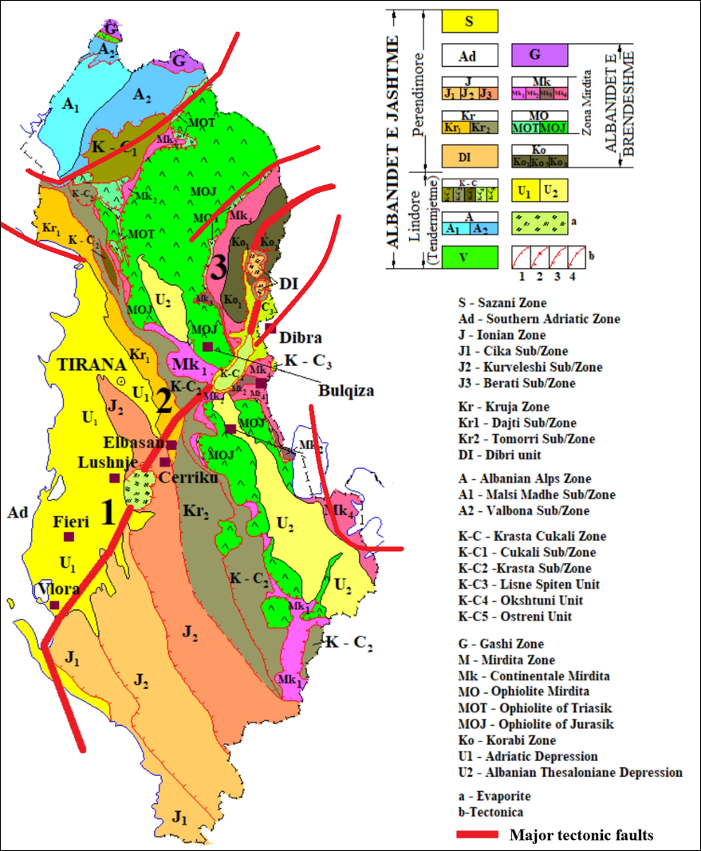
Figure 4.3: Schematic tectonic and geological map of Albania, providing further details on geological, tectonic and neotectonic processes in and around the country's territory (Aliaj et al., 2010). Major active transboundary faults are shown in red.

Flood Hazard (Hydrological Evidence)
Historical discharge records provide clear evidence of high flood potential in the basin. At Vukël station (1977–2000):

- Mean discharge: 10.35 m³/s
- Maximum recorded peak: 158 m³/s (December 1981)
- Discharge <0.5 m³/s recorded only 27 days in 23 years At Trgaj station (1949–1986):
- Mean discharge: 25.13 m³/s
- Maximum recorded peak: 472 m³/s (December 1963)
- Discharge <0.5 m³/s recorded only 9 days in 37 years

These values confirm a highly dynamic bimodal regime (autumn rainfall peak and spring snowmelt peak). The canyon morphology amplifies flow velocity, while documented river losses downstream of the confluence (estimated ~5.6 m³/s during summer field campaign -Blagojevic et al., 2020) demonstrate strong river–karst interaction.

Table 4.4 Catchment areas (DEM-based delineation, Krstajic et al., 2026)
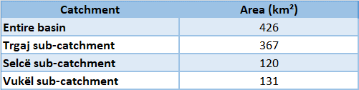

These values confirm steep headwater sub-catchments with rapid runoff response. Flash flood risk is therefore structurally embedded in basin morphology.

Climate Variability and Change
Precipitation and temperature data (1991–2019) indicate significant variability and warming trends.

Table 4.5 Mean annual precipitation (mm)
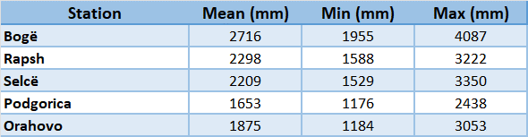

Temperature trends (1991–2019) show increase of approx. 2°C in maximum and mean annual values.

Table 4.6 Mean annual temperature (ºC)
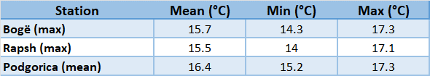
Key climate-related hazard implications:

- Reduced snow storage → higher winter runoff peaks
- Increased thermal amplitude → enhanced evapotranspiration
- Long-term decline of river discharge (~0.14 m³/s per year in late 20th century)
- High infiltration coefficient (60–70%) increases recharge sensitivity to rainfall intensity

Transboundary Risk Dimension
The Cem/Cijevna River recharges the Zeta Plain intergranular aquifer, which supplies Podgorica and supports large-scale agricultural production (Plantaže vineyards). Any modification of upstream hydrological dynamics, whether seismic-induced permeability change, extreme flood events, or climate-driven discharge decline, directly affects groundwater levels downstream. The compound interaction of:

- tectonic instability,
- flash-flood dynamics in steep karst terrain,
- increasing climatic variability, requires strengthened joint monitoring (river gauges, piezometric stations, meteorological data),real-time data exchange, and integration of hazard assessment into transboundary basin planning.

5. Current monitoring and data management practices for groundwater and groundwater-dependent ecosystems in the neighbouring countries

5.1 Monitoring types and design of monitoring networks.
The monitoring network proposed within the framework is conceived as an integrated, modular and harmonized system, which combines the monitoring of surface waters, groundwater and climatic parameters, connecting all these components into a single data management platform. The network concept is based on the following principles:
- vertical integration, linking precipitation – surface runoff – aquifer;
- spatial integration, covering representative segments of the basin in the Albanian and Montenegrin territory;
- time integration, through the combination of continuous (online) measurements and periodic field measurements;
- cross-border harmonization, with the same methodology and standards as the Montenegrin side.
This network is not intended as a short-term demonstration system, but as a monitoring infrastructure with long-term use potential.Main components of the monitoring network
The monitoring network consists of five main functional components:
- Monitoring points for surface waters (quantity and quality)
- Groundwater monitoring wells and monitoring of the karst spring
- Climate telemetric stations
- Isotopic monitoring network
- Data management and telemetry system
Surface water monitoring
Monitoring points have been selected on the Cemi/Cijevna River:
- Point 1: Tamare, representing the upper segment of the river's flow in Albanian territory;
- Point 2: Grabom Customs, representing the lower segment of the flow, immediately before the river exits Albanian territory.
- Point 3: Dinoša, downstream of the bridge, existing monitoring point on Montenegrin territory.
Groundwater monitoring
- Point 1: “Grabom” monitoring well. The monitoring well will be drilled in the Grabomi Customs area, close to the surface water monitoring point and telemetric station. Total depth: 160 m.
- Point 2: “Dinoša” monitoring well. The monitoring well will be drilled in the in the karst hinterland of the village of Dinoša. Total depth: 70 m.
- Point 3: “Confluence” monitoring well. The control well will be drilled at the confluence of the Cemi/Cijevna River and the Morača River. Total depth: 80 m.
- Point 4: Monitoring of the karst spring in the villages of Kroni and Traboini.
The wells will be equipped with, data logger for piezometric level measurement, water temperature sensor and electrical conductivity sensor.
Climatic telemetric stations
Three climate telemetric stations will be installed in:
- the Grabomi area;
- Tamara area;
- Dinoša area.
Each station will record precipitation, air temperature, relative humidity and atmospheric pressure.
Isotopic monitoring network
The isotopic network includes:
- four collectors for rainfall sampling (2 in Montenegro and 2 in Albania)
- monthly sampling of surface and groundwater.
δ¹⁸O, δ²H and Radon analyses will be used to:
- construction of the local meteor line;
- assessment of aquifer recharge areas;
- interpretation of water circulation paths in the karst system.
Data management system and telemetry
All data from:
- hydrometric sensors,
- monitoring wells and spring,
- climate stations,
This system constitutes the central functional pillar of the entire monitoring network.

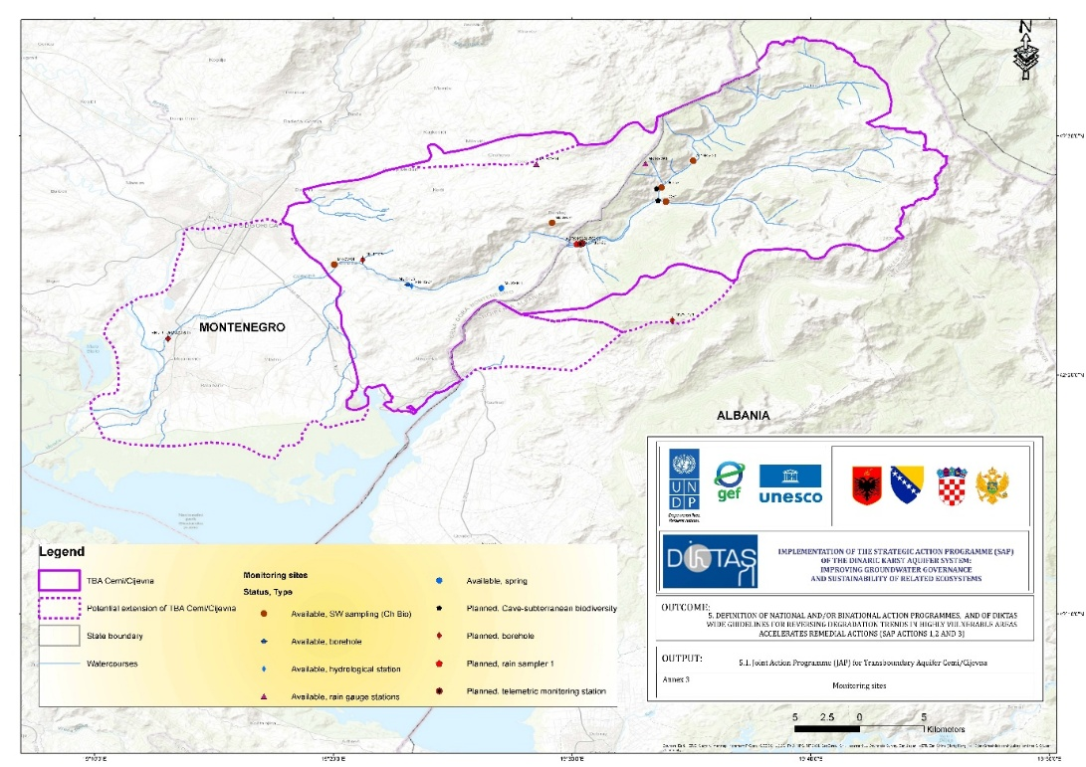
Figure 5.1 Location of surface and groundwater monitoring sites in Albania & Montenegro

5.2 Parameters and frequencies of monitoring.
In line with the EU Water Framework Directive (WFD), surface water monitoring in Cemi/Cijevna basin should include:
- Biological monitoring covering five biological quality elements: phytoplankton, phytobenthos, macrophytes, benthic invertebrate fauna, and fish;
- General physico-chemical parameters supporting biological monitoring (such as pH, temperature, dissolved oxygen, alkalinity, salinity, and nutrients);
- Monitoring of specific pollutants;
- Hydromorphological elements (flow quantity and dynamics, connectivity with groundwater, river continuity, river width and depth variations, riverbed structure, and bank composition);
- Chemical monitoring including the analysis of 45 priority substances.
The water quality status is determined based on the average values of 12 core physico-chemical parameters: BOD₅, TOC, electrical conductivity, alkalinity, pH, NH₄⁺, NO₃⁻, NO₂⁻, TN, total P, ortho-PO₄³⁻, and SO₄²⁻.
The physico-chemical parameters included:
pH value, temperature, turbidity, electrical conductivity, total dissolved solids, suspended matter, oxygen concentration, oxygen saturation (%O₂), BOD₅ (Biochemical Oxygen Demand), COD (Chemical Oxygen Demand, with KMnO₄), alkalinity, total hardness (°dH), bicarbonates (HCO₃⁻), chlorides (Cl⁻), sulfates (SO₄²⁻), nitrates (NO₃⁻), nitrites (NO₂⁻), ammonium (NH₄⁺), total nitrogen (TN), orthophosphates (o-PO₄³⁻), total phosphates (u-PO₄³⁻), total organic carbon (TOC), calcium (Ca²⁺), magnesium (Mg²⁺), total iron (u-Fe), sodium (Na⁺), potassium (K⁺), and salinity.
Supporting parameters are also measured, but their values are not used to determine the status due to the specific characteristics of groundwater quality, such as: total water hardness, O₂ content, % O₂, and suspended matter, as well as three microbiological parameters.
For pollutants, metals such as Pb, Cd, and Hg were analyzed, along with As and pesticides (176 substances from this group).
Samples are collected twice a year in spring and autumn.
Biological site monitoring
For monitoring the state of groundwater-dependent ecosystems, interesting representatives of subterranean aquatic invertebrates include: protozoa (Protozoa) and micrometazoa (Gastrotricha, Nematoda, Nemertina, Rotifera, Tardigrada, etc.), sponges (Porifera), flatworms (Turbellaria), snails (Gastropoda), oligochaetes (Oligochaeta), polychaetes (Polychaeta), leeches (Hirudinea), aquatic insects (Insecta), water mites (Hydrachnellae), and among vertebrates, amphibians (Amphibia) and fish (Gottstein 2010, Gottstein et al. 2001). Many of these species are endemic species with restricted ranges, which poses numerous difficulties in selecting appropriate fauna representatives that would be unique bioindicator, especially in Albania, where the subterrenian fauna is not yet explored. However, findings of many subterranean fauna representatives in neighboring groundwater-dependent ecosystems can be a good indicator of the dependency of those systems on groundwater.
There is a need to conduct the speleological research along Cemi/Cijevna watershed caves, using standard speleological equipment. Single Rope Technique (SRT) is used for vertical cave exploration. Microclimatic parameters should be measured as well for every monitoring site: substrate, air, and water temperature (if water is present) and relative air humidity. Photo documentation of cave entrances selected underground spaces, bio-speleological surveys, and fauna is required. Underground spaces, fauna, and cave entrances should be documented by digital camera. GPS coordinates of cave entrances should be recorded.
In all localities to be sampled, as well as the frequency of sampling, will be standardized and recorded to ensure reproducibility of results.
Biological material in subterranean habitats is collected manually using exhaustors and tweezers, with detailed examination of cave habitats. Collected fauna should be preserved in 70%, 75%, or 96% ethanol depending on conservation needs. Each sample should be properly and uniformly labelled indicating locality name, date of collection, collector, and medium. After preservation and labelling, the material is delivered to taxonomists for processing.
Additional abiotic parameters may also be recorded where applicable to better understand environmental conditions affecting biodiversity.
Aquatic fauna in cascades and shallow lakes should be collected with tweezers and aquarium nets; during diving, fauna is collected using a Sket bottle.
All collection and sampling procedures will follow ethical guidelines to minimize disturbance to cave ecosystems and species.
Dynamics of sampling:

Table 5.1 Quality elements
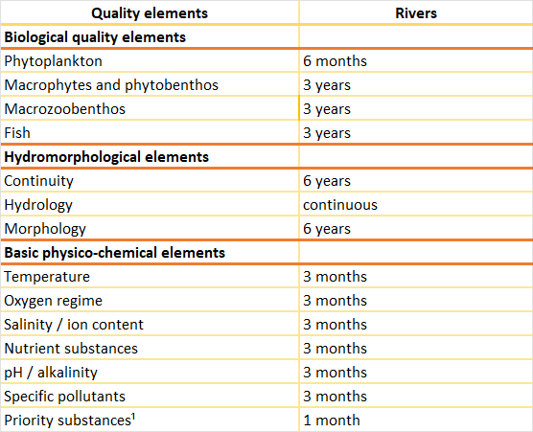

5.3 Quality Assurance (QA) / Quality Control (QC) of data.
QA/QC procedures are designed to ensure that the data collected is:
- accurate,
- stable,
- comparable in time and space,
- and fully documented.
QA/QC is implemented at all stages of monitoring, from automatic measurements to laboratory analyses.
QA/QC for automatic measurements (sensors and telemetry)
The following procedures will be applied for automatic measurements:
- initial calibration of all sensors before installation;
- periodic field verification with reference instruments;
- comparison of automatic data with manual measurements (flowmeter);
- identification and correction of anomalies (outliers, sensor drift).
All interventions and calibrations will be documented in technical records.
QA/QC for sampling and laboratory analysis
Standard procedures will be applied for sampling and laboratory analysis, including:
- use of appropriate containers for each parameter;
- clear and standardized labeling;
- chain-of-custody for each sample;
- storage and transportation under controlled conditions.
Laboratory analyses will be performed in accredited or certified laboratories according to relevant standards, guaranteeing the reliability of the results.
QA/QC for isotopic data
For isotopic analyses, the following will be provided:
- use of anti-evaporation collectors for precipitation;
- consistent monthly sampling;
- analysis in specialized laboratories for stable isotopes;
- quality control of results through international reference standards.
Data management and archiving
All project data will be stored on a centralized cloud platform, which will include:
- hydrometric data (level, flow);
- hydrogeological data (piezometric level, spring flow, EC, T);
- climate data;
- laboratory and isotopic results.
The platform will enable:
- role-controlled access;
- real-time graphic visualization;
- downloading data for further analysis.
Data structuring and documentation
Each dataset will be accompanied by complete metadata that includes:
- measurement location;
- the time and frequency of registration;
- the equipment and method used;
- the responsible operator.
This structuring guarantees the usability of the data even in the long term.
Data analysis, reporting and sharing
The data collected will be used for:
- periodic trend analysis;
- preparation of monthly, quarterly and annual technical reports;
- exchange of information between the Montenegrin and Albanian sides and relevant institutions.
The report will include:
- hydrological and hydrogeological interpretation;
- identification of extraordinary events;
- recommendations for management.
Long-term sustainability of the monitoring system
Security measures, QA/QC and structured data management ensure that the monitoring system:
- operate sustainably beyond the duration of the project;
- to produce usable data for future studies;
- to serve as a basis for future network expansion.

6. Current approach for groundwater and groundwater-dependent ecosystem status and risk assessment in the neighbouring countries.

6.1 Groundwater and groundwater-dependent ecosystems standards, criteria and threshold.
It is clear that the protection and improved management of the Cemi/Cijevna aquifer will largely depend on each country’s ability to recognize that cooperation and alignment on legal acts and management measures are key elements that can serve as improvement factors in the integration of water management policies, particularly regarding groundwater issues.
This should be achieved not only through bilateral state agreements at the central level, involving the main institutions responsible for groundwater, but also through close cooperation at the local level, which should be considered an important factor for effective implementation.
A central priority is the gradual improvement of on-site sanitation systems in the upstream Albanian and Montenegrian part of the basin. Rather than large-scale infrastructure investments that are unlikely to be feasible in dispersed mountain settlements, targeted, incremental upgrades should be promoted.
Finally, socio economic measures should be embedded within routine local governance processes rather than treated as standalone environmental actions. Integrating groundwater considerations into municipal development decisions, local tourism planning, and community investment priorities can help ensure that protection measures are sustained over time. Regular dialogue between municipalities, utilities, and community representatives can reinforce shared responsibility and reduce the perception that groundwater protection is an external or imposed agenda.
Even than each country has respective legal and institutional framework for water protection and management fully in line with EU acquis, still there is rooms and challenges on enforcement capacity related to common legal from work and criteria.
Legal mechanisms - Acceleration of process for fully implementation WFD, especially GW Directive, focusing in bylaw formulation for complete implementation of all water related directives.
Administrative mechanism - ability to enact and apply regulations;
Operational capacity - availability of human and financial resources for the implementation of policies and regulations;
Inspection/Supervision and sanctions: compliance monitoring and application of penal provisions of regulations.
Groundwater constitutes a fundamental element of water security and ecological sustainability, especially in transboundary mountain basins. In these systems, groundwater and the ecosystems dependent on it (springs, riparian habitats, vegetation associated with base flow) function as a whole. Any change in quality, quantity or recharge dynamics can have multiple effects: on drinking water supply, on agricultural production, on biodiversity and on the local economy. The protection and improved management of the Cemi/Cijevna aquifer and its dependent ecosystems requires an integrated approach where standards, criteria and threshold values ​​are not treated simply as numerical limits, but as functional instruments for decision-making, early warning and transboundary harmonisation. The Cemi/Cijevna/ system is typical of a karst mountain basin with a rapid response to precipitation, strong seasonal variations in flows and direct interaction between surface and groundwater. Precipitation and snowmelt are the main supply factors, while the rugged relief and karstified carbonate formations favour intense surface runoff and rapid infiltration into the aquifer.

These features make high-time resolution monitoring a necessity not only to understand the hydrology of the river, but also to build functional thresholds related to the risk to groundwater and dependent ecosystems.
The Cemi/Cijevna river basin (Albania–Montenegro) represents a hydrogeological system with high natural and socio-economic values. The Tamara area is a territorial and water node where different functions are concentrated:
- a water node point where a hydroelectric power plant has been built,
- a water supply point for the Tamara Waterworks, and an economic activity of water packaging under the name 'Tamara Water' and the production of bottles with the same emblem.
This coexistence of uses increases the importance of the correct implementation of standards and thresholds, but also requires strong managerial coordination to avoid cumulative pressures. This report summarizes the standards, criteria and threshold values related to the protection and management of groundwater and their dependent ecosystems in the transboundary Cemi/Cijevna river basin (Albania–Montenegro), with a focus on the upper and middle reaches of the basin and on the strategic water use nodes in the Tamara area.

Monitoring types and design of monitoring networks - Albania
The document is based on the legal framework and policies aligned with the EU (Water Framework Directive and Groundwater Directive), the Albanian drinking water standard (VKM no. 379), the FAO guidelines for irrigation waters and the EU criteria for natural mineral waters. The physico-chemical analyses carried out in the Cemi/Cijevna basin (upper and middle reaches) provide a reliable basis for verifying the threshold standards against the real situation. The report's approach is not 'parameter-by-parameter', but synthetic: the analysis is interpreted as a system of indicators that determines the chemical status of water, its capacity for multiple uses and the supporting role for groundwater-dependent ecosystems.
For long-term protection, the report recommends strengthening transboundary cooperation, harmonizing monitoring and data exchange, gradual improvements in on-site sanitation systems in mountain settlements (Albanian and Montenegrin), and integrating groundwater considerations into local decision-making (urban/rural planning, tourism, community investments).
There is a need to conduct the speleological research along Cemi/Cijevna watershed caves, using standard speleological equipment. Single Rope Technique (SRT) is used for vertical cave exploration. Microclimatic parameters should be measured as well for every monitoring site: substrate, air, and water temperature (if water is present) and relative air humidity. Photo documentation of cave entrances selected underground spaces, bio-speleological surveys, fauna and bryophytes is required. Underground spaces, fauna, bryophytes and cave entrances should be documented by digital camera. GPS coordinates of cave entrances should be recorded.
In all localities to be sampled, as well as the frequency of sampling, will be standardized and recorded to ensure reproducibility of results.
Cave diving research should be carried out by using standard cave diving techniques. Equipment includes diving regulators, air cylinders, underwater lamps for lighting. Divers should use dry trilaminate suits. Underwater photography of subterranean spaces and fauna should be recorded with a camera.
Biological material in subterranean habitats is collected manually using exhauster’s and tweezers, with detailed examination of cave habitats. Collected fauna should be preserved in 70%, 75%, or 96% ethanol depending on conservation needs. Aquatic bryophytes will be manually collected and air-dried without pressing for further analysis. Each sample should be properly and uniformly labelled indicating locality name, date of collection, collector, and medium. After preservation and labelling, the material is delivered to taxonomists for processing.
Additional abiotic parameters may also be recorded where applicable to better understand environmental conditions affecting biodiversity. Aquatic fauna in cascades and shallow lakes is collected with tweezers and aquarium nets; during diving, fauna is collected using a Sket bottle, while aquatic bryophytes are manually collected and air-dried without pressing for further analysis.
All collection and sampling procedures will follow ethical guidelines to minimize disturbance to cave ecosystems and species. Collected biological data will be analysed using statistical methods, including descriptive statistics, biodiversity indices, and comparison between localities, to assess species composition and ecological patterns.The BQEs (Biological Quality Elements) proposed for the biological monitoring of groundwater ecosystems such as snails (several new Hydrobiidae species, Plagigeyeria and Paladilhiopsis), leeches, crustaceans, and cave beetles, with highly specialized troglobionts (Hadesia, Nauticiella, Troglocaris, Speleocaris, Niphargus) (Pešić & Glöer, 2012; Polak, 2025; Djurović & Djurović, 202; Grego J. et al, 2017). Aquatic bryophytes, as part of the macrophyte quality element under the EU Water Framework Directive, serve as important bioindicators of ecological status in karst rivers. Among the macrophytes species indicating good ecological status are bryophytes such as Fontinalis antipyretica, Cinclidotus aquaticus and Rhynchostegium riparioides. Observations of bryophyte communities at the entrances of underground karst features (caves) in river canyons are particularly valuable, as they can provide early indications of water quality before it enters subterranean systems.
Abiotic basic parameters which influence the subterranean biodiversity should be recorded where applicable to better understand environmental biodiversity related conditions.
- Water temperature, as it affects chemical processes in the aquifer and biological activities.
- pH value, which determines the acidity or alkalinity of water and effects on the solubility of substances and the availability of elements.
- Dissolved oxygen, essential for oxidation processes and for the life of microorganisms (bacteria) in water.
- Electrical conductivity, which indicates the concentration of dissolved ions in water and provides insight into mineralization.
- Total dissolved solids (TDS), which reflect the level of various ionic compounds.
- Concentration of basic cations (e.g. Ca2+, Mg2+, Na+, K+) and anions (e.g. HCO3-, SO42-, Cl-).
- Parameters such as turbidity, organic and inorganic carbon (TOC, DOC)

Monitoring types and design of monitoring networks - Montenegro
The biological component of water monitoring in Montenegro, within the framework of assessing the ecological status of surface waters, is operationally carried out by the Institute of Hydrometeorology and Seismology of Montenegro (IHMS / ZHMS) through a monitoring program that includes standard biological quality elements in accordance with the Water Framework Directive. The Environmental Protection Agency of Montenegro (EPA) has a coordinating and reporting role in the area of ecological status and biodiversity, and integrates monitoring data into the national https://epa.org.me/.
The institutional framework and the Surface and Groundwater Monitoring Program are established by the Government of Montenegro. In Montenegro, there is no established national program for systematic monitoring of groundwater fauna within the framework of routine groundwater monitoring. Instead, data on groundwater organisms are collected sporadically through scientific research projects and individual studies.
Biological quality elements are monitored annually, in accordance with the national monitoring program and methodological requirements aligned with the Water Framework Directive. The Institute prepares an annual Water Quality Report, which contains an integrated assessment of the ecological status based on biological, hydromorphological, and physicochemical quality elements (https://www.meteo.co.me).

6.2 Assessment of chemical and quantitative status of groundwater.
As part of its annual monitoring program, the Institute of Hydrometeorology and Seismology of Montenegro (IHMS/ZHMS) monitors phytoplankton, phytobenthos (including diatoms), macrophytes, macrozoobenthos (benthic fauna), and fish as key indicators of the ecological status of water bodies. Also, the Institute of Hydrometeorology and Seismology of Montenegro (IHMS/ZHMS) also conducts microbiological analyses on groundwater samples from wells at multiple locations within the Cijevna catchment area (Vranj, Drešaj, Trgaj, the mouth of the Cijevna, and the Plantaže area), as part of the regular state water quality monitoring program. Biological quality elements are monitored annually, in accordance with the national monitoring program and methodological requirements aligned with the Water Framework Directive.
An assessment of the chemical and quantitative status of groundwater in the Cemi/Cijevna transboundary watershed, drawing on the jointly prepared monitoring project documentation (January 2026) and the hydrogeological synthesis prepared for joint monitoring and assessment (October 2025–January 2026). is provides.
Hydrogeological context and groundwater bodies.
The watershed is largely developed in karst carbonate formations, which create aquifers with high permeability and rapid hydraulic connections between surface water and groundwater. Downstream, the river enters the Zeta Plain, a Quaternary intergranular aquifer system that is recharged by infiltration from the river. For management purposes, two groundwater bodies are distinguished in the Montenegrin part of the basin:

- Kuči (karst) and
- the Zeta Plain (intergranular aquifer).

The river–aquifer linkage is therefore a central process controlling both groundwater quantity (recharge, storage, and discharge) and groundwater quality (transport of potential contaminants).

Assessment framework and indicators.
In line with the European Water Framework Directive (WFD) and associated groundwater legislation, groundwater status is assessed through two complementary dimensions:

- chemical status, considering compliance with quality standards/thresholds for key physico-chemical parameters and pollutants and;
- quantitative status, considering whether abstractions and hydrological pressures cause long-term depletion or adverse impacts on associated surface waters and groundwater-dependent ecosystems.

The joint monitoring project explicitly aligns its objectives and methodology with WFD principles (systematic monitoring of quantity and quality, and transboundary cooperation), and references the Groundwater Directive and related EU environmental standards.

Evidence on chemical status from existing groundwater monitoring points.
Available groundwater-quality evidence is currently strongest for the documented monitoring boreholes in Montenegro. Two boreholes described in the joint monitoring project provide indicative baseline conditions for both groundwater bodies:

- Trgaj (Kuči groundwater body) and
- Ušće (Zetska Ravnica/Zeta Plain groundwater body).

Trgaj (Kuči karst groundwater body).
The borehole is 31 m deep with a reported static water level of about 12 m. Basic physico-chemical quality is assessed as good: in 91.7% of measured parameters the quality was “excellent or very good” and in 8.3% it was “good” (reported for BOD₅). For screened pollutants, concentrations were below the laboratory limit of quantification (LOQ) for metals (As <0.20 µg/L; Cd <0.10 µg/L; Pb <0.20 µg/L; Hg <0.05 µg/L) and for pesticides. Microbiological parameters indicate episodic presence of coliform bacteria (0–21/100 ml) and fecal bacteria (0–1/100 ml), while “live bacteria” were measured (37–205/ml). The documentation reports dynamic water levels around 13.0 m and 12.1 m (two samplings), and notes sand presence during the second sampling—important for interpreting turbidity/microbial signals and well integrity.
Ušće (Zeta Plain / Zetska Ravnica groundwater body).
The borehole is 31 m deep in Quaternary terrace sediments, with a reported static water level of 8.1 m. As for Trgaj, basic physico-chemical quality is described as good, with 91.7% of parameters “excellent or very good” and 8.3% “good” (BOD₅). Metals (As, Cd, Pb, Hg) and pesticides are reported below LOQ. However, the microbiological dataset indicates notable coliform counts (640–980/100 ml) and fecal bacteria (0–311/100 ml), with live bacteria (30–55/ml). This pattern is consistent with the high vulnerability of shallow alluvial/terrace aquifers to rapid infiltration from surface pathways and local land use, and it underlines the need to interpret chemical and microbiological status together rather than relying only on metals/pesticides.
The joint monitoring project defines a harmonized list of groundwater parameters and sampling dynamics. Status determination is based on the average of 12 core physico-chemical parameters (including electrical conductivity, pH, nutrients such as NH₄⁺, NO₃⁻ and NO₂⁻, total nitrogen and phosphorus, BOD₅/TOC, alkalinity and SO₄²⁻), complemented by supporting indicators and a targeted suite of pollutants (metals such as Pb, Cd, Hg and As, plus a pesticide screening list). Groundwater sampling is planned twice per year (spring and autumn) to capture seasonal contrasts in recharge and contamination risk.
Interpretation of chemical status and main risks.
On the basis of the reported baseline results, toxic trace metals and pesticides do not currently appear as dominant issues at the documented monitoring boreholes (values below LOQ). The most consequential chemical-status risks are therefore linked to parameters that respond rapidly in karst and shallow alluvial systems: microbiological contamination, organic matter (BOD₅/TOC), and nutrients (nitrates, ammonium, total N/P). The contrast between Trgaj (low bacterial counts) and Ušće (high coliform counts) reinforces the need to assess status by groundwater body and by vulnerability setting: karst and intergranular aquifers may respond differently to the same pressures due to differences in filtration capacity, flow paths, and land use.
Evidence on quantitative status and river–aquifer exchanges.
Quantitative status in the Cemi/Cijevna system is controlled by the balance between highly variable recharge (rainfall and snowmelt), rapid runoff generation, infiltration losses from the river, and abstractions—particularly in the Zeta Plain, where municipal and agricultural pumping is important. Both the hydrogeological synthesis and the joint monitoring project emphasize that, in many segments, the river and surrounding aquifers are in direct hydraulic interaction, alternating between losing conditions (river recharging aquifer during high flow) and gaining conditions (aquifer sustaining river flow during dry periods).
Piezometric evidence from the Zeta Plain indicates a spatial groundwater-depth gradient and a dynamic response to recharge events. In the vicinity of the Cem/Cijevna River, groundwater is relatively deep, supporting the interpretation that the river discharges into (recharges) the aquifer. In the five-well network used for regional analysis (Trgaj, Bioce, Plantaže, Cemovsko Polje and Vuksan Lekic), karst wells show fast, high-amplitude responses to rainfall, while wells in the Quaternary aquifer show more gradual seasonal variations. Reported average depths to groundwater are approximately 12.5 m at Trgaj, 33.5 m at Cemovsko Polje, 25 m at Plantaže and 23 m at Vuksan Lekic, with several meters of seasonal amplitude (up to about 14 m at Cemovsko Polje).
Implications for quantitative status classification.
The available evidence supports three operational conclusions for quantitative status assessment:

- groundwater levels in the karst system can react rapidly to rainfall and river-stage variations, which implies that single-time measurements are insufficient and continuous logging is needed;
- the river is likely a key recharge component not only for the Zeta Plain intergranular aquifer but also, locally, for the karst system (e.g., at Trgaj), so maintaining environmental flows and avoiding systematic river depletion in dry periods is directly linked to groundwater availability; and (3) existing piezometric time series are still too short (and in some stations contain gaps/errors) to confidently identify long-term declining trends, but the monitoring design is adequate to detect trends once continuous datasets accumulate.

Data gaps and priorities for a defensible status assessment.
At present, the status assessment should be presented as preliminary, with clear priorities to strengthen it over the next monitoring cycles.
For chemical status: expand bacteriological monitoring and relate results to hydrometeorological events; ensure consistent QA/QC; and establish groundwater-body-specific threshold values and trend assessment for nutrients and organic matter.
For quantitative status: complete rating curves and harmonized discharge datasets for river gauges; conduct a topographic survey at Trgaj to quantify the hydraulic head difference between river water level and groundwater level (critical for exchange direction); maintain continuous piezometric logging (10-minute telemetry where available); and link abstractions (where data exist) to seasonal groundwater-level behavior.
Overall conclusion (current evidence).
Based on the available baseline groundwater-quality results and the current understanding of system dynamics, the groundwater bodies associated with the Cemi/Cijevna watershed appear to have generally good physico-chemical conditions with respect to screened metals and pesticides, while microbiological indicators highlight vulnerability—particularly in shallow intergranular/terrace settings. Quantitatively, groundwater levels and recharge are highly dynamic and strongly linked to river behaviour and rainfall/snowmelt, supporting the need for continuous monitoring before a robust long-term status classification can be issued. The joint Albania–Montenegro monitoring programme is therefore not only a compliance instrument, but the primary technical basis to move from a qualitative understanding to a defensible WFD-aligned classification of chemical and quantitative groundwater status.
As result, we provide a joint, policy-oriented synthesis of groundwater chemical status in the Cem/Cijevna transboundary basin, combining:
- the June 2025 analytical dataset from the Albanian part of the basin (eight points, M-1 to M-8), and
- the baseline groundwater borehole summaries reported for the Montenegrin part
of the basin within the Joint Monitoring Project (Trgaj in the Kuči groundwater body;
- Ušće in the Zetska Ravnica/Zeta Plain groundwater body).

The purpose is to provide a concise comparative narrative that can be inserted into the joint intergovernmental reporting template.

Albanian part of the basin – June 2025 analytical results (M-1 to M-8).
The June 2025 dataset covers key karst springs (Grabom, Grabom 2, Tamara, Tamara 2, Vermosh Qendër, Kroni i Zekës) and two river points (Cemi in Selcë and Cemi in Vukël). Across all points, waters are mildly alkaline (pH 7.33–7.54), with low mineralization (~119–199 mg/L) and low electrical conductivity (183.7–294 µS/cm). Nutrients are very low: maximum N-NO₃⁻ is 0.18 mg/L as N (≈ 0.797 mg/L as NO₃⁻) and maximum N-NH₄⁺ is 0.017 mg/L as N (≈ 0.0219 mg/L as NH₄⁺). Lead ranges up to 0.90 µg/L, while arsenic is consistently reported below the reporting threshold (<0.01 µg/L). These results indicate a favourable baseline chemical condition in the Albanian headwaters at the time of sampling.

Table 6.1. Key parameter ranges in Albania (June 2025; M-1 to M-8).
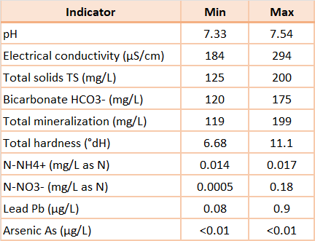

From a risk-management perspective, the results support the view that upstream karst springs currently show low contamination pressure for nutrients and trace metals. Maintaining this baseline requires preventive controls on diffuse pressures (wastewater, livestock, agricultural inputs) and special attention to karst recharge zones where travel times can be short.
Montenegrin part of the basin – baseline borehole summaries (Trgaj and Ušće).
The Joint Monitoring Project provides baseline groundwater quality summaries for two boreholes representing the two key groundwater bodies in Montenegro. The chemical-status determination in the project is aligned with EU Water Framework Directive (WFD) practice and uses the average of 12 core physico-chemical parameters (BOD₅, TOC, electrical conductivity, alkalinity, pH, NH₄⁺, NO₃⁻, NO₂⁻, total nitrogen, total phosphorus, ortho-phosphate and sulfate), complemented by broader supporting parameters and a targeted list of pollutants (metals including Pb, Cd, Hg and As, plus pesticide screening).

Table 6.2. Baseline groundwater quality summaries for Montenegro (Joint Monit. Project).
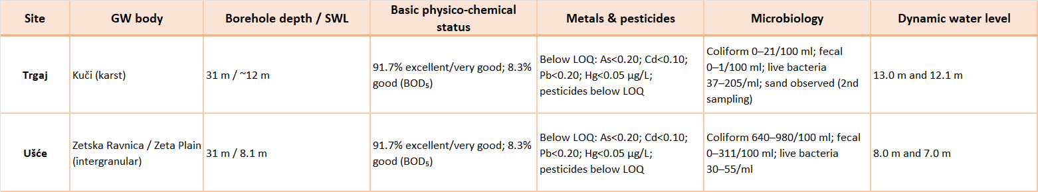

The Montenegrin baseline indicates that trace metals and pesticides are not currently detected above laboratory quantification limits at the two boreholes. However, microbiological indicators differ markedly between the groundwater bodies: Trgaj (karst setting) shows low bacterial counts, whereas Ušće (alluvial/terrace setting near the confluence with Morača) shows high coliform and occasional fecal bacteria. This pattern is consistent with the higher susceptibility of shallow intergranular aquifers to rapid infiltration from surface pathways and local pressures, and it reinforces the need to evaluate chemical and microbiological evidence together.
Surface water monitoring – discharge and quality
Surface water sampling will be carried out monthly at each monitoring point. Monitored parameters include:

- basic physicochemical parameters (pH, temperature, conductivity, dissolved oxygen);
- nutrients (NO₃⁻, NO₂⁻, NH₄⁺, PO₄³⁻);
- organic parameters (BOD₅, COD);
- bacteriological parameters;
- heavy metals (with monthly frequency).

Sampling and storage of samples will be carried out according to ISO standards, ensuring the integrity and representativeness of the data.
Continuous water level measurements will be performed at two river sections and converted to discharge using rating curves calibrated with periodic flowmeter measurements. Manual discharge measurements will be carried out seasonally and during high-flow events. Water quality will be monitored through monthly sampling for physico-chemical and bacteriological parameters and heavy metals during a 12-month period. This item includes:

- level sensors for two monitoring points on the Cemi/Cijevna River;
- flowmeter for periodic flow measurements;
- initial installation and calibration;
- periodic maintenance.

6.3 Assessment of chemical and ecological status of groundwater-dependent ecosystems.
Groundwater-dependent ecosystems in the Cemi/Cijevna basin (springs, aquatic and terrestrial habitats linked to the base flow) are particularly sensitive to gradual changes in quality. For this reason, threshold values ​​should be interpreted as functional limits: if exceeded, the probability of loss of ecological sustainability, reduction of biodiversity and impairment of ecosystem services increases.
Under current conditions, the synthetic analysis shows that the 'non-degradation' threshold has not been exceeded. However, this should not lead to complacency. In mountain basins with dispersed settlements, the most typical pressures are diffuse and cumulative (sanitation, tourism, local agricultural practices). Therefore, the monitoring system should be focused, regular and harmonised across borders.
Ecological status of the water body includes assessment of all components influencing the water body such as hydro morphology, socio-economic activities, chemical quality data and biological quality data.
For monitoring the state of groundwater-dependent ecosystems, interesting representatives of subterranean aquatic invertebrates include: protozoa (Protozoa) and micrometazoa (Gastrotricha, Nematoda, Nemertina, Rotifera, Tardigrada, etc.), sponges (Porifera), flatworms (Turbellaria), snails (Gastropoda), oligochaetes (Oligochaeta), polychaetes (Polychaeta), leeches (Hirudinea), aquatic insects (Insecta), water mites (Hydrachnellae), and among vertebrates, amphibians (Amphibia) and fish (Gottstein 2010, Gottstein et al. 2001).
Many of these species are endemic species with restricted ranges, which poses numerous difficulties in selecting appropriate fauna representatives that would be unique bioindicator, especially in Albania, where the subterranean fauna is not yet explored.
However, findings of many subterranean fauna representatives in neighbouring groundwater-dependent ecosystems can be a good indicator of the dependency of those systems on groundwater.
Among the macrophytes species indicating good ecological status are bryophytes such as Fontinalis antipyretica, Cinclidotus aquaticus and Rhynchostegium riparioides. Observations of bryophyte communities at the entrances of underground karst features (caves) in river canyons are particularly valuable, as they can provide early indications of water quality before it enters subterranean systems.
A precise interpretation requires a good geological and hydrogeological knowledge of the site, including the interaction of water with the environment, which allows for an understanding of geochemical processes and anthropogenic impacts on groundwater. Equally important is the assessment and monitoring of biodiversity. Understanding the presence and dynamics of aquatic fauna, macrophytes (bryophytes) provides essential information on the ecological status and resilience of groundwater-dependent ecosystems, complementing geochemical and hydrological data. Continuous monitoring is important for reliable analyses and drawing conclusions about the quality and condition of groundwater.

In Montenegro quality assurance and quality control procedures for biological monitoring are conducted by the Institute of Hydrometeorology and Seismology of Montenegro (IHMS/ZHMS) in accordance with standardized methodologies aligned with the Water Framework Directive, as well as applicable national regulations and rules in the field of water and environmental protection, and relevant international standards.
Biological sampling (phytoplankton, phytobenthos including diatoms, macrophytes, macrozoobenthos, and fish) is conducted according to harmonized field protocols, during defined sampling periods, and using prescribed laboratory procedures, thereby ensuring methodological consistency between monitoring locations. Quality control measures include taxonomic verification of identified species, the application of nationally adopted biological indices for assessing ecological status, verification of species lists, and an internal expert review, in accordance with legal obligations and technical guidelines for water monitoring (https://www.meteo.co.me).

6.4 Trend analysis.
Joint interpretation and transboundary messages.

Taken together, the datasets suggest a generally favourable chemical baseline across the basin regarding nutrients and trace metals, with a key vulnerability signal linked to microbiological contamination in vulnerable settings (notably the Zeta Plain groundwater body). For the joint report, three messages are particularly relevant:

- Upstream Albanian headwaters currently show low nutrient/metal pressure, which is an important ‘source-area’ condition to preserve;
- The Montenegrin Zeta Plain aquifer shows a clear microbiological signal, indicating the need to prioritize sanitation and protection of recharge pathways and abstraction points;
- Because karst and river–aquifer exchanges can transfer signals rapidly across borders, the agreed joint monitoring programme (spring and autumn sampling, plus continuous hydrological logging) is essential to confirm trends, identify episodic contamination events, and support WFD-aligned status classification.

6.5 Risk assessment.
The pressures assessment and resultant status are central to understanding and quantifying the gaps between environmental objectives and current state of waterbodies in the river basin. The assessment is necessarily a mixture of analytical and descriptive criteria depending on the level of data available.
Whereas assessment of waterbody status can be a reasonably simple exercise by comparison against standards based on a single analytical sample, assessment of pressures is more complex, because a) pressures are typically more diffuse and harder to measure b) different pressures combine in complex ways to influence a water body’s status.
Quantification of pressures requires significant amounts of good quality data, much of which is not collected in Albania. Nevertheless, pressure can be quasi-quantified based on high-level data (General Indicators), generally available or feasibly obtainable with field-surveys and by using expert judgement.
Groundwater contamination is a potentially serious issue for long term sustainable use of groundwater, especially where it may be used for drinking water or beverage production purposes, or where aquatic or terrestrial ecosystems are depending on groundwater.
If contamination of used aquifers increases, it possibly raises serious public health issues, and will be very difficult to reverse. Apart from hazardous chemical substances, contamination can arise from agriculture, industrial activities and urban pollution such as mining, dumpsites and sewage. In this way numerous contaminants can end up in the groundwater, like hydrocarbons, nitrates, metals and fecal pollution from human sewage. Agricultural fertilizers and animal wastes applied to cropland are usually the largest diffuse sources of nitrate in groundwater, which can be hazardous to health in excessive amounts.
If abstractions from groundwater bodies are not balanced by recharge into the aquifers, the quantitative status of the groundwater bodies will not be in a good status.
Because there are no or only limited groundwater quality data, a full status assessment cannot be performed properly. Biological quality monitoring data will be part of the ecological status of the groundwater bodies.

7. Institutional and transboundary cooperation measures

7.1 Jurisdiction and operations of the Joint Water Management Commission of the Republic of Albania and Montenegro.
Albania and Montenegro have adopted a legal framework that largely aligns national legislation with the Water Framework Directive (2000/60/EC) and the Groundwater Directive (2006/118/EC), aiming at sustainable management and protection of water resources.
Related to the common cooperation a Memorandum of Understanding for the Drin Basin – Drin Declaration was signed in November 2011 by the countries of the Drin Basin (Montenegro, Albania, North Macedonia, Greece, and Kosovo). The aim of this document is to strengthen cross-border cooperation in integrated water management and sustainable development of the region, in accordance with the Water Convention and the Water Framework Directive.
The bilateral agreement between countries of Montenegro and Republic of Albania concluded in 2018 on water management, the Cross-border cooperation on the Cijevna/Cemi River – supported by the Water Convention’s Implementation Committee as part of the advisory procedure on the Cijevna/Cemi River (2023), was signed.
Although respective states have signed a bilateral agreement in 2018 on transboundary water management, including shared aquifers, its implementation is limited, and does not cover joint monitoring, data sharing, or coordinated risk assessment procedures.
Focusing on practical coordination, shared information, and inclusive dialogue, Albania and Montenegro can significantly reduce groundwater vulnerability and strengthen resilience without creating unnecessary institutional complexity.
These mechanisms provide a realistic foundation for long-term cooperation, aligning technical needs, institutional capacities, and socio-economic realities across the transboundary karst system.
Effective protection of the TBA Cemi/Cijevna depends on stable and operational cross-border cooperation, that reflects the basin’s strong hydrogeological connectivity and pronounced upstream–downstream dependencies.
A technical Commision is created as part of Billateral Commision. The Commision is composed by representatives of 6 main Albanian Institution related to the use of water (the same is in Montenegro site)first priority is the establishment of a Sstanding bilateral technical coordination mechanism focused on solving better management and protection of water sourcesspecifically on groundwater. This mechanism does not need to take the form of a new legal institution, but rather a regularized platform under existing national mandates, supported initially through DIKTAS II Project.
Opportunities for strengthening cooperation in the TBA Cemi/Cijevna can be organized as part of Join Water Management Commision around four strategic pillars.
- Joint monitoring and information exchange;
- Coordinated risk management and protection measures
- Sustainable land-use and tourism pressure management
- Institutional dialogue and community engagement
Each pillar responds directly to the institutional asymmetries, stakeholder engagement gaps, and governance vulnerabilities identified in the preceding sections. Together, they provide a practical pathway for moving from ad hoc collaboration toward more stable and effective transboundary groundwater governance.
A simple, predefined notification protocol between upstream authorities and downstream utilities would significantly improve preparedness. Such a protocol should clarify who informs whom, within what timeframe, and through which channels, without requiring complex legal arrangements.

7.2 Joint data sharing mechanism.
The Joint Data Sharing Mechanism between Albania and Montenegro is grounded in the bilateral agreement signed in Shkodër on 3 July 2018 and approved by Decision No. 745, dated 19 December 2018.
The agreement establishes a structured legal and institutional framework for cooperation in the management of shared transboundary water resources. It reflects a transition from fragmented, reactive management toward an integrated and coordinated approach aligned with European principles, particularly those of the EU Water Framework Directive and relevant international conventions on transboundary waters.
At its core, the object of the agreement is to regulate cooperation in addressing issues related to the sustainable management of shared freshwater resources where activities in one country may affect the quantity or quality of water in the other.
The purpose is twofold: first, to prevent and reduce transboundary impacts; and second, to ensure equitable and reasonable utilization of shared waters through coordination, transparency, and mutual notification.
This reflects a preventive and precautionary philosophy, emphasizing early information exchange and joint decision-making before impacts occur. The agreement defines broad but clearly structured areas of cooperation, including water balance assessments, protection against harmful impacts, pollution control, maintenance and regulation of watercourses, management of shared hydraulic infrastructure, and coordinated action regarding major shared waters such as Lake Skadar/Shkodra, the Drin and Buna rivers, Morača, Cijevna/Cem, and other transboundary systems.
An important operational element is the obligation to notify the other Party in advance of major water releases from reservoirs that may cause downstream flooding, strengthening joint flood-risk management.

Institutional organization
The agreement establishes a Permanent Bilateral Commission for Water Resources Management, composed of 20 members (10 from each country), to be established within 30 days of the agreement’s entry into force, and technical commission composed by 6 members in each country. The members of the Commission in both countries were nominated.
The Commission serves as the central coordinating body responsible for supervising implementation, defining priorities, and adopting decisions. The Commission has adopt i Its internal rules of procedure at the first meeting and determine its competencies and objectives On Rules of Procedures on the Water Management Commission document.

Decision-making within the Commission is based on unanimity. While this ensures balanced protection of national interests and consensus-based governance, it may also present challenges when technical interpretations differ or when urgent measures are required. Transparency is explicitly emphasized: the Commission must regularly inform the public and facilitate public participation in its work and in the implementation of its decisions.

Monitoring challenges and the data sharing mechanism
A central pillar of the data sharing joint data sharing mechanism is the regular and timely exchange of accurate and complete data and information concerning shared water resources. The agreement explicitly requires both Parties to ensure appropriate monitoring systems to assess water quantity, water quality, and overall water status.
Furthermore, the Parties must agree on the type and purpose of information to be exchanged, including hydrogeological data, water abstractions, infrastructure operation, technical status of hydraulic structures, and other relevant information necessary for preventing and mitigating transboundary impacts.
This framework implies several practical monitoring challenges:

- Methodological Harmonization – For data to be comparable and useful, both countries must harmonize monitoring methodologies, laboratory standards, calibration procedures, sampling frequency, and parameter selection. Without methodological consistency, shared data may lead to conflicting interpretations.
- Network Compatibility – Existing national monitoring networks must be compatible in terms of station placement, spatial coverage, and measurement protocols.
- Comparable hydrometric and quality monitoring stations are essential for reliable cross-border assessments.
- Data Management and Early Warning Systems – The agreement foresees the use of monitoring data for warning purposes in case of dangerous events.

This requires real-time communication channels, standardized reporting formats, and clearly defined institutional responsibilities, including: Capacity and Infrastructure Gaps – Effective monitoring of quantitative and qualitative parameters demands adequate laboratory capacity, technical equipment, digital data systems, and trained personnel.
The agreement recognizes the need for financial support and potential international assistance to strengthen joint initiatives.
Monitoring, therefore, is not only a technical obligation but a strategic instrument that underpins prevention, dispute avoidance, and evidence-based decision-making.

Role of technical working groups
The agreement empowers the Bilateral Commission to establish permanent sub-committees, ad hoc sub-committees, and expert working groups as needed. These technical bodies play a decisive role in operationalizing the joint data-sharing mechanism. They are responsible for developing harmonized monitoring protocols, defining common parameter lists, proposing joint monitoring programs, and preparing technical assessments that support consensus within the Commission.
In cases of transboundary damage or disputes, joint working groups may be formed to assess impacts and propose corrective measures. This strengthens accountability by linking monitoring results with responsibility and mitigation measures.
In conclusion, join data sharing mechanism part of the Bilateral Agreement between Albania and Montenegro is structured around a legally binding commitment to transparency, coordinated monitoring, and institutional cooperation. The Permanent Bilateral Commission provides governance and oversight, while technical working groups ensure scientific rigor and methodological harmonization. Monitoring systems and data exchange serve as the backbone of preventive water management, enabling early warning, pollution control, flood risk coordination, and sustainable utilization of shared transboundary water resources.

7.3 Options for funding through EU and International Programs.
To date, EU and international programmes have contributed to the Cem/Cijevna basin area mainly through enabling and preparatory actions, rather than direct, large-scale basin-specific investments. Through IPA II and the current IPA III framework, Albania has strengthened its national water governance system, environmental legislation, and alignment with EU directives on water, wastewater, and nature protection, within which the Cem basin is included as part of national river basin planning (European Commission, 2023; INSTAT, 2024).
In the northern regions, including Malësi e Madhe, IPA Cross-Border Cooperation Albania–Montenegro has supported projects related to environmental protection, sustainable tourism, and local development in border areas, helping to build experience in joint planning, stakeholder engagement, and cross-border coordination. In parallel, EU LIFE-supported initiatives and UNECE Water Convention activities have contributed to environmental awareness, pilot monitoring approaches, and dialogue on transboundary water cooperation in northern Albania and comparable karst basins. Although these interventions have not always been explicitly labelled as Cem basin projects, they have laid the institutional, technical, and cooperative groundwork that underpins current JAP priorities.
Ongoing initiatives and potential linkages to JAP implementation
At present and looking ahead, the Cem/Cijevna basin represents a high-potential area for more targeted JAP-related investments under EU and international funding instruments. IPA III and IPA CBC Albania–Montenegro provide concrete opportunities to support actions directly aligned with JAP priorities, including groundwater protection in karst systems, reduction of pollution from wastewater and solid waste, establishment of systematic monitoring networks, and strengthening of municipal and basin-level capacities. EU LIFE offers scope for pilot and demonstration actions focused on ecosystem restoration, climate adaptation, and nature-based solutions, while UNECE frameworks support the development of structured transboundary cooperation with Montenegro. Collectively, these instruments can shift support from preparatory and enabling measures toward measurable, basin-specific outcomes, ensuring that JAP actions in the Albanian part of the Cem basin are implemented in a coordinated, results-oriented, and EU-aligned manner.

Table 7.1. Potential Funding Sources and Implicat. for JAP (Albanian Part of the Cem Basin)
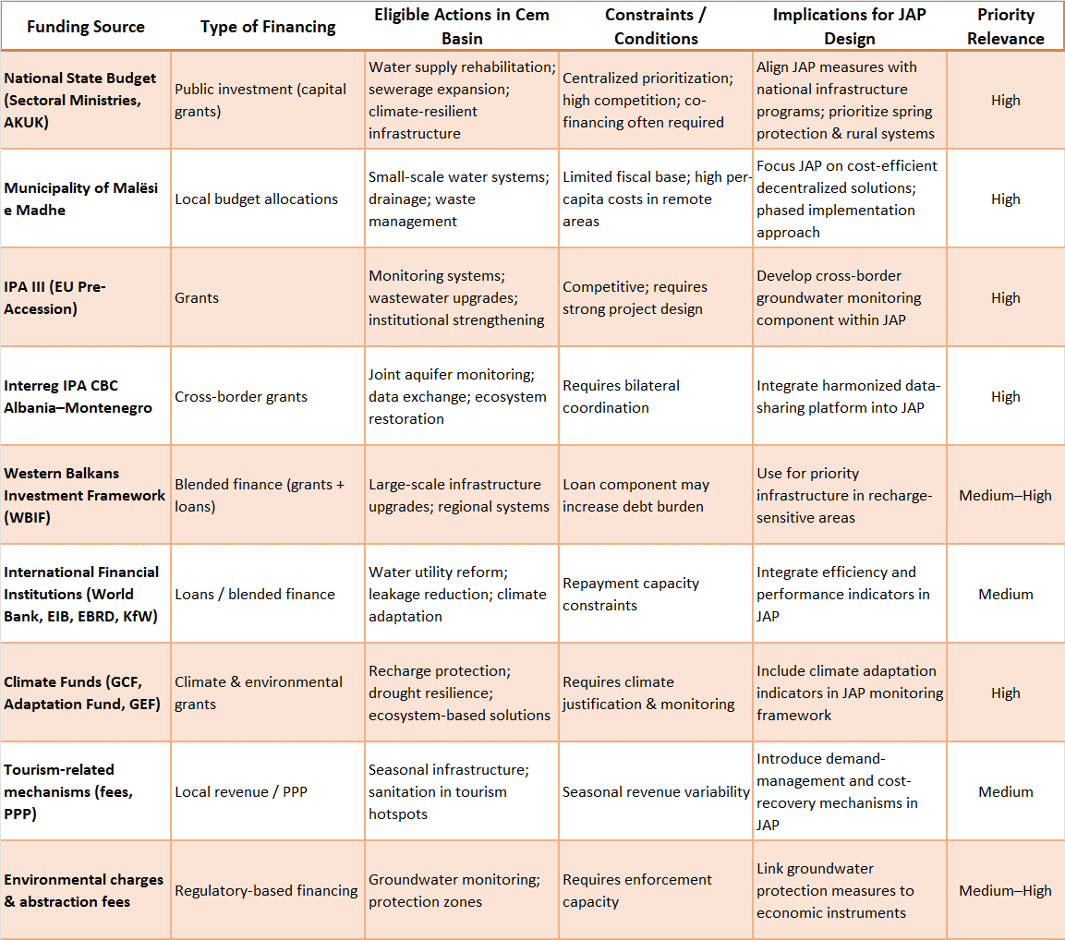
Strategic Financing Implications for JAP
The financing architecture for the Albanian part of the Cem basin implies that JAP should:
- Combine national infrastructure funding with EU cross-border instruments.
- Prioritize grant-based financing for groundwater monitoring and protection.
- Use blended finance selectively for infrastructure in recharge-sensitive zones.
- Integrate climate adaptation logic to unlock environmental funds.
- Strengthen municipal project preparation capacity to increase fund absorption.
- Introduce economic instruments (fees, cost recovery) aligned with groundwater protection goals.

Given demographic decline and fiscal limitations in Kelmend and Malësi e Madhe, JAP implementation will depend on:
- Leveraging external grant funding,
- Prioritizing low-cost decentralized systems,
- Embedding transboundary cooperation mechanisms,
- And integrating climate-resilient groundwater protection measures into funding proposals.

Table 7.2. Link Between Investment Directions in the Albanian Cem Basin and JAP Chapters
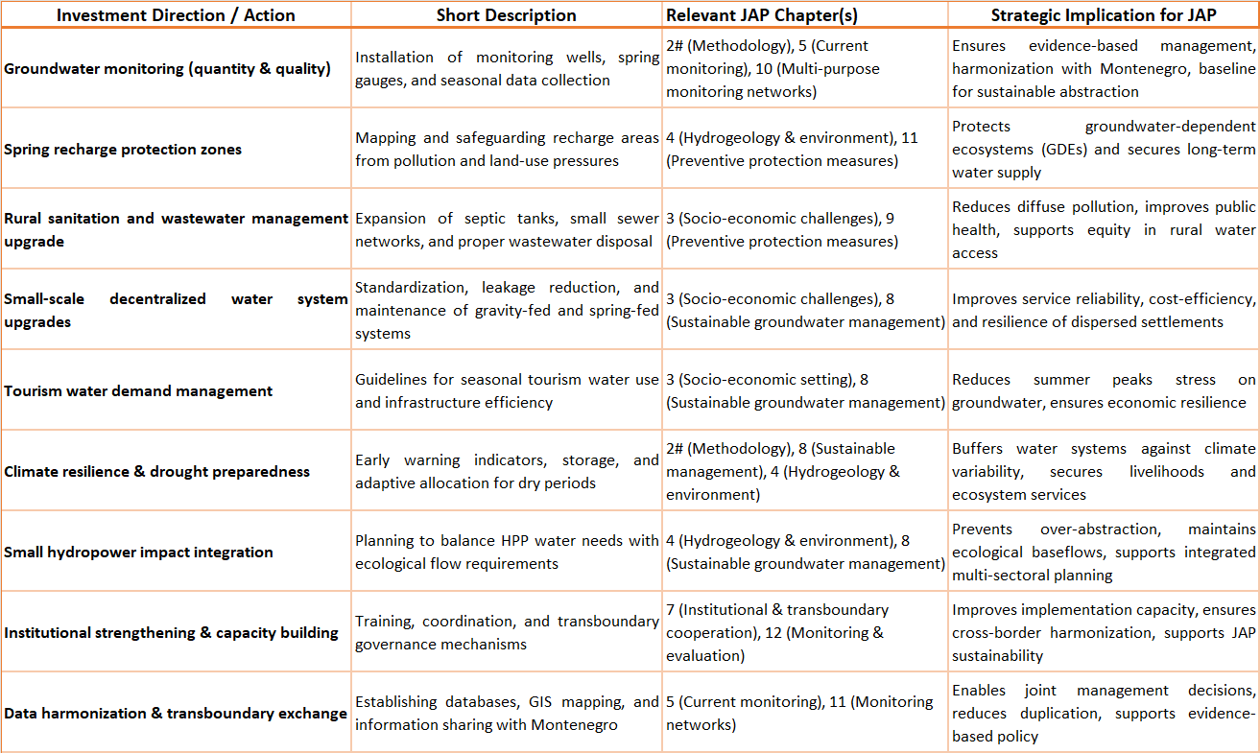
The implementation of measures defined in the Joint Action Programme (JAP) for the Cemi/Cijevna Transboundary Aquifer (TBA) requires the coordinated use of national resources and international sources of financing. Given the complexity of the karst hydrogeological system and the diversity of identified pressures, the activities envisaged under the JAP include technical, institutional, and infrastructure components whose implementation exceeds the capacity of regular budgetary resources of the competent authorities. The mobilisation of external financial mechanisms therefore represents a key prerequisite for the effective operational implementation of the proposed measures.
Financial support for activities within the Cemi/Cijevna TBA may be secured through a combination of European Union funds, international development programmes, and national financial instruments. EU programmes focusing on environmental protection, climate resilience, water management, and transboundary cooperation constitute a primary source of funding for strengthening monitoring systems, improving data exchange, protecting recharge zones, and enhancing institutional capacities. At the same time, international organisations and development institutions provide support to projects that link natural-resource management, ecosystem protection, and socio-economic development.
Within these programmes, support may be directed towards activities such as the establishment and modernisation of groundwater monitoring stations, the development of transboundary information systems and GIS platforms, pilot measures for the protection of karst aquifer recharge zones, the improvement of decentralised sanitation systems in sensitive areas, as well as the development of early-warning systems and institutional mechanisms for coordinated risk management.

Particular importance is attached to instruments supporting transboundary cooperation, as the nature of the Cemi/Cijevna karst system requires coordinated action by both countries. Projects implemented on a joint basis have enhanced prospects for funding, particularly where they are aligned with the objectives of international conventions and strategic policy frameworks in the fields of water and environmental protection. In this regard, the JAP serves as a strategic reference framework for identifying priority investment directions and preparing project initiatives.
In addition to international funding sources, national financial mechanisms also play an important role, including water funds, water-use charges, and the application of the “polluter pays” principle in accordance with national legislation. These instruments are particularly relevant for ensuring the long-term sustainability of measures, including continuous monitoring, equipment maintenance, and the implementation of protective actions in sensitive areas.
The following section presents key funding sources and their linkage with JAP priorities, as well as the institutional actors with a central role in the preparation and implementation of potential projects.

Table 7.3. Overview of Potential Funding Sources
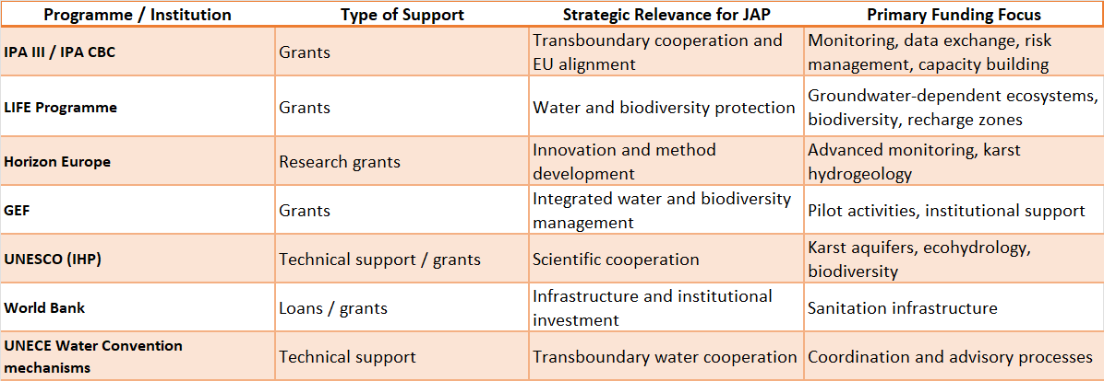

7.4. Strengthening institutional role and capacities.
Effective protection and sustainable management of the shared groundwater resource in the TBA Cemi Cijevna depend on institutions at different administrative levels being able to perform clearly defined roles and coordinate effectively across borders. Groundwater governance in the basin is characterised by strong hydrogeological interdependence combined with uneven institutional capacity, fragmented responsibilities and limited routine cross border coordination. These conditions reduce consistency and timeliness of prevention measures and weaken preparedness for incidents.
Responsibilities relevant to groundwater governance are distributed across national, sub national and local institutions covering water management, environmental protection, spatial planning, sanitation, tourism regulation and emergency response. National level institutions generally hold stronger technical competence and policy authority. However, many pressures originate at local level through sanitation practices, land use change and seasonal activities, where municipal capacity and operational tools are weaker, especially in dispersed upstream Albanian settlements.
Institutional cooperation across borders has so far been largely project based and ad hoc. While this enables occasional information sharing, it does not provide a stable framework for systematic alignment of monitoring, protection measures and response procedures. As a result, interfaces between key institutions are not always operationalised, responsibilities may overlap or remain unaddressed, and opportunities for joint prevention and early warning are limited.
Under the Joint Action Program, strengthening institutional roles and capacities focuses on improving coordination between existing institutions, clarifying responsibilities along the groundwater governance chain and reinforcing operational capacity at the levels where pressures originate. This approach builds on existing mandates and avoids creating new legal bodies or parallel structures, ensuring feasibility and long term sustainability.
A standing coordination function will be operationalised through designated focal points and routine technical exchange between institutions responsible for water management, environment, spatial planning, sanitation and tourism. Its role is to facilitate structured information flow, promote shared interpretation of monitoring results and support coordinated decision making on issues affecting groundwater protection. Priorities include emerging risks, planned developments in recharge areas and management of seasonal pressures.
Clarification of institutional roles and interfaces is a central component. Joint working sessions supported by concise written coordination notes will define responsibilities related to monitoring, land use planning, sanitation control, tourism management and emergency response. Particular attention will be given to interfaces between national water authorities, municipalities, utilities and inspection functions operating in recharge and protection zones.
Capacity strengthening will prioritise sub national and local authorities as key implementation actors. Support will focus on practical implementation challenges including inspection and management of on site sanitation, enforcement of protection zones in karst terrain, integration of groundwater considerations into planning decisions, and coordination with tourism permitting and infrastructure development. Emphasis will be placed on applied learning and practical tools rather than generic training.
Groundwater monitoring practices will be strengthened through further alignment of parameters, sampling frequency and data formats across borders. Responsibilities remain with competent institutions, while structured data exchange and joint interpretation are facilitated through the coordination mechanism. This improves transparency, supports shared risk awareness and strengthens trust between institutions.
Institutional preparedness for incidents will be improved through agreed cross border notification and response procedures. These procedures will define roles and communication channels for utilities, environmental authorities, municipalities and focal points in the event of contamination, accidental pollution or abnormal groundwater behaviour. Clear and tested procedures enable faster responses, reduce uncertainty and strengthen public confidence.
Overall, strengthening institutional roles and capacities under the Joint Action Program aims to ensure that institutions act in a coordinated, informed and timely manner. By reinforcing existing structures, clarifying responsibilities, strengthening local capacity and improving cross border coordination, the Program supports more effective protection of the shared aquifer and a durable foundation for sustained cooperation.

Strengthening Institutional role and capacities - Montenegro Context
In the Montenegrin part of the Cemi/Cijevna Transboundary Aquifer (TBA), institutional responsibilities for groundwater management are distributed among the line ministry responsible for water resources, the Water Administration, the Environmental Protection Agency, the Institute of Hydrometeorology and Seismology, and the Geological Survey of Montenegro. Local self-governments also play a significant role, particularly in spatial planning, communal infrastructure, and the protection of water sources. This institutional arrangement establishes a formal framework for the application of Integrated Water Resources Management (IWRM) principles, including groundwater monitoring, abstraction control, and the implementation of protection measures.
Despite this formal framework, operational capacities for groundwater protection in karst areas such as the Cemi/Cijevna catchment remain constrained. Key challenges include the limited density and technical capacity of the groundwater monitoring network, insufficient oversight of small-scale and individual abstractions, and the inadequate integration of recharge zone protection into local spatial planning instruments. These constraints are particularly pronounced in areas with dispersed settlements and decentralized sanitation systems, where the intrinsic vulnerability of the karst aquifer significantly increases exposure to diffuse pollution pressures.
With regard to transboundary cooperation, a legal and institutional basis is in place through bilateral agreements and cooperation mechanisms supported by international frameworks. However, practical arrangements for joint groundwater monitoring, systematic data exchange, and coordinated risk management have yet to be fully operationalized. Strengthening technical coordination between the competent institutions of Montenegro and Albania-especially in relation to harmonized monitoring approaches, data sharing, and the planning of protective measures in recharge areas-constitutes a core institutional priority under the Joint Action Program (JAP).
Evidence from European transboundary regions indicates that the long-term effectiveness and sustainability of cooperation depend not only on formal agreements, but also on the establishment of stable institutional mechanisms, the development of mutual trust among stakeholders, and continuous technical coordination.
This section draws on the findings of the Governance and Gender Diagnostic Analysis (GGDA) for the Cemi/Cijevna TBA in Montenegro and Albania, as well as on relevant national legislation governing water management, local self-government, and spatial planning.

7.5. Strengthening stakeholder engagement and public awareness
In the Albanian part of the Cem/Cijevna River Basin, covering the Municipality of Malësi e Madhe and the Administrative Unit of Kelmend, stakeholder engagement and public awareness are essential for the successful implementation of the Joint Action Programme (JAP). Due to the dispersed nature of settlements, low population density in mountain villages, and limited local mountain infrastructure, public participation and informed decision-making require structured approaches that are fully integrated into JAP actions.
JAP defines specific socio-economic and environmental actions where stakeholder engagement is critical, including: groundwater protection, wastewater and solid waste management, river monitoring, biodiversity conservation, climate adaptation, and sustainable tourism management. In practice, this involves supporting local communities, municipal authorities, NGOs, and cross-border partners to actively participate in planning, implementation, and monitoring of these actions.
Current experiences in the region demonstrate the value of combining technical capacity with participatory approaches. For instance, NGO initiatives by EcoAlbania and Riverwatch have engaged local communities in water quality monitoring, awareness campaigns, and pilot river protection activities, providing models for JAP engagement strategies (Riverwatch, 2015; EcoAlbania, 2023). Similarly, IPA Cross-Border Cooperation (IPA CBC) Albania–Montenegro has facilitated workshops and joint planning sessions, bringing together local authorities, NGOs, and citizens to coordinate actions across the border (European Commission, 2021). EU4Rivers / EU for Water has established operational monitoring systems and citizen-oriented reporting tools that allow communities to follow water quality in near-real-time, directly linking public awareness to JAP monitoring actions (EU4Rivers, 2025). It`s important to include participants from all targets of interests, men and women, young people as well as all those subjects and individuals connected to the business, tourism or institutions connected to public services and education.
In line with JAP priorities, stakeholder engagement actions should focus on three main areas:
- Targeted Awareness Campaigns: Informing residents, farmers, and tourism operators about groundwater vulnerability, pollution risks, and sustainable water use practices. Activities can include school programs, community workshops, and informational signage at key river corridors, particularly in high-altitude settlements like Vermosh, Razma, and Boga.
- Participatory Action in Water and Environmental Management: Involving local stakeholders in mapping pollution sources, monitoring water quality, reporting illegal dumping, and identifying priority sites for ecosystem restoration. These activities not only support data collection for JAP indicators but also increase local ownership of river protection measures.
- Multi-Stakeholder Coordination Platforms: Formalizing communication and joint decision-making between municipalities, national agencies, NGOs, and cross-border counterparts in Montenegro. These platforms are instrumental for planning seasonal water demand management, coordinating transboundary river actions, and integrating community input into JAP implementation.

By embedding these actions within the JAP framework, stakeholder engagement becomes an operational tool rather than a peripheral activity. It ensures that public participation contributes to measurable outcomes, such as improved compliance with environmental regulations, increased community-led monitoring activities, reduction of local pollution incidents, and enhanced awareness of climate and seasonal water challenges.
Structured engagement, combined with technical monitoring and cross-border cooperation, ensures that residents are active participants in river basin management, thereby increasing the effectiveness and sustainability of JAP interventions.
Effective groundwater governance in the TBA Cemi Cijevna depends not only on institutional coordination but also on the awareness, behaviour, and involvement of stakeholders whose practices influence groundwater quality and long term sustainability. In the basin, stakeholder engagement remains fragmented and uneven. Formal consultation channels exist, but groundwater specific engagement is limited and cross border stakeholder interaction is largely absent outside project based initiatives.
Transparency and feedback are integral to engagement. Stakeholders should have access to basic information on groundwater status, planned measures, and engagement outcomes through mechanisms defined in the Stakeholder Involvement Plan. Engagement activities will be monitored using agreed indicators and adjusted over time based on stakeholder feedback.

Table 7.4 Stockholders role
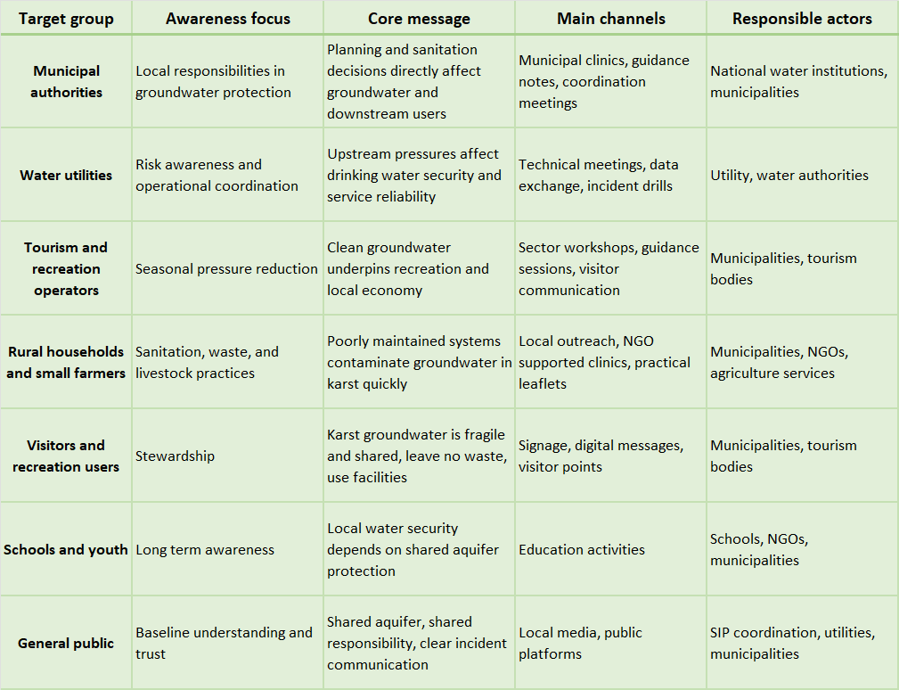

Strengthening stakeholder engagement and public awareness –Montenegro context
In the Montenegrin part of the Cemi/Cijevna Transboundary Aquifer (TBA), stakeholder engagement and the strengthening of public awareness constitute key elements of sustainable groundwater management. Local populations in the areas of Tuzi, Zeta, and the peri-urban zone of Podgorica rely to a significant extent on groundwater for domestic use, agricultural activities, small family-based enterprises, and recreational and tourism services associated with the Cemi/Cijevna canyon. At the same time, a large number of users depend on small-scale or individual water supply sources that are not fully covered by formal permitting and monitoring systems, further underscoring the need for targeted information dissemination and the active involvement of local communities in water management processes.
Particular attention can be given to awareness-raising through educational activities in schools, local information campaigns, and cooperation with public water supply utilities, which maintain direct contact with water users. Such activities contribute to a better understanding of the vulnerability of the karst system, promote responsible groundwater use, and enhance community willingness to support the protection measures envisaged under the Joint Action Program (JAP).
From a socio-economic perspective, particularly vulnerable groups include small-scale farmers, households in rural and semi-rural settlements, and women, who play an important role in agricultural and service-related activities linked to water resources. Strengthening their participation in planning and implementation processes contributes to greater social equity and the long-term sustainability of groundwater management. Activities under the JAP should therefore support the development of local capacities, awareness campaigns on the vulnerability of the karst system, and mechanisms for two-way communication between competent institutions and water users.
Research on transboundary cooperation indicates that the active involvement of local actors, trust-building, and the development of a shared understanding of challenges are critical factors for the long-term stability of joint initiatives.
In the context of the transboundary dimension, the involvement of local communities and civil society organizations on both sides of the border can contribute to trust-building, the exchange of experiences, and a better understanding of the shared dependence on the same karst system. Such an approach supports not only environmental objectives related to groundwater protection, but also broader social resilience and sustainable local development within the Cemi/Cijevna TBA.
This section is based on the findings of the Governance and Gender Diagnostic Analysis (GGDA) for the Cemi/Cijevna TBA in Montenegro and Albania, as well as relevant national legislation on water management, local self-government, and spatial planning.

7.6 Engagement of local and regional authorities.
Municipalities often hold direct responsibilities for land-use planning, public utilities and services, and community awareness programmes, which position them as key actors in ensuring that basin policies are understood and supported at the public level. However, in many cases local administrations require enhanced technical support, funding, and organizational capacity to effectively participate in basin planning and cross-border coordination.
Coordination and Transboundary Cooperation: Local and regional institutions facilitate dialogue and joint action with NGOs, national ministries, and Montenegrin counterparts. Platforms supported by UNECE, IPA CBC, and other EU programs allow authorities to synchronize river basin management, coordinate seasonal water use, and monitor ecological impacts across borders.
The Table 7.5. clearly illustrates how the actions of local and regional authorities in Albania are linked to the transboundary dimension, connecting operational responsibilities, socio-economic benefits for local communities, and the impact on cooperation with Montenegro and transboundary ecosystems.

Table 7.5. Local and Regional Authorities’ Engagement & Relevance for the Transboundary Dimension (Albanian Cem Basin)
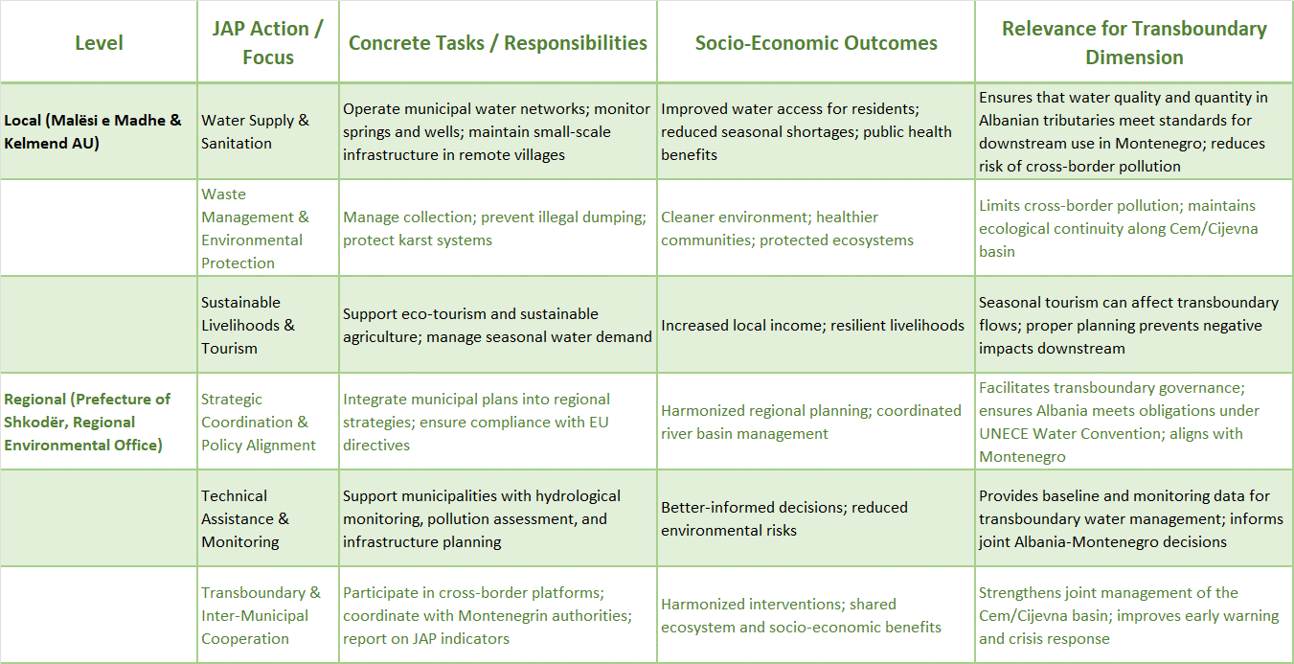

Local authorities in upstream Albania face structural constraints including limited budgets, dispersed settlements, and weak technical staffing. This reduces the ability to oversee septic systems, identify dumping hotspots, and integrate groundwater vulnerability into municipal development planning. As a result, groundwater risk management tends to be reactive and fragmented.
Downstream in Montenegro, municipal functions are more operationally embedded and linked to public service accountability, but pressures from peri urban expansion and land use change create continuing governance challenges. Coordination between planning, wastewater management, and groundwater protection is not always consistent, particularly under rapid development.
Under the Joint Action Program, engagement of local and regional authorities focuses on strengthening their role as implementation actors and ensuring meaningful involvement in coordination and feedback processes. Engagement will be recurring, practical, and linked to responsibilities and capacity.
Vertical coordination between national institutions and municipalities will be strengthened to improve clarity of roles and consistency in implementation. Two way communication is essential so municipalities can report constraints and local knowledge, and national institutions can adapt guidance and priorities accordingly.
Cross border engagement between local authorities will be encouraged where it improves alignment, especially around shared pressure types and sensitive zones. This can include joint thematic workshops or practical exchanges focused on sanitation, waste management, and seasonal pressure management.
Groundwater management within the Cemi/Cijevna Transboundary Aquifer (TBA) cannot rely exclusively on national-level institutions, as a substantial share of the pressures affecting the karst aquifer originates at the local level, through land use practices, communal infrastructure, spatial planning, and local economic development. Local and regional authorities therefore play a critical role in the operational implementation of the measures envisaged under the Joint Action Program (JAP), particularly with regard to pollution prevention, the protection of recharge zones, and risk management.
On the Montenegrin side, this primarily concerns the municipalities of Tuzi and Zeta, as well as the peri-urban area of the Capital City of Podgorica. On the Albanian side, relevant local government units include those responsible for the Malësi e Madhe area and adjacent zones encompassed by the TBA. Local self-government authorities hold direct competencies in spatial and urban planning, the issuance of planning and construction conditions, the management of communal systems, the organization of water supply and sanitation services, and the implementation of local development policies. These functions position them as key actors in the implementation of measures related to the control of diffuse pollution, the improvement of wastewater collection and treatment systems, the protection of water sources, and the management of pressures associated with tourism and construction activities.
European practice recognizes local and regional authorities as the primary drivers of the operational dimension of transboundary cooperation, particularly where joint planning processes and access to international funding serve as incentives for coordinated action.
The JAP foresees the strengthening of the role of local and regional authorities through their active involvement in the planning and implementation of measures, systematic data exchange with national institutions, and participation in transboundary coordination mechanisms. Of particular importance is the integration of groundwater protection considerations into local spatial plans and development documents, ensuring that areas of high vulnerability and recharge zones of the karst aquifer are adequately taken into account in the planning of new infrastructure, tourism, and residential developments.
At the regional level, cooperation between local authorities on both sides of the border can contribute to the harmonization of approaches to managing pressures with transboundary impacts, particularly in relation to sanitation infrastructure, waste management, and the protection of sensitive natural areas. The exchange of experience, joint training activities, and participation in transboundary projects further strengthen institutional capacities and contribute to trust-building among stakeholders.
Through such an approach, local and regional authorities become key agents for the practical implementation of the JAP on the ground, ensuring a direct link between strategic groundwater protection objectives and concrete spatial interventions. Their systematic involvement enhances the effectiveness of measures, improves policy coherence, and supports the long-term sustainability of the management of the shared Cemi/Cijevna karst aquifer.

Table 7.6. Role of Local and Regional Authorities in the Implementation of JAP Measures (AL-ME)
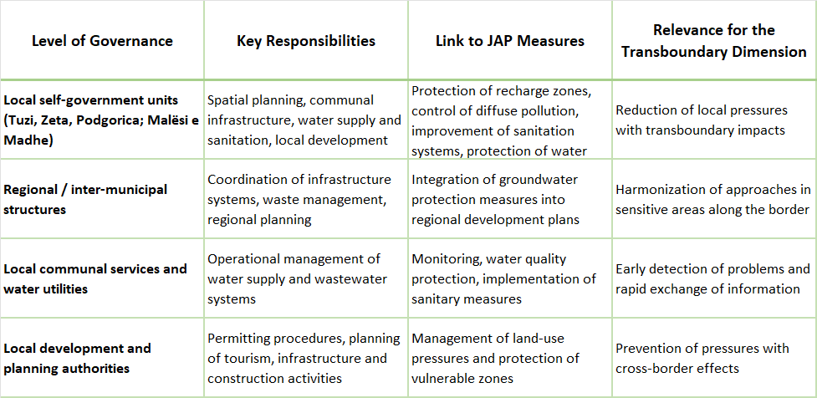

This section is based on findings of the GGDA (Governance and Gender Diagnostic Analysis) for the Cemi/Cijevna TBA for Montenegro and Albania, as well as relevant national legislation on water management, local self-government and spatial planning.

8. Measures for sustainable groundwater management.

8.1 Strategic approach to sustainable groundwater management (in rural areas).
This section outlines strategic and operational measures for the sustainable management of groundwater in the Cemi/Cijevna transboundary basin. The recommendations are based on the hydrogeological setting of the basin (karst headwaters and intergranular Zeta Plain aquifer), the results of recent groundwater quality assessments (Albania – June 2025; Montenegro – Trgaj and Ušće boreholes), and the joint monitoring framework established under the Albania–Montenegro cooperation process.
Rural areas within the Cemi/Cijevna transboundary watershed play a crucial role in groundwater recharge, water supply security, and ecosystem stability. The basin is characterized by karst aquifers in the upper mountainous zones and intergranular aquifers in the downstream Zeta Plain. Rural settlements, agriculture, livestock activities, and decentralized wastewater systems directly interact with these hydrogeological systems. A strategic approach to sustainable groundwater management in rural areas must therefore prioritize prevention, monitoring, adaptive management, and cross-border coordination.
Prevention-Based on protection of recharge zones
Karst aquifers dominate the upstream Albanian part of the basin and parts of the Kuči groundwater body in Montenegro. Due to high permeability and rapid infiltration, contamination can travel quickly with limited natural attenuation. Sustainable management therefore requires: (i) formal delineation of groundwater protection zones around major springs and boreholes; (ii) restriction of uncontrolled wastewater discharge, livestock concentration, and solid waste disposal within recharge areas; (iii) integration of karst vulnerability mapping into municipal spatial planning. Preventive protection is more effective and economically efficient than downstream remediation.
Karst terrains in rural headwater zones (e.g., Grabom, Tamara, Vermosh, Selcë) are highly vulnerable to rapid infiltration. Because natural attenuation capacity is limited, groundwater protection must focus on preventive measures. Strategic actions include: formal delineation of protection zones around springs and boreholes; regulation of construction and waste disposal in recharge areas; and integration of groundwater vulnerability mapping into municipal land-use planning. In rural settings, low-cost preventive measures are significantly more effective than post-contamination remediation.
Sustainable abstraction sanitation and wastewater management
Groundwater abstraction in the Zeta Plain supports drinking water supply and agriculture. To maintain good quantitative status, abstraction rates should be linked to seasonal recharge conditions. Measures include: establishing abstraction registers and reporting obligations; periodic review of pumping permits; implementation of drought contingency plans during low-flow periods; and evaluation of cumulative abstraction impacts on river–aquifer interaction.
Decentralized sanitation systems are common in rural communities and represent a primary risk for microbiological contamination of groundwater. All villages in Albanian part, within of Cemi/Cijevna watershed are not connected with sewage system that actually is inexistent. Strategic measures should include: upgrading or sealing septic systems; introducing small-scale wastewater treatment units where population density justifies investment; periodic inspection of septic tanks; and technical guidance for households. Special attention is required in shallow intergranular settings and near springs.
Environmentally responsible agricultural practices
Agriculture and livestock activities contribute to diffuse nutrient pressures. Although current datasets indicate low nitrate concentrations in upstream springs, long-term sustainability requires proactive management. Recommended measures include: controlled fertilizer application based on soil testing; establishment of buffer strips near watercourses and sinkholes; improved manure storage; and seasonal restrictions during high-recharge periods. Agricultural advisory services should integrate groundwater protection into rural development programmes.
Adaptive groundwater abstraction in rural supply systems
Although current datasets show generally low nutrient and metal concentrations, diffuse pressures remain a long-term risk. Recommended actions include: upgrading rural wastewater treatment systems; promoting good agricultural practices (optimized fertilizer application, buffer strips near watercourses); improving manure storage; and conducting awareness campaigns for local communities on groundwater vulnerability.
Rural water supply schemes often rely directly on springs or shallow boreholes. Sustainable abstraction requires linking withdrawal rates to seasonal recharge conditions. Strategic measures include: installation of simple flow meters; periodic review of abstraction volumes; contingency planning during drought periods; and community-level water-saving awareness. Maintaining environmental flow in connected river systems is essential for long-term recharge stability.
Community awareness and capacity building
In rural areas, groundwater protection depends strongly on local awareness. Education programmes should explain the rapid transport characteristics of karst systems and the shared nature of transboundary aquifers. Engaging municipalities, schools, farmers, and local associations in groundwater stewardship enhances long-term compliance and reduces unintentional contamination risks.
Strengthened monitoring and early warning
Sustainable rural groundwater management requires reliable data. The existing joint monitoring programme should be strengthened through: continuous piezometric logging in representative wells (especially in the Zeta Plain); harmonized sampling twice per year (spring and autumn) for core chemical parameters; basic piezometric tracking in key rural wells; regular microbiological screening in vulnerable intergranular settings; and real-time data exchange between Albanian and Montenegrin authorities. Early warning systems for extreme rainfall events should be linked to post-event water-quality checks, particularly in karst areas.
Monitoring stations at Trgaj and Ušće should serve as long-term reference points for trend analysis as well as they of Grabom and Tamara.

Cross-border rural coordination mechanisms
Because the Cemi/Cijevna system functions as a single hydrological unit, rural groundwater management in Albania and Montenegro should be coordinated. Joint technical meetings, harmonized protection standards, shared data platforms, and coordinated awareness campaigns ensure consistency across the watershed. Transboundary cooperation reduces risks and enhances funding opportunities under EU and regional environmental programmes.
A strategic approach to sustainable groundwater management in rural areas must therefore combine preventive land-use control, improved sanitation, responsible agriculture, adaptive abstraction management, strengthened monitoring, and community engagement. In a karst-dominated transboundary basin such as Cemi/Cijevna, early intervention and long-term cooperation represent the most cost-effective path toward maintaining good chemical and quantitative groundwater status.
Climate change adaptation measures
Observed warming trends and shifts from snow-dominated to rainfall-dominated regimes increase hydrological variability. Adaptive groundwater management should therefore include: integration of climate projections into recharge and abstraction planning; enhanced monitoring during extreme rainfall events; protection of natural retention areas; and safeguarding ecological flows to maintain river–aquifer balance.
Institutional and transboundary cooperation measures
Because the Cemi/Cijevna system functions as a single hydrological unit, sustainable management requires formalized transboundary cooperation. Key measures include: joint annual technical reviews of groundwater status; shared databases and harmonized methodologies; development of a joint groundwater risk map; and coordination of infrastructure planning in both countries. Long-term sustainability depends on consistent political and technical collaboration.
Strategic outlook
The current evidence suggests a generally favorable groundwater baseline condition in the basin, but the system remains inherently vulnerable due to karst dynamics, river–aquifer exchanges, and increasing climatic variability. Sustainable groundwater management in the Cemi/Cijevna basin should therefore prioritize prevention, monitoring, adaptive abstraction control, and transboundary coordination. Maintaining good chemical and quantitative status will directly support drinking water security, agricultural productivity, ecosystem health, and long-term regional resilience.

8.2 Promotion of water-efficient technologies.
Promotion of water-efficient technologies in the Cemi / Cijevna transboundary basin
Albania - Montenegro, 2026–2035 strategic framework
The Cemi/Cijevna transboundary basin is characterized by abundant but under-utilized water resources, uneven infrastructure, and a socio-economically vulnerable rural population. Within the Albanian section of the basin — particularly the Kelmend Administrative Unit in Malësi e Madhe -water use intersects critically with agriculture, livelihoods, and emerging tourism. These demands, combined with limited formal irrigation systems and seasonal pressure on groundwater and springs, create a compelling need for water-efficient technologies that enhance both sustainability and socio-economic well-being.
At the European level, the principle of “water efficiency first” has been firmly embedded in recent policy frameworks, including the European Water Resilience Strategy. This principle prioritizes reducing water demand, improving efficiency, and deploying technological solutions before expanding supply-side infrastructure (European Commission, 2025).
The European Environment Agency highlights that improved water efficiency across key sectors—especially agriculture, public water supply, and industry—can deliver significant water savings and strengthen long-term resilience to drought and water scarcity (European Environment Agency [EEA], 2025).
Technological solutions such as smart metering, digital monitoring, and sensor-based systems enable real-time tracking of water use, early leak detection, and improved operational management of water distribution networks. These technologies are particularly important in areas with aging infrastructure and limited maintenance capacity, where non-revenue water losses represent both an economic and environmental burden (European Commission, 2025).
From a socio-economic standpoint, this approach is particularly relevant for peripheral and rural areas such as the Cem basin, where large-scale infrastructure investments may be financially constrained. At the same time, efficiency gains can generate immediate economic and social benefits. Promoting water-efficient technologies at the basin scale—including smart metering, precision irrigation, water reuse systems, and digital monitoring—constitutes a core strategy for enhancing the sustainability of water resources, reducing water losses, and strengthening system resilience in the Cem/Čijevna transboundary river basin.
From a socio-economic perspective, these measures yield high returns by reducing water demand, enhancing operational efficiency, and bolstering long-term water security for local communities and economic activities. Beyond environmental benefits, they also support improved livelihoods, reduce the vulnerability of rural populations, particularly for women (the gender asymmetry in the region, affects both access to and benefits from new technologies), and promote more equitable and resilient water governance across the Cem/Čijevna transboundary basin.
Although the basin is characterized by relatively high natural water availability, growing pressures from climate variability, demographic change, agriculture, and seasonal tourism intensify the need for demand-side water management solutions. In this context, water efficiency measures offer cost-effective and socially inclusive pathways to improve water security without increasing abstraction pressures.
To realize these benefits, interventions should include capacity building, gender-responsive finance mechanisms, and institutional support for rural extension services. Comparative experiences from water management initiatives within Albania demonstrate that investments in irrigation services can produce substantial socio-economic returns for smallholder farmers and rural women alike.
In the agricultural sector, which remains a dominant livelihood source in the Albanian part of the Cem basin, precision and digital irrigation technologies offer substantial socio-economic benefits. The use of soil moisture sensors, automated irrigation controllers, and data-driven irrigation scheduling allows farmers to align water application with actual crop needs and climatic conditions. Evidence from EU river basins demonstrates that digital irrigation planning can reduce agricultural water demand by approximately 20% or more, without compromising crop yields or productivity (EEA, 2025). For small-scale and family-based farms, including those where women play a central role in farm management and labor, such efficiency gains contribute to reduced production costs, improved income stability, and lower vulnerability to seasonal water stress.
Not only agriculture, but also the water reuse and rainwater harvesting technologies are increasingly recognized as essential components of sustainable and circular water management. The reuse of treated wastewater for non-potable purposes—such as irrigation, landscaping, and industrial cooling—reduces pressure on freshwater abstractions and enhances system resilience during dry periods (EEA, 2025). Similarly, rainwater harvesting systems at household, farm, and tourism-facility levels can supplement local water supplies and mitigate seasonal shortages.
In the Cem basin, where tourism development is expanding and water demand peaks during summer months, these technologies are particularly relevant from both a socio-economic and water-governance perspective.
Emerging approaches, including water-sensitive design solutions and nature-based technologies, such as constructed wetlands, further support water efficiency objectives. These systems integrate storm water capture, grey water reuse, and natural treatment processes into local planning and infrastructure, offering co-benefits for ecosystem protection, landscape management, and local employment generation. Such solutions are especially suitable for rural and semi-rural settlements, where decentralized systems may be more feasible and socially acceptable than centralized infrastructure.
To ensure widespread adoption of water-efficient technologies in the Cem/Čjevna basin, enabling socio-economic and institutional frameworks are required.
Adoption of WETs in rural, mountain environments like Kelmend faces several socio-economic and institutional challenges such as: targeted financial incentives ( because of the high initial investment costs and limited access to affordable financing hinder adoption, particularly for poorer households), access to technical training and advisory services, and improved access to financing mechanisms; linkage with national and EU water strategies and regional and cross-border development programs; integration with climate adaptation plans for agriculture and tourism to enhance the resilience and economic stability as well as the community-based approaches, to ensure that socio-economic benefits, including labour savings and increased productivity, are equitably distributed.
Table 8.1. Indicators (Socio-Economic Focus)
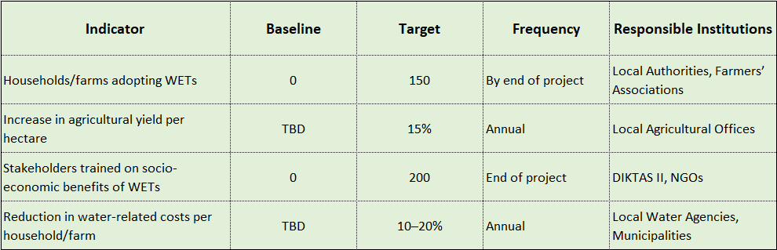

Table 8.2. Key Socio-Economic Activities, Expected Results, and Indicators for Water-Efficient Technologies in the Cem/Čijevna Basin”
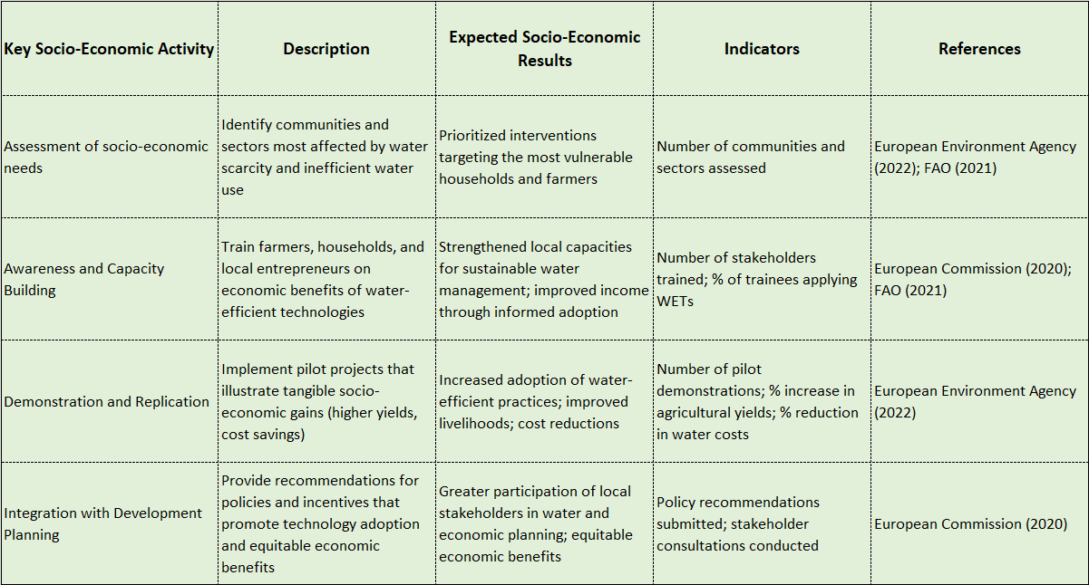

Vision and strategic objective
The Governments of Albania and Montenegro recognize water efficiency as a strategic pillar of sustainable groundwater management in the Cemi/Cijevna basin. This Action Plan aims to reduce abstraction pressure, enhance drought resilience, protect ecological flows, and maintain good quantitative and chemical status of groundwater bodies through coordinated promotion of water-efficient technologies.
Strategic targets (2026–2035)
- The following indicative targets are proposed for the basin:
- Reduce agricultural water abstraction by at least 25% by 2030 compared to baseline.
- Reduce non-revenue water in rural supply systems to below 25% by 2030.
- Ensure that 80% of new irrigation systems use drip or smart irrigation technologies.
- Equip all abstractions above 10 l/s with digital flow meters by 2028.
- Introduce wastewater reuse systems in at least 50% of seasonal tourism facilities by 2030.

Priority action areas

Agriculture
- Subsidy schemes for drip and subsurface irrigation.
- Soil moisture monitoring and smart scheduling.
- Conditional abstraction permits linked to efficiency standards.
- Training programs for farmers on water-saving practices.

Rural water supply
- Installation of smart metering and leak detection systems.
- Pressure management and network rehabilitation.
- Establishment of District Metered Areas (DMA).
- Real-time monitoring of spring discharge and reservoirs.

Tourism and services
- Mandatory low-flow fixtures in new constructions.
- Incentives for greywater recycling systems.
- Rainwater harvesting for non-potable uses.
- On-site tertiary wastewater treatment for reuse.

Industrial and commercial users
- Mandatory water audits for users above defined thresholds.
- Promotion of closed-loop and recycling systems.
- Incentivized tariffs for reduced consumption.

Governance and institutional coordination
A Joint Technical Working Group shall oversee implementation, monitor progress, and ensure harmonization of efficiency standards. Annual reporting on abstraction trends, efficiency indicators, and climate risk shall be exchanged.
Financing mechanisms
Implementation shall mobilize:
- National budget allocations.
- EU IPA and Green Agenda funding.
- Climate adaptation financing mechanisms.
- Public-private partnerships. • Tariff-based reinvestment schemes.

Monitoring and performance indicators
Key performance indicators (KPIs) include:
- Annual groundwater abstraction volumes.
- Percentage of efficient irrigation systems installed. • Non-revenue water levels.
- Seasonal abstraction reduction during drought periods.
- Number of facilities implementing reuse systems.

Climate adaptation integration
Water efficiency shall be recognized as a primary climate adaptation measure. Demand-side management must complement supply-side investments to mitigate projected summer baseflow reductions in the Western Balkans.
Transboundary commitment
Both countries commit to harmonizing standards, exchanging best practices, and jointly evaluating progress every three years. A mid-term review shall be conducted in 2030.
Conclusion
This Intergovernmental Action Plan establishes a coordinated roadmap for improving water efficiency in the Cemi/Cijevna basin, strengthening groundwater protection, and ensuring long-term sustainability.

8.3 Guide to control and licencing of groundwater exploitation and wastewater discharge.
Licensing of groundwater exploitation and wastewater discharge are determined through permits issued by the Water Administration of Montenegro.
In Albania licensing for all development activities including groundwater exploitation and wastewater treatment plant is competence of Ministry of Infrastructure and Energy (MIE) Licensed Companies apply to WRMA for respective permitting on groundwater exploitation or wastewater discharge.
The main water resource permitting Institution in central level are:
- National Council of Territory and Water (NCTW); (besides the other, responsible for transboundary issues)
- Water Resource Management Agency. (WRMA) (besides the other, operate as secretariat of NCTW)

The main Institution in local level are:
- Council of Water River Basin (CWRB); (issued water permits and authorization base on RBMP)
- Water Administration Office (WAO), (besides the other operate as secretariat of (CWRB).

All applications for water permit addressed to the WRMA via electronic system. WRMA valuate the application file and based on RBMP condition and in cooperation with other Institution (if necessary), prepare the file for CWRB discussion and decision.
Related to the control of groundwater exploitation and wastewater discharge there are two Institution responsabil.
Albania Geologic Service (AGS) is the main state Institution dealling will groundwater monitoring based on RBM Plans. This Institution is part of Ministry of Infrastructure and Energy, which complicate cooperation with other water related institutions, related to use and water monitoring.
The main one is National Environmental Agency (NEA) part of Ministry of Tourisem and Energy (MTE). This Institution is responsabile beside others for the control and monitoring of ecological parameter of water resorces including groundwater and surface water.
Montenegro
In the Montenegrin groundwater governance is more operationally embedded within municipal and utility systems, reflecting higher population density, stronger institutional presence, and direct dependency on reliable water supply.
Primary institutions is Ministry of Agriculture, Forestry and Water Management (MAFWM) - Directorate for Water Management.
It holds responsibility for water management policy, regulation, and coordination at national level, including groundwater protection and abstraction control. While the Directorate provides the formal regulatory framework, its capacity to influence upstream pressures originating outside national borders remains limited, requiring structured transboundary cooperation mechanisms.
The Water Directorate-WD (Uprava za vode) is tasked with the operational implementation of water management policies, including issuing permits, monitoring water resources, maintaining water registers, and ensuring compliance with water use and protection measures.
Water management directorates and regulatory bodies, including the Water Directorate (WD), the Water Inspection, and the Energy and Regulated Utilities Agency (REGAGEN), provide technical oversight, permitting functions, and coordination with municipal authorities. While the Water Directorate and Water Inspection focus on operational management and compliance monitoring of water resources, REGAGEN regulates public water supply and wastewater services, including licensing, tariff approval, and performance oversight. Their combined role is most visible in downstream and peri-urban areas, where infrastructure, population density, and water use demand active management and coordinated oversight.
Detailed guide to control and licensing of groundwater exploitation and wastewater discharge
Legal Basis – Republic of Albania
This guide is based on Law No. 29/2024 'On Water Resources', as amended (partially aligned with Directive 2000/60/EC, Directive 2006/118/EC, Directive 91/271/EEC and related EU acquis). The law defines groundwater bodies, good quantitative and chemical status, environmental objectives, ecological flow (Q355), and pollution control obligations (see Law No. 29/2024).
Licensing procedures, application forms, review deadlines, institutional competences (AMBU, Basin Council, National Council of Territory and Water), and validity conditions are regulated under Council of Ministers Decision No. 319 dated 11.06.2025.
Articles 135–146 of Law 29/2024 regulate issuance, renewal, modification, suspension and revocation of water use permits, including abstraction and wastewater discharge.
Legal Basis – Republic of Montenegro
In Montenegro, groundwater abstraction and wastewater discharge are governed by the Law on Waters of Montenegro, the Law on Environment, the Law on Concessions, and secondary legislation regulating water permits and emission limits. The legal framework is aligned with the EU Water Framework Directive and the UNECE Water Convention.
Basin-specific hydrogeological vulnerability
The Cemi/Cijevna basin consists predominantly of karst carbonate formations with rapid infiltration, high transmissivity, and strong surface–groundwater interaction. Losing reaches and ponor zones create direct hydraulic pathways toward the Zeta Plain aquifer. This significantly increases vulnerability to contamination.
Licensing of Groundwater Abstraction
All groundwater abstraction beyond domestic use requires prior authorization. Applications must include hydrogeological assessment, pumping tests (≥72 hours), sustainable yield calculation, baseline chemical analysis, and monitoring plan in accordance with Law 29/2024 requirements.
Sustainable abstraction must not compromise good quantitative status or ecological flow (Q355). Where cumulative abstraction risks deterioration of status, the permit shall include seasonal restrictions. Abstraction exceeding 10 l/s, or located within 5 km of the state border, should trigger transboundary notification.
Licensing of Wastewater Discharge
Discharge permits are mandatory for any effluent entering surface water, groundwater, karst features or infiltration fields. Direct discharge into ponors or losing river segments is prohibited.
Effluent limit values shall comply with national emission standards and EU-aligned requirements. For sensitive karst zones, recommended thresholds include: BOD5 < 25 mg/L, COD < 125 mg/L, TSS < 35 mg/L, NH4 < 2 mg/L, NO3 < 50 mg/L, Total P < 1 mg/L.
Institutional Procedure (Albania)
According to Decision No. 319/2025, applications are submitted electronically via e-Albania. AMBU conducts formal and technical review within defined deadlines (5–10 working days initial review; up to 50 working days for complex documentation).
Final decisions are adopted by AMBU, the Basin Council, or the National Council of Territory and Water, depending on abstraction scale and activity type.
Compliance, Monitoring and Enforcement
Permits must define abstraction limits, monitoring frequency, reporting obligations, and sanctions for non-compliance. Authorities may suspend or revoke permits under Articles 145–146 of Law 29/2024.
A joint Albania–Montenegro permit registry and annual data exchange are recommended to prevent transboundary deterioration.
Transboundary Coordination Protocol
For activities with potential cross-border impact, prior notification between competent authorities is required. Emergency pollution response mechanisms shall be jointly defined and activated in case of accidental contamination.
This coordinated legal and technical approach ensures maintenance of good chemical and quantitative status of groundwater bodies in the Cemi/Cijevna basin and aligns with EU water governance principles.

8.4 Guide to Managed Aquifer Recharge (MAR) strategy (optional)
The Cemi/Cijevna transboundary basin represents a hydrogeologically complex system where karst carbonate formations dominate the upstream mountainous and canyon sections, while intergranular aquifers characterize the downstream Zeta Plain. Seasonal discharge variability is significant, with high winter and spring flows and reduced summer baseflow. In this context, Managed Aquifer Recharge (MAR) should be considered a climate-adaptive instrument aimed at enhancing groundwater resilience without disturbing the natural hydraulic balance of this sensitive system.
In the upstream Albanian territory and the canyon reach entering Montenegro, natural recharge is already intensive due to rapid infiltration and losing river segments. However, this karst setting is highly vulnerable to contamination and rapid transboundary transport. Therefore, direct artificial recharge in highly karstified zones is not recommended unless supported by detailed hydrogeological investigation and strict water quality control.
The downstream sector interacting with the Zeta Plain aquifer provides more suitable conditions for structured recharge enhancement. During high-flow periods, surplus river discharge could be diverted into engineered infiltration basins, recharge trenches, or riverbank filtration systems. Such systems would allow seasonal storage of winter excess flows and controlled abstraction during summer drought.
In the Cemi/Cijevna basin, MAR should prioritize stabilization of seasonal storage rather than increasing long-term abstraction capacity. The objective is to buffer climatic variability, protect ecological flows, and reduce pressure on spring systems that sustain local communities.
Water quality safeguards are fundamental. Only water meeting defined chemical and microbiological standards should be used for recharge. Pre-treatment through sedimentation basins and continuous monitoring must accompany any recharge intervention, particularly in zones hydraulically connected to karst conduits.
Climate projections for the Western Balkans indicate increased drought frequency and potential reduction of summer baseflow. MAR can function as a strategic buffer, capturing surplus winter flow and storing it underground, thereby reducing the need for surface reservoirs and maintaining river morphological integrity.
A basin-specific MAR strategy should therefore include: hydrogeological suitability mapping; identification of recharge priority zones in the downstream intergranular aquifer; numerical modeling of recharge capacity; impact assessment on springs and dependent ecosystems; and establishment of a transboundary notification mechanism for projects near the state border.
Monitoring should integrate groundwater level logging, river discharge monitoring, tracer studies where necessary, and chemical baseline evaluation. Performance indicators must assess both quantitative benefits and absence of chemical deterioration.
In institutional terms, MAR projects require authorization under national water legislation in both Albania and Montenegro. For recharge interventions potentially affecting shared groundwater bodies, a joint technical review and coordinated monitoring framework are recommended.
Managed Aquifer Recharge in the Cemi/Cijevna basin should therefore be understood not as an infrastructure expansion strategy, but as a carefully controlled resilience mechanism tailored to a karst-intergranular transboundary system. If implemented cautiously and cooperatively, MAR can strengthen groundwater security, mitigate drought risk, and contribute to maintaining good quantitative and chemical status across the basin.

8.5 Conjunctive use of surface and groundwater (optional).
The Cem (Cemi/Cijevna) River basin represents a hydraulically interconnected karst–intergranular system in which surface water and groundwater cannot be managed independently. Hydrogeological assessments, monitoring data, and seasonal discharge analysis from the joint Albania–Montenegro studies confirm strong river–aquifer interaction, particularly in losing reaches entering Montenegro and in the downstream sector hydraulically connected with the Zeta Plain aquifer.
In this context, conjunctive use must be understood as an integrated operational strategy rather than parallel management of two separate resources.
Hydrological records indicate pronounced seasonal variability, with high flows during late winter and spring and reduced baseflow conditions in summer. During high-flow periods, the river contributes significantly to natural recharge processes, while in dry months groundwater abstraction increases, especially for rural supply, irrigation, and seasonal tourism. This pattern creates structural pressure on aquifers during the most vulnerable period of the hydrological year.
In the upstream Albanian section and the canyon reach, the karst system facilitates rapid infiltration and subsurface transport. Artificially increasing abstraction in these zones without coordination with river discharge conditions may reduce ecological flow and destabilize spring systems. Conversely, during high discharge periods, unused surplus flows represent an opportunity for enhanced seasonal storage through managed recharge or optimized abstraction scheduling.
In the downstream Montenegrin sector, particularly where the river interacts with the Zeta Plain intergranular aquifer, conjunctive use offers clear operational advantages. Riverbank filtration and controlled seasonal recharge can support summer pumping without exceeding sustainable yield. This approach allows winter surface-water surplus to contribute to groundwater storage, reducing pressure on the aquifer during drought periods.
Quantitative status assessments from groundwater monitoring indicate generally stable chemical conditions but highlight the importance of maintaining abstraction within recharge capacity limits. Conjunctive management can reduce risk of overexploitation by shifting abstraction patterns: prioritizing surface water use during wet periods and groundwater use during controlled dry periods, while maintaining ecological flow thresholds.
A basin-specific conjunctive use strategy should include: (1) real-time monitoring of river discharge and groundwater levels; (2) definition of seasonal abstraction rules linked to flow thresholds; (3) integration of Managed Aquifer Recharge where hydrogeologically suitable; (4) cumulative impact assessment of abstraction permits; and (5) transboundary data exchange to ensure coordinated decisions.
Climate projections for the Western Balkans suggest increased summer drought frequency and reduced baseflow. Under such conditions, conjunctive use becomes a primary adaptation mechanism. By treating the river and aquifer as a single storage and supply system, the basin can increase resilience without constructing major structural interventions that may disrupt natural morphology.
In institutional terms, conjunctive management requires harmonization of abstraction permits, shared monitoring protocols, and annual technical review between Albanian and Montenegrin authorities. Joint evaluation of groundwater levels, abstraction volumes, and river discharge trends will allow adaptive management responsive to climatic variability.
In conclusion, conjunctive use in the Cem/Cijevna basin should be implemented as a dynamic, seasonally adaptive management framework that optimizes the balance between surface water availability and groundwater storage. Properly coordinated, this approach strengthens water security, preserves ecological integrity, and supports long-term sustainability of the transboundary karst–intergranular system.

8.6 Community Participation in groundwater governance.
Community participation is a critical component of effective groundwater governance between Albania and Montenegro in the shared Cemi Cijevna aquifer. In highly connected karst systems, many pressures on groundwater originate from everyday practices related to sanitation, waste disposal, livestock management and small scale economic activities. Communities are therefore not only beneficiaries of groundwater protection, but also key actors whose behavior directly influences groundwater quality and long term sustainability.
In upstream areas of Albania, rural households rely directly on groundwater through springs, private wells and small communal systems. At the same time, awareness of groundwater vulnerability and of upstream downstream linkages remains uneven. Many pressures are diffuse and cumulative, such as poorly maintained on site sanitation systems or informal waste disposal, and their impacts are not immediately visible locally. However, due to karst connectivity, contamination can travel rapidly and affect downstream users in Montenegro.
Downstream communities in Montenegro are more closely linked to centralised water supply systems and therefore experience groundwater risks indirectly through service quality and public health concerns. This creates higher visibility of impacts, but not necessarily stronger awareness of upstream drivers.
Under the Joint Action Program between Albania and Montenegro, community participation is designed to be practical, inclusive and proportionate. Participation mechanisms focus on enabling communities to:
Understand groundwater vulnerability in karst environments

- Recognize upstream downstream interdependence
- Contribute local knowledge on pressure points and risk areas
- Provide feedback on proposed measures
- Adopt realistic and achievable practices that reduce contamination risk

Community engagement will priorities simple, locally adapted formats such as village meetings, sanitation focused clinics, thematic discussions on waste management and land use, and participatory awareness activities supported by municipalities and civil society organizations. Communication will avoid technical terminology and focus on clear cause effect relationships between local practices and groundwater impacts.
Civil society organizations in Albania and Montenegro can play a bridging role, particularly in upstream areas where institutional presence is limited. They can help build trust, facilitate dialogue, and ensure that women, youth and vulnerable groups are included in participation processes.
Transparency is central to effective participation. Communities will be informed about groundwater conditions, identified risks and planned measures through municipal communication channels, local media, notice boards and, where feasible, digital platforms. Clear feedback channels will allow communities to raise concerns and receive responses, strengthening trust in institutions.
By strengthening community participation in Albania and Montenegro, the Joint Action Program aims to reduce diffuse pressures on groundwater, support behavioural change and reinforce shared stewardship of the aquifer. Community participation enhances legitimacy, effectiveness and sustainability of transboundary groundwater governance.

8.7 The role of stakeholders in implementation and monitoring of transboundary cooperation and governance.
National water authorities in Albania and Montenegro coordinate groundwater quantity and quality monitoring, validate and consolidate data, ensure methodological consistency and support cross border exchange of information. They lead the assessment of progress against agreed indicators and provide the technical basis for evaluation of governance and management measures.
Environmental authorities and inspectorates contribute through compliance monitoring and enforcement activities related to groundwater protection zones, pollution sources, sanitation systems and environmentally sensitive activities. Their findings support evaluation of the effectiveness of regulatory and preventive measures.
Municipal authorities in both countries support monitoring and evaluation at local level. They report on implementation of sanitation, land use and tourism related measures, identify local pressures and provide feedback on feasibility and effectiveness of actions. Municipalities also facilitate stakeholder participation in review meetings and consultations.
Water utilities in Montenegro provide abstraction, discharge and water quality data and support incident reporting. Given their direct dependency on groundwater, they contribute to early warning and evaluation of risk management measures and participate in joint interpretation of monitoring results.
Tourism and recreation authorities contribute by tracking visitor numbers, seasonal dynamics and compliance with environmental guidance in sensitive areas. Their inputs support evaluation of measures addressing tourism related pressures.
Civil society organisations and community groups support participatory monitoring and qualitative evaluation of governance effectiveness. Their role includes reporting local issues, providing feedback on stakeholder engagement and contributing to assessments of transparency, trust and inclusiveness.
Monitoring and evaluation results will be reviewed periodically through joint technical and stakeholder review processes involving Albanian and Montenegrin institutions. These reviews will assess progress, identify gaps and agree on corrective actions. Stakeholder feedback will inform adjustments to implementation approaches over time.

Table 8.3 Stakeholders’ roles in monitoring and evaluation

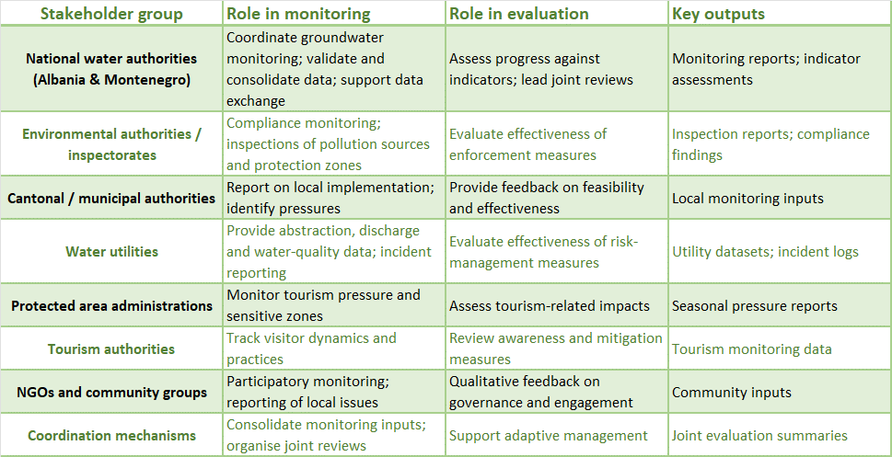

Table 8.4 Stakeholder list
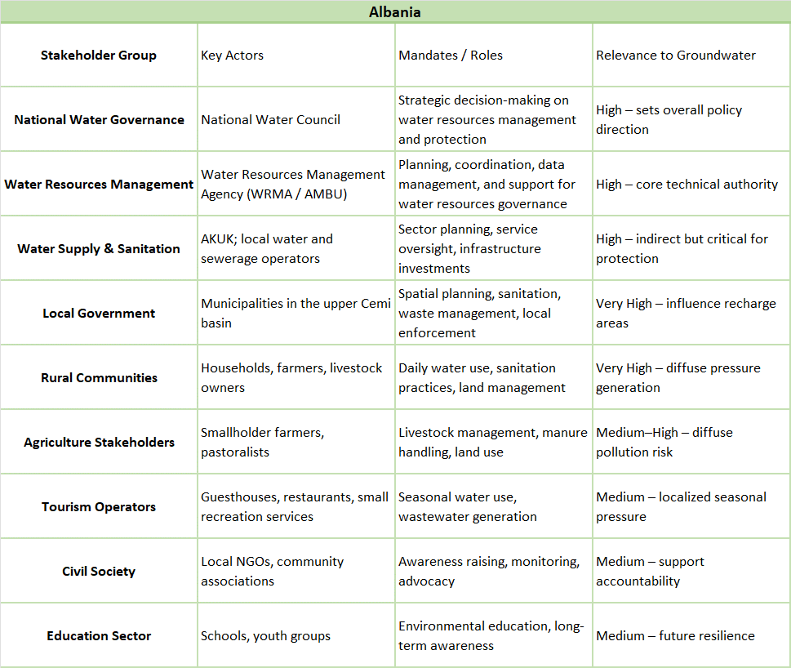

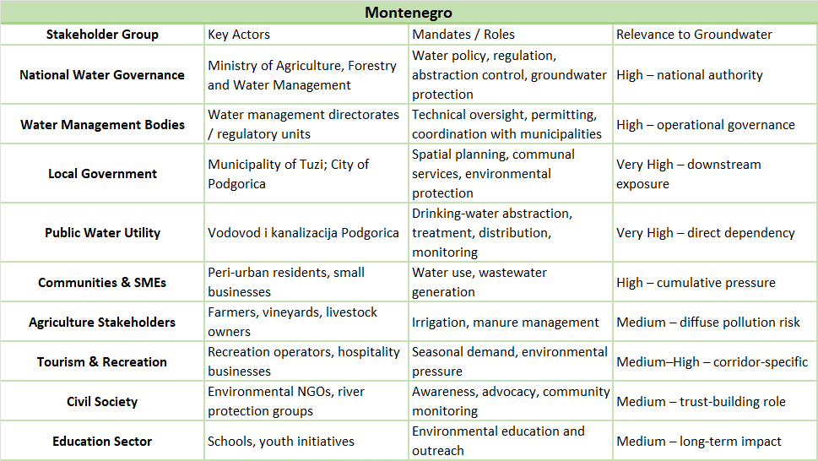

Table 8.5 Cross Border Institutions
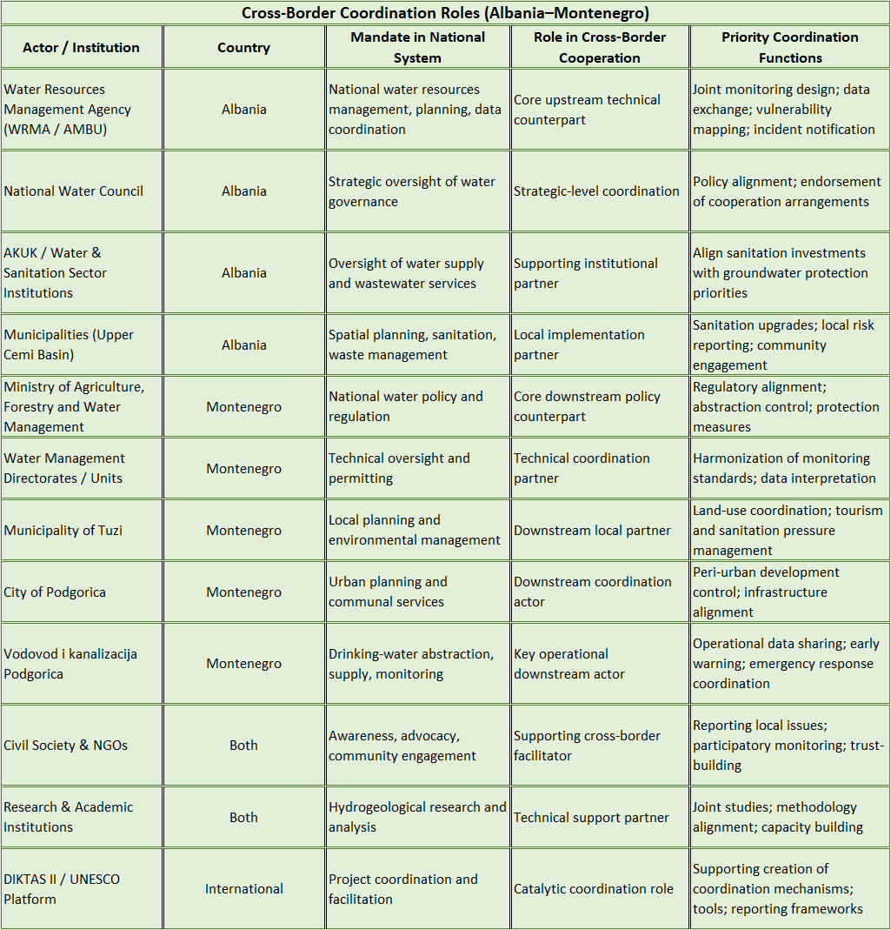

Stakeholder influence and dependency
Stakeholders differ significantly in influence and dependency. National institutions combine high influence with low to moderate direct dependency. Water utilities combine high dependency with moderate influence. Local authorities and tourism related authorities hold moderate influence but face capacity constraints. Communities and small economic users have high dependency but low individual influence. This imbalance creates a governance challenge because those most dependent on groundwater often have the least authority and capacity to drive protection measures, while those with high influence are institutionally distant from local pressures.
Transboundary asymmetries
Stakeholder roles and capacities differ across Albania and Montenegro due to different administrative systems, levels of decentralisation and enforcement capacity. These asymmetries complicate coordination and contribute to perception gaps, particularly where upstream diffuse pressures affect downstream public water security. Effective implementation of the Joint Action Program therefore requires differentiated engagement and capacity strengthening that recognises upstream downstream dependencies while promoting shared responsibility across the border.

8.8 Communication strategy.
Communication Strategy aims to strengthen the visibility, understanding, and stakeholder engagement of the DIKTAS II Project at the national level, while ensuring alignment with regional and international partners (UNESCO, UNDP, GEF).
Its important to translate complex hydrogeological and transboundary governance concepts into accessible, engaging, and locally relevant communication products that foster awareness, trust, and collaboration.
Communication under DIKTAS II is not limited to visibility. It supports stakeholder participation, awareness-raising and knowledge sharing.
Communication Objectives
- Increase public and institutional awareness about the Dinaric Karst Aquifer System and its importance.
- Strengthen stakeholder engagement, with particular attention to gender equality and inclusion.
- Improve visibility of project results and impact at national level.
- Facilitate knowledge exchange between national and regional partners.
- Support science-to-policy communication and public understanding of groundwater governance.
Target Audiences
Communication activities will be tailored to the following groups:
- National and local government institutions
- Water management authorities
- Environmental agencies and NGOs
- Academic and scientific community
- Media professionals
- Local communities in karst areas
- Youth and students
- Women and vulnerable groups in water-dependent areas
Each audience will receive adapted messaging, balancing technical accuracy with clarity and accessibility.
Key Messages (Core Narrative)
- Groundwater is invisible but essential.
- The Dinaric Karst Aquifer is one of Europe’s most important shared water systems.
- Groundwater does not respect borders, cooperation is necessary.
- Pollution and overuse pose serious risks.
- Sustainable management ensures water security, ecosystem protection, and long-term development.
- Inclusive governance, including women’s participation, strengthens water management outcomes.
Communication Pillars (National Level)
- Visibility & Public Awareness
- Develop and maintain national-level social media presence (Facebook & Twitter/X).
- Produce short explanatory content (factsheets, infographics, short videos).
- Launch thematic campaigns (e.g., World Water Day, “What Lies Beneath” concept).
- Ensure consistent branding (UNESCO–GEF–UNDP–DIKTAS).
Deliverables:
- Quarterly newsletter
- Press releases for major milestones
- Awareness materials for public events
Technical Communication & Knowledge Translation
- Translate technical outputs (TDA updates, monitoring reports) into simplified summaries.
- Develop policy briefs and 2-page explanatory documents.
- Prepare presentations, talking points, and briefing materials for national and regional events.
- Support reporting and Monitoring & Evaluation (M&E) communication components.
Regional & IW:LEARN Contribution
- Identify national case studies to share on IW:LEARN.
- Contribute communication materials for regional knowledge exchange.
- Support participation in international events when authorized.
Tools & Platforms
- Social Media (Facebook, Twitter/X)
- Project Newsletter (Quarterly)
- Website updates (in coordination with the International Expert)
- Media outreach (national press)
- Visual library (photos, maps, field documentation)
- Communication calendar (aligned with international environmental days)

Implementation Approach
- Conduct a rapid communication audit (existing materials, gaps, channels).
- Develop a 6–12 month content plan aligned with project milestones.
- Coordinate regularly with Project Manager, International Expert and technical teams.
- Ensure timely production of communication materials linked to Outputs 1.4, 6.1, and 6.3.
Monitoring & Evaluation
- Communication impact will be monitored through:
- Social media engagement metrics
- Event participation levels
- Media coverage
- Stakeholder feedback
- Newsletter distribution analytics
- Contribution to project reporting
Conclusion
Effective communication within DIKTAS II is a strategic tool that supports governance, cooperation, and sustainability of shared groundwater resources. As Local Communication Expert, to ensure that project achievements, scientific knowledge, and policy developments are clearly understood, locally contextualized, and effectively shared, contributing to stronger stakeholder ownership and long-term impact.

8.9 Conflict resolution.
More than conflict resolution, actual situation requar much more discusion, meetings, and agreement for minimaising and resolution of existing issues related to the water resource management in transboundary area.
Actually there is no permanent bilateral institution dedicated specifically to groundwater governance in the TBA Cemi/Cijevna. Cooperation between Albania and Montenegro has historically occurred through international agreements, reporting obligations, and project-based initiatives rather than standing operational mechanisms.
Institutional asymmetry is evident:

- Albania exhibits strong central policy authority but weak local implementation capacity in the upper basin.
- Montenegro exhibits stronger downstream operational institutions but limited leverage over upstream drivers of risk.
- Data exchange, joint monitoring, and coordinated incident response are not yet institutionalized and rely on ad hoc communication or project platforms.
- DIKTAS II provides a practical framework for addressing these gaps by supporting harmonized monitoring, shared indicators, and structured dialogue between institutions. However, long-term effectiveness will depend on translating project-based cooperation into routine institutional practice.

The institutional analysis confirms that groundwater governance challenges in the TBA Cemi/Cijevna are not rooted in the absence of institutions, but in uneven capacity, fragmented responsibilities, and limited operational coordination across borders.
Strengthening governance therefore requires:

- Clearer operational linkages between upstream and downstream institutions.
- Routine data sharing and joint interpretation mechanisms.
- Explicit recognition of upstream–downstream dependencies in institutional mandates and cooperation arrangements.
- These findings inform the assessment of stakeholder engagement, cooperation gaps, and opportunities presented in the following sections.

Transboundary cooperation should also extend beyond technical institutions to include municipalities and key stakeholder groups. Local authorities play a central role in land-use planning, sanitation management, and enforcement, yet they are often excluded from cross-border dialogue. Structured involvement of municipalities would help align local actions with basin-wide protection objectives. Similarly, NGOs and community organizations can support awareness raising, local monitoring, and trust-building across the border.

9. Preventive protection measures.

9.1 Groundwater vulnerability map, classified hazard map and risk map
This section presents a concise, screening-level framework for the preparation of a groundwater vulnerability map, a classified hazard map and a groundwater risk map for the transboundary area (TBA) Cemi/Cijevna. The approach is intended to support the Montenegro-led assessment while incorporating the available baseline information for the Albanian part of the TBA. Because detailed and harmonized datasets are currently limited for the Albanian side, the proposed methodology is intentionally conservative and based on a data-limited, expert-supported assessment that can be refined later as additional hydrogeological, land-use and monitoring information becomes available.
For the Albanian part of the basin, the available information indicates that the Cemi/Cijevna river and the springs hydraulically connected to it are used for drinking water, energy production, agriculture and livestock, and for the general daily needs of villages and the tourism sector, especially bars, restaurants and hotels. The river system also supports the forests covering both sides of the valley. At the same time, no intensive agriculture is reported, apart from small agricultural plots. This means that large-scale diffuse agro-industrial pressures are not expected, but localized pressures may still be relevant, especially where small settlements, tourism facilities, livestock activities or inadequate sanitation are located close to springs, stream channels or infiltration-prone areas.
For the purposes of this section, groundwater vulnerability is understood as the intrinsic susceptibility of groundwater to contamination, determined by natural factors such as hydrogeological setting, aquifer type, soil and cover conditions, recharge characteristics and the degree of hydraulic connectivity between surface water and groundwater. A hazard map, in contrast, identifies and classifies the potential contamination sources and pressure-generating activities in the basin. The risk map then combines these two dimensions, recognizing that risk is highest where significant hazards coincide with highly vulnerable hydrogeological conditions. In practical terms, the risk map should be understood as a decision-support product derived from the interaction between intrinsic vulnerability and hazard intensity, not as a substitute for site-specific studies or sanitary protection zone delineation.
Given the current data constraints, especially on the Albanian side, a tiered GIS-based screening methodology is recommended. The vulnerability map should be developed first, using available spatial layers and hydrogeological expert judgement. Even where detailed hydrogeological datasets are incomplete, a credible preliminary assessment can still be produced by combining proxy information such as hydrogeological setting and aquifer type, river and spring connectivity, slope and terrain morphology, soil or cover thickness where available, land cover permeability and the location of known drinking-water springs or abstraction points. In areas with fractured or karstic conditions, or where river–spring interaction is strong, vulnerability should be treated cautiously and not underestimated simply because detailed tracer tests or structural datasets are not yet available. A five-class vulnerability scale (very low, low, moderate, high and very high) is appropriate at this stage.
The classified hazard map should be prepared as a pressure inventory with hazard ranking. For the Albanian part of the TBA Cemi/Cijevna, the most relevant hazards are expected to be settlements and household wastewater systems (including septic systems where present), tourism-related facilities such as bars, restaurants and hotels, small-scale agriculture and livestock, and any local road-related runoff or informal waste disposal points where these occur. Energy-related uses may also be relevant in specific locations, although their importance for groundwater contamination risk depends on the type of infrastructure and operational practices. Because no intensive agriculture is reported, widespread high hazard from diffuse agricultural pollution is not expected. However, this does not exclude moderate to high localized hazard conditions in places where wastewater disposal is insufficient or where multiple seasonal tourism facilities are concentrated near sensitive water receptors. A simple five-class hazard scale (very low to very high) is sufficient for a first harmonized map.
The groundwater risk map should then be generated by overlaying the vulnerability and hazard maps in order to identify priority areas for monitoring and management. At this stage, a standard screening matrix may be used to combine vulnerability and hazard classes into risk classes ranging from very low to very high. The practical value of this map lies in helping identify locations where preventive action is most urgent, particularly around drinking-water-related springs and river-connected groundwater systems. In the Albanian part of the basin, even relatively modest pressures may produce meaningful risk where hydrogeological vulnerability is elevated and where communities or tourism services depend directly on the resource.
A preliminary qualitative interpretation for the Albanian side suggests that the basin has high receptor importance because the water system supports drinking water supply, livelihoods, tourism activities, small agricultural and livestock uses, and ecosystem functions including forest support. This high dependence increases the significance of any contamination event, even if the pressure source is small in spatial extent. The absence of intensive agriculture is a positive factor and likely reduces broad diffuse nutrient and pesticide pressures compared with more intensively cultivated basins. Nevertheless, localized chronic pressures related to village wastewater, septic systems and tourism service infrastructure may be among the most relevant hazards in a mountain-valley rural setting. Small farming and livestock activities are likely to represent low to moderate hazard overall, but risk may increase where they are located close to springs, stream banks or infiltration-prone terrain.
For the final five-page deliverable, the mapping package should include three coordinated maps and a small set of standardized tables. The first map should present groundwater vulnerability classes across the TBA Cemi/Cijevna, including the transboundary boundary, the Albanian and Montenegro sectors, the river network, the main springs or abstraction points where available, and the main settlements. The second map should show the classified hazards, including settlement-related pressures, tourism-related pressures, small agricultural and livestock areas (generalized where exact boundaries are unavailable), roads and any known or probable pressure hotspots. The third map should present the resulting groundwater risk classes and clearly highlight priority areas for monitoring or protection measures, especially where drinking-water-related sources are located.
A compact hazard classification table should accompany the maps and summarize the likely hazard types on the Albanian side. In narrative terms, villages and household wastewater systems can be treated as a moderate to high localized hazard depending on sanitation infrastructure and distance from springs or the river. Tourism facilities, especially bars, restaurants and hotels, should also be treated as a moderate to high localized hazard because of wastewater generation and strong seasonal fluctuations in pressure. Small agricultural plots and small-scale livestock activities can generally be treated as low to moderate hazard, with local exceptions near sensitive receptors. Intensive agriculture is currently not a significant pressure according to the available information. Energy-related uses should be listed as site-specific pressures requiring verification. Informal waste disposal, if present, should be treated as a potentially significant localized hazard and confirmed through field checks.
The principal limitation of this assessment is the lack of detailed and harmonized hydrogeological, land-use and infrastructure data for the Albanian part of the TBA Cemi/Cijevna. For this reason, the present approach should be explicitly presented as a screening-level assessment based on currently available evidence and expert judgement. This is still technically valid and useful for the current reporting stage, provided that the limitations are clearly stated and the maps are framed as preliminary planning tools. The next step should be a rapid field-based verification on the Albanian side, focusing on drinking-water springs and intakes, villages and tourism facilities, sanitation conditions, visible waste disposal points and other locally relevant pressures. This would allow the preliminary vulnerability, hazard and risk maps to be progressively refined and better harmonized with the Montenegro-side assessment.
In summary, even with limited detailed information for the Albanian part of the TBA Cemi/Cijevna, it is possible to produce a credible and useful preliminary groundwater vulnerability, hazard and risk mapping framework using a precautionary, data-limited and expert-based approach. This is justified by the high socio-economic and ecological importance of the river and spring system and by the fact that localized pressures, particularly those related to settlements, tourism and sanitation, may still create significant groundwater risks in vulnerable hydrogeological settings.

9.2 Guidelines for harmonization of criteria for: delineation and types of measures in sanitary protection zones.
Harmonization should be based on the following principles:

- Risk-based approach – SPZ boundaries and measures should depend on the level of risk to the water source.
- Hydrogeological approach – delineation should not rely only on fixed distances, but should also consider aquifer type, groundwater flow, travel time, and vulnerability.
- Precautionary principle – particularly important for karst environments and highly sensitive sources.
- Legally and institutionally feasible implementation – measures should be clear, enforceable, and practically applicable by responsible institutions.
- Periodic review – zones and measures should be updated when new hydrogeological, monitoring, or land-use data become available.

Albania – current situation and key elements for harmonization
The available material indicates that in Albania sanitary protection zones have not been fully implemented in practice, except for the first zone (immediate / strict protection zone), while the delineation of the other zones (Zone II and Zone III) remains largely at the level of methodological recommendation rather than systematic implementation.
The framework refers to:

- legal and sub-legal acts on drinking water quality and sanitary protection zones;
- the requirement to define sanitary protection zones for surface and groundwater sources used for drinking water supply;
- responsibilities of water supply operators/administrators and relevant public health and water management institutions.

Classification of sanitary protection zones (Albania)
Zone I – immediate / strict sanitary protection zone;
Zone II – near / preventive protection zone;
Zone III – distant / buffer protection zone.

In practice, for the first zone, indicative boundaries are often provided according to hydrogeological conditions (e.g., typical radii around sources), while for Zones II and III hydrogeological calculations are required (travel time, effective porosity, aquifer thickness, discharge, etc.).

Technical assessment of key gaps (Albania)

- the recommended methodology exists, but has not been fully institutionalized and is not widely implemented by water utilities/operators;
- for karst formations, despite their known vulnerability, a dedicated approach in monitoring and differentiated criteria is still lacking;
- groundwater monitoring does not sufficiently include karst-specific elements (conceptual model, representativeness of monitoring points, specific parameters, risk-based monitoring frequency).

Conclusion for harmonization (Albania): Albania has a legal and methodological basis and a defined zonation concept, but needs stronger implementation in:

- detailed delineation criteria,
- field-level application,
- risk-based monitoring,
- and karst-specific approaches.

Montenegro – key elements for harmonization (initial support material)

Basic framework referenced for sanitary protection zones
For Montenegro, sectoral documents and reports refer to the existence of a Rulebook on methods for determining and maintaining sanitary protection zones for drinking water sources and restrictions within these zones (commonly referenced as a 2009 regulation), as well as complementary acts related to drinking water and groundwater monitoring.
This indicates that Montenegro, similarly to Albania, has an established legal basis for sanitary protection zoning, but practical implementation remains a key issue.
Structure of sanitary protection zones (Montenegro)
According to planning and climate adaptation documents in Montenegro, the existing framework provides for three sanitary protection zones, broadly consistent with the regional approach:

Zone I – immediate protection (minimum protected perimeter around the source, fencing/marking, only source-related activities allowed);
Zone II – zone with strong restrictions on activities that may affect water quality;
Zone III – wider protection / catchment-buffer zone determined according to topography and natural features, aimed at reducing risks from persistent pollutants.
Some policy/planning materials also refer to practical thresholds linked to the size of the population supplied (e.g., when all three zones must be defined), which may be useful as a technical reference for discussion, though not necessarily for direct legal transposition.

Important practical findings (Montenegro)-highly relevant for harmonization

Recent policy and planning documents in Montenegro emphasize that, although a legal framework exists:

- a significant share of sources/water utilities do not have clearly delineated sanitary protection zones;
- financial and human resources for hydrogeological studies and implementation of measures are limited;
- continuous field monitoring and operational/monitoring data are insufficient;
- revision of the rulebook and stronger integration of SPZs into spatial planning and cadastre are needed.
These findings are highly relevant because they closely match the challenges identified in the Albania material (partial implementation, monitoring gaps, need for stronger capacity and standardization).

Proposal for harmonized criteria for delineation of sanitary protection zones (AL–MN)
This section proposes a common harmonized basis that can be adapted by each country in accordance with national legislation.

Harmonized zoning typology (proposal):

Zone I – Immediate / strict protection
- Directly protects the intake/source/well from immediate contamination.
- Should be fenced, marked, and access-controlled.
- Only activities necessary for operation of the water supply system should be allowed.
Zone II – Near protection / preventive zone
- Intended to prevent contamination from microbiological pollution and pollutants with short to medium persistence.
- Boundaries should preferably be defined using travel time and a hydrogeological model.
Zone III – Distant protection / buffer / catchment zone
- Intended to control long-term pressures, diffuse pollution, and chemical risks.
- Boundaries should be based on the catchment/recharge area, topographic and hydrogeological features, and land use.

Minimum harmonized delineation criteria (proposal)

For both countries, delineation should be based on the following hierarchy:

- Hydrogeological conceptual model (mandatory)
- Source/well data (discharge, exploitation regime, seasonal variability)
- Aquifer type (porous, fractured, karst; confined/unconfined)
- Travel time / flow path analysis (where sufficient data exist)
- Natural/topographic/hydrogeological boundaries
- Land-use and pressure mapping
- Uncertainty assessment and application of the precautionary principle

Specific requirement for karst aquifers (strong proposal)
For karst aquifers, both countries should provide:
- differentiated delineation criteria;
- use of karst-specific hydrogeological evidence (tracer tests, hydraulic connections, discharge/turbidity variability, response to rainfall, etc., where feasible);
- more intensive and risk-adapted monitoring.
This element is critical because existing practice indicates insufficient dedicated treatment of karst systems, particularly in monitoring design and risk management.

Proposal for harmonized types of measures within sanitary protection zones (AL–MN)

- Prohibited activities
- Restricted / conditionally allowed activities
- Permitted activities under good practice
- Monitoring, control and reporting obligations

Table 9.1 Harmonized matrix of measures (model)
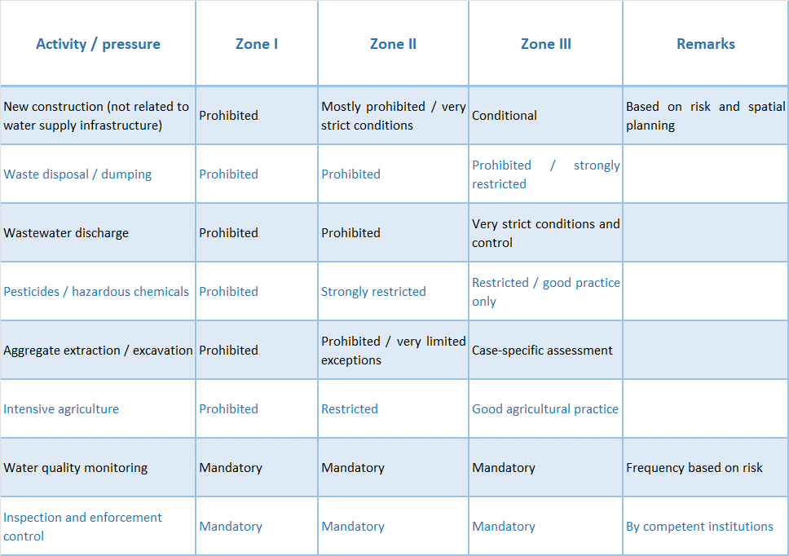
Note: In the final version, this table should be refined using harmonized legal terminology with input from AL and MN legal policy experts.
Common gaps and harmonization opportunities (AL–MN)
Based on the preliminary review of the Albania material and the supporting references for Montenegro, several shared challenges emerge.

- partial implementation of sanitary protection zones in practice;
- insufficient technical and financial capacity for hydrogeological studies and enforcement;
- monitoring systems not fully standardized based on risk;
- limited integration of SPZs into spatial planning and cadastre;
- insufficient karst-specific treatment in some methodological and monitoring elements.

Harmonization opportunities (proposal)

- a common minimum format for hydrogeological SPZ studies/elaborates;
- harmonized terminology for the 3-zone system and categories of measures;
- a minimum dataset required for delineation;
- a minimum monitoring protocol (parameters, frequency, reporting);
- a common procedure for periodic revision of SPZ boundaries;
- integration into GIS/cadastre and spatial planning systems.

Immediate recommendations
To make the final document strong and submission-ready, it is recommended to include:

- One comparative AL–MN table (legal framework + institutions)
- One table on harmonized delineation criteria
- One table on measures by zone
- One schematic figure (Zone I–II–III around a source/well)
- One illustrative map (typical case or transboundary setting, if available)

Table 9.2 Criteria and zones
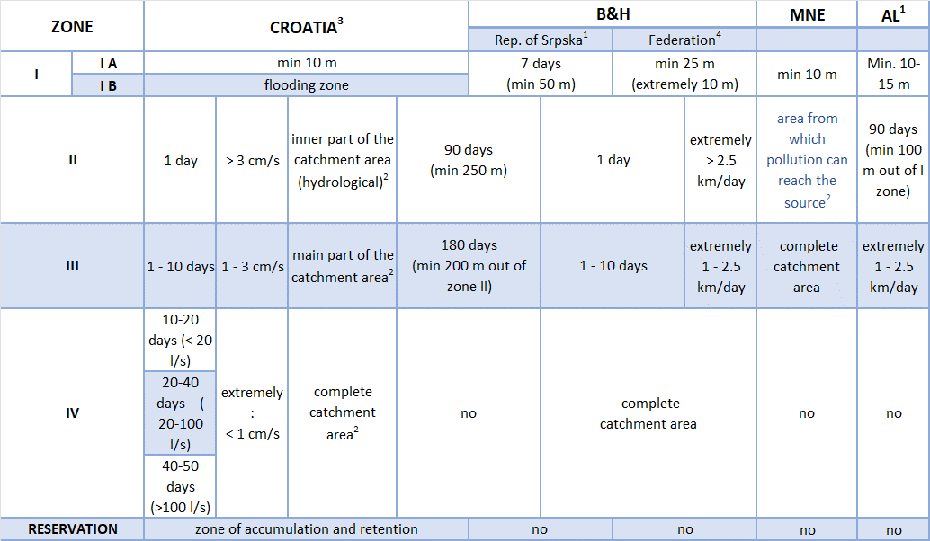
¹ no specific criteria for the karst areas
² without criteria for delineation the protection zones
³ regulation from 2011 and 2013.
⁴ regulation from 2012.
⁵ regulation from 2024.

9.3 Regulation, guidelines and risk-based criteria for subsurface wastewater discharge.
The Directive 91/271/EEC has been partially transposed in Albania mainly through the Law “On Water Resource” This law has been drafted as part of the legal package within the framework of the full approximation of Albanian legislation in the field of water resources management with the European Union acquis in this field through the support of the project “European Union Support for Integrated Water Management in Albania”, financed by the EU and ADA.
The Law No. 9115/2003 “On Environmental treatment of waste water” and the DCM No 177 dated 31.03.2005 “On allowed water discharges norms and their zoning criteria in received water environment’’, However, despite of the high level of transposition, the implementation of both directives is still at an initial stage.
At EU level the new “Water Reuse Regulation” encourages circular approaches to water reuse in agriculture and it lays down the minimum requirements for water quality and monitoring, as well as the provisions on risk management, for the safe use of reclaimed water in the context of integrated water management
Water discharge activities in Albania are subject to several permit/authorization which are issued by different entities: the National Water Council (NWC) and the River Basin Council (RBC) are the key institutions in regard to the issuance of permit/authorization on usage of water and discharges of waste water, while the environmental permit is issued by the National Environmental Agency (NEA).
As foreseen by the Law 29/2024 for “Water Resources” water use permits/authorization are issued by the respective RBCs when the activity falls within the borders of that RBC; on the other hand, water use permits/authorizations are issues by the National Water Council (NWC) for certain water use purposes or when the activity falls in more than one River Basin.
MTE together with its specialised agencies and the environmental inspectorate are responsible for the continuous control of activities that cause water pollution including effluents from waste water treatment plants (WWTPs). More specifically, Water Supply and Sewerage Company (WSSCs) implement the monitoring off effluent discharges from WWTP (emissions), while AMBU is performing authorisation monitoring in the receiving waters downstream of the discharge point to assess the impact of effluents on the receiving waters.
Upon decision of Council of Ministers no.568, dated 17.17.2019 ‘On establishment, manner of organisation and functioning of NEA’ the competences of the State Inspectorate of Environment, Forests, Water and Tourisms related to environment were transferred to NEA.
The responsible institutions designated by special laws shall monitor the quality and quantity of industrial waste water production and their discharges into surface or groundwaters, under the overall management of the AMBU.
The responsibilities for organising water Service Provision (water supply drinking water supply, waste water collection and waste water treatment) lies with the Municipality within their territory. However Albanian Government adopted on 11th of May 2022, the DCM no. 302 “on national policies for the reorganization of the water services”, which aims at reorganizing the existing water supply and sewerage companies, through the cooperation agreement between the WSSCs and the MIE.
This DCM is encouraging the establishment of joint water services companies, through ad hoc agreements between the Ministry of Infrastructure and Energy (MIE) and the municipalities, pursuant to article 14 of the Law no. 139/2015 on Local Self-Government on “Cooperation between two or more local self-government units”. Besides, the DCM regulates the form of the agreement for the establishment of a joint company owned by MIE/AKUM and the participating municipalities, the transfer of assets and liabilities to the new joint competency company and the Draft Statute which details all the roles and responsibilities of the main institutional set-up. The process is currently on-going.
In the past years Albania has been going through an important process of reform of the entire water sector, thus the current institutional set up has to be reflected into the national legal framework and the system of competences should be clearly defined.
In the analysis of the existing and missing secondary legislation, some duplications have been identified, particularly with reference to:

- the criteria for the construction and operation of sewerage systems and waste water treatment plants,
- the identification and designation of the sensitive areas, as well as
- the definition and quantification of damages to the water resources.

The upcoming adoption of the draft law on waters could be the chance to correct few inconsistencies related to the recent restructuring of the institutional set-up, repealing laws / by laws which will no longer be necessary and inconsistent or duplicated laws.
Finalisation of the Water Resource Law, and in particular in defining the transitional provisions, it would be important to:

- transpose article 17 of the UWWTD on the establishment of an implementation programme for the Directive;
- align the final / transitional provisions and the entry into force of the UWWTD with the implementation plan proposed in the DSIP, and to consider, if needed, to develop and negotiate the request to EU for a transitional implementation period, and
- to consider a transitional period for the existing and new water discharge permits, to be in compliance with the requirements of the Law,
- to consider and eventually repeal the existing provisions, particularly the Law No. 9115/2003 “On Environmental treatment of waste water” and the DCM no. 177/2005 on liquid discharge norms and criteria for zoning water environment, adopted pursuant to articles 14 and 16 of the Law no. 9115/2003.

The following section aims at presenting the identified gaps and needs of the Albanian Administration to fully perform its functions, and the measures identified to achieve the capacity to implement the UWWTD.

- Regulatory Planning – This function lacks legal acts and bylaws for the reorganization of sewerage services, removal and treatment of polluted waters on a regional basis,
- Regulation and permitting - The identified measures aim at setting quality standards, compliance and monitoring procedures, for the issuance of permits.
- Monitoring - The Monitoring and the inspection departments of the National Environmental Agency (NEA) need to be enforced with adequate capacities and standardized methods and parameters for water monitoring and designing monitoring programs, in accordance with the Water Framework Directive (WFD) and DCM No.267 dated 07.05.2014 for monitoring priority substances in surface waters.

9.4 Control and mitigation of the impact of point and non-point pollution sources on GW and GWDE status.
This section proposes a practical framework for controlling and mitigating the impact of point and non-point pollution sources on groundwater (GW) and groundwater-dependent ecosystems (GWDEs) in the transboundary area (TBA) Cemi/Cijevna. It is written as a compact, implementation-oriented text for inclusion in the final report and is designed to work under the current condition of uneven data availability between the Albanian and Montenegrin parts of the basin. The approach builds on the DIKTAS process and its follow-up logic, on national water policy and water management strategy documents in both countries, and on scientific literature addressing karst aquifer vulnerability and monitoring in the Cijevna basin.
The need for this measure package is particularly strong in Cemi/Cijevna because the basin is hydrogeologically sensitive and transboundary, with high permeability in karst and intergranular aquifers, river losses along the channel, and strong surface water-groundwater interaction. The published basin study for Cijevna (Montenegro–Albania) highlights exactly these features and shows why pollution control cannot rely only on conventional surface-water thinking. It also links vulnerability assessment (EPIK and DRASTIC) with the design of a joint monitoring network, which is directly relevant to the present section.
At the policy level, both countries already have the strategic and legal foundations to justify stronger pollution prevention and control. In Albania, the Law on Integrated Water Resources Management explicitly includes protection of transboundary waters and groundwater status, pollution prevention and reduction, and monitoring obligations as core objectives of water governance. In Montenegro, the Water Management Strategy (published by the Water Administration and available through the government/data portals) is a comprehensive strategic document with dedicated chapters on groundwater, water quality protection, prevention of pollution from concentrated and diffuse sources, and development of monitoring and information systems. In addition, Montenegro’s Municipal Wastewater Management Plan (2020–2035) is directly relevant for reducing point-source pressures from settlements and tourism development.
For the Albanian side of the TBA, even though detailed pollution inventories are currently limited, the available local information indicates that the river and connected springs are used for drinking water, local livelihoods, tourism services (bars, restaurants, hotels), agriculture and livestock at small scale, and ecosystem support (including forests). This means the dominant risk is not necessarily heavy industrial pollution, but rather a combination of localized wastewater pressures, seasonal tourism loads, sanitation gaps, and scattered rural activities in a vulnerable hydrogeological setting. In karst systems, such pressures can produce rapid and disproportionate impacts on springs and dependent ecosystems if they occur in hydraulically connected zones. This is fully consistent with the broader karst monitoring and management literature, which emphasizes representativeness of monitoring sites, frequency of observations, and early warning parameters in vulnerable karst aquifers.
The control and mitigation approach should therefore be structured around a source-pathway-receptor logic. The sources are point and non-point pressures (settlement wastewater, septic systems, tourism facilities, animal waste, small agricultural inputs, road runoff, local waste disposal). The pathways are karst conduits, fractured zones, thin-cover infiltration areas, river losses, and shallow groundwater circulation. The receptors are drinking-water springs and intakes, groundwater bodies, river-connected aquifers, and groundwater-dependent ecosystems along the valley. In practical terms, this means that effective action in Cemi/Cijevna must combine land-based pollution control, hydrogeology-informed zoning, and joint monitoring/response protocols rather than relying on a single measure type.
For point sources, the first priority is wastewater and sanitation management in settlements and tourism clusters. The strongest immediate gains for groundwater and GWDE protection are usually achieved by reducing untreated or poorly treated wastewater discharges, improving collection systems where feasible, upgrading septic systems where sewerage is not feasible, and preventing direct discharge to losing stream reaches, sink zones, or infiltration-prone areas. This is especially important for seasonal tourism facilities, where hydraulic and pollution loads may increase sharply during peak periods. The control package should include minimum technical standards for wastewater disposal near springs and abstraction points, mandatory inspection of on-site sanitation systems in sensitive zones, and a phased program for rehabilitation or replacement of failing septic systems. These priorities are aligned with the strategic direction of Albania’s WSS sector reforms and Montenegro’s wastewater planning framework.
For non-point sources, the focus should be on proportional, locally adapted measures rather than generic restrictions. Since intensive agriculture is not reported for the Albanian part, broad agro-industrial control measures are less relevant than targeted management of small plots, livestock areas, manure storage, and riverbank/infiltration-zone practices. The most cost-effective approach is to apply “good practice with hydrogeological sensitivity,” including controlled manure storage, avoidance of fertilizer/manure spreading immediately before heavy rainfall, setbacks from springs and riverbanks, and prohibition of waste dumping in sink-like or highly infiltrative terrain. These measures should be prioritised in areas already identified as moderate to high vulnerability in the screening maps proposed under Section 9.1.
A specific category that deserves explicit treatment in this TBA is mixed rural-tourism pressure. In many mountain-valley systems, pollution loads are not individually large but become significant cumulatively when villages, restaurants, guesthouses and seasonal facilities are clustered along the river corridor. For Cemi/Cijevna, this cumulative effect can be more important than any single source, especially where river losses recharge the aquifer or where springs respond rapidly to rainfall and runoff inputs. The mitigation response should therefore include cumulative pressure screening at sub-basin level, not only site-by-site permitting. This is also consistent with the DIKTAS logic of basin-scale vulnerability and management mapping for transboundary karst systems.
Monitoring and early warning are central control measures, not only supporting tools. The Cijevna basin study already proposed a joint groundwater monitoring network with observation points, automatic river and spring stations, piezometers and data transmission; this provides a concrete technical basis for the pollution control and mitigation framework in the present section. The broader karst monitoring literature further supports more intensive and representative monitoring in karst than standard low-frequency routines, and recommends combining hydrological, physicochemical and microbiological parameters with real-time or near-real-time data handling where possible. For the TBA, this means that mitigation should include both preventive infrastructure measures and operational monitoring measures (trigger thresholds, incident response, temporary abstraction restrictions, and public notification protocols where needed).
In operational terms, the recommended control and mitigation package for the TBA should be implemented in three layers. The first layer is prevention at source, focused on wastewater, sanitation, solid waste management, and safe handling/storage of oils, fuels and chemicals in settlements and tourism/service areas. The second layer is pathway interruption and spatial control, including hydrogeology-informed setbacks, protection of losing reaches and sink zones, restrictions in highly vulnerable recharge areas, and alignment with sanitary protection zoning around drinking-water sources. The third layer is receptor protection and response, including prioritized monitoring of springs/intakes, rapid incident reporting, coordinated sampling across the border, and temporary emergency measures during contamination events. This three-layer structure makes the section usable both for hydrogeologists and legal/policy experts because it links technical risk pathways to enforceable management instruments.
Because the section concerns both GW and GWDE status, protection measures should not be limited to chemical thresholds for potable use. In the Cemi/Cijevna setting, groundwater-dependent ecosystems may be affected by contamination pulses, chronic nutrient loading, turbidity events, reduced dilution during dry periods, and flow regime alterations related to abstractions or infrastructure operation. The published basin literature and karst monitoring literature both emphasize the importance of hydrological dynamics and event-based variability, which means status protection should integrate quantity-quality interactions wherever possible.
For this reason, mitigation measures should include at least a basic ecological screening of vulnerable spring and riverine habitats in areas where groundwater discharge is known or suspected.
From an institutional perspective, implementation should be phased and jointly coordinated. The Albanian side can begin with a rapid inventory and screening of point and diffuse pressures in the TBA, even before a full dataset is available, while the Montenegrin side can contribute existing datasets, classifications and planning instruments from its water management and wastewater planning frameworks. A joint AL–MN technical protocol should then harmonize source categories, minimum monitoring parameters, incident reporting format, and risk-ranking criteria so that maps and measures remain comparable across the border. This is in line with the transboundary governance rationale of DIKTAS and with the monitoring network concept already developed for the basin.
For the final report presentation (up to four pages), this section should be accompanied by one compact map and two short tables rather than a long list of measures. The map should show major point and non-point pressure zones overlaid on the vulnerability/risk background from Section 9.1, with springs/intakes and GWDE-sensitive areas highlighted. The first table should classify key source types (settlements/septic systems, tourism facilities, small agriculture/livestock, roads, waste disposal, site-specific energy-related installations) by likely pollution mechanism, expected intensity, and preferred control measures. The second table should present a phased mitigation plan (immediate, medium-term, longer-term) with indicative responsible institutions and minimum evidence/monitoring requirements for both countries.

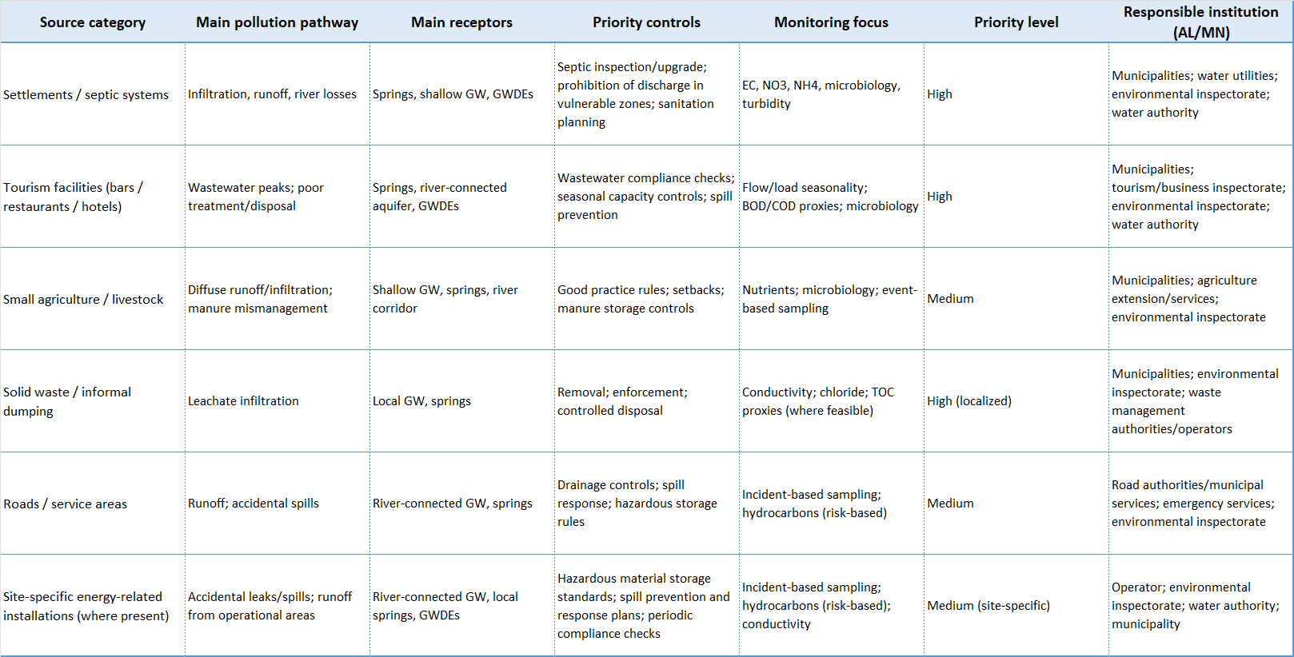
Table 9.3 Matrix for the Report

This section should be explicitly framed as a practical, risk-based and progressively refinable package. It does not require complete data at the outset to begin implementation. In a karstic transboundary basin such as Cemi/Cijevna, delaying action until a perfect dataset exists would create avoidable risks for drinking water sources and groundwater-dependent ecosystems. The more realistic and defensible approach is to apply immediate preventive controls on known source categories, strengthen monitoring and cross-border information exchange, and update the control/mitigation package as the vulnerability, hazard and risk mapping is refined.

9.5 Guidelines for risk assessment and risk management of catchment areas for abstraction points used for human consumption.
This section provides practical guidelines for risk assessment and risk management of catchment areas for abstraction points used for human consumption in the transboundary area (TBA) Cemi/Cijevna/Cjevna. It is written as a compact, report-ready framework that can be applied under current conditions of uneven data availability, while remaining fully compatible with later refinement as new hydrogeological, operational and land-use information becomes available. The section is aligned with the risk-based approach promoted by the recast EU Drinking Water Directive (notably Article 8 on catchment risk assessment and risk management for abstraction points), and with the WHO Water Safety Plan approach, which treats risk management as a continuous “catchment-to-consumer” process focused on priority risks and progressive improvement.
The need for this guidance is particularly strong in the Cemi/Cijevna/Cjevna basin because the area is hydrogeologically sensitive and transboundary. Published work on the Cijevna River Basin (Montenegro–Albania) describes a system where karst and intergranular aquifers coexist, groundwater-surface water interaction is strong, and river losses along the channel can be significant, especially during dry periods. These conditions increase the importance of catchment-based risk management because contamination introduced in one part of the system may reach abstraction-related springs or hydraulically connected groundwater rapidly and with limited natural attenuation.
For the Albanian part of the TBA, the section should explicitly recognize the operational reality that water is abstracted from the Cemi/Cijevna river by the water utility for human consumption, and that hydropower plants (HPPs) are also present on the river. This is a crucial addition because it means the catchment risk framework must address not only classic pollution threats, but also cumulative pressures and operational interactions between drinking water abstraction, hydropower infrastructure/operation, seasonal tourism demand, rural settlements and ecosystem needs. Your previously provided context also indicates that the river and connected water resources serve drinking water, agriculture and livestock, tourism services, village needs and forest-supported ecosystem functions, while intensive agriculture is not present (except small plots). This combination suggests a risk profile dominated by localized and cumulative pressures rather than large diffuse agro-industrial loads.
The legal and policy basis for this section can be presented as a harmonized AL–MN framework. In Albania, Law No. 111/2012 on Integrated Management of Water Resources explicitly includes protection and improvement of groundwater and transboundary waters, pollution prevention and rational use of water resources among its core purposes, providing a solid legal basis for catchment risk assessment and management around abstraction points. For Montenegro, sectoral consultation material and related documentation confirm the legal use of sanitary protection zones (I, II and III zones), note that many water intakes have only the immediate zone established, and reference national responsibilities for monitoring water quantity and quality and for planning measures against accidental pollution. These points are directly relevant for risk-based management of abstraction catchments in the Montenegro part of the TBA and for harmonization across the border. DIKTAS-related outputs and follow-up transboundary groundwater work provide the broader regional rationale for coordinated management, particularly in karst-sensitive transboundary systems where monitoring, common concepts and interoperable measures are essential.
The core guideline should be based on a source–pathway–receptor model, but written in practical management language. In the Cemi/Cijevna/Cjevna context, the receptors are the abstraction points used for human consumption, the associated springs and hydraulically connected groundwater, and the dependent riverine and spring ecosystems. The pathways include karst conduits, fractures, shallow groundwater circulation, river losses, bank infiltration and runoff-infiltration transfer in thin-soil terrain. The sources include wastewater from settlements and tourism facilities, septic systems, small-scale livestock and agriculture, waste disposal, road runoff and accidental spills, and site-specific risks related to infrastructure operation (including HPP-related facilities where oils, fuels, maintenance chemicals or emergency discharge situations may be relevant). A risk management guideline that does not explicitly account for pathways is likely to underestimate risk in this basin.
For risk assessment, the recommended procedure is to begin with a structured inventory of abstraction points and their catchment context. Each abstraction point used for human consumption should be described in a standard profile that includes source type (river intake, spring, well, mixed system), location, operator, use for public supply, approximate served population or demand profile, seasonal variability, known water quality issues, relation to sanitary protection zones (if established), and relation to upstream pressures and hydropower structures. This basic profiling step is essential because the same hazard can produce different risk levels depending on abstraction type and operational dependence. WHO’s water safety planning logic strongly supports this system description step before risk scoring and measure selection.
The catchment risk assessment itself should then classify hazards by likelihood and consequence, but in a way adapted to local data limitations. In the Albanian part of the TBA, the absence of intensive agriculture means the highest risks are more likely to arise from untreated or poorly treated wastewater, failing septic systems, tourism-related seasonal peaks, accidental spills, and poorly managed waste disposal in hydraulically sensitive areas than from broad-scale pesticide loading. At the same time, the presence of HPPs on the river means the assessment should include operational and indirect risks, such as changes in flow regime that may affect dilution capacity, temporary low-flow conditions that amplify pollutant concentration, and accidental releases associated with maintenance or storage areas. These are not automatically high risks in every location, but they must be screened systematically because they can become critical in abstraction-relevant reaches.
For practical scoring in the report, the risk assessment can be structured around a semi-quantitative matrix with four ratings: low, moderate, high and very high. Likelihood should be assessed based on presence/frequency of the pressure source, proximity to the abstraction point or hydraulically connected recharge zone, existence/quality of control infrastructure, and seasonal variability. Consequence should be assessed based on potential impact on human consumption use (including microbiological and chemical safety), ability to detect contamination rapidly, availability of alternative supply, and potential concurrent impact on groundwater-dependent ecosystems. This approach keeps the method simple enough for cross-border application while remaining consistent with the EU/WHO risk-based philosophy.
Risk management measures should be selected according to the hierarchy of prevention, control, monitoring and response. Prevention should focus on reducing pollutant generation and exposure in the catchment, especially near abstraction-sensitive zones. For the Cemi/Cijevna/Cjevna basin, this means prioritizing wastewater and sanitation improvements in settlements and tourism areas, enforcing no-discharge rules in highly vulnerable zones, improving management of septic systems, and preventing dumping or storage of hazardous materials in infiltration-prone areas. Control measures should include hydrogeology-informed setbacks, alignment with sanitary protection zones where these exist, and interim protective restrictions where formal zones are incomplete. The Montenegro consultation material is particularly relevant here because it confirms the three-zone sanitary protection system while also noting that many intakes have only immediate protection zones established; this strengthens the case for using risk-based interim catchment controls while formal delineation and full zoning are being completed.
Monitoring should be treated as an integral part of risk management, not only as post-factum checking. The Cijevna basin scientific literature and broader karst groundwater monitoring literature both emphasize the need for monitoring designs that reflect hydrogeological dynamics and event-driven responses, especially in karst settings. In practical terms, abstraction-point risk management should include routine monitoring, event-based sampling (e.g., after heavy rainfall, turbidity spikes, accidents), and operational trigger values linked to response actions. Parameters should be selected according to the dominant local risks, but for the current TBA context this will generally include basic field parameters (e.g., EC, temperature, turbidity), microbiological indicators where relevant for public supply, nutrients in rural pressure areas, and risk-based chemical indicators in locations influenced by roads, workshops, HPP-related operational zones or waste storage.
A specific guideline element should address multiple-use conflict and cumulative pressure management. Because the Cemi/Cijevna river serves drinking water abstraction, hydropower use, local livelihoods and tourism simultaneously, risk management cannot be limited to single permits or isolated inspections. Catchment areas for abstraction points should be managed with cumulative pressure screening, especially in sub-reaches where several activities overlap and where the river may lose water to the aquifer. In such areas, even moderate individual pressures may combine into a high risk for drinking water abstraction points and connected groundwater. This is where the vulnerability and hazard/risk mapping under Section 9.1 becomes directly operational: those maps should be used to prioritize which abstraction catchments require immediate field verification, tighter controls and more frequent monitoring.
For governance and implementation, the guidance should propose a joint AL–MN minimum protocol rather than a fully uniform legal regime. The protocol should harmonize the minimum content of abstraction-point catchment risk assessments, source categories, severity classes, monitoring triggers and incident reporting formats. Albania and Montenegro can maintain national legal terminology and permitting procedures, but the analytical logic and reporting outputs should be comparable across the border. This is consistent with the transboundary management rationale in DIKTAS and with the monitoring-centered recommendations developed in the Cijevna basin literature.
For report presentation (up to four pages), this section can be made strong and compact by combining a short narrative with one figure and one table. The figure should be a simple conceptual diagram showing the abstraction point, upstream catchment pressures, pathways (runoff, infiltration, river losses, karst transfer), control points and monitoring points. The main table should summarize the risk assessment and management framework for abstraction catchments, with columns such as: abstraction point type, dominant hazards, vulnerability/pathway conditions, risk level, key preventive controls, monitoring requirements, and incident response trigger. If space permits, a second very small table can list the minimum dataset required for each abstraction-point catchment assessment (location, source type, operator, uses, sanitary zone status, main pressures, monitoring points, incident contacts).
The section should also make clear that the current version is a screening-level guideline that can be implemented immediately and improved progressively. This is important because the lack of complete data on the Albanian side should not delay action where human consumption is involved. A defensible and practical approach is to start with known abstraction points (including the water utility abstraction from the Cemi/Cijevna river), apply a precautionary catchment risk assessment, introduce immediate controls for obvious hazards, and then refine the assessment as additional hydrogeological and operational data are collected. That approach is fully consistent with both the WHO Water Safety Plan philosophy and the risk-based requirements reflected in the EU drinking water framework.
For the Albanian part of the TBA Cemi/Cijevna, the current version of the guideline should explicitly use the following concrete operational facts already known at this stage: (i) water is abstracted from the Cemi/Cijevna river by the water utility for human consumption, and (ii) hydropower plants (HPPs) are present on the river. These two facts are sufficient to justify immediate inclusion of abstraction-point catchment risk screening and cumulative pressure assessment in the Albanian sector, even before a full source inventory is completed. In practical terms, they mean that risk management must address both water quality protection and operational interactions (including low-flow sensitivity, dilution capacity and accidental pollution response in reaches relevant for abstraction).
Albania’s integrated water governance framework identifies the Agency for Water Resources Management (AMBU) as the competent authority for integrated water management, responsible for the water resources inventory, water cadaster, register of water users, and river basin management planning, working through four river basin offices. This is highly relevant for catchment risk assessment because it provides the institutional basis for abstraction-point inventorying, water-user information and basin-level coordination. In parallel, the National Environment Agency (AKM/NEA) publicly presents monitoring and reports/publications functions on its official website, including environmental monitoring pages and annual environmental state reporting (e.g., the 2022 State of Environment report entry and downloadable report listing). These sources can be used as official references for assembling the Albanian evidence base for risk assessment and risk management of abstraction catchments.
Table. 9.4 Minimum dataset and concrete evidence inputs for risk assessment of abstraction-point catchments (Albanian part, TBA Cemi/Cijevna)
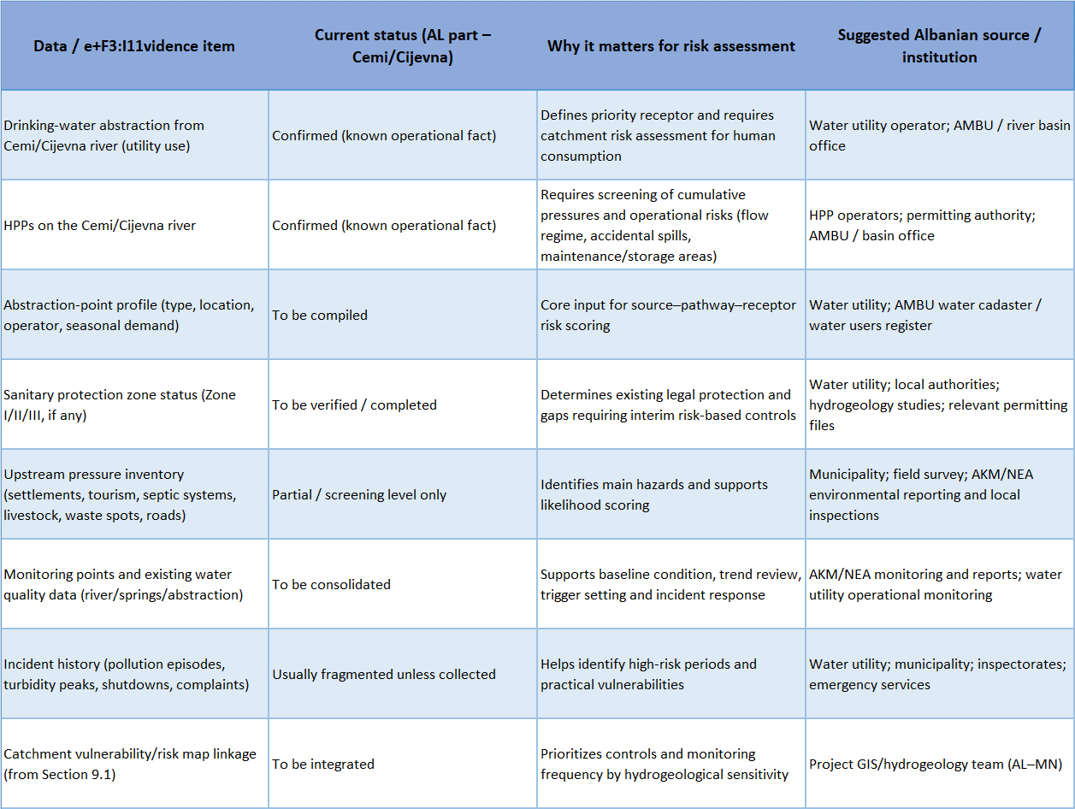

Note: in the absence of a complete dataset, the first version of the abstraction-catchment risk assessment should proceed with confirmed operational facts (drinking-water abstraction and HPP presence), rapid field verification and compilation of existing institutional records, followed by progressive refinement of source inventories, monitoring data and vulnerability mapping.

9.6 Land Use Planning Instruments for Groundwater Vulnerability Mitigation
The Corine map of information on the land covering and environment' is an inventory of land use cover divided in 44 classes, and presented as a cartographic product, at a scale of 1:100 000. This database is operationally available for most areas of Europe and is operated by the European Environment Agency.

Corine land cover information is used to set the baseline of land cover classes, which aids to minimise impacts to economic activity due to plan implementation without conflicting with the objectives of the WFD. This information also provides a baseline for assessing potential damage to designated landscapes as a result of Plan implementation, i.e. important for Strategic Environmental Assessment of the RBMP Programme of Measures. The Corine land cover for the Drini-Buna River Basin is represented in Figure below.

Figure 9.1 Corine land cover in the Drini-Buna River Basin

Majority of the territory is mountain dominated by forest and small part of it is flat area especially on the west part of basin dominated by agriculture land. Run-off in this part remains a challenge for river pollution.
Among the three regions, Shkoder has the most developed agriculture sector since Kukes and Dibra are mostly mountainous regions. In flat agricultural areas like those of Shkoder region, changes in the economic system of the country have also been accompanied by changes in the agriculture sector of Albania. Consequently, today, the agriculture sector has been shifting from a family-based system to an intensive agriculture system with significative changes in cropping pattern and agriculture structure. This has been translated in reality by an increase in agriculture inputs such as pesticides, herbicides and nutrients, which need to be considered.
Estimate unit water irrigation demands does not differentiate between different crop types or the moisture holding capacity of different soil types, which could affect the magnitude and timing of irrigation demands. The simple method for water demand may be selected because of inadequate information about soil types and cropping patterns in the basin; in addition, it was thought that any prediction of future cropping patterns would be too uncertain to yield useful information for proper calculation of water irrigation required.

10. Development of multi-purpose monitoring network of surface water, groundwater and groundwater dependent ecosystems.

10.1 Context and objectives of multi-purpose monitoring networks
In the context of management of river basins, all countries involved in the DIKTAS II project have obligation to align their methodological approach with the requirements of the EU Water Framework Directive (WFD) its daughter directives and CIS guidance. This primarily pertains to establishing all types of monitoring necessary for the development of River Basin Management Plans (RBMP).
The EU WFD and its daughter directives inadequately define the criteria for establishing monitoring in karst regions. Karst terrains are characterized by the high permeability of fractured and karstified carbonate rocks, allowing for fast infiltration of precipitation, which results in a strong dominance of underground flow in karst areas. Consequently, there is a lack of a developed surface water network and, unlike other aquifers, developed ecosystems in groundwater. Furthermore, due to the relief of the terrain, often the same water appears multiple times during its flow towards the erosion base, first as groundwater and then as surface water.
The greatest water quality issues in karst areas are turbidity and microbiological contamination. According to the requirements of the WFD, biological monitoring of groundwater is not foreseen and is generally not carried out in the catchment areas of major springs. Water from karst aquifers is globally utilized as a quality and reliable source of drinking water. The discharge of larger springs is mostly monitored, but variations in groundwater levels during different hydrological periods are very rarely measured, which is a problem in groundwater balancing under varying hydrological conditions and optimal utilization of groundwater for various purposes.
Considering the afore mentioned and the fact that each country has its own approach to establishing monitoring, it is essential to define a common approach to the fundamental principles before establishing joint monitoring in the Transboundary Aquifer (TBA):
- Define the criteria that a representative monitoring station must meet to be included in the quantitative and qualitative monitoring of groundwater and surface water
- Define the method and frequency of sampling
- Define the sampling procedure from wells and springs for biological monitoring needs
- Jointly determine the locations of monitoring stations
- Jointly establish monitoring stations for stable isotopes
- Harmonize analytical methods for determining individual parameters
- Harmonize databases and the method of data exchange
The primary goals of multi-purpose monitoring are:
- To create a basis for the optimal utilization and protection of groundwater and surface waters in the Cemi/Cijevna TBA
- To enable monitoring of the quantitative and qualitative status of groundwater at the borders of the countries sharing the Cemi/Cijevna TBA.

10.2 Legal and policy background.
Groundwater is formally recognized and integrated within national planning frameworks in both Albania and Montenegro; however, this integration remains largely normative and insufficiently operationalized for karst and transboundary aquifers.
Both states Albania and Montenegro has signed a bilateral agreement on transboundary water management, including shared aquifers, dispate its implementation is limited and does not cover joint monitoring, data sharing, or coordinated risk assessment procedures.
In this contest and condition taking advantage of DIKTAS II project, both countries should consider as good opportunity with respective benefits in different sectors of economy. In this context updated and improvement of existing bilateral agreement is must, which should be follow by realistic plan of measures for common implementation.
Establishing a harmonized and jointly agreed monitoring framework represents the most immediate and impactful opportunity for cooperation. Given the karstic connectivity of the basin, shared understanding of groundwater conditions is essential for effective risk management.
Key opportunities include:
- Agreeing on a core set of monitoring parameters for groundwater quantity and quality,
- Identifying and jointly validating priority monitoring points in upstream and downstream areas,
- Establishing routine data exchange protocols between Albanian and Montenegrin institutions.
Organizing periodic joint data interpretation meetings to build a common understanding of trends, anomalies, and emerging risks.

10.3 Joint management targets and priorities.
The joint management targets of TBA Cemi/Cijevna are to establish a joint multi-level monitoring system, which includes unifying qualitative, quantitative, and biological monitoring of underground and surface waters, as well as the monitoring of stable isotopes at TBA Cemi/Cijevna. This includes the formation of identical databases in each country and the definition of protocols for data exchange. This entails the joint selection of monitoring stations, jointly defining parameters and analytical methods, establishing mutual sampling methods and dynamics, and harmonizing the assessment of quantitative and qualitative status of groundwater and surface waters, as well as risk assessment.
Priority activities include:
- Harmonizing the sampling method and chemical and biological parameters for interlinking biological and quality monitoring of groundwaters
- Defining parameters and dynamics of sampling
- Selecting monitoring stations for quantitative groundwater monitoring in the vicinity of major sources
- Initiating stable isotope monitoring
- Creating identical databases in each country
- Defining a protocol for data exchange.

10.4 Selection of monitoring sites and parameters.
Selection of groundwater monitoring sites is based on the conceptual model of TBA Cemi/Cijevna.
Proposed groundwater monitoring sites are:
- Quality and biological monitoring on the main springs of the TBA Cemi/Cijevna: Grabom, Grabom 2, Tamara, Tamara 2, Vermoch, Spring of Zekes, Cemi in Selca, Cemi in Vukel on the Albania side and 2 or 3 springs on the Montenegro side.
- Quality and biological monitoring on 2 exploratory wells (Ušće and Trgaj i) and the planned new one in Montenegro,
Proposed quantitative monitoring sites are:
- The main springs: Grabom, Grabom 2, Tamara, Tamara 2, Vermoch, Spring of Zekes, Cemi in Selca, Cemi in Vukel on the Albania side and 2 or 3 springs on the Montenegro side.
- Exloratory wells: Ušće and Trgaj and the planned new one in Montenegro,
List of physico-chemical parameters included in groundwater quantitative montoring.
Twelve (12) core physico-chemical parameters: BOD₅, TOC, electrical conductivity, alkalinity, pH, NH₄⁺, NO₃⁻, NO₂⁻, TN, total P, ortho-PO₄³⁻, and SO₄²⁻ and pH value, temperature, turbidity, electrical conductivity, total dissolved solids, suspended matter, oxygen concentration, oxygen saturation (%O₂), BOD₅ (Biochemical Oxygen Demand), COD (Chemical Oxygen Demand, with KMnO₄), alkalinity, total hardness (°dH), bicarbonates (HCO₃⁻), chlorides (Cl⁻), sulfates (SO₄²⁻), nitrates (NO₃⁻), nitrites (NO₂⁻), ammonium (NH₄⁺), total nitrogen (TN), orthophosphates (o-PO₄³⁻), total phosphates (u-PO₄³⁻), total organic carbon (TOC), calcium (Ca²⁺), magnesium (Mg²⁺), total iron (u-Fe), sodium (Na⁺), potassium (K⁺), and salinity.
Supporting parameters will be also measured as well. These parameters include total water hardness, O₂ content, % O₂, and suspended matter.
For pollutants, metals such as Pb, Cd, and Hg will be analysed, along with As and pesticides (176 substances from this group).
Sampling dynamics will be 4 times a year.

Table 10.1 Ecological indicators in biological monitoring and sampling frequency
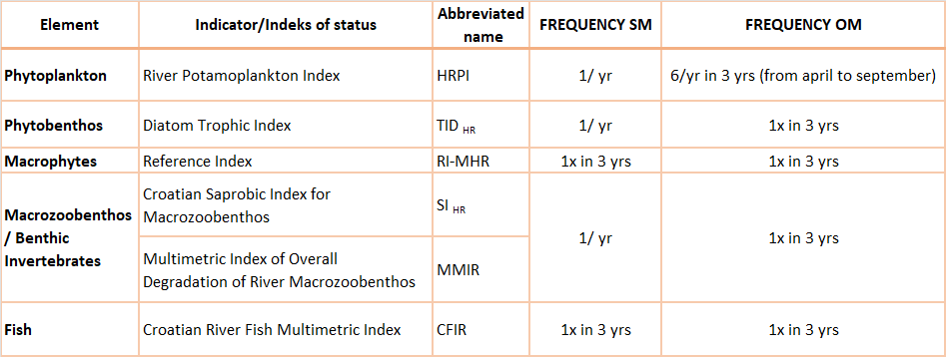

Table 10.2 Physico-chemical parameters in biological monitoring and sampling frequency
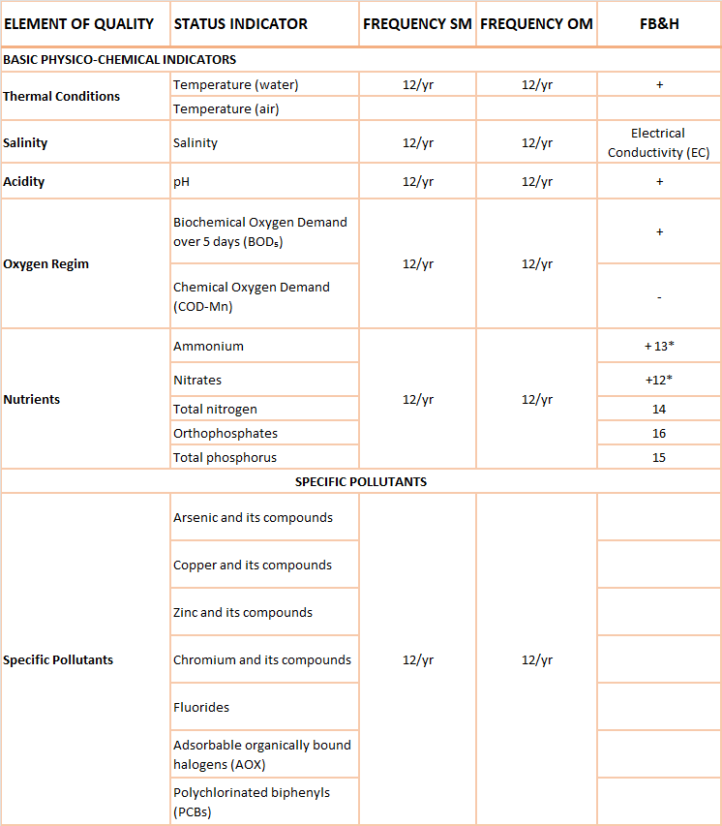

Proposed surface water monitoring sites are:
- Two monitoring points have been selected on the Cemi/Cijevna River in the Albanian territory:
- Tamare, representing the upper segment of the river's flow in Albanian territory.
- Grabom Customs, representing the lower segment of the flow, immediately before the river exits Albanian territory.
- One monitoring points have been selected on the Cemi/Cijevna River on the Montenegro side Drinoša
List of physico-chemical parameters included in surface water quantitative montoring include: pH value, temperature, turbidity, electrical conductivity, total dissolved solids, suspended matter, oxygen concentration, oxygen saturation (%O₂), BOD₅ (Biochemical Oxygen Demand), COD (Chemical Oxygen Demand, with KMnO₄), alkalinity, total hardness (°dH), bicarbonates (HCO₃⁻), chlorides (Cl⁻), sulfates (SO₄²⁻), nitrates (NO₃⁻), nitrites (NO₂⁻), ammonium (NH₄⁺), total nitrogen (TN), orthophosphates (o-PO₄³⁻), total phosphates (u-PO₄³⁻), total organic carbon (TOC), calcium (Ca²⁺), magnesium (Mg²⁺), total iron (u-Fe), sodium (Na⁺), potassium (K⁺), and salinity.
Sampling dynamics will be 4 times a year.

Table 10.3 Sampling frequency for ecological monitoring of surface waters
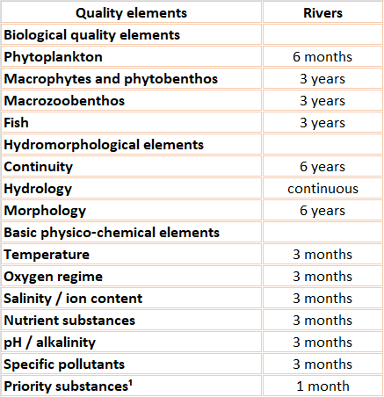

10.5 Sampling protocols.
Water sampling should be conducted simultaneously, or within as short a timeframe as possible, at all monitoring stations. The sampling should be carried out by an authorized person from the accredited laboratory that performs physical-chemical analyses of water, according to the standards for sampling groundwater and surface water.
Water sampling for biological monitoring should be conducted at the same time with the sampling for physical-chemical analyses of water from springs and surface waters.

10.6. Integration of existing national monitoring networks.
The establishment of a multi-purpose monitoring network is primarily aimed at improving the existing monitoring networks in each country for the optimal management of the transboundary aquifer Cemi/Cijevna.
The final proposal for the establishment of the multi-purpose monitoring system will be made after an assessment of groundwater balance, evaluation of the quantitative status of groundwater, preparation of vulnerability maps, creation of a registry of potential polluters, and risk assessment of pollution of groundwater and surface waters.
Following the completion of the final proposal for the multi-purpose monitoring network, a multi-criteria analysis of the existing monitoring systems will be conducted, and suggestions for their improvement will be made.

10.7 Data collection validation and storage.
Data collection will be conducted when the parameters for each monitoring program are finalized, and sampling and water analysis begin. Data evaluation will be carried out in laboratories where the water analyses will take place and in the agency of each country responsible for monitoring of groundwater and surface waters.
Ultimately, the data will be stored in a harmonized database managed by the agency in each country responsible for monitoring.

10.8 Quality assurance and standardisation.
Quality assurance and standardization will be ensured after the parameters for each monitoring program are defined and established, along with the prescribed methods and dynamics of sampling. Additionally, accredited laboratories will be engaged for the sampling and analysis of water samples.

10.9 Harmonised data exchange and reporting protocols.
Harmonized protocols for data exchange will be developed once the coordinated databases are created and the agencies responsible for implementing groundwater and surface water monitoring in each country are identified.
Each agency will submit annual reports on data exchange to the relevant ministry of their respective country and to the interstate commission for water management.

10.10 GIS integration and visualization.
GIS integration and visualization will be implemented after all monitoring stations are finalized. The spatial representation of the locations of monitoring stations will be one of the layers in the GIS project DIKATAS II, which will be accessible on internet.
Once a specific number of data points are collected and processed, the condition of water at individual monitoring stations will be able to be displayed in the GIS.

10.11 Implementation roadmap and action plan.
Once all the previously mentioned precondition for the establishment of a multi-purpose monitoring networks for groundwater and surface waters are fulfilled, an implementation plan will be developed, and action plan will be created within which priorities will be defined.

11. Guidelines for establishing remediation measures for contaminated aquifer zones

11.1 Remediation purpose and objectives.
The purpose of remediation in the Cem/Cijevna basin is to protect and improve the quality of groundwater and surface water resources while ensuring their sustainable use for local communities and ecosystems. Because the basin is characterized by a sensitive karst hydrogeological system and an important transboundary river corridor between Albania and Montenegro, remediation objectives must address both environmental protection and risk management. The remediation process therefore aims not only to correct existing contamination problems but also to prevent future degradation of water resources. Within such a hydrogeologically vulnerable environment, remediation activities must be carefully designed to safeguard drinking water sources, maintain ecological integrity, and reduce environmental risks associated with human activities.
One of the primary objectives of remediation in the basin is the protection of drinking water resources derived from karst springs and groundwater bodies. Local communities rely heavily on spring water for drinking water supply and small-scale irrigation. Due to the high permeability and rapid groundwater flow typical of karst systems, contaminants entering the subsurface can quickly reach these springs with very limited natural attenuation. As a result, the remediation strategy must prioritize the prevention of contamination pathways that could threaten these water resources. Measures aimed at improving wastewater management, controlling pollutant infiltration from septic systems, and reducing diffuse pollution from agricultural activities are therefore essential components of the remediation approach. Ensuring that water quality parameters remain within acceptable drinking water standards is a key objective for maintaining public health and water security.
Preventing groundwater contamination within the karst aquifer system represents another key remediation objective. Karst aquifers are extremely vulnerable to pollution because they lack the natural filtration capacity typical of granular aquifers. Pollutants can migrate rapidly through fractures, conduits and dissolution channels, potentially affecting groundwater quality across large distances. For this reason, remediation strategies in the basin should emphasize the control of pollutant infiltration from surface sources. This includes improving septic system performance in rural areas, implementing better management of livestock waste, and regulating activities that may pose risks to groundwater quality. By reducing the entry of contaminants into the subsurface environment, these measures can significantly lower the risk of long-term groundwater degradation.
The transboundary character of the Cem/Cijevna basin also requires that remediation objectives address potential cross-border environmental impacts. Because the river originates in Albania and flows downstream into Montenegro, contamination in the upstream catchment may affect water resources and ecosystems across national borders. Consequently, remediation strategies must be aligned with international principles of transboundary water management and environmental cooperation. Maintaining water quality before the river crosses the border is essential for protecting downstream ecosystems and ensuring equitable water resource use between the two countries. Strengthening institutional cooperation and data exchange between Albanian and Montenegrin authorities will therefore play an important role in achieving these objectives.
Another important aspect of remediation planning is the establishment of site-specific cleanup levels and environmental endpoints. These targets define acceptable concentrations of contaminants and environmental conditions that remediation measures should achieve. Cleanup levels in the Cem/Cijevna basin should primarily reflect drinking water protection standards, ecological quality objectives and the natural hydrochemical background conditions of the karst aquifer. Parameters such as nitrates, dissolved oxygen, pH, electrical conductivity and microbiological indicators represent important indicators for assessing water quality conditions. In particular, microbiological contamination indicators such as E. coli are critical in rural environments where wastewater management infrastructure is limited. Maintaining these parameters within acceptable limits is essential for protecting human health and aquatic ecosystems.
Remediation endpoints should not be defined solely in terms of numerical concentration limits but also in terms of broader environmental outcomes. These outcomes may include the stabilization of groundwater quality trends, the reduction of pollution indicators in river water and the maintenance of ecological conditions that support aquatic biodiversity. Healthy macroinvertebrate communities and stable hydrochemical conditions in groundwater can serve as indicators that remediation objectives are being successfully achieved. These environmental endpoints provide a practical framework for evaluating the long-term effectiveness of remediation measures.
The monitoring network proposed for the Cem/Cijevna basin will play a crucial role in supporting remediation objectives. Continuous monitoring of hydrological conditions and periodic laboratory analyses of water quality parameters will allow scientists and water managers to track contamination trends and evaluate the effectiveness of implemented management measures. Monitoring results will also provide the scientific basis for refining cleanup targets and adjusting remediation strategies over time. In this way, remediation planning becomes part of an adaptive environmental management process capable of responding to changing environmental conditions and improved scientific knowledge.
Ultimately, the purpose of remediation in the Cem/Cijevna basin is to ensure the long-term protection of water resources, preserve the ecological integrity of the river system and support sustainable development within the basin. By combining restoration measures with pragmatic risk reduction strategies, remediation efforts can address both existing environmental pressures and future contamination risks. Such an integrated approach is essential for safeguarding the valuable karst groundwater resources of the basin and maintaining their availability for future generations.

11.2 Regulatory and policy context.
The regulatory and institutional framework relevant to the management of groundwater contamination within the Cemi/Cijevna Transboundary Aquifer (TBA) is based on legislation governing water protection, environmental protection, and land management in Albania and Montenegro. Although the national legal systems of both countries contain provisions addressing the prevention of water pollution and liability for environmental damage, specific procedures for the remediation of contaminated aquifers remain only partially developed, particularly in the context of highly vulnerable karst aquifer systems.
In Montenegro, the primary legal framework for groundwater protection is established through the Water Law (“Official Gazette of the Republic of Montenegro”, No. 27/07; “Official Gazette of Montenegro”, Nos. 73/10, 32/11, 47/11, 48/15, 52/16, 55/16, 2/17, 80/17, 84/18, 84/24), which regulates the status of waters, conditions for their use, protection, and monitoring of water resources. The law introduces principles of integrated water management at the river basin level, protection of water bodies, and the obligation to prevent deterioration of their status. The regulatory framework is further supported by the Environmental Protection Law (“Official Gazette of Montenegro”, Nos. 52/16, 59/18, 10/23) and related by-laws governing water quality monitoring, wastewater discharge, and the protection of water supply sources. These regulations introduce the principles of pollution prevention and the “polluter pays” principle, as well as obligations to prevent and limit the introduction of harmful substances into surface and groundwater. However, while the legislation provides the legal basis for identifying sources of pollution and implementing protection or corrective measures, the national legal framework does not yet include detailed procedures specifically addressing remediation of contaminated aquifers.
An additional aspect of resource protection relevant to groundwater quality is regulated through the Law on Agricultural Land (“Official Gazette of the Republic of Montenegro”, Nos. 15/92, 59/92; “Official Gazette of Montenegro”, No. 32/2011) and the Rulebook on permissible quantities of hazardous and harmful substances in soil and methods for their testing (“Official Gazette of the Republic of Montenegro”, No. 18/97). These regulations address the protection of soil from degradation and contamination, including limits on hazardous substances, thereby indirectly contributing to groundwater protection, particularly in environmentally sensitive karst areas.
In Albania, the legal framework for water resources management is established through the Law on Water Resources (Law No. 29/2024), which introduces principles of integrated water resources management and is aligned with the requirements of the EU Water Framework Directive and the Groundwater Directive. The law defines rules for the use, protection, and monitoring of water resources, including pollution control, the issuance of water-use permits, and the establishment of sanitary protection zones around water supply sources. In addition, the Environmental Protection Law introduces the principles of prevention and environmental liability, including obligations to implement restoration or rehabilitation measures in cases where environmental degradation occurs.
In both countries, the regulatory framework for water protection is based on the principles of pollution prevention, emission control, and water quality monitoring, as well as the obligation to identify sources of contamination and implement appropriate protection measures. However, in karst aquifer systems-where contaminant transport can be rapid and spatially complex due to the presence of fractures, conduits, and large recharge areas-the existing legal framework still lacks detailed methodological guidance for addressing groundwater contamination and remediation.
For the Cemi/Cijevna Transboundary Aquifer, which represents an important source of drinking water supply and supports groundwater-dependent ecosystems, the regulatory and institutional frameworks in both countries provide the foundation for identifying and managing contamination risks. At the same time, the development of operational guidance for remediation and the strengthening of transboundary cooperation in monitoring, data exchange, and risk management represent important elements for the future sustainable management of this shared karst aquifer system.

11.3 Contaminated site characterisation and risk assessment.
The contaminated site assessment focuses on the Albanian part of the Cemi/Cijevna River catchment, located in the northern Albanian Alps along the transboundary basin shared between Albania and Montenegro.
The study area includes approximately seven to eight rural settlements distributed along the upper reaches of the basin, including villages such as Selcë, Vukël, Tamara and Grabom. These settlements are situated in mountainous terrain with elevations ranging from approximately 150–200 m above sea level in the lower valley areas to more than 1500 m above sea level in the upper mountainous zones.
The river system originates from two main headwater branches:
- Cemi i Selcës
- Cemi i Vuklit
which merge downstream to form the Cem/Cijevna River, a transboundary river flowing from Albania toward Montenegro.
Water supply in the villages relies almost entirely on natural karst springs, which are used both for drinking water and for irrigation of small agricultural plots. There is generally no centralized water treatment infrastructure, and water is consumed directly from the sources.
Wastewater management infrastructure in the area is very limited.
The settlements:
- are not connected to sewerage networks,
- have no wastewater treatment plants,
- rely mainly on primitive septic pits,
- often discharge greywater directly into the surrounding environment or drainage pathways.
In addition, livestock farming is common in the villages. Many households keep cattle, sheep, goats and occasionally pigs, and small animal stables are present within the settlements. Waste from these activities is usually stored locally without engineered containment structures.
These conditions create potential diffuse contamination sources that may affect both groundwater and surface water systems.
Potential contamination sources
Based on the current land use conditions in the Albanian section of the basin, contamination sources are primarily diffuse and anthropogenic, rather than industrial. The most relevant potential contamination sources include:
- Septic pits and domestic wastewater
- Livestock farming and manure storage
- Small pig farms and animal stables
- Direct discharge of greywater into drainage pathways
- Agricultural runoff from small cultivated areas
Additionally, two small hydropower plants located along the Cem River may influence the hydrological regime and aquatic biodiversity, although they are not expected to introduce significant chemical contamination.
Table 11.1 Main contamination sources and potential pathways
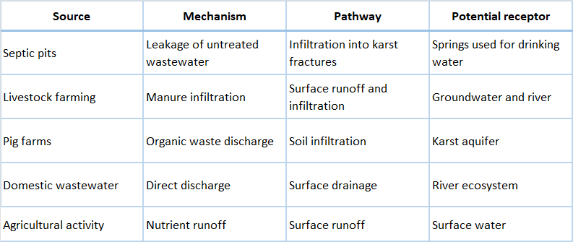
Because karst aquifers provide limited natural filtration, contaminants may migrate relatively quickly through the system.
Status of monitoring infrastructure
At present, no operational monitoring stations exist in the field within the Albanian section of the basin. However, a comprehensive monitoring network has been designed within the framework of a proposed transboundary monitoring project. The proposed monitoring system includes:
- two surface water monitoring stations along the Cemi River (Tamara and Grabom border crossing),
- a groundwater monitoring well near the border area in Grabom,
- telemetric hydrological and climatic monitoring stations,
- isotopic monitoring of precipitation, river water and groundwater.
- physico-chemical and biological monitoring (one point in Grabom border and another one in Tamara)
The monitoring network is designed to allow the integration of hydrological, hydrogeological, climatic and isotopic data, which will enable a more comprehensive understanding of water circulation processes within the basin.
However, the installation of this monitoring infrastructure depends on future investment and project implementation.
Preliminary risk assessment
Based on the available information, the main environmental risks in the basin are associated with diffuse rural pollution and the high vulnerability of karst groundwater systems.
The main receptors potentially affected by contamination include:
- local populations using spring water for drinking purposes
- agricultural plots irrigated with spring water
- aquatic ecosystems within the Cem River
- downstream transboundary water resources.
Given the karstic nature of the aquifer and the absence of wastewater infrastructure, the risk of microbiological contamination and nutrient transport is considered moderate to high in localized areas.
However, due to the limited monitoring data currently available, a comprehensive quantitative risk assessment cannot yet be conducted. The implementation of the proposed monitoring network will therefore be essential for improving the understanding of contamination risks within the basin.

11.4 Design of contaminated site monitoring network and sampling strategy
Integration of physico-chemical and biological monitoring
Physico-chemical and biological monitoring will be integrated into the monitoring network at the same locations or in close proximity to the telemetric monitoring stations.
This approach allows the combination of:
- continuous hydrological data collected through sensors
- periodic water quality sampling
- ecological monitoring indicators.
Table 11.2 Water quality monitoring parameters
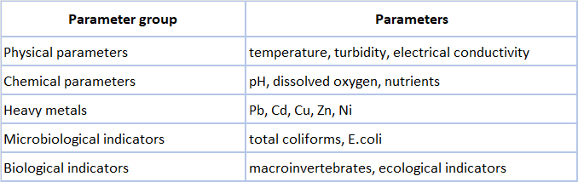
Physico-chemical and biological monitoring will be conducted through periodic field sampling and laboratory analysis.
This integrated monitoring strategy allows the identification of:
- pollution sources related to settlements
- seasonal variations linked to tourism activity
- ecological impacts on the river system.
Groundwater monitoring strategy
Groundwater monitoring will be carried out through the installation of a dedicated monitoring well near the Grabom border area. In Montenegro, monitoring wells will be installed in the village of Dinoša and at the confluence of the Cemi/Cijevna River into the Morača River.
The objective of this monitoring well is to observe the behaviour of the transboundary karst aquifer system. The monitoring well will be equipped with:

- automatic water level sensor
- temperature sensor
- electrical conductivity sensor
- telemetry system for real-time data transmission.

Table 11.3 Groundwater monitoring parameters
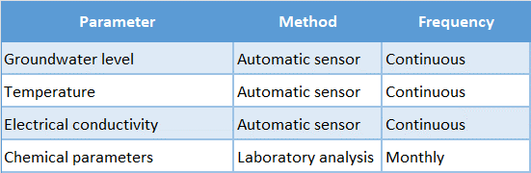
These observations will allow the analysis of:
- groundwater recharge events
- seasonal aquifer dynamics
- potential contamination processes.
Climatic monitoring network
Climatic monitoring is an essential component of the monitoring network because precipitation plays a key role in the recharge of the karst aquifer system.
Telemetric climatic stations will record:
- precipitation
- air temperature
- atmospheric pressure
- relative humidity.
These data are necessary for interpreting hydrological processes within the basin and for understanding seasonal variations in river discharge and groundwater recharge.

Isotopic monitoring network
Isotopic monitoring will be implemented in order to determine the origin and circulation of water within the hydrological system.
A pluviometric station dedicated to isotopic monitoring of precipitation will be installed at the Grabom border location and in the village of Dinoša . This location was selected because it represents a strategic point for observing the isotopic signature of precipitation entering the transboundary basin. Monthly isotopic sampling will include:
- precipitation
- river water
- groundwater.
The analyses will focus on the isotopic parameters: δ18O, δ2H and Radon, also. These measurements will support:
- the construction of the local meteoric water line
- identification of groundwater recharge areas
- analysis of surface water–groundwater interaction.

Sampling strategy
The sampling strategy combines continuous monitoring and periodic sampling. Continuous monitoring includes:
- river water level
- groundwater level
- climatic parameters.
Periodic sampling includes:
- physico-chemical water analyses
- microbiological analyses
- biological monitoring
- isotopic analyses.

Table 11.4 Sampling frequency
Monitoring component | Frequency
Hydrological monitoring | continuous
Groundwater monitoring | continuous
Physico-chemical sampling | Monthly
Microbiological sampling | Monthly
Biological monitoring | Seasonal
Isotopic sampling | Monthly
This sampling strategy allows the detection of both short-term hydrological events and long-term environmental trends.

11.5 Defining remediation goals (e.g., restoration vs. risk reduction)
The definition of remediation goals represents a critical step in the management of contaminated sites, particularly in hydrogeologically sensitive environments such as karst aquifers. In the case of the Cem/Cijevna basin, remediation objectives must be formulated by considering the specific environmental conditions of the area, the vulnerability of the karst groundwater system, the socio-economic importance of water resources for local communities, and the transboundary character of the river basin.
In general, remediation strategies can be oriented toward two main objectives: full environmental restoration or risk reduction and management. Full restoration aims to return environmental conditions to their original or natural state prior to contamination. In contrast, risk reduction focuses on lowering contaminant concentrations or exposure pathways to levels that no longer pose unacceptable risks to human health or ecosystems.
In the Cemi/Cijevna basin, remediation goals must be carefully balanced between these two approaches. The basin is characterized by high-quality natural water resources that support rural communities, ecosystems and tourism activities. Water from karst springs is widely used for drinking water supply and small-scale irrigation, while the river itself represents an important ecological corridor. Consequently, the protection of water quality must be considered a primary objective.
However, the hydrogeological characteristics of karst aquifers introduce significant challenges for remediation. Karst systems typically exhibit rapid groundwater flow, complex conduit networks and limited natural filtration capacity. Once contaminants enter such systems, they may travel quickly over large distances, making complete restoration difficult or technically unrealistic in some circumstances. For this reason, remediation goals must also consider pragmatic approaches that focus on risk reduction and the prevention of further contamination.
In the context of the Cemi/Cijevna basin, remediation goals are therefore defined according to three complementary principles. The first principle is the protection of drinking water resources, particularly the karst springs that supply local communities. Any remediation strategy must prioritize the safeguarding of these sources by preventing contamination pathways and maintaining water quality within acceptable standards.
The second principle is the protection of aquatic ecosystems in the Cemi/Cijevna River and its tributaries. The river supports diverse biological communities and plays an important role in maintaining ecological connectivity across the transboundary basin. Potential contamination from untreated wastewater, tourism-related activities and livestock farming may introduce nutrients, microbiological contaminants and organic pollutants into the river system. Remediation efforts must therefore aim to maintain or restore ecological conditions that support healthy aquatic ecosystems.
The third principle is the prevention of transboundary environmental impacts. Because the Cem River flows from Albania into Montenegro, contamination originating in the upstream catchment may affect downstream water resources across national borders. Remediation goals must therefore align with international principles of transboundary water management and the objectives of European environmental legislation, including the Water Framework Directive.
An important aspect of defining remediation goals is the identification of acceptable water quality targets. These targets should be consistent with national legislation and relevant European environmental standards. In addition, they should reflect the natural hydrogeochemical characteristics of the basin, which are influenced by the carbonate geology and karst hydrogeology of the region.

Table 11.5 Conceptual remediation objectives for the Cemi/Cijevna basin
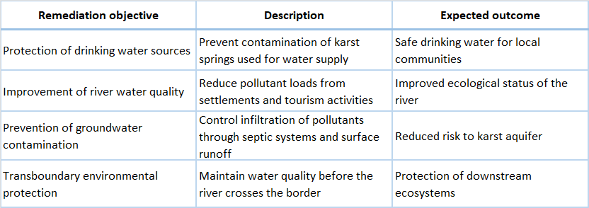
In practice, the selection between restoration and risk reduction approaches depends on the nature and scale of the contamination problem. In cases where pollution sources are clearly identified and manageable, such as localized wastewater discharges, remediation may aim toward environmental restoration through improved wastewater management and pollution prevention measures. In other cases, particularly where diffuse pollution sources are involved, risk reduction strategies may be more appropriate.
For example, in rural settlements without centralized wastewater treatment systems, complete elimination of contamination sources may not be immediately feasible. In such situations, remediation efforts may focus on gradual improvements, such as upgrading septic systems, implementing wastewater management measures for tourism facilities and improving environmental awareness among local communities.
The establishment of the proposed monitoring network in the Cemi/Cijevna basin will play an essential role in defining and refining remediation goals over time. Continuous monitoring of hydrological, chemical and biological parameters will allow the identification of contamination trends, evaluation of environmental risks and assessment of the effectiveness of implemented management measures.
Ultimately, remediation goals for the Cemi/Cijevna basin should be viewed as part of an adaptive environmental management process. As additional monitoring data become available and the understanding of the hydrogeological system improves, remediation strategies may be adjusted in order to achieve both environmental protection and sustainable use of water resources within this sensitive transboundary karst basin.

11.6 Site-specific cleanup levels and endpoints.
Defining site-specific cleanup levels and remediation endpoints is an essential component of groundwater protection and environmental risk management. In the Cem/Cijevna basin, these levels must reflect both the hydrogeological characteristics of the karst aquifer and the actual use of water resources by local communities. Because groundwater and spring water are directly used for drinking water supply and small-scale irrigation, remediation targets must prioritize the protection of human health and the preservation of natural water quality conditions.
Karst aquifers are highly vulnerable to contamination due to their high permeability, rapid groundwater flow and limited natural filtration capacity. Pollutants introduced at the surface may travel quickly through fractures and karst conduits, potentially reaching springs and surface water bodies in relatively short time periods. For this reason, cleanup levels must be designed to ensure that contaminant concentrations remain below thresholds that could pose risks to drinking water supplies, ecosystems or downstream water users.
In the Albanian section of the Cemi/Cijevna basin, site-specific cleanup targets should therefore be aligned with drinking water protection standards, as well as environmental quality objectives applicable to surface water ecosystems. These standards provide reference concentrations for chemical contaminants, microbiological parameters and other indicators of water quality. Where possible, cleanup levels should also take into account the natural hydrochemical background conditions of the karst aquifer system.
The determination of cleanup levels follows a risk-based approach. This approach considers the relationship between contaminant sources, transport pathways and potential receptors such as drinking water springs, river ecosystems and downstream water users. Cleanup targets must therefore ensure that contaminant concentrations remain below levels that could affect these receptors.
In rural mountain environments such as the Cemi/Cijevna basin, contamination pressures are typically associated with domestic wastewater discharge, livestock farming activities and tourism-related wastewater generation, particularly in settlements such as Tamara. Consequently, cleanup objectives often focus on parameters associated with organic pollution, microbiological contamination and nutrient loading.
The establishment of site-specific cleanup endpoints also requires consideration of the intended environmental outcome of remediation measures. In some cases, remediation may aim to restore environmental conditions to natural background levels. In other situations, the objective may be to reduce contamination to levels that no longer pose unacceptable risks to human health or ecosystems.
In the Cemi/Cijevna basin remediation endpoints should therefore aim to achieve the following outcomes:
- protection of drinking water sources derived from karst springs
- maintenance of good ecological status of the Cem River
- prevention of contaminant transport toward downstream transboundary waters
- long-term stability of groundwater quality in the karst aquifer.
The monitoring network proposed for the basin will play a crucial role in verifying whether these endpoints are achieved. Continuous monitoring of hydrological conditions combined with periodic laboratory analyses of water quality parameters will allow the evaluation of whether contaminant concentrations remain within acceptable limits.

Table 11.6 Example cleanup targets for the Albanian section of the Cem/Cijevna basin
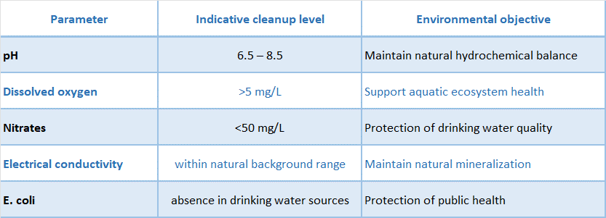
These values represent typical environmental targets associated with drinking water protection and aquatic ecosystem health. In practice, site-specific cleanup levels may be refined based on monitoring data collected within the basin and on the natural hydrochemical characteristics of the local karst system. In addition to chemical parameters, microbiological indicators are particularly important in rural catchments where wastewater treatment infrastructure is limited. Monitoring of bacteriological indicators such as E. coli and total coliform bacteria provides essential information about contamination risks related to domestic wastewater or livestock activities.
Cleanup endpoints should therefore not be defined solely in terms of numerical concentration limits but also in terms of broader environmental outcomes. These may include the stabilization of groundwater quality trends, the reduction of pollution indicators in river water, and the maintenance of ecological conditions capable of supporting aquatic biodiversity.

Table 11.7 Environmental endpoints for remediation
Because environmental conditions in the basin may evolve over time, cleanup levels and remediation endpoints should be periodically reviewed and adjusted through the adaptive management framework described in previous sections. Monitoring results will provide the scientific basis for evaluating whether remediation objectives are being achieved and whether additional management measures are required.
Ultimately, the establishment of site-specific cleanup levels and endpoints in the Cem/Cijevna basin supports the long-term protection of water resources, the preservation of river ecosystems and the sustainable use of groundwater resources by local communities.

11.7 In-situ and ex-situ remediation technologies for PCB-contaminated karst groundwater.
Remediation of groundwater contaminated with polychlorinated biphenyls (PCBs) presents significant technical challenges, particularly in karst hydrogeological environments such as the Cem/Cijevna basin. Karst aquifers are characterized by highly heterogeneous permeability, rapid groundwater circulation through fractures and conduits, and limited natural filtration capacity. These conditions can facilitate the rapid migration of contaminants over large distances and complicate the implementation of conventional remediation techniques.
PCBs are persistent organic pollutants (POPs) with strong hydrophobic properties and high chemical stability. In aquatic environments they tend to adsorb onto suspended particles, sediments, and organic matter, rather than remaining entirely dissolved in groundwater. In karst systems, PCBs may accumulate within sediment deposits, low-velocity zones, and fracture fillings, from which they may be periodically remobilized during high-flow events or flood conditions. Consequently, remediation strategies must consider both groundwater and sediment contamination pathways.
In the context of transboundary karst aquifers, remediation approaches must also be selected carefully to avoid unintended impacts on downstream water resources. Technologies must therefore be evaluated not only for their removal efficiency but also for their compatibility with sensitive hydrogeological systems and ecological environments.
Remediation technologies for PCB-contaminated groundwater can generally be divided into two broad categories: in-situ technologies, which treat contamination directly within the subsurface, and ex-situ technologies, which involve the extraction and treatment of contaminated water or sediments outside the aquifer.

In-situ remediation technologies
In-situ remediation technologies are generally preferred in karst aquifers because they minimize disturbance to the subsurface and reduce the need for large-scale groundwater extraction. However, their application in karst environments requires careful design due to the complexity of groundwater flow pathways.
One of the most widely used in-situ approaches for persistent organic contaminants is enhanced bioremediation. This technique relies on the stimulation of naturally occurring microorganisms capable of degrading chlorinated organic compounds. In anaerobic conditions, certain bacteria can promote reductive dechlorination processes, gradually transforming highly chlorinated PCB molecules into less chlorinated and potentially less toxic compounds. The effectiveness of this approach depends on the availability of suitable microbial communities and the presence of appropriate redox conditions.
Another promising in-situ approach is the use of reactive barriers, commonly referred to as permeable reactive barriers (PRBs). These systems are installed across groundwater flow paths and contain reactive materials that adsorb or degrade contaminants as groundwater flows through them. For PCB contamination, reactive media may include activated carbon, biochar, or specialized sorbent materials capable of capturing hydrophobic organic compounds. PRBs can be particularly useful in karst systems where groundwater flow is concentrated along identifiable conduits or fracture zones.
In addition to adsorption-based methods, emerging technologies such as in-situ chemical reduction and advanced oxidation processes have also been investigated for the degradation of persistent organic pollutants. These techniques involve the injection of reactive agents capable of breaking down complex organic molecules into less harmful products. However, their application in karst aquifers requires careful assessment because rapid groundwater flow may limit contact time between contaminants and reactive agents.
Another approach involves the use of in-situ sorptive amendments, such as activated carbon particles injected into sediments or aquifer materials. These amendments can immobilize PCBs by binding them strongly to the sorbent material, thereby reducing their mobility and bioavailability. Although this method does not completely remove contaminants, it can significantly reduce environmental risks.

Ex-situ remediation technologies
Ex-situ remediation technologies involve the extraction of contaminated groundwater or sediments followed by treatment at the surface. These methods are often used when contamination levels are high or when in-situ treatment is insufficient.
One of the most common approaches is the pump-and-treat system, which involves pumping contaminated groundwater from the aquifer and treating it through a combination of physical and chemical processes. For PCB removal, treatment methods may include activated carbon adsorption, advanced filtration systems, and oil-water separation techniques. Pump-and-treat systems can be effective for controlling contaminant plumes and preventing further migration.
Another ex-situ option is sediment removal and treatment, particularly in river environments where PCBs may accumulate in sediments. Dredged sediments can be treated through stabilization techniques or disposed of in controlled hazardous waste facilities. In karst river systems, however, sediment removal must be carefully managed to avoid ecological disturbance.
Thermal treatment technologies may also be applied to highly contaminated materials. These processes involve heating contaminated sediments or soils to temperatures that destroy organic contaminants. While effective, such methods are typically expensive and are usually reserved for localized contamination hotspots.
In some cases, constructed wetlands or engineered treatment systems may be used to reduce contaminant loads before water enters sensitive ecosystems. These systems rely on natural biological processes and sedimentation mechanisms to capture pollutants. Although they are more commonly applied to nutrient and organic pollution, they may also contribute to reducing PCB transport associated with suspended sediments.

Comparison of remediation technologies
The selection of appropriate remediation technologies must consider several factors, including contaminant concentration, hydrogeological conditions, environmental sensitivity, and economic feasibility.

Table 11.8 Comparison of remediation technologies for PCB-contaminated groundwater
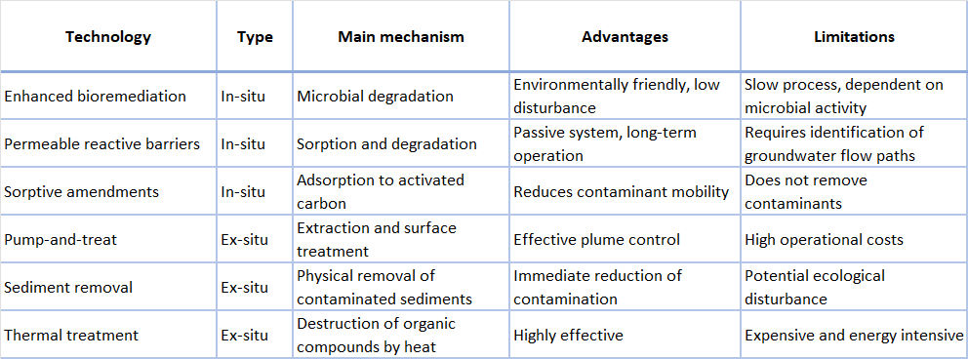

Applicability to karst aquifers
The application of remediation technologies in karst aquifers requires particular attention to the complex flow dynamics and structural heterogeneity of these systems. Unlike porous aquifers, groundwater in karst environments often flows through discrete conduits, fractures and cavities. This makes it difficult to ensure uniform distribution of remediation agents.
Consequently, remediation strategies in karst aquifers often rely on targeted interventions combined with long-term monitoring. Instead of attempting to treat the entire aquifer, remediation efforts may focus on controlling contamination sources, intercepting contaminant pathways, and protecting sensitive receptors such as drinking water springs.
The integration of remediation technologies with the monitoring network proposed for the Cem/Cijevna basin will allow the evaluation of remediation effectiveness and support adaptive management strategies.

Integrated remediation approach
In many cases, the most effective remediation strategy involves a combination of in-situ and ex-situ techniques. For example, in-situ adsorption barriers may be used to reduce contaminant migration, while pump-and-treat systems may be applied in localized areas to remove contaminated groundwater.
An integrated approach may include:
- source control measures to prevent new contamination
- in-situ treatment to immobilize contaminants within the aquifer
- targeted ex-situ treatment for highly contaminated zones
- long-term monitoring to evaluate remediation effectiveness.
Such strategies are particularly suitable for transboundary karst aquifers, where the protection of shared water resources requires careful coordination and adaptive management.
Ultimately, the selection of remediation technologies must be guided by a detailed understanding of the hydrogeological system, the distribution of contaminants, and the environmental priorities of the basin

11.8 Emergency response planning.
Effective emergency response planning is a critical component of environmental management in transboundary river basins, particularly in hydrogeologically sensitive areas such as karst aquifer systems. In the Cem/Cijevna basin, the vulnerability of the karst groundwater system, the direct use of spring water for drinking purposes, and the transboundary nature of the river increase the potential consequences of accidental contamination events. For this reason, a structured and coordinated emergency response framework is required to ensure rapid detection, assessment and mitigation of environmental incidents that could affect both surface water and groundwater resources.
Emergency situations in the basin may arise from a variety of sources. Potential incidents include accidental discharges of pollutants from transport activities, failures of wastewater containment systems, sudden releases of contaminants from tourism facilities, illegal waste disposal, or natural events such as floods that mobilize contaminated sediments. In karst environments, contaminants can infiltrate rapidly through fractures and conduits and may travel quickly through the subsurface, making early detection and rapid response particularly important.
The primary objective of emergency response planning in the Cem/Cijevna basin is to minimize environmental damage and protect drinking water resources. This requires the establishment of procedures that allow authorities to react quickly when contamination events occur. Such procedures should include the identification of responsible institutions, communication protocols between agencies, and operational measures to contain and mitigate pollution.
A key element of the emergency response system is the early detection of contamination events. The monitoring network proposed for the basin will play an essential role in this process. Continuous hydrological measurements, combined with periodic water quality monitoring, can help detect abnormal changes in parameters such as turbidity, electrical conductivity, or dissolved oxygen, which may indicate pollution events. Once the monitoring infrastructure becomes operational, telemetry-based data transmission will allow near real-time observation of hydrological conditions and support early warning capabilities.
When an abnormal environmental signal or pollution event is detected, the first step in the response process is the rapid verification of the incident. Field teams should be mobilized to collect additional samples and confirm the nature and extent of the contamination. This phase may involve rapid physico-chemical measurements in the field, visual inspections of potential pollution sources, and preliminary laboratory analyses. Accurate identification of the pollutant and its origin is essential for determining appropriate mitigation measures.
Following the confirmation of contamination, authorities must implement containment measures aimed at limiting the spread of pollutants. In river systems such as the Cem, this may include temporary barriers, diversion of contaminated water flows, or isolation of localized pollution sources. In the case of groundwater contamination risks, protective actions may involve restricting the use of affected springs or wells until water quality has been verified.
An important component of emergency response planning is the protection of drinking water supplies. Many communities in the Cem/Cijevna basin rely directly on karst springs for drinking water. In the event of contamination, local authorities must be prepared to temporarily suspend water abstraction from affected sources and provide alternative water supply solutions. Public communication and information dissemination are therefore essential to prevent potential health risks.
Because the Cem/Cijevna River is a transboundary watercourse, emergency response procedures must also include cross-border coordination mechanisms between Albania and Montenegro. Pollution events occurring in the upstream catchment may affect downstream water resources in the neighbouring country. Therefore, rapid information exchange between the responsible environmental authorities of both countries is necessary to ensure coordinated response actions and to prevent the propagation of contamination across the border.
The institutional framework for emergency response should involve several levels of coordination. Local authorities are typically responsible for the first response and field investigation, while national environmental agencies provide technical support and coordinate monitoring activities. In cases of significant environmental incidents, regional or national emergency management structures may also become involved.
To ensure preparedness, emergency response plans should include clear operational procedures, predefined communication channels and regular training activities for relevant institutions. Simulation exercises and emergency drills can help improve coordination between agencies and test the effectiveness of response protocols.

Table 11.9 Main stages of emergency response planning
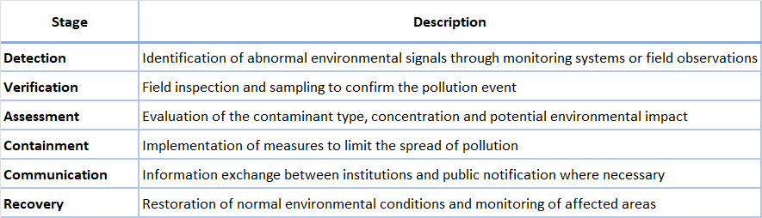
Finally, emergency response planning must be integrated with the long-term monitoring and environmental management framework of the basin. Data collected through the monitoring network will provide essential information for evaluating the causes of contamination events and improving future response strategies. Over time, this adaptive approach will contribute to strengthening the resilience of the Cem/Cijevna basin and ensuring the protection of its valuable water resources.

11.9 Stepwise and risk-based remediation planning.
Remediation planning in environmentally sensitive catchments requires a structured and adaptive approach that prioritizes environmental protection while remaining technically and economically feasible. In the Albanian section of the Cem/Cijevna basin, remediation planning must consider the specific hydrogeological characteristics of the area, including the presence of highly permeable karst formations, strong hydraulic connections between groundwater and surface water, and the dependence of local communities on natural springs for drinking water supply.
The Albanian part of the basin includes several small mountain settlements such as Selcë, Vukël, Lepusha, Tamara, Grabom and Hoti, which are characterized by dispersed habitation, traditional livestock farming and growing tourism activity, particularly in the village of Tamara. Wastewater infrastructure in the area is very limited, and most settlements rely on primitive septic pits or direct discharge of greywater into the surrounding environment. These conditions create potential diffuse pollution pressures that may affect both the Cem River and the associated karst aquifer.
Given these conditions, remediation planning must follow a stepwise and risk-based approach, where interventions are prioritized according to the level of environmental risk and the vulnerability of water resources. This approach allows decision-makers to focus first on the most critical issues while progressively improving environmental conditions in the basin.
The first step in risk-based remediation planning involves the identification and characterization of contamination sources within the Albanian part of the basin. Potential sources include untreated domestic wastewater, livestock waste from small animal farms, tourism-related wastewater discharges, and local agricultural activities. Because contamination in this region is predominantly diffuse rather than industrial, remediation measures must focus primarily on improving environmental management practices rather than large-scale engineering interventions.
Once potential contamination sources have been identified, the next stage involves the evaluation of environmental risks to key receptors. In the Cem/Cijevna basin, the most sensitive receptors include karst springs used for drinking water supply, the river ecosystem, and downstream transboundary water resources. Particular attention must be given to areas where surface water and groundwater interact strongly, as contaminants introduced at the surface may rapidly infiltrate through karst fractures and reach groundwater flow systems.
Following risk evaluation, remediation planning proceeds with the prioritization of intervention measures. Priority actions should focus on preventing the entry of contaminants into the hydrological system. This includes improving wastewater management in villages, promoting environmentally responsible tourism practices in Tamara, and implementing measures to reduce the direct discharge of polluted water into the river.
The implementation of remediation measures should follow a gradual and adaptive process. Because many of the environmental pressures in the basin are related to rural infrastructure limitations, remediation strategies must be compatible with the socio-economic conditions of the region. Incremental improvements in wastewater management, combined with public awareness initiatives and improved environmental monitoring, can significantly reduce contamination risks over time.
The monitoring network proposed for the Cem/Cijevna basin will play a central role in the stepwise remediation process. Monitoring data will provide the scientific basis for identifying pollution trends, evaluating the effectiveness of implemented measures, and adjusting remediation strategies when necessary. Continuous hydrological monitoring combined with periodic water quality sampling will allow authorities to track environmental changes and detect potential contamination events.

Table 11.10 Stepwise remediation framework for the Albanian section of the Cemi/Cijevna basin
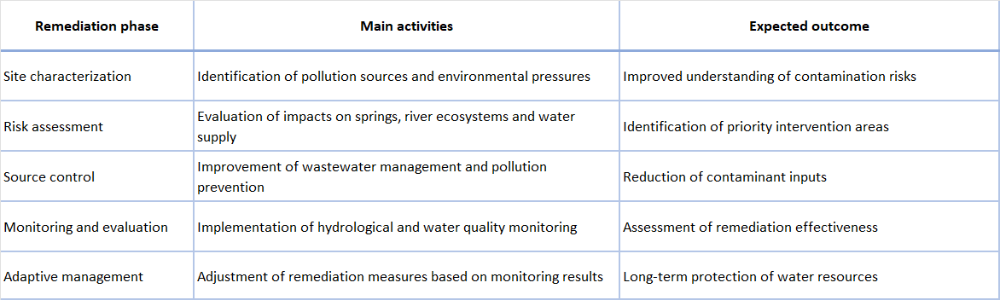
A key advantage of the stepwise approach is that it allows remediation measures to be implemented progressively, without requiring large-scale infrastructure investments at the initial stages. Instead, efforts can focus first on the most critical pollution sources and gradually expand to broader environmental management initiatives.
In the Albanian section of the Cem/Cijevna basin, this approach is particularly appropriate due to the rural character of the region and the limited availability of wastewater treatment infrastructure. By prioritizing pollution prevention, improving environmental practices and strengthening monitoring capacity, it is possible to significantly reduce environmental risks while maintaining the ecological integrity of the river system.
Ultimately, the goal of stepwise and risk-based remediation planning is not only to address existing environmental pressures but also to establish a framework for sustainable water resource management in the basin. Through coordinated monitoring, risk assessment and targeted interventions, the Albanian section of the Cem/Cijevna basin can maintain high water quality standards while supporting the socio-economic development of local communities and protecting downstream transboundary water resources.

11.10 Pilot testing and phased implementation.
The implementation of remediation and monitoring measures in the Cemi/Cijevna basin requires a gradual and adaptive approach. Given the hydrogeological complexity of the karst system, the limited availability of baseline monitoring data, and the predominantly diffuse nature of pollution sources, it is essential to first test monitoring and management measures at a pilot scale before expanding them across the entire basin.
Pilot testing represents a critical intermediate step between conceptual planning and full-scale implementation. It allows the validation of monitoring methodologies, the evaluation of environmental conditions under real field conditions, and the identification of potential technical or operational challenges. In the Cemi/Cijevna basin, pilot implementation will focus on the installation and operation of the proposed monitoring network, combined with initial environmental management measures targeting the most sensitive locations.
The pilot phase will be conducted in the Albanian part of the basin, primarily focusing on the two key monitoring locations: Tamara and Grabom border crossing. These locations have been selected because they represent hydrologically and environmentally strategic points within the river system. Tamara represents the upper segment of the Albanian river section and the main settlement area influenced by tourism activity, while Grabom represents the downstream control point before the river crosses into Montenegro.
Pilot implementation will initially focus on the installation of basic monitoring infrastructure and the collection of baseline hydrological and water quality data. This includes the installation of telemetric sensors for water level monitoring in the Cem River, the establishment of a groundwater monitoring well in the Grabom area, and the installation of a pluviometric station dedicated to isotopic monitoring of precipitation. These instruments will allow continuous monitoring of key hydrological parameters while supporting periodic sampling for laboratory analysis.
The pilot phase will also allow the testing of the proposed sampling strategy for physico-chemical and biological monitoring. Water quality sampling will be conducted in the same locations or in close proximity to the telemetric monitoring stations, ensuring that hydrological and environmental data can be integrated effectively. Particular attention will be given to seasonal variations in water quality, especially during the summer period when tourism activity in Tamara increases significantly and potential wastewater discharges into the river may occur.
The monitoring data collected during the pilot phase will serve several important functions. First, it will provide a baseline dataset describing the natural hydrological and hydrochemical conditions of the basin. Second, it will allow the identification of spatial and temporal trends in water quality that may indicate pollution pressures. Third, it will support the calibration of hydrological and hydrogeological models that may be developed in the future to improve the understanding of water circulation processes in the karst system.
A phased implementation strategy is particularly appropriate for the Cem/Cijevna basin because it allows gradual expansion of the monitoring network and environmental management measures as additional information becomes available. The first phase focuses on establishing the monitoring infrastructure and collecting baseline data. The second phase focuses on improving environmental management practices in settlements and tourism facilities, particularly with regard to wastewater management. The final phase involves the long-term operation of the monitoring network and the continuous evaluation of environmental conditions in the basin.

Table 11.11 Phased implementation framework for the Cemi/Cijevna basin
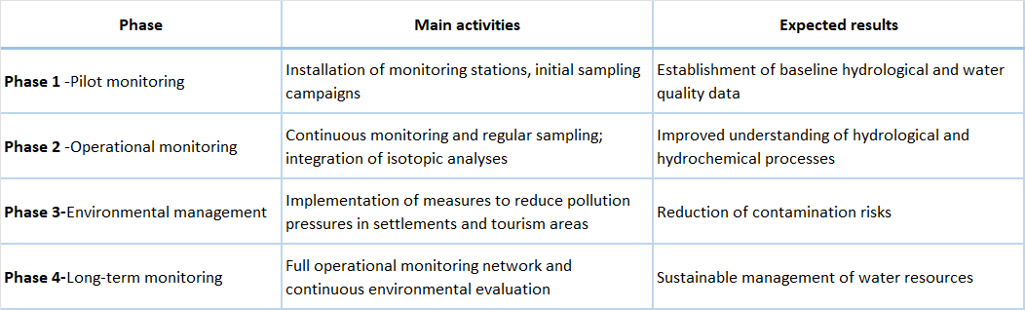
The phased implementation strategy also allows the progressive refinement of monitoring methodologies. During the pilot phase, data collection procedures, sampling frequencies and analytical methods can be evaluated and adjusted if necessary. This iterative process ensures that the monitoring system becomes increasingly reliable and efficient over time.
An important aspect of pilot testing is the evaluation of seasonal hydrological dynamics in the basin. The Cemi/Cijevna River exhibits strong seasonal variability, influenced by precipitation, snowmelt and climatic conditions in the mountainous catchment. Pilot monitoring will allow the identification of peak flow events, low-flow conditions and potential changes in water quality associated with hydrological variability.

Table 11.12 Key parameters monitored during pilot implementation
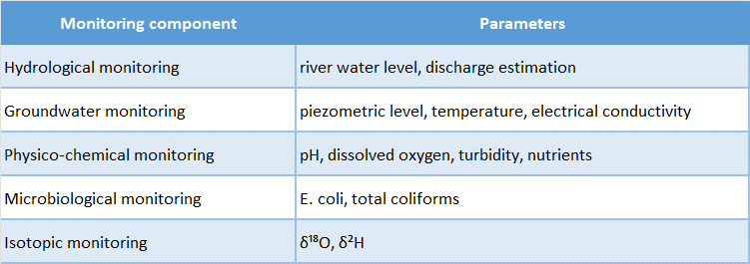
In addition to the monitoring parameters listed above, field observations and periodic ecological assessments may provide valuable information on the environmental status of the river ecosystem. Such assessments can help identify potential impacts of tourism, wastewater discharge or other anthropogenic activities in the basin.
Although the pilot implementation phase focuses primarily on monitoring and environmental assessment, it also creates the foundation for future remediation actions if necessary. The availability of reliable environmental data will allow authorities to identify priority areas where intervention measures may be required, such as improving wastewater management in tourism facilities or strengthening environmental protection measures for drinking water sources.
Ultimately, the success of the phased implementation strategy depends on the effective collaboration between local authorities, national environmental institutions and cross-border partners. The Cem/Cijevna basin represents a shared water resource system, and its sustainable management requires coordinated monitoring efforts and information exchange between Albania and Montenegro.
By combining pilot testing with a phased implementation strategy, the proposed monitoring program provides a practical and scientifically robust pathway for improving the understanding and management of water resources in the Albanian section of the Cemi/Cijevna basin.

11.11 Effectiveness monitoring of remediation.
Monitoring the effectiveness of remediation and pollution prevention measures represents an essential component of environmental management in the Cemi/Cijevna basin. In hydrogeologically sensitive environments such as karst aquifers, remediation actions must be accompanied by systematic monitoring in order to verify whether implemented measures are achieving their intended objectives.
Effectiveness monitoring focuses on evaluating improvements in surface water quality, groundwater protection and ecological conditions following the implementation of environmental management and remediation measures. Particular attention is given to pressures originating from rural settlements, tourism activities in the village of Tamara, livestock farming, and wastewater discharge practices.
The monitoring of remediation effectiveness will rely on the monitoring network proposed for the Albanian section of the basin, which includes monitoring points at Tamara and the Grabom border area, as well as groundwater observations through the proposed monitoring well near Grabom. These monitoring locations provide representative information on hydrological and environmental conditions within the Albanian part of the river catchment.
Effectiveness monitoring aims to determine whether implemented measures contribute to:
  - the reduction of pollutant inputs to the Cem River,
  - the protection of karst groundwater used as drinking water sources,
  - the improvement of ecological conditions in the river system.
An important first step in this process is the establishment of baseline environmental conditions. During the initial phase of monitoring, hydrological data, physico-chemical parameters and microbiological indicators will be collected in order to define the natural variability of water quality within the basin. These baseline data will serve as a reference for evaluating future environmental changes.
Once remediation or pollution reduction measures are introduced, monitoring results will be compared with baseline conditions in order to assess whether improvements in water quality and ecosystem health are occurring. Because hydrological conditions in mountain catchments may vary significantly between seasons, the evaluation of remediation effectiveness must consider natural variability related to precipitation, snowmelt and seasonal river discharge.
Table 11.13 Key indicators used for effectiveness monitoring in the basin
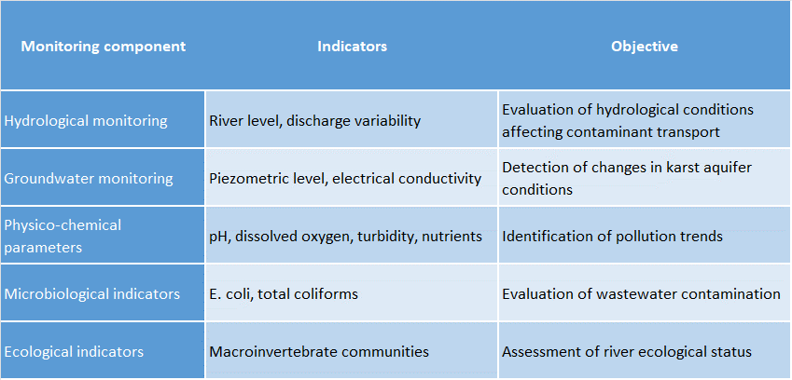
Monitoring results will be analysed through temporal and spatial comparisons between different monitoring locations in the basin. For example, comparisons between upstream conditions near Tamara and downstream conditions near Grabom may help identify the influence of local pollution sources and evaluate whether environmental management measures are reducing contaminant loads along the river.
In addition to laboratory measurements, field observations and environmental inspections will also contribute to the evaluation process. Observations of wastewater discharges, tourism infrastructure, livestock activities near the river and land-use changes provide valuable contextual information that helps interpret monitoring data.
Mapping of monitoring results will also play an important role in evaluating remediation effectiveness. Spatial representation of water quality indicators will allow environmental managers to identify areas where pollution pressures are decreasing and areas where additional intervention may be required.

Table 11.14 Evaluation framework for remediation effectiveness
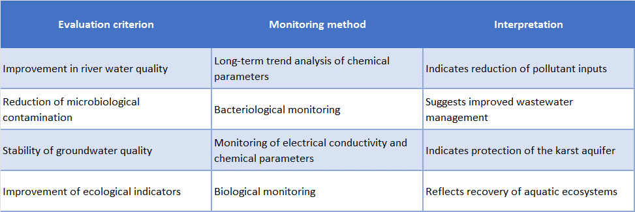
Because environmental conditions and human pressures in the basin may change over time, effectiveness monitoring must be integrated into an adaptive management framework. Monitoring results will allow authorities to adjust environmental management strategies, modify remediation actions where necessary, and improve the long-term protection of water resources.
In the Albanian section of the Cemi/Cijevna basin, the continuous evaluation of remediation effectiveness will contribute to the protection of drinking water sources, the preservation of river ecosystems and the sustainable management of this sensitive mountain catchment.

11.12 Adaptive management and optimization strategies.
Adaptive management represents a key principle in the environmental management of complex hydrogeological systems, particularly in karst environments where groundwater flow paths, recharge dynamics and contaminant transport processes may vary significantly over time. In the Cemi/Cijevna basin, adaptive management provides a flexible framework that allows monitoring results, environmental observations and operational experience to continuously inform and improve remediation and environmental protection strategies.
The hydrogeological setting of the basin, characterized by fractured carbonate rocks and highly permeable karst formations, creates conditions in which environmental processes may respond rapidly to climatic variability and human pressures. Seasonal changes in precipitation, snowmelt and river discharge can influence groundwater recharge, contaminant transport and water quality conditions. At the same time, human activities such as tourism, livestock farming and wastewater discharge from rural settlements may introduce localized environmental pressures. Under such conditions, fixed management strategies may not always remain effective over long periods of time. Adaptive management therefore allows environmental measures to evolve in response to new data and changing conditions.
In the Cem/Cijevna basin, adaptive management is closely linked to the implementation of the proposed monitoring network. Continuous hydrological monitoring, combined with periodic physico-chemical, microbiological and ecological sampling, will generate valuable datasets describing the environmental behaviour of the river and the associated karst aquifer. These data provide the scientific basis for evaluating the effectiveness of implemented remediation and pollution prevention measures.
Adaptive management involves a cyclical process that includes monitoring, evaluation, decision-making and adjustment of management measures. Initially, monitoring activities provide information on hydrological conditions and water quality trends within the basin. These data are then evaluated in order to identify potential environmental changes, emerging pollution risks or unexpected responses of the hydrogeological system. Based on this evaluation, environmental management strategies may be adjusted in order to improve their effectiveness.
In practical terms, adaptive management in the Albanian section of the basin may involve adjustments to monitoring frequency, the addition of new monitoring parameters, or the modification of pollution prevention measures in areas where environmental pressures are identified. For example, if monitoring results indicate increased microbiological contamination downstream of populated areas such as Tamara, additional investigations may be conducted to identify potential wastewater discharge points and to introduce targeted mitigation measures.
Another important component of adaptive management is the optimization of monitoring and remediation strategies. As new information becomes available, monitoring locations, sampling frequencies and analytical parameters may be refined in order to focus resources on the most relevant environmental indicators. Optimization allows monitoring programs to become more efficient while maintaining the ability to detect environmental changes and contamination risks.
Optimization strategies may also include the gradual expansion of the monitoring network. During the initial phases of monitoring implementation, only a limited number of monitoring stations may be operational. As experience is gained and environmental data accumulate, additional monitoring points may be introduced in locations where hydrological interactions or potential contamination pathways require further investigation.
In the context of the Cemi/Cijevna basin, adaptive management also supports the long-term protection of drinking water resources. Because many rural communities rely directly on karst springs for drinking water supply, maintaining high water quality standards is essential for both environmental protection and public health. Continuous monitoring of water quality parameters will allow early identification of potential contamination risks, enabling authorities to respond before significant impacts occur.
Adaptive management also facilitates coordination between environmental protection measures and local socio-economic activities. Tourism development in the village of Tamara represents an important economic opportunity for the region, but it may also increase pressure on water resources through wastewater generation and seasonal population fluctuations. Monitoring data can therefore help guide local planning decisions, ensuring that tourism development remains compatible with environmental protection objectives.
The success of adaptive management depends on effective institutional coordination and the availability of reliable environmental data. Environmental authorities responsible for water management in the basin should regularly review monitoring results, assess environmental trends and update management strategies where necessary. Periodic technical evaluations and environmental reporting can support this process and ensure that management decisions remain informed by scientific evidence.
Ultimately, adaptive management and optimization strategies contribute to the long-term sustainability of water resource management in the Cemi/Cijevna basin. By combining continuous monitoring with flexible management approaches, environmental authorities can respond effectively to changing conditions, improve remediation strategies and ensure the protection of both groundwater and surface water resources in this sensitive karst environment.

11.13 Transboundary and interagency coordination.
Effective management of water resources in the Cem/Cijevna basin requires strong coordination mechanisms both between institutions within Albania and Montenegro, and between the competent authorities of Albania and Montenegro. The river system represents a shared transboundary resource, and environmental pressures or pollution events occurring in the upstream sections of the basin may directly influence downstream ecosystems and water users across the national border. For this reason, environmental monitoring, risk management and remediation planning must be supported by structured institutional cooperation.
Within the Albanian section of the basin, several institutions play a role in water resource management, environmental monitoring and pollution control. These include national environmental authorities responsible for water management policies, regional environmental agencies responsible for environmental inspections and monitoring activities, and local municipalities responsible for land use planning and local infrastructure management. The situation is similar in Montenegro. Effective coordination among these institutions is essential for ensuring that monitoring data are shared, environmental risks are identified in a timely manner, and appropriate management measures are implemented when needed.
Interagency coordination within Albania is particularly important in rural mountainous areas such as the Cem basin, where environmental pressures are mainly related to diffuse sources including settlements, tourism facilities, livestock farming and local agricultural activities. Because wastewater management infrastructure is limited in many villages, environmental protection measures often depend on coordinated actions between local authorities, environmental inspectors and water management agencies. Regular communication between these institutions allows the identification of potential pollution sources and supports the implementation of preventive measures aimed at protecting both groundwater and surface water resources.
At the transboundary level, cooperation between Albania and Montenegro is essential due to the hydrological continuity of the Cem/Cijevna River. The river originates in Albania and flows downstream into Montenegro, meaning that environmental conditions in the Albanian section of the basin directly influence downstream water quality and ecological status. Consequently, the exchange of hydrological and water quality information between the two countries represents a key element of transboundary water management.
The monitoring network proposed within the project framework provides an important basis for strengthening this cooperation. Monitoring data collected at the downstream station near Grabom will provide valuable information on the environmental status of the Albanian section of the basin before the river crosses the border. These data can be shared with Montenegrin authorities in order to support joint evaluation of hydrological conditions and environmental trends in the basin.
Information exchange mechanisms may include periodic technical meetings between experts, shared access to monitoring data, and coordinated environmental reporting. Such cooperation allows both countries to better understand hydrological processes in the basin and to respond more effectively to potential environmental risks.
Transboundary coordination is also particularly important in the context of emergency situations. Accidental pollution events occurring in upstream areas may rapidly propagate downstream due to the hydrological dynamics of the river system and the rapid transport processes typical of karst environments. In such cases, rapid communication between national authorities is necessary in order to implement timely mitigation measures and to protect downstream water resources.
In addition to bilateral cooperation, transboundary coordination in the Cem/Cijevna basin is consistent with broader European principles of integrated water resources management. Collaborative monitoring, information exchange and joint environmental assessments contribute to improving the long-term protection of water resources in the basin while supporting sustainable development in both countries.
Overall, effective interagency and transboundary coordination will play a crucial role in ensuring that monitoring, remediation and environmental management strategies implemented in the Albanian section of the Cem/Cijevna basin contribute to the sustainable protection of this shared water resource system.

11.14 Funding and liability considerations.
In the context of the Cemi/Cijevna Transboundary Aquifer (TBA), the financial and institutional aspects of remediation of contaminated aquifer zones represent an important element of long-term groundwater management. In karst hydrogeological systems, where groundwater flow is often rapid and difficult to predict, the identification of pollution sources, the implementation of remediation measures, and long-term monitoring may require significant financial and technical resources. For this reason, remediation planning should also include appropriate financial mechanisms that enable the sustainable implementation of groundwater protection measures.
In Albania and Montenegro, the legal framework for water and environmental protection establishes the basic principles of liability for pollution and the obligation to undertake measures to prevent or limit negative impacts on water resources. Of particular importance is the “polluter pays” principle, according to which the costs of environmental remediation and protection should be borne by the entity responsible for causing pollution, when such an entity can be identified. However, in karst aquifer systems the identification of pollution sources can often be complex due to large recharge areas and the rapid transport of pollutants through karst fractures, conduits, and channels.
For this reason, remediation in such systems often requires a combination of different financing sources, including national water management funds, budgets of local authorities, as well as support from international programmes and projects related to water resource protection and institutional capacity building. In the context of the Cemi/Cijevna TBA, coordination between institutions of Albania and Montenegro, as well as data exchange and joint monitoring, can contribute to more effective planning and implementation of remediation measures, particularly in cases where contamination may have transboundary impacts (Table X).
Table 11.15. Potential funding sources and responsible institutions for Relevance for groundwater protection and corrective actions in the Cemi/Cijevna TBA
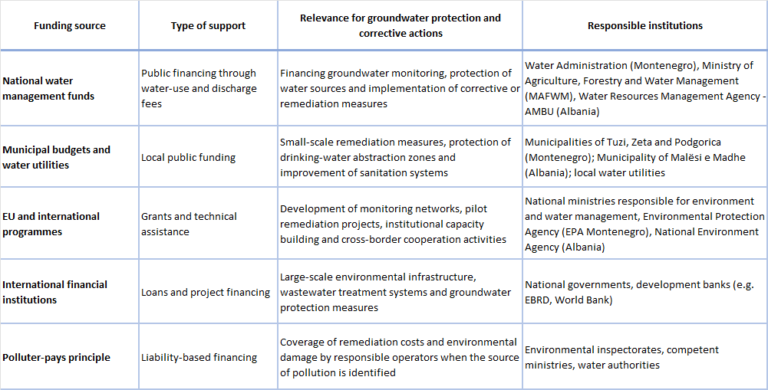

12. Monitoring and evaluation of progress of the JAP Cemi/Cjevna.

12.1 Performance Indicators.
A recommended framework is provided for monitoring the implementation of the Joint Action Program (JAP) for the Cemi/Cjevna TBA, offering a coherent structure for evaluating progress, supporting adaptive decision‑making, and reinforcing long‑term cooperation between Albania and Montenegro in managing this shared karst system. The performance indicators within the framework are organized into four domains: institutional, legal and fiscal, technical, and policy planning, each representing a distinct yet interconnected dimension of effective transboundary groundwater governance.
This framework explicitly follows the approach set out in the “Global Framework for Action on Groundwater Governance”, the final output of the FAO/UNESCO/IAH/World Bank/GEF “Groundwater Governance Project”, which emphasizes that sound governance requires: i) strong institutions, ii) clear legal and financial instruments, iii) technically robust measures, and iv) planning grounded in reliable evidence. By reflecting these principles, the JAP adopts a structure that supports practical implementation while remaining consistent with internationally recognized groundwater‑governance standards.
The indicators are designed to be practical, measurable, and compatible with the administrative capacities of both countries. They emphasize cooperation, transparency, compliance, and the systematic application of technically sound measures, all of which contribute to the long‑term protection of groundwater resources and groundwater‑dependent ecosystems. The recommended structure is also intended to align with national monitoring practices, environmental planning processes, and existing international cooperation arrangements, allowing results generated under the JAP to be efficiently incorporated into broader reporting requirements.
Together, these indicators form an integral part of the overall monitoring architecture for the JAP for the Cemi/Cjevna TBA. While this subsection explains their purpose, characteristics, and the rationale for organizing them into coherent domains, the full set of indicators, presented in structured tables, is provided in Annex 13.5. The annex consolidates all indicators relevant for the JAP and groups them according to principal activity clusters, including institutional and transboundary cooperation measures, measures for sustainable groundwater management, preventive protection measures, approaches to establishing multi‑purpose monitoring networks, and guidelines for developing remediation measures for contaminated aquifer zones.
Institutional Indicators
Institutional indicators are intended to measure how effectively the organizational arrangements for cooperation, coordination, and participation function in practice. Given the highly interconnected nature of the Cemi/Cjevna TBA, it is recommended that special attention be devoted to indicators that reflect cross‑border collaboration and mutual trust.
A core component of institutional performance is regular bilateral data sharing. It is therefore advisable to monitor the proportion of groundwater and groundwater‑dependent ecosystem monitoring sites for which data are exchanged according to jointly agreed formats and schedules. Complementarily, the preparation of joint status reports on groundwater conditions offers a clear indicator of the countries’ ability to interpret data collaboratively and produce harmonized assessments.
Another recommended set of institutional indicators relates to stakeholder participation. These include the frequency of multi‑stakeholder meetings, the diversity of representation, and the extent to which stakeholder perspectives influence JAP‑related decisions. Such indicators serve as proxies for the inclusiveness and transparency of governance processes, which are especially important in areas where groundwater use intersects with tourism, agriculture, and public water supply.
Performance of the joint water‑management bodies can also be tracked by monitoring the number of groundwater‑related agenda items discussed annually, the number of jointly adopted resolutions, and the implementation of joint field activities. These indicators provide concrete evidence of how well the bilateral governance architecture is functioning and whether it is evolving toward more practical and solution‑oriented cooperation.
Institutional capacity development may be evaluated by tracking the number of trained staff in hydrogeology, monitoring, data quality assurance, law, and enforcement, as well as the gradual establishment and strengthening of dedicated groundwater units or teams in relevant institutions. Such indicators help ensure that the JAP is supported by adequate human resources over time.
Legal and Fiscal Indicators
Legal and fiscal indicators are recommended to assess the degree to which regulatory frameworks and financial mechanisms are operationalized to support groundwater protection and sustainable use. They provide important information about the level of compliance with established rules and the effectiveness of enforcement.
Among the key legal indicators are the percentage of licensed groundwater abstractions, the comprehensiveness of the registry of wells and springs, and the frequency and outcomes of inspections, including compliance rates and the number of violations corrected. It is also advisable to track the number of illegal abstractions closed or regularized and the extent to which discharge permitting procedures are consistently applied. These indicators offer insight into whether groundwater resources are effectively safeguarded under the existing legal framework.
In addition to monitoring legal instruments, it is recommended to track fiscal mechanisms that underpin sustainable resource management. These include the scope and uptake of financial incentives for water‑efficient technologies, the degree to which such incentives lead to measurable reductions in groundwater abstraction or pollution pressure, and the annual volume of water saved per unit of incentive granted. Furthermore, tracking the implementation of cost‑recovery measures, especially for large commercial groundwater users, helps assess whether financial contributions appropriately support the costs associated with monitoring, data management, and enforcement under the JAP.
Collectively, these legal and fiscal indicators contribute to understanding whether the enabling environment is sufficiently robust to ensure compliance, promote responsible use, and provide sustainable funding for the long‑term management of the aquifer.
Technical Indicators
Technical indicators measure the direct effects of management measures implemented under the JAP. They are focused on quantifying improvements in groundwater status, reductions in pressures, and the performance of interventions aimed at strengthening aquifer resilience.
One recommended group of technical indicators relates to the adoption of water‑saving technologies in both agriculture and domestic use. Suggested measures include the adoption rate among target user groups, the annual volume of groundwater saved, and trends in nitrates or other key quality parameters at priority abstraction points. Such indicators provide evidence of reduced stress on groundwater bodies and improved water‑quality outcomes in vulnerable areas. Where pilot activities such as managed aquifer recharge (MAR) are implemented, additional indicators may include the annual infiltration volume achieved, corresponding changes in groundwater levels at observation wells, and observable changes in water quality, such as turbidity or bacteriological content.
Technical indicators also serve an important role in validating the effectiveness of monitoring systems. The reliability of monitoring networks can be assessed through metrics such as the number of operational monitoring stations, continuity of time‑series measurements, and the share of stations meeting agreed quality‑control standards.
Policy Planning Indicators
Policy planning indicators assess how effectively the JAP’s strategic intentions are translated into operational practice and whether implementation remains aligned with agreed policy directions. These indicators help determine if planned activities are carried out as scheduled, if institutional responsibilities are met, and if the program is progressing toward its long‑term objectives.
A central element in this group is the adoption and financing of operational plans that convert JAP measures into concrete, time‑bound actions. Clearly defined quantitative and qualitative targets, such as groundwater‑level objectives, quality thresholds, or specific risk‑mitigation outcomes, enhance the precision and transparency of expected results.
Progress under the JAP can also be assessed through the preparation of regular implementation reports. These reports document achievements, highlight constraints, and propose adjustments needed for the next planning cycle. Indicators may additionally track the effectiveness of communication and awareness‑raising activities, including the reach of public‑information efforts, results of stakeholder‑awareness surveys, and the availability of targeted informational materials.
Where competing interests or user demands arise, policy planning indicators can also be used to monitor the functioning of conflict‑resolution procedures. Relevant measures include the number of disputes addressed, the average time required to reach a resolution, and the level of satisfaction expressed by the parties involved. Taken together, these indicators show whether planning processes and policy instruments are successfully guiding coordinated and cooperative management under the JAP.
Recommended Approach to Monitoring and Reporting
For each indicator, it is recommended to establish a clear baseline, define realistic targets, and specify an appropriate monitoring frequency. Institutional, legal, and fiscal indicators can generally be evaluated annually, while many technical indicators should follow the measurement intervals defined by the monitoring network. Planning‑related indicators should be reviewed annually, with more extensive evaluations aligned with longer water‑management planning cycles.
Both countries are encouraged to prepare joint annual progress summaries, consolidating indicator results and highlighting priority measures for the subsequent cycle. A more comprehensive review of indicators and measures is recommended every six years, ensuring alignment with broader water‑management planning processes (RBMPs) and allowing for the structured refinement of JAP measures.

12.2 Periodic reporting.
Periodic reporting is an essential component of the performance‑indicator monitoring established for the Joint Action Program (JAP) for the Cemi/Cjevna TBA. It ensures that the indicators described in the preceding section are translated into actionable information and that implementation progress can be measured in a transparent and comparable manner by both countries. Reporting serves several functions simultaneously: it documents the extent to which planned measures are carried out, evaluates whether governance arrangements are functioning as intended, identifies challenges that may require corrective action, and provides a basis for updating and refining the JAP over time. The overall purpose of this reporting system is therefore not only to measure performance, but also to reinforce cooperation, strengthen accountability, and support adaptive management.
To fulfil these functions, periodic reporting should follow a structured approach that links performance indicators, institutional responsibilities, and harmonized reporting tools. This approach is built on a set of methodological elements designed to support consistent and comparable reporting, with detailed descriptions provided in subchapter 13.6 “Methodological tools and templates for indicator tracking” within the Annexes. These elements are organized into four mutually supportive categories: methodological guidance, standardized reporting templates, monitoring protocols, and capacity‑building components. Each category has a specific role, and together they contribute to a coherent reporting cycle that aligns institutional obligations, technical procedures, and data requirements across the Albanian and Montenegro parts of the TBA.
The reporting process should begin with methodological guidance that defines how performance indicators are to be measured, validated, and interpreted. In the context of the JAP, this methodological foundation is operationalized through Template 1 (Annual Indicator Reporting Table) and Template 2 (Dashboard for Governance Indicator Tracking), which translate the guidance into practical reporting formats. Template 1 establishes common definitions for baseline values, target values, trends, and review frequency, while Template 2 supports clear interpretation by summarizing indicator status and trends in a structured visual overview. Together, these tools help ensure that indicator values carry a consistent meaning on both sides of the border and that definitions and methods remain harmonized throughout the reporting cycle.
The second element consists of standardized templates that maintain uniformity in reporting indicator status and ensure that information submitted by both countries is directly comparable. This function is served by Template 3 (Data Quality Assurance & Harmonization Checklist), which provides a step‑by‑step process for validating the consistency, accuracy, and cross‑border comparability of indicator data, and by Template 4 (Indicator Selection & Prioritization Flowchart), which defines a transparent and harmonized approach for selecting and prioritizing indicators before they are included in reporting. These templates support periodic updates, enable indicator values to be aggregated into joint summaries, and facilitate structured interpretation across the institutional, legal and fiscal, technical, and policy‑planning domains.
Monitoring protocols constitute the third component of the framework and establish the procedures by which data are collected, validated, and documented in practice. The JAP adopts Template 5 (Monitoring Protocol Table), which specifies agreed monitoring procedures, responsible institutions in each country, measurement frequency, and required tools; and Template 6 (Stakeholder Involvement Log), which documents participation and engagement activities relevant for certain governance‑related indicators. These templates ensure that monitoring steps are implemented consistently for groundwater‑level measurements, water‑quality sampling, sanitation inspections, tourism‑pressure observations, stakeholder attendance records, and documentation of cross‑border cooperation activities.
The fourth element comprises the capacity‑building components that accompany and reinforce the reporting cycle. Template 7 (Qualitative Capacity‑Building Assessment Form) provides a structured way to assess cooperation, transparency, responsiveness, and engagement quality across the institutions involved in indicator tracking. The template enables both countries to identify capacity needs, evaluate institutional strengths and weaknesses, and define steps for improving coordination and performance in future reporting cycles. Over time, systematic use of this assessment contributes to more accurate reporting and supports more robust and informed decision‑making at the transboundary level.
Together, these four elements form a coherent system for structuring periodic reporting. Each reporting cycle involves data collection by responsible institutions, national‑level validation, cross‑border harmonization, preparation of indicator summaries using standardized templates, and joint interpretation of results during bilateral coordination meetings. This process produces annual progress summaries that consolidate indicator values, assess the realism of targets, and identify priority actions for the following year. More comprehensive evaluations should be prepared every six years, aligned with national water‑management planning cycles (RBMPs).

12.3 Plan review (every six years).
National water strategies and River Basin Management Plans (RBMPs) in both Albania and Montenegro establish the primary policy foundation for groundwater governance, addressing water abstraction, pollution control, protection of vulnerable aquifers, and integration of groundwater into broader resource management frameworks. As for WFD this plans should be revised each six year.
In Montenegro, The River Basin Management Plans adopted in 2021 define groundwater bodies, establish environmental objectives, and introduce protective measures consistent with the Water Framework Directive (WFD). However, although legal alignment is strong, detailed hydrogeological characterization of karst systems and operationalization of measures remain limited. Direct discharges into groundwater are prohibited, yet enforcement capacity and monitoring coverage require further strengthening.
In Albania, Integrated Water Resources Management (IWRM) principles and river basin planning frameworks provide an increasingly structured approach to groundwater protection. Existing Drin-Buna RBMP expired year 2026.
The policy framework formally recognizes groundwater vulnerability, particularly in karst environments, and emphasizes sustainable abstraction, pollution control, institutional strengthening, and gradual expansion of monitoring systems. Nevertheless, implementation capacity remains uneven across regions, while monitoring coverage and enforcement capacities require continued enhancement.
Although both countries Albania and Montenegro should revise the Cejvni/Cemi JAP, as part of Drini RB follow the same review of the RBMP itself, which means the review of this should be done every six years.

12.4 Stakeholders role in monitoring and evaluation.
Monitoring and evaluation of the Joint Action Program between Albania and Montenegro require coordinated involvement of stakeholders whose mandates, activities and practices influence groundwater governance outcomes. Stakeholder participation in monitoring and evaluation ensures transparency, data reliability, accountability and adaptive management.
National water authorities in Albania and Montenegro coordinate groundwater quantity and quality monitoring, validate and consolidate data, ensure methodological consistency and support cross border exchange of information. They lead the assessment of progress against agreed indicators and provide the technical basis for evaluation of governance and management measures.
Environmental authorities and inspectorates contribute through compliance monitoring and enforcement activities related to groundwater protection zones, pollution sources, sanitation systems and environmentally sensitive activities. Their findings support evaluation of the effectiveness of regulatory and preventive measures.
Municipal authorities in both countries support monitoring and evaluation at local level. They report on implementation of sanitation, land use and tourism related measures, identify local pressures and provide feedback on feasibility and effectiveness of actions. Municipalities also facilitate stakeholder participation in review meetings and consultations.
Water utilities in Montenegro provide abstraction, discharge and water quality data and support incident reporting. Given their direct dependency on groundwater, they contribute to early warning and evaluation of risk management measures and participate in joint interpretation of monitoring results.
Tourism and recreation authorities contribute by tracking visitor numbers, seasonal dynamics and compliance with environmental guidance in sensitive areas. Their inputs support evaluation of measures addressing tourism related pressures.
Civil society organisations and community groups support participatory monitoring and qualitative evaluation of governance effectiveness. Their role includes reporting local issues, providing feedback on stakeholder engagement and contributing to assessments of transparency, trust and inclusiveness.
Monitoring and evaluation results will be reviewed periodically through joint technical and stakeholder review processes involving Albanian and Montenegrin institutions. These reviews will assess progress, identify gaps and agree on corrective actions. Stakeholder feedback will inform adjustments to implementation approaches over time.

13. Annexes.

13.1 Hydrogeological Map
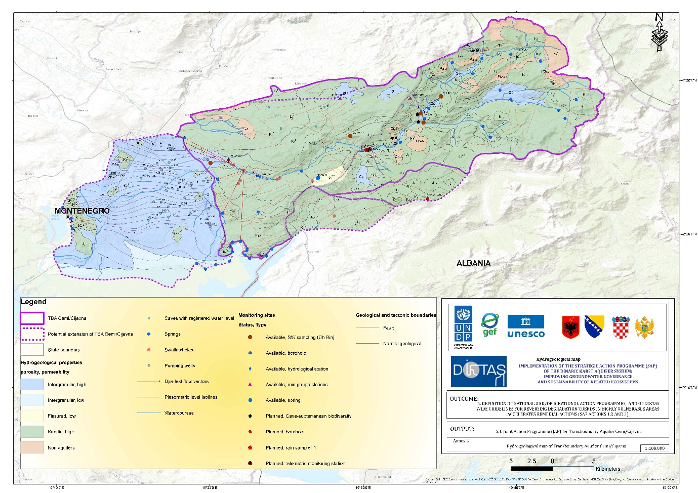
Figure 13.1 Hydrogeological map of Cemi/Cijevna TBA

13.2 Monitoring Station
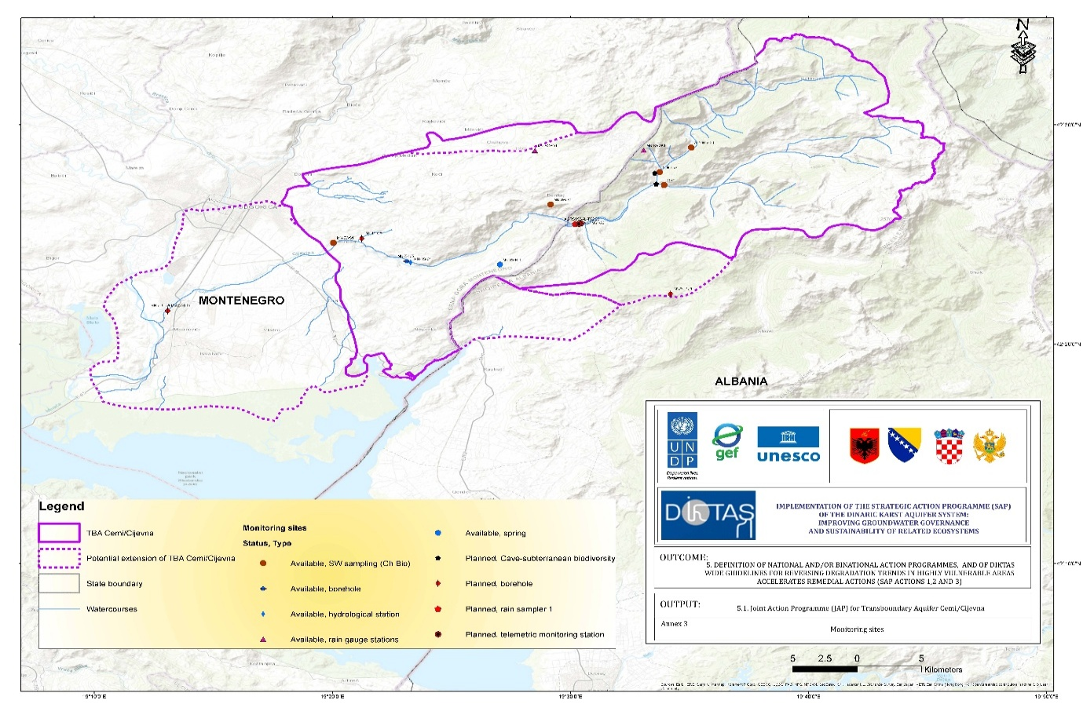Figure 13.2 Map of surface, grounwater and hydrometeorology monitoring in Cemi/Cijevna TBA.

13.3 Stakeholder list
Table 13.1 Stockholders list
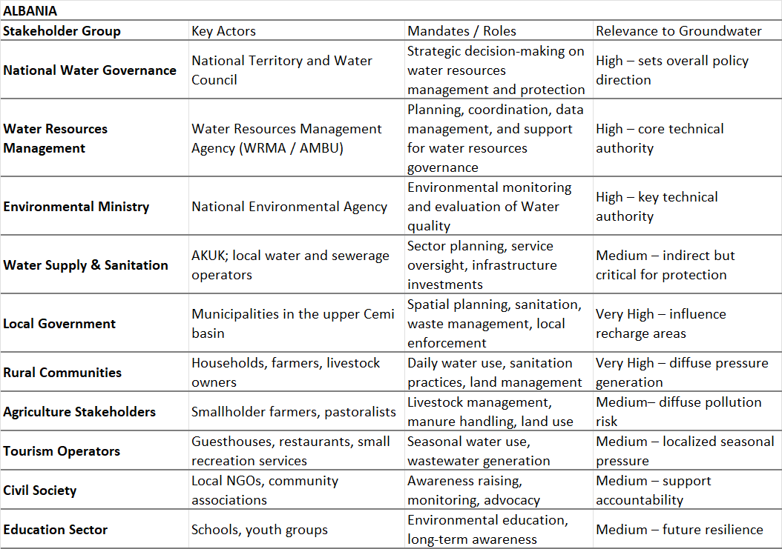
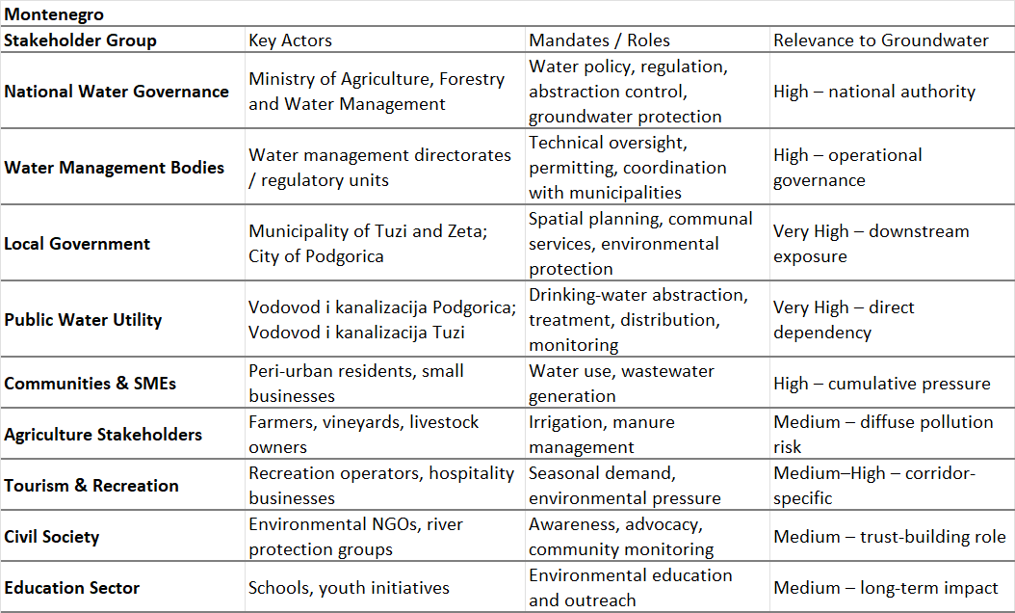

Table 13.2 Cros border Institucional coordination
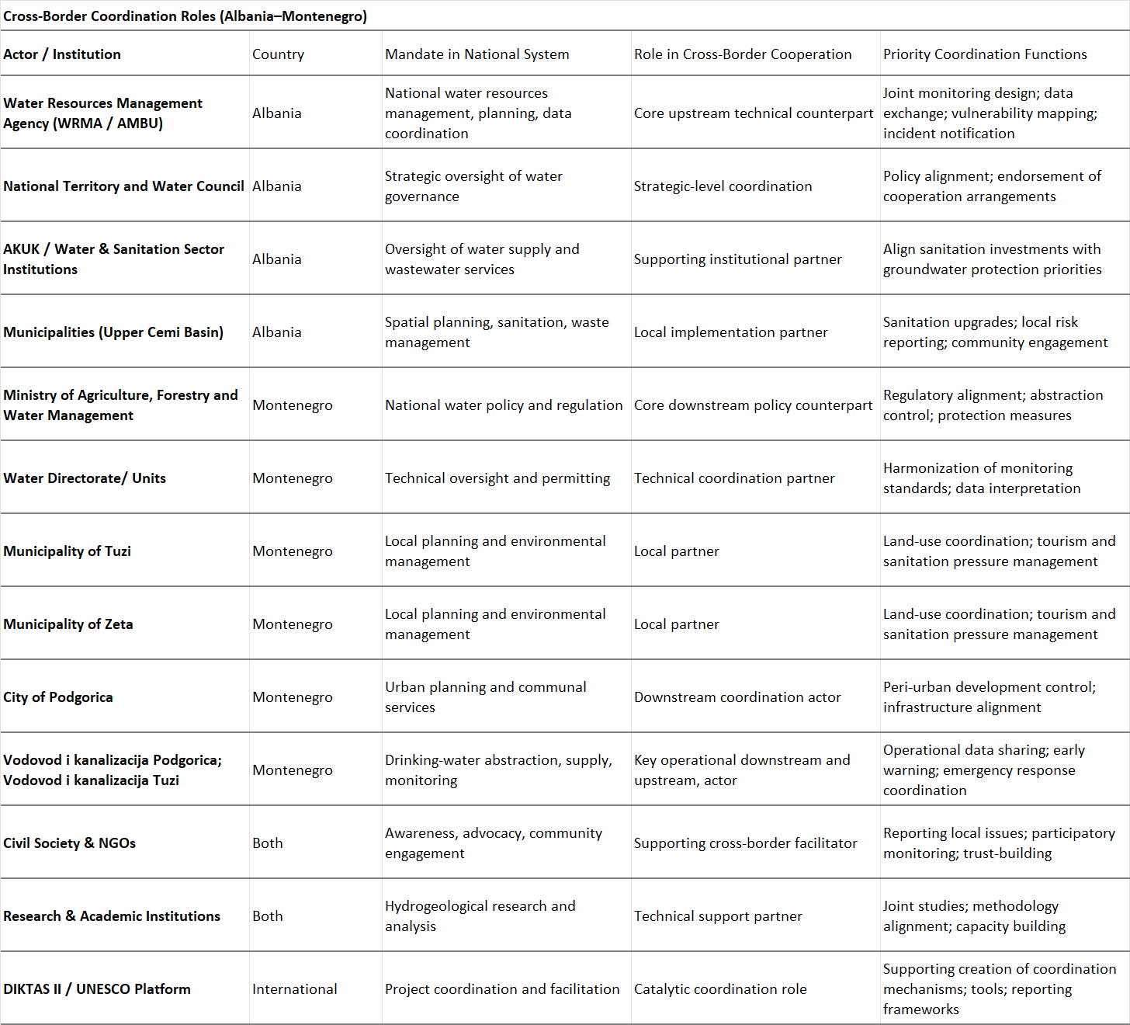

13.4 References..
Both countries have adopted a legal framework that largely aligns national legislation with the Water Framework Directive (2000/60/EC) and the Groundwater Directive (2006/118/EC), aiming at sustainable management and protection of water resources.
This section provides a consolidated list of national and regional legal and policy documents relevant for groundwater governance, management, and protection in the TBA Cemi/Cijevna. These references support the analyses, recommendations, and proposed measures presented in this report.
The comprehensive table of main water legislation (Laws & DCM) related to the Water Governance and Management are shown below.
International Laws, and Agreements, EU directives
Barcelona Convention – Convention for the Protection of the Marine Environment and the Coastal Region of the Mediterranean (1976, revised 1995),
Convention on the Protection and Use of Transboundary Watercourses and International Lakes, Helsinki, 1992.
Convention on the Transboundary Effects of Industrial Accidents, Helsinki, 1992.,
Environmental Liability Directive (2004/35/EC).
Groundwater Directive (GWD), Directive 2006/118/EC and 2014/80/EU.
Habitats Directive (92/43/EEC)
INSPIRE Directive, Directive 2007/2/EC.
Water legislation (Laws & DCM) and study and Reports related to the Water Governance and Management
Council of Ministers of Albania. (2021). National Waste Management Strategy 2021–2027. Tirana, Albania.
Dević, N. (2025). Study on the Status, Protection and Valorization of Groundwater Resources of the Zeta Plain. Geological Survey of Montenegro, Podgorica, Montenegro.
Dević, N. (2013). Final report on hydrogeological investigations for the preparation of a hydrogeological cadastre for water use in public water supply and bottling. Geological Survey of Montenegro, Podgorica, Montenegro.
EEA – European Environment Agency. (2020). Persistent Organic Pollutants in Europe: Environmental Risks and Management. Copenhagen.
Environmental Protection Agency of Montenegro (EPA). (2024). Information on the State of the Environment in Montenegro 2024. Podgorica.
EPTISA Southeast Europe d.o.o. (Consortium leader). (2025). Flood Risk Management Plan for the Adriatic River Basin. Project: Support to Implementation and Monitoring of Water Management, Montenegro. Client: Capital Projects Administration of Montenegro.
EPTISA Southeast Europe d.o.o. (Consortium leader). (2025). Flood Risk Management Plan for the Danube River Basin. Project: Support to Implementation and Monitoring of Water Management, Montenegro. Client: Capital Projects Administration of Montenegro.
European Commission. (2023). Albania Environmental Performance Review. Brussels.
European Commission. (2023). Albania: Environmental Monitoring and Assessments. Brussels.
European Commission. (2023). Water Resilience and Groundwater Vulnerability in Karst and Alluvial Systems. Brussels.
FAO, UNESCO-IHP, IAH, World Bank Group & GEF. (2016). Global Framework for Action to Achieve the Vision on Groundwater Governance. Rome/Paris/Washington D.C.
GEF IW: LEARN. (2015). Transboundary Diagnostic Analysis and Strategic Action Programme Development: A Manual for Practitioners.
INSTAT – Institute of Statistics of Albania. (2023). Environmental Statistics of Albania. Tirana.
INSTAT – Institute of Statistics of Albania. (2023). Sustainable Development Goals: SDG Indicator 6.3.1 – Proportion of Wastewater Safely Treated. Tirana.
Ministry of Agriculture and Forestry and Water Management of Montenegro. (2021). Water Management Plan for the Adriatic River Basin District. Government of Montenegro.
Ministry of Agriculture and Forestry and Water Management of Montenegro. (2021). Water Management Plan for the Danube River Basin District. Government of Montenegro.
Ministry of Agriculture and Rural Development. (2017). Water Management Strategy of Montenegro. Podgorica.
Ministry of Agriculture and Rural Development. (2023). Agricultural Water Use and Irrigation in Northern Albania. Tirana.
Ministry of Ecology, Spatial Planning and Urbanism of Montenegro. (2020). National Wastewater Management Plan of Montenegro (2020–2035). Podgorica.
Ministry of Infrastructure and Energy of Albania. (2022). Water Resources Management Plan – Albania. Tirana.
Ministry of Tourism and Environment of Albania. (2021). Annual Report on Environmental Protection. Tirana.
Ministry of Tourism, Ecology, Sustainable Development and Northern Development of Montenegro. (2024). National Waste Management Plan 2024–2028. Podgorica.
MONSTAT – Statistical Office of Montenegro. (2011). Census of Population, Households and Dwellings in Montenegro: First Results. Podgorica.
MONSTAT – Statistical Office of Montenegro. (2023). Census of Population, Households and Dwellings 2023. Podgorica.
Municipality of Tuzi. (2023). Local Environmental Action Plan of the Municipality of Tuzi 2024–2027. Tuzi.
Municipality of Zeta. (2024). Local Environmental Protection Plan of the Municipality of Zeta 2024–2028. Official Gazette of Montenegro – Municipal Regulations 28/2025.
UNDP Montenegro. (2023). Management of PCBs in Montenegro. Podgorica. Available at: https://www.undp.org/cnr/montenegro/projects/upravljanje-pcb-om
UNEP – United Nations Environment Programme. (2016). Guidelines for the Environmentally Sound Management of PCBs.
UNEP – United Nations Environment Programme. (2016). Stockholm Convention on Persistent Organic Pollutants: Polychlorinated Biphenyls (PCBs) Guidance.
WHO – World Health Organization. (2017). Polychlorinated Biphenyls (PCBs) in Drinking-water.
World Bank. (2022). Albania Climate Risk Assessment: Impacts on Water Resources and Agriculture. Washington, D.C.
World Bank. (2022). Water Supply and Sanitation Sector Review: Albania. Washington, D.C.
Beqiraj, A. et al. (2024). National Groundwater Vulnerability Map of Albania.
Blagojevic, B. et al. (2020). Transboundary groundwater resource management: needs for monitoring the Cijevna River Basin.
DIKTAS (2013). Transboundary Diagnostic Analysis of the Dinaric Karst.
Krstajic, J., Beqiraj, A., Sterckx, A. (2026). Hydrogeological Study of the Transboundary Cem/Cijevna River Basin. SAFEGE (2020). Adriatic River Basin Management Plan.
Pambuku, A. & Radojević, D. (2026). June 2025 analytical dataset; M 1 Grabom to M 8 Cemi in Vukël), Cemi/Cijevna monitoring_project Al MNE DIKTAS II – Final version (baseline borehole summaries; parameter list and monitoring dynamics).
Pambuku, A. & Radojević, D. (2026). Joint Monitoring Project: Surface and Groundwater – Cemi/Cijevna River Watershed (Cross-border Area Albania–Montenegro). Final version 19.02.2026.
Beqiraj, A. & collaborators (2026). Hydrogeological synthesis / evidence base for joint monitoring and assessment in the Cem/Cijevna River Basin (draft cleaned 06.02.2026).
SAFEGE (2020). Adriatic River Basin Management Plan (Montenegro) – referenced in the hydrogeological synthesis.
Del Val Alonso et al. (2019). GEF-DRIN pilot project outputs on aquifer vulnerability and monitoring zone identification – referenced in the hydrogeological synthesis.
GEF-DRIN (2021). Dataset/maps used for depth to groundwater and groundwater elevation analysis – referenced in the hydrogeological synthesis.
DIKTAS (2013, 2015). Transboundary Diagnostic Analysis and Atlas outputs for the Dinaric Karst – referenced in the hydrogeological synthesis.
European Commission. (2020). European Water Resilience Strategy. Publications Office of the European Union.
European Commission. (2025). Recommendation on the European Water Resilience Strategy: Water efficiency first principle.
European Commission. (2025). EU policy guidance on smart water management and digital solutions.
European Environment Agency. (2022). Water savings for a water-resilient Europe (EEA Report No. 12/2022). https://www.eea.europa.eu/
European Environment Agency. (2025). Water efficiency and resilience in Europe: Reducing demand and strengthening adaptive capacity.
Food and Agriculture Organization (FAO). (2021). The State of Food and Agriculture: Making agrifood systems more efficient, inclusive and resilient. FAO. https://www.fao.org/
OECD. (2015). Stakeholder engagement for inclusive water governance. Paris.
UNECE. (2015). Reconciling resource uses in transboundary basins. Geneva.
World Bank. (2010). Gender dimensions of water management. Washington, DC.
DIKTAS Strategic Action Program (SAP) metadata and project description, IW:LEARN (document listing and project context).
DIKTAS TDA summary page (Cijevna/Cemi aquifer context and linkage to Skadar Lake; search result summary).
Blagojević, M. et al. (2020). Transboundary groundwater resource management: needs for monitoring the Cijevna River Basin (Montenegro–Albania), Environmental Earth Sciences 79:74.
Stevanović, Z. and Stevanović, A.M. (2021). Monitoring as the Key Factor for Sustainable Use and Protection of Groundwater in Karst Environments—An Overview, Sustainability 13(10):5468.
Republic of Albania, Law No. 111/2012 on Integrated Management of Water Resources (English translation).
Albania Water Supply and Sewerage Sector Strategy (2023–2030 draft text and policy/action structure; Ministry source PDF) and related approval reference (DCM No. 448/2023 via QBZ listing).
Montenegro Water Management Strategy (published via Government/Water Administration and open data portal; strategy document includes groundwater, water quality protection, concentrated and diffuse pollution prevention, monitoring and information systems).
Municipal Wastewater Management Plan of Montenegro (2020–2035) (Government of Montenegro archived publication page).

13.5 Qualitative indicators for groundwater governance.

Institutional Indicators
Table. 13.3 Institutional Indicators.
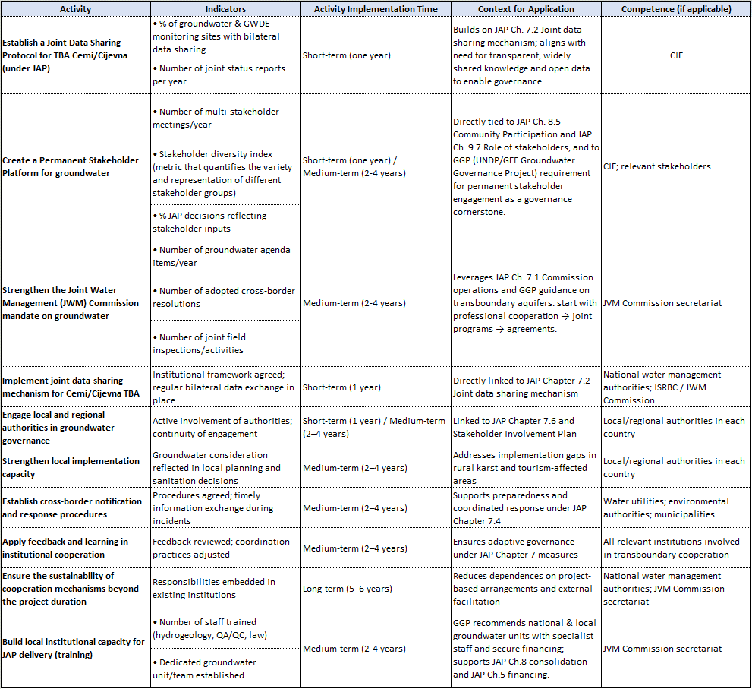

Legal and Fiscal Indicators
Table 13.4 Legal and Fiscal Indicators
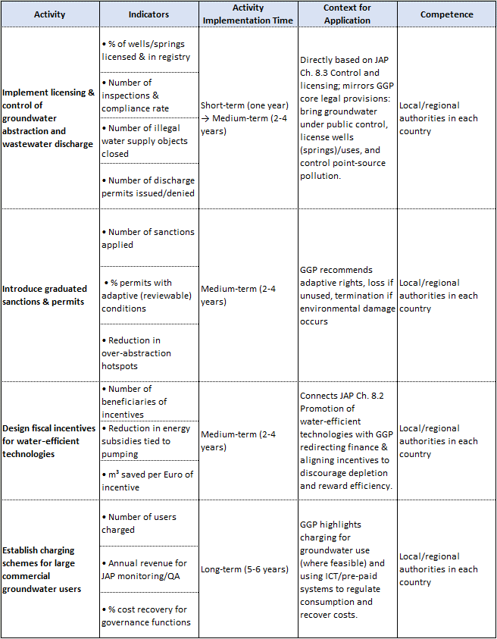

Technical Indicators
Table 13.5 Technical Indicators
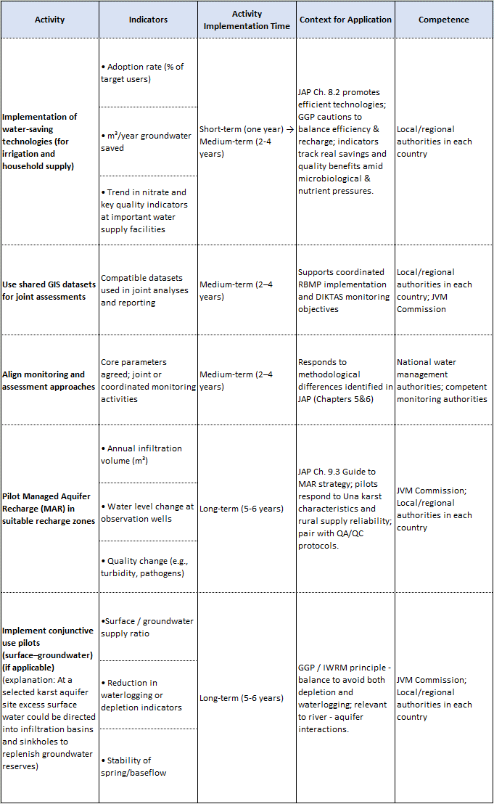

Policy and Planning Indicators
Table 13.6 Policy and Planning Indicators
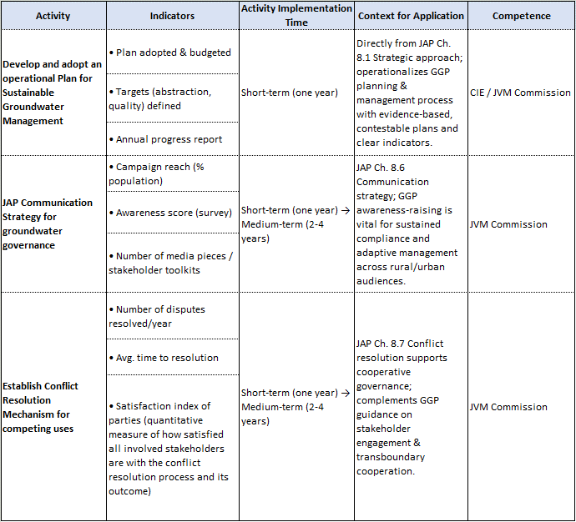

13.6 Monitoring and remediation best practice examples.

National context of groundwater resources and groundwater monitoring in Albania
Groundwater resources represent one of the most important components of the water supply system in Albania. A significant part of drinking water supply for urban and rural communities depends directly on springs, wells, karst aquifers, intergranular aquifers and fractured aquifer systems. In many mountainous and karstic regions, springs are the dominant abstraction points, while in the main lowland basins groundwater is mainly exploited through production wells. This makes groundwater not only a natural resource of strategic importance, but also a sensitive environmental component that requires systematic monitoring, protection and long-term management.
The hydrogeological conditions of Albania are highly diverse. Carbonate formations, especially limestones and dolomites, form important karst aquifer systems in the Albanian Alps, the Cemi/Cijevna region, the Drin basin, the Shkodra area, the Kruja carbonate structures, the Ionian zone and several other mountainous regions. These aquifers are generally characterized by high permeability, rapid infiltration, well-developed underground drainage systems, important springs and strong seasonal variations in discharge. In parallel, the Quaternary alluvial deposits of the main river valleys host porous aquifers that are intensively used for water supply, irrigation and local economic activities. Flysch, magmatic and metamorphic formations generally have lower groundwater potential, although locally they may sustain small springs or limited water supply systems.
At national level, groundwater monitoring in Albania has traditionally focused on selected springs and wells distributed across the main hydrogeological units. The monitoring system has provided valuable information on groundwater levels, spring discharge and chemical composition, but it still remains limited when compared with the requirements of modern groundwater management under the European Water Framework Directive and Groundwater Directive principles. The monitoring network is not yet sufficiently dense, continuous or technologically modernized to fully support quantitative and qualitative status assessment of groundwater bodies, especially in areas affected by climate variability, over-abstraction, urban expansion or potential contamination pressures.
A major limitation of the existing system is that many monitoring points are not dedicated observation points. In several cases, groundwater levels are measured in or near production wells used for water supply. These measurements may be influenced by pumping regimes, interruptions in abstraction, seasonal demand and local operational conditions. As a result, the measured water levels do not always represent the natural piezometric behavior of the aquifer. This is particularly important in productive alluvial aquifers and in pressured aquifers, where drawdown caused by exploitation may be confused with natural groundwater fluctuations if the monitoring design is not carefully established.
Another important limitation is related to the irregularity and fragmentation of hydrochemical monitoring. In Albania, chemical analyses of groundwater have often been performed seasonally or periodically, but not always with the same frequency, the same set of parameters or the same level of spatial continuity. Long-term datasets exist for several groundwater points, but the data are not always organized in a modern database that allows immediate statistical evaluation, trend analysis, hydrochemical classification, early warning interpretation or comparison with environmental objectives. Parameters such as pH, electrical conductivity, major ions, mineralization, hardness, nitrates and selected metals are usually considered, but pesticides, emerging contaminants, microbiological parameters and isotopic indicators are rarely included in a systematic way.
The institutional framework also requires further strengthening. Groundwater monitoring is carried out within the national environmental monitoring framework, with responsibilities distributed among national institutions. However, effective groundwater management requires stronger coordination among the institutions responsible for groundwater, surface water, drinking water supply, environmental protection, river basin management, climate data and local infrastructure. Data exchange among institutions remains one of the most important practical challenges. A modern groundwater monitoring system should not only generate data, but also transform these data into information for decision-making, risk assessment, planning and protection of drinking water resources.
In this context, Albania needs to gradually move from a conventional monitoring approach toward an integrated, risk-based and technology-supported groundwater monitoring system. Such a system should combine dedicated observation wells, representative springs, river monitoring stations, automatic sensors, telemetry, hydrochemical and microbiological analyses, isotope monitoring, database management and periodic interpretation by hydrogeologists. This is especially important in transboundary karst basins, where groundwater flow does not necessarily follow administrative borders and where pollution or water abstraction in one part of the basin may affect water resources in another.

Relevance of improved monitoring and protection measures for karst aquifers
Karst aquifers require a specific monitoring and protection approach because their hydraulic behavior is very different from that of porous aquifers. In porous aquifers, groundwater flow is generally slower and more diffuse, and the geological medium may provide a certain degree of natural filtration. In karst systems, however, water can infiltrate rapidly through fractures, sinkholes, swallow holes, enlarged conduits and highly permeable zones. This means that contaminants introduced at the surface may reach springs or groundwater outlets in a relatively short time, sometimes with limited natural attenuation.
For this reason, the protection of drinking water sources in karst regions cannot be based only on the immediate area surrounding a spring. The real protection zone may extend far upstream or across hidden underground drainage pathways. Surface catchments and groundwater catchments may not always coincide. A spring located in one valley may receive recharge from another area through underground karst connections. Therefore, the delineation of protection zones in karst requires hydrogeological investigation, field mapping, discharge measurements, water chemistry, tracer tests, isotopic interpretation and a good conceptual model.
The Cemi/Cijevna basin represents a typical case where these principles are highly relevant. The basin is mountainous, transboundary and dominated in large parts by carbonate formations. The interaction between river water, karst aquifers and springs is one of the key hydrogeological questions. Possible river losses, rapid infiltration, underground flow pathways and spring discharge dynamics must be understood before sustainable management measures can be proposed. The protection of drinking water sources in this basin is therefore directly linked to the improvement of the monitoring system.
Good practice in karst groundwater management requires that monitoring should not be limited to water quality sampling alone. It must include quantitative, qualitative and process-based monitoring. Quantitative monitoring should include spring discharge, river discharge, groundwater levels where wells exist, precipitation and, where possible, automatic water level and temperature measurements. Qualitative monitoring should include major ions, nutrients, heavy metals, microbiological parameters and, in selected campaigns, isotopes or natural tracers. Process-based monitoring should help understand how water moves through the system, how quickly recharge reaches springs, how river water interacts with groundwater and how vulnerable the system is to pollution.
In karst basins used for drinking water supply, remediation should also be understood in a broad sense. It is not only the technical cleaning of already contaminated groundwater. In many cases, especially where no major contamination event has yet been documented, remediation must include preventive and corrective measures designed to reduce risk before pollution occurs. This includes protection zones, control of wastewater discharge, improvement of sanitation systems, regulation of potentially polluting activities, emergency response planning, early warning monitoring and continuous evaluation of the quality of drinking water sources.

Existing situation in the Cemi/Cijevna transboundary basin
The Cemi/Cijevna River basin is one of the most important transboundary karst basins shared between Albania and Montenegro. The upper part of the basin lies in Albania, where the river system develops through mountainous terrain and karstic formations before crossing into Montenegro. The basin has high environmental, hydrological and hydrogeological value. It is also important for local communities, biodiversity, drinking water supply and future transboundary cooperation.
On the Albanian side, the valley of the Cemi River includes several rural settlements and water resources that are directly linked to the karst hydrogeological system. The villages in the area are not connected to centralized wastewater sewerage networks. This represents an important pressure factor for groundwater and surface water quality, especially in a karst environment where infiltration may be rapid and natural filtration limited. Domestic wastewater is generally managed through local or individual solutions, which may increase the risk of microbiological contamination, nutrient input and local deterioration of water quality, particularly during wet periods when infiltration and runoff are more active.
Drinking water supply in the Albanian part of the basin is strongly dependent on natural springs. A key source is located in the Cemi River valley in the area of Selce, with a discharge that fluctuates approximately between 120 and 150 l/s. This discharge indicates a very important local and strategic groundwater resource. The spring is significant not only for water supply, but also for understanding the functioning of the karst aquifer system. Its protection must therefore be considered a priority within the DIKTAS II framework.
Despite the importance of the basin, there are currently no permanent monitoring stations for either surface water or groundwater in the Albanian part of the Cemi/Cijevna basin. This is one of the most important gaps from the perspective of transboundary water management. Without permanent monitoring, it is difficult to assess seasonal variations, long-term trends, flood and drought responses, groundwater-surface water interaction, spring discharge behavior, or the potential impact of local pollution pressures.
At present, the available data are mainly based on selected sampling points that have been investigated and analyzed by Ing. Arben Pambuku through a project financed by the Albanian Government. These sampling activities extended from the village of Grabom to the village of Vermosh and provided important first-level information on water quality and the hydrogeological characteristics of the area. Such data are valuable because they represent one of the few direct scientific datasets available for the Albanian side of the Cemi basin. However, they cannot replace a permanent monitoring network, because campaign-based sampling provides only a partial picture of a dynamic karst system.
In addition to these sampling activities, a project proposal has been prepared within the DIKTAS II framework by hydrogeological experts from Albania and Montenegro for the Cemi/Cijevna transboundary basin. This proposal is an important step because it recognizes the need for a coordinated binational approach. The basin cannot be properly assessed if each country works only within its administrative territory. The hydrogeological functioning of the system, the river-aquifer interactions, the vulnerability of drinking water sources and the potential pollution pathways require a joint conceptual model and a shared monitoring strategy.
The lack of permanent monitoring in the Cemi/Cijevna basin creates uncertainty in several important aspects. First, the natural discharge regime of the main springs is not sufficiently documented through continuous measurements. Second, the seasonal and event-based response of the river and springs is not well quantified. Third, potential links between precipitation, river flow, karst infiltration and spring discharge are not yet fully demonstrated. Fourth, the absence of microbiological and chemical time series makes it difficult to evaluate the real risk to drinking water sources. Finally, without a shared database, Albania and Montenegro cannot fully compare their observations or develop a common interpretation of the basin.

Main pressures and risks for drinking water sources
The main pressure in the Albanian part of the Cemi/Cijevna basin is not necessarily industrial pollution, but rather the combination of karst vulnerability, rural settlements, lack of sewerage networks and insufficient monitoring. In karst regions, even relatively small pollution sources may become important if they are located in recharge zones or near infiltration pathways connected with springs.
The absence of wastewater sewerage networks in the villages of the basin must be considered a key risk factor. Domestic wastewater, septic systems or uncontrolled discharges may introduce microbiological contamination, organic matter, ammonium, nitrates and other pollutants into the environment. In a non-karstic aquifer, part of this pollution may be attenuated by soil and sediment filtration. In karst, however, the protection capacity of the geological medium is often limited, particularly where soil cover is thin, fractures are open and infiltration is rapid.
Another pressure is related to local agriculture and livestock activity. Although the area is mountainous and not characterized by intensive agriculture on the scale of lowland basins, small-scale farming and livestock may still contribute nutrients and microbiological loads, especially near streams, springs and recharge areas. These pressures should not be exaggerated, but they should be included in a risk-based monitoring approach.
Roads, small settlements, tourism activities and solid waste management may also represent local sources of pressure. Accidental spills, uncontrolled dumping, fuel leakage, waste disposal near riverbanks or poor sanitation during periods of increased seasonal movement may have local effects. In a transboundary basin, these issues require early identification because pollution may be transported downstream or through karst pathways beyond the point where it originated.
From a drinking water protection perspective, the Selce spring system requires particular attention. A discharge of 120-150 l/s is significant and indicates an important aquifer outlet. Such a source should not be protected only by a narrow sanitary perimeter around the spring. A wider hydrogeological protection concept is required. This should include the identification of recharge zones, potential infiltration areas, nearby settlements, possible wastewater pathways, river interaction zones and vulnerable karst structures.
The risk is increased by the lack of continuous data. If monitoring is performed only occasionally, short-term contamination events may be missed. Microbiological contamination in karst springs may occur after intense rainfall, snowmelt or rapid runoff events, but may disappear before the next sampling campaign. Therefore, a spring may appear clean during routine sampling while still being vulnerable during hydrological events. This is one of the reasons why good practice in karst aquifers requires both periodic laboratory analyses and automatic field monitoring.

Good practice for groundwater monitoring in the Cemi/Cijevna basin
A good monitoring system for the Cemi/Cijevna basin should be designed according to the hydrogeological behavior of the basin and not only according to administrative convenience. The system should combine monitoring of groundwater, springs, river flow, precipitation, water quality and potential pollution pressures. It should be simple enough to be maintained by the responsible institutions, but sufficiently robust to produce data useful for management decisions.
The first element should be the establishment of permanent monitoring points. In the Albanian part of the basin, at least one permanent monitoring station should be installed near Grabom, close to the transboundary section, and another monitoring point should be considered in the Tamare-Selce area, where important drinking water resources and karst springs are present. These points should be selected after joint field verification by Albanian and Montenegrin hydrogeologists.
For surface water, the monitoring system should include river level and discharge measurements. Since the Cemi River may interact with karst aquifers, river monitoring is not only hydrological but also hydrogeological. Continuous or periodic discharge measurements would help identify gaining and losing river sections, seasonal variability, low-flow conditions and flood responses. Where possible, acoustic current meter measurements should be used during field campaigns to improve discharge estimates.
For groundwater and springs, the Selce spring should be included as a priority monitoring point because of its drinking water importance and discharge magnitude. The monitoring should include spring discharge, temperature, electrical conductivity, pH, turbidity and periodic chemical and microbiological analyses. Automatic sensors may be installed where technically feasible, especially for water level, temperature and electrical conductivity. In karst systems, rapid changes in these parameters may indicate recharge events, mixing processes or pollution pulses.
A CTD-diver and barometric compensation system could significantly improve the quality of monitoring data. CTD-divers can continuously record water level, temperature and electrical conductivity. Barodivers are necessary for correcting pressure variations and obtaining reliable water level data. These instruments are particularly useful in karst springs, wells, river stations or monitoring boreholes, where short-term changes may be important. Telemetry should be considered for key stations so that data can be transmitted automatically to a central database.
Hydrochemical monitoring should include a standard group of parameters: pH, electrical conductivity, temperature, dissolved oxygen, alkalinity, major cations and anions, nitrates, ammonium, phosphates, sulphates, chlorides, bicarbonates, calcium, magnesium, sodium, potassium, total dissolved solids and hardness. Heavy metals should be included at least periodically, especially where geological or anthropogenic conditions justify their analysis. Microbiological parameters are essential for drinking water protection, particularly E. coli and total coliforms, because the absence of sewerage networks makes microbiological risk one of the most relevant concerns.
In addition to conventional hydrochemistry, isotope monitoring should be gradually introduced. Stable isotopes of oxygen and hydrogen can help identify recharge altitude, seasonal recharge patterns and connections between precipitation, river water and springs. In selected investigations, natural tracers such as radon or other indicators may help clarify groundwater-surface water interaction. These techniques are not necessary at every point, but they are very useful in the conceptual understanding of a transboundary karst basin.
A shared database should be one of the main outputs of the DIKTAS II monitoring approach. The database should include all Albanian and Montenegrin monitoring points, coordinates, station type, measured parameters, sampling dates, laboratory results, field measurements, discharge data and metadata. It should be structured in a way that allows periodic interpretation, quality control, trend analysis and reporting. Without a common database, even good field measurements may remain fragmented and underused.

Existing monitoring in Montenegro
Water quality monitoring in Montenegro is carried out by the state administration body responsible for hydrometeorological affairs (Institute for Hydrometeorology and Seismology of Montenegro), according to the annual Surface and Groundwater Monitoring Program. The purpose of testing water properties is to determine the status of water: surface water (as a chemical and ecological status) and underground water (as a chemical and quantitative status). The elements for determining each of the mentioned statuses are determined as very good, good, moderate, bad and very bad, and for individual artificial and significantly modified water bodies the classification is made based on the ecological potential as good, moderate, bad and very bad.
In 2024, the Montenegrin state water monitoring was carried out in the subject Cijevna river basin at 2 locations of ground water and 2 locations of surface water.

Groundwater monitoring
- Borehole at the location "UŠĆE" (Cijevna)
Geological setting: Quaternary terrace sediments
Depth: 31 m
Static water level (NPV): 8.1 m
Internal diameter: 121 mm
Year of drilling: 2018
Ušće Cijevne is a new borehole located near Podgorica, close to the confluence of the Cijevna River with the Morača River, on the right bank of the Cijevna, and belongs to the Zetska Ravnica Groundwater Body (GVTPV).
From the perspective of basic physico-chemical parameters, the water showed good quality status. In 91.7% of the measured parameters, the water quality was excellent or very good, while in 8.3% of the parameters it was good (BOD₅).
Concentrations of pollutants were below the limit of quantification (LOQ) for metals (in μg/L: As < 0.20; Cd < 0.10; Pb < 0.20; Hg < 0.05) and for pesticides.
Regarding microbiological quality, coliform bacteria were found (640–980/100 ml), fecal bacteria (0–311/100 ml), and live bacteria (30–55/ml).
The dynamic water level was 8.0 m and 7.0 m.
- Borehole at the location „Trgaj“ (Cijevna)
Geological setting: Quaternary terrace sediments
Depth: 31 m
Static water level (NPV): 12 m
Internal diameter: 121 mm
Year of drilling: 2018
Trgaj is a new borehole located in the Tuzi area and belongs to the Kuči Groundwater Body (GVTPV).
From the perspective of basic physico-chemical parameters, the water showed good quality status. In 91.7% of the measured parameters, water quality was excellent or very good, while in 8.3% of the parameters it was good (BOD₅ parameter).
The concentrations of pollutants were below the limit of quantification (LOQ) for metals (in μg/L: As < 0.20; Cd < 0.10; Pb < 0.20; Hg < 0.05) and for pesticides.
Regarding microbiological quality, coliform bacteria were detected (0–21/100 ml), fecal bacteria (0–1/100 ml), and live bacteria (37–205/ml). During the second sampling, a small amount of sand was present in the water.
The dynamic water level was 13.0 m and 12.1 m.

List of parameters and dynamics of sampling
The water quality status is determined based on the average values of 12 core physico-chemical parameters: BOD₅, TOC, electrical conductivity, alkalinity, pH, NH₄⁺, NO₃⁻, NO₂⁻, TN, total P, ortho-PO₄³⁻, and SO₄²⁻.
The physico-chemical parameters included:
pH value, temperature, turbidity, electrical conductivity, total dissolved solids, suspended matter, oxygen concentration, oxygen saturation (%O₂), BOD₅ (Biochemical Oxygen Demand), COD (Chemical Oxygen Demand, with KMnO₄), alkalinity, total hardness (°dH), bicarbonates (HCO₃⁻), chlorides (Cl⁻), sulfates (SO₄²⁻), nitrates (NO₃⁻), nitrites (NO₂⁻), ammonium (NH₄⁺), total nitrogen (TN), orthophosphates (o-PO₄³⁻), total phosphates (u-PO₄³⁻), total organic carbon (TOC), calcium (Ca²⁺), magnesium (Mg²⁺), total iron (u-Fe), sodium (Na⁺), potassium (K⁺), and salinity.
Supporting parameters are also measured, but their values are not used to determine the status due to the specific characteristics of groundwater quality, such as: total water hardness, O₂ content, % O₂, and suspended matter, as well as three microbiological parameters.
For pollutants, metals such as Pb, Cd, and Hg were analyzed, along with As and pesticides (176 substances from this group).
Samples are collected twice a year in spring and autumn.

Locations of surface water monitoring sites within the TBA
Surface waters of the Cijevna River are sampled at:
- Dinoša, downstream of the bridge
Coordinates: 42.405344 N, 19.328162 E
- Cijevna Grabon (border)
Coordinates: 42.43861 N, 19.481 E
List of parameters and dynamics of sampling
In line with the EU Water Framework Directive (WFD), surface water monitoring in Montenegro should include:
- Biological monitoring covering five biological quality elements: phytoplankton, phytobenthos, macrophytes, benthic invertebrate fauna, and fish;
- General physico-chemical parameters supporting biological monitoring (such as pH, temperature, dissolved oxygen, alkalinity, salinity, and nutrients);
- Monitoring of specific pollutants;
- Hydromorphological elements (flow quantity and dynamics, connectivity with groundwater, river continuity, river width and depth variations, riverbed structure, and bank composition);
  - Chemical monitoring including the analysis of 45 priority substances.
The physico-chemical parameters included:
pH value, temperature, turbidity, electrical conductivity, total dissolved solids, suspended matter, oxygen concentration, oxygen saturation (%O₂), BOD₅ (Biochemical Oxygen Demand), COD (Chemical Oxygen Demand, with KMnO₄), alkalinity, total hardness (°dH), bicarbonates (HCO₃⁻), chlorides (Cl⁻), sulfates (SO₄²⁻), nitrates (NO₃⁻), nitrites (NO₂⁻), ammonium (NH₄⁺), total nitrogen (TN), orthophosphates (o-PO₄³⁻), total phosphates (u-PO₄³⁻), total organic carbon (TOC), calcium (Ca²⁺), magnesium (Mg²⁺), total iron (u-Fe), sodium (Na⁺), potassium (K⁺), and salinity.
Table 13.7 Dynamics of sampling:
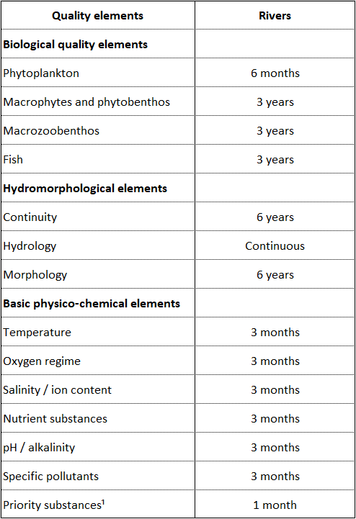

Protection and remediation measures for drinking water sources
In the context of the Cemi/Cijevna basin, remediation should be understood as a combination of preventive protection, corrective intervention and risk reduction measures. Since the main objective is the protection of drinking water sources, the first priority should be to prevent contamination rather than to react after contamination has already occurred.
The first measure should be the delineation of drinking water protection zones for the Selce spring and other important sources. In karst areas, these protection zones should be based on hydrogeological criteria. A simple circular buffer around the spring is not sufficient. The protection concept should consider recharge areas, karst morphology, geological structures, river losses, fracture zones, settlement locations and potential pollution pathways. Where data are insufficient, provisional protection zones may be established and later refined through monitoring, tracer tests and field investigations.
The second measure should be the control of domestic wastewater. Since the villages in the basin are not connected to sewerage networks, wastewater management is a key issue. Good practice would require an inventory of existing sanitation systems, identification of houses or facilities located near springs, streams or infiltration zones, and development of low-cost local wastewater solutions adapted to mountainous rural conditions. These may include sealed septic systems, small decentralized treatment units, constructed wetlands or other appropriate technologies. The objective is not only environmental improvement, but direct protection of drinking water sources.
The third measure should be the control of activities in sensitive recharge zones. Waste disposal, livestock concentration, fuel storage, road maintenance materials, uncontrolled construction and other potentially polluting activities should be restricted or carefully managed near springs, riverbanks, swallow holes and identified recharge zones. This requires cooperation with local authorities and communities, because groundwater protection cannot be achieved only through technical reports. It must be translated into land-use rules and local awareness.
The fourth measure should be the development of an emergency response plan. In a karst basin, accidental pollution may travel quickly. For this reason, the responsible authorities should know in advance what actions must be taken in case of fuel spills, wastewater discharge, microbiological contamination or other accidental events. The emergency plan should identify responsible institutions, communication channels, sampling procedures, temporary restrictions on drinking water use and public notification protocols.
The fifth measure should be monitoring after intervention. Remediation or protection measures are useful only if their effectiveness is verified. If a wastewater improvement measure is implemented in a village, the quality of nearby springs and streams should be monitored before and after intervention. If a protection zone is established, monitoring should verify whether microbiological or chemical indicators improve over time. This creates a feedback loop between management actions and scientific evidence.
For the Cemi/Cijevna basin, remediation should therefore be presented not as a single engineering action, but as a phased process. The first phase is characterization of the system. The second phase is identification of pressures and vulnerable zones. The third phase is implementation of preventive and corrective measures. The fourth phase is effectiveness monitoring. The fifth phase is adaptation of measures according to monitoring results. This approach is consistent with good European practice and with the logic of risk-based groundwater protection.

Proposed monitoring concept for the Albanian side of the Cemi/Cijevna basin
Based on the current situation, the Albanian side of the basin requires a practical but scientifically sound monitoring concept. The first step should be to formalize the existing knowledge from previous sampling campaigns carried out from Grabom to Vermosh. These data should be organized, interpreted and used as the baseline for the design of permanent monitoring. The work carried out by Ing. Arben Pambuku through the Albanian Government-financed project provides an important starting point and should be integrated into the DIKTAS II knowledge base.
The second step should be the establishment of a small but representative permanent monitoring network. This network should include at least one transboundary river monitoring station near Grabom, one monitoring point in the Tamare-Selce sector, the main drinking water spring in Selce, and selected additional springs or river points depending on field accessibility and hydrogeological relevance. The objective should not be to create a large network immediately, but to establish a reliable core network that can be expanded later.
The third step should be the introduction of automatic monitoring. At selected points, sensors should record water level, temperature and electrical conductivity. These parameters are relatively simple, but highly informative in karst systems. Sudden changes in conductivity or temperature may indicate recharge, mixing or pollution events. Continuous data also allow comparison with rainfall and river discharge, which is essential for understanding the functioning of the basin.
The fourth step should be the integration of precipitation monitoring. A pluviometric station, preferably with isotope sampling capacity, would be very useful in the upper Albanian part of the basin. Precipitation data are necessary for water balance, recharge interpretation and climate-related analysis. Isotope data would help understand the altitude and seasonality of recharge, especially if compared with spring and river water.
The fifth step should be regular hydrochemical and microbiological monitoring. At minimum, sampling should be performed seasonally, but additional event-based sampling should be carried out after intense rainfall or snowmelt events. In karst aquifers, event-based sampling is often more informative than routine sampling because contamination and turbidity peaks may occur during short hydrological windows.
The sixth step should be joint interpretation with Montenegro. The Cemi/Cijevna basin cannot be divided scientifically at the border. Albanian monitoring data should be compared with Montenegrin data downstream. This would help identify whether changes observed in Montenegro are related to upstream conditions, local pressures or natural hydrogeological processes. The DIKTAS II framework offers an appropriate platform for this cooperation.

Conclusions and recommendations
The Cemi/Cijevna transboundary basin is a strategically important karst basin where groundwater, surface water and drinking water resources are closely connected. The Albanian side of the basin contains important springs, rural settlements, karst aquifers and river sections that influence the downstream part of the system. The Selce spring, with a discharge fluctuating approximately between 120 and 150 l/s, is a major drinking water resource and should be treated as a priority point for protection and monitoring.
The current monitoring situation is not sufficient for long-term transboundary groundwater management. There are no permanent monitoring stations for groundwater or surface water in the Albanian part of the basin. Existing information is mainly based on selected sampling and analyses carried out in 2025 through a government-financed project by Ing. Arben Pambuku, covering the area from Grabom to Vermosh villages. These data are valuable and should be used as a baseline, but they need to be complemented by permanent monitoring, automatic measurements, hydrochemical and microbiological time series, and a shared Albanian-Montenegrin database.
The lack of wastewater sewerage networks in the villages of the basin represents a significant risk factor, especially because the hydrogeological environment is karstic and therefore highly vulnerable. Domestic wastewater, septic systems and local sanitation practices may affect springs and river water, particularly during wet periods. Protection of drinking water sources must therefore be based on risk assessment, delineation of hydrogeological protection zones and practical wastewater management measures adapted to rural mountainous conditions.
Good practice for the basin should include permanent monitoring points, automatic sensors, spring discharge measurements, river discharge measurements, seasonal and event-based sampling, microbiological analyses, isotope investigations and integrated data management. The monitoring system should be designed jointly by Albanian and Montenegrin experts and should support a shared conceptual model of the basin.
Remediation in the Cemi/Cijevna basin should be understood mainly as preventive and corrective protection of groundwater resources used for drinking water supply. The most important measures are not large-scale engineering interventions, but the establishment of protection zones, control of wastewater, reduction of local pollution risks, emergency response planning and continuous monitoring of the effectiveness of implemented measures.
The DIKTAS II project provides an important opportunity to move from fragmented observations toward an integrated transboundary monitoring and protection system. Such a system would improve scientific understanding, support drinking water safety, strengthen cooperation between Albania and Montenegro and create a practical model for karst groundwater management in the wider Dinaric region.

13.7 Methodological tools and templates for indicator tracking
Templates for groundwater governance indicator tracking are organized into four mutually supportive categories:
A) METHODOLOGICAL GUIDANCE
B) STANDARDIZED REPORTING TEMPLATES
C) MONITORING PROTOCOLS
D) CAPACITY‑BUILDING COMPONENTS
More detailed information on the purpose and use of each template is provided in Section 12.2 “Periodic Reporting” of the JAP for TBA Cemi/Cijevna.

- METHODOLOGICAL GUIDANCE
TEMPLATE 1 – ANNUAL INDICATOR REPORTING TABLE
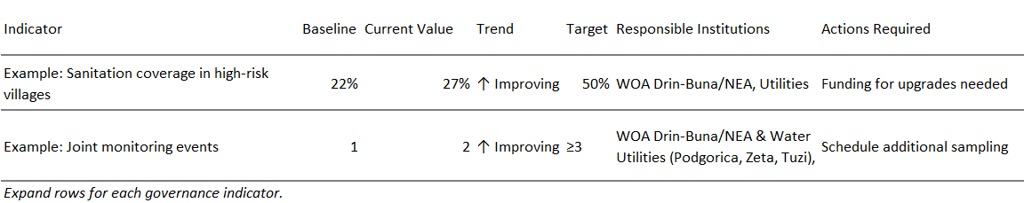

TEMPLATE 2 – DASHBOARD FOR GOVERNANCE INDICATOR TRACKING
(Reporting dashboard can be updated yearly)
TBA Cemi/Cijevna – Governance Indicator Dashboard (Example)
Reporting Year: ______
Indicator | Status | Trend | Alert Level | Comments
Legal harmonization | 65% alignment | ↑ | 🟡 Medium | Draft amendments pending
Data sharing frequency | Quarterly uploads | ↑ | 🟢 Good | Functioning platform
Stakeholder participation | 60% inclusiveness | → | 🟡 Medium | Private sector under-represented
Sanitation upgrades | 14% implemented | ↑ | 🟠 Low | Funding constraints
Tourism environmental compliance | 25% operators | → | 🟡 Medium | Training needed
Joint monitoring events | 2 per year | ↑ | 🟠 Needs improvement | Target ≥3
Legend:
🟢 = Good progress
🟡 = Moderate progress
🟠 = Needs improvement
🔴 = Critical attention required

- STANDARDIZED TEMPLATES FOR REPORTING INDICATOR STATUS
TEMPLATE 3 – DATA QUALITY ASSURANCE & HARMONIZATION CHECKLIST
(Use this checklist every time data is submitted by Montenegro or Albania authorities.)
1. Technical Consistency
□ Units of measurement harmonized (e.g., mg/L, L/s)
□ Same sampling frequency applied
□ Same laboratory methods or mutually recognized methods
□ Metadata complete (location, time, method, weather conditions)
2. Internal Validation (Country Level)
□ Data reviewed by national technical institution
□ Errors, missing values, outliers addressed
□ Clear explanation for any gaps
3. Cross-Border Harmonization
□ Indicators calculated using identical formulas
□ Thresholds and classification levels matched
□ Data comparable across both sides of the TBA
4. Final Quality Verification
□ Approved by responsible institutions in Albania and Montenegro
□ Ready for inclusion in joint reporting
□ Archived in shared digital platform

TEMPLATE 4 – INDICATOR SELECTION & PRIORITIZATION FLOWCHART (TEXT DIAGRAM)
STEP 1: Identify management need
STEP 2: Define governance question
STEP 3: Check indicator relevance (Does it measure pressure, state, response, or cooperation?)
STEP 4: Check feasibility
- Is data available?
- Can both countries measure it?
STEP 5: Cross-border harmonization test
- Same definitions?
STEP 6: Prioritize
- High relevance + High feasibility + High transboundary significance
STEP 7: Approve indicator and assign responsibilities

- MONITORING PROTOCOLS
TEMPLATE 5 – MONITORING PROTOCOL TABLE
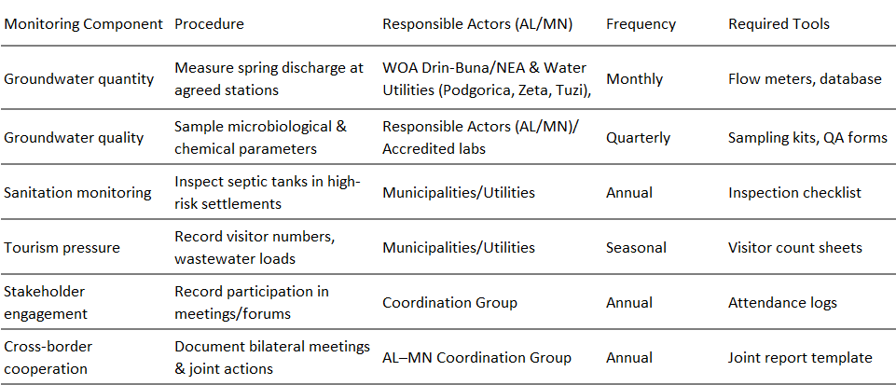

TEMPLATE 6 – STAKEHOLDER INVOLVEMENT LOG (FOR MONITORING PARTICIPATION)
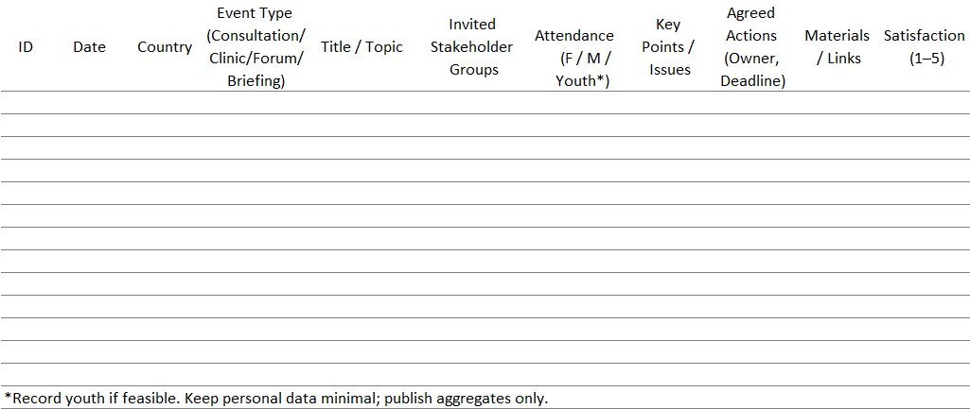

- CAPACITY BUILDING COMPONENTS
TEMPLATE 7 – QUALITATIVE CAPACITY-BUILDING ASSESSMENT FORM (TRUST & COOPERATION)
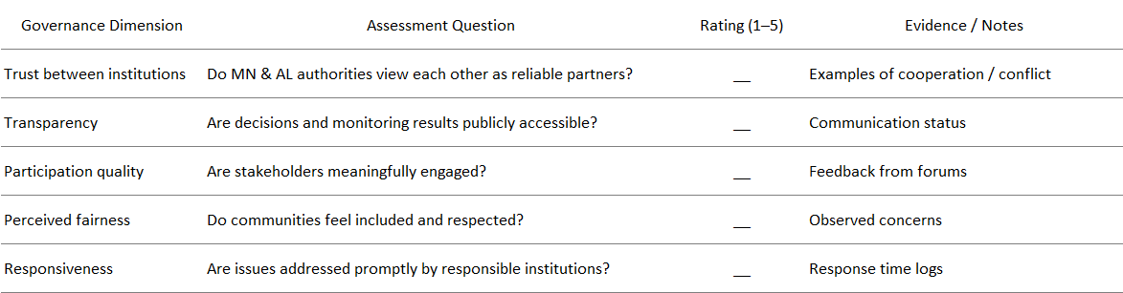

https://faolex.fao.org/docs/pdf/alb112561E.pdf
https://faolex.fao.org/docs/pdf/alb52544E.pdf
https://faolex.fao.org/docs/pdf/alb66988.pdf
https://faolex.fao.org/docs/pdf/alb163693.pdf
https://faolex.fao.org/docs/pdf/alb67467.pdf
https://www.instat.gov.al/media/vurntwyn/regional-statistical-yearbook-2024-fin.pdf
WHO & UNICEF. (2021). Progress on household drinking water, sanitation and hygiene.
Enti Rregullator i Ujit (ERRU). (2025). Tarifat aktuale të ujit – Shoqëria Rajonale Ujësjellës Kanalizime Shkodër sh.a. Retrieved from https://erru.al/tarifat-aktuale/ (erru.al)
World Bank. (2022). Albania Water Sector Governance and Financing Diagnostic. Washington, DC: World Bank. https://documents.worldbank.org/en/publication/documents-reports/documentdetail/099909012212231011/p1774360bad0f508609a4308670f99046aa
National Agency for Water Supply and Sewerage (AKUK). (2025, November 22). WPIP / MIP V Program showcased at the 13th Balkans Joint Conference and Exhibition. WPIP / MIP V Programme. Retrieved from https://wpip-mipv.al
AKUM & AKUK. (2025). Progress Report on the Regionalization of Water Supply and Sewerage Services in Albania. Tirana: Albanian Water Supply and Sewerage Services Regulatory Bodies.
Ministry of Infrastructure and Energy (MIE). (2023). Water Supply and Sewerage Sector Strategy 2022–2030. Government of Albania
Enti Rregullator i Ujit (ERRU). (2023). Raporti Vjetor 2022. ERRU. Retrieved from https://erru.al/wp-content/uploads/2023/08/Raporti_Vjetor_2022-FINAL.pdf
State Authority for Geospatial Information (ASIG) is a central public institution that carries out its activities based on Law No. 72/2012, dated June 28, 2012, “For the Organization and Operation of the National Geospatial Information Infrastructure in the Republic of Albania”, updated. Retrived from: https://asig.gov.al/en/asig-and-aspa-organize-the-training-satellite-imagery-applications-for-geospatial-data-improvement/
World Bank. (2023). Albania: Water supply services reform and improvement. Retrieved from https://www.worldbank.org/en/news/press-release/2022/05/12/albania-to-reform-and-improve-its-water-supply-services-with-world-bank-support
Albanian Water Partnership. (2023). Monitorimi i rezervuarëve në përputhje me Direktiven Kuadër për Ujin: Një hap i domosdoshëm drejt menaxhimit të qëndrueshëm të burimeve ujore. Retrieved from https://albanianwaterpartnership.org
Kurowska-Pysz, J., & Szczepańska-Woszczyna, K. (2017). The analysis of the determinants of sustainable cross-border cooperation and recommendations on its harmonization. Sustainability, 9(12), 2226. https://doi.org/10.3390/su9122226
Kurowska-Pysz, J., & Szczepańska-Woszczyna, K. (2017). The analysis of the determinants of sustainable cross-border cooperation and recommendations on its harmonization. Sustainability, 9(12), 2226. https://doi.org/10.3390/su9122226
Drini-Buna Final River Basin Management Plan-December 2018

