DIKTAS II
Monitoring site visit – TBA UNA
IMPLEMENTATION OF THE STRATEGIC ACTION PROGRAMME (SAP) OF THE DINARIC KARST AQUIFER SYSTEM: IMPROVING GROUNDWATER GOVERNANCE AND SUSTAINABILITY OF RELATED ECOSYSTEMS
Korenica (CRO) - Bihać (BH), 7-9 April 2026

Field trip Report

Site Visit Objectives

Visit locations proposed in the Monitoring design for Una TBA, draft 1 (Output 3.1 and Output 3.2)

Check possibilities for the equipment instalment in the field and prepare brief report from each monitoring site

Allow experts to share updates and inputs on the monitoring design, draft 1

Background documentation for the site visit

GEF Project Document

The Monitoring design for Una TBA, draft 1 (Output 3.1)

Introduction
Guidance for the development of a comprehensive Groundwater Monitoring (GWM) system in the Transboundary Aquifer (TBA) Una represents one of the key outputs of the DIKTAS II Project. This guidance includes several interrelated activities, namely: 3.1 Design of the DIKTAS groundwater multi-purpose monitoring network – TBA Una, 3.2 Establishment of monitoring in TBA Una, and 5.1 Development and implementation of the Joint Action Programme (Output 5).
Based on the draft document (Draft 1, OUTPUT 3.1. Design of DIKTAS-wide groundwater multi-purpose monitoring network, SITE 1: TBA Una shared between Bosnia and Herzegovina and Croatia) prepared by Hydrogeology WG within the framework of these activities, which included an analysis of the existing monitoring system, as well as the geological and hydrogeological characterization of the area and the development of a conceptual hydrogeological model of the TBA Una, the establishment and optimization of a multi-purpose groundwater monitoring network have been proposed. The development of the monitoring network followed a stepwise approach, including hydrogeological characterization and the development of a conceptual model, analysis of the existing monitoring system and IMPRESS analysis, and finally the proposal, design, and optimization of the monitoring network.
The proposed monitoring concept aims to improve the existing system in both quantitative and qualitative terms, including the selection of key monitoring locations for the observation of hydrological, hydrogeological, hydrogeochemical, and biological parameters, as well as continuous measurement of water quantities at springs and ponors representing the main recharge and discharge components of the groundwater system. In order to verify the proposed monitoring points and assess their suitability for long-term monitoring purposes, a field visit to all planned locations was organized with the participation of national and international experts. The outcomes of the field visit provide the basis for the final confirmation and potential refinement of the groundwater monitoring network design and support the subsequent establishment of monitoring activities within the TBA Una.
Day 1- 07 April 2026.: Arrival of participants, Hotel Lyra, Ličko Petrovo Selo 52, 53233 Ličko Petrovo Selo
The list of the participants:
Boban Jolović, DIKTAS II Project Manager
Želimir Pekaš, International Hydrogeology Expert
Maja Oštrić, National Hydrogeology Expert - Croatia
Ivan Vučković, National Biodiversity Expert - Croatia
Uroš Jurošević, National Hydrogeology Expert – Bosnia and Herzegovina

On the first day, the participants arrived at the designated meeting location. After all participants had gathered, a preparatory meeting was held during which the planned activities and site visits scheduled for the following two days were presented and discussed.

Based on the prepared map and Document 3.1 – Monitoring in TBA Una, the proposed monitoring network and upcoming monitoring activities were outlined. Particular attention was given to the planned monitoring locations, the objectives of the field verification, and the logistical arrangements for the site visits.

Day 2- 08 April 2026.:
No. | Time | Activity | Responsible person
1 | 10:00–12:00 | Meeting in Bihać City | Vildana Zulić
2 | 12:00–15:00 | Field visit of all water supply springs: Ostrovica, Toplica near Vakuf, Klokot and Privilica near Bihać | Elvir Čelebić
3 | 15:00-16:00 | Visit to Klokot 1 and 2 borehols, and Željava airport | Dušan Nahod
4 | 16:00–18:00 | Visit to Koreničko polje and ponors Prijeboj and ponor near Korenica | Dušan Nahod

Activity 1: At 10:00-12:00, a meeting was held in the City of Bihać, attended by representatives of the DIKTAS II project, representatives of the City of Bihać, and representatives of the Bihać Water Utility. The meeting was chaired by Ms. Vildana Zulić, Assistant Mayor for Development Management, Municipal Services, and Environmental Protection. She outlined the importance of cooperation and support for project activities.
Subsequently, the Project Manager, Mr. Boban Jolović, briefly presented the project and its main objectives, while Mr. Želimir Pekaš presented the details of the planned monitoring activities on the transboundary aquifer.
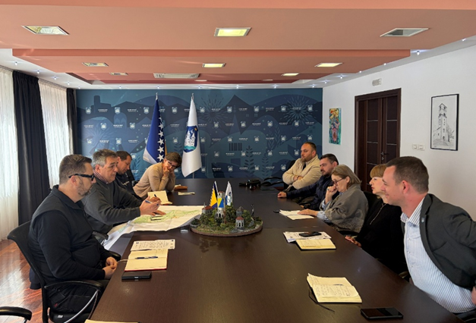
Table 1. List of participants at Bihać meeting
Name | Institution
Mrs Vildana Zulić | Bihać City
Mr Anel Kajtezović | Bihać City
Mr Aljoša Bobić | Vodovod Bihać
Mr Boban Jolović | DIKTAS II Project Manager
Mr Želimir Pekaš | DIKTAS II International expert for Hydrogeology
Mr Uroš Jurošević | National expert – Hydrogeology B&H
Ms Maja Oštrić | National expert – Hydrogeology Croatia
Mr Ivan Vučković | National expert – Biodiversity Croatia
Activity 2: At 12:00-15:00: Field visit of all water supply springs: Ostrovica, Toplica near Vakuf, Klokot and Privilica near Bihać was led by technical personel of Vodovod Bihać, Mr. Elvir Čelebić who explained technical detalis of the water supply syistem and the main springs characteristics.

Site visit at the Ostrovica spring

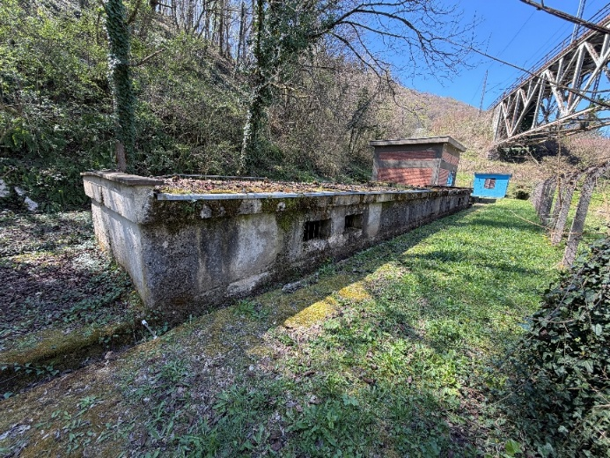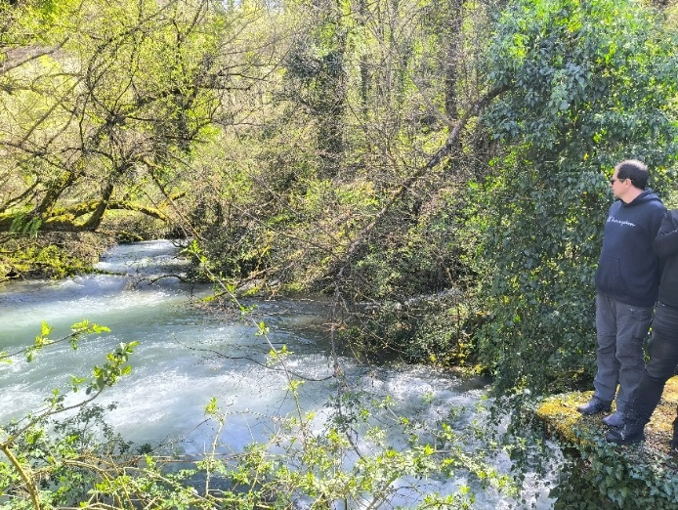
Figure 1. Site visit headwaters of Ostrovica

- Groundwater quantity (water abstraction) and quality monitoring (basic physicochemical parameters and microbiological quality) is conducted by the water supply company – Vodovod Bihać
- Water abstraction is registered daily (manual, Figure 2)
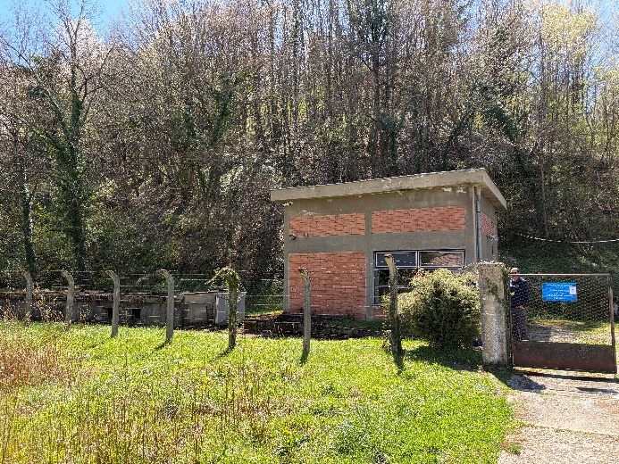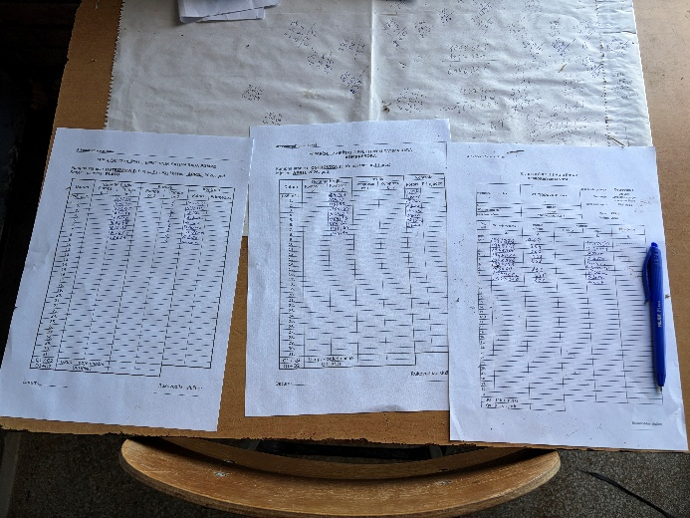
Figure 2. Water abstraction is measured daily (manual)

- Since only abstracted water quantities are measured at the spring, a staff gauge will be installed downstream to measure the total discharge of the entire spring system, given that the spring is dispersed. The proposed location is shown in Figure 3.
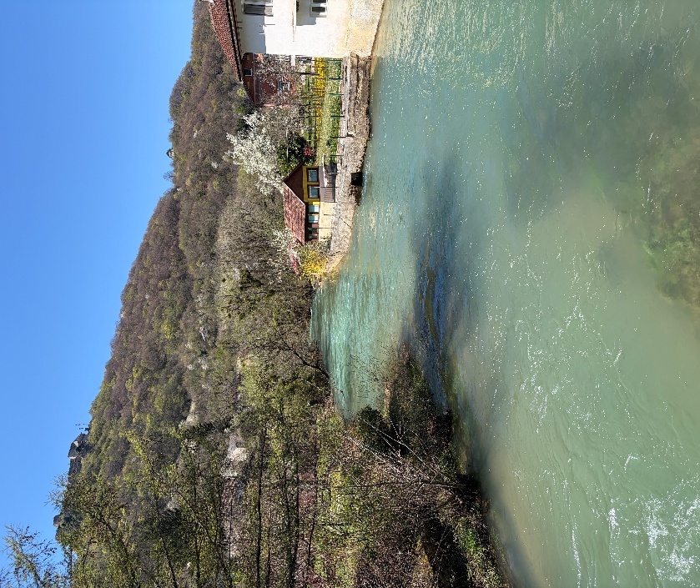
Figure 3. Proposed location for staff gauge installation

- Isotopic monitoring will be conducted at spring Ostrovica (stable isotopes of oxygen (δ¹⁸O) and hydrogen (δ²H))
- Research monitoring of the ecological status for surface water, includes the collection and analysis of biological water quality elements (in accordance with Table 1), basic physico-chemical and specific pollutant indicators (in accordance with Table 2), and hydromorphological indicators (in accordance with Table 3). Following the field survey conducted, monitoring is proposed at Headwaters of Ostrovica.

Table 1. Ecological status indicators for biological quality elements and samling frequency
Quality Element | Indicator/Indeks of status | The pressure indicated by the biological element | Frequency Surveillance monitoring | Frequency Operational Monitoring
Phytoplankton | River Potamoplankton Index (HRPI) (monitoring in the lower part of large rivers) | nutrient salt pressure | 1/ yr | 6/yr in 3 yrs (from april to september)
Phytobenthos | Diatom Trophic Index (TID _{HR}) | nutrient salt pressure | 1/ yr | 1x in 3 yrs
Macrophytes | Reference Index (RI-MHR) | nutrient salt pressure/general degradation | 1x in 3 yrs | 1x in 3 yrs
Macrozoobenthos/ Benthic Invertebrates | Croatian Saprobic Index for Macrozoobenthos (SI _{HR}) | Organic pressure | 1/ yr | 1x in 3 yrs
Macrozoobenthos/ Benthic Invertebrates | Multimetric Index of Overall Degradation of River Macrozoobenthos (MMIR) | hydromorphological changes / general degradation | 1/ yr | 1x in 3 yrs
Fish | Croatian River Fish Multimetric Index (CFIR) | hydromorphological changes / general degradation | 1x in 3 yrs | 1x in 3 yrs

Table 2. Ecological status indicators for basic physico-chemical and sampling frequency
Quality Element | Status indicator | Frequency Surveillance monitoring | Frequency Operational Monitoring | FB&H
BASIC PHYSICO-CHEMICAL INDICATORS
Thermal Conditions | Temperature (water) | 12/yr | 12/yr | +
Thermal Conditions | Temperature (air)
Salinity | Salinity | 12/yr | 12/yr | Electrical Conductivity (EC)
Acidity | pH | 12/yr | 12/yr | +
Oxygen Regim | Biochemical Oxygen Demand over 5 days (BOD₅) | 12/yr | 12/yr | +
Oxygen Regim | Chemical Oxygen Demand (COD-Mn) | 12/yr | 12/yr | -
Nutrients | Ammonium | 12/yr | 12/yr | + 13*
Nutrients | Nitrates | 12/yr | 12/yr | +12*
Nutrients | Total nitrogen | 12/yr | 12/yr | + 14
Nutrients | Orthophosphates | 12/yr | 12/yr | + 16
Nutrients | Total phosphorus | 12/yr | 12/yr | + 15
SPECIFIC POLLUTANTS
Specific Pollutants | Arsenic and its compounds | 12/yr | 12/yr
Specific Pollutants | Copper and its compounds | 12/yr | 12/yr
Specific Pollutants | Zinc and its compounds | 12/yr | 12/yr
Specific Pollutants | Chromium and its compounds | 12/yr | 12/yr
Specific Pollutants | Fluorides | 12/yr | 12/yr
Specific Pollutants | Adsorbable organically bound halogens (AOX) | 12/yr | 12/yr
Specific Pollutants | Polychlorinated biphenyls (PCBs) | 12/yr | 12/yr

Table 3. Provides an overview of the ecological status indicators for hydromorphological elements in rivers
Quality Element | Status Indicator | Monitoring Indicator | Frequency of Assessment in Surveillance and Operational Monitoring
Hydrological Regime | Water quantity and flow dynamics | Water level/discharge | Continuous
Hydrological Regime | Connectivity with groundwater | Water level/discharge, groundwater levels | Continuous
River Continuity |  | Water level/discharge of hydraulic structures | Continuous / Every 6 years
Morphological  Conditions | Bathymetric properties | Granulometric properties, hydraulic structures | Every 6 years

Site visit at the Toplica spring

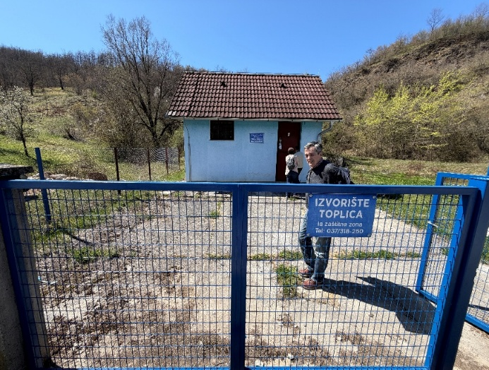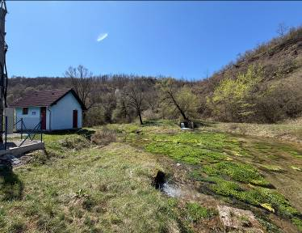

Figure 4. Site visit Toplica
- Groundwater quantity (water abstraction) and quality monitoring (basic physicochemical parameters and microbiological quality) is conducted by the water supply company – Vodovod Bihać
- Water abstraction is registered weekly (manual)
- Isotopic monitoring will be conducted at spring Ostrovica (stable isotopes of oxygen (δ¹⁸O) and hydrogen (δ²H))
- Research monitoring of the ecological status for surface water will include the collection and analysis of biological water quality elements (in accordance with Table 1), basic physico-chemical and specific pollutant indicators (in accordance with Table 2), and hydromorphological indicators (in accordance with Table 3). Following the field survey conducted, monitoring is proposed at the Headwaters of Toplica.

Site visit at the headwaters of Privilica

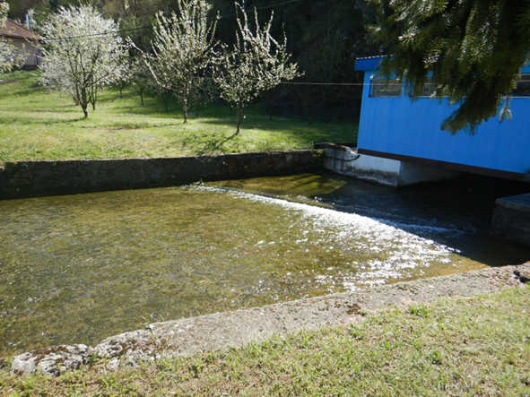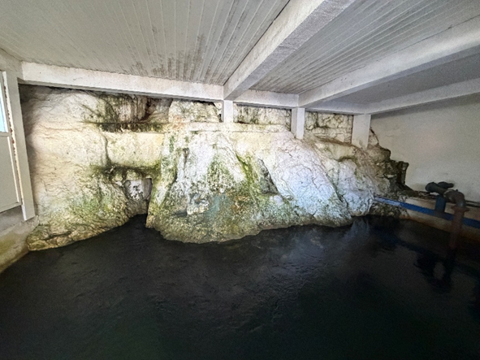
Figure 5. Site visit headwaters of Privilica

- Groundwater quantity (water abstraction) and quality monitoring (basic physicochemical parameters and microbiological quality) is conducted by the water supply company – Vodovod Bihać
- Continuous quantitative monitoring is planned at the overflow/discharge, in addition to monitoring abstracted quantities.
- Quality monitoring will be established in accordance with the WFD, GWD and DWD (monthly sampling).
- Installation of an instrument for continuous turbidity measurement is planned at the Klokot spring
- Isotopic monitoring will be conducted at the Privilica spring (stable isotopes of oxygen (δ¹⁸O) and hydrogen (δ²H))
- Following the field survey conducted microbiological monitoring is proposed at the Headwaters of Privilica:
- sampling station only for microbiological elements including the following parameters:
- Number of coliform bacteria (CFU/100 ml)
- Number of faecal coliforms (CFU/100 ml)
- Number of aerobic bacteria (CFU/ml)

Site visit at the headwaters of Klokot

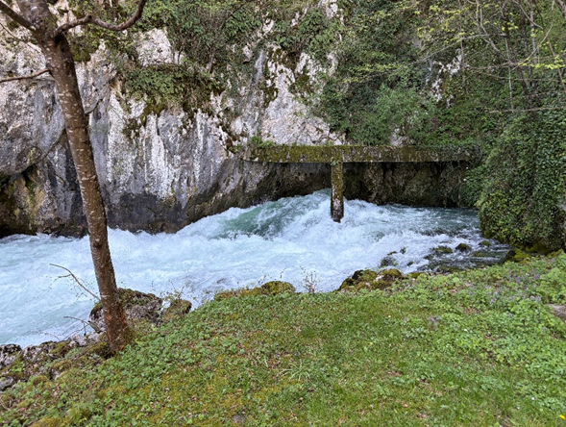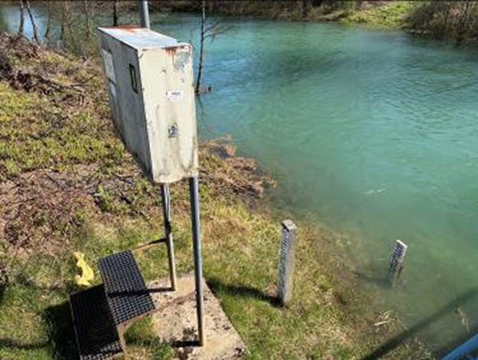

Figure 6. Site vist: headwaters of Klokot (left) ; Klokot gaging station (right)

- Groundwater quantity (water abstraction) and quality monitoring (basic physicochemical parameters and microbiological quality) is conducted by the water supply company – JP ‘’Vodovod’’ Bihać
- Water abstraction is registered automatically
- Overflow is measured at the Klokot Gaging Station (GS), an automated station located downstream of the bridge (Figure 6, right).
- Quality monitoring will be established in accordance with the WFD, GWD and DWD (monthly sampling).
- Installation of an instrument for continuous turbidity measurement is planned at the Klokot spring
- Isotopic monitoring will be conducted at the Klokot spring (stable isotopes of oxygen (δ¹⁸O) and hydrogen (δ²H))
- Research monitoring of the ecological status for surface water, includes the collection and analysis of biological water quality elements (in accordance with Table 1), basic physico-chemical and specific pollutant indicators (in accordance with Table 2), and hydromorphological indicators (in accordance with Table 3). Sampling location for biological water quality elements approximately 50-75 m downstream of the spring, prior to the fishpond.
- Biospeleological research and investigations of basic physical and chemical indicators (Table 4) are planned at the Una spring and the Klokot spring.
- Table 4. Monitoring plan
 | PARAMETER | FREQUENCY
BASIC PHYSICO-CHEMICAL PARAMETERS | Water temperature | 12/yr
BASIC PHYSICO-CHEMICAL PARAMETERS | pH value | 12/yr
BASIC PHYSICO-CHEMICAL PARAMETERS | Dissolved oxygen | 12/yr
BASIC PHYSICO-CHEMICAL PARAMETERS | Electrical conductivity | 12/yr
BASIC PHYSICO-CHEMICAL PARAMETERS | Total dissolved solids (TDS) | 12/yr
BASIC PHYSICO-CHEMICAL PARAMETERS | Basic cations (e.g. Ca²⁺ , Mg²⁺ , Na⁺, K⁺) and Anions (e.g. HCO₃⁻, SO₄²⁻ , Cl⁻). | 12/yr
BASIC PHYSICO-CHEMICAL PARAMETERS | Turbidity | 12/yr
BASIC PHYSICO-CHEMICAL PARAMETERS | Organic and Inorganic carbon (TOC, DOC) | 12/yr
BASIC PHYSICO-CHEMICAL PARAMETERS | Nitrite (NO₂⁻);Nitrate (NO₃⁻); Ammonium (NH₄⁺)  Orthophosphates (PO₄³⁻) | 12/yr
BIOLOGICAL PARAMETERS | Benthic macroinvertebrates | 2/yr
BIOLOGICAL PARAMETERS | Verterbrates | 2/yr

Activity 3: At 15:00-16:00: Field visit of boreholes Klokot 1 and 2 that are part of investigative groundwater monitoring netrork in GGWB Una, and Željava airport was led by Dušan Nahod.

Site visit Željava airport and boreholes
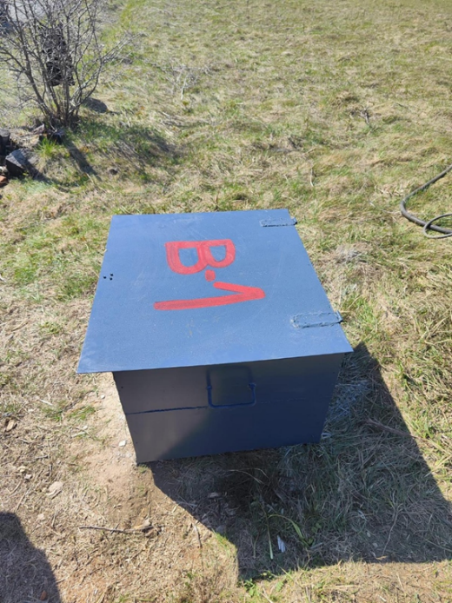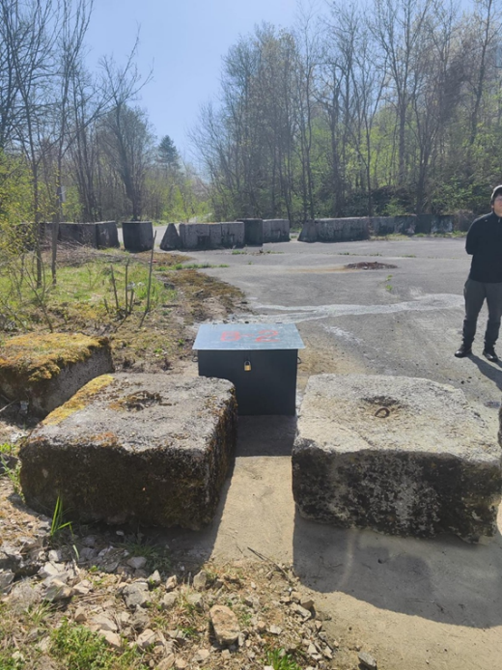

Figure 7. Site vist: headwaters of Klokot (left) ; Klokot gaging station (right)
- Groundwater quantity: Three exploratory wells (Klokot-1, Klokot-2, and a new borehole Klokot-3) – continuous groundwater level monitoring using automatic data loggers (temperature, conductivity);
- Drilling one borehole – Klokot-3 (Drilling and completion of a piezometer (observation well) to a depth of approximately 200 m and borehole diameter of 125 mm, including drilling operations, installation of casing and well construction, well development and flushing, and step-drawdown pumping test with a minimum duration of 24 hours. The scope of works shall include complete physico-chemical and bacteriological water quality analysis and installation of a submersible sampling pump for groundwater monitoring and sampling. Upon completion of the works, a concrete protection block and protective cap shall be constructed and installed. Supervision during the execution of works shall be ensured)
- Installation of data loggers
- Isotopic monitoring will be conducted at the borehole Klokot-1 and rain samplers (stable isotopes of oxygen (δ¹⁸O) and hydrogen (δ²H)
- Installation of rain samplers at: 1) Željava Airport 2) Plješevica ; for isotope sampling
- Installation of meteorological stations and precipitation monitoring sites at Plješevica to support both hydrological observations (water balance assessment) and stable isotope studies (LAT: 15.751; LNG 44.793)

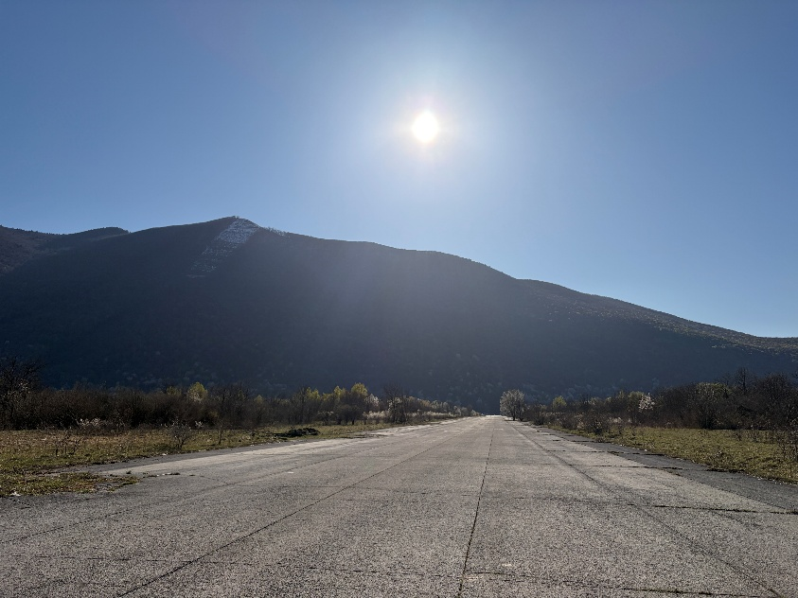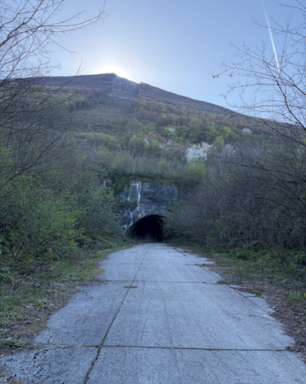
Figure 8. Željava airport
For the exploratory wells (Klokot 1, Klokot 2 – HR; Klokot 3 – BiH) microbiological analyses are proposed, including the following parameters:
- Number of coliform bacteria (CFU/100 ml)
- Number of faecal coliforms (CFU/100 ml)
- Number of aerobic bacteria (CFU/ml)

Activity 4: At 16:00-18:00: Field visit of ponor Prijeboj and Koreničko polje ponors (ponor near Koreinca).
On the last part of the first day, we completed the visit to important ponors in Koreničko Polje: Prijeboj and the ponor near Korenica. Due to high water levels at the time of the visit, the ponor near Korenica was not accessible.

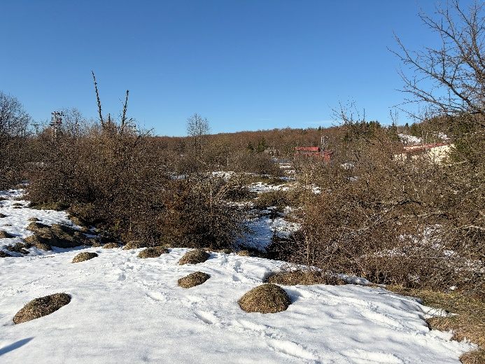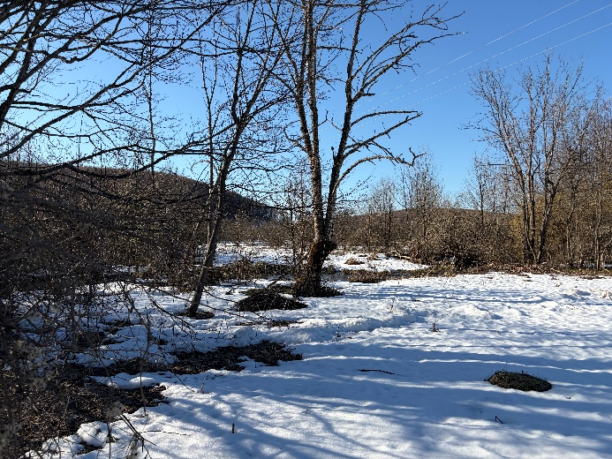
Figure 9. Prijeboj – sinkhole zone

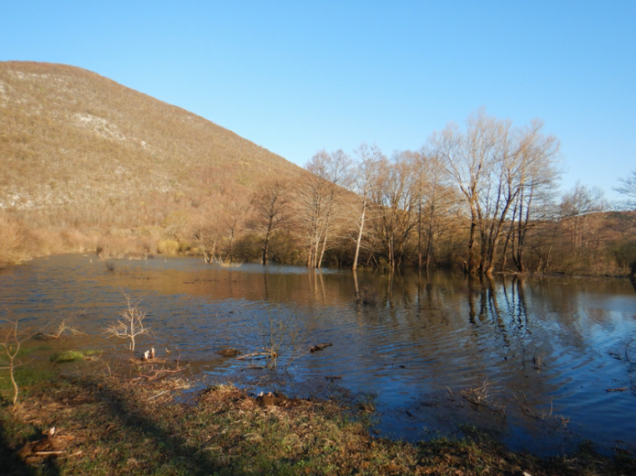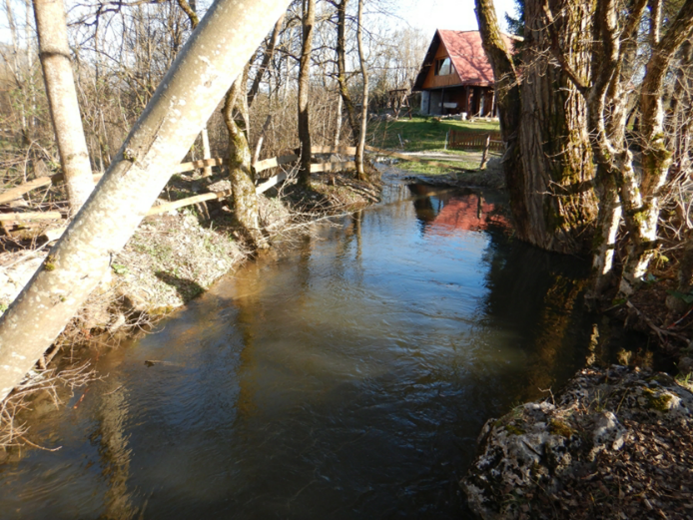
Figure 10. Ponor Korenički (left); Ponor Kompolje Koreničko (right)

Day 3- 09 April 2026.:

No. | Time | Activity | Responsible person
1 | 9:00–12:00 | Bjelopolje, Lapačko polje- ponors | Dušan Nahod
2 | 12:00–16:00 | Mazinsko polje; Krbavsko polje ponors- Pejićev ponor
Activity 1: At 09:00-12:00: Field visit of Bjelopolje, Lapačko polje- ponors, Mazinsko polje was led by Dušan Nahod.
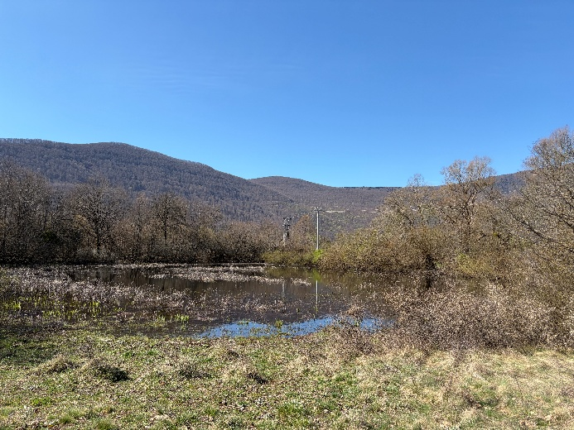
Figure 11. Bjelopolje, sinkhole
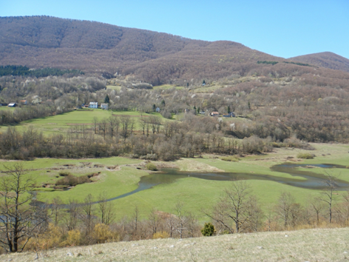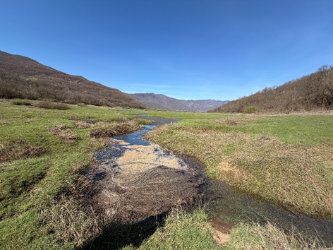
Figure 12. Lapačko polje, sinkhole Bare
Activity 2 At 12:00-16:00: Field visit of Mazinsko and Krbavsko polje and ponors

8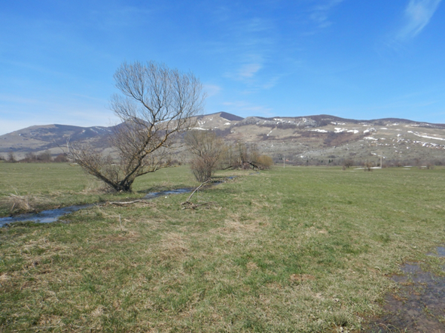 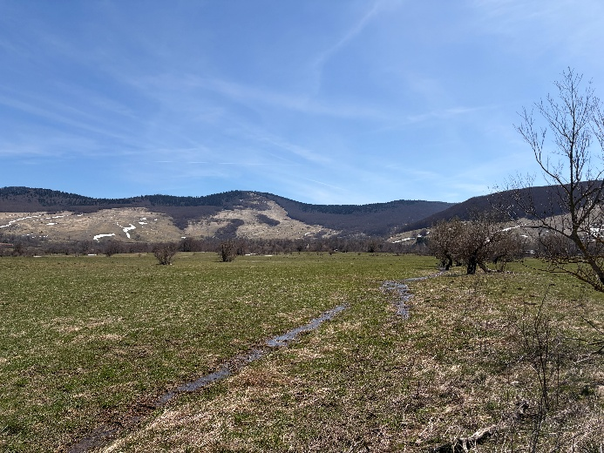
Figure 13. Mazinsko polje

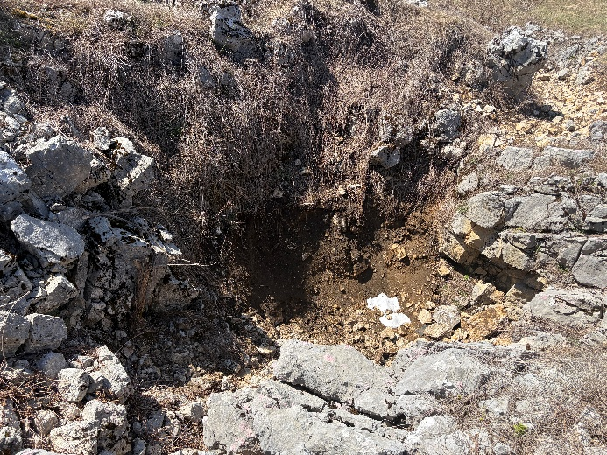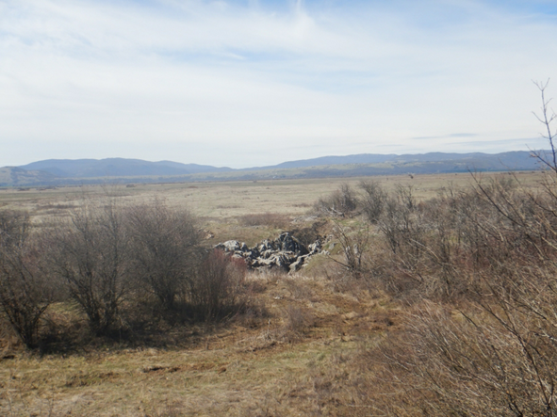
Figure 14. Krbavsko polje (Jaruga-Vidrovac ponor)
- Installation of meteorological stations and precipitation monitoring sites at additional locations to support both hydrological observations (water balance assessment) and stable isotope studies.
- Table 4. Proposed locations of new meteorological and hydrological monitoring stations
LOCATION | LAT | LNG | Type
Plješivica | 15.751 | 44.793 | Meteorological
Krbava | 15.671 | 44.616 | Meteorological
Mazin | 15.468 | 44.456 | Meteorological
Rudanovački most | 15.691 | 44.77 | Hydrological
Udbina | 15.763 | 44.546 | Hydrological

- Water level monitoring on ponors using data loggers (Divers), combined with seasonal discharge measurements (at least four times per year)
- Installation of Rain samplers at: 1) Prijeboj 2) Ponor near Korenica
- Isotopic monitoring will be conducted on ponors (table 5) and rain samplers (stable isotopes of oxygen (δ¹⁸O) and hydrogen (δ²H)

- Chemical and Biological monitoring on ponors
The most important ponors, that are in Krbavsko and Koreničko polje, and have been traced, are planned as new locations for chemical and biological monitoring.
Table 5. provide the list of ponors relevant for the monitoring.

Table 5. List of ponors for biological monitoring
NAME | Tracing | Connection_ Spring
Ponor na Lapčkom polju (Bare), fig. 12. | 21.03.1972. | Positive: Ostrovica, Dobrenica
Ponor Jaruga – Vidrovac, fig 14. | 25.06.1969 | Positive: Klokot, Privilica
Ponor kod Korenice, fig. 10 | 6.03.2020 | Positive: Klokot, Privilica
Ponor u Mazinu, fig. 13 | 26.03.1973. | Positive: Ostrovica
Prijeboj , fig. 9 | 16.9.1982; 6.03.2020 | Positive: Klokot, Privilica, Žegar
Pejićev ponor | 17.06.2020. | Positive: Klokot, Privilica
Proposed monitoring locations at ponors be included as part of the investigative monitoring programme, with the parameters and frequencies for chemical and biological monitoring provided in Table 4.

- Surface Monitoring – Biodiversity – Consolidated Overview

Research monitoring the ecological status for surface water, includes the collection and analysis of biological water quality elements (in accordance with Table 1), basic physico-chemical and specific pollutant indicators (in accordance with Table 2), and hydromorphological indicators (in accordance with Table 3). Following the field survey conducted, monitoring is proposed at the following measuring stations:
BIH – sampling station for surface water
- Headwaters of Ostrovica – Kulen Vakuf
- Headwaters of Toplice near Klisa site
- Headwaters of Klokot – sampling location for biological water quality elements approximately 50-75 m downstream of the spring, prior to the fishpond
- Headwaters of Privilica – sampling station only for microbiological elements including the following parameters:
- Number of coliform bacteria (CFU/100 ml)
- Number of faecal coliforms (CFU/100 ml)
- Number of aerobic bacteria (CFU/ml)

HR - sampling station for surface water
- Loskum spring – Donji Lapac
- Krka spring – Una tributary (border crossing)
- Joševica – headwaters section
- Una – spring (Donja Suvaja)
- Vrelo Koreničko spring – headwaters section

