DIKTAS II

IMPLEMENTATION OF THE STRATEGIC ACTION PROGRAMME (SAP) OF THE DINARIC KARST AQUIFER SYSTEM: IMPROVING GROUNDWATER GOVERNANCE AND SUSTAINABILITY OF RELATED ECOSYSTEMS

OUTPUT 3.1.

Design of DIKTAS-wide
groundwater multi-purpose monitoring network
SITE 1: TBA Una shared between
Bosnia and Herzegovina and Croatia

March 2026

PREPARED BY DIKTAS II PROJECT TEAM, EXPERT GROUP 1 and EXPERT GROUP 2
Želimir Pekaš, International Expert for Hydrogeology/Water Management
Maja Oštrić, National Expert for Hydrogeology, Croatia
Uroš Jurošević, National Expert for Hydrogeology, Bosnia and Herzegovina
Ivan Vučković, National Expert for Biodiversity, Croatia
Anita Dedić, National Expert for Biodiversity, Bosnia and Herzegovina

SUPPORT
Boban Jolović, Project Manager

ACRONYMS (a selection)
AVP Sava -Agency for watershed area of Sava River
CW- Croatian Waters
WFD- Water Framework Directive (Directive 2000/60/EC)
GWD- Groundwater DIrective (Directive 2006/118/EC)
DWD- Drinking Water Directive ( Directive 2020/218 )
GWM- Ground Water Monitoring
GQS- Groundwater Quality Standards

Contents

1 INTRODUCTION 7
2 MONITORING PURPOSE AND APPROACH IN UNA TBA 8
3 GEOGRAPHIC, GEOLOGICAL AND HYDROGEOLOGICAL OVERVIEW OF THE UNA TBA 10
3.1 GEOLOGY 11
3.1.1 Tectonics 11
3.1.2 Geological characteristics 12
3.2 HYDROGEOLOGY 12
3.2.1 Hydrogeologcal characteristics 12
3.2.2 General directions and rate of groundwater flow 13
3.2.3 Hydrogeological Units and Aquifer Characteristics 15
4 CONCEPTUAL MODEL OF THE TBA UNA AS FUNDATION FOR MONITORING DESIGN 16
4.1 HYDROGEOLOGIC UNITS 16
4.2 SOURCES OF RECHARGE 19
4.2.1 Precipitation 20
4.2.2 Losing streams and sinkholes as concentrated recharge mechanisms 21
4.3 Groundwater Flow System 24
4.4 DISCHARGE AREAS 25
4.4.1 Springs 26
4.4.2 Gaining streams 28
4.4.3 Wetlands 28
4.4.4 Lakes and reservoirs 29
4.4.5 Wells (pumping) 29
4.5 BOUNDARIES OF THE MODEL 29
4.6 ANTHROPOGENIC INFLUENCES 31
4.6.1 Groundwater abstractions 31
4.6.2 Point spurces of pollution 31
4.6.3 Diffuse sources of pollution 32
5 MONITORING IN TBA UNA 36
5.1 EXISTING MONITORING 36
5.1.1 Groundwater monitoring 36
5.1.2 Surface water monitoring 42
5.1.3 HYDROMETEOROLOGICAL MONITORING 44
5.2 MONITORING PARAMETERS WITH MONITORING FREQUENCIES 46
5.2.1 GW chemical status 46
5.2.2 SW chemical status 50
5.2.3 SW ecological status 53
5.3 PROPOSAL FOR THE MONITORING IMPROVEMENT 55
5.3.1 Groundwater quality 56
5.3.2 Groundwater quantity 59
5.3.3 Hydrometeorological monitoring 60
5.3.4 Stable isotope 60
6 MONITORING EQUIPMENT ACQUISITION COSTS ESTIMATION 61
7 ANNUL MONITORING PROGRAM COSTS ESTIMATION 62
8 MONITORING RESPONSIBILITY AFTER THE END OF THE DIKTAS II PROJECT 62
9 CONCLUSIONS 62

LIST OF TABLES

Table 1. Sinkhole–spring hydraulic connections identified by tracer tests
Table 2. Table 2: Watter supply springs
Table 3. Groundwater quality monitoring stations in TBA Una
Table 4. Surface water monitoring stations in TBA Una
Table 5. List od meteorological stations in TBA Una
Table 6. List of hydrological stations in TBA UNA
Table 7. Parameters Used for Groundwater Chemical Status Assessment and Required Annual Testing Frequency- GWS and Specific pollutants
Table 8. Additional Parameters Used for Groundwater Chemical Status Assessment and Required Annual Testing Frequency
Table 9. Ecological status indicators for biological elements and samling frequency
Table 10. Ecological status indicators for basic physico-chemical and samling frequency
Table 11. Ecological status indicators for basic physico-chemical and samling frequency
Table 12. Technical details for Klokot-1 and Klokot-2
Table 13. List of ponors for biological monitoring
Table 14. Monitoring plan – DIKTAS II
Table 15. List of equipment
Table 16. List of services and work

LIST OF FIGURES

Figure 1 Topographic map with TBA UNA boundary
Figure 2: Hydrogeological map
Figure 3: Spatial distribution of average annual precipitation
Figure 4: Spatial distribution of sinkholes, springs and rivers
Figure 5: Spatial distribution of springs and rivers
Figure 6: Conceptual Hydrogeological model of TBA Una
Figure 7: Point sources of pollution
Figure 8: Diffuse sources of pollution
Figure 9a: CORINE LAND COVER 2018
Figure 9b: CORINE LAND COVER 2000
Figure 10 Qualitative Groundwater monitoring in TBA UNA
Figure 11 Quantitative Groundwater monitoring in TBA UNA
Figure 12 Surface water monitoring in TBA UNA
Figure 13 Locations of meteorological stations in TBA UNA
Figure 14 Locations of hydrological stations in TBA UNA
Figure 15 Locations of ponors proposed for monitoring in TBA UNA

LIST OF ANNEXES

1. Topographic map with the TBA Una boundary
digital and raster, 1:100.000

2. Hydrogeologic map with cross-section of the TBA Una
digital and raster, 1:100.000

3. Comprehensive groundwater monitoring map of TBA Una,
digital and raster, 1:100.000

INTRODUCTION
This document provides guidance for the development of a comprehensive Groundwater Monitoring (GWM) system in the Transboundary Aquifer (TBA) Una, shared by Bosnia and Herzegovina and Croatia. It also represents one of the planned outputs of the DIKTAS II project, specifically Output 3.1, and serves as the foundation for the establishment of monitoring under Output 3.2 in one of the selected pilot areas, namely TBA Una. The monitoring system established under Outputs 3.1 and 3.2 will also play an important role in the development and implementation of the Joint Action Programme (Output 5).
This document, Guidance for the Development of a Comprehensive Groundwater Monitoring (GWM) System in the Transboundary Aquifer (TBA) Una, provides an analysis of the existing groundwater monitoring system in the TBA Una, on both the Croatian and Bosnian and Herzegovinian parts of the basin. In addition, it analyses the existing surface water monitoring, groundwater-dependent ecosystems monitoring, and related hydrometeorological monitoring.
The analysis shows that monitoring systems in the two countries are at different levels of alignment with EU standards and identifies key gaps, weaknesses, and opportunities for improvement. Based on this assessment, the document proposes the establishment of an integrated monitoring system for the TBA Una, including chemical, quantitative, hydrometeorological, and biological monitoring components.

MONITORING PURPOSE AND APPROACH IN UNA TBA
Groundwater monitoring has been conducted for many years in both countries within the Una TBA; however, following Croatia’s accession to the EU and the ongoing harmonization processes in Bosnia and Herzegovina, the monitoring approach has gradually been adjusted and aligned with EU standards and requirements. In Croatia, water legislation is fully aligned and implemented in accordance with the Water Framework Directive (WFD), the Groundwater Directive (GWD), and the Drinking Water Directive (DWD). In the Federation of Bosnia and Herzegovina, water legislation is largely aligned with the WFD and partially aligned with the GWD and DWD; however, further harmonization and full implementation of these directives are still ongoing.
The main objective of the groundwater monitoring system in the Una TBA is to ensure systematic assessment of groundwater quantity and chemical status, verify compliance with applicable EU and national standards, detect long-term trends, and identify significant pressures and impacts on groundwater bodies and groundwater-dependent ecosystems. Through the proposed monitoring improvements, particular attention is given to the specific characteristics of karst aquifers, recognizing that existing EU directives do not fully address the hydrogeological complexity and high vulnerability of karst systems. The enhanced monitoring approach aims to better capture karst-specific processes, rapid recharge dynamics, and contaminant transport mechanisms. The monitoring system provides the scientific basis for sustainable groundwater management and informed decision-making in a transboundary context.
This document follows a stepwise methodological approach. First, the hydrogeological characteristics of the TBA Una were analysed and a conceptual model of the transboundary aquifer was developed to improve understanding of the recharge–groundwater flow–discharge system, groundwater utilization, and potential contaminant sources. The conceptual model serves as the foundation for designing and optimizing the monitoring network. Based on this framework, the existing monitoring systems were assessed in both countries.
The design of the monitoring system is based on a risk-based and pressure-oriented approach, taking into account representativeness of monitoring locations, spatial distribution of pressures, data availability, cost-effectiveness, and harmonization between the two countries. Special attention is given to ensuring comparability of monitoring data through standardized parameters, methodologies, and quality assurance procedures.
The document provides a detailed description of the current monitoring systems implemented in the TBA Una on the territories of the Republic of Croatia and Bosnia and Herzegovina. The monitoring framework includes groundwater monitoring (quantitative and qualitative), surface water monitoring (ecological and chemical status), and hydrometeorological monitoring. Particular emphasis is placed on identifying deficiencies and gaps in the existing groundwater monitoring system, especially in karst environments, as EU legislation does not fully address the specific hydrogeological characteristics and complexities of karst aquifers. Based on this assessment and gap analysis, proposals are presented for the establishment of an improved and harmonized monitoring system for the TBA Una that supports long-term transboundary cooperation and sustainable groundwater management.

GEOGRAPHIC, GEOLOGICAL AND HYDROGEOLOGICAL OVERVIEW OF THE UNA TBA
The transboundary aquifer Una is situated in the border zone between Croatia and Bosnia and Herzegovina. It extends across the western part of Bosnia and Herzegovina, including the Bihać region and part of the Una-Sana Canton, and into the eastern part of Croatia, within the Lika region. The aquifer is developed in a predominantly karstified carbonate environment and represents an important shared groundwater resource for both countries.
The estimated total area of the TBA at Una is 1,692 km², of which around 78 % is karst terrain. The Croatian portion of the TBA covers 1,526 km² while the B&H portion covers 166 km².
The TBA at Una belongs mostly to the Una river basin, and a smaller part to the Korana river basin (tributary of the River Kupa). The average flow of the River Una near Bihać is 90 m³/s. The largest portion of the TBA Una, or 654 km², belongs to the catchment area of Klokot 1 and 2 springs (Kupusović, 2004). The Ostrovica spring drains approximately 200 km² (Slišković, 1973), whereas the rest is drained by smaller springs including Dobrenica, Privilica, Ilijića Springs, Žegar, Toplica.
The area is characterized by geomorphological contrasts, from the Una–Korana plateau in the northeastern part, through the central mountainous zone dominated by the Plješevica massif, to extensive karst poljes in the western and southwestern parts. The most prominent morphological feature is the Plješevica mountain range, occupying the central part of the area and reaching elevations exceeding 1,600 m above sea . To the northeast and west, the transboundary aquifer (TBA) area is bordered by the mountain systems of Mala Kapela and Krbava. These mountain ranges enclose typical karst poljes, including Bihaćko, Koreničko, Krbavsko, Lapačko and Bijelo polje, situated at elevations ranging from 537 m above sea level (the lowest point of Lapačko polje) to 740 m above sea level (the highest point of Koreničko polje). In addition to these major karst poljes, numerous smaller uvalas and other characteristic karst landforms (uvalas, sinkholes, dolines, and the absence of permanent surface watercourses) are present, giving the northeastern and particularly the western and southwestern parts of the area a distinctly karstic landscape character.
In the northwestern part of Bosnia and Herzegovina, the transboundary Una aquifer covers the areas of the Bihać and Kulen Vakuf municipalities. The Una River meanders between these regions along the border of Croatia and Bosnia and Herzegovina.

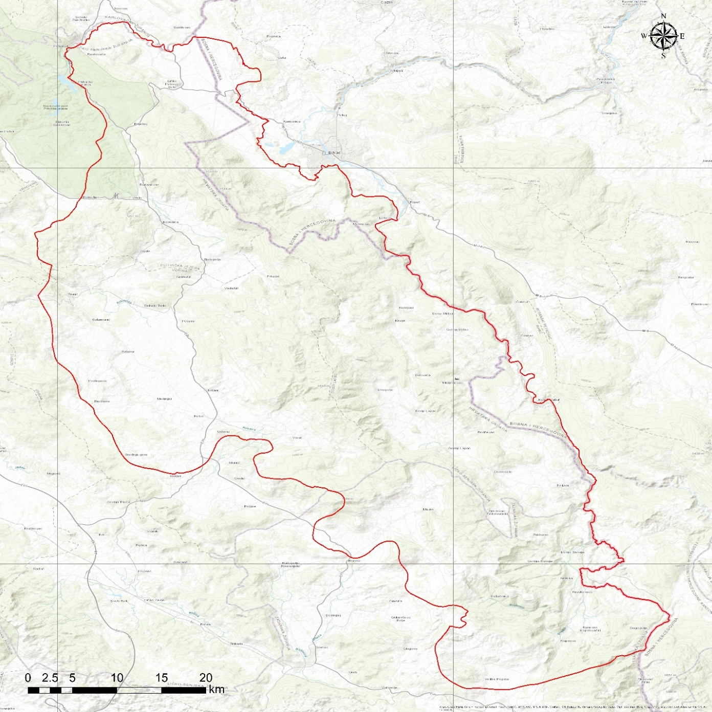
Figure 1 Topographic map with TBA UNA boundary

GEOLOGY
The geological structure of the Una Transboundary Aquifer (TBA) reflects the structural and stratigraphic complexity of the Dinarides. The aquifer is predominantly developed within Mesozoic carbonate formations that have been strongly affected by tectonic deformation. These geological conditions exert a major control on groundwater flow and discharge.

Tectonics
The terrain within the delineated Una Transboundary Aquifer (TBA) is characterized by a highly complex tectonic structure dominated by brittle deformation. Structural development is primarily controlled by normal and reverse faulting, while upright and overturned folds occur less frequently. Major faults define the boundaries between tectonic units and predominantly follow the Dinaric (NW–SE) strike, while a secondary fault system is oriented approximately perpendicular to this trend. Numerous minor faults and crushed zones further increase structural heterogeneity and strongly influence groundwater circulation.
From north to south, several major tectonic units are distinguished within the TBA: the Lika Highlands, Mala Kapela–Lička Plješivica, Kulen Vakuf–Čemernica, and Bihaćko Polje–Bosanski Petrovac units. The Mala Kapela–Lička Plješivica unit represents the central tectonic element of the northern part of the TBA and is composed predominantly of carbonate rocks.
Fault systems play a key hydrogeological role, as intensive karstification developed along fault zones, creating preferential groundwater flow paths. Faults oriented southwest–northeast, consistent withthe Dinaric structural trend, are particularly important, as they intersect older structures and enable groundwater flow perpendicular to the main strike of the mountain chains. Along these fault zones, dominant regional groundwater flow occurs from the Krbavsko and Koreničko Polje toward the Klokot and Privilica springs.

Geological characteristics
The oldest rocks exposed within the TBA are Permo–Triassic evaporitic sediments, which form an important subsurface barrier controlling the emergence of the Una River. These units are overlain by Lower Triassic clastic deposits, developed in the areas of Korenica, Bijelo Polje, Udbina, and the Kremen and Čemernica mountains. Middle Triassic formations are dominated by limestones, while Upper Triassic sequences consist mainly of dolomites.
Jurassic rocks form the largest and most continuous part of the aquifer system, particularly in the Donji Lapac area, along the margins of the Bruvno structural unit, and at the southwestern edge of the Krbava polje. Jurassic lithologies are dominated by limestones, with subordinate dolomites, providing high permeability and intensive karstification. Cretaceous carbonate rocks build most of the Plješevica massif, with limestones prevailing in the Lower Cretaceous and alternating limestones and dolomites in the Upper Cretaceous.
Paleogene deposits include Eocene carbonate rocks and coarse clastic breccias, while Neogene sediments are represented by Middle Miocene limestones, marls, and clastics in the Bihać Basin. Neogene clastic deposits play an important hydrogeological role, directing groundwater toward major karst springs such as Klokot and Privilica.
Quaternary deposits are widespread but generally thin and comprise Pleistocene sands and Holocene tufa, alluvial, deluvial, and marsh deposits distributed along river valleys and near major springs.
Red soils with limestone debris form a thin cover over carbonate bedrock, while sediments within karst poljes represent former paleolake environments and important zones of groundwater recharge and discharge. The Krbava polje is especially notable due to its large spatial extent and sediment thickness exceeding 80 m.

HYDROGEOLOGY

Hydrogeologcal characteristics
The Una TBA represents a hydraulically integrated karst groundwater system that extends across the territories of Croatia and Bosnia and Herzegovina. Groundwater recharge areas are predominantly located in Croatia, while major discharge zones, including large karst springs in the Una River valley, occur mainly in Bosnia and Herzegovina. This spatial separation of recharge and discharge areas defines the aquifer as a typical transboundary karst system.
The most significant hydrogeological collectors within the system are carbonate rocks—limestones, dolomitic limestones, and dolomites of Triassic, Jurassic, and Cretaceous age—characterized by well-developed karst–fracture porosity. In the Una River valley, springs commonly occur at the contact between permeable carbonate formations and underlying Triassic (T₁) and Paleozoic (P) clastic deposits, which act as basal hydraulic barriers and control the position of groundwater discharge.
Lithological and structural conditions strongly control subsurface flow directions. The aquifer occupies an extensive karst area extending from the Korana River basin in the northwest to the Velika Popina area in the southeast. It includes the mountainous massifs of Lička Plješevica, Čemernica, Mala Kapela, and parts of the Lika Sredogorie, as well as major karst poljes such as Koreničko Polje, Bijelo Polje, Krbavsko Polje and Lapačko Polje. Numerous tracer tests have confirmed that all these karst poljes are hydraulically connected to springs along the Una River.
The Lička Plješevica massif consists of interbedded Jurassic and Cretaceous carbonate rocks forming a synclinal structure which, despite its pronounced morphology, does not act as a barrier to groundwater flow.
Groundwater from karst poljes located on the southwestern side of the massif flows through the masiff toward major springs in the wider Bihać area, including the Klokot and Ostrovica springs. Tracer tests confirm groundwater connections from the Korana River zone as well as from the Koreničko and Krbavsko poljes. Koreničko Polje functions as a groundwater “stepping zone,” hosting permanent springs fed from the Mala Kapela massif. In contrast, Krbavsko Polje is characterized by less productive karst springs due to its relatively small recharge area within the Lika Sredogorje. During periods of intense precipitation, however, groundwater inflow exceeds the capacity of ponor zones, resulting in temporary flooding of the lowest parts of the polje.
Lapačko Polje represents a continuation of the Lička Plješevica massif toward the Čemernica area. Although it differs significantly in geological composition, it exhibits a similar hydrogeological function. During dry summer periods, this karst polje is practically devoid of active springs, explaining why water supply for the town of Lapac relies on the Ostrovica spring near Vakuf, located in the neighboring country. During wet periods, significant groundwater inflow enters the polje and subsequently infiltrate back into the karst subsurface along the margins of the polje. Tracer tests conducted in the ponor zones have confirmed hydraulic connections with the Ostrovica spring in the Una River valley.
The spring zone of the Una River in the Srb area is of particular hydrogeological interest. Springs emerge at the base of the Čemernica massif, whose upper parts are composed of impermeable Triassic clastic rocks. Under typical anticlinal conditions, such springs would be expected to have limited discharge; however, in this case, impermeable clastic formations overlie permeable carbonate rocks, enabling groundwater inflow from more distant recharge areas within the Lika karst. Tracer tests have confirmed connections between minor ponor zones on the western side of the massif near Mazin and the Ostrovica spring near Vakuf. Groundwater inflows toward the Una River source zone are also linked to recharge areas in Lika, although these connections have not yet been directly confirmed by tracer tests.
Local groundwater accumulations of low productivity have developed within Upper Cretaceous flysch formations. Neogene sediments act as confining cover units above the karst aquifers, while Permian–Werfenian formations represent basal impermeable barriers to the movement of groundwater.

General directions and rate of groundwater flow
The Transboundary Aquifer Una (TBA Una) is developed predominantly within Mesozoic carbonate rocks, mainly limestones, with subordinate occurrences of Jurassic and Triassic limestones. These rocks are intensely fractured and faulted, providing high surface infiltration capacity that enables rapid recharge of the aquifer by precipitation and sinking streams. The main recharge area of the aquifer is in the territory of Croatia.
General groundwater flow directions are oriented exclusively from Croatia toward Bosnia and Herzegovina, as demonstrated by numerous dye tracing tests that cross the international boundary. These results confirm the transboundary character of the aquifer and indicate that groundwater circulation is directed toward major discharge zones along the Una River valley. The absence of a clear relationship between hydraulic gradient and groundwater velocity confirms that groundwater flow is governed primarily by conduit development and tectonic control rather than by gradient-driven conditions. The highest tracer recoveries were recorded at the most productive karst springs, emphasizing their role as principal drainage outlets of the karst groundwater system.
Groundwater flow is predominantly aligned with the NW–SE Dinaric structural trend, which provides more favorable hydrogeological conditions and higher flow velocities compared to the transverse NE–SW direction (Figure 2).
The overall circulation pattern consists of local flow paths between nearby ponors and springs, intermediate connections across karst poljes, and dominant regional flow systems draining extensive recharge areas of the Lika karst toward major springs in the Una River valley.
Measured groundwater flow velocities range from approximately 0.11–0.22 cm/s (from the Prijeboj ponor toward the Privilica and Žegar springs) up to 14.64 cm/s (from the Donji Lapac ponor to the Ostrovica spring), with the most common velocities ranging between 1 and 4 cm/s.
In Bosnia and Herzegovina, smaller springs contributing to groundwater discharge include Toplica–Klisa, Ilijića Vrelo, Panjak, Bistrica, Žegar, Đakulin Loskun, Crnoć–Nebljuši, and Draga. In Croatia, the main springs include Koreničko, Čuić, Krčevine, Krbavica, Udbina, Joševica, Mala Nateka, Velika Nateka, and the Una springs. The combined minimum discharge of the springs in Croatia is approximately 0.68 m³/s.
Some springs feeding Una River (Klokot, Privilica) have the stable isotope signature of the Plitvice catchment, which suggests a hydrologic connection of these two systems and the same infiltration area in Croatia. The more positive deuterium values of the Una River catchment suggest another infiltration area more in the south and closer to the moisture source from the Adriatic Sea and indicate lower mean altitude of recharge area of Una River (average altitude 230 m a.s.l.) than that of the Plitvice Lakes catchment (average altitude 700 m a.s.l.). (Babinka, 2007)
Besides the groundwater flow from the karst fields in the south of the Plitvice Lakes to Una River, which have been proven with dye and isotopic methods, the stable isotope pattern also suggests a groundwater flow from the north side of the Plitvice Lakes towards Una River. This hypothesis is emphasized by a very similar isotopic signature of Korana River (Plitvice Lakes) and the springs Klokot and Privilica near Bihać. (Babinka, 2007).

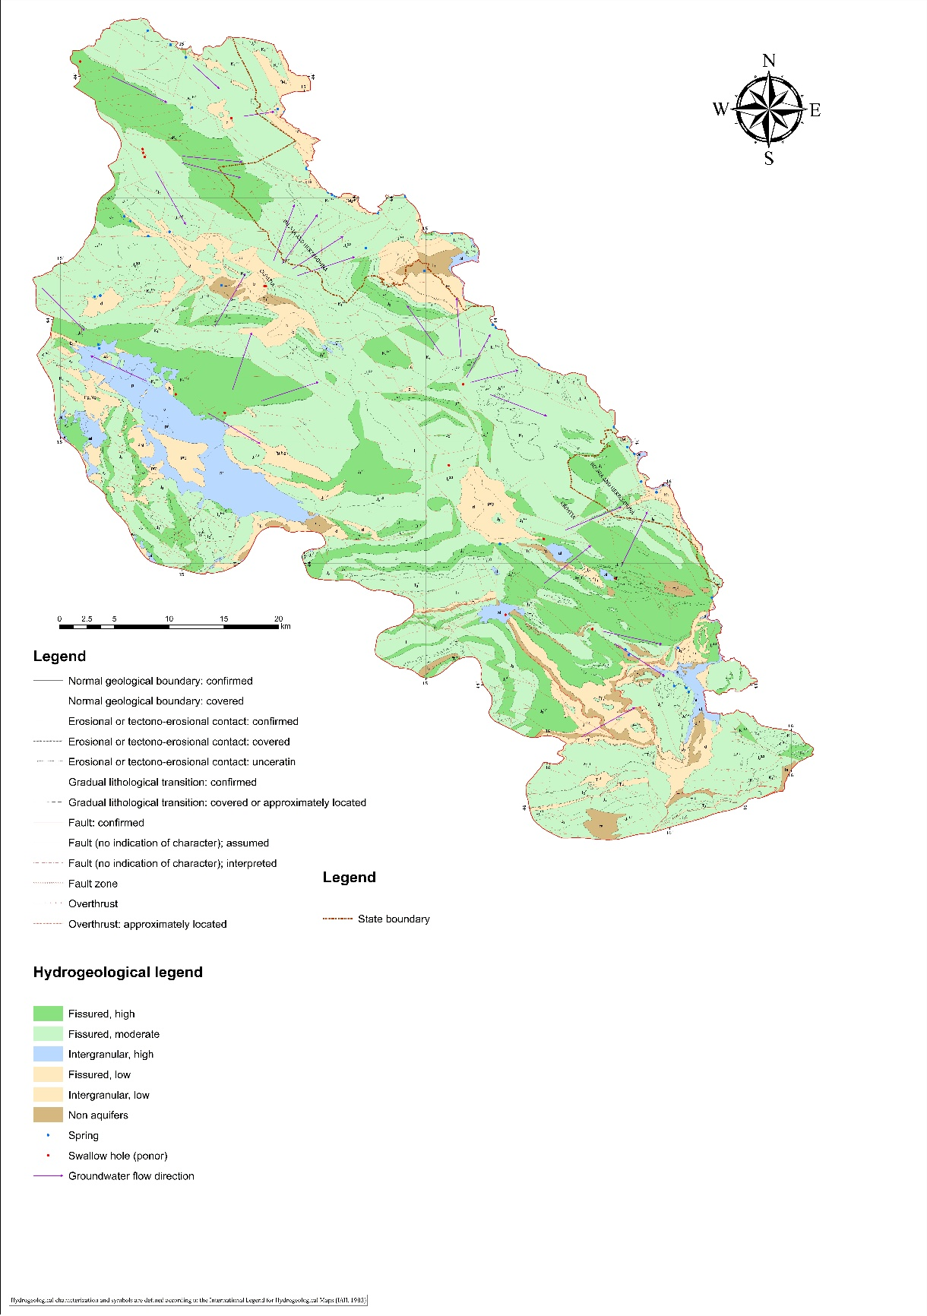
Figure 2: Hydrogeological map

Hydrogeological Units and Aquifer Characteristics
Based on lithological composition, rocks and deposits in the investigated area can be classified into units with intergranular porosity and rocks with fissured–cavernous porosity. According to permeability criteria, both permeable and impermeable formations are present.
Considering lithological composition, porosity structure, spatial relationships of the identified geological units, and the permeability of rocks and deposits, and in accordance with the International Legend for Hydrogeological Maps (UNESCO, 1983), the following hydrogeological environments have been distinguished:
Intragranular aquifers
  - Extensive and highly productive aquifers
  - Local or discontinuous productive aquifers, or extensive but moderately productive aquifers
Fissured aquifers, including karst aquifers
  - Extensive and highly productive aquifers
  - Local or discontinuous productive aquifers, or extensive but moderately productive aquifers
Strata (Intergranualr of fissured rocks) with local and limited groundwater resources, or strata with essentialy no groundwater resources
  - Strata with local and limited groundwater resources
  - Strata with essentially no groundwater resources
The most important hydrogeological collectors are carbonate rocks—limestones, dolomitic limestones, and dolomites of Triassic, Jurassic, and Cretaceous age characterized by karst–fracture porosity. Due to their great thickness and relatively limited surface exposure, significant vertical variations in permeability occur. These rocks host typical karst aquifers, characterized by rapid groundwater exchange, resulting in pronounced discharge fluctuations of karst springs. The underlying horizon is characterized by a lower degree of karstification and slower siphonal groundwater circulation; it is mostly covered by Neogene aquitards and contains a confined (artesian) aquifer.
The aquifers exhibit high filtration capacity, rapid groundwater exchange and circulation of sinking waters, and irregular hydraulic connections. Groundwater-level fluctuations are very large and variable, and the spring discharge variability coefficient (Qmax/Qmin) typically exceeds 10.

CONCEPTUAL MODEL OF THE TBA UNA AS FUNDATION FOR MONITORING DESIGN
Conceptual hydrogeological model provides a simplified but scientifically robust representation of the groundwater system, integrating geological, structural, and hydrogeological information into a unified framework. In complex karst environments such as the TBA Una, groundwater flow is highly heterogeneous and structurally controlled, making conceptualization essential for understanding recharge, flow, and discharge processes.
The conceptual model identifies the main recharge areas, dominant groundwater flow pathways, storage zones, and discharge locations, as well as their mutual hydraulic relationships. It incorporates the results of geological investigations, hydrogeological characterization, and tracer tests to identify key elements controlling groundwater circulation.
This integrated understanding forms the basis for designing of an effective groundwater monitoring system, allowing for the selection of representative monitoring locations, relevant parameters, and appropriate monitoring frequencies. By linking system behavior with monitoring objectives, the conceptual model ensures that monitoring activities adequately reflect the dynamics of the karst aquifer and support groundwater protection and sustainable management.

HYDROGEOLOGIC UNITS
Based on lithological composition, type of porosity, hydraulic properties, and groundwater availability, hydrogeological environments within the study area were first classified in accordance with the Legend for Hydrogeological Maps (UNESCO, 1983). This classification distinguishes intergranular aquifers, fissured and karst aquifers, as well as strata with limited or negligible groundwater resources.
For the purposes of the conceptual hydrogeological model and monitoring design, these environments are further grouped into three principal hydrogeological units according to their permeability and hydraulic function within the groundwater system: aquifers, aquitards, and aquicludes.
This functional classification provides a simplified and operational framework for describing groundwater flow, recharge, storage, and discharge processes within the Transboundary Aquifer Una.
Accordingly, aquifers represent permeable geological units with significant groundwater storage and transmission capacity, aquitards comprise less-permeable units that restrict groundwater flow and act as partial hydraulic barriers, while aquicludes consist of nearly impermeable formations that form effective boundaries to groundwater movement.
AQUIFERS – PERMEABLE LAYERS
The most significant hydrogeological collectors are carbonate rocks – limestones, dolomitic limestones, and dolomites of Triassic, Jurassic, and Cretaceous age, characterized by karst–fracture porosity and high to moderate permeability .
Limestones of the Cretaceous (K₂¹ , K₂¹⁺² , K₂^{1,2}, K₂¹⁻², ₁₋₃K₂). the Jurassic (J₁¹⁻³ , J₁¹⁻⁴, J₁³, J₁⁴ , J₂ ) and, to a lesser extent, the Midlle Triasic in southern part of TBA (²T₂¹ , ²T₂² ) belong to the group of high permeability rocks.
Rocks with fissured porosity and moderate to locally high permeability include Triasic sediments (T₁² , T₂¹ , T₂² , T₃ , T₃^{2,3}), Jurassic formations – predominantly dolomites and limestones (J₁ , J₁^{1,2} , J₁¹⁻³ , J₁¹⁻⁴ , J₁¹ , J₁³, J₁⁴, J_{2 ,} J₃^{1,2} , J₃^{2,3}) as well as Cretaceous sediments (K₁, K₁¹⁺², K₁¹⁻³ , K₁³⁻⁵ , K₂¹ , K₂^{1,2} , K₂¹⁺²) and tufa deposits (i).
The limestones are mostly well stratified, with typical bed thicknesses of 20–50 cm, locally increasing to thicker or even massive varieties. Smaller interbeds and lenses of dolomite are locally present within limestone sequences.
From a hydrogeological perspective, secondary porosity dominates in these rocks, primarily in the form of fracture and fracture–dissolution porosity, while cavernous porosity may also occur in the subsurface. This porosity developed as a result of tectonic fracturing and intensive karstification along faults and fracture systems. Consequently, these rocks are characterized by high vertical and horizontal permeability, enabling effective infiltration of precipitation and horizontal groundwater circulation. Numerous ponors and karren have developed on the surface.
Due to intense tectonic deformation, fracturing, and karstification of the rock mass, a highly specific surface and underground hydrographic network has developed within the limestone terrains. Where Triassic, Jurassic, and Cretaceous limestones and dolomites crop out, groundwater recharge occurs through direct infiltration of precipitation, as well as by subsurface inflow from the west and southwest.
Groundwater is stored within underground retention zones developed along networks of fissures and conduits, depending on the depth and degree of karstification. Drainage predominantly occurs at the lowest erosion base, through springs of variable discharge capacity. Jurassic and Cretaceous limestones form the principal aquifers of the Klokot and Privilica spring catchment, which are largely discharged along the southwestern margin of the Bihaćko Polje at the Arkovac, Klokot, Vedro Polje, Žegar, Privilica, and Dobrenica springs.
These rocks constitute the majority of the terrain with a hydrogeological function of permeable areas and are marked in dark green and green in Annex 2.
Aquifers also include deposits with intergranular porosity and high permeability, represented by Quaternary sediments of various genetic types: proluvial deposits (pr), sandy deposits (p), alluvial deposits (al), and gravelly deposits (s). Lithologically, these deposits consist predominantly of coarse clastics, including gravels, sands, and sandy clays.
They are mainly distributed within alluvial sediments formed by the recent courses of the Una and Korana rivers, as well as by watercourses traversing the Krbavsko Polje. Deposits formed by watercourses with a high sand content are also present in this area.
Although alluvial sediments are generally considered aquifers, in this case, due to the pronounced karstification of the underlying bedrock, groundwater readily infiltrates into the karstified subsurface, limiting long-term groundwater retention within the Quaternary cover.
AQUITARDS – LESS-PERMEABLE LAYERS
Low-permeability clastic deposits and rocks with fissured and intergranular porosity are classified as aquitards. These include both low-permeability clastic deposits and low-permeability carbonate rocks.
Low-permeability clastic deposits identified along the eastern marginal part of the investigated area (Bihaćko Polje) comprise limited outcrops of limestone marls, marls, and tuffs with coal interbeds of Miocene age (M₂, ¹M₂ , ²M₂). Due to their restricted spatial distribution, these deposits function only as local hydrogeological barriers.
Low-permeability Triassic formations include clayey limestones ²T₁) and consolidated breccias (¹T₂). middle and upper Triassic formations represented by marls, volcanogenic sediments, sandstones, breccias, conglomerates, limestones, clastites, and rare dolomite interbeds (T₂², T₃¹⁻²) as well as dolomites with clay, tuffites, and breccias (¹T₃).
Jurassic low-permeability units include dolomites and flaggy limestones with cherts and breccias (J₃^{2,3}), limestones with clayey breccia interbeds (J₃¹⁺²), and quartz sandstones with gypsum (J₃2,3). Paleogene and Neogene deposits such as limestone breccias and conglomerates (Pg, Ng), as well as marls (Pl), also belong to this group.
Quaternary deposits with low permeability are also distinguished, including silty clay deposits (prg), deluvial deposits (d), marsh deposits (b), and terra rossa and slope sediments (ts: red soils, loams, gravels, and sands). These deposits occur at several locations within the investigated area, shallow aquitards. Marsh sediments consist of clays of various colours, silty sands, and gravels covered with humus.
These deposits are generally of small thickness and variable lithological composition. Although composed of mixed clastic material, clay and silt fractions dominate, resulting in low hydraulic conductivity, depending on deposit thickness.
Due to their complex and insufficiently understood structural relationships, these rocks are interpreted as relative hydrogeological barriers to karst groundwater flow. They form groundwater bodies of very limited capacity and act as basal barriers to the karst aquifers developed in Jurassic i Cretaceous limestones and dolomites.
AQUICLUDES – NEARLY IMPERMEABLE LAYERS
Impermeable or nearly impermeable deposits (aquicludes with locally permeable interbeds) in the investigated area include Lower Triassic (T₁¹) formations, composed of sandstones, schists and limestone breccias of the Seisian stage, as well as schists, sandstones, limestones and dolomites of the Campilian stage (T₁²). Within these formations, individual lithological members locally exhibit partial or even moderate permeability; however, such occurrences do not affect the overall impermeable character of the formations.
In the investigated area, these deposits form a hydrogeological barrier at the base of more permeable units. Impermeable rocks of this type occur primarily in the Krbavsko Polje area and in the south-western part of Koreničko Polje, in the transitional zone toward Bijelo Polje.
Additional impermeable Triassic deposits are distinguished in the central and southern parts of the study area, east and west of Stražbenica. These units are represented by red sandy–marly schists (¹T₁) and various clastic rocks, including shaly marls, tuffs, limestones with cherts, and related lithologies. Deposits of tuffitic clastics of Upper Triassic age (T₃^{1–2}) are also included in this group. Owing to their lithological composition and low hydraulic conductivity, these formations act as regional aquicludes, limiting vertical groundwater flow and forming the basal boundary of karst aquifers.
Based on lithological composition, type of porosity, hydraulic properties, and groundwater availability, hydrogeological environments within the study area were first classified in accordance with the Legend for Hydrogeological Maps (UNESCO, 1983). This classification distinguishes intergranular aquifers, fissured and karst aquifers, as well as strata with limited or negligible groundwater resources.
For the purposes of the conceptual hydrogeological model and monitoring design, these environments are further grouped into three principal hydrogeological units according to their permeability and hydraulic function within the groundwater system: aquifers, aquitards, and aquicludes.
This functional classification provides a simplified and operational framework for describing groundwater flow, recharge, storage, and discharge processes within the Transboundary Aquifer Una.
Accordingly, aquifers represent permeable geological units with significant groundwater storage and transmission capacity, aquitards comprise less-permeable units that restrict groundwater flow and act as partial hydraulic barriers, while aquicludes consist of nearly impermeable formations that form effective boundaries to groundwater movement.

SOURCES OF RECHARGE
Recharge represents the process by which water enters and replenishes the groundwater system. In the investigated karst area of the Una River catchment, recharge is primarily controlled by climatic conditions, lithology, surface morphology, and the degree of karstification.
There are two main mechanisms of groundwater recharge: infiltration of rainwater and direct percolation of surface water into underground aquifers. Direct infiltration of precipitation occurs over extensive karst terrains composed of highly permeable limestones and dolomites, where well-developed karst–fracture porosity enables rapid infiltration with minimal surface runoff, particularly in areas with limited soil cover.
Additional recharge occurs through direct percolation of surface water, including losing streams, sinking streams, and ponors, which represent highly efficient and concentrated recharge pathways into the karst aquifer system.
From a groundwater protection perspective, ponors and sinkholes are particularly important, due to the direct hydraulic connection between surface water and groundwater through karst formations, with sinkholes and ponors being the most dominant recharge features in this region. Permanent sinkholes are generally more active and drain larger catchment areas
These recharge mechanisms represent the initial component of the recharge–flow–discharge sequence illustrated in the conceptual hydrogeological model and form a key basis for defining groundwater vulnerability and the design of an appropriate monitoring network.

Precipitation
Precipitation data are presented in Figure 4, which shows the spatial distribution of average annual precipitation as a raster map. The analysis is based on data from 567 main, climatological, and rain gauge stations, using average daily precipitation records for the reference period 1961–1990. The precipitation map was generated using the regression kriging method, with a raster resolution of 1 × 1 km, covering the territory of the Republic of Croatia. The territory of Bosnia and Herzegovina is not included in the raster dataset. However, precipitation analysis for the same reference period at the Bihać meteorological station, considered representative station for the B&H part of the Una TBA, indicates a mean annual precipitation of 931.9 mm, which is consistent with precipitation amounts observed in the lower reaches of the Una River basin.
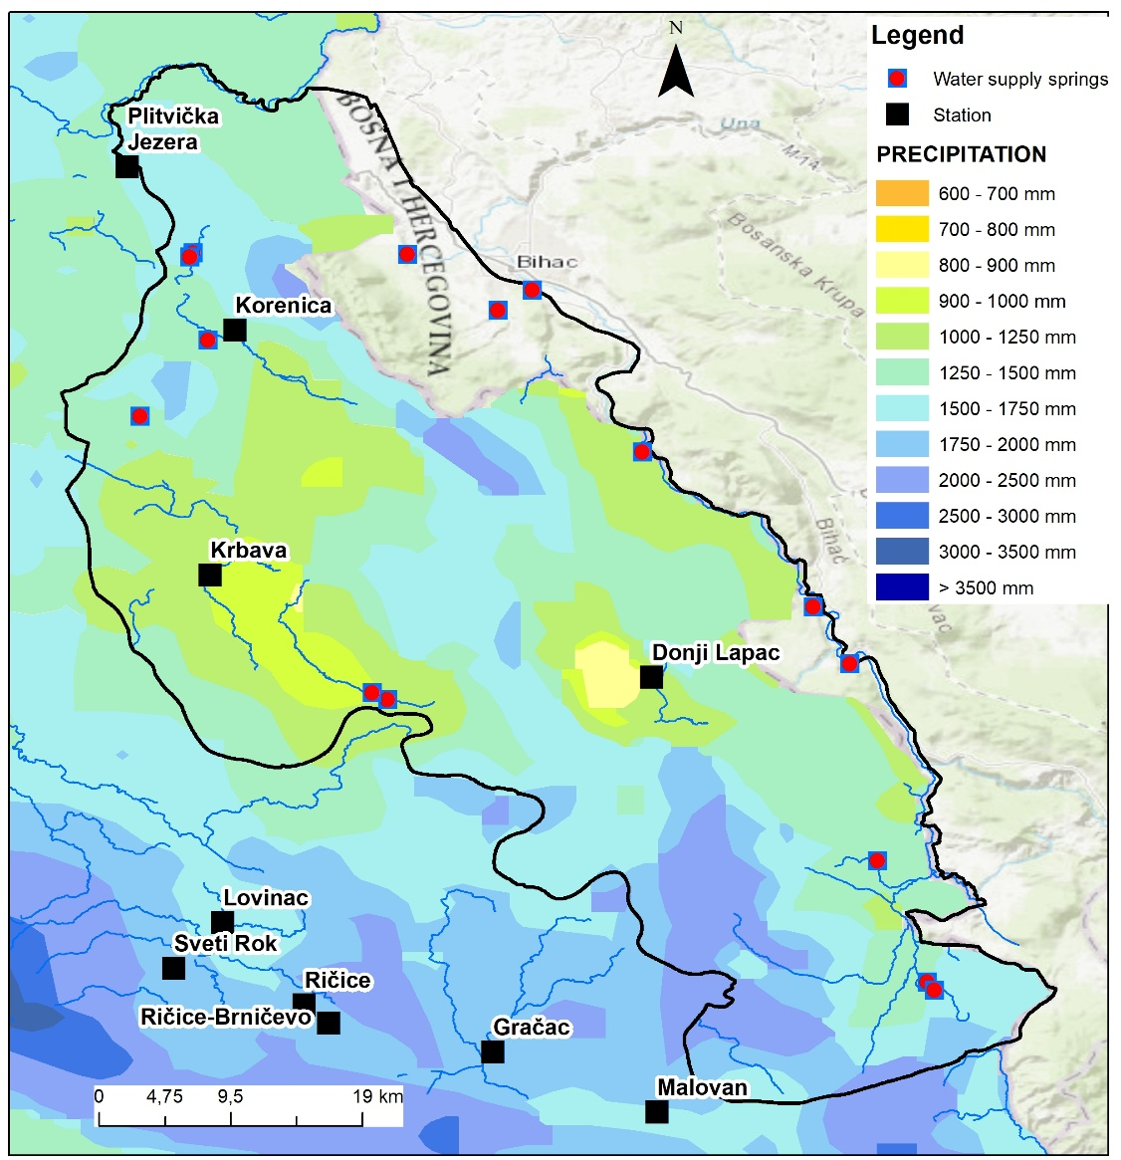
Figure 3: Spatial distribution of average annual precipitation
The spatial distribution of precipitation exhibits pronounced variability, largely controlled by topography and orographic effects. Higher precipitation values are associated with elevated karst terrains and mountain massifs, while lower values occur in karst poljes and valley areas. This pattern is consistent with the Dinaric karst setting and strongly influences groundwater recharge conditions.
In the context of the conceptual hydrogeological model, precipitation represents the primary and most widespread recharge input to the karst aquifer system. Due to the high permeability and well-developed karst–fracture porosity of carbonate rocks, a substantial proportion of precipitation infiltrates directly into the subsurface, with limited surface runoff.
Areas characterized by higher precipitation totals coincide with the main recharge zones, supplying groundwater to regional flow systems that discharge toward major springs in the Una River valley. Consequently, the precipitation pattern shown in Figure 4 provides a key framework for understanding recharge distribution and for defining priority areas in groundwater monitoring and protection.

Losing streams and sinkholes as concentrated recharge mechanisms
In the karst environment of the Una TBA, losing streams, sinking streams, and ponors represent closely related manifestations of the same recharge mechanism, whereby surface water is directly transferred into the groundwater system through hydraulically connected karst features.
In the Una karst system, water losses are particularly pronounced within karst poljes, where surface streams commonly disappear into the subsurface through ponors and fractured carbonate beds. River and stream sections flowing over karstified limestones and dolomites allow rapid infiltration through open fractures, enlarged fissures, and sinkhole zones, resulting in concentrated recharge directly into the karst aquifer.
Recharge through losing streams is strongly seasonal. During periods of high water levels, large volumes of surface water are rapidly transferred into the subsurface, activating deep conduit systems and contributing to regional groundwater flow toward major discharge springs. During low-flow periods, surface-water losses are reduced or intermittent, and recharge is limited to permanent ponors and active fracture zones.
Sinkholes (ponors) represent direct and highly efficient entry points into the karst aquifer system. Recharge through ponors is typically rapid and concentrated, bypassing the soil zone and entering the subsurface through open conduits, fractures, and karst channels. As a result, this type of recharge is characterized by minimal natural filtration, making ponors particularly sensitive points with respect to groundwater quantity and quality.
Due to their hydraulic efficiency, ponors exert a strong control on groundwater flow patterns, influencing both the direction and velocity of subsurface circulation within the karst system.
Tracer tests and hydrogeological investigations have demonstrated that sinkhole–spring relationships in the investigated area are complex and highly dispersed. A single ponor may be hydraulically connected to several springs, while individual springs may receive recharge from multiple ponors. These relationships reflect the presence of a branched and heterogeneous conduit network, operating at local, intermediate, and regional scales.
Table 1: Sinkhole–spring hydraulic connections identified by tracer tests
SINKHOLE | CONNECTION SPRING
Ponor u Dnopolju | Ostrovica,
Ponor u Dnopolju | Toplica
Ponor u Dobroselu | Ostrovica
Ponor na Lapčkom polju (Bare) | Ostrovica
Ponor na Lapčkom polju (Bare) | Dobrenica
Ponor Jaruga - Vidrovac | Klokot I
Ponor kod Korenice | Klokot I
Ponor kod Korenice | Klokot II
Ponor kod Korenice | Ilića Vrelo
Ponor kod Korenice | Vedro polje - Panjak
Ponor u Mazinu | Ostrovica
Jama kod Vijenca | Toplica
Jama kod Vijenca | Crno vrelo
Jama kod Vijenca | Loskun-Pećina
Jama kod Vijenca | Loskun-Džakula
Jama kod Vijenca | Dobrenice – Lijepa voda
Jama kod Vijenca | Dobrenica
Jama kod Vijenca | Piskovac
Rastovača | Klokot
Prijeboj 1 | No confirmed connections; several connections are assumed.
Željava | Klokot I
Željava | Klokot II
Željava | Privilica
Željava | Žegar
Željava | Arkovac
Željava | Briševac
Brezovac Dobroselski | Joševica
Brezovac Dobroselski | Samac
Brezovac Dobroselski | Kamčarovac
Brezovac Dobroselski | Vrelo Une
Brezovac Dobroselski | Mala Neteka
Brezovac Dobroselski | Velika Neteka
Koreničko polje | Klokot I
Koreničko polje | Klokot II
Koreničko polje | Privilica
Koreničko polje | Dobrenica
Koreničko polje | Ilica Vrelo
Prijeboj 2 | Klokot I
Prijeboj 2 | Klokot II
Prijeboj 2 | Žegar
Prijeboj 3 | Klokot I
Prijeboj 3 | Klokot II
Pejićev ponor | Klokot I

Several ponors, including those in Donje Polje, Dobroselo, Mazin, and Koreničko Polje, predominantly drain toward the Ostrovica spring, indicating a major regional flow pathway toward the Una River valley. Other ponors, such as Jaruga–Vidrovac, Rastovača, Pejićev ponor, and ponors near Korenica, show strong connections to Klokot I and Klokot II, confirming the role of the Klokot spring system as the principal regional discharge zone.
Highly dispersed hydraulic connections are observed at Željava and Prijeboj, where tracer tests indicate links to multiple springs, including Klokot I, Klokot II, Privilica, Žegar, Arkovac, and Briševac. These ponors function as major distributive nodes, capable of recharging several flow systems depending on hydraulic conditions. Figure 5 illustrates the spatial distribution of sinkholes, springs, and their hydraulic interconnections.
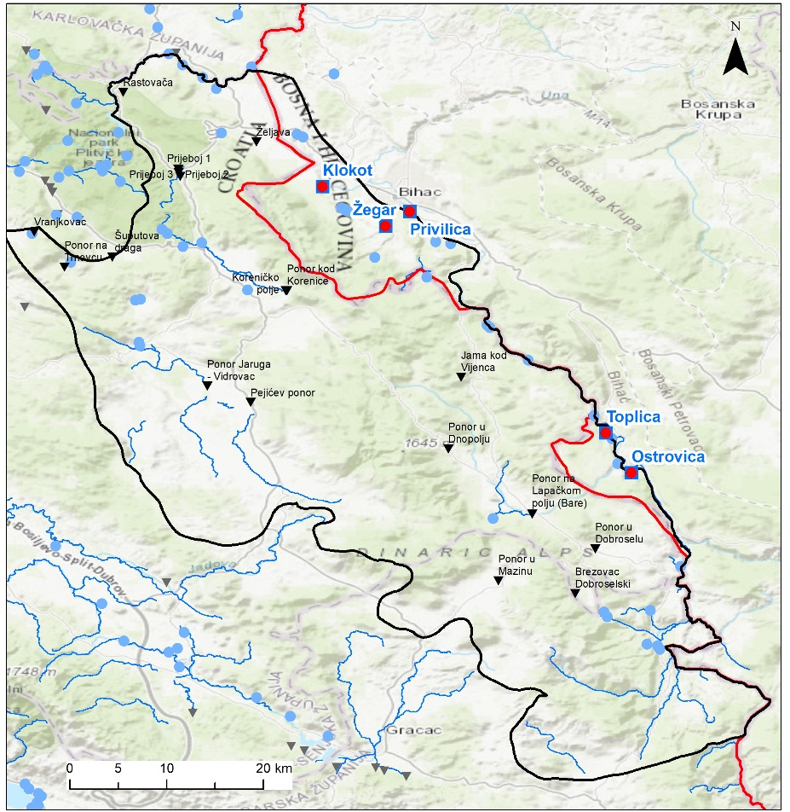
Figure 4: Spatial distribution of sinkholes, springs and rivers
The identified recharge mechanisms demonstrate that losing streams and ponors represent key control points within the karst groundwater system, governing the initiation, direction, and distribution of subsurface flow. The direct hydraulic linkage between recharge areas, conduit-controlled flow paths, and discharge springs results in rapid groundwater circulation and strong hydraulic connectivity across the system.
Because recharge through losing streams and ponors bypasses natural filtration, the karst aquifer exhibits high vulnerability to contamination. Consequently, these features represent priority locations for groundwater monitoring, both in terms of water quantity and water quality. Once groundwater enters the karst aquifer through these natural recharge mechanisms, its circulation occurs through a complex network of fissures and conduits, as described in the following section on the groundwater flow system.
Artificial groundwater recharge and irrigation return flow are not present in the investigated area. Groundwater recharge is therefore entirely controlled by natural processes, including precipitation infiltration, losing streams, and concentrated recharge through ponors and sinking streams.

Groundwater Flow System
Recharge from extensive karst terrains surrounding the Krbavsko, Prijeboj, and Koreničko Polje karst fields, as well as from the Plješivica Mountain massif, drains toward major springs in the Bihać valley, ranging from Klokot to Dobrenica. Additional karst poljes east of the Una River (Gornje and Donje Lapačko, Mazin, and Bijelo Polje) discharge groundwater to springs along the Una River valley between Dobrenica and Ostrovica.
In the Lika karst poljes on the left bank of the Una River, groundwater circulation occurs through both diffuse and concentrated sinking flow paths, draining toward one or more springs located at significantly lower elevations (<380 m a.s.l.) in the Una canyon and valley. Some ponors, particularly Donji Lapac and Prijeboj, also show local and intermittent hydraulic connections toward higher karst levels (>570 m a.s.l.) within the Lika massif (Gornji Lapac, Krbava, Koreničko Polje). These upward connections are characterized by lower hydraulic gradients and limited hydraulic significance. Overall, the dominant regional groundwater flow direction is toward the Una River valley, with the notable exception of the Prijeboj–Mirić Štropina connection draining toward the Korana River basin.
Tracer tests indicate that the main groundwater flow directions from high-elevation and high-infiltration ponors are oriented toward the north and northeast, while ponors at lower elevations exhibit greater dispersion toward multiple springs. Prijeboj is unique in showing hydraulic connections in all directions. Flow paths are strongly controlled by lithology and tectonic structure. Groundwater flow directions from recharge areas toward discharge zones are indicated by arrows in the conceptual sketch, highlighting dominant northward and northeastward regional flow toward the Una River valley.
Measured apparent groundwater velocities range from 1.4 to 14.6 cm/s, confirming highly developed conduit flow. Koreničko Polje shows dispersed discharge toward several springs (Klokot, Vedro Polje, Privilica, Dobrenica), although the largest proportion of flow is directed toward the Klokot spring. Krbavsko Polje is hydraulically connected exclusively to Klokot, whereas ponors in Donji and Gornji Lapac and Brezovac drain predominantly toward Ostrovica. Mazin shows a single connection to Ostrovica.
Most ponors (Željava, Vučjak, Prijeboj, Korenica, Krbava) belong to the Klokot spring catchment. Separate deep conduit pathways from Krbava and Korenica toward Klokot are inferred, supported by tracer studies indicating a vertical supply conduit exceeding 110 m in depth. During high-water conditions, Prijeboj acts as a major distributive node, connecting simultaneously to the Una valley, Krbavsko and Koreničko Polje, and the Plitvice area.
A distinct and anomalous northwest-directed groundwater flow from the Vučjak ponor toward Klokot was identified, representing an inverse flow direction relative to other documented connections.
No systematic relationship between hydraulic gradient and groundwater velocity was observed, indicating that structural and conduit-controlled flow dominates over gradient-controlled flow in the karst aquifer system.
The results of tracer tests conducted in the Una River catchment indicate a highly complex and ramified karst drainage system, characterized by rapid, concentrated, and frequently multidirectional groundwater flow. Subsurface connections between swallow holes in the karst poljes of the Lika region and springs in the Bihać area are controlled by privileged karst conduits, whereby a single ponor may be hydraulically connected to one or several springs, while multiple ponors may contribute to the discharge of a single spring.
Hydraulic head distribution is controlled by elevation differences between recharge areas located at higher karst plateaus and discharge areas at significantly lower elevations within the Una River valley.
Most swallow holes exhibit dispersed recharge patterns with pronounced branching of underground flow paths, particularly those located at higher elevations (Prijeboj, Koreničko Polje, Krbavsko Polje). In contrast, ponors situated at lower elevations (Vučjak, Željava) display lower dispersion and higher groundwater velocities, indicating a more mature and hydraulically efficient karstification in zones closer to the main discharge areas.
During high-water conditions, a larger number of underground connections becomes active, including secondary flow paths, whereas under low-flow conditions groundwater drainage is largely restricted to deep, well-developed karst conduits. More distant karst poljes (Krbavsko and Koreničko Polje) predominantly drain toward the lowest and most productive springs (Klokot and Ostrovica), while connections to smaller springs are limited or intermittent.
Tracer test results demonstrate that groundwater velocities are not correlated with hydraulic gradient, confirming the dominance of conduit-controlled flow and strong structural control over groundwater circulation. The highest tracer recoveries were recorded at the most productive springs, emphasizing their role as principal drainage outlets of the karst aquifer system.
The Dinaric structural trend (NW–SE) provides more favorable hydrogeological conditions and higher groundwater velocities compared to the transverse NE–SW direction, highlighting the fundamental role of tectonic structures in the development and functioning of the karst aquifers.
The groundwater flow system can be subdivided into local, intermediate, and regional components. Local flow systems are represented by short and shallow connections between nearby ponors and springs, particularly within individual karst poljes. Intermediate flow systems connect karst poljes to springs at moderate distances and elevations. Regional flow systems dominate the overall circulation, draining large recharge areas of the Lika karst toward major springs in the Una River valley.

DISCHARGE AREAS
Identifed locations where groundwater leaves the subsurface:
- Springs
- Gaining streams
- Wetlands
- Lakes and reservoirs
- Wells (pumping)
Discharge areas represent locations where groundwater leaves the subsurface and returns to the surface water system. In the investigated karst area of the Una River catchment, groundwater discharge is predominantly controlled by the structure and karstification of carbonate rocks, as well as by the position of the regional erosion base represented by the Una River valley.
Groundwater discharge occurs primarily through karst springs, while other discharge mechanisms such as gaining streams, wetlands, lakes, reservoirs, and pumping wells play a secondary or negligible role within the regional hydrogeological system.

Springs
Karst springs represent the dominant and most significant groundwater discharge features in the study area. The largest number of springs is located along the Una River valley, where groundwater drains from extensive recharge areas developed within the karst terrains of Lika and adjacent regions.
Several major springs are of particular importance due to their role in public water supply (Table 2). These springs exhibit pronounced variability in discharge, reflecting the rapid and conduit-controlled groundwater flow characteristic of karst aquifers.
The City of Bihać and its suburban settlements are supplied with drinking water from five karst springs and one subartesian well (table 2). Klokot Spring represents a groundwater source developed in karst aquifers, located approximately 6 km west of Bihać. The abstraction is performed at the spring of the Klokot River, which emerges from a karst cave situated at the foot of the Željava Plateau (Baljevac Polje). The minimum discharge of the spring is estimated at approximately 3 m³/s. Currently, about 250 l/s of water is abstracted through a concrete intake structure and transported for the water supply of the City of Bihać and surrounding settlements. The pumping station is equipped with four pumps serving two pumping directions: toward the urban water supply network via the Komarac reservoir, and toward suburban settlements via the Klokotska Glavica reservoir, supplying Klokot, Kamenica, Izačić, Turija–Vrsta, and Krnja Gata.
The Privilica spring is located in the settlement of the same name, on the left bank of the Una River, approximately 2 km upstream from the city center of Bihać. It represents a karst groundwater source. Water abstraction is performed through a longitudinal capture gallery. The pumping station contains four pumps serving two pumping directions: toward the urban network via the Debeljača reservoir supplying the city of Bihać, and via the Sokolac–Novi reservoir supplying suburban settlements including Sokolac, Orljani, Ribić, Golubić, Dobrenica, Lohovo, Pritoka, and Ripač. The total transport capacity is approximately 100 l/s, while the minimum discharge of the Privilica spring is about 50 l/s.
The Trebljenik–Žegar spring is located near Bihać, within the Grmeč military barracks, and forms an integral part of the Bihać water supply system. It represents a karst groundwater source.
The Žegar spring is captured at 5 l/s, while the minimum capacity of the source is approximately 3 l/s.
The Ostrovica spring is located on the left bank of the Una River, in the settlement of Kulen Vakuf, and represents a karst groundwater source. In the past, this source also supplied the municipality of Donji Lapac (Republic of Croatia), giving it a transboundary significance until Donji Lapac was connected to an alternative water source. The Ostrovica spring is a typical karst spring. A capture structure has been constructed at the spring, enabling abstraction of approximately 50 l/s, while the minimum discharge of the spring is estimated at 750 l/s. From the intake structure, water is pumped to a reservoir from which the settlement of Kulen Vakuf is supplied by gravity. From the same reservoir, water is pumped to the Kalati reservoir, from which, through several pressure-breaking chambers, the settlements of Klisa, Demirovića Brdo, and Poljice are supplied.
The Toplica spring represents a karst groundwater source located in the settlement of Klisa, on the left bank of the Una River, approximately 5 km north of Kulen Vakuf. A capture structure has been constructed at the spring, abstracting about 15 l/s for the supply of the settlements Orašci and Ćukovi, while the minimum discharge of the Toplica spring is approximately 100 l/s. The Toplica spring is a typical karst spring, recharged from a catchment area that lies predominantly within the territory of the Republic of Croatia.
The Gata source consists of subartesian wells with an abstraction capacity of approximately 8 l/s, while the minimum capacity is about 5 l/s. This source represents groundwater developed in karst aquifers.

Table 2. Watter supply springs
NAME | WATER SUPPLY COMPANY | WATER PERMINT (l/s)
Vrelo koreničko | Ličke vode | 60
Čujića Krčevine | Ličke vode | 15
Bukovac | Ličke vode | 7,5
Kraljevac | Ličke vode | Not in use
Krbavica | Ličke vode | 35
Joševica | Ličke vode | 34,50
Loskun | Ličke vode | 5
Kotlina | Vodovod Zadar | 15
Bijeli klanac | Vodovod Zadar | 15
Klokot | Vodovod i kanalizacija d.o.o. Bihać | 250*
Privilica | Vodovod i kanalizacija d.o.o. Bihać | 100*
Żegar- Trbljenik | Vodovod i kanalizacija d.o.o. Bihać | 5
Ostrovica | Vodovod i kanalizacija d.o.o. Bihać | 150*
Toplica | Vodovod i kanalizacija d.o.o. Bihać | 50*
Gata (Mlakulja) | Arteški bunar- toplice | 8
* From RBMP Sava, Annex 10-1

The spatial distribution and discharge behavior of springs indicate that they represent the terminal points of local, intermediate, and regional groundwater flow systems, as defined in the conceptual hydrogeological model.

Gaining streams
In addition to spring discharge, groundwater locally contributes to surface flow through gaining reaches of the Una River and its tributaries, particularly downstream of major karst springs. In these sections, groundwater inflow supports baseflow and contributes to maintaining river discharge during dry periods.
However, gaining stream conditions are spatially limited and represent a secondary discharge mechanism compared to concentrated discharge through karst springs.

Wetlands
Wetlands do not represent a significant component of groundwater discharge within the regional karst system. Where present, they are limited to small, local occurrences and are primarily associated with shallow groundwater conditions. Their influence on the regional groundwater balance is negligible.

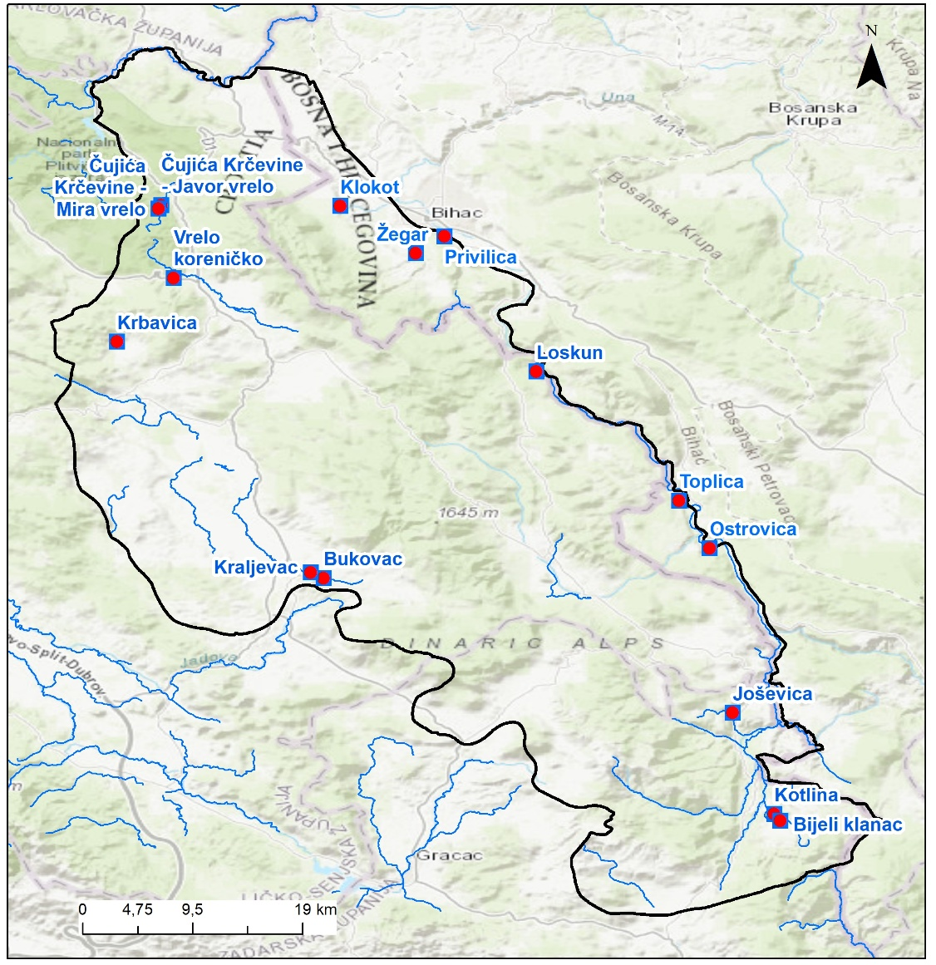
Figure 5: Spatial distribution of springs and rivers

Lakes and reservoirs
jejeNatural lakes and reservoirs do not constitute relevant groundwater discharge zones in the investigated area. No permanent surface water bodies exist that would significantly interact with the regional karst groundwater system in terms of discharge.

Wells (pumping)
Groundwater abstraction through pumping wells in the investigated area is generally limited and does not represent a major discharge component of the regional groundwater system. Water supply is predominantly based on karst springs, which constitute the primary groundwater discharge and abstraction points within the Una River catchment.
An exception is the Gata supply, which consists of subartesian wells developed in karst aquifers and used for public water supply (Table 2). The total abstraction capacity of this source is approximately 8 l/s, with a minimum yield of about 5 l/s. According to pumping records from 2022, the average abstraction rate amounted to approximately 5.2 l/s. Although this represents a localized form of groundwater abstraction, available data are insufficient to reliably assess the spatial extent of its influence, its impact on regional groundwater levels, or its interaction with nearby springs and surface waters.
Due to the limited number of pumping wells, relatively small abstraction rates, and the lack of long-term hydrogeological monitoring data, groundwater abstraction through wells is not considered a significant controlling factor of the overall groundwater discharge regime within the conceptual model. Consequently, well abstraction is treated as a local and secondary discharge component, while the regional groundwater system is dominated by natural discharge through karst springs.
Overall, groundwater discharge in the investigated area is strongly dominated by karst springs, which represent the primary outlets of the groundwater system and the most critical elements for groundwater management and protection. Other discharge mechanisms are of minor or local importance and do not significantly influence the regional groundwater flow regime.

BOUNDARIES OF THE MODEL
The conceptual hydrogeological model defines the spatial and hydraulic limits of the groundwater flow system by identifying physical and hydraulic boundaries that control groundwater movement. In karst environments, these boundaries are often diffuse and structurally controlled; nevertheless, they can be conceptually classified into no-flow boundaries, constant-head boundaries, and recharge boundaries.
No-flow boundaries represent zones across which groundwater flow is negligible or absent. In the investigated area, such boundaries are primarily associated with low-permeability or impermeable lithological units and locally developed aquicludes, which form the basal boundary beneath the karst aquifers and limit vertical groundwater circulation. These units define the lower extent of the active karst flow system. In addition, certain tectonic structures, such as faults and fault zones filled with clayey or crushed material, may locally act as lateral no-flow boundaries. However, due to the heterogeneous nature of karst systems, the hydraulic role of faults is spatially variable, and some structures may function as preferential groundwater flow paths rather than barriers.
Constant-head boundaries are represented by surface water bodies that impose relatively stable hydraulic heads on the groundwater system. In the study area, the Una River represents the most important constant-head boundary and defines the regional erosion base of the karst aquifer system. Major karst springs located along the Una River valley discharge groundwater at elevations controlled by river stage, effectively functioning as fixed-head outlets of the groundwater system. Locally, river reaches downstream of major springs act as gaining streams, contributing to hydraulic equilibrium between groundwater and surface water. Other surface water bodies, such as lakes and reservoirs, do not play a significant role as constant-head boundaries due to their limited extent or absence.
Recharge boundaries define the upper limits of the groundwater flow system and correspond to watershed divides separating adjacent drainage basins. In the investigated area, recharge boundaries generally coincide with topographic and structural divides between the Una River catchment and neighboring basins, including the Korana River basin. These boundaries control the spatial extent of recharge from precipitation, ponors, and losing streams and delineate areas contributing groundwater to the main discharge zones along the Una River valley. Due to the karstified nature of the terrain, recharge boundaries may locally deviate from surface watershed divides, reflecting subsurface flow across structural features.
The defined boundaries establish the framework of the conceptual hydrogeological model, within which groundwater flow directions, recharge and discharge processes, and monitoring locations are interpreted. Although the exact position of some boundaries remains uncertain due to the complexity of karst systems, their conceptual definition provides a consistent basis for understanding groundwater circulation and for designing an effective groundwater monitoring network.

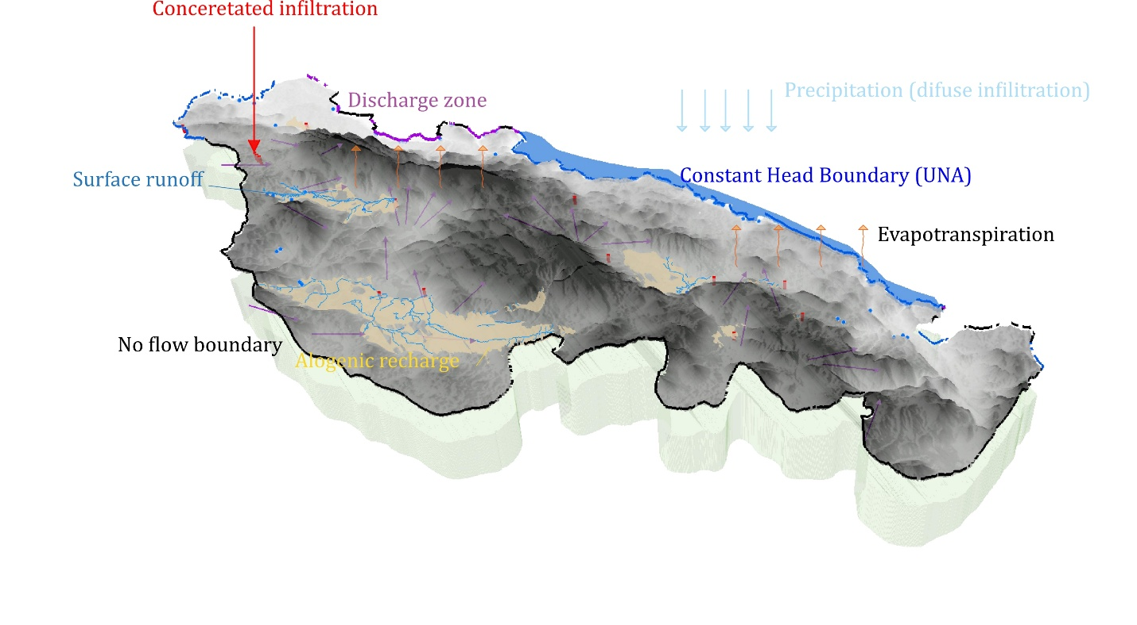
Figure 6: Conceptual Hydrogeological model of TBA Una
In the 3D block diagram of the TBA Una conceptual model (Figure 6), the defined boundaries are explicitly represented to illustrate their spatial relationships within the groundwater flow system. No-flow boundaries are depicted as the basal and lateral limits of the model domain, corresponding to low-permeability lithological units that constrain vertical and lateral groundwater movement. The basal boundary represents the lower limit of active karst circulation, while selected structural elements are shown to indicate their potential role as either hydraulic barriers or preferential flow zones. The Una River is represented as the principal constant-head boundary, forming the regional discharge zone and controlling hydraulic gradients within the karst aquifer system. Springs located along the river valley are illustrated as fixed-head outlets, linking subsurface flow paths to the surface drainage network. Recharge boundaries are shown along watershed divides that delimit the spatial extent of the modeled system and define the areas contributing groundwater through diffuse infiltration, ponors, and losing streams. The 3D visualization integrates these boundary conditions into a coherent spatial framework, allowing for a clearer interpretation of groundwater flow directions and hydraulic connectivity. By explicitly depicting recharge areas, discharge zones, and hydraulic constraints, the block diagram enhances the understanding of system behavior and supports the placement of monitoring points within hydrologically meaningful positions.

ANTHROPOGENIC INFLUENCES
The pollutants/pressures in the catchment area were identified based on the current 3rd RBMP of Croatia, and include point and diffuse sources of pressure as well as the GW abstractios presented in the following text and figures. A GIS database was developed for the purposes of the IMPRESS analysis, a methodology used to identify significant pressures and assess their impacts on water bodies. As part of this process, pollutants were first identified and classified into point and diffuse sources. The data were collected from national databases, reports, maps, aerial imagery, field surveys, and various institutions, and were subsequently organized into categories such as infrastructure, industry, and agriculture. Following the
In accordance with the methodology of the third RBMP of Croatia and the second Sava RBMP. , as well as the IMPRESS analysis framework, the following pressures were addressed separatelyin the subsequent chapters: groundwater abstraction, and point and diffuse sources of pollution.

Groundwater abstractions
The main pressure are springs used for water supply. There is only minor number of wells in the area and this quantities are negligable. In croatian part of TBA Una, there are only 4 water permits four water permits have been issued, mainly in the area of Udbina, specifically the Krbava field, and primarily for agricultural purposes (irrigation and livestock). The main pressures related to water abstraction are described in Subchapter 4.4.1 and presented in Table 2 and Figure 5.

Point spurces of pollution
Point sources of pollution are presented in Figure 7. Several categories of point pollution sources have been identified in the TBA Una area, with livestock farms being the most numerous (shown on the map according to livestock unit size). Waste disposal sites also represent a significant pressure on water quality. In the TBA Una area, three active landfills have been identified (Bare, Čojluk, and Kalebovac) and one rehabilitated landfill (Prijeboj). These landfills were identified based on hazard analyses prepared for the second River Basin Management Plan (RBMP) of the Republic of Croatia and were, at that time, undergoing remediation.
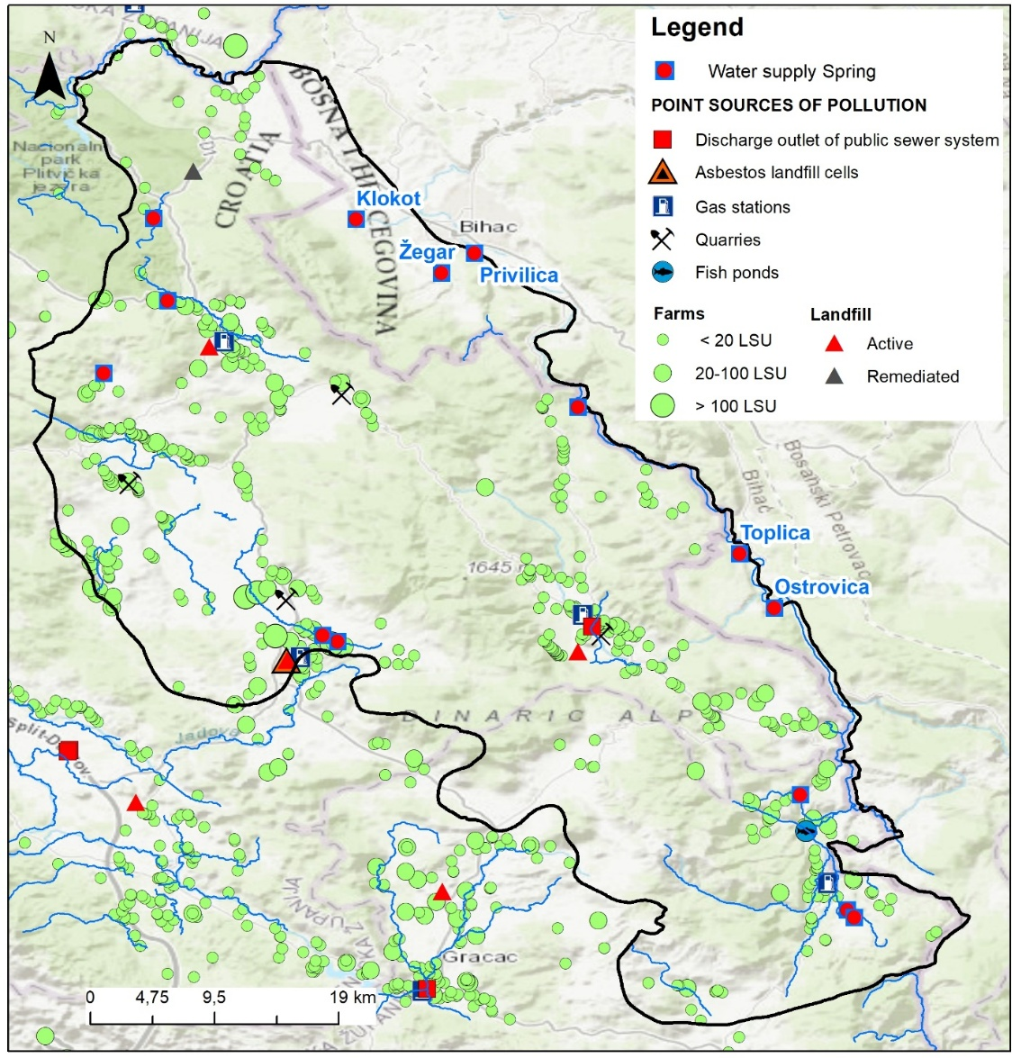
Figure 7: Point sources of pollution

Diffuse sources of pollution
Diffuse sources of pollution are presented in Figure 8. Several categories of diffuse pollution sources have been identified in the TBA Una area, with individual wastewater systems identified as the most significant pressure.
In the hazard analysis conducted for the purposes of the second RBMP, agriculture was separately assessed as an important diffuse pollution source, using the CORINE Land Cover 2006 dataset as a base layer to identify agricultural areas and subsequently quantify fertilizer and pesticide consumption. In this phase, we did not perform detailed analyses, as agriculture is not considered the most significant pressure in the TBA Una area. However, a more detailed analysis of newer CORINE Land Cover datasets (e.g., 2018) as well as the 2000 dataset is necessary to identify possible land-use changes in the basin, particularly urbanization and construction activities, especially within the area of the Plitvice Lakes National Park. For this reason, Figure 9 presents the CORINE Land Cover datasets from 2000 and 2018 to illustrate and compare land cover changes over time.

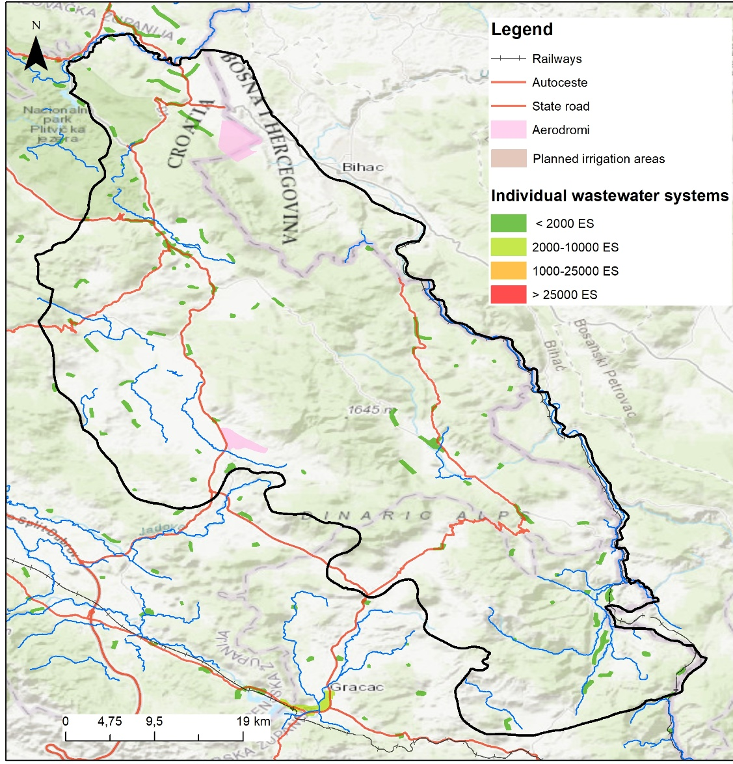
Figure 8: Diffuse sources of pollution

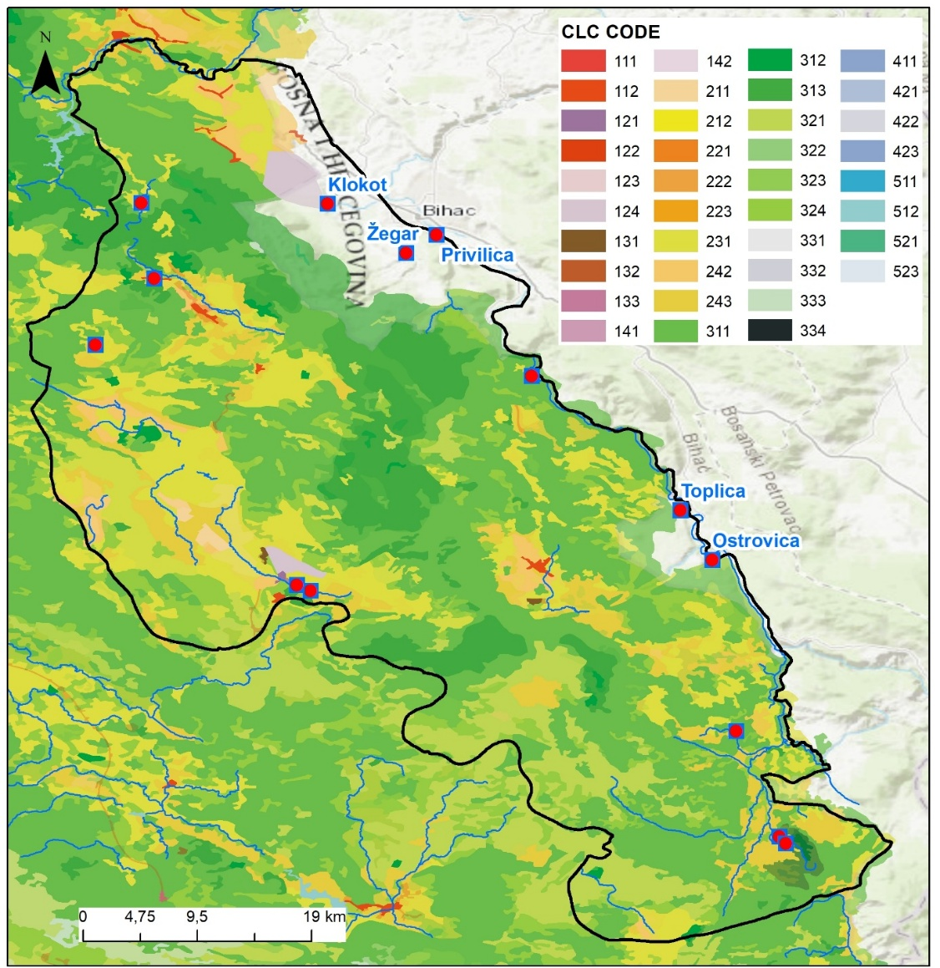
Figure 9a: CORINE LAND COVER 2018

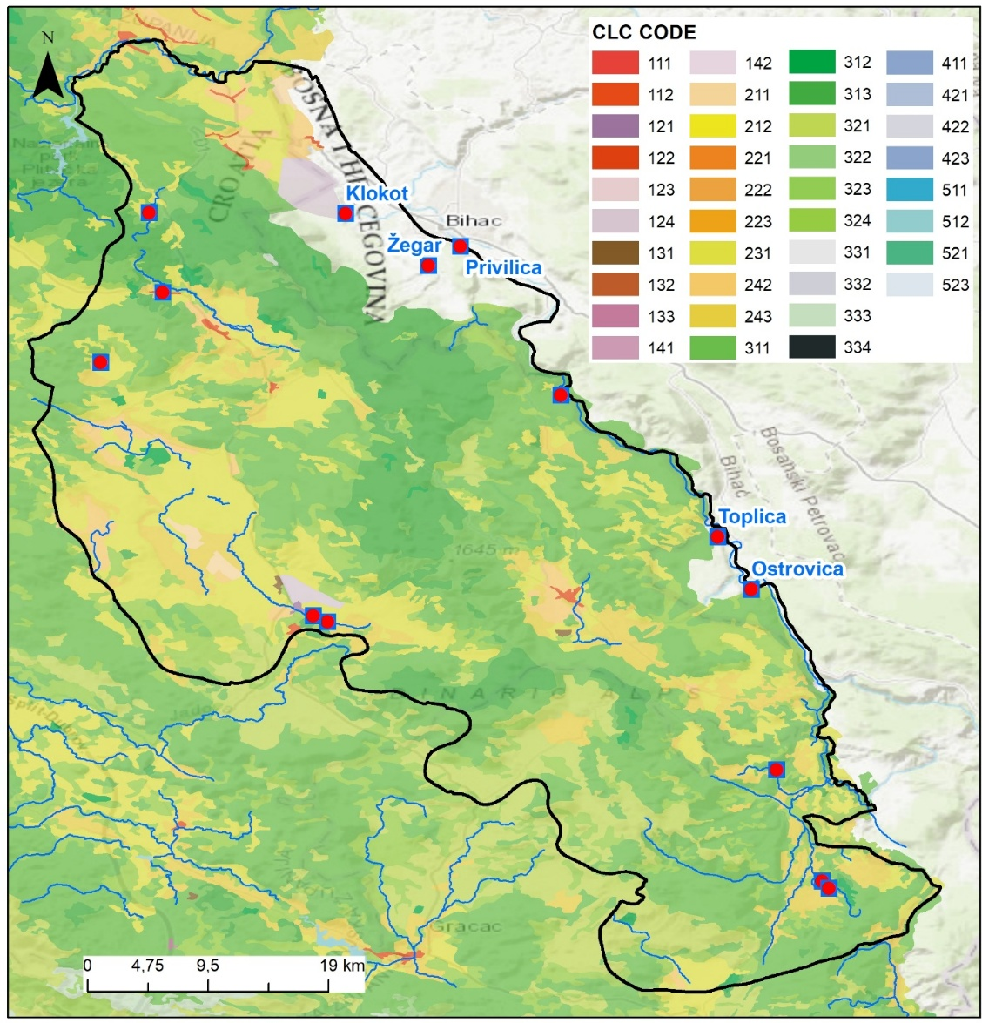
Figure 9b: CORINE LAND COVER 2000

MONITORING IN TBA UNA
Although Croatia is EU member and B&H is a candidate country for EU membership, they both have River Basin Management Plans (RBMP) in force. Two RBMP are relevant for TBA Una: the third RBMP until 2027. currently valid in Croatia and second RBMP for Sava River in the Federation of BiH (2022-2027). All the data in this chapter regarding the monitoring are provided from this official documentation and relevant institutions.
In Croatia water legislation is fully aligned and implemented with the Water Framework Directive (WFD), the Groundwater Directive (GWD), and the Drinking Water Directive (DWD), while in Federation of Bosnia and Herzegovina Water legislation is largely aligned with the WFD and partly aligned with the GWD and the DWD; so further harmonisation and implementation are still ongoing.
In both RBMP, there are three types of monitoring for surface waters (SW) as well as groundwater (GW) that are conducted in accordance with the objectives of WFD: surveillance monitoring, operational monitoring, and investigative (research) monitoring.
In both countries, hydrometeorological monitoring is organized at the level of national institutes and is primarily focused on flood protection and flood risk management, while its application for water resources balance assessment, including groundwater for drinking water supply and groundwater balance analysis, is considerably more limited.
In karst areas groundwater bodies are generally connected with surface waters. A typical example of such a connection is the emergence of groundwater at the contact with less permeable clastic layers deposited in karst fields, the formation of surface flows along karst fields, and their infiltration into the subsurface when encountering karstified carbonate rocks. Although ponors are important in karst areas, playing a crucial role in both groundwater quantity and quality, their significance has often been neglected in monitoring programs.
This chapter provides a detailed description of the monitoring conducted at TBA Una, both in the territories of the Republic of Croatia and Bosnia and Herzegovina. Existing monitoring in TBA Una consists of the following: groundwater monitoring (quantitative and qualitative); surface water monitoring (ecological and chemical); meteorological monitoring and the above mentioned types of monitoring will be described in detail in the following text.
A brief analysis of the existing monitoring system is provided in Subchapter 5.1, while Subchapter 5.2 presents a proposal for new monitoring including the appropriate monitoring types and methodologies. The emphasis was given to the deficiencies of the current-existing groundwater monitoring in karst, since EU legislation does not deal with these specificities in sufficient detail and possible improvement through the proposed monitoring is given.

EXISTING MONITORING
This chapter provides a brief analysis of the existing monitoring system in subchapters 5.1.1 to 5.1.3, highlighting the main shortcomings of the current monitoring, by monitoring type in both countries, along with proposed improvements.

Groundwater monitoring
Before EU integration, both countries monitored groundwater mainly for human consumption, focusing on chemical and microbiological parameters (regarding GW quality) and abstraction quantities regarding GW quantity. Ecological or comprehensive environmental assessments were largely absent, and monitoring networks were less dense and less standardized than today. Monitoring of quantities was generally the responsibility of water utilities, primarily for the purpose of calculating water use charges. For this reason, abstracted (pumped) volumes were measured, while total volumes were only occasionally determined. Overflow volumes at water supply springs were not a legal requirement and were therefore mostly monitored through hydrological stations located downstream from the springs.
The assessment of groundwater status remains limited, particularly in Bosnia and Herzegovina, where a comprehensive groundwater monitoring network has not yet been fully established, especially in karst part of Sava cathchment. In contrast, Croatia has fully implemented chemical groundwater monitoring, and groundwater status is assessed through standardized testing in accordance with regulatory frameworks. Overall, Bosnia and Herzegovina still lacks an integrated monitoring system for both groundwater quality and quantity, while Croatia applies systematic monitoring and assessment procedures.
Although groundwater monitoring today is much improved compared to the past—covering both chemical and quantitative status—its main limitation is that it does not adequately account for the specific characteristics of karst aquifers. Karst systems have rapid flow paths, strong heterogeneity, and high vulnerability to pollution, which are not fully captured by standard monitoring networks. As a result, localized contamination or rapid changes in water quality can go undetected, even though overall monitoring meets EU directive requirements.
The following chapters describe in detail qualitative and quantitative groundwater monitoring in TBA UNA in both Croatia and BIH:

Qualitative Groundwater Monitoring
In TBA Una monitoring of groundwater quality is performed on all springs used for water supply and according to DWD (and national Drinking Water Act) while the groundwater monitoring for assessment of GW Chemical status in karst aquifers is not yet established in B&H. In Croatian part of TBA Una there is a significant improvement in groundwater chemical monitoring from the first RBMP when there was onlyone monitoring stations compared to the 3rd RBMP and seven monitoring stations. Monitoring of groundwater on all GW monitoring stations in Croatia is in accordance with WFD; GWD and DWD.
Both countries have harmonized their national water legislation in accordance with the EU Water Directives (WFD, GWD, and DWD). However, for groundwater in karst aquifers, the parameters used for status assessment under the Water Framework Directive are insufficient and do not fully reflect actual conditions. More relevant are the physicochemical and chemical parameters monitored under the Drinking Water Directive, which better represent water quality in karst systems. Also, the sampling frequency prescribed by EU legislation (DWD especially) is not sufficient to adequately characterize karst aquifers.
The Water Management Plan for the Sava River Basin District in the Federation of Bosnia and Herzegovina (2022–2027) foresees the implementation of a groundwater monitoring network as part of its programme of measures. In this context, a 2019 study conducted by the Sava River Basin Agency selected 20 representative karst springs for monitoring, including the Klokot Spring.
The assessment of chemical status is conducted according to groundwater quality standards (GQS: nitrates and pesticides- and the threshold values for specific pollutants. In Croatia, these standards are established under the Regulation on Water Quality Standards (Official Gazette RC, No. 96/2019, 20/2023, and 50/2023, Annex 6), while in the Federation of Bosnia and Herzegovina, they are defined by the Decision on the Characterization of Surface and Groundwater, Reference Conditions, and Parameters (Official Gazette FBiH, No. 1/14, Annex 8).
In terms of GW chemichal status, grouped GWB Una (code CSGI-18) in RBMP of Croatia has been assessed as having good chemical status while Sava RBMP due to the lack of monitoring dana did not make assessment of GWB.
Figure 10 shows the locations of existing groundwater monitoring stations in the TBA Una, with details provided in Table 3
Table 3. Groundwater quality monitoring stations in TBA Una
Name | Code | X | Y | Z | Type | State
Una, izvorište Donja Suvaja | 14004G | 16,1093 | 44,4022 | 390 | S2, O3, I; DWD | Croatia
Loskun izvorište, Donji Lapac | 30222G | 15,9544 | 44,6959 | 247 | S2; DWD | Croatia
Joševica izvorište | 30223G | 16,1067 | 44,4304 | 390 | S, O1; DWD | Croatia
Vrelo Koreničko - izvorište | 30322G | 15,6721 | 44,7687 | 697 | S; DWD | Croatia
Krbavica izvorište | 30323G | 15,6285 | 44,7190 | 690 | S; DWD | Croatia
*Klokot 1, Vojni aerodrom Željava | 30327 | 15,7716 | 44,8393 | 346 | I | Croatia
*Klokot 2, Vojni aerodrom Željava | 30328 | 15,7643 | 44,8311 | 342 | I | Croatia
Čujića Krčevina | 30330 | 15,6604 | 44,8228 | 720 | S; DWD | Croatia
Izvor Korenica (Korenička rijeka) | 30331 | 15,6573 | 44,7853 | 670 | S; DWD | Croatia
Klokot** | - | 15,8019 | 44,8246 | 221 | DWD | B&H
Privilica* | - | 15,8831 | 44,8013 | 235 | DWD | B&H
Ostrovica** | - | 16,0893 | 44,5584 | 299 | DWD | B&H
Toplica** | - | 16,0654 | 44,5955 | 298 | DWD | B&H
Żegar** (Trbljenik- Žegar) | - | 15,8605 | 44,7878 | 270 | DWD | B&H
Gata** | - | 15,8137 | 44,9297 | 276 | DWD | B&H
Kamp Lipa** | - | - | - | - | DWD | B&H
* Two investigation boreholes (Klokot-1 and Klokot-2 m), drilled in April 2020, were established as monitoring points for the UNA groundwater body (GWB). However, these boreholes were not included in the analysis as sampling was not possible at the time. The first groundwater sampling was conducted in 2025 following borehole cleaning
S- survaillance montoring, O- operational (01 and 03), I- investigative monitoring
**Vodovod Bihać measurement of parametars
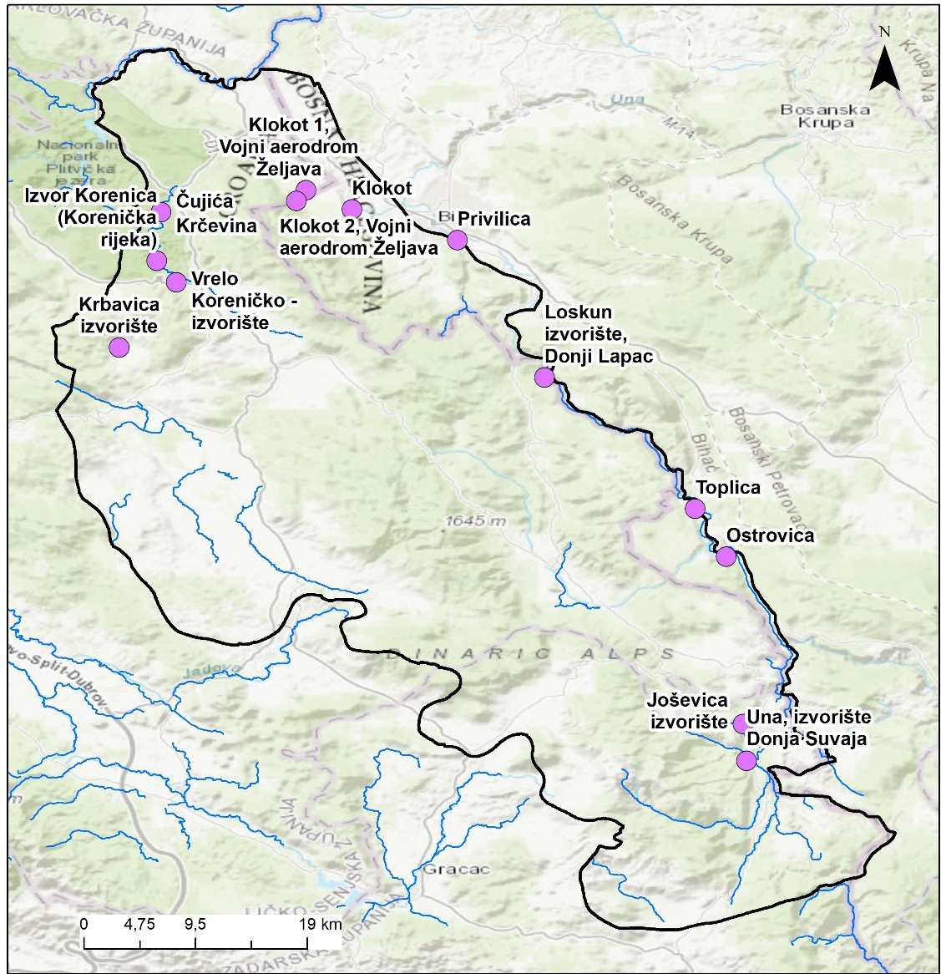
Figure 10 Qualitative Groundwater monitoring in TBA UNA
In table 3 in 7 out of 9 GW monitoring stations in Croatian part of TBA have survaillance monitoring (S), on 2 of them there is operational monitoring (Una, Donja Suvaja- 14004G and Joševica Spring - 30223G). Investigative monitoring is carried out on stations Una, Donja Suvaja- 14004G and recently on Klokot-1 (30327) and Klokot-2 (30327) boreholes. On two surveillance monitoring stations: Una, Donja Suvaja (14004G) and Loskun spring (30222G) additional parameters are measured for drinking water, as defined in the Drinking Water Quality Directive (European Commission, 2020a), but in accordance with the surveillance monitoring regime (more frequent than DWD).
However, the analysis of water samples over a five‑year period (2015-2020), conducted as part of the 2020 Klokot catchment study, indicates the following: significant and frequent increases in turbidity at the spring, occasional rises in elevated oxygen consumption, and in only a few cases, occasional increases in ammonium concentrations above the maximum allowable limits for drinking water. Furthermore, based on the analysis of microbiological parameters for the same period, it has been established that the deterioration of the microbiological quality of water at the Klokot spring is significantly associated with increased human activity in the Klokot spring catchment area, particularly due to the intensification of tourist visits to Plitvice Lakes National Park, as evidenced by the rapidly growing number of overnight stays in the area over the past five years.
Physicochemical analyses of the water samples taken from the Klokot spring in the course of this protection project show that the water, according to the parameters investigated, in most cases, fulfills the conditions set in the Rules on Health Safety of Drinking Water (Official Gazette of Bosnia and Herzegovina, No. 40/10, 43/10 and 30/12). However, many of the samples analyzed in the last 5 years show the tendency of deterioration of water quality at the spring itself.
Details of the parameters and the frequency of sampling is given later in chapter 5.2.1.

Quantitative Groundwater Monitoring
As previously noted, monitoring of GW abstraction quantities was generally the responsibility of water utilities, mainly for the purpose of calculating water-use charges. Consequently, only abstracted (pumped) volumes were routinely measured, whereas total spirng capacity was determined only occasionally. Overflow volumes at water-supply springs were not subject to legal monitoring requirements and were therefore typically assessed indirectly via hydrological stations located downstream of the springs.
Such aproach does not allow an accurate water balance assessment. A more comprehensive monitoring system, including both abstraction and overflow volumes, is needed to determine the total spring capacity. Quantitative monitoring of groundwater (GW) was generally limited to public water supply springs.Determination of spring capacity requires defining the minimum exploitable discharge corresponding to return periods of 2, 5, 10, and 20 years. The most objective evaluation of the minimum spring capacity is achieved through statistical analysis of long-term discharge data collected during continuous exploitation (by measuring both abstraction and overflow volums).
The assessment of quantitative groundwater status in RBMP of Croatia and Sava is based on the relationship between groundwater abstraction volumes and renewable groundwater resources (reserves). Renewable groundwater resources were estimated using the relationships between annual precipitation, air temperature, and specific discharge derived from raster-based spatial datasets for the reference 30-year period (1961–1990), as well as relationships between point-based precipitation and air temperature data from both the reference period and the recent period (2008–2014).
Pressure on the quantitative status of groundwater is considered significant if it exceeds 10% of the water balance reserves, as pressures above this threshold are estimated to have a substantial impact on groundwater conditions and associated ecosystems. The relatively low threshold of 10% was chosen due to the uneven annual distribution of renewable supplies, which are usually the least at the time when seasonal water needs are the highest (at the end of summer), and such critical situations, due to the lack of appropriate data on the annual distribution of water use at individual GWBs, could not be numerically quantified and analyzed due to the lack of data on water use.
In terms of GW quantitative status, grouped GWB Una (code CSGI-18) in RBMP of Croatia has been assessed as having good quantitative status while Sava RBMP due to the lack of monitoring dana did not make assessment of GWB.
Same approach was used for the RBMP of Croatia and RBMP Sava for FBIH. This approach does not fully correspond to the specificities of karst terrain, which is characterized by large seasonal variability of discharge.
For the purpose of assessing the water balance of a groundwater body, monitoring should be established at the most important springs and ponors (swallow holes), requiring a long-term dataset of both overflow and abstracted volumes.
Unlike in the Croatian part of the TBA Una, where all groundwater abstraction points must report extracted volumes to Croatian Waters, the FB&H system for abstraction reporting is less explicitly regulated. It should also be noted that in Croatia the reporting obligation applies only to abstracted quantities, and does not include overflow or unrecorded quantities, making it difficult to determine the total capacity of springs used in water supply. For other users, aside from public water supply, Croatia also requires reporting of abstraction volumes, but only as annual abstracted volume.

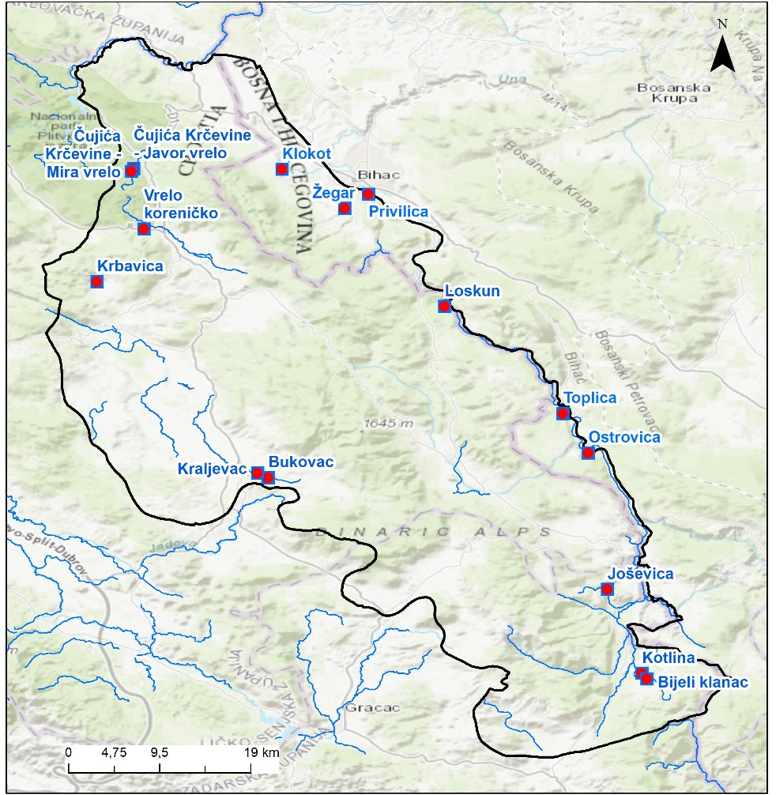
Figure 11 Quantitative Groundwater monitoring in TBA UNA
Regarding flow measurement at the Klokot spring, according to the Federal Hydrometeorological Institute (FMZ) of Bosnia and Herzegovina, the Klokot Gauging Station (GS) on the Klokot stream was originally installed on 12 November 1982 and operated until 1991. However, the FMZ analysis concluded that the hydrological data from the period 1981–1991 are not suitable for further processing.
The Klokot GS was reconstructed in 2003 and is an automated station located downstream from the bridge. The staff gauge zero level is 209.854 m a.s.l., and the distance between the Klokot GS and the mouth of the Klokot stream into the Una River is 4,300 m. Since 19 March 2005, daily water level and discharge data have been published in the FMZ Hydrological Yearbooks.
A 2020 study analyzing data from this GS reported that, during the period 2005–2014, mean daily discharges ranged from a minimum of Qmin = 2.73 m³/s (2 December 2011) to a maximum of Qmax = 75.1 m³/s (13 September 2014) (Holinger AG, 2020*).
*Holinger AG: Development of a Study on the Establishment of the Klokot (Bihać) Spring CrossBorder Sanitary Protection Zones, 2020.

Surface water monitoring
Before EU alignment, both Croatia and Bosnia and Herzegovina assessed surface water quality using an old national class-based system focused mainly on chemical parameters. Monitoring was less systematic, and pollution from municipal wastewater, industry, and agriculture was common, especially near cities. Ecological status (biology and hydromorphology) was generally not evaluated as it is under the current EU framework.
According to the EU standards, ecological status of surface waters is assessed in relation to biological, basic physico-chemical and chemical elements that accompany biological elements and hydromorphological elements. Chemical status is assessed in relation to indicators of chemical status.
Based on the definitions outlined in the WFD, 4 biological elements can be distinguished in rivers and lakes: phytoplankton and macrophytes/phytobenthos, and , macrozoobenthos (Benthic Invertebrates) and fish.
The basic physico-chemical and chemical quality elements in surface freshwater bodies are temperature, salinity, pH, oxygen regime, nutrient concentrations, and specific pollutants (arsenic, copper, zinc, chromium and their compounds, fluorides, and organically bound halogens)
The hydromorphological quality elements for rivers include elements of the hydrological regime, river continuity, and morphological conditions.
The elements of chemical status include priority and hazardous substances, which are assessed based on environmental quality standards (EQS) defined for each category of substances. A good chemical status is achieved when the observed indicators do not exceed the threshold values, expressed as: annual average concentration, maximum annual concentration and Quality standards for biota for specific categories of substances.
In terms of surface water chemical status, the RBMP of Croatia assessed the major part of the Una TBA as having very good or good chemical status, while some water bodies have been assessed as having a very bad status. Surface water bodies assessed as having bad status (Matica, Krbavica, Bare, Kabalin) are unfortunately all stream water bodies that end in the ponors: Bare and Kabalin to Pejićev ponor; Krbavica to Vidrovac ponor and Matica to ponor Korenički. This means, all the important ponors in Krbavsko and Koreničko polje that are connected and are recharge area of Klokot spring. Most of those surface bodies were assessed as very bad according to byological elements and basic physico-chemical elements.
In the Sava RBMP, the chemical status of water bodies in the Una area was generally assessed as good, or in some cases was not assessed due to a lack of monitoring data, which also prevented the assessment of groundwater bodies (GWB). Regarding ecological status, the majority of surface water bodies were classified as having very good or good status, while only one water body was assessed as moderate.
According to the 2025 Monitoring Plan for Croatia, surveillance monitoring of the elements of ecological and chemical status shall be carried out annually for the duration of the River Basin Management Plan cycle until 2027, with the exception of the biological quality elements of macrophytes and fish, which are monitored every third year, and hydromorphological elements, which are monitored once per planning cycle. Operational monitoring is conducted every third year for biological elements, and annually for physico-chemical elements, specific pollutants, and priority or priority hazardous substances.
Similar monitoring scheme is applied in the Federation of Bosnia and Herzegovina (FBiH), based on the Decision on Characterization of Surface and Groundwaters (Official Gazette FBiH, No. 1/14, Annex 11 ). Surveillance monitoring in FBiH follows the same principles, with biological elements assessed up to every three years, physico-chemical parameters monitored throughout the year, and hydromorphological elements assessed once per planning cycle. Operational monitoring is focused on at-risk water bodies, with biological elements monitored every three years and physico-chemical and chemical pollutants monitored periodically throughout the year, depending on pressure and risk.
Details of the surface water monitoring stations are provided in Table 4, and their locations are shown in Figure 12.
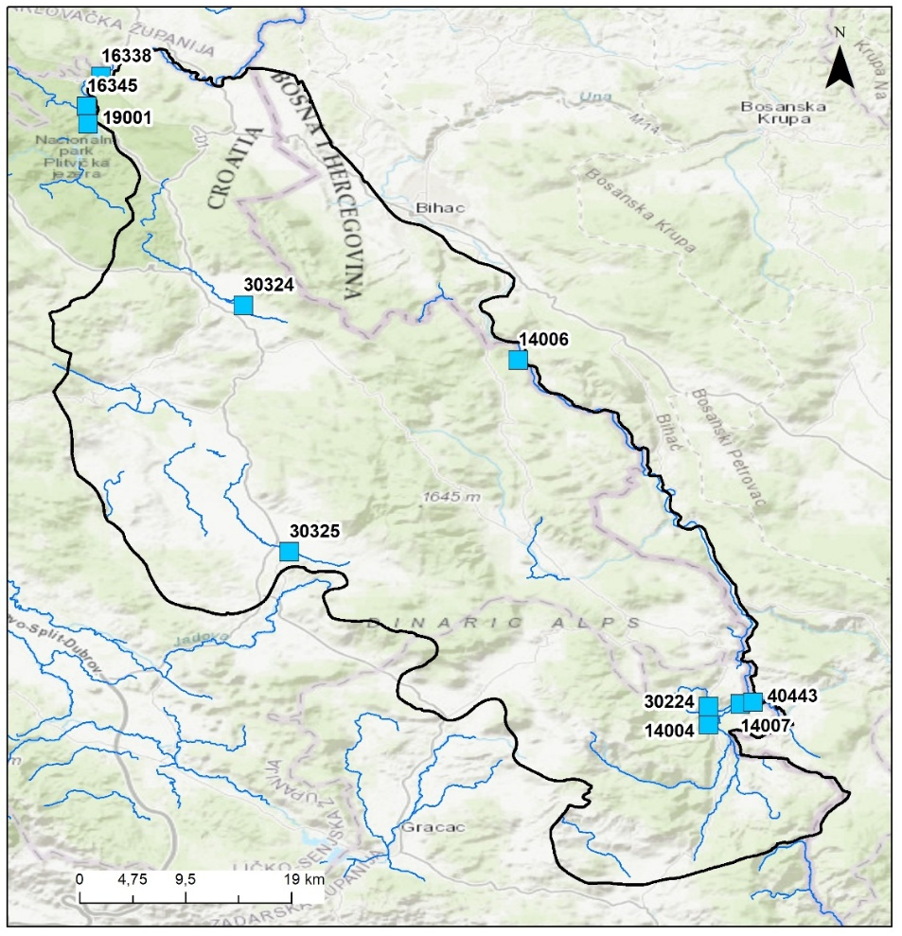
Figure 12 Surface water monitoring in TBA UNA
The list of surface waters monitoring stations is provided in Table 4:
Table 4. Surface water monitoring stations in TBA Una
Nb | CODE | NAME | TYPE | COUNTRY
1 | 14006 | Una, kod izvorišta Loskun | S | Croatia
2 | 16338 | Korana, selo Korana, Plitvička jezera | S; O | Croatia
3 | 30322S | Vrelo Koreničko-izvorište
4 | 30324 | Matica, selo Šuputi | O | Croatia
5 | 30323S | Krbavica izvorište | -
6 | 30222S | Loskun izvorište, Donji Lapac | -
7 | 30325 | Krbava, Udbina | O | Croatia
8 | 14007 | Una, nizvodno od D. Kraja | I, neaktivna | Croatia
9 | 40443 | Izvor Krke, (pritok Une), granični prijelaz |  | Croatia
10 | 30223S | Joševica izvorište | -
11 | 30224 | Joševica, most na cesti D. Suvaja-Brotnja | S
12 | 14004S | Una, izvorišite Donja Suvaja | S | Croatia
13 | BA_UNA_3 | Una | O | BIH
14 | BA_UNA_DOBRENICA_1 | Dobrenica | N | BIH
15 | BA_UNA_DROB_1 | Drobnica | N | BIH
16 | BA_UNA_KLO_1 | Klokot-ušće | O | BIH
17 | BA_UNA_KLO_1 | Klokot-izvor | O | BIH
O- Operational; S- Surveillance
Details of the parameters and the frequency of sampling is given later in chapter 5.2.2. and 5.2.3.

HYDROMETEOROLOGICAL MONITORING
Official data from the National Hydrometeorological Service were used, Croatian National Hydrometeorological Service (DHMZ) and Federal Hydrometeorological Institute (FHMI). Both institutions are responsible for meteorological and hydrologic data.
Unfortunately, a large number of hydrological and meteorological stations of this reagion of Lika in Croatia and Bihać in BIH experienced interruptions in monitoring during the military conflicts in 1990s.
METEOROLOGICAL DATA
Precipitation data for Croatia (1961–1990) are derived from DHMZ digital climate maps, providing mean annual precipitation on an approximately 1 km × 1 km raster grid (Figure 3). The list of meteorological monitoring stations for TBA UNA is provided in Table 5. and locations are shown in Figure 13.
Table 5. List od meteorological stations in TBA Una
Naziv | X | Y | Z | Type | Active from
Prijeboj | 44,8317 | 15,6644 | 704 | Main
Korenica | 44,7397 | 15,7054 | 688 | Climatological | 1981
Udbina | 44,5563 | 15,7736 | 825 | Climatological | 1996
Donji Lapac | 44,5496 | 15,9606 | 582 | Climatological | 1982
Plitvička jezera | 44,8813 | 15,6198 | 579 | Climatological | 1986-2011, 2016
Grabovac | 44,9559 | 15,6605 | 91 | Climatological | 1981-1991, 1998
Krbava | 44,6161 | 15,6736 | 637 | Inactive | 1982
Bihać | 44, 8086 | 15,8597 | 246 | Main
Ripač | 44,8137 | 15,8751 | Ripač | Automatic

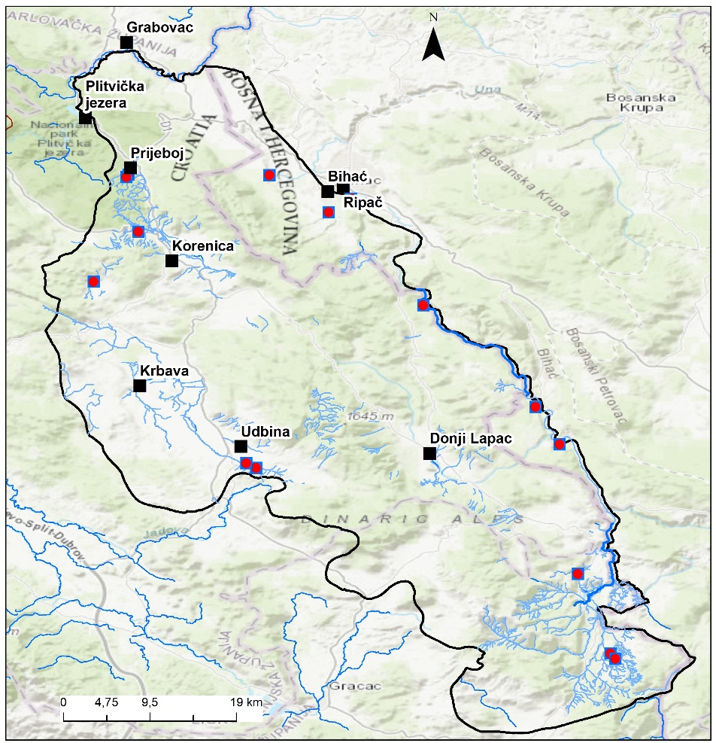
Figure 13 Locations of meteorological stations in TBA UNA
HYDROLOGICAL DATA
The list of hydrological monitoring stations for TBA UNA is provided in Table 6 while their locations are shown in Figure 14. Most of the hydrological data that are active are on river Una, and most of the stations in region of Lika are inactive stations that were active in some period until 1990-ies. Most of the stations have only measurements of water levels (often not automatic), and only some have discharges.
For the most important spring of TBA Una, Klokot in B&H the automatic gauging station (GS) was reconstructed in 2003. and have continuos monitoring of water level .

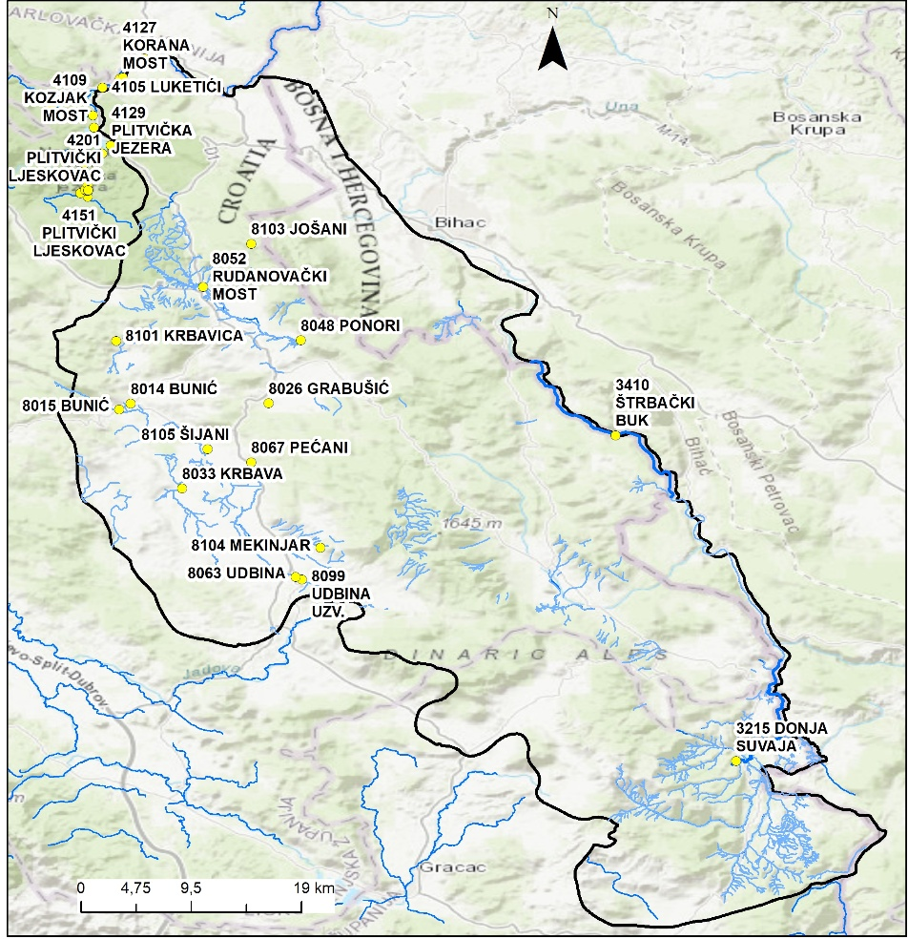
Figure 14 Locations of hydrological stations in TBA UNA

MONITORING PARAMETERS WITH MONITORING FREQUENCIES
For water status monitoring in support of river basin management planning, the responsible authorities are the Agency for the Sava River Basin (FB&H) and Croatian Waters and Josip Juraj Strossmayer Water Institute. In Croatia and BiH, the Hydrometeorological Institutes handle hydrological and meteorological monitoring and data processing, while the Institutes of Public Health are responsible for drinking water quality monitoring.

GW chemical status
The assessment of chemical status is conducted according to groundwater quality standards (GQS: nitrates and pesticides) and the threshold values for specific pollutants. In Croatia, these standards are established under the Regulation on Water Quality Standards (Official Gazette RC, No. 96/2019, 20/2023, and 50/2023, Annex 6), while in the Federation of Bosnia and Herzegovina, they are defined by the Decision on the Characterization of Surface and Groundwater, Reference Conditions, and Parameters (Official Gazette FBiH, No. 1/14, Annex 8).
The tables 7and 8 present the parameters and sampling frequency for assessing the chemical status of groundwater for both surveillance and operational monitoring. The table was adopted from the Croatian national monitoring plan for 2025, with an additional final column included for Federation of Bosnia and Herzegovina (FB&H).
Within the framework of surveillance and operational monitoring, basic and additional indicators are monitored in accordance with Annex 6 of the Regulation on Water Quality Standards. The chemical status assessment is carried out according to groundwater quality standards and the threshold values for specific pollutants (Tables 3 and 4 of Annex 6 of the Regulation), which are monitored as part of surveillance and operational monitoring. Other indicators not included in the Regulation but monitored within the surveillance and operational monitoring framework areselected according to Directive (EU) 2020/2184 on the quality of water intended for human consumption – DWD.
Table 6. List of hydrological stations in TBA UNA

CODE | Name | Country
3215 | DONJA SUVAJA | Cro
8099 | UDBINA UZV | Cro
8063 | UDBINA | Cro
3410 | ŠTRBAČKI BU | Cro
4028 | KORANA | Cro
4127 | KORANA MOST | Cro
4128 | ČATRNJA | Cro
4605 | KOZJAK | Cro
8033 | KRBAVA | Cro
8048 | PONORI | Cro
8052 | RUDANOVAČKI MOST | Cro
8101 | KRBAVICA | Cro
8014 | BUNIĆ | Cro
8103 | JOŠANI | Cro
8067 | PEĆANI | Cro
8104 | MEKINJAR | Cro
8105 | ŠIJANI | Cro
8015 | BUNIĆ | Cro
8026 | GRABUŠIĆ | Cro
 | Kralje | B&H
 | Klokot | B&H
 | Bihać | B&H
 | Ripač | B&H
 | Štrbački Buk | B&H
 | Kulen Vakuf | B&H
 | Martin Brod-nizvodno | B&H
 | Martin Brod-nizvodno | B&H
 | Manastir | B&H

Table 7. Parameters Used for Groundwater Chemical Status Assessment and Required Annual Testing Frequency- GWS and Specific pollutants
INDICATOR | FREQUENCY |  | FB&H
INDICATOR | SURVEILLANCE | OPERATIONAL | FB&H
CHEMICHAL STATUS
Nitrates | 4/yr-6/yr | 4/yr-12/yr | +
Pesticide active substances (plant protection products and biocides, in accordance with regulations on permitted active substances) |  |  | +
Organochlorine Pesticides (4,4 DDT; 2,4 DDT; 4,4 DDE; 4,4 DDD; HCB; DDT Total; Heptachlor; Heptachlorepoxide; Metoksiklor; HCH, α- and β-Endosulfan; Endosulfan Total; α-HCH, β-HCH, γ-HCH, δ-HCH) (µg/l) | 4/yr | 4/yr-6/yr | -
Cyclodiene Pesticides (Aldrin, Dieldrin, Endrin, Isodrin) (µg/l) | 4/yr | 4/yr-6/yr | -
Organophosphorus Pesticides (Dimethoate, Pirimiphos-methyl, Chlorvenphos, Chlorpyrifos (Chlorpyrifos-ethyl), Chlorpyrifos-methyl, Omethoate, Pirimiphos-methyl, Glyphosate, total organophosphorus pesticides) (µg/l) | 4/yr-6/yr | 4/yr-6/yr | -
Triazine Pesticides (Atrazine, Simazine, Terbuthylazine) | 4/yr-6/yr | 4/yr-12/yr | -
Bromazil | 6/yr | 6/yr | -
Chloroacetamides (Acetochlor, s- Metolachlor µg/l) | 4/yr | 4/yr | -
SPECIFIC POLLUTANTS
Arsenic (µg/l As) | 4/yr-12/yr | 4/yr-12/yr | +
Cadmium (µg/l Cd) | 4/yr-12/yr | 4/yr-12/yr | +
Lead (µg/l Pb) | 4/yr-12/yr | 4/yr-12/yr | +
Mercury (µg/l Hg) | 4/yr-12/yr | 4/yr-12/yr | +
Ammonium (mg/l NH₄⁺) | 4/yr-6/yr | 4/yr-12/yr | Ammonia (NH₃)
Chloride (mg/l Cl⁻) | 4/yr-6/yr | 4/yr-6/yr | +
Sulfate (mg/l SO₄²⁻) | 4/yr-6/yr | 4/yr-6/yr | +
Orthophosphate (mg/l P) | 4/yr-6/yr | 4/yr-12/yr | -
Nitrites (mg/l NO₂⁻) | 4/yr-6/yr | 4/yr-12/yr | -
Total phosphorus (mg/l P) | 4/yr-6/yr | 4/yr-12/yr | -
Trichloroethylene (µg/l TCE) | 4/yr-6/yr | 4/yr-12/yr | +
Tetrachloroethylene (µg/l PCE) | 4/yr-6/yr | 4/yr-12/yr | +
Electrical conductivity (µS/cm) | 4/yr-6/yr | 6/yr-12/yr
Cyanides (CN⁻) | - | - | +

Table 8. Additional Parameters Used for Groundwater Chemical Status Assessment and Required Annual Testing Frequency
INDICATOR | DWD  Indicator | FREQUENCY
INDICATOR | DWD  Indicator | SURVEILLANCE | OPERATIONAL
BASIC PHYSICO-CHEMICAL INDICATORS
Temperature °C |  | 4/yr-6/yr | 6/yr-12/yr
pH | + | 4/yr-6/yr | 6/yr-12/yr
Redox potential (Mv) |  | 4/yr-6/yr | 6/yr-12/yr
Total suspended solids (TSS) |  | 4/yr
Alkalinity (mg/l CaCO₃) |  | 4/yr-6/yr | 6/yr-12/yr
Total hardness (mg/l CaCO₃) |  | 4/yr-6/yr | 6/yr-12/yr
Turbidity (NTU) | + | 4/yr-6/yr | 6/yr-12/yr
Dissolved oxygen (DO) (mg/l O₂) | + | 4/yr-6/yr | 6/yr-12/yr
COD Mn (mg O₂/l) |  | 4/yr-6/yr | 6/yr-12/yr
Total Organic Carbon (TOC) (mg/l C) | + | 4/yr-6/yr | 6/yr-12/yr
Total Nitrogen (mg/l N) |  | 4/yr-6/yr | 6/yr-12/yr
Color |  | 4/yr-12/yr | 4/yr-12/yr
Odor / Smell |  | 4/yr-12/yr | 4/yr-12/yr
IONS
Calcium (mg/l) | + | 4/yr-6/yr | 4/yr-6/yr
Magnesium (mg/l) | + | 4/yr-6/yr | 4/yr-6/yr
Sodium (mg/l) | + | 4/yr-6/yr | 4/yr-6/yr
Potassium (mg/l) | + | 4/yr-6/yr | 4/yr-6/yr
Cyanides (mg/l) | + | 4/yr-6/yr | 4/yr-6/yr
Fluorides (mg/l) | + | 4/yr-6/yr | 4/yr-6/yr
Bromates (mg/l) | + | 4/yr-6/yr | 4/yr-6/yr
Hydrogen carbonates (mg/l) | + | 4/yr-6/yr | 4/yr-6/yr
Hydrogen sulfide (mg/l) | + | 4/yr | 4/yr-6/yr
Silicates (mg/l) |  | 4/yr | 4/yr-6/yr
MICROBIOLOGICAL INDICATORS
Total coliform bacteria (count/100 ml) | + | 4/yr-6/yr | 6/yr-12/yr
Fecal coliform bacteria (count/100 ml) |  | 4/yr-6/yr | 6/yr-12/yr
Fecal streptococci – intestinal enterococci (count/100 ml) | + | 4/yr-6/yr | 6/yr-12/yr
Aerobic bacteria (22°C) (count/1 ml) | + | 4/yr-6/yr | 6/yr-12/yr
Aerobic bacteria (36°C) (count/1 ml) |  | 4/yr-6/yr | 6/yr-12/yr
Clostridium perfringens, including spores (count/100 ml) | + | 4/yr | 4/yr-6/yr
Escherichia coli (count/100 ml) | + | 4/yr-6/yr | 6/yr-12/yr
Pseudomonas aeruginosa (count/100 ml) |  | 4/yr-6/yr | 6/yr-12/yr
METALS
Iron (μg/l) | + | 4/yr-12/yr | 4/yr-12/yr
Manganese (μg/l) | + | 4/yr-12/yr | 4/yr-12/yr
Copper (μg/l) | + | 4/yr-12/yr | 4/yr-12/yr
Zinc (μg/l) |  | 4/yr-6/yr | 4/yr-6/yr
Chromium (μg/l) | + | 4/yr-12/yr | 4/yr-12/yr
Nickel (μg/l) |  | 4/yr-12/yr | 4/yr-12/yr
Aluminium (μg/l) | + | 4/yr-12/yr | 4/yr-12/yr
Barium (μg/l) |  | 4/yr-6/yr | 4/yr
Beryllium (μg/l) |  | 4/yr | 4/yr
Vanadium (μg/l) |  | 4/yr | 4/yr
Antimony (μg/l) | + | 4/yr-6/yr | 4/yr-12/yr
Boron (μg/l) | + | 4/yr-6/yr | 4/yr-12/yr
Selenium (μg/l) | + | 4/yr-6/yr | 4/yr-12/yr
Cobalt (μg/l) | + | 4/yr | 4/yr-6/yr
Silver (μg/l) | + | 4/yr | 4/yr-6/yr
Uranium (μg/l) | + | 4/yr-6/yr | 4/yr-12/yr
PHARMACEUTICAL COMPOUNDS
Erythromycin (μg/l) |  | 4/yr | 4/yr
Azithromycin (μg/l) |  | 4/yr | 4/yr-6/yr
Sulfamethoxazole (μg/l) |  | 4/yr | 4/yr
Torasemide (μg/l) |  | 4/yr | 4/yr
Azithromycin N-desmethylazithromycin (μg/l) |  | 4/yr | 4/yr
Memantine (μg/l) |  | 4/yr | 4/yr
Warfarin (μg/l) |  | 4/yr | 4/yr
Carbamazepine (μg/l) |  | 4/yr | 4/yr
HYDROCARBONS
Halogenated hydrocarbons (1,1,1-Tetrachloroethane, Trichloroethylene, 1,1,2-Trichloroethane, 1,2-Dichloroethane, Hexachlorobutadiene, Tetrachloromethane (Carbon tetrachloride), Trichloromethane (Chloroform), Dichloromethane) (μg/l) |  | 4/yr-6/yr | 4/yr-6/yr
Aromatic hydrocarbons (benzene, total xylenes, toluene) (μg/l) | + | 4/yr-6/yr | 4/yr-6/yr
Polycyclic aromatic hydrocarbons (PAHs: benzo(a)pyrene, benzo(b)fluoranthene, benzo(k)fluoranthene, benzo(ghi)perylene, indeno(1,2,3-cd)pyrene) (μg/l) | + | 4/yr-6/yr | 4/yr-6/yr
ORGANIC COMPOUNDS – DETERGENTS
Anionic detergents (μg/l) | + | 4/yr-6/yr | 4/yr-6/yr
Non-ionic detergents (μg/l) | + | 4/yr-6/yr | 4/yr-6/yr
Total phenols (μg/l) | + | 4/yr-6/yr | 4/yr-6/yr
OTHER ORGANIC COMPOUNDS
Bisphenol A (BPA) (μg/l) |  | 4/yr-6/yr
Chloroacetamides μg/l) |  | 4/yr
Acetochlor (μg/l) |  | 4/yr | 4/yr
S-metolachlor (μg/l) |  | 4/yr | 4/yr

SW chemical status
According to the EU standards, Chemical status is assessed in relation to indicators of chemical status. The elements of chemical status include priority and hazardous substances. In Croatia, these standards are established under the Regulation on Water Quality Standards (Official Gazette RC, No. 96/2019, 20/2023, and 50/2023; Annex 5), while in the Federation of Bosnia and Herzegovina, they are defined by the Decision on the Characterization of Surface and Groundwater, Reference Conditions, and Parameters (Official Gazette FBiH, No. 1/14, Annex 7).
The tables shows the monitoringt frequency, which is for surveiilance monitoring of chemical status, carried out annually at regular intervals once a month, avoiding extreme hydrological conditions. Trend monitoring of the 20 priority substances in sediments, as well as 11 priority substances in biota, as defined by the Regulation on Water Quality Standards, at surveillance monitoring stations is conducted once every three years. At operational monitoring stations, priority substances in sediments and biota are analyzed annually (Table 5.xx).
The tables 9- present the parameters and sampling frequency for assessing the chemical status of surface water for both surveillance and operational monitoring.

Table 9 Parameters used for surface water Chemical Status Assessment and Required Annual Testing Frequency-
No. | Priority Substance | CAS Number | Monitoring Frequency in Water | Monitoring Frequency in Sediment | Monitoring Frequency in Biota
1 | Alachlor | 15972-60-8 | 12/yr
2 | Anthracene | 120-12-7 | 12/yr | 1/3 yr., 1/yr
3 | Atrazine | 1912-24-9 | 12/yr
4 | Benzene | 71-43-2 | 12/yr
5 | Brominated diphenyl ethers | n/a | 12/yr | 1/3 yr., 1/yr | 1/3 yr.
6 | Cadmium and its compounds | 7440-43-9 | 12/yr | 1/3 yr., 1/yr
6.1 | Carbon tetrachloride | 56-23-5 | 12/yr
7 | C10–13 chloroalkanes | 85535-84-8 | 12/yr | 1/3 yr., 1/yr
8 | Chlorfenvinphos | 470-90-6 | 12/yr
9 | Chlorpyrifos | 2921-88-2 | 12/yr
9.1 | Aldrin | 309-00-2 | 12/yr | Additional every 3 years
9.2 | Dieldrin | 60-57-1 | 12/yr | Additional every 3 years
9.3 | Endrin | 72-20-8 | 12/yr | Additional every 3 years
9.4 | Isodrin | 465-73-6 | 12/yr | Additional every 3 years
10 | Total DDT | 50-29-3 | 12/yr | Additional once per year
11 | 1,2-Dichloroethane | 107-06-2 | 12/yr
12 | Dichloromethane | 75-09-2 | 12/yr
13 | Di(2-ethylhexyl) phthalate (DEHP) | 117-81-7 | 12/yr | 1/3 yr., 1/yr
14 | Diuron | 330-54-1 | 12/yr
15 | Endosulfan | 115-29-7 | 12/yr | Additional once per year
16 | Fluoranthene | 206-44-0 | 12/yr | 1/3 yr., 1/yr | 1/yr
17 | Hexachlorobenzene | 118-74-1 | 12/yr | 1/3 yr., 1/yr | 1/3 yr.
18 | Hexachlorobutadiene | 87-68-3 | 12/yr | 1/3 yr., 1/yr
19 | Hexachlorocyclohexane | 608-73-1 | 12/yr | 1/3 yr., 1/yr
20 | Isoproturon | 34123-59-6 | 12/yr
21 | Lead and its compounds | 7439-92-1 | 12/yr | 1/3 yr., 1/yr
22 | Mercury and its compounds | 7439-97-6 | 12/yr | 1/3 yr., 1/yr | 1/3 yr.
23 | Naphthalene | 91-20-3 | 12/yr
24 | Nickel and its compounds | 7440-02-0 | 12/yr
25 | Nonylphenol | 104-40-5 | 12/yr
26 | Octylphenol | 140-66-9 | 12/yr
27 | Pentachlorobenzene | 608-93-5 | 12/yr | 1/3 yr., 1/yr
28 | Pentachlorophenol | 87-86-5 | 12/yr
29 | Polycyclic aromatic hydrocarbons (PAH) | n/a | 12/yr
29.1 | Benzo(a)pyrene | 50-32-8 | 12/yr | 1/3 yr., 1/yr | 1/yr
29.2 | Benzo(b)fluoranthene | 205-99-2 | 12/yr
29.3 | Benzo(k)fluoranthene | 207-08-9 | 12/yr
29.4 | Benzo(ghi)perylene | 191-24-2 | 12/yr
29.5 | Indeno(1,2,3-cd)pyrene | 193-39-5 | 12/yr
30 | Simazine | 122-34-9 | 12/yr
31 | Tetrachloroethylene | 127-18-4 | 12/yr
32 | Trichloroethylene | 79-01-6 | 12/yr
33 | Tributyltin compounds | 36643-28-4 | 12/yr | 1/3 yr., 1/yr
34 | Trichlorobenzene | 12002-48-1 | 12/yr
35 | Trichloromethane | 67-66-3 | 12/yr
36 | Trifluralin | 1582-09-8 | 12/yr
37 | Dicofol | 115-32-2 | 12/yr | 1/3 yr., 1/yr | 1/3 yr.
38 | Perfluorooctane sulfonic acid (PFOS) | 1763-23-1 | 12/yr | 1/3 yr., 1/yr | 1/3 yr.
39 | Quinoxyfen | 124495-18-7 | 12/yr | 1/3 yr., 1/yr
40 | Dioxins and dioxin-like compounds | n/a | 12/yr | 1/3 yr., 1/yr | 1/3 yr.
41 | Alkylphenols | 74070-46-5 | 12/yr
42 | Alfenos | 42576-02-3 | 12/yr
43 | Cypermethrin | 52315-07-8 | 12/yr
44 | Dichlorvos | 62-73-7 | 12/yr
45 | Hexabromocyclododecane (HBCDD) | n/a | 12/yr | 1/3 yr., 1/yr | 1/3 yr.

Surface water Ecological status
According to the EU standards, ecological status of surface waters is assessed in relation to biological, basic physico-chemical and chemical elements that accompany biological elements and hydromorphological elements. In Croatia, these standards are established under the Regulation on Water Quality Standards (Official Gazette RC, No. 96/2019, 20/2023, and 50/2023, Annex 2), while in the Federation of Bosnia and Herzegovina, they are defined by the Decision on the Characterization of Surface and Groundwater, Reference Conditions, and Parameters (Official Gazette FBiH, No. 1/14, Annex 5).
Surveillance monitoring of ecological status and chemical status is carried out every year of the River Basin Management Plan cycle until 2027, with the exception of biological elements such as macrophytes and fish, which are monitored every three years.Table 10 shows ecological status indicators for biological elements in rivers and sampling frequancy.

Table 10. Ecological status indicators for biological elements and samling frequency
Element | Indicator/Indeks of status | Abbreviated name | FREQUENCY SM | FREQUENCY OM
Phytoplankton | River Potamoplankton Index | HRPI | 1/ yr | 6/yr in 3 yrs (from april to september)
Phytobenthos | Diatom Trophic Index | TID _{HR} | 1/ yr | 1x in 3 yrs
Macrophytes | Reference Index | RI-MHR | 1x in 3 yrs | 1x in 3 yrs
Macrozoobenthos/ Benthic Invertebrates | Croatian Saprobic Index for Macrozoobenthos | SI _{HR} | 1/ yr | 1x in 3 yrs
Macrozoobenthos/ Benthic Invertebrates | Multimetric Index of Overall Degradation of River Macrozoobenthos | MMIR | 1/ yr | 1x in 3 yrs
Fish | Croatian River Fish Multimetric Index | CFIR | 1x in 3 yrs | 1x in 3 yrs
Table 11 shows ecological status indicators for the basic physico-chemical and chemical quality elements in rivers.
Table 11. Ecological status indicators for basic physico-chemical and samling frequency
ELEMENT OF QUALITY | STATUS INDICATOR | FREQUENCY SM | FREQUENCY OM | FB&H
BASIC PHYSICO-CHEMICAL INDICATORS
Thermal Conditions | Temperature (water) | 12/yr | 12/yr | +
Thermal Conditions | Temperature (air)
Salinity | Salinity | 12/yr | 12/yr | Electrical Conductivity (EC)
Acidity | pH | 12/yr | 12/yr | +
Oxygen Regim | Biochemical Oxygen Demand over 5 days (BOD₅) | 12/yr | 12/yr | +
Oxygen Regim | Chemical Oxygen Demand (COD-Mn) | 12/yr | 12/yr | -
Nutrients | Ammonium | 12/yr | 12/yr | + 13*
Nutrients | Nitrates | 12/yr | 12/yr | +12*
Nutrients | Total nitrogen | 12/yr | 12/yr | + 14
Nutrients | Orthophosphates | 12/yr | 12/yr | + 16
Nutrients | Total phosphorus | 12/yr | 12/yr | + 15
SPECIFIC POLLUTANTS
Specific Pollutants | Arsenic and its compounds | 12/yr | 12/yr
Specific Pollutants | Copper and its compounds | 12/yr | 12/yr
Specific Pollutants | Zinc and its compounds | 12/yr | 12/yr
Specific Pollutants | Chromium and its compounds | 12/yr | 12/yr
Specific Pollutants | Fluorides | 12/yr | 12/yr
Specific Pollutants | Adsorbable organically bound halogens (AOX) | 12/yr | 12/yr
Specific Pollutants | Polychlorinated biphenyls (PCBs) | 12/yr | 12/yr

In sinking rivers and rivers that dry up due to hydromorphological changes, the measurement frequency is six times per year during the periods January–March and October–December.

PROPOSAL FOR THE MONITORING IMPROVEMENT
The proposal presented here is based on the conceptual model described in Chapter 4, in which two subcathcments were defined within the TBA Una: one corresponding to the Klokot–Privilica springs and the other to the Ostrovica–Toplica springs.
To ensure that the newly established monitoring is as effective as possible, it is proposed to implement a multi-purpose groundwater monitoring network in the Klokot–Privilica catchment that is part of TBA UNA.
Regarding the existing monitoring, improvements are needed in both the qualitative and quantitative assessment of groundwater status within the TBA Una and the Klokot–Privilica subcatchment:
It is proposed to establish monitoring at significant ponors in the Koreničko and Krbavsko poljes, which represent the recharge areas of the Klokot and Privilica springs and from which underground connections to these springs have been confirmed through tracer tests. This monitoring would include continuous measurement of water quantities (at both the ponors and the springs) as well as the assessment of chemical and biological parameters.
In order to delineate the catchment area more accurately, it is recommended, in addition to further groundwater investigations using tracer tests, to carry out isotopic studies with stable isotopes within the recharge area. Furthermore, hydrological catchment delineation methods should be applied, particularly water balance analysis, which compares precipitation input with spring discharge in order to estimate the catchment size. For this purpose, it is necessary to expand the existing hydrometeorological monitoring network.
In terms of existing GW chemical monitoring, this means
- Chemical monitoring on the main springs of the catchement: Klokot and additionaly Privilica and Žegar (WFD, GWD and DWD)
- Chemical monitoring on 3 exploratory wells (Klokot -1 and Klokot- 2 in Croatia) and the planned one in B&H (Klokot 3)
- Chemical and biological monitoring on ponors
Regarding the existing quantitative monitoring this means:
- Klokot, Privilica and Žegar -continuous measurement of overflow and abstrated quantities on daily basis).
- Exloratory wells: Klokot-1, Klokot-2 and new borehole, measurement of groundwater levels
- Ponors: continuous measurement of water level and seasonal measurement of discharge
Regarding the hydrometeorological monitorinig this means:
- Instalment of meteorological station and precipitation measurement on additional locations
Based on this model and the existing monitoring network, a new monitoring scheme has been designed to more accurately characterize the features of this karst aquifer. The program would provide detailed data on groundwater quality, quantity, and dynamics, ultimately enabling the assessment of hazards and risks associated with the aquifer and supporting more effective water management.
Different types of monitoring and the further details are explained in the following text:

Groundwater quality
For the purpose of improvement and establishing of multi-purpose monitoring network in TBA UNA we propose to use all the existing monitoring locations with the proposed improvements and some new monitoring sites (springs, exloratory wells and ponors) for both quality and quantity monitoring.

Monitoring of Quality on springs
On Croatian part of TBA Una and the Klokot catchment, all important springs are monitored according to WFD and DWD. Vodovod Bihać publishes daily reports on basic physicochemical parameters and microbiological quality for the springs used in the public water supply system (Klokot, Privilica, Ostrovica, Toplica, Žegar, and Gata). According to the monitored parameters, the water quality in most cases meets the requirements prescribed by the Rules on Health Safety of Drinking Water (Official Gazette of Bosnia and Herzegovina, Nos. 40/10, 43/10, 30/12 and 62/17).
However, the analysis of water samples over a five‑year period (2015-2020), conducted as part of the 2020 Klokot catchment study, indicates the following: significant and frequent increases in turbidity at the spring, occasional rises in elevated oxygen consumption, and in only a few cases, occasional increases in ammonium concentrations above the maximum allowable limits for drinking water. Furthermore, based on the analysis of microbiological parameters for the same period, it has been established that the deterioration of the microbiological quality of water at the Klokot spring is significantly associated with increased human activity in the Klokot spring catchment area, particularly due to the intensification of tourist visits to Plitvice Lakes National Park, as evidenced by the rapidly growing number of overnight stays in the area over the past five years.
The proposed establishment of chemical monitoring includes monitoring at all three springs within the catchment: Klokot, Privilica and Žegar, according to WFD, GWD and DWD. It is recommended to conduct sampling on a monthly basis and to install an instrument for continuous turbidity measurement at the Klokot spring.

Quality on exploratory wells
For the purpose of national groundwater monitoring, groundwater protection, and cross-border cooperation, two exploratory wells were drilled in 2020. at the location of Željava airport in the immediate proximity of state border between Croatia and Bosnia & Herzegovina, namely Klokot-1 and Klokot-2, both to a target depth of 250 m. Both boreholes are in the immediate hinterland of the Klokot spring at the altitude of 345 m m a.s.l. (Klokot -1) and 346 m m a.s.l. (Klokot -2), both are 250 m deep. Upon the completion of drilling, underground water samples were taken from each borehole and delivered to Main Water Man-agement Laboratory in Water Agency of Croatia, Zagreb, where detailed analyses were performed.
At the end of 2024, investigative (research) GW monitoring was planned for the assessment of human imapact from activities in the Plitvice Lakes National Park to Klokot spring used for water supply of Bihać.
During the initial field visit and inspection of the exploratory wells, structural damage and blockages in the borehole channels were discovered in both piezometers. Cleanining and rehabilitation of both piezometers was perforemed during November of 2025. Samples for investigative monitoring were taken from both exploratory wells the same day November 6th.
Technical details for both exploratory wells are given in table 12.

Table 12. Technical details for Klokot-1 and Klokot-2
 | Klokot-1 | Klokot-2
Depth | 250 | 250
Elevation (M a.s.l.)
Ø = 250 mm | 0-39,5 | 0-46
Ø = 178 mm | 39,5-202 | 46-250
Ø = 136 mm. | 202-250
PVC pipes- solid 125.0 / 114.3mm | 0-151  163-166  181-184  202-205 | 0-154  166-190  201-226  224-250 (settling chamber)
PVC pipes- filter 125.0 / 114.3mm | 151-163  166-181  184-202 | 154-166  190-201  226-244
Pump level (for sampling) | 150 | 153

Except the existing investigative monitoring on those two existing exploratory wells Klokot-1 and Klokot-2, additional exploratory well in the B&H teritory should be drilled and used for GW monitoring.
Monitoring plan is to conduct sampling on a monthly basis on all 3 exloratory wells.

Chemical and Biological monitoring on ponors
The most important ponors, that are located in Krbavsko and Koreničko polje, and have been traced, are planned as new locations for chemical and biological monitoring.
Table 13. provide the list of ponors relevant for the monitoring. The locations of ponors listed in table are shown in Fig. 15.

Table 13. List of ponors for biological monitoring
NAME | Tracing | Connection_ Spring
Ponor na Lapčkom polju (Bare) | 21.03.1972. | Positive: Ostrovica, Dobrenica
Ponor Jaruga - Vidrovac | 25.06.1969 | Positive: Klokot, Privilica
Ponor kod Korenice | 6.03.2020 | Positive: Klokot, Privilica
Ponor u Mazinu | 26.03.1973. | Positive: Ostrovica
Prijeboj | 16.9.1982; 6.03.2020 | Positive: Klokot, Privilica, Žegar
Pejićev ponor | 17.06.2020. | Positive: Klokot, Privilica

Proposed monitoring locations at ponors be included as part of the investigative monitoring programme, with the parameters and frequencies for chemical and biological monitoring provided in Table 14.

Table 14. Monitoring plan – DIKTAS II
 | PARAMETER | FREQUENCY
BASIC PHYSICO-CHEMICAL PARAMETERS | Water temperature | 12/yr
BASIC PHYSICO-CHEMICAL PARAMETERS | pH value | 12/yr
BASIC PHYSICO-CHEMICAL PARAMETERS | Dissolved oxygen | 12/yr
BASIC PHYSICO-CHEMICAL PARAMETERS | Electrical conductivity | 12/yr
BASIC PHYSICO-CHEMICAL PARAMETERS | Total dissolved solids (TDS) | 12/yr
BASIC PHYSICO-CHEMICAL PARAMETERS | Basic cations (e.g. Ca²⁺ , Mg²⁺ , Na⁺, K⁺) and  Anions (e.g. HCO₃⁻, SO₄²⁻ , Cl⁻). | 12/yr
BASIC PHYSICO-CHEMICAL PARAMETERS | Turbidity | 12/yr
BASIC PHYSICO-CHEMICAL PARAMETERS | Organic and Inorganic carbon (TOC, DOC) | 12/yr
BASIC PHYSICO-CHEMICAL PARAMETERS | NO₂⁻, NO₃⁻,NH₄⁺, PO₄³⁻ | 12/yr
BIOLOGICAL PARAMETERS | Benthic macroinvertebrates | 1/yr
BIOLOGICAL PARAMETERS | Verterbrates | 1/yr

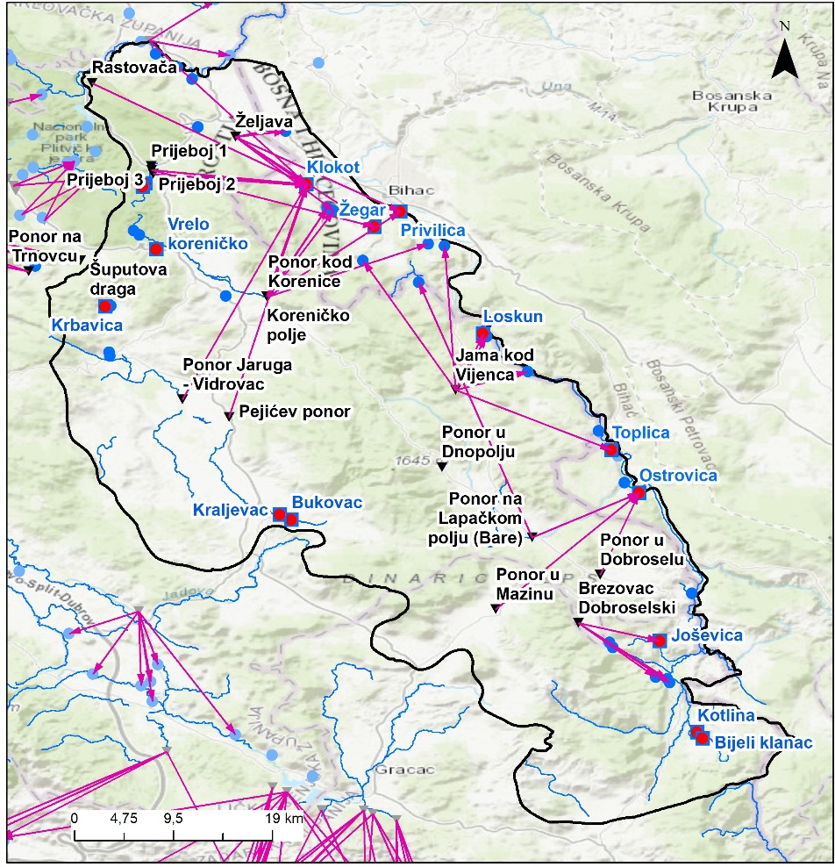
Figure 15 Locations of ponors proposed for monitoring in TBA UNA

Groundwater quantity
Observations and measurements of hydrological values at the Klokot stream are carried out regularly at the hydrological gauging station (GS) of the same name (Klokot GS). There are no systematic measurements of hydrological values for the Privilica spring and other smaller springs. In addition to the fact that the largest portion of water is rising at the Klokot spring, the water from the underground hinterland of this spring also rises in a number of much smaller springs for which there are no organized hydrological measurements. According to data from 2004. these are: Privilica spring (from which 120 l/s is abstracted for water supply), Žegar (estimated capacity about 5 l/s), Smiljanovac (about 5 l/s), Duparica (about 3 l/s), Gata source (about 8 l/s) and a number of other sources (Arkovac, Brišovac, Vedro Polje, etc.).
In order to quantify capacities of main springs, it's necessary to establish continuous measurement of overflow quantities on Privilica and Žegar springs and seasonal discharge measurements of smaller springs. The Bihać Water Utility should systematically record daily pumping/abstraction rates for each spring. Additionally, continuous monitoring on exloratory wells and ponors should be established.
In summary, quantitative monitoring should be established as follows:
- Privilica and Žegar springs – continuous monitoring of overflow/discharge; with seasonal discharge measurements on smaller springs
- Three exploratory wells (Klokot-1, Klokot-2, and a new borehole Klokot-3) – continuous groundwater level monitoring using automatic data loggers;
- Ponors (table 13) – continuous water level monitoring using data loggers (Divers), combined with seasonal discharge measurements (at least four times per year)

Hydrometeorological monitoring
Installation of meteorological stations and precipitation monitoring sites at additional locations to support both hydrological observations (water balance assessment) and stable isotope studies. The plan includes the installation of three new portable meteorological stations that will complement and strengthen the existing monitoring network. In addition, two locations have been designated for the establishment of new hydrological monitoring stations
The proposed locations of the new stations are presented in Table 15.

Table 15. Proposed locations of new meteorological and hydrological monitoring stations
LOCATION | LAT | LNG | Type
Klokot | 15.80 | 44.82 | Meteorological
Mazin | 15.97 | 44.46 | Meteorological
Debelo brdo – Jaruga | 15.70 | 44.65 | Meteorological
Krbavica |  |  | Hydrological
Matica (Korenica) |  |  | Hydrological

The installation will include all necessary equipment, site preparation, mounting structures and protective elements to ensure reliable long-term operation of the monitoring system. The new stations will be integrated into the existing monitoring network to improve spatial coverage of meteorological and hydrological measurements within the study area.

Stable isotope
Isotopic investigations represent a key component in understanding the origin, recharge processes, flow paths and mixing dynamics of groundwater within the catchment. The sampling programme will include nine rainwater collection sites distributed across the catchment at different elevations in order to capture spatial variability in precipitation isotopic composition. In addition, five ponors (sinking streams), representing the main groundwater recharge points, and five springs, reflecting the principal groundwater discharge locations, will be included in the monitoring network.
Sampling should ideally be carried out over multiple seasons to capture temporal variations in precipitation and groundwater contributions, including periods of high and low flow. This approach will allow for a more comprehensive interpretation of recharge processes, groundwater circulation patterns and interactions between surface water and groundwater within the catchment system.
All samples must be collected in clean, inert containers (e.g., HDPE or glass), clearly labeled with the date, location, and sample type, and stored under cool, dark conditions to prevent contamination or alteration prior to analysis. Laboratory analyses focus on stable isotopes of oxygen (δ¹⁸O) and hydrogen (δ²H), which allow the identification of water sources, estimation of residence times, and assessment of mixing between different flow components. Where relevant, additional isotopes (e.g., ³H+He, ³H, ¹⁴C) may be used to investigate groundwater age.
The interpretation of isotopic data should be integrated with hydrological measurements (water level, discharge) and chemical analyses to reconstruct flow dynamics, assess the contributions of different recharge areas, and evaluate interactions between surface and subsurface waters. All sampling and analyses must be conducted in accordance with national standards and using accredited laboratory procedures to ensure reliability and comparability of results. Proper documentation, including sampling logs and chain-of-custody records, is essential for quality control and future reference.The precise sampling sites for rainwater, springs, and ponors will be established after comprehensive preparatory work, including detailed analysis of existing data (desk study) and on-site field reconnaissance, to ensure representative coverage of the catchment and capture key hydrological features.

MONITORING EQUIPMENT ACQUISITION COSTS ESTIMATION
Table 15 provides a list of the equipment required to implement the proposed monitoring programme, while Table 16 presents the services and works necessary for its implementation.
Table 15. List of equipment
NB | Item | Technical specifications | Quantity | Unit of Measure | Suggested supplier(s) | Unit cost | Cost | Remark/Related services
1 | Levelogger 5 LTC | The Levelogger® 5 LTC logs water level, temperature, and conductivity. It combines a datalogger, 8-year battery, Hastelloy® pressure sensor, temperature detector, and conductivity sensor within a small waterproof housing, 22 mm x 208 mm (7/8" x 8.2"). | 6 | cm, m, ft, psi, kPa, bar (ºC, ºF) | Solinist | 1700 | 10200 | Level measurement range (200 m) for 3 ; Level measurement range (20 m) for 3 ;
2 | Levelogger 5, M20 | The Levelogger 5 is an absolute (non-vented) datalogger, which measures groundwater and surface water levels and temperature. Water levels are displayed as temperature compensated pressure readings, and can be barometrically compensated with the aid of a Barologger 5. | 5 | cm, m, ft, psi, kPa, bar (ºC, ºF) | Solinist | 800 | 4000
3 | Barologger 5, M1.5 Assy. | The Barologger 5 uses algorithms based on air pressure only. It measures and logs changes in atmospheric pressure and temperature, which are then used to compensate water level readings recorded by a Levelogger. | 3 | kPa, bar | Solinist | 400 | 1200
4 | Field reader 5 assembly | Otpical reader for levelogger and barolloger | 3 |  | Solinist | 400 | 1200
5 | SS cable assembly and hooks (200 m) | SS cable assembly and hooks for levelogger and barolloger. 200 m per pcs. | 5 | m | Solinist | 200 | 1000
6 | Rain Sampler RS-1 set | This Rain Sampler was especially designed for collecting and sampling composite monthly samples as requested for stable isotope precipitation networks, but it can be used for any purpose rain and snow sampling if you wish to avoid re-evaporation and the use of medicinal paraffin oil, as presence of oil fractions in the water sample can create various problems for laboratory analysis. | 3 | L | Palmex | 500 | 1500
7 | Rain Sampler RS-2 set | This Rain Sampler was especially designed for collecting and sampling composite monthly samples as requested for stable isotope precipitation networks, but it can be used for any purpose rain and snow sampling if you wish to avoid re-evaporation and the use of medicinal paraffin oil, as presence of oil fractions in the water sample can create various problems for laboratory analysis. | 5 | L | Palmex | 1000 | 5000
8 | HDPE bottle | 30 ml round bottle, narrow neck, HDPE, leak-proof PP cap, 12pcs/pack | 90 | - | Almas-Trade | 10 | 900
9 | Syringe filters for the water filtration | Disposable nylon syringe filters, 0.45 µm pore size, 25 mm diameter, non-sterile, for water sample filtration. 100 pcs/pack | 10 | - |  | 70 | 700
10 | Disposable Syringes | Disposable plastic syringes, 60 ml, Luer-lock type, non-sterile, latex-free, suitable for laboratory sample filtration. 125 pcs/pack | 8 | - |  | 100 | 800
11 | Multimeter for portable field measurement (pH, conductivity, DO) | Wireless ready digital multi meter for portable field measurement, with triple channel input, color graphic display incl. data logger and USB  interfaces, meter in field case set with IDS sensors: digital pH electrodes SenTix® 940, digital conductivity cell TetraCon® 925, optical DO probe  FDO® 925, QSC Kit, short instruction manual, stand, beaker, CD-ROM, driver software for USB, rechargeable batteries, cable, universal power  supply, armoring SM Pro. | 2 |  | WTW | 3500 | 7000
12 | Wirelles weather station | TECHNICAL SPECIFICATION  1. Datalogger with integrated GPRS modem  2. Combined sensors for measuring of air temperature, air relative humidity, radiation (insolation), air (atmospheric) pressure, wind speed and direction  3. Combined sensor on ultrasonic principle, for measuring speed and direction of wind at 10m height  4. Pluviometer with heater, scale based  5. Temperature and relative humidity sensor  6. Voltage regulator  7. Network overvoltage protection  8. Transformer for device  9. Battery 12V, 52Ah  10. Protective cabinet, metal IP66  11. Pipe 4” for installation of pluviometer and combined sensor (separately) at 2m height  12. Carrying pole 10m height | 3 |  | Davis Instruments | 1500 | 4500 | Supply, Delivery and Installation. Training in handling, operation and management.
13 | Online turbidity meter | Measurement range: 0 – 100 NTU Accuracy: ±2 % or better Resolution: 0.01 NTU | 1 |  |  | 5000 | 5000 | Supply, Delivery and Installation. Training in handling, operation and management.
14 | Automatic Hydrometric Stations | 1. Data logger – with GPRS modem integrated  2. Pressure probe (0 ... 10 m)  3. Pressure probe cable  4. Solar panel 60W  5. Voltage regulator  6. Power control unit  7. Solar overvoltage protection  8. Solar power supply regulator  9. Battery, 12V, 52Ah  10. Protective cabinet, metal, IP66 | 2 |  |  | 22000 | 44000 | Supply, Delivery and Installation. Training in handling, operation and management.
15 | Staff gauge | Staff gauge with holders: 0-300cm. | 5 |  |  | 500 | 2500 | Supply, Delivery and Installation.

All the necessary equipment (water level and other data loggers, meteorological, hydrological stations, rain sampler, etc.) will be acquired through the DIKTAS project in accordance with the UNESCO procurement system.
At the end of this chapter, the necessary services and works that need to be contracted are also listed separately, such as the implementation of biological monitoring, hydrological monitoring and analyses, as well as isotope investigations.

ANNUL MONITORING PROGRAM COSTS ESTIMATION
Estimation of the costs reletad to the monitoring program, comprises sampling and spacific analyses is proposed in the following table.
Table 17. Two years monitoring program costs estimation
NB | Name | Technical specifications | Service/work | Period | Cost | Remark
1 | Driling of exploratory well in B&H | Drilling and completion of a piezometer (observation well) to a depth of approximately 200 m and borehole diameter of 125 mm, including drilling operations, installation of casing and well construction, well development and flushing, and step-drawdown pumping test with a minimum duration of 24 hours. The scope of works shall include complete physico-chemical and bacteriological water quality analysis and installation of a submersible sampling pump for groundwater monitoring and sampling. Upon completion of the works, a concrete protection block and protective cap shall be constructed and installed. Supervision during the execution of works shall be ensured. | Work | 6 months | 100000 | All works shall be carried out in accordance with applicable national legislation, technical standards and regulations.
2 | Biological monitoring | Chemical and biological monitoring in accordance with Chapter 5.3.1.3 | Service | 24 | 42000 | Laboratory analyses.
3 | Hydrogeological monitoring: groundwater water analysis | Hydrogeological monitoring in accordance with Chapter 5.3.2 | Service | 24 | 20000 | Laboratory analyses.
4 | Stable isotope analysis | Stable Isotope Study in accordance with Chapter 5.3.4 | Service | 24 | 70000 | Includes: laboratory analysis comprising 528 analyses of stable isotopes of oxygen (δ¹⁸O) and hydrogen (δ²H), and 16 analyses for groundwater age determination (³H, ¹⁴C and He)
5 | Hydrogeological, hydrological, biological and stable isotope monitoring. | In accordance with Chapters: 5.3.1.3; 5.3.2; 5.3.3; 5.3.4 | Service | 24 | 24000 | Sampling campaigns

