DIKTAS II
Monitoring site visit – TBA CEMI/CIJEVNA
IMPLEMENTATION OF THE STRATEGIC ACTION PROGRAMME (SAP) OF THE DINARIC KARST AQUIFER SYSTEM: IMPROVING GROUNDWATER GOVERNANCE AND SUSTAINABILITY OF RELATED ECOSYSTEMS
Podgorica/Tuzi (MN) – Grabom/Tamare/Vukel (AL), 27-29 April 2026
REPORT

Site Visit Objectives
- Visit locations proposed in the Monitoring design for Cijevna TBA, draft 1 (Output 3.1
and Output 3.2)
- Check possibilities for the equipment instalment in the field and prepare brief report from
each monitoring site
- Allow experts to share updates and inputs on the monitoring design, draft 1

Background documentation for the site visit
- GEF Project Document
- The Monitoring design for Cemi/Cijevna TBA, draft 1 (Output 3.1)

Table of Contents
Introduction 3
Day 1, Site visit, Albania 4
Day 2 Site visit, Montenegro 10
Day 3 Site visit, Montenegro 14

List of Tables
Table 1. Physic-chemical parameters for surface water quality monitoring along Cemi/Cijevna TBA. 5
Table 2. biological parameters for the surface water quality monitoring along Cemi/Cijevna TBA. 6
Table 3. Overview of Proposed Monitoring Locations and Monitoring Components Identified During the Field Visit in Albania 9
Table 4. Overview of Proposed Monitoring Locations and Monitoring Components Identified During the Field Visit in Montenegro 14

List of Figures and Maps
Figure 1. Sampling point for the surface water monitoring, Grabom, Cemi River, Albania 5
Figure 2. Tamara monitoring site, Albania 7
Figure 3. Subterranean biodiversity monitoring site, Cemi TBA, Albania 7
Figure 4. Vukel Spring monitoring site, AL 8
Figure 5. Sensitive benthic macroinvertebrates, Plecoptera 8
Figure 6. An existing groundwater monitoring borehole (B-8), Montenegro 11
Figure 7. Krvenica Cave Spring, Montenegro 12

Introduction
To ensure the effective management of the TBA Cemi/Cijevna, the implementation of a multi-purpose monitoring network within the TBA Cemi/Cijevna area has been proposed. The multi-purpose monitoring aims to improve the existing monitoring system, assess the risks, pressures and status of both groundwater bodies and groundwater dependent ecosystems, ensure sustainable management of the transboundary aquifers.
Therefore, Expert Group 1 of the DIKTAS II project (subgroups for hydrogeology and biodiversity) proposed, during March 2026, the first draft of the monitoring design for the Cemi/Cijevna TBA (Component 3, Outcome 3, Output 3.1, related to SAP Priority Action 1).
Beside the selection of the appropriate monitoring stations, the site visit served as a first step for the definition of the groundwater dependent ecosystems, both groundwater aquatic associated ecosystems (GDAAEs) and groundwater dependent terrestrial ecosystems (GDTEs). In this regard monitoring stations for the biological monitoring of the surface water quality (GDAAEs) have been defined in both sides, respectively 2 in Cemi River, Albania, of which 1 sampling site will serve for the establishment of quality elements reference conditions, and 1 at Cijevna River, Montenegro.
The riparian vegetation along the Cemi/Cijevna river basin will be used for the definition of the GDTEs with the focus on the NATURA 2000 habitats.
For the monitoring of subterranean biodiversity, 2 monitoring station (caves) have been defined; 1 in Albania (Tamara village) and 1 in Montenegro (Krvenica village).
The proposed monitoring design includes key ponors in the Cijevna River canyon, two new boreholes — the first located in Montenegro, in Dinoša village, and the second near the confluence of the Cemi/Cijevna River with the Morača River — as well as karst springs in the villages of Kroni and Traboini. In addition, biological monitoring sites in Montenegro will be identified during the field visit.
In Albania, the proposed monitoring locations include the Grabom border crossing area, consisting of a monitoring well, an isotopic rain collector, a telemetric station, and one site on the Cemi River for physical-chemical and biological sampling. A second monitoring point is planned in the village of Tamara, where the installation of an additional telemetric station is foreseen. The monitoring network in Albania also includes available biological monitoring sites: two on Cemi Selces (AL10R Vr20 and another site with an unknown ID) and one on Cemi Vukel (CM2).
Field reconnaissance activities and verification of the proposed monitoring locations were carried out during the period from 27 to 28 April 2026 through site visits to each proposed monitoring location.
Therefore, the project manager organized the field visit according to the schedule presented below, with the participation of the national and international experts listed below.
The list of the participants:
Boban Jolović, DIKTAS II Project Manager
Želimir Pekaš, International Hydrogeology Expert
Erjola Keci, National Biodiversity Expert - Albania
Arben Pambuku, National Hydrogeology Expert – Albania
Neda Dević, National Legal Expert – Montenegro
Snežana Dragićević, National Biodiversity Expert – Montenegro
Dragan Radojević, National Hydrogeology Expert – Montenegro

Day 1, Site visit, Albania

Tour led by Arben Pambuku and Erjola Keci

Site visit at the Grabom border crossing

- Groundwater quantity and quality monitoring (groundwater level, temperature and electrical conductivity – EC) is conducted at a monitoring well located near the Albania–Montenegro border, on the left bank of the Cijevna/Cemi River. The monitoring location is positioned at the coordinates 42.4246262 N, 19.5019595 E.
- Isotopic precipitation monitoring will be conducted at an isotopic pluviometer station equipped with an isotopic rain collector, located at the Grabom border crossing. The monitoring location is positioned at the coordinates 42°25'28.29"N, 19°29'30.59"E.
- A telemetric station for remote data transmission is planned in the Grabom border crossing area, approximately 1 km downstream from the monitoring well, due to accessibility and security considerations. The station will be connected to the monitoring equipment for continuous data transmission. (It should be clarified whether the telemetric station will be located near the exploratory borehole or at the Grabom border crossing due to security considerations).
- Physical-chemical and biological monitoring will be carried out at the left bank of the river, Grabom sampling point. Within the monitoring program, two sampling campaigns will be organized. The monitoring location is positioned at the coordinates 42.4265739 N, 19.5267847 E (Fig. 1; Map.x)
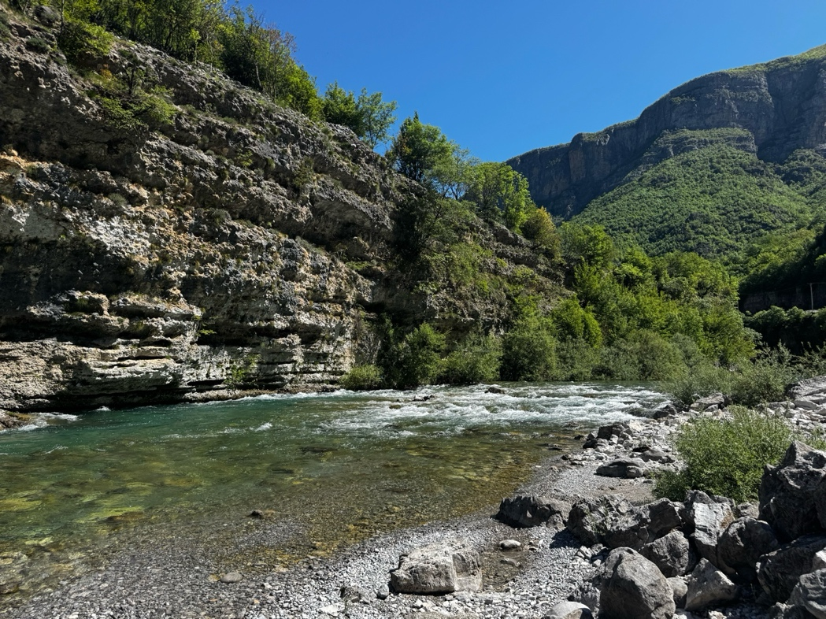
Figure 1. Sampling point for the surface water monitoring, Grabom, Cemi River, Albania
The monitoring parameters, physic-chemical and biological used for the ecological status assessment of the surface water quality (GDAAEs) and the respective monitoring frequency along the Cemi/Cijevna TBA, are presented in the tables below (Tables. 1&2).

Table 1. Physic-chemical parameters for surface water quality monitoring along Cemi/Cijevna TBA.
Quality Element | Status indicator | Frequency Surveillance/operational monitoring
Thermal Conditions | Temperature (water) | 2/yr
Thermal Conditions | Temperature (air)
Salinity | Salinity | 2/yr
Acidity | pH | 2/yr
Oxygen Regime | Biochemical Oxygen Demand over 5 days (BOD₅) | 2/yr
Oxygen Regime | Chemical Oxygen Demand (COD-Mn) | 2/yr
Nutrients | Ammonium | 2/yr
Nutrients | Nitrates | 2/yr
Nutrients | Total nitrogen | 2/yr
Nutrients | Orthophosphates | 2/yr
Nutrients | Total phosphorus | 2/yr

Table 2. biological parameters for the surface water quality monitoring along Cemi/Cijevna TBA.
Biological Quality Element (BQE) | Indicator | Pressure | Frequency of monitoring
Phytobenthos | Diatom Trophic Index (TID) | nutrient salt pressure | 2/yr
Macrophytes | Reference Index (RI-MHR) | nutrient salt pressure/general degradation | 2/yr
Macro zoobenthos/ Benthic Invertebrates | Saprobic index (SI)  Multimetric Index (MMIR) | Organic Pressure  Hydromorphological changes | 2/yr

Site visit in Tamara village
- Monitoring of river discharge and climatic parameters will be conducted in the area of the HEC Tamara hydropower plant. A second telemetric station is planned at the monitoring point located near the hydropower station in the village of Tamara (42.4719149 N, 19.5697904 E).
- Monitoring of physic-chemical parameters is seasonally carried out by the Albanian National Environment Agency (NEA) at two locations on the Cemi River: Cemi Selces (unknown ID) and Cemi Vukel (CM2).
Subterranean biodiversity monitoring will be carried out at one cave in Albania, Tamara (Fig. 3) through cave diving research by using standard diving techniques.

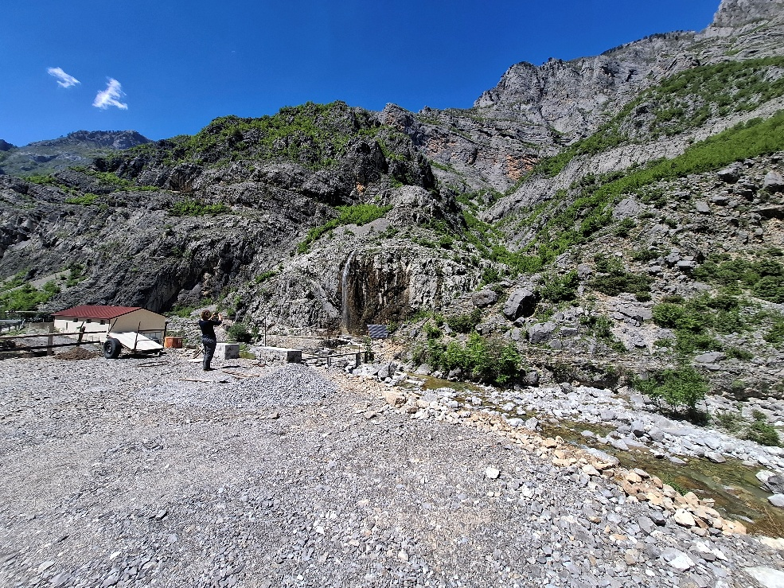
Figure 2. Tamara monitoring site, Albania

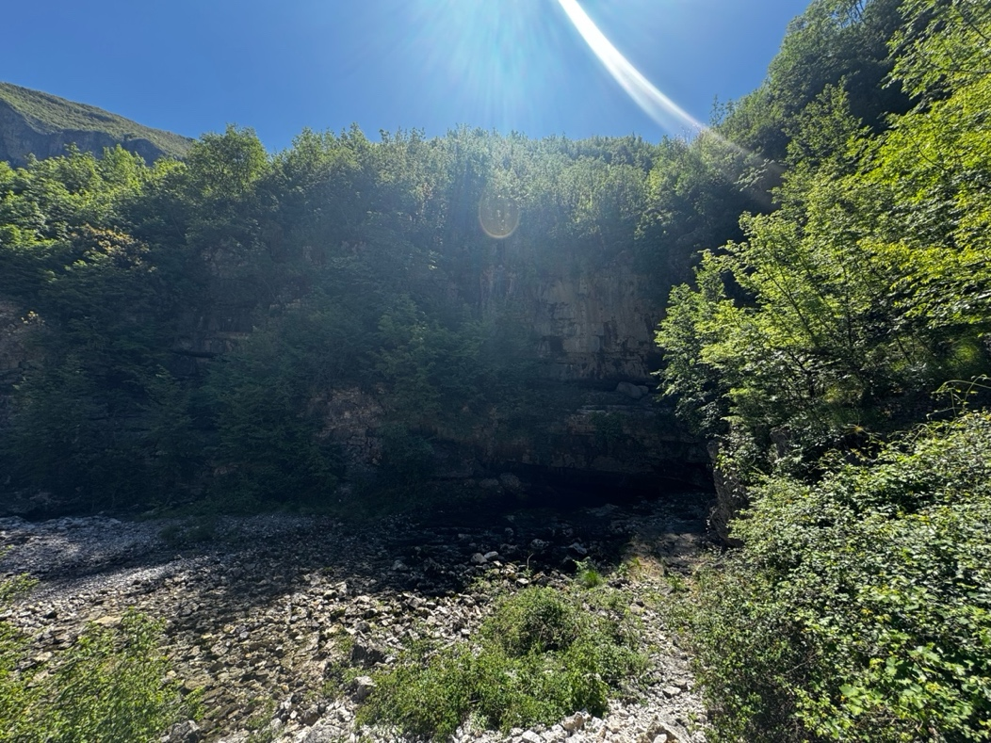
Figure 3. Subterranean biodiversity monitoring site, Cemi TBA, Albania

Site visit in Vukel village
- Physical-chemical and biological parameters monitoring of the Vukel Spring, located in the source area on the right bank of the Cijevna River, will be conducted as a reference (baseline) monitoring point due to the low anthropogenic pressure in the area. Within the monitoring program, two sampling campaigns will be organized. The monitoring location is positioned at the coordinates 42.480375 N, 19.657834 E (Fig.4&5).
- In addition, rain samplers for stable isotope analyses will be installed at this location.

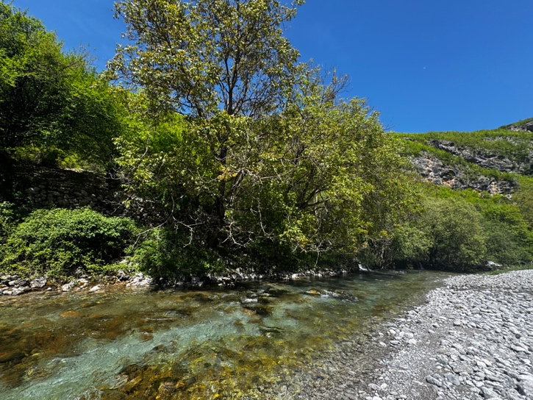
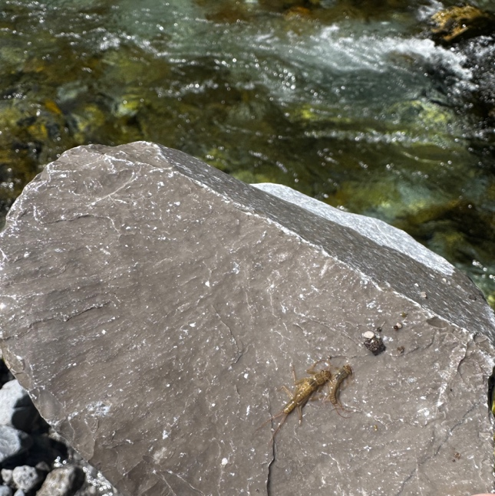
Figure 4. Vukel Spring monitoring site, AL

Figure 5. Sensitive benthic macroinvertebrates, Plecoptera

Table 3. Overview of Proposed Monitoring Locations and Monitoring Components Identified During the Field Visit in Albania
Place | Monitoring component | Easting (m) | Northing (m) | Monitoring purpose | Remarks
Grabom | Monitoring well drilling site | 19.5019595 | 42.4246262 | Groundwater quantity and quality monitoring (groundwater level, temperature and electrical conductivity – EC). | Selected as the most suitable location for hydrogeological monitoring
Grabom | Isotopic pluviometer station | 19°29'30.59" | 42°25'28.29" | Collection of precipitation samples for stable isotope analysis (δ¹⁸O, δ²H) | Installed near the existing customs facility building
Grabom | Telemetric monitoring station (No.1) | 19°29'30.59" | 42°25'28.29" | Continuous monitoring
Grabom | Physical-chemical and biological monitoring of the Cemi/Cijevna River | 19.5267847 | 42.4265739 | Biological Quality Elements (BQEs) monitoring. | Two sampling campaigns.
Tamara | Telemetric station (No.2 – Tamara HPP area) | 19.5697904 | 42.4719149 | Monitoring of river discharge and climatic parameters | Located in the HEC Tamara hydropower plant area
Tamara | Physic-chemical parameters monitored by the National Environment Agency (NEA) is available at two locations on the Cemi River: Cemi Selces (unknown ID) and Cemi Vukel (CM2). |  |  | physic-chemical water quality parameters monitoring. | Existing monitoring.
Tamara | one potential monitoring site for subterranean biodiversity monitoring located at south tamara in the left bank, close to the main road | Coordinates??? | Coordinates??? | Subterranean biodiversity monitoring. | two sampling campaigns
Vukel | Physical-chemical and biological elements monitoring at the Vukel Spring sampling site | 19.657834 | 42.480375 | Biological Quality Elements (BQEs) monitoring.  Establish Quality Reference Conditions according to WFD | Two sampling campaigns.
Vukel | Isotopic pluviometer station | 19.657834 | 42.480375 | Collection of precipitation samples for stable isotope analysis (δ¹⁸O, δ²H) | In addition, rain samplers for stable isotope analyses will be installed at this location

Day 2 Site visit, Montenegro

Tour led by Dragan Radojević, Neda Dević and Snežana Dragićević

Groundwater, surface water, biological and meteorological monitoring sites (boreholes and springs)
Site visit in Ljaljkovići–Mitrovići villages (confluence of the Cijevna River and the Morača River)
- An existing groundwater monitoring borehole (B-8) is used for groundwater monitoring purposes in Montenegro and is operated by the Institute of Hydrometeorology and Seismology of Montenegro (IHMS). The borehole is located on the right-bank river terrace of the Cijevna River, composed of glaciofluvial sediments. The total borehole depth is 31 m. The recorded groundwater level was 8.1 m below ground level (measured on 03 July 2018). The location coordinates are 6600090; 4691069, with an elevation of 15 m a.s.l.
- Groundwater quantity and quality monitoring (groundwater level, temperature and electrical conductivity – EC) is planned near the confluence of the Cijevna River and the Morača River. The location of the new exploratory borehole will be determined during additional hydrogeological field investigations.
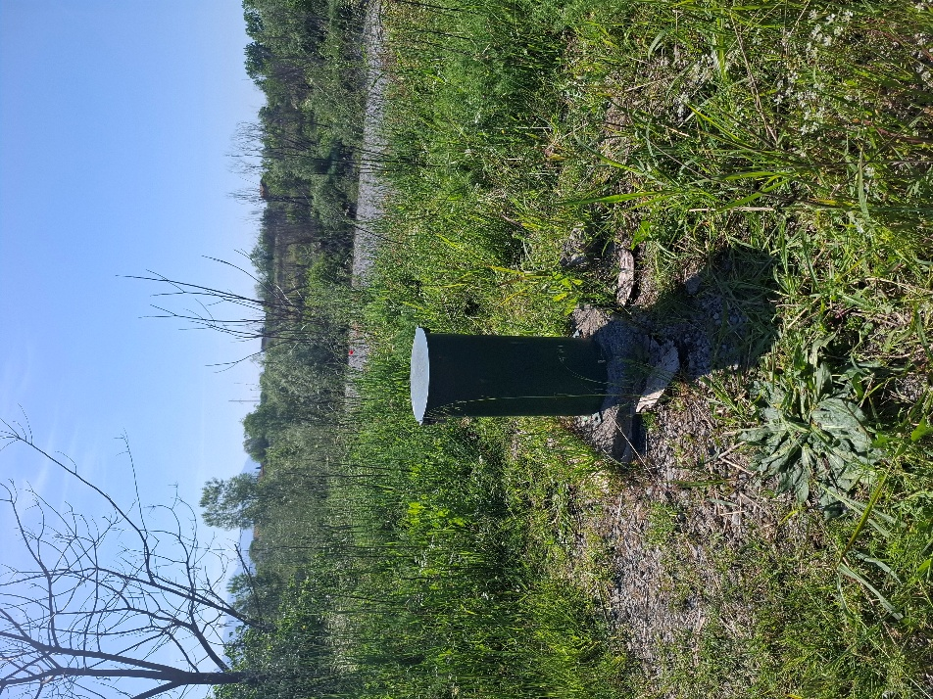
Figure 6. An existing groundwater monitoring borehole (B-8), Montenegro
Site visit in Ržanički most – Kuće Rakića
An existing groundwater monitoring borehole (IB-45) in the Zeta Plain area is operated by the Geological Survey of Montenegro (GSM). A diver logger for real-time monitoring of groundwater level, water temperature, and electrical conductivity (EC) has been installed in the borehole. The borehole is located on the left-bank terrace of the Cijevna River, composed of glaciofluvial sediments, underlain by Cretaceous limestones. The total borehole depth is 120 m. The recorded groundwater level was 19.35 m a.s.l. (measured on 28 April 2026). The location coordinates are 6607395.826; 4695438.016, with a ground elevation of 60.79 m a.s.l.

Site visit in Kroni and Traboini village
- The karst spring in the villages of Kroni and Traboini will be equipped with a data logger (diver) for continuous monitoring of water level (stage), based on which spring discharge will be calculated.
- Isotopic precipitation monitoring will be conducted at an isotopic pluviometer station equipped with an isotopic rain collector, located near the spring.
- Installation of an automatic climatological station.
- Physical-chemical and biological sampling of the karst spring will be conducted for the assessment of water quality and subterranean biodiversity. Within the monitoring program, two sampling campaigns will be organized.
The monitoring location is positioned at the coordinates 6619418, 4695385, with an elevation of 409 m a.s.l.
Site visit in Vuksan Lekići village - Krvenica Cave Spring
- Physical-chemical and biological sampling of the Krvenica Cave will be conducted for the assessment of subterranean biodiversity. Within the monitoring program, two sampling campaigns will be organized.
- The monitoring location is positioned at the coordinates 6610976, 4690674, with an elevation of 37.5 m a.s.l.
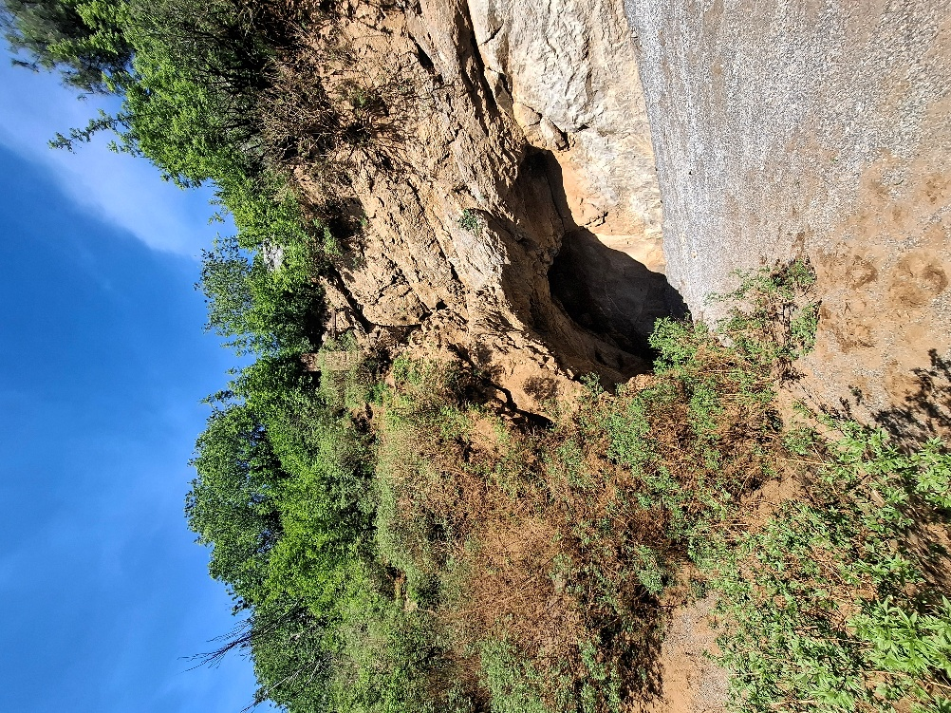
Figure 7. Krvenica Cave Spring, Montenegro

Site visit in Dinoša village
- Groundwater quantity and quality monitoring (groundwater level, temperature and electrical conductivity – EC) is planned near the village of Dinoša. The location of the new exploratory borehole will be determined during additional hydrogeological field investigations.
- Ponors located in the Cijevna River canyon in the village of Dinoša, near the former Rokšped facility. The location coordinates are 6612714, 4696187, with an elevation of 93 m a.s.l.

Table 4. Overview of Proposed Monitoring Locations and Monitoring Components Identified During the Field Visit in Montenegro
Place | Monitoring component | Easting (m) | Northing (m) | Monitoring purpose | Remarks
Ljaljkovići–Mitrovići  (Confluence of the Cijevna River and the Morača River) | An existing groundwater monitoring borehole (B-8) | 4691069 | 6600090 | Groundwater monitoring. | Existing monitoring by IHMS.
 | New exploratory borehole |  |  | Groundwater quantity and quality monitoring (groundwater level, temperature and electrical conductivity – EC). | The location will be determined during additional hydrogeological field investigations.
Ržanički most – Kuće Rakića | An existing groundwater monitoring borehole (IB-45) | 4695438.016 | 6607395.826 | Continuous GW monitoring. | Existing monitoring by GSM.
Kroni and Traboini | The karst spring will be equipped with a data logger (diver) for continuous monitoring of water level (stage). | 4695385 | 6619418 | Groundwater quantity and quality monitoring (groundwater level, temperature and electrical conductivity – EC). | Real time monitoring.
Kroni and Traboini | Isotopic pluviometer station | 4695385 | 6619418 | Collection of precipitation samples for stable isotope analysis (δ¹⁸O, δ²H) | Installed near the karst spring.
Kroni and Traboini | Installation of an automatic climatological station | 4695385 | 6619418 | Meteorological observations. | Installed near the karst spring.
Kroni and Traboini | Physical-chemical and biological elements monitoring of the Kroni and Traboini Spring | 4695385 | 6619418 | Biological Quality Elements (BQEs) monitoring. | Two sampling campaigns.
Krvenica Cave Spring | Subterranean biodiversity monitoring of the Krvenica cave spring. | 4690674 | 6610976 | Subterranean biodiversity monitoring. | Two sampling campaigns.
Dinoša | New exploratory borehole |  |  | Groundwater quantity and quality monitoring (groundwater level, temperature and electrical conductivity – EC). | The location will be determined during additional hydrogeological field investigations.

Day 3 Site visit, Montenegro
09:00-10:00 Preparation of the draft Minutes of the site visit and closure of the field visit activities were also completed during this period.
10.00-11:00 A meeting was held with Ms. Anela Sijarić from the Ministry of Ecology, Sustainable Development and Northern Region Development, attended by the Montenegro and international experts.

