DIKTAS II

IMPLEMENTATION OF THE STRATEGIC ACTION PROGRAMME (SAP) OF THE DINARIC KARST AQUIFER SYSTEM: IMPROVING GROUNDWATER GOVERNANCE AND SUSTAINABILITY OF RELATED ECOSYSTEMS

OUTPUT 3.1.

Design of DIKTAS-wide
groundwater multi-purpose monitoring network
SITE 1: TBA Cemi/Cijevna shared between
Albania and Montenegro

March 2026

PREPARED BY DIKTAS II PROJECT TEAM, EXPERT GROUP 1 AND EXPERT GROUP 2
Arben Pambuku, National Expert for Hydrogeology, Albania
Dragan Radojevic, National Expert for Hydrogeology, Montenegro
Vedran Furtula, Expert for GIS, Bosnia and Herzegovina
Erjola Keçi, National Expert for Biodiversity, Albania
Ivan Vučković, National Expert for Biodiversity, Croatia

SUPPORT
Boban Jolović, Project Manager

ACRONYMS (a selection)
AMBU - Agency of water resources management
GW- Groundwater
WFD- Water Framework Directive (Directive 2000/60/EC)
GWD- Groundwater Directive (Directive 2006/118/EC)
DWD- Drinking Water Directive (Directive 2020/218)
GWM- Ground Water Monitoring
GQS- Groundwater Quality Standards

Contents

1 INTRODUCTION 7
1.1 General context and significance of the project 7
1.2 European political and legal framework 8
1.3 Brief description of the Cemi/Cijevna watershed 8
1.4 The need for an integrated monitoring project 9
1.5 Overall project goal 9
1.6 Added value of the project 9
2. MONITORING PURPOSE AND APPROACH IN THE CEMI/CIJEVNA TBA 10
2.1 Principles of integrated water resources monitoring 10
2.2 Overall monitoring objective 10
2.3 Specific monitoring objectives 11
2.3.1 Establishment of a unified cross-border monitoring network 11
2.3.2 Continuous monitoring of surface water quantity 11
2.3.3 Monitoring of surface water quality 11
2.3.4 Groundwater monitoring in the transboundary aquifer 11
2.3.5 Integration of climate monitoring into hydrological analysis 12
2.3.6 Determination of water origin through isotopic monitoring 12
2.3.7 Application of Radon-222 as a tracer in the karst system 12
2.3.8 Monitoring continuity and infrastructure security 12
2.3.9 Data management and reporting system 13
3. GEOGRAPHIC, GEOLOGICAL AND HYDROGEOLOGICAL OVERVIEW OF THE CEMI/CIJEVNA TBA 13
3.1 Geology 17
3.1.1 Tectonic setting 17
3.1.2 Geological characteristics 18
3.2 Hydrogeology 20
3.2.1 Hydrogeological characteristics 20
3.2.2 General directions and rate of groundwater flow 21
3.2.3 Hydrogeological units and aquifer characteristics 23
4. CONCEPTUAL MODEL OF THE CEMI/CIJEVNA TBA AS FOUNDATION FOR MONITORING DESIGN 23
4.1 HYDROGEOLOGICAL UNITS 25
4.1.1 Aquifers – permeable geological formations 26
4.1.2 Aquitards – low permeability formations 27
4.1.3 Aquicludes – nearly impermeable formations 27
4.2 SOURCES OF RECHARGE 28
4.2.1 Groundwater-Dependent Ecosystems 29
4.2.2 Precipitation 30
4.2.3 Losing streams and concentrated recharge mechanisms 30
4.3 GROUNDWATER FLOW SYSTEM 30
4.4 DISCHARGE AREAS 31
4.4.1 Springs 31
4.4.2 Gaining streams 32
4.4.3 Wetlands 32
4.4.4 Lakes and reservoirs 32
4.4.5 Wells and groundwater abstraction 32
4.5 Boundaries of the conceptual model 32
4.6 Anthropogenic influences 33
4.6.1 Groundwater abstractions 33
4.6.2 Point sources of pollution 33
4.6.3 Diffuse sources of pollution 33
5. MONITORING IN THE CEMI/CIJEVNA TRANSBOUNDARY BASIN 34
5.1 EXISTING MONITORING 35
5.1.1 Groundwater monitoring 36
5.1.2 Surface water monitoring 36
5.1.3 Hydrometeorological monitoring 36
5.2 MONITORING PARAMETERS WITH MONITORING FREQUENCIES 37
5.2.1 Groundwater chemical status 38
5.2.2 Surface water chemical status 39
5.2.3 Surface water ecological status 39
5.3 PROPOSAL FOR MONITORING IMPROVEMENT 40
5.3.1 Groundwater quality monitoring 43
5.3.2 Groundwater quantity monitoring 45
5.3.3 Hydrometeorological monitoring 46
5.3.4 Stable isotope monitoring 46
5.3.5 Radon monitoring as a groundwater tracer 46
5.3.6 Data management and integration 47
6. MONITORING EQUIPMENT ACQUISITION COSTS ESTIMATION 48
Summary of the budget - detailed financial budget 49
7. ANNUAL MONITORING PROGRAM COSTS ESTIMATION 53
8. MONITORING RESPONSIBILITY AFTER THE END OF THE DIKTAS II PROJECT 53
9. CONCLUSIONS 54
10. REFERENCES 59

LIST OF TABLES

Table 1. Monthly rainfall of the Cemi/Cijevna basin. 16
Table 2. Multiannual flows of the Cemi/Cijevna River in Cemi and Selcë. 17
Table 3. Monthly flows of the Cemi/Cijevna River in Cemi and Selca. 17
Table 4. Characteristic flows of major karst spring in the TBA Cemi River 28
Table 5 Biological indicators 29
Table 6. Coordinates of the springs sampled in Cemi/Cijevna river basin (AKKSHI&ASHSH project, 2025-2026) 31
Table 7. Three main categoriesof surveillance monitoring suggested by WFD 34
Table 8. Basic physico-chemical parameters for monitoring groundwater-dependent ecosystems in the Cemi/Cijevna basin 40
Table 9. Monitoring programe proposed 41
Table 10. Summary results – June 2025 43
Table 11. Main measured parameters and hydrochemical types of the main springs 44
Table 12. Proposed monitoring infrastructure in the Albanian part of the Cemi/Cijevna basin 47
Table 13. Detailed budget for equipments in Albania 50
Table 14 Detailed budget for equipments in Montenegro 51
Table 15. Total expenses 52

List of figure
Figure 1 Location of the Cemi/Cijevna transboundary basin Topographic map 7
Figure 2 Hydrographic network, AL-MNE 15
Figure 3 Albanian geological map, scale 1:25 000, sheet K-34-51-D-b (001 - Grabom) 19
Figure 4 Albanian geological map, scale 1:25 000, sheet K-34-52-C-a (Tamara). 19
Figure 5 Geological map, scale 1:100 000, excerpt from the Basic geological map of Montenegro, section “Titograd 20
Figure 6 Hydrogeological map 21
Figure 7 Groundwater flow path in the karst aquifer of Cemi Cijevna river with state boundary 22
Figure 8 Groundwater flow path in the karst aquifer of Cemi Cijevna river with state boundary 22
Figure 9 Conceptual Hydrogeological model of TBA Cemi/Cijevna with state boundaries 24
Figure 10 Conceptual Hydrogeological model of TBA Cemi/Cijevna without state boundaries 24
Figure 11 Map of proposed monitoring network 37
Figure 12 Schoeller diagram showing the major ion composition of groundwater and surface water samples from the Cemi/Cijevna basin. The diagram indicates the dominance of calcium–bicarbonate waters typical for karst aquifers developed in carbonate rocks. 45

List of annexes

1. Map 1 — Regional Context (~1:2,500,000)
2. Map 2 — Watershed / Catchment Boundary (~1:500,000)
3. Map 3 — Hydrographic Network & Sub-basins (~1:100,000)

INTRODUCTION

1.1 General context and significance of the project

Sustainable management of water resources in transboundary regions represents one of the key challenges of contemporary environmental governance and regional development policies in Europe. River basins that extend across national borders form interconnected hydrological and hydrogeological systems in which natural processes and human activities occurring in one country may directly influence water resources in neighbouring states. For this reason, effective management of such systems requires coordinated monitoring, data exchange and joint scientific understanding (European Commission, 2000).
The Cemi/Cijevna River basin represents an important transboundary catchment shared between Albania and Montenegro. The river originates in the Albanian Alps and flows through mountainous karst terrain before entering the territory of Montenegro, where it eventually joins the Morača River and contributes to the hydrological system of Lake Shkodra.
Due to its geographical position and hydrogeological characteristics, the basin constitutes a complex natural system of considerable hydrological, ecological and socio-economic importance for both countries. Surface water and groundwater resources of the basin support local communities, sustain valuable ecosystems and represent an important strategic resource for regional development.
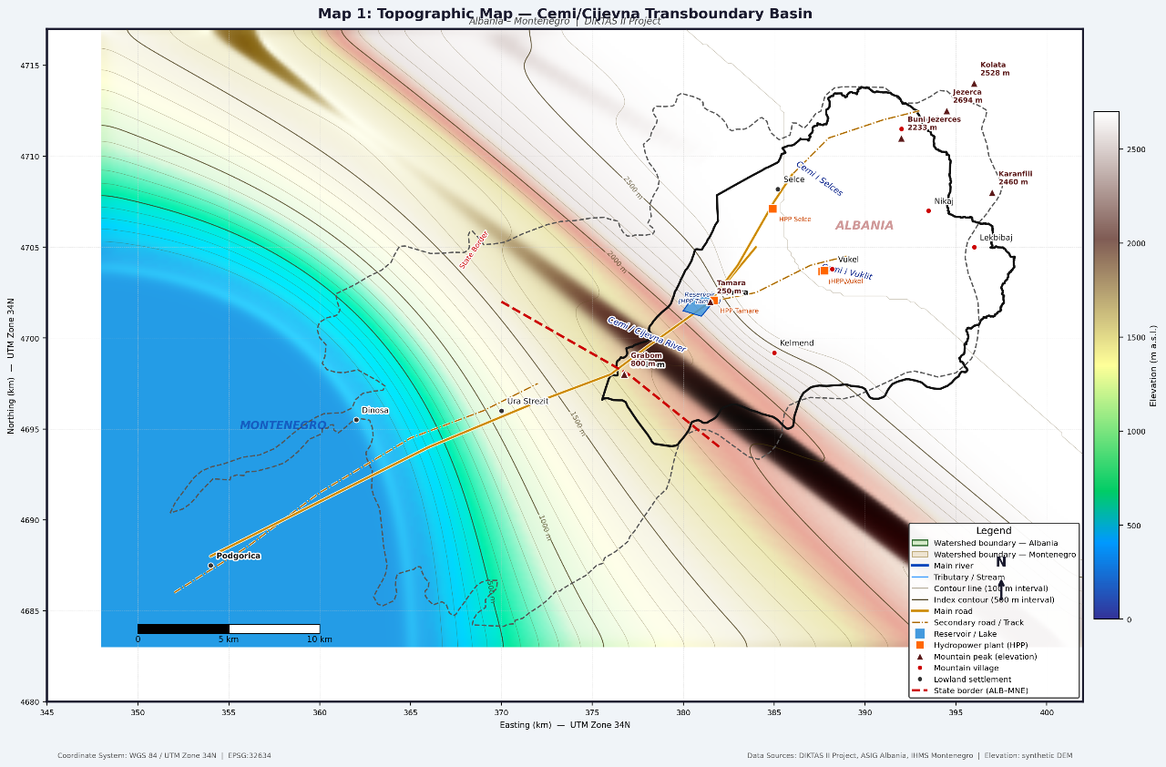
Figure 1 Location of the Cemi/Cijevna transboundary basin
Topographic map

At the same time, the basin is characterized by dynamic hydrological processes associated with steep topography, high precipitation and extensive carbonate formations of the Dinaric karst system. These characteristics create strong hydraulic interactions between surface water and groundwater systems (Ford & Williams, 2007).
Despite the importance of the basin, historical monitoring activities have often been fragmented and implemented separately within the two countries. Differences in monitoring methodologies, spatial coverage and data availability have limited the development of a comprehensive understanding of the hydrological functioning of the system.
The present project therefore aims to establish a scientifically grounded and technically coordinated monitoring framework for the Cemi/Cijevna transboundary basin.

1.2 European political and legal framework

The development of a joint monitoring system for the Cemi/Cijevna basin is closely aligned with the principles and objectives of the European Union water policy framework. In particular, the project reflects the requirements of the Water Framework Directive (2000/60/EC), which establishes the river basin as the fundamental unit for water resources management and emphasizes the importance of systematic monitoring of water quantity, quality and ecological status.
The Directive also highlights the need for cooperation between countries sharing transboundary water bodies, with the aim of achieving good ecological and chemical status of waters through coordinated management strategies. In this context, monitoring represents one of the essential tools for assessing water status, identifying pressures and supporting the design of appropriate management measures.
In addition to the Water Framework Directive, the project is consistent with the objectives of several related European policies and directives, including the Groundwater Directive (2006/118/EC) and the Environmental Quality Standards Directive (2008/105/EC), which provide specific guidance on groundwater protection and the monitoring of priority substances in aquatic environments.
The initiative is also aligned with the broader framework of cross-border cooperation programmes supported by the European Union, including IPA and Interreg mechanisms, which encourage neighbouring countries to develop joint monitoring systems, exchange data and strengthen institutional cooperation in the management of shared natural resources.
Within this policy context, Albania and Montenegro share a common interest in establishing a coordinated monitoring system that will facilitate not only compliance with European standards but also the development of a robust scientific basis for long-term management of the Cemi/Cijevna river basin.

1.3 Brief description of the Cemi/Cijevna watershed

The Cemi/Cijevna River basin is located in the mountainous region of the Albanian Alps and represents a typical transboundary alpine catchment shared between Albania and Montenegro. The river originates in northern Albania and flows through steep mountainous terrain before crossing the state border and continuing across the Zeta Plain in Montenegro, where it ultimately joins the Morača River.
The total length of the Cemi/Cijevna River is approximately 62 km, while the overall catchment area covers about 368 km², of which around 238 km² lie within the territory of Albania. The average altitude of the basin exceeds 1200 m above sea level, reflecting the strongly mountainous character of the region.
Hydrologically, the river is formed by the confluence of two main tributaries: the Cemi of Selca, which constitutes the northern branch, and the Cemi of Vukël, forming the southern branch. These two branches meet near the village of Tamara, after which the river continues toward the southwest before leaving Albanian territory near Grabom and entering Montenegro.
The basin is characterized by steep slopes, narrow valleys and high-energy river flows. River channels are predominantly composed of gravel and rocky materials, and the hydrological regime is strongly influenced by intense precipitation and seasonal snowmelt. As a result, the river responds rapidly to meteorological events, displaying significant seasonal and inter-annual variability in discharge.
From a hydrogeological perspective, the basin is dominated by carbonate formations of the Dinaric karst system. Extensive limestone and dolomite formations have undergone strong karstification, resulting in highly permeable aquifers with complex networks of fractures, conduits and underground drainage pathways. These conditions favour rapid infiltration of precipitation and create strong hydraulic connectivity between surface waters and groundwater systems.
Such hydrogeological characteristics make the basin particularly dynamic but also vulnerable to external pressures, including climate variability, land-use changes and potential sources of pollution. Understanding these processes requires systematic and harmonized monitoring of both surface water and groundwater components of the basin.

1.4 The need for an integrated monitoring project

Existing monitoring activities within the Cemi/Cijevna basin have historically been limited in spatial and temporal coverage and have often been conducted independently by the two neighbouring countries. As a result, available datasets are fragmented and frequently based on different methodologies, monitoring frequencies and technical standards.
This situation has created several challenges for the effective assessment of water resources in the basin. In particular, the lack of harmonized monitoring has limited the ability to produce comparable datasets, analyze long-term hydrological trends and develop reliable conceptual or numerical models of the system.
An integrated transboundary monitoring approach is therefore essential in order to overcome these limitations. By establishing a coordinated monitoring network with harmonized methodologies, standardized measurement frequencies and compatible equipment, it becomes possible to treat the basin as a single hydrological and hydrogeological system rather than as two separate national segments.
Such an integrated monitoring framework will provide the necessary scientific basis for evaluating the current status of water resources, identifying potential pressures and risks, and supporting the development of effective management strategies for the sustainable use and protection of the basin.

1.5 Overall project goal

The primary objective of the project is to establish and operate a joint monitoring system for surface water and groundwater within the Cemi/Cijevna transboundary basin. The system is designed to generate reliable, continuous and comparable data that will support integrated water resources management and strengthen cross-border cooperation between Albania and Montenegro. This objective will be achieved through the installation of modern monitoring infrastructure, the application of advanced measurement technologies and the integration of hydrological, hydrogeological, climatic and isotopic monitoring approaches. The project also aims to establish a shared database and data management system that will allow participating institutions to access and interpret monitoring results in a coordinated manner.

1.6 Added value of the project

The added value of the project lies in its ability to move beyond traditional, fragmented monitoring practices and create a scientifically robust framework for understanding the functioning of the Cemi/Cijevna basin as a unified transboundary system.
By combining hydrological measurements, groundwater monitoring, climate observations and isotopic analyses, the project will generate a comprehensive dataset capable of supporting advanced hydrogeological interpretation and water balance assessment. In addition, the project will contribute to strengthening institutional cooperation between Albania and Montenegro, facilitating data exchange and joint decision-making in the management of shared water resources.
In this way, the project represents not only a technical monitoring initiative but also an important step toward the long-term protection and sustainable management of water resources in one of the most environmentally valuable regions of the Western Balkans.

2. MONITORING PURPOSE AND APPROACH IN THE CEMI/CIJEVNA TBA

2.1 Principles of integrated water resources monitoring

The monitoring framework proposed for the Cemi/Cijevna transboundary basin is based on the fundamental principles of integrated water resources management and transboundary cooperation. These principles recognize that river basins and aquifer systems represent natural hydrological units that function independently of administrative and political borders. Consequently, monitoring systems in such environments must be designed in a coordinated and harmonized manner in order to ensure reliable and comparable data across the entire basin.
In the context of the Cemi/Cijevna basin, monitoring activities must address the strong interactions between climatic conditions, surface water processes and groundwater dynamics within the karst environment. The complex hydrogeological structure of the basin, dominated by highly permeable carbonate formations, requires a monitoring system capable of capturing both rapid hydrological responses and longer-term groundwater processes.
The monitoring concept developed within this project therefore integrates several complementary components, including surface water monitoring, groundwater monitoring, hydrometeorological observations and isotopic investigations. These components are designed to operate within a unified monitoring framework that allows the interpretation of hydrological processes at the scale of the entire transboundary basin. The monitoring approach is further guided by European water management standards, particularly those established under the Water Framework Directive, which emphasize the importance of systematic monitoring for assessing water status, identifying pressures and supporting sustainable water management policies.

2.2 Overall monitoring objective

The overall objective of the monitoring system proposed in this project is to establish a harmonized and sustainable monitoring framework for surface water and groundwater within the Cemi/Cijevna transboundary basin.
The monitoring system is intended to generate reliable and continuous datasets that will support the understanding of hydrological and hydrogeological processes within the basin, facilitate cross-border data exchange and provide a scientific basis for coordinated water resources management between Albania and Montenegro. Through the establishment of modern monitoring infrastructure and harmonized methodologies, the system aims to overcome the limitations of previous monitoring efforts and create a comprehensive observational network capable of supporting both scientific analysis and water management decision-making.

2.3 Specific monitoring objectives

2.3.1 Establishment of a unified cross-border monitoring network
One of the key objectives of the project is the establishment of a unified monitoring network covering both the Albanian and Montenegrin parts of the Cemi/Cijevna basin. The monitoring network is designed to operate according to harmonized methodologies, standardized measurement frequencies and comparable monitoring equipment.
Such harmonization is essential for ensuring that data collected in the two countries can be directly compared and interpreted within a common hydrological framework. The unified monitoring network will therefore provide the foundation for joint interpretation of hydrological processes and for coordinated management of shared water resources.

2.3.2 Continuous monitoring of surface water quantity
Continuous monitoring of surface water discharge represents a central component of the monitoring system. River flow measurements will be carried out at representative monitoring points within the Albanian territory, including stations located at Tamara and near the Grabom border crossing.
At these locations, water levels will be recorded using automatic sensors capable of transmitting data at short time intervals through telemetric systems. Periodic flow measurements will also be conducted using flowmeters in order to establish and calibrate stage–discharge relationships.
The resulting hydrological data series will be correlated with existing hydrometric observations in Montenegro, particularly those from the Dinoša monitoring station, enabling the development of a continuous and coherent discharge record for the entire river system.

2.3.3 Monitoring of surface water quality
Monitoring of surface water quality constitutes another important component of the monitoring framework. Regular sampling will be carried out in order to evaluate the physico-chemical and microbiological characteristics of the river water and to detect possible variations associated with seasonal hydrological conditions or anthropogenic influences.
The monitoring programme will include measurements of key physico-chemical parameters, nutrients and selected trace elements. In addition, bacteriological analyses will be performed in order to assess the sanitary quality of the water.
The collected data will allow the evaluation of water quality trends and the comparison of measured concentrations with national and European water quality standards.

2.3.4 Groundwater monitoring in the transboundary aquifer
Groundwater monitoring represents a crucial element of the project due to the strong hydrogeological connections between the Cemi/Cijevna River and the surrounding karst aquifer systems. In order to observe groundwater dynamics within the transboundary aquifer, a monitoring well will be installed near the state border in the area of Grabom. The monitoring well will capture the same karst aquifer system that extends into the territory of Montenegro and is monitored by existing wells in the karst hinterland of the Dinoša area. The last monitoring point in the basin is the newly planned piezometer at the mouth of the Cemi/Cijevna River, at its confluence with the Morača River. This will enable monitoring of the system’s outflow.
The well will be equipped with automatic sensors capable of continuously recording groundwater level, temperature and electrical conductivity. Data will be transmitted in real time through a telemetric system, allowing the analysis of groundwater responses to precipitation events, river discharge variations and seasonal hydrological changes.

2.3.5 Integration of climate monitoring into hydrological analysis
Hydrological processes within mountainous basins such as Cemi/Cijevna are strongly influenced by climatic factors, particularly precipitation and temperature. For this reason, the monitoring system will include telemetric climate stations capable of providing high-resolution meteorological data.
These stations will measure precipitation, air temperature, atmospheric pressure and other relevant climatic parameters. The collected data will contribute to the analysis of spatial and temporal variations in precipitation and will improve the interpretation of hydrological processes within the basin. Climate monitoring will also support the development of water balance assessments and facilitate the evaluation of potential impacts of climate variability on water resources.

2.3.6 Determination of water origin through isotopic monitoring
Isotopic monitoring will be used as an additional tool for understanding the origin and circulation pathways of water within the basin. Monthly sampling of precipitation, surface water and groundwater will be conducted for isotopic analysis, focusing primarily on the stable isotopes of oxygen and hydrogen (δ¹⁸O and δ²H).
These analyses will enable the construction of a local meteoric water line and provide valuable information on groundwater recharge processes, residence times and hydraulic connections between different parts of the hydrological system.
Isotopic monitoring will therefore complement hydrological and hydrogeological measurements and contribute to a more comprehensive understanding of water circulation within the basin.

2.3.7 Application of Radon-222 as a tracer in the karst system
The use of Radon-222 as a natural tracer represents an innovative component of the monitoring approach. In karst environments such as the Cemi/Cijevna basin, surface water and groundwater interactions may occur rapidly and at multiple locations along the river course.
Radon-222, a naturally occurring radioactive gas produced by the decay of radium within rocks and sediments, is typically present in significantly higher concentrations in groundwater than in surface water. This contrast allows radon measurements to be used as an indicator of groundwater inputs to river systems.
By measuring radon concentrations along selected segments of the Cemi/Cijevna River and in nearby springs, it becomes possible to identify zones of groundwater inflow or river leakage into the karst aquifer. Such information is essential for understanding river–aquifer connectivity and for improving the conceptual hydrogeological model of the basin.

2.3.8 Monitoring continuity and infrastructure security
Ensuring the long-term continuity of monitoring operations represents an important operational objective of the project. Monitoring equipment will therefore be installed within protective structures designed to minimize the risk of vandalism or accidental damage.
Additional security measures may include the installation of surveillance cameras and periodic maintenance inspections of monitoring stations. These measures are intended to ensure the reliability of monitoring equipment and the continuity of data collection.

2.3.9 Data management and reporting system

The monitoring system will be supported by a centralized data management platform designed to store, archive and process all monitoring data generated during the project.
The platform will allow participating institutions in Albania and Montenegro to access monitoring results through controlled data-sharing mechanisms. It will also facilitate the preparation of technical reports and support the long-term analysis of hydrological and hydrogeological trends within the basin.
By establishing a common data management system, the project will ensure that monitoring results remain accessible and usable even after the completion of the DIKTAS II project.

3. GEOGRAPHIC, GEOLOGICAL AND HYDROGEOLOGICAL OVERVIEW OF THE CEMI/CIJEVNA TBA

a- Geographic characteristics of the study area -Geographic position and extent of the basin
The Cemi/Cijevna River basin represents a transboundary mountainous watershed located in the western part of the Balkan Peninsula, shared between northern Albania and southeastern Montenegro. The river originates in the Albanian Alps and flows through a highly mountainous landscape before crossing the state border and continuing across the Zeta Plain in Montenegro, where it ultimately joins the Morača River.
The total length of the Cemi/Cijevna River is approximately 62 km, while the total catchment area covers about 368 km², of which approximately 238 km² are located within the territory of Albania. The average elevation of the basin exceeds 1200 m above sea level, reflecting the strongly mountainous character of the upper part of the watershed.
Hydrologically, the river system is formed by the confluence of two principal tributaries: the Cemi of Selca, representing the northern branch, and the Cemi of Vukël, representing the southern branch. These two branches merge near the village of Tamara, after which the river flows toward the southwest and exits Albanian territory near Grabom before entering Montenegro.
In the downstream section within Montenegro, the river crosses the Zeta Plain and eventually discharges into the Morača River, which drains toward Lake Skadarsko/Shkodra. Due to its geographical location and hydrogeological characteristics, the basin forms an integral part of the wider Lake Skadarsko/Shkodra hydrological system.

b- Climatic characteristics

The Cemi/Cijevna basin is characterized by a mountainous-alpine climate, strongly influenced by the topographic conditions of the Albanian Alps and the Dinaric mountain range. Climatic conditions in the basin include relatively cool summers, cold winters and large seasonal variations in temperature.
One of the dominant climatic features of the basin is the high annual precipitation, which represents the primary source of recharge for both surface waters and karst aquifers. Average annual precipitation in the basin reaches values exceeding 2000 mm, among the highest recorded in Albania and Montenegro.
Precipitation occurs throughout the year, although the highest amounts are typically recorded during the autumn and winter months. During winter, a significant portion of precipitation falls in the form of snow, particularly in the higher elevations of the basin. Snow accumulation and subsequent melting play an important role in the seasonal hydrological regime of the river.
Due to the steep relief and the presence of highly permeable karst formations, precipitation often results in rapid hydrological responses, including rapid increases in river discharge and intense infiltration into carbonate formations. These processes highlight the importance of continuous climatic monitoring for understanding hydrological dynamics within the basin.
These characteristics justify the need for climate monitoring with high temporal resolution, in order to understand the hydrological response of the system to meteorological events.
In Montenegro, two rain gauge stations "Kovačica" and "Orahovo" are located within the basin, high in the karst hinterland at an altitude of 944 m and 875 m. The average annual precipitation for the precipitation station "Orahovo" is about 2300 mm

c- Hydrographic characteristics of the Cemi/Cijevna River

The Cemi/Cijevna River represents a typical mountain river system of the Dinaric karst region, characterized by steep gradients, narrow valleys and high-energy flow conditions.
The river channel is predominantly composed of coarse sediments, including gravel and rocky materials, which facilitate rapid water flow and frequent morphological adjustments. Seasonal variations in discharge are significant and are primarily controlled by precipitation patterns and snowmelt processes.
Hydrometric data indicate that river discharge varies substantially throughout the year. Maximum flows are generally recorded during spring and autumn periods associated with intense rainfall and snowmelt, while minimum flows occur during the summer months.
Hydrological measurements carried out in previous decades indicate that the long-term average discharge of the Cijevna River in Montenegro reaches approximately 26 m³/s, while significantly lower flows may occur during dry summer periods. In some sections of the river, particularly across the Zeta Plain, partial infiltration of river water into the subsurface may occur during low-flow conditions due to the presence of permeable sediments and karst formations.
These characteristics demonstrate the highly dynamic nature of the river system and underline the importance of continuous hydrological monitoring for understanding the water balance of the basin.
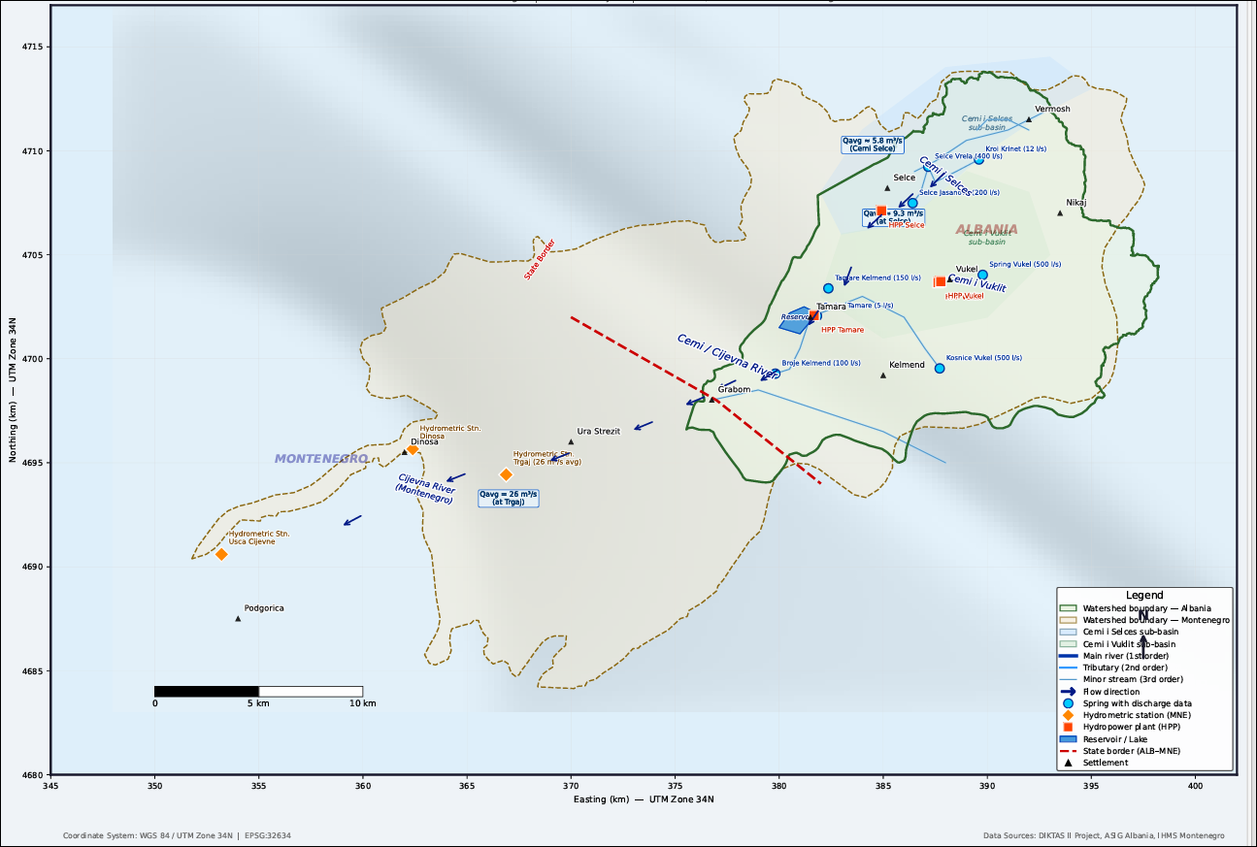
Figure 2 Hydrographic network, AL-MNE

Precipitation is the main supply factor for both surface waters and karst aquifers. Due to the pronounced relief and steep slopes, precipitation often causes:

- rapid increase in flows,
- intense surface runoff,
- rapid infiltrations into karstified carbonate formations.

In this regard, it should be noted that the area under study, which is part of the Albanian and Montenegrin Alps, is distinguished by very high values ​​of precipitation that fall during the year. The amounts of precipitation in the Albanian area approach 2022 mm per year, which are undoubtedly among the highest. Taking into account the high altitude above sea level that the Tamara area has, it is understood that during the winter period the phenomenon of snow is always present. To analyze the parameters of atmospheric precipitation falling in the Cemi/Cijevna River watershed, we have based ourselves on the multi-year data that exist at the meteorological measurement sites of the respective watershed. The data for the multi-year average value of the precipitation height according to the above measurement sites are given in the table.

Table 1. Monthly rainfall of the Cemi/Cijevna basin.
Rainfall | Months |  |  |  |  |  |  |  |  |  |  |  | Annual
Rainfall | 1 | 2 | 3 | 4 | 5 | 6 | 7 | 8 | 9 | 10 | 11 | 12 | Annual
Cemi | 319 | 314 | 217 | 201 | 149 | 110 | 67 | 87 | 163 | 269 | 406 | 380 | 2682
Selce | 191 | 188 | 168 | 163 | 114 | 81 | 35 | 68 | 111 | 240 | 314 | 274 | 1947

These characteristics justify the need for climate monitoring with high temporal resolution, in order to understand the hydrological response of the system to meteorological events.
In Montenegro, two rain gauge stations "Kovačica" and "Orahovo" are located within the basin, high in the karst hinterland at an altitude of 944 m and 875 m. The average annual precipitation for the precipitation station "Orahovo" is about 2300 mm.
Some other main characteristics of the Cemi/Cijevna River are described as below:

- fast and energetic flow,
- bed mainly gravel and rock,
- narrow and deep sections in some segments,
- large seasonal variability of flows.

River flows are directly affected by:

- intense rainfall,
- melting snow,
- and the contribution of groundwater in certain segments.

These features make the Cemi/Cijevna River a highly dynamic system, where continuous measurements and periodic calibration of flows are essential for an accurate hydrological interpretation. For the treatment of water flow, we are based on the hydrometric data that exist in the respective areas. Specifically, in the Cem River we have hydrometric measurements: a period of observations of 1981-1989 and the other with a survey period from 1978-1989. Data from several neighboring measurement sites were also used, such as: Selcë (1959-2000), Vukel 1990-2000 and Nikaj in Lekbibaj (1970-1989). In summary, the main characteristics of these measurement sites are given in Table 2&3.

Table 2. Multiannual flows of the Cemi/Cijevna River in Cemi and Selcë.
Source: Former Albanian Hydromet Institute
No | Location | F  (km²) | H  (m) | L  (km) | Time of data (years) | Discharges  (m³)
1 | Cemi | 173 | 1600 | 21 | 1959-2000 | 9.30
2 | Selca | 30.7 | 1514 | 8.2 | 1981-1989 | 5.78

Table 3. Monthly flows of the Cemi/Cijevna River in Cemi and Selca.
Source: Former Albanian Hydromet Institute
Period | January | February | March | Aprill | Maj | June | July | August | September | October | November | December
1990 | 4.8 | 6.1 | 5.7 | 22.5 | 8.6 | 4.4 | 3.2 | 2.7 | 3.1 | 18.9 | 19.3 | 13.5
1991 | 5.9 | 9.0 | 10.0 | 13.2 | 22.4 | 16.9 | 4.6 | 3.7 | 4.1 | 11.3 | 29.5 | 7.5
1992 | 2.6 | 2.0 | 4.3 | 12.7 | 10.7 | 9.6 | 3.4 | 1.3 | 1.6 | 16.5 | 19.1 | 8.7
1993 | 3.7 | 1.6 | 6.0 | 13.3 | 8.3 | 4.9 | 2.3 | 1.8 | 8.8 | 9.9 | 17.2 | 19.5
1994 | 11.0 | 5.5 | 7.3 | 16.0 | 15.9 | 7.7 | 2.6 | 1.6 | 1.9 | 3.5 | 4.4 | 0.6
1995 | 11.6 | 9.5 | 10.9 | 9.9 | 20.2 | 12.4 | 2.0 | 4.2 | 14.3 | 2.1 | 8.6 | 17.3
1996 | 10.5 | 9.1 | 6.4 | 16.1 | 22.1 | 11.9 | 2.9 | 2.1 | 14.2 | 18.5 | 19.4 | 15.9
1997 | 11.4 | 5.9 | 5.9 | 9.5 | 18.0 | 9.4 | 3.0 | 4.3 | 4.2 | 8.7 | 12.0 | 16.7
1998 | 7.7 | 3.4 | 3.7 | 14.1 | 15.7 | 8.9 | 3.5 | 1.3 | 13.3 | 17.2 | 13.5 | 10.0
1999 | 7.3 | 7.7 | 9.1 | 15.0 | 20.0 | 13.2 | 5.8 | 3.9 | 1.4 | 3.1 | 10.9 | 25.4
2000 | 6.8 | 4.3 | 5.7 | 16.8 | 11.5 | 4.4 | 5.4 | 1.2 | 5.2 | 6.6 | 13.1 | 11.2
Montenegro
The long-term average discharge of the Cijevna River at the “Trgaj” gauging station, located immediately upstream of the entrance to the Zeta Plain, is approximately 26 m³/s. The maximum mean monthly discharges at this gauging station are recorded in May and amount to about 43 m³/s, while the minimum mean monthly discharges, recorded in July, are around 5 m³/s. During the driest period of the year, discharges at this profile may decrease to as little as 1 m³/s. In the summer period, the waters of the Cijevna River completely dry up along the section of its course across the Zeta Plain.
It should be taken into account that a part of the Cijevna River course in Montenegro sinks during the summer period and recharges the Zeta Plain, while another portion of the sinking waters feeds springs along the margins of the Zeta Plain, such as Ribnička Vrela, Vitoja, Mileš, and the intermittent spring Krvenica.

3.1 Geology

3.1.1 Tectonic setting
The geological structure of the Cemi/Cijevna basin forms part of the broader Dinaric tectonic zone, which extends across the western Balkan Peninsula. The region is characterized by complex tectonic structures resulting from the interaction of the Adriatic microplate with the Eurasian plate.
The geological formations of the basin are organized in elongated structures generally trending southwest–northeast, reflecting the dominant tectonic orientation of the Dinaric Alps. These structures include folded and faulted carbonate sequences that have undergone significant deformation during successive tectonic phases.
Tectonic discontinuities such as faults and fractures play an important role in controlling groundwater circulation within the basin. These structural elements often act as preferential pathways for groundwater flow and may influence the location of springs and zones of surface water–groundwater interaction.

3.1.2 Geological characteristics
The geological structure of the basin is dominated by carbonate rock formations of Mesozoic age, which constitute the principal lithological units of the Albanian Alps and the southern Dinaric region. These formations include limestone and dolomite sequences deposited during the Triassic, Jurassic and Cretaceous periods.
Upper Triassic formations are represented mainly by massive limestone and dolomitized limestone units that form the steep slopes of the river valleys. These rocks are frequently characterized by extensive fracturing and karstification.
Jurassic formations consist primarily of limestone sequences with varying lithological characteristics, including marly limestones, biomicritic limestones and dolomitized carbonate units. These formations often contain fossil remains such as bivalves, gastropods and crinoids.
Cretaceous formations are also present in certain parts of the basin and consist mainly of thick carbonate deposits that contribute to the development of karst aquifers.
Quaternary deposits are generally limited to valley bottoms and riverbeds and consist mainly of alluvial sediments such as gravel, sand and silt. These unconsolidated deposits form relatively thin layers, typically a few meters thick, and are associated with recent fluvial processes. The combination of these lithological units creates complex geological conditions that strongly influence groundwater circulation and the hydraulic interaction between surface water and aquifer systems.
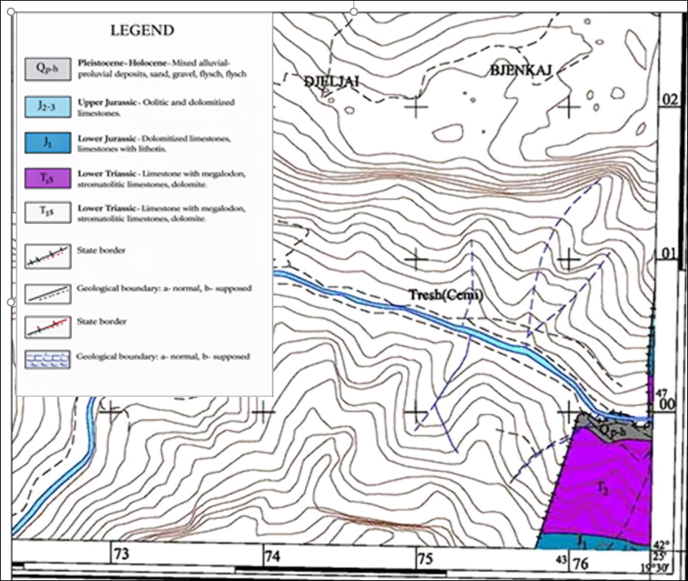
Figure 3 Albanian geological map, scale 1:25 000, sheet K-34-51-D-b (001 - Grabom)

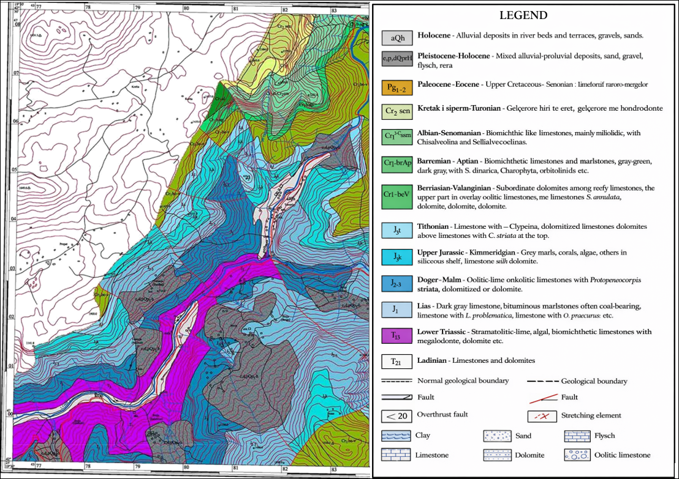
Figure 4 Albanian geological map, scale 1:25 000, sheet K-34-52-C-a (Tamara).
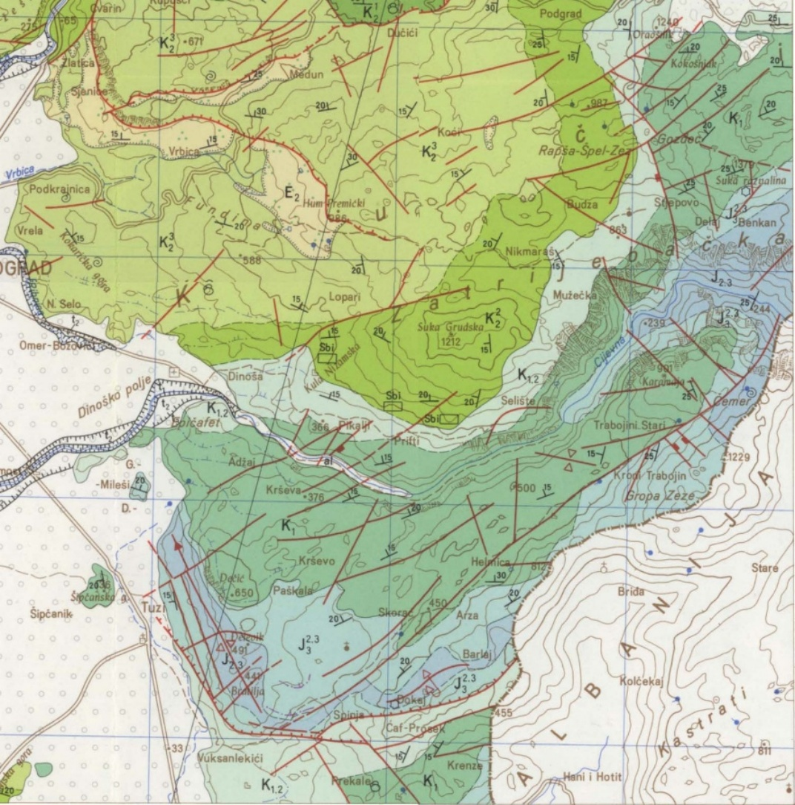
Figure 5 Geological map, scale 1:100 000, excerpt from the Basic geological map of Montenegro, section “Titograd

The geological structure described above is based on the geological maps of Albania and Montenegro at scales of 1:25 000 and 1:100 000 respectively (Albanian Geological Survey, 2003; Geological Survey of Montenegro).

3.2 Hydrogeology

3.2.1 Hydrogeological characteristics
From a hydrogeological perspective, the Cemi/Cijevna basin is characterized by the dominance of karst aquifers developed within carbonate formations. Limestone and dolomite rocks exhibit a high degree of fracturing and karstification, resulting in extremely high hydraulic permeability. Karst aquifers are typically characterized by heterogeneous permeability and rapid groundwater circulation through fractures, conduits and dissolution channels (Goldscheider & Drew, 2007).
Groundwater circulation within these formations occurs primarily through networks of fractures, fissures and karst conduits. As a result, groundwater systems within the basin respond rapidly to precipitation events and display significant fluctuations in piezometric levels.
Numerous karst springs occur throughout the basin and represent the main natural discharge points of the aquifer system. These springs often emerge at lithological contacts between permeable carbonate formations and less permeable rocks or along tectonic discontinuities.
Spring discharges vary widely depending on hydrogeological conditions and recharge intensity, ranging from small springs with flows of less than 1 l/s to larger springs with discharges exceeding 20–30 l/s.

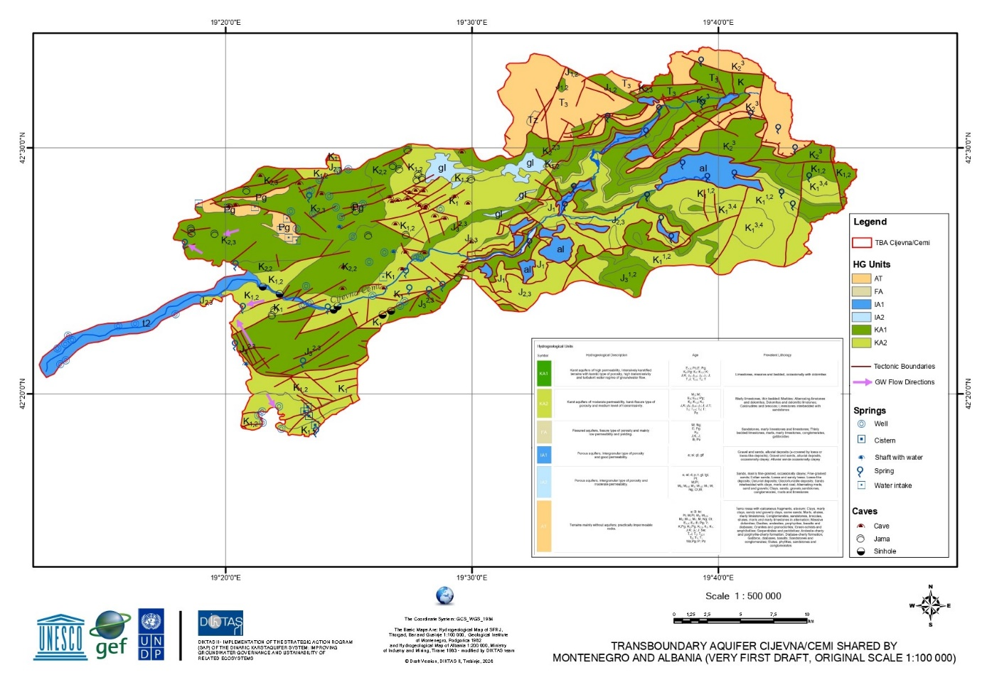
Figure 6 Hydrogeological map

3.2.2 General direcions and rate of groundwater flow
Groundwater flow within the basin is controlled by a combination of topographic gradients, lithological conditions and tectonic structures. Recharge occurs primarily through infiltration of precipitation in the mountainous areas of the Albanian Alps.
Due to the high permeability of carbonate formations, infiltrated water rapidly enters the karst system and flows through underground conduits toward lower elevations. Groundwater flow generally follows the regional hydraulic gradient toward the downstream sections of the basin and ultimately contributes to the hydrological system of the Morača River and Lake Skadar/Shkodra.
In certain sections of the basin, particularly along the river valley, hydraulic interaction between surface water and groundwater may occur. Depending on hydrological conditions, the river may either recharge the aquifer through infiltration or receive groundwater inflow from nearby karst springs.

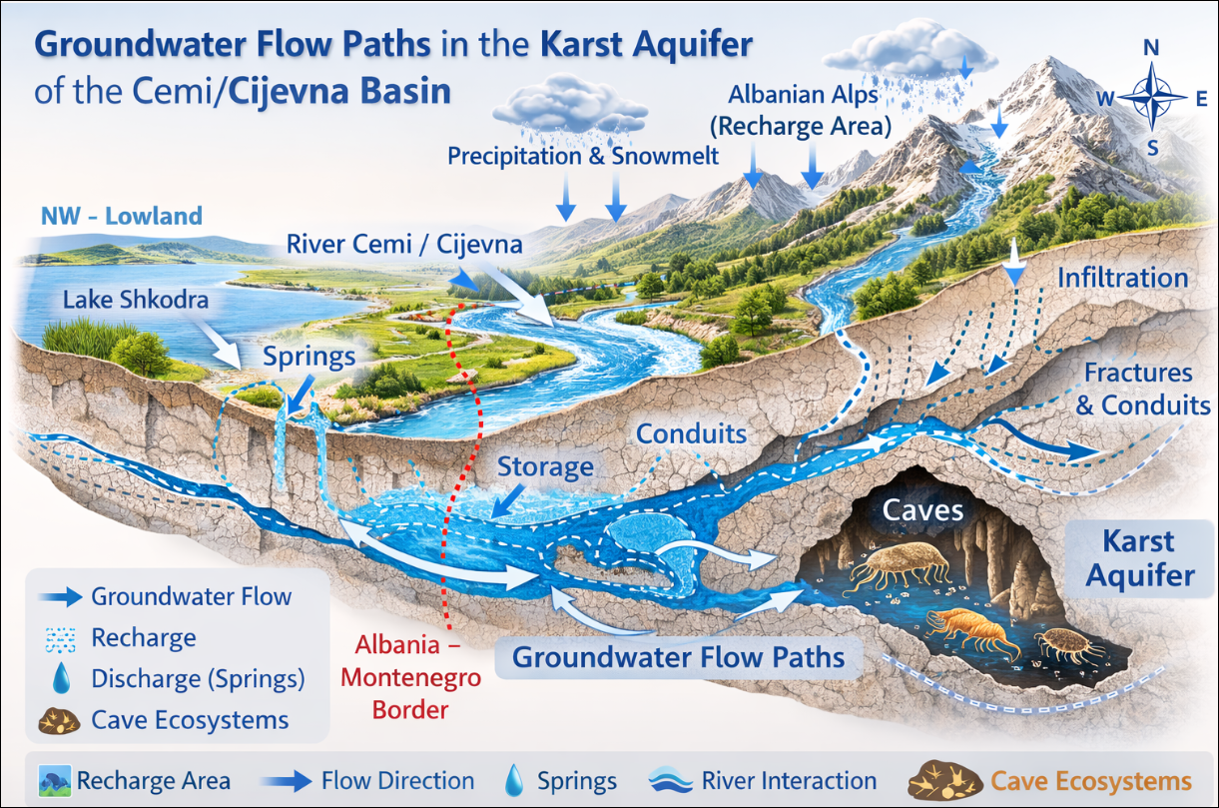
Figure 7 Groundwater flow path in the karst aquifer of Cemi Cijevna river with state boundary

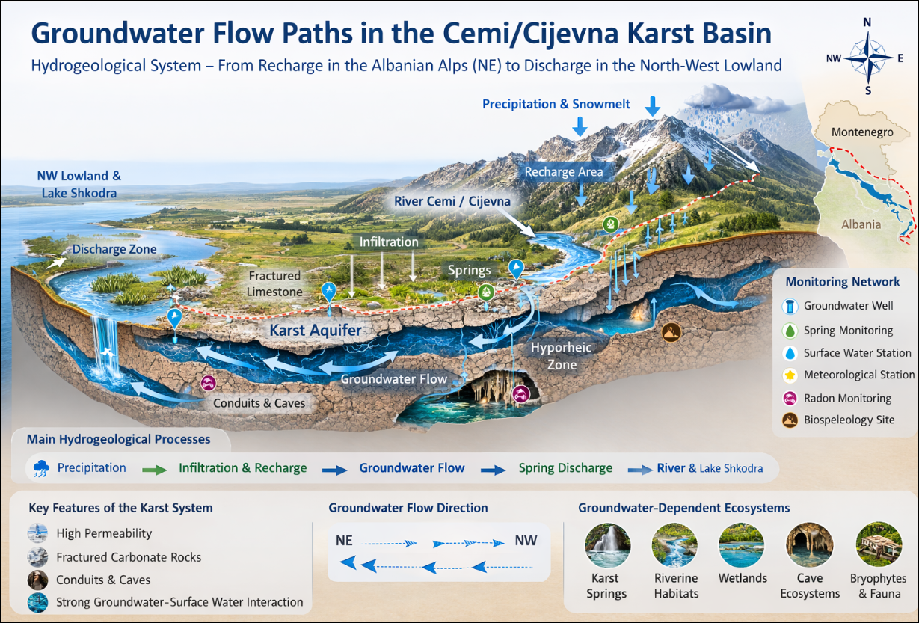
Figure 8 Groundwater flow path in the karst aquifer of Cemi Cijevna river with state boundary

3.2.3 Hydrogeological units and aquifer characteristics

The hydrogeological structure of the basin can be broadly divided into two main types of hydrogeological units.
The first group includes highly permeable carbonate aquifers, which represent the dominant hydrogeological unit in the basin. These aquifers are characterized by well-developed karst systems and large groundwater storage capacities.
The second group includes unconsolidated Quaternary deposits located primarily along river valleys. Although these deposits are relatively limited in spatial extent, they may locally form shallow intergranular aquifers associated with river sediments.
The interaction between these hydrogeological units contributes to the complexity of the basin’s groundwater system and plays an important role in controlling the dynamics of surface water–groundwater exchange.

4. CONCEPTUAL MODEL OF THE CEMI/CIJEVNA TBA AS FOUNDATION FOR MONITORING DESIGN

Conceptual hydrogeological model

The conceptual hydrogeological model provides a simplified yet scientifically grounded representation of the groundwater system within the transboundary Cemi/Cijevna basin. It integrates geological structure, lithological composition, tectonic features and hydrogeological characteristics into a unified framework that supports the interpretation of groundwater circulation processes. The conceptual hydrogeological model defines the spatial and hydraulic limits of the groundwater flow system by identifying physical and hydraulic boundaries that control groundwater movement.
Recharge boundaries define the upper limits of the groundwater flow system and correspond to watershed divides separating adjacent drainage basins. In karst environments, these boundaries are often diffuse and structurally controlled; nevertheless, they can be conceptually classified into no-flow boundaries, constant-head boundaries, and recharge boundaries.
No-flow boundaries represent zones across which groundwater flow is negligible or absent. In the investigated area, such boundaries are primarily associated with low-permeability or impermeable lithological units and locally developed aquicludes, which form the basal boundary beneath the karst aquifers and limit vertical groundwater circulation. These units define the lower extent of the active karst flow system. In addition, certain tectonic structures, such as faults and fault zones filled with clayey or crushed material, may locally act as lateral no-flow boundaries. However, due to the heterogeneous nature of karst systems, the hydraulic role of faults is spatially variable, and some structures may function as preferential groundwater flow paths rather than barriers.
Constant-head boundaries are represented by surface water bodies that impose relatively stable hydraulic heads on the groundwater system.

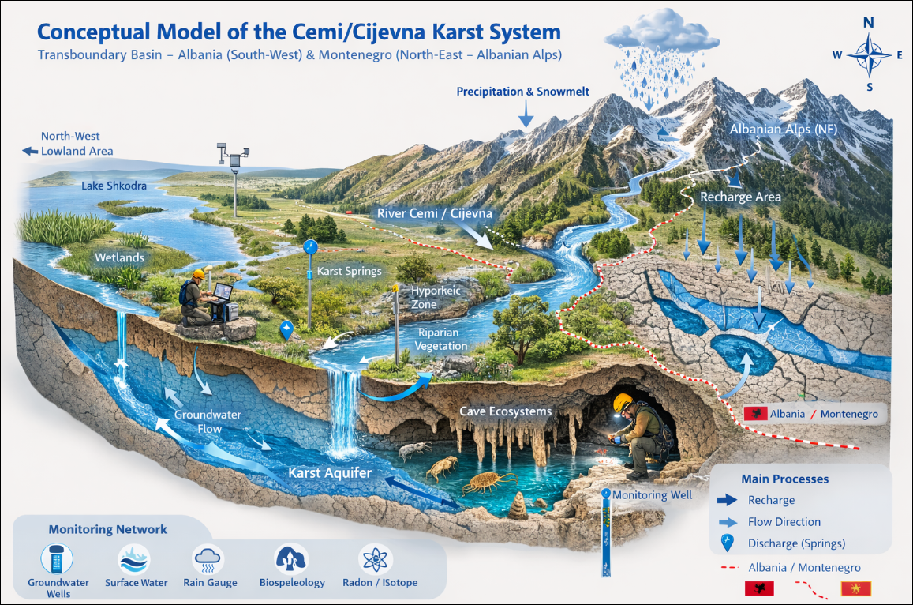
Figure 9 Conceptual Hydrogeological model of TBA Cemi/Cijevna with state boundaries

In the study area, the Cemi/Cijevna River represents the most important constant-head boundary and defines the regional erosion base of the karst aquifer system. Major karst springs located along the Cemi/Cijevna River valley discharge groundwater at elevations controlled by river stage, effectively functioning as fixed-head outlets of the groundwater system. Locally, river reaches downstream of major springs act as gaining streams, contributing to hydraulic equilibrium between groundwater and surface water. Other surface water bodies, such as lakes and reservoirs, do not play a significant role as constant-head boundaries due to their limited extent or absence.

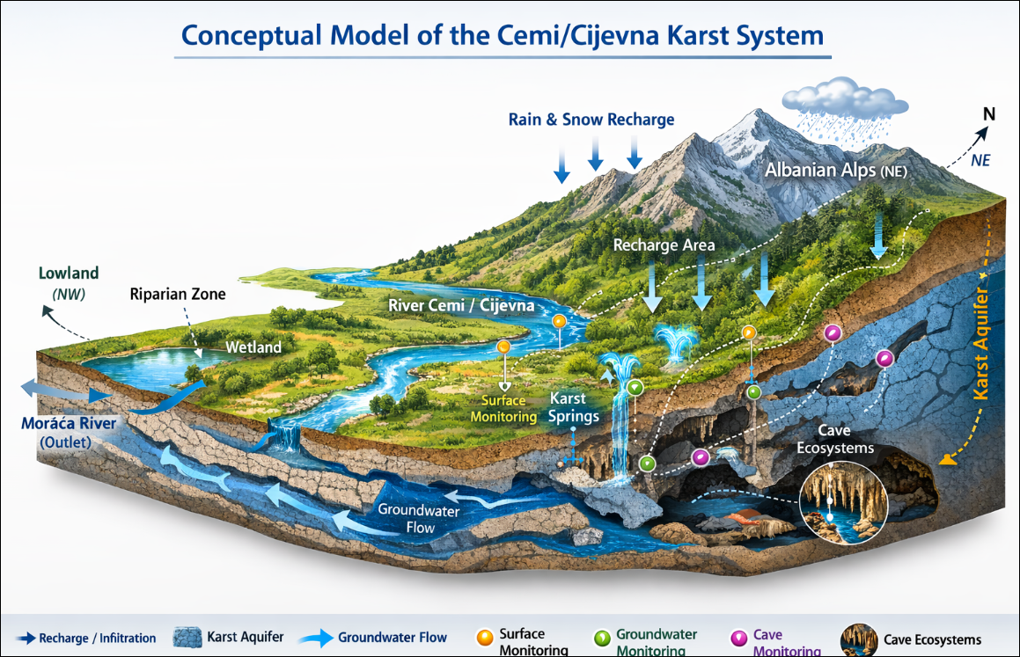
Figure 10 Conceptual Hydrogeological model of TBA Cemi/Cijevna without state boundaries

In complex karst environments such as the Cemi/Cijevna transboundary basin, groundwater flow is typically highly heterogeneous and structurally controlled. The presence of carbonate formations affected by intensive tectonic fracturing and karstification results in a groundwater system characterized by rapid infiltration, variable storage conditions and complex flow pathways. Under such conditions, the development of a conceptual hydrogeological model is essential for understanding the fundamental processes controlling groundwater recharge, flow and discharge.
The conceptual model identifies the principal recharge areas located in mountainous carbonate terrains, the dominant groundwater flow pathways through fractured and karstified formations, the underground storage zones developed within the karst system, and the main discharge areas represented by springs and river–aquifer interactions. In addition, the model considers the hydraulic relationships between these elements and their influence on the overall groundwater circulation within the basin.
The model incorporates geological and hydrogeological information derived from geological maps, hydrogeological investigations and available hydrological observations. This integrated understanding provides the scientific basis for the design of the groundwater monitoring system proposed within the project.
By linking the behaviour of the groundwater system with monitoring objectives, the conceptual model supports the selection of representative monitoring locations, appropriate monitoring parameters and suitable monitoring frequencies. In this way, the monitoring network can effectively capture the dynamics of the karst aquifer system and contribute to the sustainable management and protection of groundwater resources in the Cemi/Cijevna basin.
The defined boundaries establish the framework of the conceptual hydrogeological model, within which groundwater flow directions, recharge and discharge processes, and monitoring locations are interpreted. Although the exact position of some boundaries remains uncertain due to the complexity of karst systems, their conceptual definition provides a consistent basis for understanding groundwater circulation and for designing an effective groundwater monitoring network.
In the 3D block diagram of the TBA Cemi/Cijevna conceptual model (Figures 9&10), the defined boundaries are explicitly represented to illustrate their spatial relationships within the groundwater flow system. No-flow boundaries are depicted as the basal and lateral limits of the model domain, corresponding to low-permeability lithological units that constrain vertical and lateral groundwater movement. The basal boundary represents the lower limit of active karst circulation, while selected structural elements are shown to indicate their potential role as either hydraulic barriers or preferential flow zones. The Cemi/Cijevna River is represented as the principal constant-head boundary, forming the regional discharge zone and controlling hydraulic gradients within the karst aquifer system. Springs located along the river valley are illustrated as fixed-head outlets, linking subsurface flow paths to the surface drainage network. Recharge boundaries are shown along watershed divides that delimit the spatial extent of the modeled system and define the areas contributing groundwater through diffuse infiltration, ponors, and losing streams. The 3D visualization integrates these boundary conditions into a coherent spatial framework, allowing for a clearer interpretation of groundwater flow directions and hydraulic connectivity. By explicitly depicting recharge areas, discharge zones, and hydraulic constraints, the block diagram enhances the understanding of system behavior and supports the placement of monitoring points within hydrologically meaningful positions.

4.1 HYDROGEOLOGICAL UNITS

Based on lithological composition, type of porosity, hydraulic properties and groundwater availability, the hydrogeological environments within the Cemi/Cijevna basin can be classified according to the principles of the UNESCO International Legend for Hydrogeological Maps (1983). This classification distinguishes between intergranular aquifers, fissured and karst aquifers, as well as geological formations with limited or negligible groundwater resources.
For the purposes of the conceptual hydrogeological model and the design of the monitoring system, these hydrogeological environments are grouped into three principal functional categories according to their permeability and hydraulic role within the groundwater system:

- Aquifers – permeable formations capable of storing and transmitting significant quantities of groundwater;
- Aquitards – formations with lower permeability that restrict groundwater flow and act as semi-permeable hydraulic barriers;
- Aquicludes – formations that are nearly impermeable and effectively limit groundwater movement.

This functional classification provides a simplified and operational framework for describing groundwater recharge, storage, flow and discharge processes within the Cemi/Cijevna Transboundary Aquifer system.

4.1.1 Aquifers – permeable geological formations

The principal aquifers within the Cemi/Cijevna basin are represented by carbonate rocks of Mesozoic age, predominantly limestones, dolomitic limestones and dolomites belonging to Triassic, Jurassic and Cretaceous formations characterized by karst–fracture porosity and high to moderate permeability.
These rocks are characterized by karst–fracture porosity and generally exhibit moderate to high hydraulic permeability. Their hydrogeological behaviour is largely controlled by secondary porosity developed through tectonic fracturing and karstification processes. Dissolution of carbonate rocks along fractures and faults has resulted in the formation of karst conduits, fissures and cavities that facilitate rapid groundwater movement.
In many parts of the basin, carbonate formations crop out extensively at the surface, forming the dominant geological environment of the Albanian Alps and adjacent Dinaric regions. In such areas, groundwater recharge occurs primarily through direct infiltration of precipitation into the karstified rock mass. Additional recharge may occur through infiltration from surface water bodies, particularly in sections of the river where losing conditions are present.
Groundwater within these formations is stored in underground retention zones associated with fracture networks and karst conduits. The depth and capacity of these storage zones depend on the degree of karstification and the structural characteristics of the rock mass.
Discharge from these aquifers occurs mainly through karst springs, which are distributed along lithological contacts, tectonic structures or valley margins where groundwater flow intersects the land surface. These springs exhibit variable discharge rates depending on seasonal recharge conditions and hydraulic gradients within the aquifer system.
In addition to carbonate aquifers, limited intergranular aquifers are locally present within Quaternary deposits in Albania consisting of gravel, sand and sandy clay sediments. These deposits are mainly distributed along the river valley and alluvial plains in Montenegro. Although they may locally store groundwater, their hydrogeological significance is generally limited due to the rapid infiltration of water into the underlying karstified bedrock.
Limestones of the Cretaceous and Triasic belong to the group of high permeability rocks. Rocks with fissured porosity and moderate to locally high permeability include Triasic sediments, Jurassic formations where predominate dolomites and limestones as well as Cretaceous sediments
The limestones are massive, well stratified. Smaller interbeds and lenses of dolomite are locally present within limestone sequences.
From a hydrogeological perspective, secondary porosity dominates in these rocks, primarily in the form of fracture and fracture–dissolution porosity, while cavernous porosity may also occur in the subsurface. This porosity developed as a result of tectonic fracturing and intensive karstification along faults and fracture systems. Consequently, these rocks are characterized by high vertical and horizontal permeability, enabling effective infiltration of precipitation and horizontal groundwater circulation. Numerous ponors and karren have developed on the surface.
Due to intense tectonic deformation, fracturing, and karstification of the rock mass, a highly specific surface and underground hydrographic network has developed within the limestone terrains. Where Triassic, Jurassic, and Cretaceous limestones and dolomites crop out, groundwater recharge occurs through direct infiltration of precipitation, as well as by subsurface inflow from the west and southwest.
Aquifers also include deposits with intergranular porosity and high permeability, represented by Quaternary sediments of various genetic types: proluvial deposits, sandy deposits, alluvial deposits, and gravelly deposits. Lithologically, these deposits consist predominantly of coarse clastics, including gravels, sands, and sandy clays.
They are mainly distributed within alluvial sediments formed by the recent courses of the Cemi/Cijevna river, as well as by some tributaries in Montenegro. Deposits formed by watercourses with a high sand content are also present in this area.
Although alluvial sediments are generally considered aquifers, in this case, due to the pronounced karstification of the underlying bedrock, groundwater readily infiltrates into the karstified subsurface, limiting long-term groundwater retention within the Quaternary cover.

4.1.2 Aquitards – low permeability formations

Aquitards within the basin are represented by geological formations with relatively low hydraulic conductivity that restrict groundwater flow and act as partial hydraulic barriers within the aquifer system.
These formations may include various clastic deposits and low-permeability carbonate rocks, such as marls, clayey limestones, breccias and volcanogenic sediments. In certain parts of the basin, flysch formations composed of alternating layers of sandstones, marls and claystones may also function as aquitards.
Due to their limited permeability, these formations generally impede vertical groundwater movement and may locally control the direction of groundwater flow within the karst aquifer system. In some cases, they form the basal boundary of carbonate aquifers and contribute to the development of springs along lithological contacts.
Quaternary deposits containing significant proportions of clay and silt may also act as shallow aquitards in valley areas. These sediments often consist of mixed clastic materials such as silty sands, clays and slope deposits that display relatively low hydraulic conductivity.
Although these formations are not completely impermeable, their presence significantly influences the hydraulic behaviour of the groundwater system by limiting groundwater circulation and creating localized hydrogeological compartments.

4.1.3 Aquicludes – nearly impermeable formations

Aquicludes within the Cemi/Cijevna basin are represented by geological formations that exhibit very low permeability and therefore act as effective barriers to groundwater movement.
These formations may include compact clay-rich rocks, schists and other low-permeability lithologies that form the structural base of the hydrogeological system. Although certain lithological layers within these formations may locally exhibit limited permeability, their overall hydrogeological behaviour remains essentially impermeable.
In the regional hydrogeological framework, these units form the basal boundary of the karst aquifer system, restricting deeper groundwater circulation and defining the lower limit of groundwater flow within the basin.
The presence of aquicludes is therefore important for understanding groundwater storage conditions and the vertical structure of the hydrogeological system.
Due to intense tectonic deformation, fracturing, and karstification of the rock mass, a highly specific surface and underground hydrographic network has developed within the limestone terrains. Where Triassic, Jurassic, and Cretaceous limestones and dolomites crop out, groundwater recharge occurs through direct infiltration of precipitation, as well as by subsurface inflow from the west and southwest. Aquifers also include deposits with intergranular porosity and high permeability, represented by Quaternary sediments of various genetic types.

4.2 SOURCES OF RECHARGE

Recharge of groundwater within the Cemi/Cijevna transboundary basin occurs primarily through direct infiltration of precipitation over extensive carbonate terrains of the Albanian Alps and the adjacent Dinaric mountain belt. Due to the high permeability of limestone and dolomite formations, infiltration processes are highly efficient and constitute the dominant mechanism of aquifer recharge.
Recharge areas are mainly located in mountainous regions characterized by exposed carbonate formations where precipitation can rapidly infiltrate through fractures, fissures and karst conduits. These recharge zones correspond largely to the areas where Triassic, Jurassic and Cretaceous carbonate formations crop out at the surface, as illustrated in the geological and hydrogeological maps of the study area (Figures 2–8).
The spatial distribution of recharge zones is strongly controlled by lithological composition, structural features and geomorphological conditions. In highly karstified terrains, precipitation infiltrates rapidly into the subsurface, limiting surface runoff and contributing directly to groundwater storage within the karst system.
Recharge processes are therefore closely related to climatic conditions and seasonal precipitation patterns. As indicated by the precipitation data presented in Table 2 of the baseline study, the basin receives substantial annual rainfall, which represents the principal water input to both surface and groundwater systems.

Table 4. Characteristic flows of major karst spring in the TBA Cemi River
No | Source | UTM Easting | UTM Northing | Z | Yield  Q | Ca | Mg | Na | HCo3 | SO4 | Cl | Tm | Dr | Th | T | Name_of_source
1 | Spring | 389604 | 4709583 | 1100 | 12 | 0.034 | 0.008 | 0.006 | 0.140 | 0.010 | 0.007 | 0.207 | 0.13 | 6.86 | 6.00 | Kroi Krinet
2 | Spring | 387165 | 4709233 | 700 | 400 | 0.030 | 0.003 | 0.010 | 0.109 | 0.012 | 0.003 | 0.173 | 0.09 | 5.06 | 5.30 | Selce Vrela
3 | Spring | 384316 | 4708644 | 800 | 100 | 0 | 0 | 0 | 0 | 0 | 0 | 0 | 0 | 0 | 6.00 | Selce Kelmend
4 | Spring | 386415 | 4707484 | 625 | 200 | 0.033 | 0.007 | 0.002 | 0.128 | 0.008 | 0.003 | 0.183 | 0.112 | 6.3 | 9.20 | Selce Jasanova
5 | Spring | 389783 | 4704035 | 600 | 500 | 0.036 | 0.002 | 0.007 | 0.122 | 0.008 | 0.005 | 0.181 | 0.118 | 5.63 | 6.30 | Spring Vukel
6 | Spring | 382366 | 4703386 | 400 | 150 | 0 | 0 | 0 | 0 | 0 | 0 | 0 | 0 | 0 | 9.50 | Tamare Kelmend
7 | Spring | 381817 | 4702056 | 250 | 5 | 0 | 0 | 0 | 0 | 0 | 0 | 0 | 0 | 0 | 0 | Spring Tamare
8 | Spring | 387164 | 4700937 | 600 | 40 | 0 | 0 | 0 | 0 | 0 | 0 | 0 | 0 | 0 | 7.00 | Kosnice Vukel
9 | Spring | 387714 | 4699537 | 625 | 500 | 0.033 | 0.003 | 0.004 | 0.103 | 0.017 | 0.003 | 0.166 | 0.102 | 5.49 | 5.20 | Kosnice Vukel
10 | Spring | 379817 | 4699287 | 450 | 100 | 0.035 | 0.005 | 0.018 | 0.144 | 0.006 | 0.008 | 0.219 | 0.138 | 5.48 | 9.80 | Broje Kelmend

4.2.1 Groundwater-Dependent Ecosystems
Groundwater-dependent ecosystems (GDEs) represent an important component of karst hydrogeological systems. These ecosystems rely directly or indirectly on groundwater for maintaining their ecological structure and functioning.
In Albania, approximately two-thirds of national groundwater resources occur within karst aquifers, which supply more than 60% of the water used for human consumption (DIKTAS TDA, 2013). Karst terrains are therefore of exceptional importance not only for water resources but also for biodiversity conservation.
Within the Dinaric karst region, groundwater circulation supports a variety of ecosystems including springs, wetlands, riverine habitats and subterranean cave environments. These ecosystems often host highly specialized and endemic species adapted to stable groundwater conditions.
The Cemi/Cijevna transboundary watershed represents an ecologically important karst system characterized by strong hydraulic connectivity between surface water and groundwater. The ecological significance of the Cijevna River has been formally recognized in Montenegro, where the river has been designated as a protected natural asset since 2017 (Radulović et al., 2021).
Groundwater-dependent ecosystems associated with the basin include:
- karst springs and spring habitats
- riverine and riparian ecosystems connected to groundwater discharge
- cave and subterranean aquatic ecosystems
- wetlands dependent on groundwater
- hyporheic zones along the river channel
These ecosystems provide important habitats for a wide range of organisms including invertebrates, aquatic plants and specialized cave fauna.
Karst subterranean environments in Albania remain largely unexplored from a biodiversity perspective. Existing studies have focused mainly on subterranean gastropods, representing only a small fraction of the potential species richness of these ecosystems (Grego et al., 2017). Because of the strong interaction between groundwater and surface water in karst terrains, monitoring of groundwater resources should also consider the ecological status of groundwater-dependent ecosystems.
Table 5 Biological indicators
Indicator | Type | Relevance
Macrozoobenthos | Biological | Sensitive to pollution and flow changes
Cave crustaceans (Niphargus etc.) | Biological | Indicator of groundwater quality
Bryophytes | Biological | Indicator of good ecological status
Water temperature | Physico-chemical | Controls biological activity
Dissolved oxygen | Physico-chemical | Indicator of water quality
Electrical conductivity | Physico-chemical | Reflects mineralization

4.2.2 Precipitation

Precipitation represents the primary source of groundwater recharge within the basin. The mountainous terrain of the Albanian Alps is characterized by high annual precipitation values exceeding 2000 mm, with significant seasonal variability.
A portion of this precipitation contributes directly to river discharge, while a substantial fraction infiltrates into the carbonate formations and replenishes the karst aquifer system. During winter months, precipitation frequently occurs in the form of snow at higher elevations. Subsequent snowmelt during spring provides an important contribution to groundwater recharge.
The relationship between precipitation and groundwater recharge is therefore a key component of the basin’s water balance and is an important factor considered in the design of the monitoring system.

4.2.3 Losing streams and concentrated recharge mechanisms

In addition to diffuse recharge through precipitation, groundwater recharge may also occur through concentrated infiltration processes typical of karst environments.
Certain sections of the Cemi/Cijevna River and its tributaries may function as losing stream segments, where surface water infiltrates into the karstified subsurface. These zones of concentrated recharge occur where the river channel intersects highly fractured carbonate formations or where karst conduits are directly connected to the riverbed.
Preliminary hydrogeological observations indicate that such losing conditions may occur in segments upstream of the Tamara area, where part of the river discharge may infiltrate into the karst system and contribute to groundwater flow. These processes play an important role in the overall water balance of the basin and are therefore considered in the conceptual hydrogeological model.
The identification of these recharge zones represents one of the key objectives of the monitoring system, which combines hydrometric measurements, hydrochemical observations and isotopic analyses to better understand surface water–groundwater interactions.

4.3 GROUNDWATER FLOW SYSTEM

Groundwater flow within the Cemi/Cijevna basin is primarily controlled by the regional topographic gradient from the mountainous recharge zones of the Albanian Alps toward the downstream areas located in Montenegro and the Zeta Plain.
After infiltration, groundwater flows through complex networks of fractures and karst conduits developed within carbonate formations. Due to the heterogeneous nature of karst systems, groundwater flow paths may vary significantly in space and time.
In highly karstified areas, groundwater may move rapidly through large conduits and channels, resulting in rapid hydrological responses to precipitation events. In other areas, groundwater circulation occurs through smaller fractures and pores within the rock matrix, leading to slower groundwater movement.
The conceptual model assumes that groundwater generally flows from the high recharge zones in the Albanian Alps toward lower elevations, eventually contributing to the hydrological system of the Morača River and Lake Shkodra.
The distribution of springs within the basin provides important evidence of groundwater flow pathways. Several springs with significant discharge rates have been identified in the study area, as summarized in Table 5 and illustrated in the hydrogeological maps (Figures 6–8).
These springs represent the natural outlets of the karst aquifer system and provide valuable observation points for monitoring groundwater behaviour.

4.4 DISCHARGE AREAS

Groundwater discharge within the Cemi/Cijevna basin occurs through several types of natural and anthropogenic outlets. These discharge zones represent the final stage of groundwater circulation and play a key role in the hydrological functioning of the basin.

4.4.1 Springs
Karst springs constitute the most important natural discharge points of the groundwater system. Numerous springs occur along the margins of carbonate formations and in valley bottoms where groundwater flow intersects the land surface.
The discharge rates of these springs vary considerably depending on seasonal recharge conditions and the hydraulic characteristics of the aquifer system. Some springs exhibit relatively stable flow conditions, while others respond rapidly to precipitation events.
Several important springs within the basin have been identified and analysed within the framework of the present study. Their locations and hydrochemical characteristics are presented in Tables 5 and 7 of the baseline datasets.
These springs provide important information about groundwater recharge areas, flow pathways and hydrochemical characteristics of the karst aquifer system.

Table 6. Coordinates of the springs sampled in Cemi/Cijevna river basin (AKKSHI&ASHSH project, 2025-2026)
No | Spring name | UTM Easting | UTM Northing | Z
1 | Grabom | 377362.13 | 4696733.57 | 320
2 | Grabom 2 | 379026.43 | 4698231.94 | 147
3 | Tamara | 381809.27 | 4702031.36 | 246
4 | Tamara 2 (b. 5) | 380881.66 | 4700994.79 | 207
5 | Vermosh | 392701.73 | 4715929.56 | 1094
6 | Spring of Zekes (Lepushë) | 395302.65 | 4709511.24 | 1294
7 | Cemi in Selca | 387794.78 | 4708832.52 | 814
8 | Cemi in Vukel | 389782.95 | 4704043.52 | 543

4.4.2 Gaining streams
In some sections of the river network, groundwater discharge contributes directly to surface water flow. These gaining stream segments occur when groundwater levels within the aquifer are higher than the river water level, allowing groundwater to flow into the river channel.
Such conditions are typical of karst environments and may occur along sections of the Cemi/Cijevna River where groundwater emerges through springs or diffuse seepage zones along the riverbanks. Monitoring these interactions is essential for understanding the hydraulic connection between surface water and groundwater systems.

4.4.3 Wetlands
Wetlands within the basin are relatively limited due to the steep mountainous terrain and the high permeability of carbonate formations. However, small wetland areas may develop locally in valley depressions where groundwater discharge maintains saturated soil conditions.
Although these areas are not extensive, they may provide valuable indicators of shallow groundwater conditions.

4.4.4 Lakes and reservoirs
The Cemi/Cijevna basin does not contain major lakes or reservoirs within the studied area. However, the river ultimately contributes to the Morača River system and subsequently to Lake Shkodra.
Understanding groundwater circulation within the upstream basin therefore contributes to the broader understanding of the hydrological dynamics of the Lake Shkodra watershed.

4.4.5 Wells and groundwater abstraction
Groundwater abstraction within the basin is generally limited and mainly associated with local water supply systems. Monitoring wells, however, represent important observation points for understanding groundwater dynamics.
Within the framework of this project, the proposed monitoring well in the Grabom area will provide valuable information on groundwater levels, hydrochemical characteristics and the response of the aquifer system to hydrological events.

4.5 Boundaries of the conceptual model

The boundaries of the conceptual hydrogeological model correspond to the natural limits of the Cemi/Cijevna river basin. These boundaries are defined primarily by topographic divides separating the basin from adjacent catchments within the Albanian Alps and the Dinaric mountain system. From a hydrogeological perspective, however, karst systems may allow groundwater flow to cross surface watershed boundaries through subsurface conduits. For this reason, the conceptual model considers the possibility of hydraulic connections extending beyond the strictly defined surface basin boundaries.
Understanding these potential connections is one of the objectives of the monitoring system proposed within the project.

4.6 Anthropogenic influences

4.6.1 Groundwater abstractions
Human use of groundwater within the basin remains relatively limited due to the predominantly mountainous character of the region and the availability of natural springs. Nevertheless, localized groundwater abstractions for domestic supply or small-scale agricultural activities may occur. Although current abstraction rates are not expected to significantly affect the regional groundwater balance, systematic monitoring remains important for detecting possible changes in groundwater levels or water quality.

4.6.2 Point sources of pollution
Potential point sources of pollution within the basin may include settlements, small industrial facilities or infrastructure located near the river or within recharge areas. Although the overall level of industrial activity in the basin is relatively low, localized pollution sources could affect both surface water and groundwater quality.

4.6.3 Diffuse sources of pollution
Diffuse pollution may originate from agricultural activities, land-use changes or other human activities occurring across the basin. In karst environments, diffuse pollution represents a particular concern because contaminants can infiltrate rapidly through permeable carbonate formations and reach groundwater systems with limited natural filtration.
For this reason, monitoring of water quality parameters is essential for identifying potential pollution risks and ensuring the long-term protection of water resources within the basin.

5. MONITORING IN THE CEMI/CIJEVNA TRANSBOUNDARY BASIN

Although Albania is a candidate country for membership in the European Union and Montenegro is currently in the process of accession negotiations, both countries have adopted national water management frameworks that are largely aligned with the principles of the European Union water legislation. River Basin Management Plans (RBMP) have been developed in accordance with the requirements of the Water Framework Directive (WFD) and represent the main strategic instruments for water resources management.
Within the context of the Cemi/Cijevna transboundary basin, two river basin management frameworks are particularly relevant: the River Basin Management Plan for the Drin–Buna–Shkodra basin in Albania and the River Basin Management Plan for the Adriaticbasin in Montenegro. These plans establish the strategic objectives for water protection, monitoring and sustainable management of surface water and groundwater resources.
Water legislation in Montenegro is largely harmonized with the Water Framework Directive (WFD), the Groundwater Directive (GWD) and the Drinking Water Directive (DWD), reflecting the country’s ongoing EU accession process. In Albania, water legislation has also been progressively aligned with European directives, particularly with the WFD, while further harmonisation and implementation of groundwater protection and drinking water directives are continuing.
According to the principles of the Water Framework Directive (WFD), water monitoring programs are generally organized into three main categories: surveillance monitoring, operational monitoring and investigative monitoring. Each monitoring type serves a specific purpose and contributes to a comprehensive understanding of the status and dynamics of water bodies within a river basin.
Table 7. Three main categoriesof surveillance monitoring suggested by WFD
Monitoring type | Main objective | Key characteristics | Application in the Cemi/Cijevna basin
Surveillance monitoring | To provide a general overview of the quantitative and chemical status of groundwater and surface water bodies | Long-term monitoring at representative sites; assessment of natural conditions and overall water quality trends | Monitoring of major springs, river sections and representative groundwater points to establish baseline conditions of the karst aquifer
Operational monitoring | To assess the impact of identified pressures on groundwater and surface water bodies and evaluate the effectiveness of management measures | Focused monitoring at locations where potential pressures or risks have been identified | Monitoring near settlements, agricultural areas and zones where groundwater abstraction or pollution pressures may occur
Investigative monitoring | To identify causes of water quality deterioration or unexpected hydrological changes and to improve understanding of hydrogeological processes | Targeted investigations including additional sampling, tracer tests or specialized monitoring techniques | Investigation of groundwater–surface water interaction, karst conduit flow paths, and potential contamination sources using methods such as isotope analysis, radon measurements and hydrogeological tracing

In the Cemi/Cijevna transboundary basin, the monitoring program should combine these three monitoring types in order to provide both a general overview of water resources and a detailed understanding of hydrogeological processes within the karst aquifer system. While surveillance monitoring establishes baseline conditions, operational monitoring focuses on areas potentially affected by human activities. Investigative monitoring is particularly important in karst environments, where groundwater flow paths are complex and may require specialized techniques such as tracer tests, isotope analysis or radon monitoring.
Hydrometeorological monitoring in both Albania and Montenegro is organized at the national level through specialized institutions responsible for meteorological and hydrological observations. These monitoring systems have historically focused primarily on flood forecasting and flood risk management. Their application for comprehensive water resources assessment, particularly with respect to groundwater resources and basin-scale water balance analysis, has been comparatively limited.
In karst regions such as the Cemi/Cijevna basin, groundwater and surface water systems are typically strongly interconnected. Groundwater frequently emerges at contacts between permeable carbonate formations and less permeable clastic layers, forming karst springs that feed surface streams. In many cases, surface water flows across karst poljes or valleys before infiltrating again into the subsurface through karstified formations.
Although karst features such as ponors and losing stream sections play a critical role in controlling groundwater recharge and water quality, their importance has often been underestimated in traditional monitoring programmes. Understanding these interactions is therefore essential for effective water resources management in karst environments.
This chapter provides a detailed overview of the monitoring activities currently conducted within the Cemi/Cijevna transboundary basin in both Albania and Montenegro. Existing monitoring includes groundwater monitoring (quantitative and qualitative), surface water monitoring (hydrological, ecological and chemical), and meteorological observations.
A brief assessment of the existing monitoring system is presented in Subchapter 5.1, while Subchapter 5.2 introduces the monitoring parameters and monitoring frequencies relevant for both groundwater and surface water systems. Subchapter 5.3 presents a proposal for improving the monitoring network within the basin, with particular emphasis on groundwater monitoring in karst environments.
Special attention is given to the limitations of existing monitoring systems in karst aquifers, as the specific characteristics of karst groundwater circulation are not always fully addressed in current monitoring frameworks. The proposed monitoring system aims to overcome these limitations by integrating hydrological, hydrogeological, hydrochemical and climatic observations into a coordinated monitoring network for the Cemi/Cijevna transboundary basin.

5.1 EXISTING MONITORING

Monitoring activities in the Cemi/Cijevna basin have historically been implemented separately by the two countries sharing the basin. As a result, existing monitoring systems differ in terms of spatial coverage, technical equipment and monitoring methodologies.
Despite these differences, several monitoring elements already exist within the basin, including hydrometric stations, groundwater observation wells and meteorological measurement sites. These monitoring activities provide valuable baseline information for understanding the hydrological characteristics of the basin.
The present project builds upon these existing monitoring elements and aims to integrate them into a coordinated monitoring system capable of supporting transboundary water management.

5.1.1 Groundwater monitoring
Groundwater monitoring within the basin currently relies on a limited number of observation wells and springs used for hydrogeological investigations and water supply monitoring.
On the Montenegrin side of the basin, groundwater monitoring is conducted through observation wells located within the Zeta Plain and the karst hinterland of the Cijevna River. Among the most important monitoring wells are the Ušće Cijevne and Trgaj boreholes, which are located near the lower part of the basin and provide information on groundwater conditions within Quaternary sediments and karst aquifers.
These boreholes are approximately 31 m deep and are installed within alluvial terrace deposits associated with the Cijevna River. Monitoring activities include measurements of groundwater level as well as analyses of basic physico-chemical parameters.
Monitoring results indicate generally good groundwater quality conditions, with most parameters falling within the categories of excellent or very good status. Concentrations of heavy metals and other pollutants are typically below detection limits, while microbiological parameters occasionally indicate the presence of bacterial contamination associated with surface influences.
Within the Albanian part of the basin, groundwater monitoring is more limited and is mainly based on observations of natural springs and hydrogeological investigations carried out in karst terrains. Several important springs located in the upper basin have been sampled for hydrochemical analysis, providing valuable information on groundwater composition and aquifer characteristics.
The coordinates and characteristics of the sampled springs are presented in the baseline dataset of the project and serve as reference points for groundwater monitoring activities.

5.1.2 Surface water monitoring
Surface water monitoring within the basin focuses primarily on the Cemi/Cijevna River and its major tributaries. Hydrological observations are carried out at several locations within the river network in order to evaluate river discharge, water level variations and water quality characteristics.
On the Montenegrin side, surface water monitoring is conducted at hydrometric stations located along the Cijevna River, including the station near Dinoša, which provides long-term hydrological observations of river discharge.
Within the Albanian territory, the monitoring network includes sampling points located near Tamara and Grabom, representing the upper and lower segments of the river before it crosses the state border. These monitoring locations have been selected due to their hydrological representativeness and their importance for understanding river–aquifer interactions.
At these monitoring sites, water samples are periodically collected for physico-chemical and microbiological analyses. The monitoring programme includes measurements of parameters such as pH, electrical conductivity, dissolved oxygen, major ions, nutrients and trace elements.
The results of these analyses provide valuable information on the chemical characteristics of surface water and contribute to the assessment of water quality status within the basin.

5.1.3 Hydrometeorological monitoring
Hydrometeorological monitoring represents an important component of the monitoring system because climatic factors strongly influence hydrological processes within the basin.
Several precipitation measurement stations are located within the broader basin area, including stations such as Kovačica and Orahovo, situated in mountainous regions of Montenegro. These stations provide valuable information on precipitation patterns and climatic conditions affecting the hydrological regime of the basin.
Meteorological monitoring data are essential for interpreting variations in river discharge, groundwater levels and recharge processes. They also support the analysis of the water balance within the basin and contribute to the understanding of long-term climatic influences on water resources.

5.2 MONITORING PARAMETERS WITH MONITORING FREQUENCIES

Monitoring of water resources in the Cemi/Cijevna transboundary basin includes both quantitative and qualitative parameters for surface water and groundwater systems. The monitoring programme is designed to provide sufficient information for assessing the status of water bodies, identifying potential pressures and supporting water management decisions in accordance with the objectives of the Water Framework Directive.
The selection of monitoring parameters reflects the hydrogeological characteristics of the basin, which is dominated by karst aquifers and dynamic surface water–groundwater interactions. Particular attention is therefore given to physico-chemical parameters, hydrochemical composition and indicators of potential contamination.
Monitoring frequencies are defined in order to capture both seasonal variations and long-term trends in water quality and water quantity.

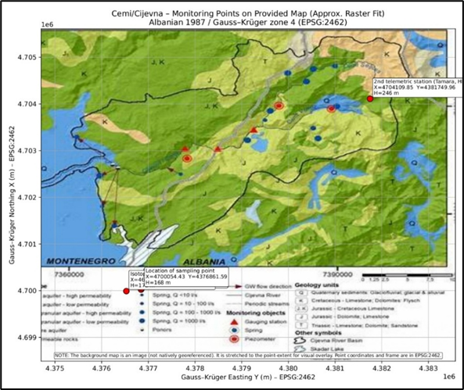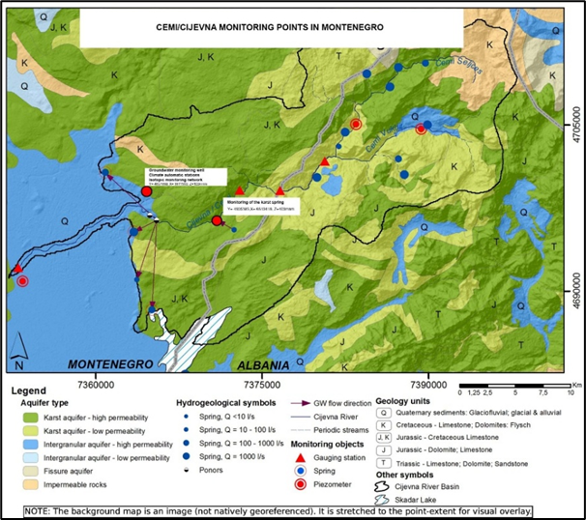
Figure 11 Map of proposed monitoring network

5.2.1 Groundwater chemical status
Monitoring of groundwater chemical status aims to assess the hydrochemical characteristics of karst aquifers within the basin and to identify possible changes related to natural processes or anthropogenic influences.
The monitoring programme includes measurements of a range of physico-chemical parameters, major ions, nutrients and trace elements that provide information about groundwater composition and water–rock interaction processes.
The main physico-chemical parameters monitored include:

- pH
- electrical conductivity
- temperature
- dissolved oxygen
- total dissolved solids

These parameters provide basic information about groundwater conditions and allow the identification of possible variations related to recharge processes or mixing between groundwater and surface water.
In addition to basic parameters, monitoring includes analyses of major ions that define the hydrochemical type of groundwater. These include:

- calcium (Ca²⁺)
- magnesium (Mg²⁺)
- sodium (Na⁺)
- potassium (K⁺)
- bicarbonates (HCO₃⁻)
- sulfates (SO₄²⁻)
- chlorides (Cl⁻)

These ions are particularly important in carbonate aquifers because they reflect the geochemical interaction between groundwater and limestone formations.
Monitoring also includes the determination of nutrients and potential pollution indicators, such as:
- nitrates (NO₃⁻)
- nitrites (NO₂⁻)
- ammonium (NH₄⁺)
- phosphates (PO₄³⁻)

Trace elements and heavy metals are also analysed in order to evaluate possible contamination from natural or anthropogenic sources. These include elements such as:

- iron (Fe)
- manganese (Mn)
- lead (Pb)
- arsenic (As)
- chromium (Cr)

The results of these analyses provide valuable information about groundwater quality within the basin. A summary of hydrochemical analyses carried out within the study area is presented in Table 6, which includes the results obtained from selected springs and river locations within the Cemi/Cijevna basin.
Groundwater sampling is generally conducted at seasonal intervals, typically twice per year, in order to capture variations between wet and dry periods.

5.2.2 Surface water chemical status
Monitoring of surface water chemical status focuses primarily on the Cemi/Cijevna River and its tributaries. The objective of this monitoring component is to evaluate the chemical composition of river water and to assess its compliance with national and European water quality standards.
Surface water monitoring includes a similar range of physico-chemical parameters as groundwater monitoring. Measurements typically include:

- temperature
- pH
- electrical conductivity
- dissolved oxygen
- turbidity
- total dissolved solids

Major ions are also analysed in order to characterize the hydrochemical composition of river water and to evaluate possible interactions with groundwater systems.
In addition, nutrient concentrations are monitored to detect possible inputs from agricultural activities, settlements or other human influences within the basin.
Monitoring of selected trace elements and heavy metals is also conducted in order to ensure that concentrations remain within acceptable environmental limits.
Surface water samples are generally collected at monthly or seasonal intervals, depending on monitoring objectives and logistical conditions.

5.2.3 Surface water ecological status
In accordance with the principles of the Water Framework Directive, monitoring of surface water bodies also includes the assessment of ecological status. Ecological monitoring evaluates the condition of aquatic ecosystems and their response to physical, chemical and hydrological pressures. Ecological monitoring typically includes biological quality elements such as:

- phytoplankton
- macrophytes and phytobenthos
- benthic macroinvertebrates
- fish communities

These biological indicators provide information about the ecological health of river ecosystems and their sensitivity to environmental changes.
In addition to biological monitoring, hydromorphological parameters such as river flow regime, channel morphology and connectivity between surface water and groundwater are also considered.
The integration of chemical, biological and hydromorphological monitoring provides a comprehensive framework for evaluating the overall ecological condition of surface water bodies within the Cemi/Cijevna basin.
The assessment of groundwater-dependent ecosystems requires the monitoring of several basic physico-chemical parameters that control both hydrogeochemical processes and biological activity in groundwater and associated habitats. The main parameters used for monitoring in the Cemi/Cijevna basin are presented in Table 8.

Table 8. Basic physico-chemical parameters for monitoring groundwater-dependent ecosystems in the Cemi/Cijevna basin
Parameter | Unit | Environmental significance | Relevance for monitoring
Water temperature | °C | Controls chemical reactions and biological processes in groundwater and aquatic habitats | Indicator of recharge conditions and groundwater–surface water interaction
pH | – | Determines acidity/alkalinity of water and affects solubility of minerals and nutrients | Important for evaluating geochemical processes and ecological suitability
Dissolved oxygen | mg/L | Essential for oxidation processes and for the survival of aquatic organisms | Indicator of water quality and biological activity
Electrical conductivity | µS/cm | Reflects the concentration of dissolved ions and overall mineralization of water | Useful for identifying groundwater sources and mixing processes
Total dissolved solids (TDS) | mg/L | Represents the total concentration of dissolved inorganic and organic substances | Indicator of salinity and mineral content of groundwater
Major ions (Ca²⁺, Mg²⁺, Na⁺, K⁺, HCO₃⁻, SO₄²⁻, Cl⁻) | mg/L | Define the hydrochemical composition of groundwater and water–rock interaction | Used to determine hydrochemical facies and identify possible contamination

These parameters provide important information on environmental conditions affecting groundwater ecosystems and allow biological observations to be interpreted in relation to hydrogeological processes.

5.3 PROPOSAL FOR MONITORING IMPROVEMENT

The analysis of the existing monitoring network within the Cemi/Cijevna transboundary basin indicates that current monitoring activities provide valuable information on hydrological conditions; however, several limitations remain with respect to spatial coverage, monitoring frequency and the integration of groundwater and surface water observations.
In particular, groundwater monitoring within karst environments remains relatively limited, while monitoring systems are often focused primarily on surface water observations and flood protection. As a result, important aspects of groundwater circulation and surface water–groundwater interaction are not sufficiently captured by existing monitoring networks.
To address these limitations, the DIKTAS II project proposes the establishment of an integrated monitoring system designed to improve the understanding of hydrological processes within the basin and to support transboundary water management between Albania and Montenegro.
The proposed monitoring improvements include the installation of new monitoring stations, the introduction of continuous measurement technologies and the integration of hydrochemical and isotopic analyses.
The monitoring program proposed for the Cemi/Cijevna transboundary basin includes a set of physical, chemical, and biological parameters designed to evaluate both the quantitative and qualitative status of groundwater and surface water bodies. The recommended monitoring frequencies are adapted to the hydrogeological characteristics of the karst aquifer and to the institutional capacities of the monitoring authorities in Albania and Montenegro.

Table 9. Monitoring programe proposed
Monitoring component | Parameter | Unit | Recommended monitoring frequency | Monitoring purpose
Groundwater quantity | Groundwater level | m | Continuous / monthly | Assessment of aquifer dynamics and groundwater storage
 | Spring discharge | L/s | Monthly | Monitoring aquifer discharge and groundwater availability
Basic physico-chemical parameters | Water temperature | °C | Monthly | Indicator of recharge conditions and groundwater–surface water interaction
 | pH | – | Monthly | Indicator of geochemical processes
 | Electrical conductivity | µS/cm | Monthly | Indicator of mineralization and groundwater origin
 | Dissolved oxygen | mg/L | Monthly | Indicator of water quality and biological activity
 | Total dissolved solids | mg/L | Seasonal | Indicator of overall mineralization
Major ions | Calcium (Ca²⁺) | mg/L | Seasonal | Characterization of carbonate dissolution processes
 | Magnesium (Mg²⁺) | mg/L | Seasonal | Identification of dolomitic influence
 | Sodium (Na⁺) | mg/L | Seasonal | Detection of mixing processes
 | Potassium (K⁺) | mg/L | Seasonal | Identification of anthropogenic inputs
 | Bicarbonates (HCO₃⁻) | mg/L | Seasonal | Dominant ion in karst aquifers
 | Sulfates (SO₄²⁻) | mg/L | Seasonal | Indicator of mineral dissolution or pollution
 | Chlorides (Cl⁻) | mg/L | Seasonal | Indicator of external contamination sources
Nutrients | Nitrates (NO₃⁻) | mg/L | Seasonal | Indicator of agricultural pressures
 | Ammonium (NH₄⁺) | mg/L | Seasonal | Indicator of organic pollution
 | Nitrites (NO₂⁻) | mg/L | Seasonal | Indicator of nitrification processes
 | Phosphates (PO₄³⁻) | mg/L | Seasonal | Indicator of nutrient enrichment
Trace elements | Iron (Fe) | µg/L | Annual | Indicator of geochemical conditions
 | Manganese (Mn) | µg/L | Annual | Indicator of redox processes
 | Lead (Pb) | µg/L | Annual | Assessment of potential contamination
 | Arsenic (As) | µg/L | Annual | Assessment of groundwater quality
Biological monitoring | Macrozoobenthos | – | Annual | Assessment of ecological status of surface waters
 | Phytobenthos (diatoms) | – | Annual | Indicator of nutrient conditions
 | Macrophytes / bryophytes | – | Every 1–3 years | Indicator of ecological integrity
 | Fish communities | – | Every 3 years | Assessment of river ecological status
Investigative monitoring | Radon (Rn-222) | Bq/L | Targeted campaigns | Identification of groundwater inflow zones
 | Stable isotopes (δ18O, δ2H) | ‰ | Seasonal campaigns | Determination of recharge sources
 | Biospeleological surveys | – | Periodic surveys | Monitoring of groundwater-dependent ecosystems

In karst environments such as the Cemi/Cijevna basin, monitoring programs must combine routine observations with targeted investigative studies. Routine monitoring provides information on long-term trends and baseline conditions, while investigative monitoring techniques such as radon measurements, isotope analysis, and biospeleological surveys allow for a better understanding of groundwater flow paths and groundwater-dependent ecosystems.

5.3.1 Groundwater quality monitoring
Improvement of groundwater quality monitoring represents one of the main objectives of the proposed monitoring system. In karst environments, groundwater systems are particularly vulnerable to contamination due to the high permeability of carbonate formations and the rapid infiltration of surface water.
The proposed monitoring programme includes the establishment of regular groundwater sampling at selected springs and observation wells located within the basin. Sampling locations have been selected in order to represent different hydrogeological conditions and recharge areas.
Hydrochemical analyses will include the determination of major ions, nutrients and trace elements in order to characterize groundwater composition and detect possible pollution sources. In addition, monitoring of microbiological parameters will provide information about the sanitary quality of groundwater resources.
This monitoring component will contribute to the long-term assessment of groundwater quality and provide essential information for the protection of drinking water resources within the basin.

Table 10. Summary results – June 2025
No. | Parameter | Unit | M-1 Grabom | M-2 Grabom 2 | M-3 Tamara | M-4 Tamara 2 (b.5) | M-5 Vermosh Center | M-6 Kroni i Zekës | M-7 Cemi (Selcë) | M-8 Cemi (Vukël)
1 | pH | - | 7.33 | 7.48 | 7.44 | 7.49 | 7.38 | 7.46 | 7.54 | 7.47
2 | Electrical Conductivity | µS/cm | 294 | 238 | 255 | 249 | 292 | 183.7 | 195.7 | 193.3
3 | Total Dissolved Solids (TDS) | mg/L | 200.0 | 161.9 | 173.4 | 169.3 | 198.6 | 124.9 | 133.1 | 131.4
4 | Bicarbonates (HCO₃⁻) | mg/L | 175 | 150 | 155 | 150 | 165 | 150 | 120 | 120
5 | Carbonates (CO₃²⁻) | mg/L | <0.2 | <0.2 | <0.2 | <0.2 | <0.2 | <0.2 | <0.2 | <0.2
6 | Dissolved Oxygen (DO) | mg/L | 10.02 | 10.18 | 9.90 | 9.85 | 9.62 | 9.74 | 9.83 | 10.40
7 | Organic Matter (OM) | mg/L | 0.8 | 0.7 | 0.4 | 0.4 | 0.6 | 0.3 | 0.4 | 0.2
8 | Magnesium (Mg²⁺) | mg/L | 12.0 | 8.4 | 4.8 | 10.8 | 20.4 | 9.6 | 6.0 | 3.6
9 | Calcium (Ca²⁺) | mg/L | 40.0 | 48.0 | 56.0 | 51.0 | 46.0 | 32.0 | 40.0 | 42.0
10 | Total Mineralization | mg/L | 149.0 | 154 | 160.2 | 172.0 | 199.0 | 119.3 | 125 | 120.0
11 | Total Hardness | °dH | 8.36 | 8.65 | 8.94 | 9.62 | 11.1 | 6.68 | 6.98 | 6.71
12 | Sulfates (SO₄²⁻) | mg/L | 3.62 | 0.38 | 0.31 | 0.50 | 6.31 | 2.5 | 0.44 | 0.37
13 | Chlorides (Cl⁻) | mg/L | 7.09 | 2.84 | 2.13 | 5.67 | 3.97 | 3.54 | 4.25 | 2.84
14 | Ammonium Nitrogen (NH₄⁺-N) | mg/L | 0.016 | 0.014 | 0.016 | 0.017 | 0.015 | 0.014 | 0.016 | 0.017
15 | Nitrates (NO₃⁻-N) | mg/L | 0.150 | 0.110 | 0.180 | 0.140 | <0.001 | <0.001 | <0.001 | 0.090
16 | Nitrites (NO₂⁻-N) | mg/L | 0.0004 | 0.0006 | 0.0004 | 0.0005 | 0.0004 | 0.0002 | 0.0006 | 0.0004
17 | Fluorides (F⁻) | mg/L | 0.02 | <0.01 | 0.03 | 0.06 | 0.07 | 0.06 | 0.13 | 0.07
18 | Phosphates (PO₄³⁻) | mg/L | 0.009 | 0.014 | 0.067 | 0.033 | 0.004 | 0.009 | 0.043 | 0.009
19 | Iron (Fe) | µg/L | 2.44 | 2.10 | 0.51 | 1.27 | 1.06 | 1.63 | 0.50 | 2.38
20 | Total Manganese (Mn) | µg/L | 1.40 | 1.23 | 1.71 | 1.30 | 1.79 | 1.11 | 0.69 | 0.61
21 | Hexavalent Chromium (Cr VI) | µg/L | <0.01 | <0.01 | <0.01 | <0.01 | <0.01 | <0.01 | <0.01 | <0.01
22 | Sodium (Na⁺) | mg/L | 3.51 | 2.66 | 3.13 | 2.87 | 4.06 | 2.49 | 2.47 | 2.14
23 | Potassium (K⁺) | mg/L | 0.15 | 0.27 | 0.26 | 0.18 | 0.93 | 0.18 | 0.05 | 0.04
24 | Lead (Pb) | µg/L | 0.73 | 0.08 | 0.90 | 0.51 | 0.30 | 0.45 | 0.24 | 0.15
25 | Cobalt (Co) | µg/L | <0.01 | <0.01 | <0.01 | <0.01 | <0.01 | <0.01 | <0.01 | <0.01
26 | Arsenic (As) | µg/L | <0.01 | <0.01 | <0.01 | <0.01 | <0.01 | <0.01 | <0.01 | <0.01

Table 11. Main measured parameters and hydrochemical types of the main springs
Sampling site | pH | EC (µS/cm) | TDS (mg/L) | Ca²⁺ (mg/L) | Mg²⁺ (mg/L) | HCO₃⁻ (mg/L) | SO₄²⁻ (mg/L) | Cl⁻ (mg/L) | Hydrochemical facies
M-1 Grabom | 7.33 | 294 | 200 | 40 | 12 | 175 | 3.62 | 7.09 | Ca–Mg–HCO₃
M-2 Grabom 2 | 7.48 | 238 | 161.9 | 48 | 8.4 | 150 | 0.38 | 2.84 | Ca–HCO₃
M-3 Tamara | 7.44 | 255 | 173.4 | 56 | 4.8 | 155 | 0.31 | 2.13 | Ca–HCO₃
M-4 Tamara 2 | 7.49 | 249 | 169.3 | 51 | 10.8 | 150 | 0.50 | 5.67 | Ca–Mg–HCO₃
M-5 Vermosh Center | 7.38 | 292 | 198.6 | 46 | 20.4 | 165 | 6.31 | 3.97 | Ca–Mg–HCO₃
M-6 Kroni i Zekës | 7.46 | 183.7 | 124.9 | 32 | 9.6 | 150 | 2.50 | 3.54 | Ca–HCO₃
M-7 Cemi (Selcë) | 7.54 | 195.7 | 133.1 | 40 | 6 | 120 | 0.44 | 4.25 | Ca–HCO₃
M-8 Cemi (Vukël) | 7.47 | 193.3 | 131.4 | 42 | 3.6 | 120 | 0.37 | 2.84 | Ca–HCO₃

Hydrogeochemical interpretation
The hydrochemical composition of the analysed water samples indicates that groundwater and surface water within the Cemi/Cijevna basin are dominated by calcium–bicarbonate type waters. This hydrochemical facies is typical for karst aquifers developed in carbonate rocks such as limestone and dolomite.
The dominance of Ca²⁺ and HCO₃⁻ ions reflects intensive dissolution of carbonate minerals during groundwater circulation through fractured and karstified carbonate formations. In several samples (M-1, M-4 and M-5) slightly elevated magnesium concentrations indicate partial influence of dolomitic lithologies, resulting in a mixed Ca–Mg–HCO₃ hydrochemical facies.
Electrical conductivity values range between approximately 183 and 294 µS/cm, while total dissolved solids vary from approximately 125 to 200 mg/L, indicating relatively low mineralization typical of recently recharged karst groundwater.
Low concentrations of sulphates, chlorides and nutrients suggest minimal anthropogenic influence and confirm the generally good chemical quality of water in the investigated basin.
Overall, the hydrochemical characteristics reflect rapid groundwater circulation, short residence time and strong hydraulic connectivity between recharge areas in the Albanian Alps and discharge zones along the Cemi/Cijevna river system.
The Schoeller diagram clearly illustrates the dominance of calcium and bicarbonate ions in all analysed samples, confirming that the waters of the Cemi/Cijevna basin belong predominantly to the Ca–HCO₃ hydrochemical facies. Slightly elevated magnesium concentrations in several samples reflect the influence of dolomitic lithologies within the karst aquifer. The generally low concentrations of sulphates and chlorides indicate minimal anthropogenic influence and confirm the good chemical status of the analysed waters.

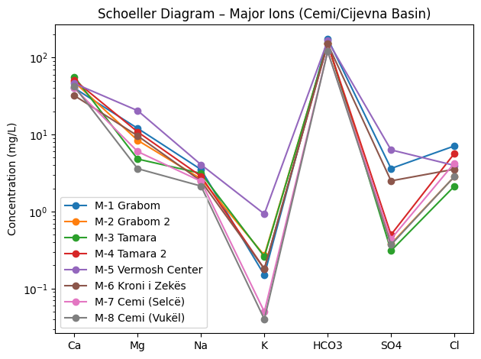
Figure 12 Schoeller diagram showing the major ion composition of groundwater and surface water samples from the Cemi/Cijevna basin. The diagram indicates the dominance of calcium–bicarbonate waters typical for karst aquifers developed in carbonate rocks.

The diagram clearly shows:

Ca²⁺ and HCO₃⁻ dominance

low mineralization (typical for karst)

slight dolomite influence (Mg) in some samples

lack of contamination (very low SO₄ and Cl).

5.3.2 Groundwater quantity monitoring
Monitoring of groundwater quantity is essential for understanding the dynamics of the karst aquifer system and for evaluating the relationship between groundwater levels, river discharge and precipitation.
Within the framework of the project, a monitoring wells will be installed in the Grabom area, near the border between Albania and Montenegro, in village Dinoša and confluence with river Moraca. This monitoring wells will provide continuous information on groundwater levels within the karst aquifer system shared by the two countries.
The well will be equipped with automatic sensors capable of measuring groundwater level, temperature and electrical conductivity. These measurements will be recorded at regular time intervals and transmitted through a telemetric data transmission system.
The karst spring in the village Kroni and Traboini will be equipped with a data logger (diver) for measuring the water level (stage), based on which the spring discharge will be calculated.
Continuous groundwater level monitoring will allow the analysis of aquifer responses to precipitation events and river flow variations and will significantly improve the understanding of groundwater circulation within the basin.

5.3.3 Hydrometeorological monitoring
Hydrometeorological observations are an essential component of the proposed monitoring system because precipitation and climatic conditions strongly influence hydrological processes within the basin. The monitoring network therefore includes the installation of modern meteorological stations capable of measuring parameters such as precipitation, air temperature, atmospheric pressure and relative humidity.
Data obtained from these stations will contribute to the analysis of hydrological processes within the basin and will support the development of water balance assessments. Continuous climatic observations will also help identify long-term trends associated with climate variability.

5.3.4 Stable isotope monitoring
Stable isotope analysis represents an important tool for understanding the origin and circulation pathways of water within karst aquifers.
Within the framework of the monitoring programme, samples of precipitation, surface water and groundwater will be collected periodically for the analysis of stable isotopes of oxygen and hydrogen (δ¹⁸O and δ²H).
Isotopic monitoring will enable the identification of recharge sources and the estimation of groundwater residence times. It will also provide valuable information on the hydraulic connections between different components of the hydrological system.
The integration of isotopic data with hydrological and hydrochemical observations will significantly enhance the understanding of groundwater circulation within the Cemi/Cijevna basin.

5.3.5 Radon monitoring as a groundwater tracer
Radon-222 measurements will be used as an additional method for identifying groundwater inflow into surface water systems. Radon is a naturally occurring radioactive gas produced by the decay of radium in rocks and soils and is typically present in significantly higher concentrations in groundwater than in surface water.
By measuring radon concentrations along the course of the Cemi/Cijevna River, it is possible to identify zones where groundwater discharges into the river or where river water infiltrates into the karst aquifer. This method is particularly useful in karst environments where traditional hydrological measurements may not be sufficient to detect subsurface flow processes.

5.3.6 Data management and integration
An important component of the proposed monitoring system is the establishment of a centralized data management platform that will store and organize monitoring data collected within the project. The system will allow participating institutions in Albania and Montenegro to access monitoring data and share information relevant to water resources management. Data collected from monitoring stations will be archived and processed in order to support scientific analysis and reporting. Such an integrated data management system is essential for ensuring the long-term sustainability of monitoring activities and for facilitating cooperation between the two countries in managing shared water resources.
In order to improve the monitoring of groundwater and surface water resources within the Albanian part of the Cemi/Cijevna basin, several monitoring installations are proposed. These include the drilling of a monitoring well, installation of telemetric stations for continuous hydrological and meteorological observations, and the installation of an isotopic pluviometer for the collection of precipitation samples used in isotope-based hydrological studies.

Table 12. Proposed monitoring infrastructure in the Albanian part of the Cemi/Cijevna basin
Monitoring component | Easting (m) | Northing (m) | Monitoring purpose | Remarks
Monitoring well drilling site | 376764 | 4698014 | Groundwater level monitoring and hydrochemical sampling | Selected as the most suitable location for hydrogeological monitoring
Telemetric monitoring station (No.1) | 376764 | 4698014 | Continuous monitoring of hydrological and meteorological parameters | Co-located with the monitoring well
Isotopic pluviometer station | 376449 | 4697978 | Collection of precipitation samples for stable isotope analysis (δ¹⁸O, δ²H) | Installed near the existing customs facility building
Telemetric station (No.2 – Tamara HPP area) | 376764 | 4698014 | Monitoring of river discharge and climatic parameters | Located in the HEC Tamara hydropower plant area

The proposed monitoring infrastructure is designed to support the investigation of groundwater recharge processes in the karst aquifer system of the Albanian Alps. The installation of an isotopic pluviometer will allow for the analysis of precipitation isotopic composition, which can later be compared with isotopic signatures of groundwater and spring water in order to identify recharge areas and groundwater residence times.

6. MONITORING EQUIPMENT ACQUISITION COSTS ESTIMATION

The implementation of the proposed monitoring system within the Cemi/Cijevna transboundary basin requires the acquisition of specialized monitoring equipment designed to support continuous and reliable observation of hydrological, hydrogeological and climatic processes.
The monitoring infrastructure proposed in this study includes equipment for groundwater monitoring, surface water monitoring, hydrometeorological observations and laboratory analyses. The selection of monitoring equipment has been based on the specific hydrogeological conditions of the basin, particularly the presence of karst aquifers and the strong interaction between groundwater and surface water systems.
The estimated costs presented in this chapter are indicative and are intended to provide an overview of the financial resources required for establishing the monitoring network. Actual costs may vary depending on equipment specifications, procurement procedures and installation conditions.
The main categories of monitoring equipment include:

Groundwater monitoring equipment

- drilling and installation of monitoring wells (piezometers);
- automatic water level loggers;
- sensors for electrical conductivity and temperature;
- telemetry systems for real-time data transmission.

Surface water monitoring equipment

- automatic water level sensors for river stage measurements;
- flow measurement instruments (current meters or acoustic Doppler devices);
- multi-parameter water quality probes capable of measuring pH, conductivity, dissolved oxygen and temperature.

Hydrometeorological monitoring equipment

- automatic meteorological stations for precipitation measurement;
- sensors for air temperature, humidity and atmospheric pressure;
- data loggers and communication modules.

Sampling and analytical equipment

- portable water sampling devices;
- field measurement instruments for physico-chemical parameters;
- equipment for hydrochemical and isotopic analyses.

In addition to monitoring equipment, costs associated with installation, calibration, maintenance and data management systems must also be considered. The establishment of this monitoring infrastructure represents a key investment for improving knowledge of hydrological processes within the basin and for strengthening transboundary cooperation in water resources management between Albania and Montenegro.

Summary of the budget - detailed financial budget

The project budget is built in full compliance with its methodology and objectives. It covers all technical and operational aspects and ensures rational and justified use of funds.

- Assumptions and price references

- Currency: EUR (€)
- VAT calculated separately
- Contingency: 5% and 10% (scenarios)
Equipment prices are indicative OTT European market prices; installation costs are based on local references.

- Drilling in limestone formations: 200 €/m (local reference).
- VAT not included. VAT is currently 20% Albania and 21 % Montenegro
- Contingency is calculated as 5% and 10% scenarios of the subtotal (without VAT).
- Isotope analyses δ¹⁸O + δ²H are budgeted using conservative European reference prices.

- Detailed budget Albania (subtotal excluding VAT)

Table 13. Detailed budget for equipments in Albania
Category | Item | Unit | Quantity | Unit price  (€) | Total  (€)
Monitoring well | Mobilization and site setup | LS | 1 | 2 500 | 2 500
Monitoring well | Drilling Ø150 mm in limestone | m | 160 | 200 | 32 000
Monitoring well | PVC casing Ø90 mm (blank) | m | 100 | 55 | 5 500
Monitoring well | PVC casing Ø90 mm (screened) | m | 60 | 70 | 4 200
Monitoring well | Gravel pack and installation | LS | 1 | 1 800 | 1 800
Monitoring well | Cement-bentonite sealing | LS | 1 | 1 200 | 1 200
Monitoring well | Well development | LS | 1 | 1 200 | 1 200
Monitoring well | Pumping test (step + 24h constant rate) and report | LS | 1 | 2 800 | 2 800
Monitoring well | Wellhead protection and safety cover | LS | 1 | 900 | 900
Supervision | Hydrogeological supervision (6 days) | day | 6 | 250 | 1 500
Supervision | Final technical well report | LS | 1 | 650 | 650
Instrumentation | OTT CTD logger (level, T, EC) | pcs | 1 | 1 600 | 1 600
Instrumentation | Barometric logger (barodiver) | pcs | 1 | 750 | 750
Instrumentation | Cables and accessories | LS | 1 | 450 | 450
Instrumentation | Installation and configuration | LS | 1 | 600 | 600
Telemetry | Telemetry unit (data logger + communication) | pcs | 2 | 2 800 | 5 600
Telemetry | Solar panel, battery, enclosure | pcs | 2 | 950 | 1 900
Telemetry | Antenna, accessories and installation | pcs | 2 | 650 | 1 300
Telemetry | Communication and hosting (12 months) | pcs | 2 | 240 | 480
Surface water | Water level sensors | pcs | 2 | 900 | 1 800
Surface water | Installation and benchmarks | pcs | 2 | 450 | 900
Surface water | Portable flowmeter | pcs | 1 | 2 200 | 2 200
Surface water | Rating curve calibration campaigns | trip | 4 | 250 | 1 000
Isotopes | Isotope rain collectors | pcs | 2 | 650 | 1 300
Isotopes | Installation of collectors | pcs | 2 | 250 | 500
Automatic climatol. station | Purchase and installation | pcs | 2 | 5 000 | 10 000
Security | IP cameras and accessories | pcs | 2 | 420 | 840
Security | Physical protection structures | pcs | 2 | 600 | 1 200
Laboratory | Physico-chemical + bacteriological analyses (24 samples) | sample | 24 | 55 | 1 320
Laboratory | Heavy metals package (24 samples) | sample | 24 | 120 | 2 880
Laboratory | Isotope analyses δ¹⁸O + δ²H (60 samples) | sample | 60 | 80 | 4 800
O&M | Annual maintenance visits | LS | 1 | 1 800 | 1 800
O&M | Annual sensor calibration | LS | 1 | 500 | 500
O&M | Monthly and annual technical reports | LS | 1 | 1 200 | 1 200
Total 99 170 €
- Detailed budget Montenegro (subtotal excluding VAT)

Table 14 Detailed budget for equipments in Montenegro
Category | Item | Unit | Quantity | Unit price  (€) | Total  (€)
Monitoring well | Mobilization and site setup | LS | 2 | 2 500 | 5 000
Monitoring well | Drilling Ø146 mm | m | 150 | 200 | 30 000
Monitoring well | PHD casing Ø124 mm (blank) | m | 100 | 55 | 5 500
Monitoring well | PHD casing Ø124 mm (screened) | m | 50 | 70 | 3 500
Monitoring well | Gravel pack and installation | LS | 2 | 1 000 | 2 000
Monitoring well | Cement-bentonite sealing | LS | 2 | 1 000 | 2 000
Monitoring well | Well development | LS | 2 | 1 000 | 2 000
Monitoring well | Pumping test (step + 24h constant rate) and report | LS | 2 | 2 800 | 5 600
Monitoring well | Wellhead protection and safety cover | LS | 2 | 900 | 1 800
Supervision | Hydrogeological supervision (6 days) | day | 6 | 250 | 1 500
Supervision | Final technical well report | LS | 2 | 500 | 1 000
Instrumentation | OTT CTD logger (level, T, EC) | pcs | 2 | 1 600 | 3 200
Instrumentation | Barometric logger (barodiver) | pcs | 2 | 750 | 1 500
Instrumentation | Cables and accessories | LS | 2 | 450 | 900
Instrumentation | Installation and configuration | LS | 2 | 500 | 1 000
Monitoring karst spring | Mobilization and site setup | LS | 1 | 2 500 | 2 500
Monitoring karst spring | Arrangement and equipping of a hydrological bar for flow in the spring catchment | LS | 1 | 2 500 | 2 500
Supervision | Hydrogeological supervision (2 days) | day | 2 | 250 | 500
Supervision | Final technical spring report | LS | 1 | 500 | 500
Instrumentation | OTT CTD logger (level, T, EC) | pcs | 1 | 1 600 | 1 600
Instrumentation | Cables and accessories | LS | 1 | 450 | 450
Instrumentation | Installation and configuration | LS | 1 | 600 | 600
Isotopes | Isotope rain collectors | pcs | 2 | 800 | 1600
Isotopes | Installation of collectors | pcs | 1 | 250 | 250
Automatic climatological station | Purchase and installation | pcs | 1 | 5 000 | 5 000
Laboratory | Physico-chemical + bacteriological analyses (48 samples) | sample | 48 | 55 | 2 640
Laboratory | Heavy metals package (24 samples) | sample | 24 | 120 | 2 880
Laboratory | Isotope analyses δ¹⁸O + δ²H (72 samples) | sample | 72 | 80 | 5 760
O&M | Annual maintenance visits | LS | 1 | 1 800 | 1 800
O&M | Annual sensor calibration | LS | 1 | 500 | 500
O&M | Monthly and annual technical reports | LS | 1 | 1 200 | 1 200
Total 96 780 €
- Financial summary

Table 15. Total expenses
Description | Formula | Amount (€)
Subtotal (excluding VAT) | Sum of Section B+C | 195.950,00
Contingency 5% (scenario) | 0.05 × Subtotal | 9.797,50
Contingency 10% (scenario) | 0.10 × Subtotal | 19.595,00
TOTAL with 5% contingency | Subtotal + Cont.5% | 205.747,50
TOTAL with 10% contingency | Subtotal + Cont.10% | 215.545,00

- This budget is indicative and intended for project planning and funding applications. Final costs shall be confirmed through official quotations and procurement procedures.
- The pumping test is included for aquifer characterization only; the monitoring well is not intended for water abstraction.
- Isotope analysis costs are conservative reference prices and may be reduced if regional laboratories are used.

7. ANNUAL MONITORING PROGRAM COSTS ESTIMATION
Following the establishment of the monitoring infrastructure described in the previous chapter, the long-term operation of the monitoring network within the Cemi/Cijevna transboundary basin will require regular financial resources to ensure the continuity and reliability of monitoring activities.
Annual monitoring program costs primarily relate to the operation, maintenance and data management of the monitoring system. These costs include periodic field measurements, laboratory analyses, maintenance of monitoring equipment, calibration of sensors, data processing and reporting activities.
One of the most significant components of the annual monitoring program costs is associated with water sampling and laboratory analyses. Regular hydrochemical analyses of surface water and groundwater samples are required in order to assess water quality conditions and detect possible changes related to natural processes or anthropogenic pressures. These analyses typically include physico-chemical parameters, major ions, nutrients and selected trace elements.
Additional costs are related to the maintenance and servicing of monitoring equipment, including the calibration of sensors, replacement of damaged components and periodic inspection of monitoring stations. In remote mountainous areas such as the upper Cemi basin, access to monitoring stations may require additional logistical resources, particularly during winter conditions.
Operational costs also include data management and processing, which involves the collection, storage and analysis of monitoring data obtained from hydrological stations, groundwater observation wells and meteorological monitoring sites. The management of monitoring data is essential for ensuring the long-term usability of collected information and for supporting reporting activities required by national and international water management frameworks.
Personnel costs associated with field measurements, sample collection and data analysis also represent an important component of the annual monitoring budget. These activities are typically carried out by specialists from hydrometeorological services, environmental agencies or research institutions responsible for water monitoring.
Although the exact costs of the monitoring program may vary depending on institutional arrangements and operational conditions, the establishment of a coordinated monitoring network within the Cemi/Cijevna basin represents a relatively modest investment compared with the long-term benefits of improved water resources management.
Ensuring the sustainability of monitoring activities beyond the duration of the DIKTAS II project is therefore essential for maintaining a reliable knowledge base on the hydrological and hydrogeological processes occurring within the transboundary basin.

8. MONITORING RESPONSIBILITY AFTER THE END OF THE DIKTAS II PROJECT

The long-term sustainability of the monitoring system established within the Cemi/Cijevna transboundary basin requires clearly defined institutional responsibilities after the completion of the DIKTAS II project. Ensuring the continuity of monitoring activities is essential for maintaining the availability of hydrological and hydrogeological data and for supporting effective transboundary water resources management.
Following the completion of the project, the responsibility for operating and maintaining the monitoring network is expected to be assumed by the relevant national institutions responsible for water management and hydrometeorological monitoring in Albania and Montenegro.
In Albania, monitoring responsibilities are expected to involve institutions such as the National Agency of Water Resources Management (AMBU) and the Institute of Geosciences, (IGJEO), which are responsible for hydrological monitoring, groundwater assessments and the management of national water resources information systems.
In Montenegro, monitoring activities are expected to continue under the responsibility of the Institute of Hydrometeorology and Seismology (IHMS), Geological Survey of Montenegro and other national institutions responsible for water management and environmental protection.
The monitoring stations and equipment installed within the framework of the DIKTAS II project will therefore become part of the national monitoring networks operated by these institutions. Their integration into existing monitoring systems will ensure the long-term continuity of data collection and facilitate the use of monitoring results for national reporting and water management planning.
An important aspect of post-project monitoring is the continued exchange of monitoring data between Albania and Montenegro. As the Cemi/Cijevna basin represents a shared transboundary water system, cooperation between the two countries remains essential for understanding hydrological processes and addressing potential water management challenges.
Data sharing mechanisms and institutional cooperation established during the DIKTAS II project should therefore continue to operate after the completion of the project. This will support joint assessments of water resources and contribute to the implementation of river basin management plans consistent with European water policy objectives.
By ensuring institutional ownership of the monitoring infrastructure and maintaining cross-border cooperation, the monitoring system developed within the DIKTAS II project can continue to provide valuable information for the sustainable management and protection of water resources within the Cemi/Cijevna transboundary basin.

9. CONCLUSIONS

The Cemi/Cijevna transboundary basin represents an important hydrological and hydrogeological system shared between Albania and Montenegro. The basin is characterized by complex karst environments, where carbonate formations of Mesozoic age dominate the geological structure and control groundwater circulation processes. These conditions result in strong interactions between surface water and groundwater systems, making integrated monitoring essential for understanding the hydrological dynamics of the basin.
The analysis presented in this report demonstrates that existing monitoring systems within the basin provide valuable information; however, important gaps remain in terms of spatial coverage, integration of monitoring components and long-term observation of groundwater dynamics. Monitoring activities have historically been implemented separately in the two countries, with limited coordination between national monitoring networks.
The conceptual hydrogeological model developed within this study provides a scientific framework for understanding groundwater recharge, flow and discharge processes within the basin. This model highlights the dominant role of karst aquifers, the importance of mountainous recharge zones and the complex hydraulic interactions between groundwater and surface water systems.
Based on the analysis of existing monitoring systems and the hydrogeological characteristics of the basin, this report proposes the development of an integrated monitoring network combining groundwater monitoring, surface water monitoring and hydrometeorological observations. The proposed monitoring system includes continuous measurements of hydrological parameters, hydrochemical monitoring of water quality and the application of advanced methods such as stable isotope analysis and radon measurements.
The monitoring system proposed within the framework of the DIKTAS II project is designed to improve the understanding of hydrological processes within the Cemi/Cijevna basin and to strengthen transboundary cooperation between Albania and Montenegro in the management of shared water resources.
The successful implementation of this monitoring system will provide a reliable scientific basis for assessing water resources status, identifying potential environmental pressures and supporting sustainable water management strategies in accordance with the principles of the European Union Water Framework Directive.
Ensuring the long-term sustainability of monitoring activities beyond the duration of the DIKTAS II project remains a key priority. Continued cooperation between national institutions responsible for water management and hydrometeorological monitoring in both countries will be essential for maintaining the monitoring network and ensuring the availability of high-quality data for future water resources planning.
The establishment of a coordinated monitoring system within the Cemi/Cijevna transboundary basin therefore represents an important step toward improving scientific knowledge of the basin and supporting the sustainable protection and management of its water resources.

ANNEXES
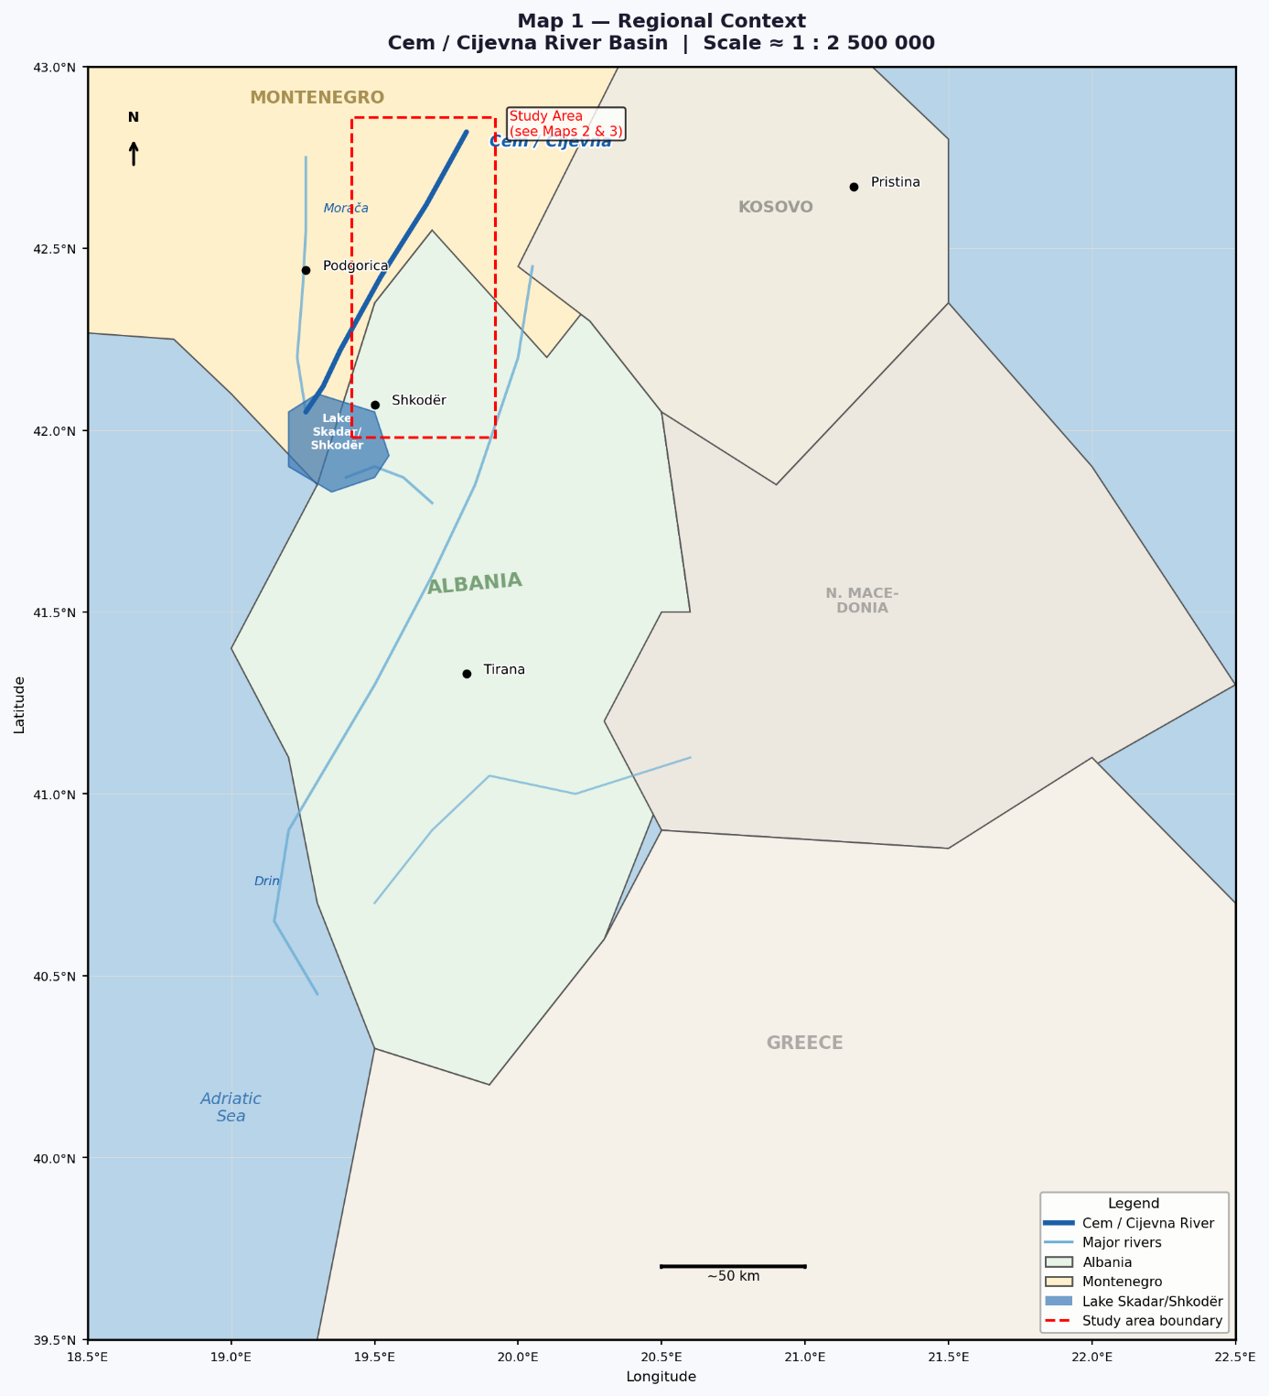
Regional Context (~1:2,500,000)
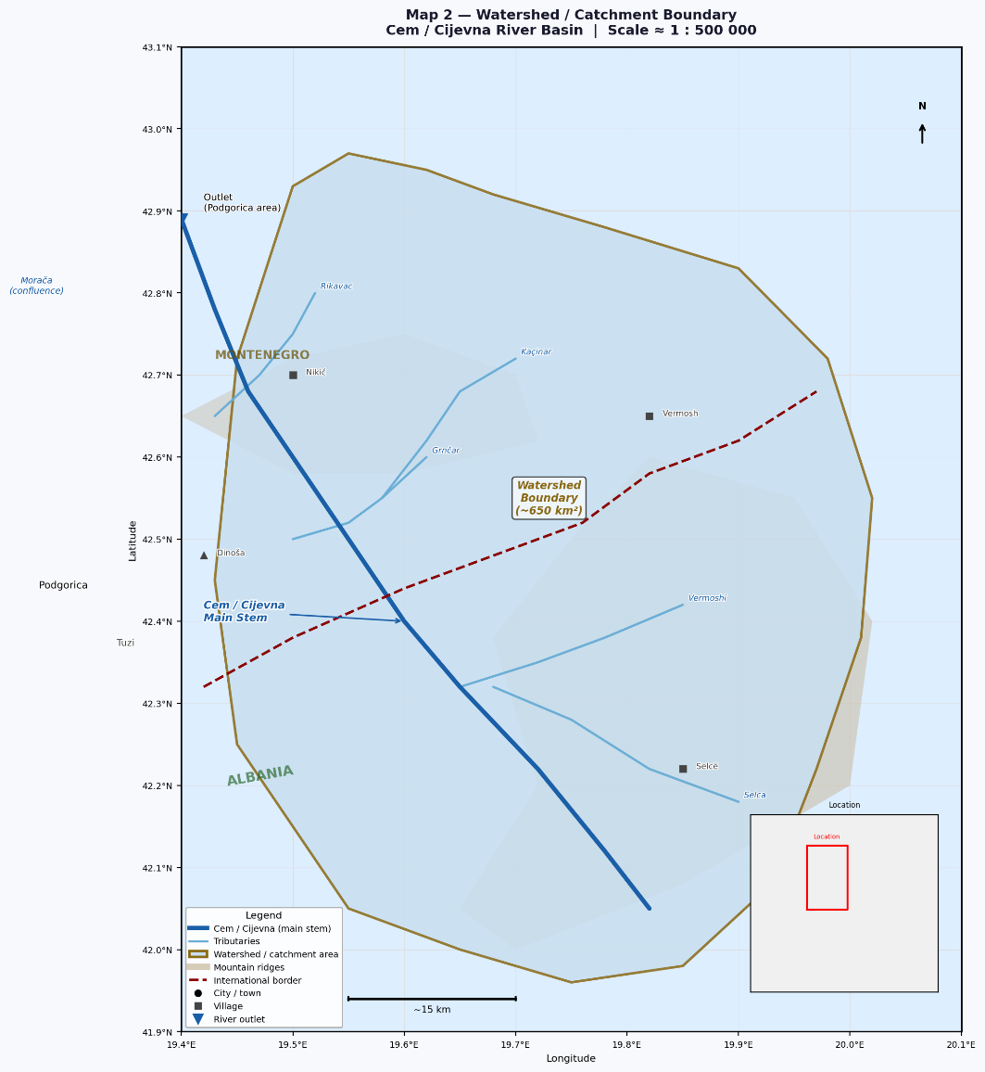
Map 2 — Watershed / Catchment Boundary (~1:500,000)

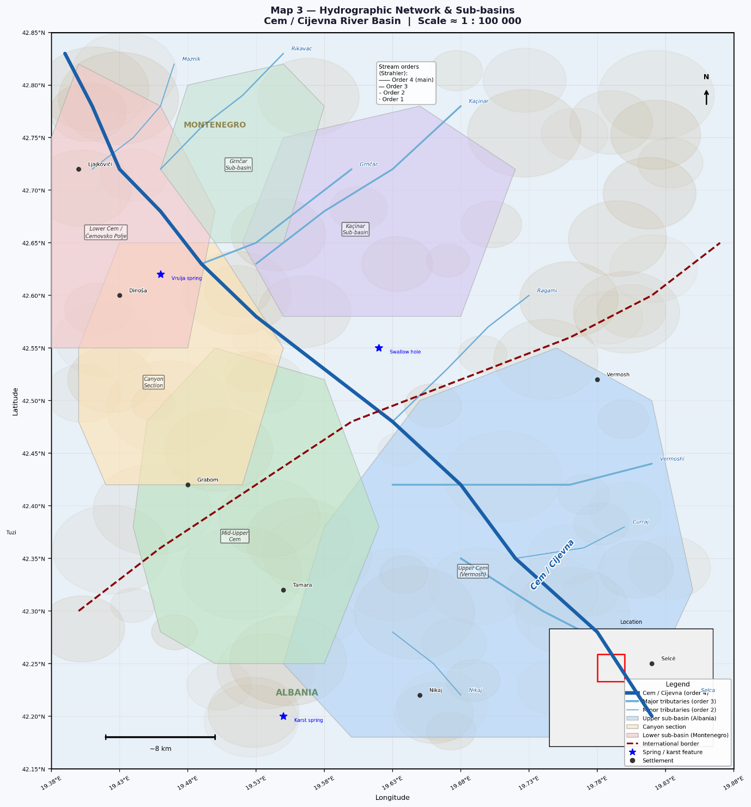
Map 3 — Hydrographic Network & Sub-basins (~1:100,000)

10. REFERENCES
- European Commission, 2000. Directive 2000/60/EC establishing a framework for Community action in the field of water policy (Water Framework Directive).
- European Commission, 2006. Directive 2006/118/EC on the protection of groundwater against pollution and deterioration.
- European Commission, 2008. Directive 2008/105/EC on environmental quality standards in the field of water policy.
- European Commission, 2020. Directive (EU) 2020/2184 on the quality of water intended for human consumption.
- Ford, D., Williams, P., 2007. Karst Hydrogeology and Geomorphology. Wiley.
- Goldscheider, N., Drew, D., 2007. Methods in Karst Hydrogeology. Taylor & Francis.
- Albanian Geological Survey, 2003. Geological Map of Albania 1:200 000.
- Basic Geological Map of the SFRJ (scale 1:100 000) , Sheet “Titograd”, Geological Survey of Montenegro (1962-1967)
- Basic Hydrogeological Map of the SFRJ (scale 1:100 000) , Sheet “Titograd”, Geological Survey of Montenegro (1972-1982)
- Hydrogeological Map of Albania, 2015.
- Geological Survey of Montenegro. Hydrogeological datasets.
- Hydrometeorological Institute of Montenegro. Hydrological datasets.
- Institute of Geosciences (IGJEO), Albania.

